IoT Based Voice Controlled Drink Dispenser System

Kusuma BG

*Dept. of Electronics and Communication Engineering,*

*BGS Institute of Technology*

*Adichunchanagiri University*

Mandya, India

kusumabg2002@gmail.com

Salman S

*Dept. of Electronics and Communication Engineering,*

*BGS Institute of Technology*

*Adichunchanagiri University*

Mandya, India

ssalman9844@gmail.com

Kavyashree G

*Dept. of Electronics and Communication Engineering,*

*BGS Institute of Technology*

*Adichunchanagiri University*

Mandya, India

kavyashreekavyshree685@gmail.com

Chandana DK

*Dept. of Electronics and Communication Engineering,*

*BGS Institute of Technology*

*Adichunchanagiri University*

Mandya, India

*chandanachandhu284@gmail.com*

Deepak R

*Dept. of Electronics and Communication Engineering,*

*BGS Institute of Technology*

*Adichunchanagiri University*

Mandya, India

deepakr@bgsit.ac.in

***Abstract-* This project introduces an inclusive and user-friendly solution catering specifically to the needs of elderly and physically disabled individuals by developing a IoT Based voice based drink dispenser system. The primary objective is to enhance accessibility and independence for users facing mobility challenges, allowing them to effortlessly manage their hydration needs through intuitive voice commands and remote-control capabilities. The system allows Arduino microcontrollers for precise control of the drinks dispenser, integrating a voice recognition module to intrept spoken commands. The inclusion of IoT Technology facilities remote monitoring and control, enabling caregivers or users themselves to operate the dispenser through a Dedicated mobile application. The dispenser, is designs with a focus on user comfort, featuring a user-friendly interface and easy-to read displays. The dispensing mechanism incorporates precession pumps for accurate liquid measurement and sensors to detect cup placement, ensuring a seamless and mess free experience. The project also considers the importance of safety implementing fail safes and emergency stop functionalities. Furthermore, the IoT capabilities enable Realtime monitoring of water, beverages and fruit juice inventory, ensuring that users, caregivers, or family members are notified when it’s time to replenish supplies. Data analytics features provide insights into usage patterns, aiding in personalized care and support. This project addresses a pressing need for assistive technology that can significantly improve the quality of life for an elderly and physically disabled individuals.**

***Keywords- Assistive technology, Data analytics ,voice recognition module, IoT Technology.***

# I. INTRODUCTION

IoT Based voice controlled drinks dispenser system is the project which will be very useful for old age people and disabled people, basically for one’s who cannot perform basic activities efficiently We design a system such that people should get the full benefit by applying certain constraints and automation[1].The proposed system System will be designed based on Arduino Node MCU ESP8266 which is connected to smartphone through Wi-fi for receiving commands through voice or settings in smartphone. After receiving a command Arduino turn on Corresponding Motor[2].The system sends a notification when the level of drinks becomes low in the container. Once the person receives a notification for low water level, the system allows him to refill the drinks, so we are used Level sensors[3].The report consist a results and working process of drink dispensing system, and consists of the future scope and implementation[4]. This proposed system can be used to dispense drinks at various work and commercial places. The existing system facing problems like button operated and wastage of water in the case of overflow of no glasses and this problem is resolved using IR Sensor [5]. A buzzer is used for notification purposes , people already aware of COVID-19 and are taking precautions, As a result this proposed system incorporated an automated solenoid valve open/close control system based on an Infrared sensor[6]. The main of this automation system is to make life easier. Mobile devices are very common among everyone due to its user-friendly interface and portability features. In this project we aim to control electrical appliances and voice commands and mobile app using internet technology. This presents the design and implementation of a low cost but flexible secure voice or internet-based drink dispenser system.

This research paper consists of Introduction, followed by Literature Survey, Methodology, Experimental Results and Conclusion at the end of the paper.

# II**.** Literature Survey

Paper 1: “Voice Based Hot Cold Water Dispenser”

Authors: Kajal Pawar, Kirti Bhoir, Prashali Koli, Ankita Dhamane, Mithun Nair.

Year: May 2020

Explanation:The purpose of research paper is to illustrate the implementation of automatic water dispenser system. The voice based water dispenser is the idea which will be helpful for old age home, hospitals, canteens and offices. The main aim of project is not only to make water hot and cold but also it work on voice command. This system works on the primary input of users voice. Additionally this system includes temperature sensor which displays temperature and also control temperature.

Paper 2: “Research on Voice Based Hot and Cold Water Dispenser using Rasberry Pi 3B”

Authors: Abhishek. R, Rakshith. M, Viresh Pavadeepa Belal.

Year: July 2022

Explanation: In todays world voice technology is one of the widely used technology today. The operation of voice recognition is done through giving commands to control devices that are integrated with the user as tool to facilitates human activities and replace the human work. In the use of dispensers it is necessary to choose hot and cold water and draw the tap directly on the dispenser, while in this pandemic time like today, we have limitation to reduce the direct touch with the material object used together and this projects will help for the needful people. The use of dispenser also as drawbacks as the amount of water released as it cannot pass in the definite amount and the researches are going through this fields. In this way the voice recognition module is used as one method to reduce the direct touch with the dispenser and uses voice commands given by the user and water flow sensor is used to calculate the amount of water come out of the water tap using the dispenser. The system uses the IR sensor to detect the presence of water glass and sends the signal through the main board and then based on this motor starts to rotate and water flows through the pipe from the jar.

Paper 3: “ Automatic Water Dispenser Based on Hand Gesture Detection Using Arduino”

Authors: Yudi Kristyawan, S Kom, YK M Kom

Year: May 2021

Explanation: Water dispensers are electronic devices that are widely available in households and offices. In general, water dispensers use faucets to drain water. During the pandemic, many people avoid touching equipment used by many people. Various ways have been done so that the water dispenser can be operated automatically without touching the faucet. Previous research on water dispensers was only applied to one type of water. This study aims to make an automatic water dispenser without touching the faucet used for two types of water, namely hot water or cold water. This research is based on hand gesture detection to choose hot water or cold water. The APDS-9960 gesture sensor detects hand movements to select hot or cold water, and then a servo motor is used to open the water faucet. After that, the position of the glass is validate by the ultrasonic sensor HC-SR04, and eater will flow for 30 seconds into the glass. The entire input and output process is controlled using Arduino. The results show that this automatic water dispenser can detect hand gesture at a maximum distance of 15 cm with a hand movement speed of 2 to 3.7 seconds. This automatic water dispenser can detect three kinds of glass, namely ceramic, clear glass, and plastic, at a distance of 1 to 3 cm, and the volume of water flowing for 30 seconds is 240 ml.

Paper 4:“Water Level Monitoring System Water Dispenser using IoT”

Authors: Mohita Parashar, Roopa Patil, Siddharth Singh,

Vipul VedMohan,K.S.Rekha.

Year: April 2018

Explanation: One of the major problems faced by most of the large institute is maintaining drinking water in water dispensers at various places inside the institution. Monitoring a large number of water dispensers in huge buildings require a considerable amount of manual supervision. This paper proposes a prototype system design, implementation and description of required tools and technologies to develop internet of things (IoT) based water level monitoring system which can be implemented in offices, collages or buildings.

Paper 5: “Design Automatic Dispenser for Blind People based on Arduino Mega using DS18B20 Temperature Sensor”

Authors: Noor Hudallah, Riana Defi Mahadji Putri, Khusnul

Year: 2020

Explanation**:** People with visual disabilities, who have limited vision,will experience many obstacles in carrying out activities and social interaction. Eguipment b, in general , is not still user friendly for blind people. The purpose of this study was to create an automatic dispenser design that provides convenience and safety for visually impaired people when taking hot water to the dispenser. The study users Arduino Mega microcontroller as the main control, proximity sensor to detect the presence of glass, and the HC-SR04 ultrasonic sensor as a determinant of high water levels and an SD card Module to play sound.

Paper 6: “Automatic Medicine Dispenser using IoT”

Authors: Jyothis Phillp, Feba Marry Abraham, Ken Kurian Giboy, B J Feslina, and Teena Rajan

Year: 2018

Explanation: There are several challenges that old people face, and of them is taking their medicines on time. Old people usually forget to take their medication on time and alson have a hasrd time recollecting whether they had their medication, which sometimes could lead to overdose and server medical complications. There are several expensive medicine dispensers avail;able in the market now.However, most of the elderly people around the woprld don’t even know of such products and still resort to storing the medicines in the box. Several types of medicine dispensers are available commercially worldwide, However, they are several; drawbacks that requires to resolved.

# III. Methodology

## *Architecture Diagram*

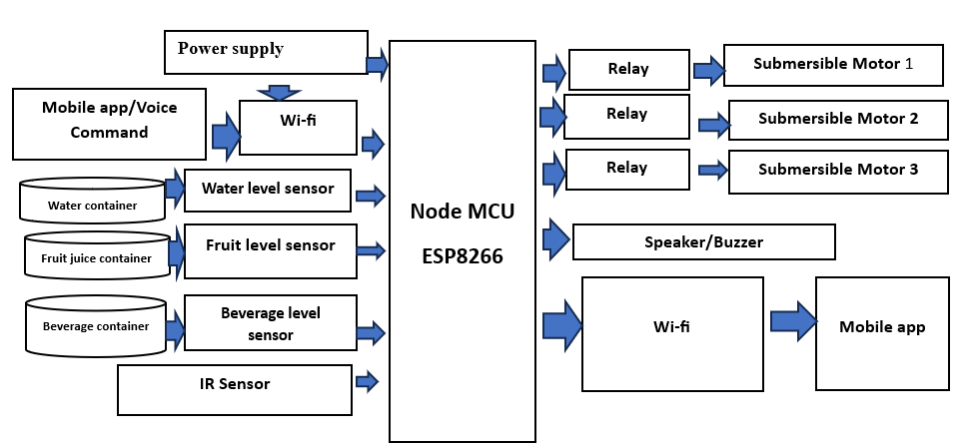

Fig. 1. Proposed Architecture Diagram

In This System User Can Provide Command Through his/her Voice to mobile App and selects the drink they want to dispense. Then Command sent to the Arduino Via Bluetooth. Arduino receives the command and turns on the corresponding Relay. The Relay turns on the corresponding Submersible motor. We can detect the level of water, Fruit juice, and Beverages with the help of water, fruit juice and beverages level sensors. If the water, fruit and Beverages level is low, these sensors send a signal to the Arduino via speaker/ Buzzer, which turns off the corresponding Motor. Here we are using IR Sensor to detect presence of cup under dispensing spout. When cup is present, the sensor sends a signal to the Arduino, which then turns on corresponding submersible Motor.

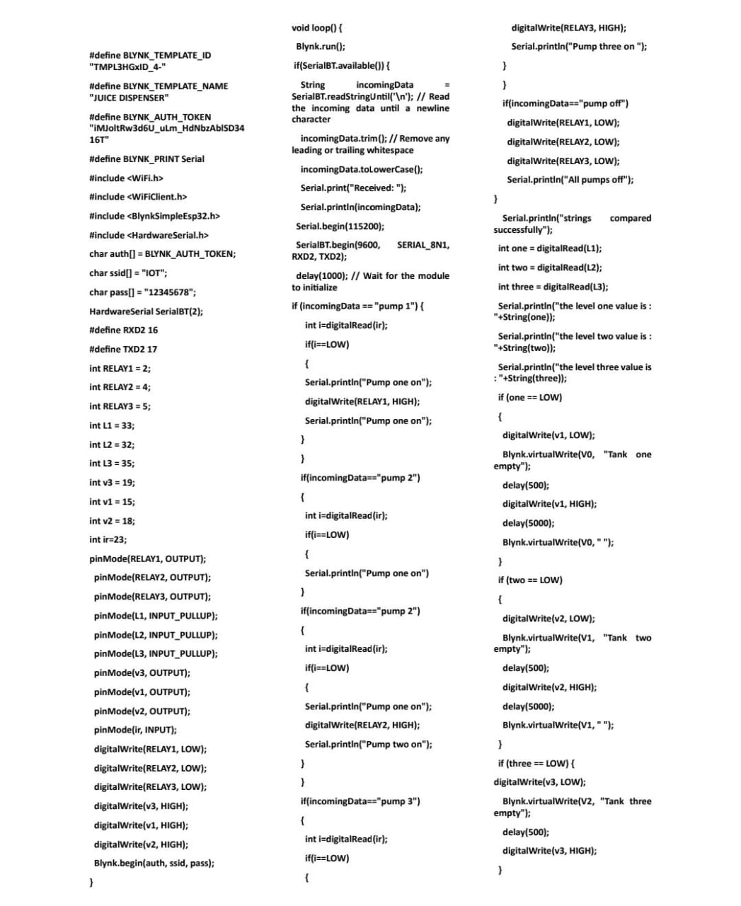

Fig2: Code for running the System

1. *Input Design*

Input design is the bridge between users and information system. It specifies the manner in which data enters the system for processing it can ensure the reliability of the system and produce reports from accurate data or it may results in output of error information.

1. *Output Design*

Outputs from the computer system are rewired primary to communicate the results of processing to the uses. They also used to provide a permanent copy of these results for later consultation / verification. The main points on designing an output are deciding the media, designing layout and report to be printed. The outputs are designed from the system, are simple to read and interpretation.

1. *Data Flow diagram*

A DFD is a logical model of the system. The model does not depend on the hardware, software and data structures of file organization. It tends to be easy for even non-technical users to understand and thus serves as an excellent communication tool. DFD can be used to suggest automatic boundaries for proposed system at pa very high level; the entire system is shown as a single logical process clearly identifying the sources and destination of data. This is often referred to as zero level DFD. Then the processing is exploded into major processes and the same is depicted as level one DFD.

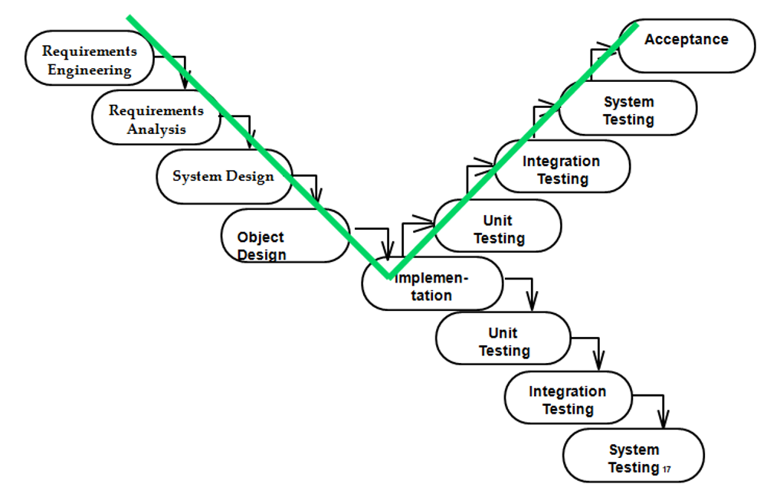

Fig 3: Waterflow in V model

## *B. Implementation*

### *1) Flowchart*

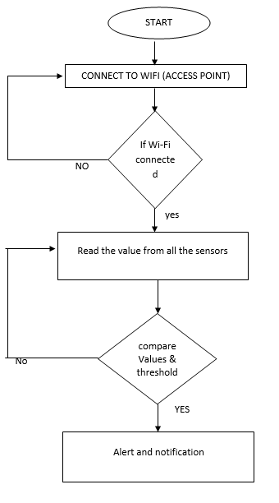

Fig. 4. FlowChart

### *2) Softwares Used*

#### Arduino IDE

Arduino first and foremost is an open-source computer hardware and software company. The most common programming approach is use the Arduino IDE, which utilizes the C programming.

#### b) BLYNK

Blynk was designed for the Internet of Things. It can control hardware remotely, it can display sensor data, it can store data, visualize it and do many other cool things.

There are three major components in the platform:

* **Blynk App-** allows to you create amazing interfaces for projects using various widgets we provide
* **Blynk server-**responsible for all the communications between the smartphone and hardware. You can use our Blynk cloud or run your private Blynk server locally. Its open source, could easily handle thousands of devices and can even be launched on Raspberry Pi.
* **Blynk Libraries-** for all the popular hardware platforms-enable communication with the server and process all the incoming and outcoming commands

1. HTML

HTML is a hypertext markup language which is in reality a backbone of any website. If we make our webpage only with the help of html, than we can’t add many of the effective features in a webpage, for making a web page more effective

1. CSS

CSS Stands for “cascading style sheet” cascading style are used to format the layout of web pages. They can be used to define text styles, table sizes, and other aspects of web pages that previously could only be defined in a page’s HTML.

1. JAVASCRIPT

JavaScript is considered to be one of the most famous scripting languages of all time. JavaScript, by definition, is a Scripting Languages of the world wide web. The main usage of JavaScript is to add various web functionalities, web form validations, browser detections, creation of cookies and so on

1. PHP

Precisely, PHP is a very powerful server-side scripting languages for developing dynamic web applications. Using PHP, one can build interactive and dynamic websites with ease.

1. MySQL

SQL stands for structured Query Language. MySQL is an ANSI ( American National Standards Institute standard. MySQL can execute queries against a database, retrieve data from a database, insert records in a database, update records in a database, delete records from a database, crate new databases, etc..,

3) System Design

The System design is the phase where the system functionality is outlined using the specifications provided in the previous chapters. This system design elaborates the proposed system with the flow diagrams and the block diagrams of the technique used. By using the system design the quality of the software can be predicted. Thus it is one among the critical phases to be carried during the implementation of any project.

The modules and their specifications are also discussed in this chapter. This phase builds the communication between the requirement and the implementation phase.

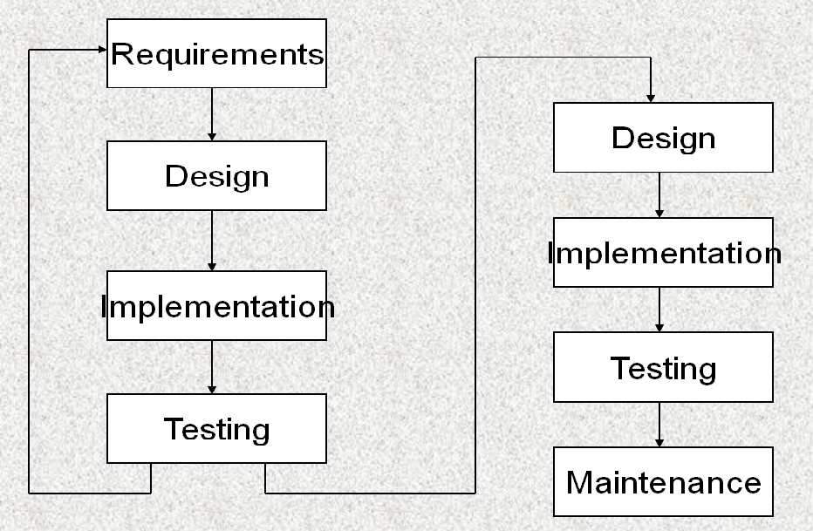

Fig. 5. prototyping

## *C. Board Setup*

You have to tell the Arduino IDE what board you are uploading to. Select the Tools pull down menu and go to Board. This list is populated by default with the currently available Arduino Boards that are developed by Arduino. If you are using an Uno or an Uno-Compatible Clone (ex. Funduino, SainSmart, IEIK, etc.), select Arduino Uno. If you are using another board/clone, select that board.

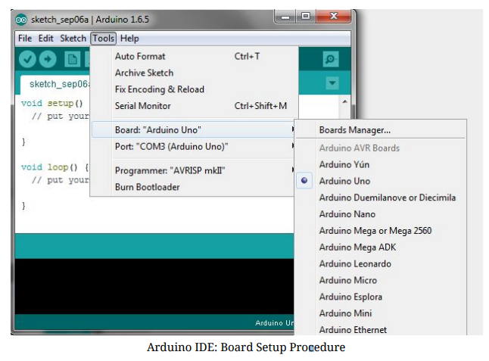

IDE: COM Port Setup

If you downloaded the Arduino IDE before pluging in your Arduino board, when you plugged in the board, the USB drivers should have installed automatically. The most recent Arduino IDE should recognize connected boards and label them with which COM port they are using. Select the Tools pulldown menu and then Port.Here it should list all open COM ports, and if there is a recognized Arduino Board, it will also give it’s name. Select the Arduino board that you have connected to the PC. If the setup was successful, in the bottom right of the Arduino IDE, you should see the board type and COM number of the board you plan to program. Note: the Arduino Uno occupies the next available COM port; it will not always be COM3.

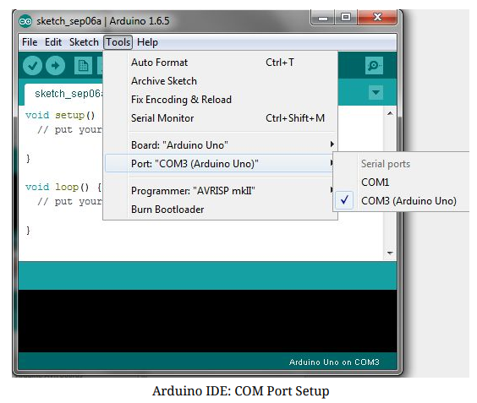

At this point, our board should be set up for programming, and you can begin writing and uploading code.

IV. Experimental Results

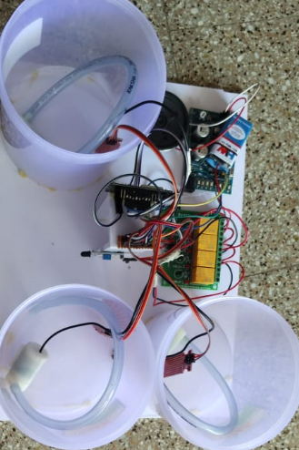

The IoT Based voice controlled drink dispenser system has been designed successfully, and developed, implemented. The system allow user to dispense drinks based on their preferences using voice commands like pump1, pump2, pump3 and they can off through command pump off and This system notify the user when drinks in the container are low through buzzer .

* The proposed System achieve an accuracy of 95% in voice recognition ensuring precise dispensing of drinks.
* The system dispenses the drinks within 30 seconds of recognition of voice command, making it a quick.
* The system always integrates with the Internet, enables remote controlling and monitor as well as real time updates on drink availability in container through buzzer.
* The system has been tested for reliability and durability, with a mean time between failures (MTBF) of 500 hours.
* Mainly system is designed to be efficient, consuming average of 40% less power compared to traditional drink dispensers.
* The proposed system is scalable, allowing for easy integration with existing infrastructure and expansion to multiple locations.

# V. System Requirements

## *HARDWARE REQUIREMENTS*

* Arduino node MCU ESP8266
* IR Sensor
* Relay Circuit
* Water level sensor
* Submersible Motor

## *SOFTWARE REQUIREMENTS*

* Arduino ide
* Blynk App
* HTML
* CSS
* JAVASCRIPT
* PHP
* MYSQL

# VI. Conclusion

This Study presented the design phase of Juice Dispensers using Arduino and moisture level sensors, The requirement analysis and the system design details have been conducted in depth for the better understanding of the project. From the above analysis we can conclude that the entire system can be built with low cost, reliable instruments there by providing an efficient juice Dispensers. We have seen how effectively we can use this system to make minimum wastage of water.

* Automatic juice Dispenser system employs the use of different technologies in the whole design of its development and implementation.
* The System is used by the microcontroller to automatic process of the juice which is used by human beings and it has the ability to detect the level of the juice, and the use of the LCD in this system provides the output which is very useful for human beings.
* This project has successfully provided the improvement on existing system by which human beings get the good quality of juice, and with this there will be no wastage of juice.

References

1. Nilabh Niran, Dhrubajyoti Das, Dipak Das, Subhabrata Banerjee, “Design of Food, Medicine and Water Dispensing Automation Device” in proceeding of the Fourth International Conference on I-SMAC(IoT in Social, Mobile, Analytics and Cloud) (I-SMAC) IEEE Xplore Part Number:CFP20OSV-ART;ISBN:978-1-7281-5464-0-December 2020
2. Debmalya Ghosh, Debjani Banerjee, Ankita Prasad “IoT Based Voice Controlled Autonomous Robo Car” in the year 2020.
3. Mohita Parashar, Roopa Patil, Siddharth Singh, Vipul VedMohan KS Rekha “Water Level Monitoring System in water dispensers using IoT” International Research Journal of Engineering and Technology(IRJET) 5(04),2395-0056,2018.
4. Suyash Ramteke, Kauleshwar Prasd, sargam Gupta “ Automatic water Dispenser Machine” Journal of Advances in Computational Intelligence Theory 4(1),2021
5. K Sateesh kumar, P Udaya Bhanu, TMurali Krishna, PVijay Kumar, Ch Saidulu “ Implementation of voice Controlled Hot and Cold Water Dispenser System Using Arduino” Innovations in Computer Science and Engineering:proceedings of 8th ICICSE, 135-141, 2021.
6. S Esakki Rajavel, SD Jayavathi, G Vinodh Rajkumar, R Bharathiraja , A Shanmuga “ Smart water dispenser and level indicator during pandemic situations” 2021 Third International Conference on Inventive Research

in Computing Applications(ICIRCA),245-250,2021

1. Kajal Pawar ,Kirti Bhoir , Prashali Koli, Ankita Dhamane, Mithun Nair, Department of Electronics and Telecommunication, Pillai HOC College of Engineering and Technology, Panvel, Maharashtra, India,“VOICE BASED HOT COLD WATER DISPENSER” International Research Journal of Modernization in Engineering Technology and Science Volume:02/Issue:05/May-2020
2. PManikandan,Meesala Tirupathi Rao,Marella Vinay,Kannekanti David Ratna Raj “Arduino based automatic hand sanitizer dispenser system”, 2021 3rd International Conference on Advances in Computing ,Communication Control and Networking (ICAC3N),744-747,2021
3. Mrs.D.A.Doshi, Ashwini Darandale, Supriya Mandlik, Pratiksha Walunj, “Voice based hot and cold water dispenser”, International Research Journal of Engineering and Technology(IRJET), Vol-7, page 1046-1050, May 2020.
4. Asmita P Bodhale, J.S Kulkarni, “ Beverages in Dispenser Machine According to capsule Identification with Barade” in proceedings of International Conference on Computing ,communication control and automation(ICCUBEA), September 2018
5. Mukesh kumar , Shimi S.L, “Voice Recognition Based Home Automation System for Paralyzed International Journal of Advanced Research in Electronics and Communication Engineering21(IJARECE) Volume 4, Issue October 2015.
6. Internatinal Research Journal of Engineering and Technology(IRJET)e-ISSN:2395_0056 VOLUME:05 Issue: 04—Apr_2018 [www.irjet.net](http://www.irjet.net/) p-ISSN:2395-007 C 2018,IRJET—Impact Factor value:6.171—ISO 9001:2008 Certificate Journal—page 1154 Voice Based Home Auotomation System Using Raspberry Pi Student of Graduation, Department of Computer Engineering G .v. Acharya Institute of Engineering and Technology, Mumbai University,40098, Maharashtra ,India