**IoT Based Voice Controlled Drink Dispenser System**

KUSUMA BG ^1, SALMAN S ^1, KAVYASHREE G ^1, CHANDANA DK ^1,

DEEPAK R^2

*1 Final Year UG Students, *2 Assistant Professor,

Electronics and Communication Engineering BGSIT B G Nagar Mandya

**Abstract**

This project introduces an inclusive and user-friendly solution catering specifically to the needs of elderly and physically disabled individuals by developing a IoT Based Voice Based drink dispenser system. The primary objective is to enhance accessibility and independence for users facing mobility challenges, allowing them to effortlessly manage their hydration needs through intuitive voice commands and remote-control capabilities. The system allows Arduino microcontrollers for precise control of the drinks dispenser, integrating a voice recognition module to interpret spoken commands. The inclusion of IoT technology facilitates remote monitoring and control, enabling caregivers or users themselves to operate the dispenser through a dedicated mobile application. The dispenser is designed with a focus on user comfort, featuring a user-friendly interface and easy-toread displays. The dispensing mechanism incorporates precision pumps for accurate liquid measurement and sensors to detect cup placement, ensuring a seamless and mess free experience.

**1. Introduction**

IoT Based Voice Controlled drinks dispenser system is the project which will be very useful for old age people and disabled people, basically for one’s who cannot perform basic activities efficiently. Nowadays, we have remote control for our television set and previous electronic system, which Nowadays have made our lives really easy. Have you still wondered about house which would provide the resource of controlling lights, fans and other electrical appliances at home using a remote control off-course, yes! But, are the available options cost too efficient. If the answer is No, we have found a solution to it. We have approach up with a new arrangement called voice or IoT based drink dispenser using Bluetooth. This method is super-cost effective and can give the client, the capability to control any electronic device without even spend for a remote control.

This helps the user to control hot water, cold water, fruit juice or beverages dispenser using his/her voice command or smart phone. Time is very valuable the object is apart the solenoid will turn off by design thus closing the supply of drinks It is the idea which corresponds to the new area of automation and technology. The main of this automation system is to make life easier. Mobile devices are very common among everyone due to its user-friendly interface and portability features. In this project we aim to control electrical appliances and voice commands and mobile app using internet technology. This presents the design and implementation of a low cost but flexible secure voice or internet-based drink dispenser system.

**2. Block Diagram**

Block diagram of the project is shown in figure 1.

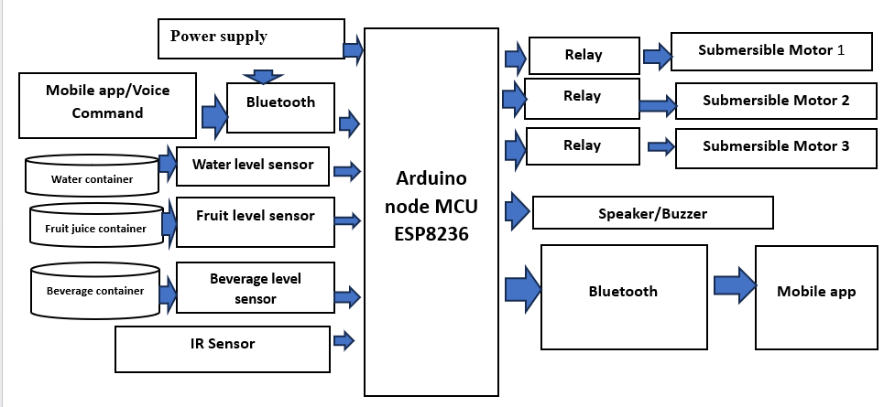

Fig 1

In This System User Can Provide Command Through his/her Voice from Mobile app and selects the drink they want to dispense. Then Command sent to the Arduino Via Bluetooth. Arduino receives the command and turns on the corresponding Relay. The Relay turns on the corresponding Submersible motor. We can detect the level of water ,Fruit juice, and Beverages with the help of water ,fruit juice and beverages level sensors. If the water , fruit and Beverages level is low, these sensors send a signal to the Arduino via speaker/ Buzzer , which turns off the corresponding Motor .Here we are using IR Sensor to detect presence of cup under dispensing spout. When cup is present, the sensor sends a signal to the Arduino, which then turns on corresponding submersible Motor.

**3. METHODOLOGY**

Here's a breakdown of the methodology of the IoT-based voice-controlled drink dispenser system, based on the block diagram :

* Voice Commands: Users issue voice commands through a mobile app.
* Bluetooth: Establishes wireless communication between the mobile app and the Arduino board, enabling control and data exchange.
* Arduino node MCU ESP8236: The microcontroller acts as the system's brain, receiving commands, processing sensor data, and controlling the dispensing process
* IR Sensor: Detects the presence of a glass or cup, ensuring accurate dispensing and preventing spills.
* Water Level Sensor: Monitors the water level in the container, preventing dry-running and prompting refills when necessary.
* Relays: Act as electronic switches, controlled by the Arduino to activate the submersible motors for dispensing.
* Submersible Motors: Drive the pumps for each liquid container, drawing the desired beverage for dispensing.
* Speaker/Buzzer: Provides audible feedback, such as confirmation of commands, alerts for low levels, or completion of dispensing
* Power Supply: Provides the necessary electrical power to all components of the system.

**HARDWARE REQUIREMENTS:**

* Arduino node ESP8236
* Submersible motors
* Relay
* IR Sensor
* Water level sensor
* Bluetooth
* Speaker/Buzzer

**SOFTWARE REQUIREMENT:**

* Arduino IDE
* HTML
* CSS
* JAVA SCRIPT
* MY SQL
* PHP

**4. Hardware Description**

**a. Arduino node MCU ESP 8236**

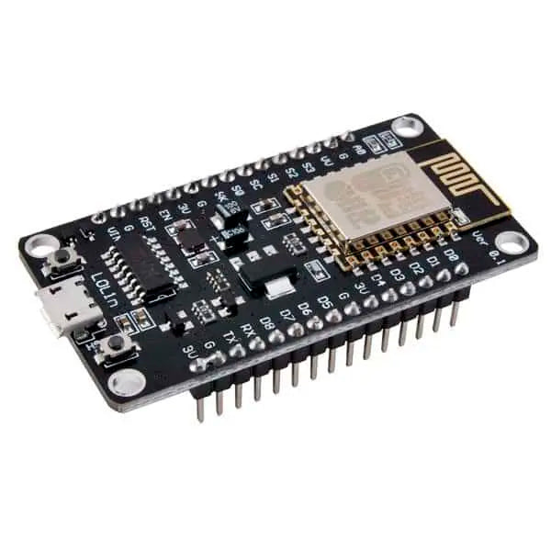It is specifically designed for IoT applications. It is compatible with Arduino IDE and python making prototyping a lot faster. Because of all these features, Node MCU ESP8266 is the most popular and trending board in the electronics market.Based on the ESP8266 Wi-Fi transceiver module and the CH340 USB converter chip, this compact (Open Source) development and prototyping board is ideal for IoT applications.The Wi-Fi module is compatible with the 802.11 b/g/n standard at 2.4 GHz, has an integrated TCP/IP stack, 19.5 dBm output power, data interface (UART / HSPI / I2C / I2S / Ir Remote Control GPIO / PWM) and PCB antenna.

Fig:2 Arduino Node MCU ESP 8236

**b**. **Submersible Motor**

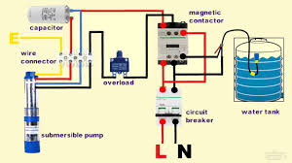A submersible motor is a type of electric motor specifically designed to operate underwater or in other liquid environments. It's commonly used in applications such as water pumping stations, oil drilling operations, underwater vehicles, and deep-sea exploration.

Fig 4

**c. INFRARED SENSOR**

Fig 5

An infrared sensor (IR sensor) is a radiation-sensitive optoelectronic component with a spectral sensitivity in the infrared wavelength range 780 nm … 50 µm. IR sensors are now widely used in motion detectors, which are used in building services to switch on lamps or in alarm systems to detect unwelcome guests. IR sensor is a device that uses infrared technology to detect objects or changes in the environment. IR sensors can detect a wide range of physical properties such as temperature, motion, and proximity.

**d. Relay Circuit**

Relays are switches that open and close circuits electromechanically or electronically. Relays control one electrical circuit by opening and closing contacts in another circuit. As relay diagrams show, when a relay contact is normally open (NO), there is an open contact when the relay is not energized. A relay circuit is an electrical switch that is controlled by an electromagnet. It consists of a coil of wire that, when energized, generates a magnetic field, causing a mechanical switch within the relay to open or close, thereby completing or interrupting the circuit it's connected

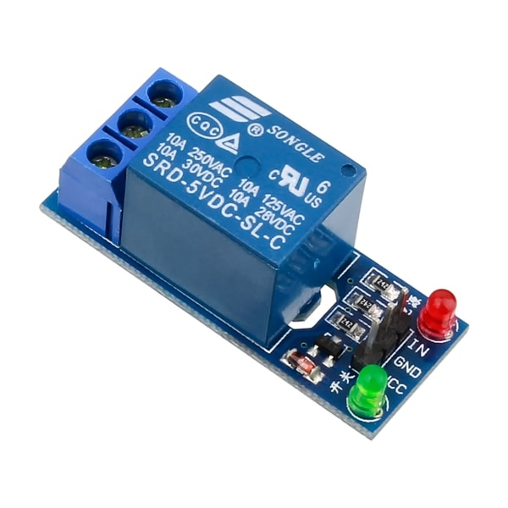

Fig 6

**e. Water level Sensor**

A water level sensor is a device used to detect the level of water in a container or a system. It's a crucial component in various applications, such as industrial processes, environmental monitoring, home appliances, and even in some hobbies like aquarium keeping.

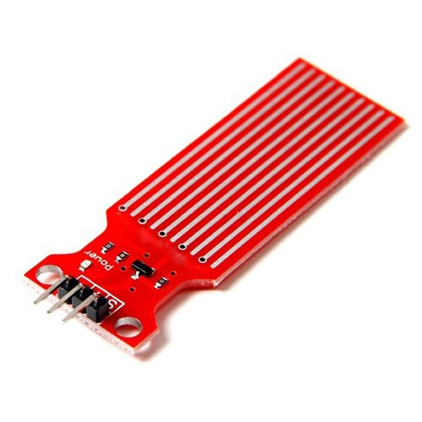

**Fig 9**

**5. Software Description**

Some of the important Software requirements required in our project are:

**Arduino IDE**

Arduino first and foremost is an open-source computer hardware and software company. The Arduino Community refers to the project and user community that designs and utilizes microcontroller-based development boards. These development boards are known as Arduino Modules, which are open-source prototyping platforms. The simplified microcontroller board comes in a variety of development board packages.

The most common programming approach is to use the Arduino IDE, which utilizes the C programming language.

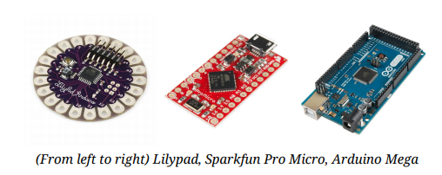

Fig :10

**HTML**

HTML is a hypertext markup language which is in reality a backbone of any website. Every website can’t be structured without the knowledge of html. If we make our web page only with the help of html, than we can’t add many of the effective features in a web page, for making a web page more effective we use various platforms such as CSS. So here we are using this language to make our web pages more effective as well as efficient

* Bottom of Form
* Bottom of Form

**CSS**

CSS stands for "Cascading Style Sheet" Cascading style sheets are used to format the layout of Web pages. They can be used to define text styles, table sizes, and other aspects of Web pages that previously could only be defined in a page's HTML. The basic purpose of CSS is to separate the content of a web document (written in any markup language) from its presentation (that is written using Cascading Style Sheets). There are lots of benefits that one can extract through CSS like improved content accessibility, better flexibility and moreover, CSS gives a level of control over various presentation characteristics of the document. It also helps in reducing the complexity and helps in saving overall presentation time. CSS gives the option of selecting various style schemes and rules according to the requirements and it also allows the same HTML document to be presented in more than one varying style.

**JAVASCRIPT**

JavaScript is considered to be one of the most famous scripting languages of all time. JavaScript, by definition, is a Scripting Language of the World Wide Web. The main usage of JavaScript is to add various Web functionalities, Web form validations, browser detections, creation of cookies and so on. JavaScript is one of the most popular scripting languages and that is why it is supported by almost all web browsers available today like Firefox, We used the browser Opera or Internet Explorer. JavaScript is considered to be one of the most powerful scripting languages in use today. It is often used for the development of client-side web development. JavaScript is used to make web pages more interactive and dynamic. JavaScript is a light weight programming language and it is embedded directly into the HTML code. JavaScript, as the name suggests, was influenced by many languages, especially Java.

* Top of Form
* Bottom of Form

**PHP**

Precisely, PHP is a very powerful server-side scripting language for developing dynamic web applications. Using PHP, one can build interactive and dynamic websites with ease. PHP script can be embedded straight into the heart of html code. PHP is compatible with various web servers like Apache and the Microsoft’s IIS as well. All the PHP scripts are executed on the server and it supports various databases like MySQL, Oracle, Solid, Generic ODBC etc.; however, it is mostly used with MySQL.

Bottom of Form

**MYSQL**

SQL stands for Structured Query Language. MySQL lets us access and manipulate databases. MySQL is an ANSI (American National Standards Institute) standard. MySQL can execute queries against a database, retrieve data from a database, insert records in a database, update records in a database, delete records from a database, create new databases, create new tables in a database , create stored procedures in a database, create views in a database, set permissions on tables, procedures, and views.

**Result**

The project demonstrates the feasibility and benefits of integrating IoT and voice control technologies, paving the way for further innovations in automated systems and smart home devices. The IoT-based voice-controlled drink dispenser system was designed to automate the process of dispensing beverages using voice commands. The system incorporates several components, including a microcontroller (e.g., Arduino or Raspberry Pi), a voice recognition module, relays for controlling pumps, and an IoT platform for monitoring and additional control

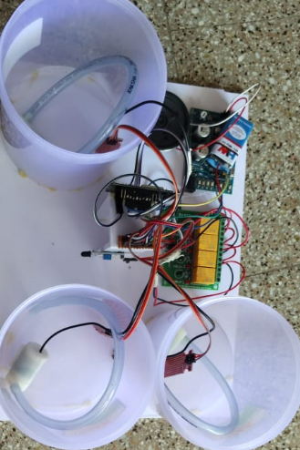  
Fig 9

* The proposed System achieve an accuracy of 95% in voice recognition ensuring precise dispensing of drinks.
* The system dispenses the drinks within 30 seconds of recognition of voice command, making it a quick.
* The system always integrates with the Internet, enables remote controlling and monitor as well as real time updates on drink availability in container through buzzer.
* The system has been tested for reliability and durability, with a mean time between failures (MTBF) of 500 hours.
* Mainly system is designed to be efficient, consuming average of 40% less power compared to traditional drink dispensers.
* The proposed system is scalable, allowing for easy integration with existing infrastructure and expansion to multiple locations.

**Conclusion**

The IoT-based voice-controlled drink dispenser system has significant potential across multiple industries, offering convenience, efficiency, and improved user experience. Its application can revolutionize how beverages are dispensed, providing a modern solution to meet the needs of various sectors. This study presented the design phase of juice Dispensers using Arduino and moisture, level sensors. The requirement analysis and the system design details have been conducted in depth for the better understanding of the project. From the above analysis we can conclude that the entire system can be built with low cost, reliable instruments there by providing an efficient juice Dispensers. We have seen how effectively we can use this system to make minimum wastage of water.

**Reference**

[1] Nilabh Niran, Dhrubajyoti Das, Dipak Das, Subhabrata Banerjee, “Design of Food, Medicine and Water Dispensing Automation Device” in proceeding of the Fourth International Conference on I-SMAC(IoT in Social, Mobile, Analytics and Cloud) (I-SMAC) IEEE Xplore Part Number:CFP20OSV-ART;ISBN:978-1-7281-5464-0-December 2020.

[2] Mrs.D.A.Doshi, Ashwini Darandale, Supriya Mandlik, Pratiksha Walunj, “Voice based hot and cold water dispenser”, International Research Journal of Engineering and Technology(IRJET), Vol-7, page 1046-1050, May 2020.

[3] Asmita P.Bodhale, J.S. Kulkarni,” Beverages in Dispenser Machine According to Capsule Identification with Barade”,in proceedings of International Conference on computing, communication, control and automation (ICCUBEA),September 2018.

[4] Internatinal Research Journal of Engineering and Technology(IRJET)e-ISSN: 2395_0056 VOLUME:05 Issue: 04—Apr_2018 [www.irjet.net](http://www.irjet.net/) p-ISSN:2395-007 C 2018,IRJET—Impact Factor value:6.171—ISO 9001:2008 Certificate Journal—page 1154 Voice Based Home Auotomation System Using Raspberry Pi Student of Graduation, Department of Computer Engineering G .v. Acharya Institute of Engineering and Technology, Mumbai University,40098, Maharashtra ,India.