**A STUDY ON ROLE OF AI IN MODERN RECRUITMENT – OPPORTUNITIES AND CHALLENGES FOR HR PROFESSIONAL**

POOJA S, SIVAKANNI S

(MBA STUDENT JERUSALEM COLLEGE OF ENGINEERING, CHENNAI

Email : sripooja804@gmail.com)

(ASSISTANT PROFESSOR MBA, JERUSALEM COLLEGE OF ENGINEERING, CHENNAI

Email : sivakanni@jerusalemengg.ac.in)

**ABSTRACT**

Artificial Intelligence (AI) is revolutionizing the recruitment landscape, presenting both opportunities and challenges for Human Resources (HR) professionals. This abstract explores the evolving role of AI in modern recruitment and its implications for HR practitioners.

AI technologies offer HR professionals a multitude of opportunities to enhance recruitment efficiency, streamline processes, and improve decision-making. From automated resume screening and candidate sourcing to predictive analytics for talent forecasting, AI empowers HR teams to optimize their workflow and allocate resources more effectively. Moreover, AI-driven chatbots and virtual assistants enhance candidate engagement by providing instant responses and personalized interactions, thereby elevating the overall candidate experience.

However, the adoption of AI in recruitment also presents challenges that HR professionals must navigate skillfully. Ethical considerations surrounding data privacy, algorithmic bias, and fairness in candidate selection require careful scrutiny and proactive measures to mitigate potential risks. Furthermore, there is a pressing need for HR professionals to develop competencies in data analysis, algorithm management, and ethical AI usage to harness the full potential of these technologies effectively.

Keywords: Artificial Intelligence (AI), recruitment, Human Resources (HR), opportunities, challenges, efficiency, decision-making, candidate engagement, ethical considerations, data privacy, algorithmic bias.

**I. INTRODUCTION**

In the fast-paced landscape of modern recruitment, Human Resources (HR) professionals are increasingly turning to Artificial Intelligence (AI) to streamline processes, enhance decision-making, and identify top talent efficiently. AI technologies have revolutionized recruitment, offering unprecedented opportunities while also presenting unique challenges for HR professionals. The role of AI in modern recruitment presents HR professionals with a multitude of opportunities to enhance efficiency, improve decision-making, and elevate the candidate experience. However, it also poses significant challenges such as algorithm bias, skill gaps, and ethical considerations. Success in leveraging AI in recruitment requires HR professionals to carefully navigate these opportunities and challenges, ensuring that technology serves as a tool to augment human capabilities rather than replace them. By embracing AI responsibly and strategically, HR professionals can revolutionize recruitment practices and drive organizational success in the digital age.

The integration of AI in modern recruitment presents immense opportunities for HR professionals to enhance efficiency, improve candidate experience, and make data-driven decisions. However, it also poses significant challenges related to bias mitigation, data privacy, maintaining the human touch, and skill development. By embracing AI responsibly and proactively addressing these challenges, HR professionals can leverage its transformative capabilities to drive innovation and success in talent acquisition. AI-powered tools enable HR professionals to automate routine tasks such as resume screening, candidate sourcing, and initial assessments. This automation significantly reduces the time and effort required to identify qualified candidates, thereby accelerating the recruitment process. AI-driven chatbots and virtual assistants can engage with candidates in real-time, providing prompt responses to queries, scheduling interviews, and offering personalized feedback. Such interactions enhance the overall candidate experience, fostering positive impressions of the organization.

This study aims to explore the multifaceted role of AI in modern recruitment and its implications for HR professionals. By examining the opportunities and challenges associated with AI adoption, this research seeks to provide insights into how HR professionals can leverage AI effectively while mitigating potential risks. Through an in-depth analysis of current trends, best practices, and case studies, this study intends to offer practical recommendations for HR professionals to navigate the evolving landscape of recruitment in the AI era.

In summary, the integration of AI in recruitment presents a transformative opportunity for HR professionals to streamline processes, enhance decision-making, and improve candidate experiences. However, it also necessitates a nuanced understanding of the challenges and ethical considerations inherent in AI adoption. By embracing AI technologies responsibly and proactively addressing its implications, HR professionals can harness the full potential of AI to drive innovation and efficiency in recruitment practices.

**II. OBJECTIVES OF THE STUDY**

**PRIMARY OBJECTIVE**

A Study on role of AI in modern recruitment – opportunities and challenges for HR professional.

**SECONDARY OBJECTIVES**

* To understand the role of AI in today’s Human resource management
* To identify where AI is lacking in human resources management
* To study the kind of problem faced to develop AI in human resources

**III. NEED OF THE STUDY**

* Implementing AI in HR requires HR professionals to acquire new skills such as data analysis, algorithm interpretation, and technology management.
* Integrating AI systems with existing HR technologies and processes can be complex and time-consuming.
* AI-powered chatbots and virtual assistants can provide real-time support to candidates, offering personalized guidance and feedback throughout the hiring process.
* AI algorithms can analyze large volumes of data to identify patterns and trends, helping HR professionals make more informed decisions about recruitment, performance management, and workforce planning.

**IV. SCOPE OF THE STUDY**

Artificial intelligence not only simplifies processes but also helps in making logical decisions by removing biases. It can bring in a paradigm shift to areas of HR operations such as recruiting, learning and development. Another significant role of HR manager in the company is to advise business leaders of upcoming technologies and the way they can be used to improve employee performances. It pays a pivotal role in driving the organizational change by successfully integrating human and digital workforces pragmatically. HR needs to be more than ready for embracing technological advancements to raise the bar of accuracy and proficiency. Since this is the beginning stage, this report holds goods for the surveyor for future references.

**V. LIMITATIONS OF THE STUDY**

* There is a lack of face to face interactions with respondents.
* This study is conducted within a limited time.
* The sample size was limited to 107 respondents.

**VI. REVIEW OF LITERATURE**

A literature review gives an overview of the field of enquiry; what has already said on the topic, who are the key writers, what are the prevailing theories and hypothesis, what questions are being asked and what methodologies and methods are appropriate and useful. The following are the main reasons for spending time and effort on a review of the literature before embarking on research project.

**DEFINITION**

A literature review is a comprehensive summary of previous research on a topic. The literature review surveys scholarly articles, books, and other sources relevant to a particular area of research.

**Dr Jeremy Nunn(2019):** In the paper title **the emerging impact of AI on HR at present** AI became most important in almost every industry it is the dream of every HR manager to use AI in their organization mainly automates communication with candidates the two important things in AI it mainly eliminates biasness while selecting the candidates and increasing efficiency of the candidates AI mainly helps in screening process it analyze candidates profile and interact with them and take a decision of selecting the right candidates it mainly reduces the burden of work and the main focus will be on the top candidates, AI can do facial recognition and also it conducts the interviews basing upon education levels and their ability etc., through AI the gaps can be filled in HR department like mainly regarding to training and development that means automatically analyzing the skills and requirements to fulfilled by employees it mainly connects company`s vision and to achieve the goals. AI starts from recruitment and at last compensation level it mainly used so for sure AI will be an emerging technology in every organization.

**Rajeev Bhardwaj☹January 5th 2019)** In this article titled Artificial Intelligence Is Revolutionizing Hiring to Engagement it was clearly stated that any organization will receive plenty of resumes out which only 10% are relevant. From hiring to employee engagement, artificial intelligence is transforming the way thanks to the advent of AI supported systems. This process is now taken over by software search algorithm that are able to successfully prove out the few people matching your requirements from a pile of irreverent applications. Artificial intelligence is re-shaping and revolutionizing every sphere in life including HR management It can be incorporated in process like boarding, performance, review, feedback, training, retention apart from talent acquisition. Hence, it allows HR manager greater time and energy to focus on mentoring and motivating employees. HR department is highly benefited with the AI supporting system

**Peter (2018)**: In the paper titled **the impact of AI on HR function** clearly shows that in near coming future AI is going to bring a drastic change in the way of implementing HR practices with the implementation of ai in an organization. It is true that several jobs may be affected but in reality it raises the productivity of an organization although some of the western companies are successful in integrating AI with some HR practices and became productive and others are still counting on the cost aspects and out of all the HR practices recruitment is the best function in integrating with AI from sourcing, screening the qualified applicants and finally it is the duty of the governments and the respective organizations to reshape, reskill and upgrading their work force to compete with these intelligent machines.

**DR Owais Ahmed(2018)**: In the paper titled **AI in HR,** it mainly stated that it increases the effective working of an organization and reduces the burden of HR managers it mainly provides personalized employee experiences like it the new employees join in an organization then they don’t know where to go and with whom they have to contact then AI plays an important role in it by providing help desk to the employees they can post their queries in it and can get the possible solutions. AI helps us to take variation requests like to grant leaves it also helps us to know about the rules and procedures of the company it can be used anywhere at any time and it answers all employee’s questions there will be some algorithms in AI which makes recruiting process easy for HR practitioner there will be unbiased selection and development in the organization. AI can identify patterns of stress, employees feels at organizational level and what type of remedies should be taken to overcome them so mainly it is an automation process that does the repetitive value-added tasks.

**Ian Bailie Head of HR – “An Examination of Artificial Intelligence and its Impact on Human Resources” (2018)** This report tells about big firms that adopt AI and examine the basics of AI and explore how AI is being applied in HR. It has been developed for those that would like to learn more about the potential application of AI in HR. It examines both industry and academic sources to develop a representation of AI and its application in business with a specific focus on HR. The report also uses primary research found in Cognition’s directory of AI powered HR products, survey results, and interviews with vendors and experts. It focused on the few questions around the budget to implement new tools for AI, technology advanced enough from ROI perspective, HR having the right technical expertise to work with AI and considering ethical implications when implementing AI technology.

**VII. RESEARCH METHODOLOGY**

**RESEARCH DESIGN**

Research methodology is considered as the nerve of the project. Without a proper well-organized research plan, it is impossible to complete the project and reach to any conclusion. The project was based on the survey plan. The main objective of survey was to collect appropriate data, which work as a base for drawing conclusion and getting result. Therefore, research methodology is the way to systematically solve the research problem. Research methodology not only talks of the methods but also logic behind the methods used in the context of a research study and it explains why a particular method has been used in the preference of the other methods.

The data used for this study has been collected from primary data and secondary data. Primary data has been collected through questioner from 107 respondents based on systematic sampling method. The secondary data had been collected from various source of research, journals, books and magazines.

**COLLECTION OF DATA**

**PRIMARY DATA**

For this purpose, questionnaires were prepared in such that all necessary data would be collected. Sampling method used for data collection is systematic method, the size of the sample is 107 respondents.

**SECONDARY DATA**

Information regarding the project, secondary data was also required. These data were collected from various source of research journals, books, magazines and internet.

**VIII. DATA ANALYSIS & INTERPRETATION**

**PERCENTAGE ANALYSIS OF THE RESPONDENTS**

**TABLE 1** – PERCENTAGE ANALYSIS OF GENDER OF THE RESPONDENTS

|  |  |  |  |  |  |
| --- | --- | --- | --- | --- | --- |
| **GENDER** | | | | | |
|  | | Frequency | Percent | Valid Percent | Cumulative Percent |
| Valid | Male | 50 | 46.7 | 46.7 | 46.7 |
| female | 57 | 53.3 | 53.3 | 100.0 |
| Total | 107 | 100.0 | 100.0 |  |

**CHART – 1**

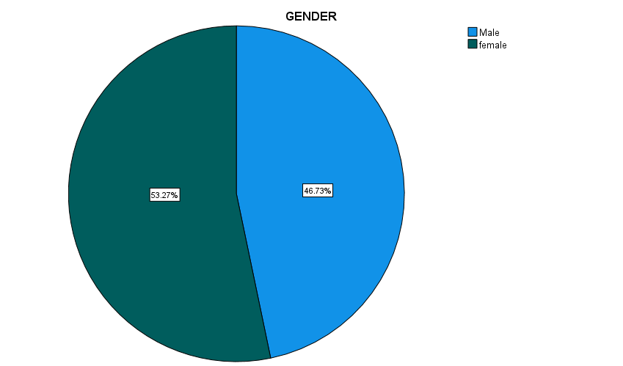

**INTERPRETATION**

From the above table, it can infer that 53.27% of the respondents are Female and 46.73% of the respondents are Male. Most of the respondents are Female.

**TABLE 2** – PERCENTAGE ANALYSIS OF YEAR OF EXPERIENCE

|  |  |  |  |  |  |
| --- | --- | --- | --- | --- | --- |
| **Year of experience** | | | | | |
|  | | Frequency | Percent | Valid Percent | Cumulative Percent |
| Valid | 0 - 1 year | 64 | 59.8 | 59.8 | 59.8 |
| 2 -3 years | 28 | 26.2 | 26.2 | 86.0 |
| 4 - 5 years | 5 | 4.7 | 4.7 | 90.7 |
| Above 5 years | 10 | 9.3 | 9.3 | 100.0 |
| Total | 107 | 100.0 | 100.0 |  |

**CHART – 2**

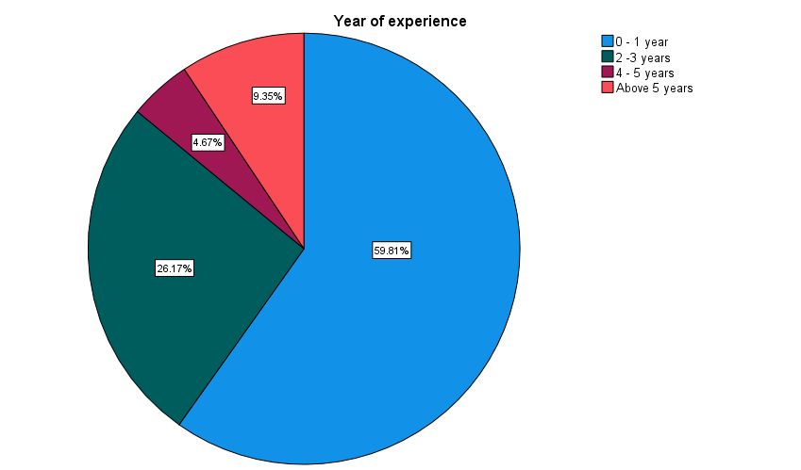

**INTERPRETATION**

From the above table, it can infer that 59.81% of the respondents are 0-1year experience and 26.17% of the respondents are 2-3 years of experiences and 4.67% of the respondents are 4-5 years of experiences and 9.35% of the respondents are above 5 years of experiences. Most of the respondents have experience of 0-1 year.

**TABLE 3** – PERCENTAGE ANALYSIS OF HOW FAMILIAR ARE YOU WITH THE CONCEPT OF AI IN THE CONTEXT OF HRM?

|  |  |  |  |  |  |
| --- | --- | --- | --- | --- | --- |
| **How familiar are you with the concept of AI in the context of human resource management (HRM)?** | | | | | |
|  | | Frequency | Percent | Valid Percent | Cumulative Percent |
| Valid | very familiar | 49 | 45.8 | 45.8 | 45.8 |
| somewhat familiar | 52 | 48.6 | 48.6 | 94.4 |
| not familiar at all | 6 | 5.6 | 5.6 | 100.0 |
| Total | 107 | 100.0 | 100.0 |  |

**CHART – 3**

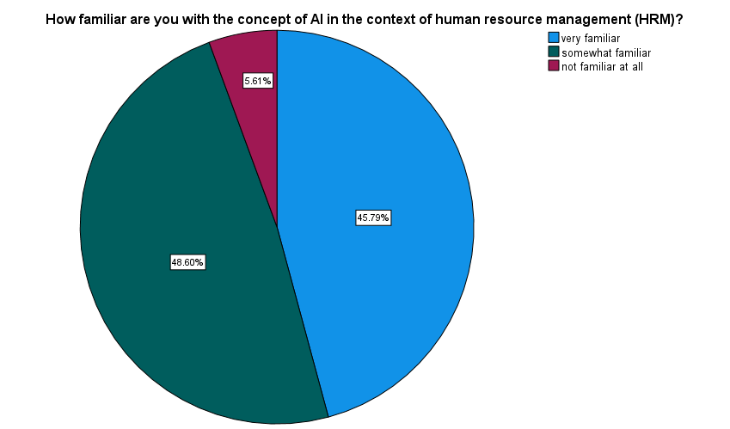

**INTERPRETATION**

From the above table, it can infer that 45.79% of the respondents are very familiar and 48.60% of the respondents are somewhat familiar and 5.61% of the respondents are not familiar at all. Most of the respondents are somewhat familiar about the concept of AI in HRM.

**TABLE 4** – PERCENTAGE ANALYSIS OF HOW EXTENSIVELY IS AI CURRENTLY UTILIZED IN YOUR ORGANIZATION’S HR PROCESSES?

|  |  |  |  |  |  |
| --- | --- | --- | --- | --- | --- |
| **How extensively is AI currently utilized in your organization's HR processes?** | | | | | |
|  | | Frequency | Percent | Valid Percent | Cumulative Percent |
| Valid | not at all | 21 | 19.6 | 19.6 | 19.6 |
| limited implementation | 60 | 56.1 | 56.1 | 75.7 |
| moderate implementation | 16 | 15.0 | 15.0 | 90.7 |
| extensive implementation | 10 | 9.3 | 9.3 | 100.0 |
| Total | 107 | 100.0 | 100.0 |  |

**CHART – 4**

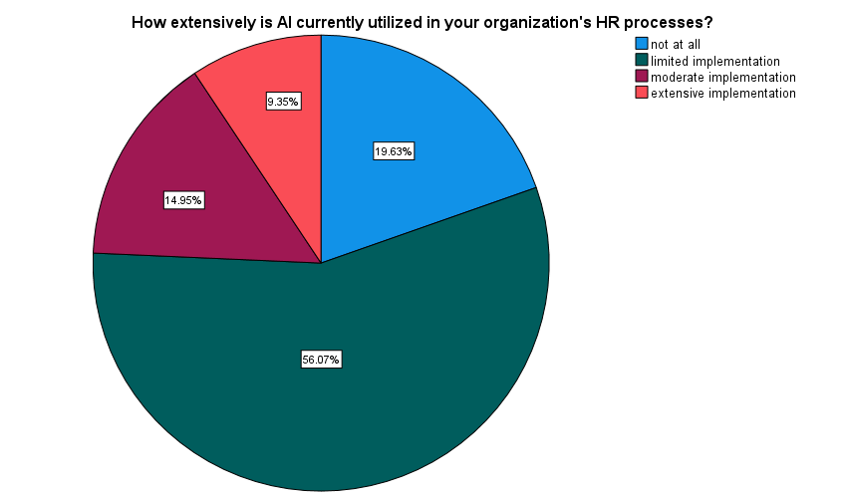

**INTERPRETATION**

From the above table, it can infer that 19.63% of the respondents chosen not at all and 56.07% of the respondents chosen limited implementation and 14.95% of the respondents chosen moderate implementation and 9.35% of the respondents chosen extensive implementation. Most of the respondents chosen limited implementation of AI is utilized in their organization.

**CHI-SQUARE**

Chi-square analysis is a valuable tool for examining relationships between categorical variables and determining whether the observed associations are statistically significant.

To find out the association between primary benefits of integrating AI into HRM processes and aspect of recruitment does AI primarily assist HR professionals.

**NULL HYPOTHESIS (H0):** There is no significant association between primary benefits of integrating AI into HRM processes and aspect of recruitment does AI primarily assist HR professionals.

**ALTERNATIVE HYPOTHESIS (H1):** There is a significance association between primary benefits of integrating AI into HRM processes and aspect of recruitment does AI primarily assist HR professionals.

|  |  |  |
| --- | --- | --- |
| **Test Statistics** | | |
|  | In your opinion, what are the primary benefits of integrating AI into HRM processes? | Which aspect of recruitment does AI primarily assist HR professionals with? |
| Chi-Square | 68.561a | 38.234b |
| Df | 4 | 3 |
| Asymp. Sig. | .000 | .000 |
| a. 0 cells (0.0%) have expected frequencies less than 5. The minimum expected cell frequency is 21.4. | | |
| b. 0 cells (0.0%) have expected frequencies less than 5. The minimum expected cell frequency is 26.8. | | |

**INTERPRETATION**

From the above table, we find that the significant value is .000, which is less than table value 0.05, so the null hypothesis is rejected and alternative hypothesis is accepted.

Therefore, there is a significance association between primary benefits of integrating AI into HRM processes and aspect of recruitment does AI primarily assist HR professionals.

**CORRELATION**

Correlation refers to a statistical measure that indicates the extent to which two variables change together. In other words, it quantifies the relationship or association between two variables. Correlation does not imply causation; just because two variables are correlated does not mean that changes in one variable cause changes in the other.

To find out the significance Relationship between familiar with the concept of AI in the context of human resource management and year of experience.

**NULL HYPOTHESIS (H0):** There is no significance Relationship between familiar with the concept of AI in the context of human resource management and year of experience.

**ALTERNATIVE HYPOTHESIS (H1):** There is a significance Relationship between familiar with the concept of AI in the context of human resource management and year of experience.

|  |  |  |  |
| --- | --- | --- | --- |
| **Correlations** | | | |
|  | | How familiar are you with the concept of AI in the context of human resource management (HRM)? | Year of experience |
| How familiar are you with the concept of AI in the context of human resource management (HRM)? | Pearson Correlation | 1 | .039 |
| Sig. (2-tailed) |  | .691 |
| N | 107 | 107 |
| Year of experience | Pearson Correlation | .039 | 1 |
| Sig. (2-tailed) | .691 |  |
| N | 107 | 107 |

**INTERPRETATION**

From the above table, we find that the significant value is .691, which is greater than table value 0.05, so the Null hypothesis is accepted and Alternative hypothesis is rejected.

Therefore, there is no significance Relationship between familiar with the concept of AI in the context of human resource management and year of experience.

**ANOVA**

Analysis of variance, or ANOVA is a statistical method that separates observed variances data into different components to use for additional tests. A one – way ANOVA is used for three or more groups of data to gain information about the relationship between the dependent and independent variables.

To find a significant difference between biggest challenge in integrating AI systems with existing HR software or processes and allocating resources for AI development in HR.

**NULL HYPOTHESIS (HO):** There is No Significant difference between biggest challenge in integrating AI systems with existing HR software or processes and allocating resources for AI development in HR.

|  |  |  |  |  |  |
| --- | --- | --- | --- | --- | --- |
| **ANOVA** | | | | | |
| What is the biggest challenge in integrating AI systems with existing HR software or processes? | | | | | |
|  | Sum of Squares | df | Mean Square | F | Sig. |
| Between Groups | 4.938 | 2 | 2.469 | 6.676 | .002 |
| Within Groups | 38.463 | 104 | .370 |  |  |
| Total | 43.402 | 106 |  |  |  |

**ALTERNATIVE HYPOTHESIS (H1):** There is a significant difference between biggest challenge in integrating AI systems with existing HR software or processes and allocating resources for AI development in HR.

**INTERPRETATION**

From the above table we find the significant value is 0.002 is less than table value 0.05, so the Null hypothesis is rejected and Alternative Hypothesis H1 is accepted.

Therefore, there is a significant difference between biggest challenge in integrating AI systems with existing HR software or processes and allocating resources for AI development in HR.

**IX. FINDINGS**

* According to the study in gender that 53.27% of the respondents are Female and 46.73% of the respondents are Male. Most of the respondents are Female.
* According to the study in year of experience 59.81% of the respondents are 0-1year experience and 26.17% of the respondents are 2-3 years of experiences and 4.67% of the respondents are 4-5 years of experiences and 9.35% of the respondents are above 5 years of experiences. Most of the respondents have experience of 0-1 year.
* According to the study in familiarity of concept of AI in HRM 45.79% of the respondents are very familiar and 48.60% of the respondents are somewhat familiar and 5.61% of the respondents are not familiar at all. Most of the respondents are somewhat familiar.
* According to the study of how extensively is AI currently utilized in your organization 19.63% of the respondents chosen not at all and 56.07% of the respondents chosen limited implementation and 14.95% of the respondents chosen moderate implementation and 9.35% of the respondents chosen extensive implementation. Most of the respondents chosen limited implementation.
* According to the study in Chi-square, there is a significance association between primary benefits of integrating AI into HRM processes and aspect of recruitment does AI primarily assist HR professionals.
* According to the study in Correlation there is no significance Relationship between familiar with the concept of AI in the context of human resource management and year of experience.
* According to the study in Anova there is a significant difference between biggest challenge in integrating AI systems with existing HR software or processes and allocating resources for AI development in HR.

**X. SUGGESTIONS**

* Integrating AI tools with existing HR systems and processes can be complex and time-consuming. HR professionals need to carefully plan and manage the implementation process to ensure a smooth transition and maximize the benefits of AI.
* Implementing AI in recruitment requires HR professionals to acquire new skills and knowledge related to technology and data analytics. Organizations need to invest in training programs to upskill their HR teams accordingly.
* While AI can streamline many aspects of recruitment, it may lack the human touch that is crucial for building relationships with candidates and assessing their cultural fit within an organization.
* AI systems collect and analyze vast amounts of candidate data, raising concerns about privacy and security. HR professionals must ensure compliance with data protection regulations and maintain transparency in their use of AI technologies.

**XI. CONCLUSION**

AI offers significant opportunities to enhance recruitment processes, HR professionals must navigate various challenges to ensure its successful implementation. By addressing biases, maintaining the human touch, prioritizing data privacy, investing in training, and carefully managing integration, HR professionals can harness the power of AI to improve efficiency, accuracy, and fairness in recruitment while delivering a positive candidate experience.

By addressing these challenges head-on and embracing the opportunities that AI offers, HR professionals can position themselves as strategic partners in driving innovation and growth within their organizations. Through a thoughtful integration of AI technologies into recruitment strategies, HR professionals can streamline processes, attract top talent, and ultimately contribute to the overall success of their organizations in the digital age. Embracing AI while balancing ethical considerations and human touch will be key to unlocking the full potential of AI in modern recruitment practices.

**REFERENCE**

* Martinsons, M. G., & Davison, R. M. (2019). Introduction to the special issue on artificial intelligence and machine learning in business and economics. Journal of Business Research, 99, 529-531.
* Redman, T., Goodhue, D., & Watson, R. (2018). AI: The ultimate job killer? MIS Quarterly Executive, 17(3).
* Strohmeier, S. (2018). The potential of artificial intelligence in human resource management: challenges, opportunities, and research agenda. The Journal of Applied Business Research, 34(2), 261-282.
* Van Dijck, J., & Poell, T. (2018). Social media platforms and education: critical reflections on the regulatory landscape. Learning, Media and Technology, 43(1), 59-74.
* Yeo, C., & Kirsch, C. (2017). Artificial intelligence and employment: Will AI and robotics lead to mass unemployment? Journal of Innovation Management, 4(4), 1-7.
* Sullivan, J. (2017). The future of recruiting: How AI will transform hiring. Harvard Business Review.