**COMPARATIVE ANALYSIS OF HYBRID ENERGY SYSTEM**

**ABSTRACT**

This paper presents a comparative analysis of hybrid energy system using MATLAB/SIMULINK. Solar, Wind and Diesel are the main sources of the system and battery is considered as the backup source. The main objective of this paper is supply uninterrupted power to the load under varying load conditions. Here we have also compare and analyze the load characteristics and efficiencies of the three different hybrid energy system. The three different hybrid energy systems considered are PV/wind/battery, PV/wind/diesel and PV/wind/battery/diesel hybrid energy systems.The best hybrid model from the above mentioned threedifferent hybrid systems are determined under varying load condition.

1. **INTRODUCTION**

The hybrid system is a combination of two or more renewable and non-renewable energy resources. The hybrid power generation is much reliable when compared to the power generated by an individual source. The analysis of hybrid energy system is important to determine the best system that gives continuous power supply undervarying load conditions. Many renewable resources are available in nature, the possible hybrid energy systems we considered are:

* Photovoltaic/Wind/Battery hybrid energy system.
* Photovoltaic/Wind/Diesel hybrid energy system.
* Photovoltaic/Wind/Diesel/Battery hybrid energy system.

In [1], authors have analyzed the reliability ofwind/diesel hybrid energy system.In [2], Photovoltaic/Wind hybrid energy system theload characteristics under varying load conditions are analyzed and by using converters they maintained the stable system.In[3] photovoltaic/Wind/Battery system the battery is used as a backup source and in Photovoltaic/Wind/Diesel system the diesel is used as the backup sourceboth the systems are compared and determine which gives high efficiency.

The literatures discussed above are the analysis of single hybrid energy system with load characteristics or efficiency. In this paper three different hybrid energy systems whose load characteristics and efficiencies are analyzed under various load conditions. Using the simulation results determine which combination of the hybrid system performs the best.

**2. PROPOSED METHODOLOGY**

**2.1 INDIVIDUAL SYSTEM**

**A. Analysis of Photovoltaic system**

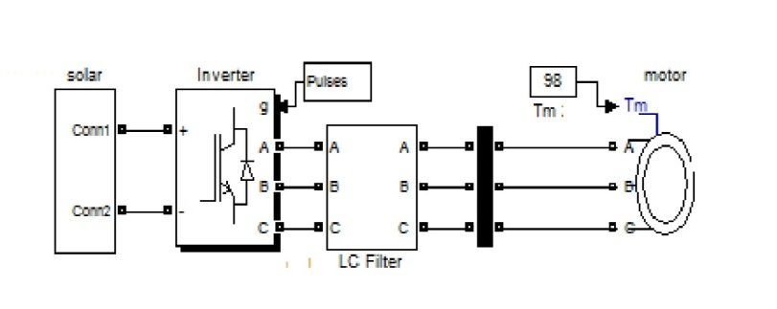

**Fig. 1 Simulink model of Photovoltaic system**

The photovoltaic system consists of four cells connected in series. The voltage generated from the cells is not sufficient to supply the load. So the generated voltage is given to the boost converter to increase the voltage level.The major components used in boost converter are inductor, capacitor, diode and switch. The pulse width of the pulse generator is 65% of the time period. The total time period is 1/100000 sec

The range of inductance and capacitance are 2.332e-3 H and 6000e-6 F. The output voltage 535 volts from the circuit are given to the LC filter. It reduces the error signals and then it is given to the inverter. As the load considered here is a varying one so, a three phase induction motor is taken into account. The motor rating is 15KW 400V 50Hz 1460rpm. The load characteristics of the individual photovoltaic system are analyzed. The simulation results are obtained.

**B. Analysis of wind energy system**

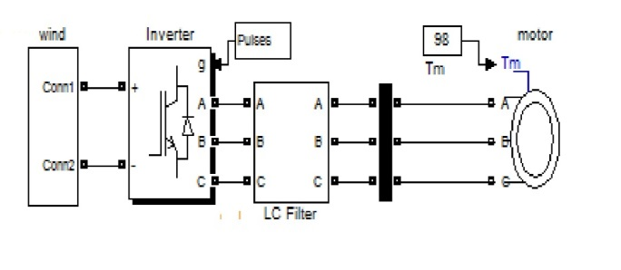

**Fig.2 Simulink model for Wind energy system**

In wind generator, a doubly fed induction generator is used to generate the electricity as the load that is considered here is varying one. The wind generator induces voltage depending upon the wind speed. If the wind speed is greater than 8 m/s then it starts to generate voltage and if the wind speed is greater than 25 m/s then generator will stop. The doubly fed induction generators have the characteristics likehigh efficiency, economic and can generate voltage at varying speed. The generated voltage is rectified, inverted and then filtered to get an accurate voltage of 400 volts. Then the voltage is given to load and the load characteristics are analyzed for the wind energy system. The simulation results are obtained.

**C.DIESEL ENERGY SYSTEM**

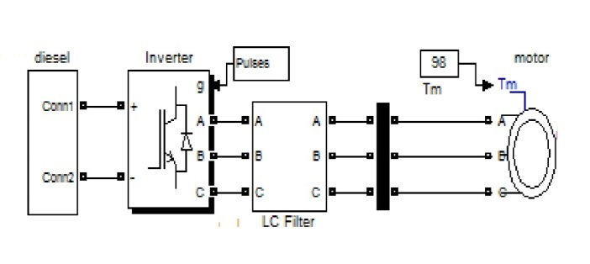

**Fig.3 Simulink model for Diesel energy system**

Diesel generators are used as a backup source in many organizations as it generates a constant voltage. When the photovoltaic and wind energy system are not available then a diesel generator will supply voltage to load.The generated voltage are rectified, inverted and then filtered to get accurate electricity. Then it is supplied to the load as three phase asynchronous motor. The load characteristics are analyzed.

1. **LOAD FORECASTING**

Table 1. Forecasting

|  |  |
| --- | --- |
| **STRATEGY** | **DESCRIPTION** |
| PV/wind/battery | In this system when load<=30kw individual system (either PV or wind or battery) can supply with respect to the input. If the load >30kw then individual system voltage are reduced. So, to compensate this problem wind/ battery or PV/battery sources are combined to supply. |
| PV/wind/diesel | In this system when load<=30kw individual system (PV or wind or diesel) can supply with respect to the input. If the load >30kw then individual system voltage are reduced. So, to compensate this problem PV/diesel, wind/diesel or PV/wind/diesel sources are combined to supply. |
| PV/wind/diesel/ battery | In this system when load<=30kw individual system (PV or wind or battery or diesel) can supply with respect to the input. If the load >30kw then individual system voltage are reduced. So, to compensate this problem PV/diesel or wind/diesel or PV/wind/diesel or PV/wind/battery sources are combined to supply. |

**4.HYBRID ENERGY SYSTEM**

**4.1 Photovoltaic/Wind/Battery**

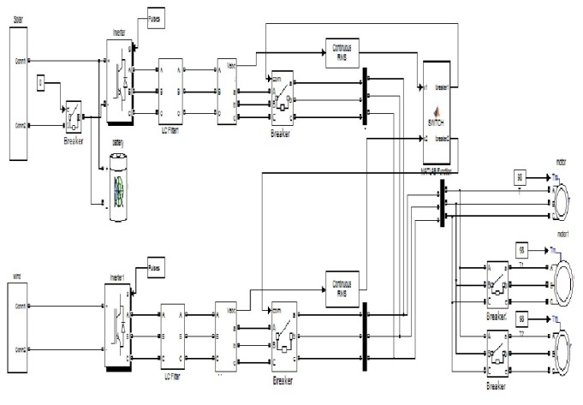

**Fig.4 modelling of PV/Wind/Battery energy system**

A MATLAB function block is used to hybrid the three different energy resources. To analyze the hybrid energy system under varying load conditions three loads such as 15 kW are considered.When the load is less than or equal to 30kw and the PV generates maximum energy then the switch related to the PV system will close and supply power to the load. The program is written in the user define function block according to the condition.The PV and wind will not produce power simultaneously they will not be available at the same time. When the wind produces maximum energy then it will supply voltage to load and at the same time the PV charges the battery.

Finally when both the systems are not available then the battery will dischargevoltage to load. Thus when the load increases, the sources are combined and supplied to the load. The load characteristicsaccording tothe various load conditions are analyzed.

**4.2 PV/Wind/Diesel hybrid energy system**

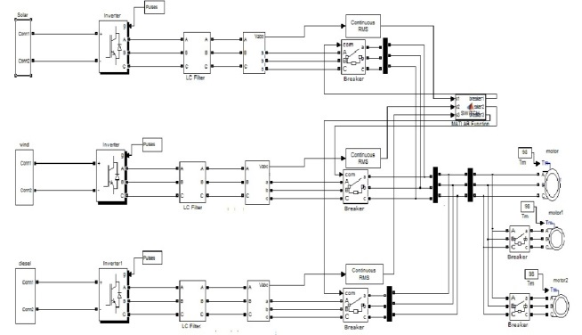

**Fig.5 Modelling of PV/Wind/Diesel energy system**

The hybrid energy system is shown in the fig.5. In this hybrid system a diesel generator is used as the backup source for producing a constant power gives constant power supply to the load when both PV and wind are not available. And when the load is greater than or equal to 30kw the PV and diesel are combined and supplied to the load. When the load is less than 30kw then the PV or wind which produces maximum power will supply to load. If all the three sources are combined and produce a 30kw then all the switches are closed and supplied to load. Thus the hybrid system is analyzed and the output characteristics are analyzed.

**4.2 PV/Wind/Battery/Diesel hybrid energy system:**

Both the diesel generator and battery are used as the backup source in this system as shown in Fig.6. The combinations are wind/diesel, PV/diesel, wind/battery, PV/battery etc. If the individual system produce 30kw power then it will supply voltage to the load otherwise both will combine and supply to the load.

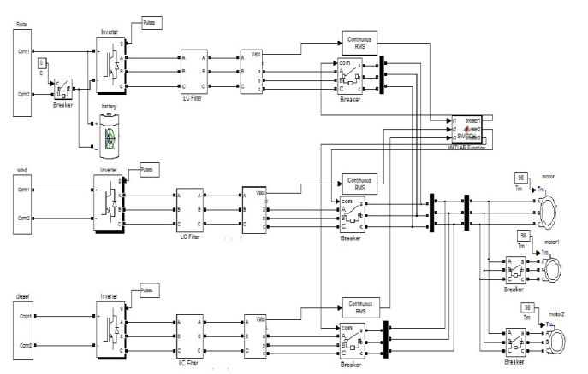

**Fig.6 Modelling of PV/Wind/Diesel/Battery energy system**

**5. RESULTS AND DISCUSSIONS**

**2.1. A Analysis of photovoltaic system**

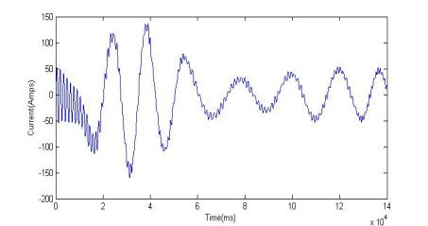

**Fig.7a Stator current**

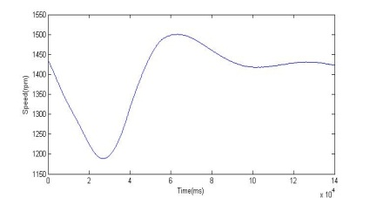

**Fig.7b Rotor speed**

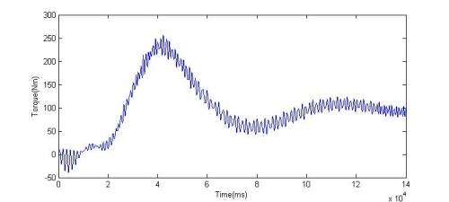

**Fig.7c Torque**

The Fig (1) shows the simulation for photovoltaic system. The results for the system are shown in a Fig. (7a), Fig (7b) and Fig. (7c). Tostudy the characteristics of photovoltaic system by taking a constant load parameters. The load considered here is induction motor with the rating of 15 kW 400V 1460 RPM. At initial stage the induced electromagnetic force should be zero in motor so it draws 5 to 7 times the rated full load current more current. The torque is inversely proportional to speed,

T = P*60/2piN

Where, T = torque in N-m

N = speed of the motor in rpm

P = output power in watts

So, whenever the speed increases the torque gets decreases and vice versa.

**2.1. B Analysis of wind energy system**

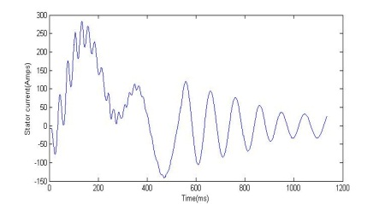

**Fig.8a Stator current**

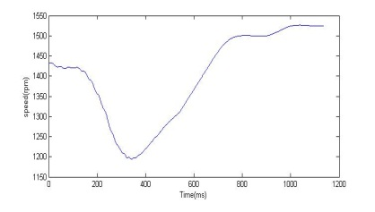

**Fig.8b Rotor speed**

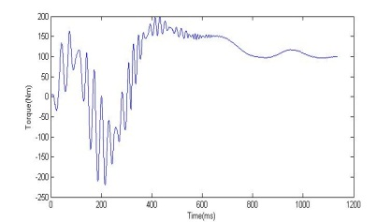

**Fig.8c Torque**

The Fig (2) shows the simulation for wind energy system. The results for this system are analyzed and shown in Fig (8a), Fig (8b), and Fig (8c). In photovoltaic system as already discussed the load characteristics of an induction motor. With the same load but the sources here considered is wind energy.

**2.1.C Analysis of diesel energy system**

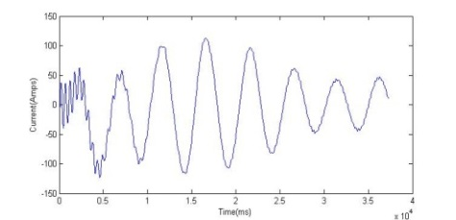

**Fig.9a stator current**

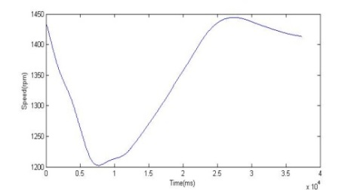

**Fig.9b Rotor speed**

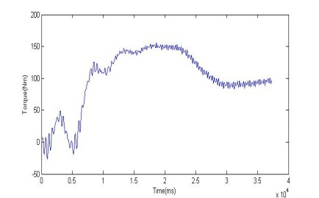

**Fig.9c Torque**

The Fig (3) shows the simulation diagram for Diesel energy system. The simulation results for wind system are shown in Fig (9a), Fig (9b), and Fig (9c). Here the diesel is considered as source to supply voltage the load. It is used as a backup source to supply constant voltage to load. According to the input, the load characteristics are analyzed.

**4.1 Analysis of PV/Wind/Battery energy**

**LOAD 1(15 Kw 400V 50Hz)**

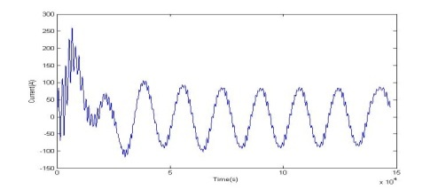

**Fig.10a stator current**

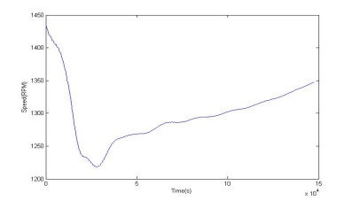

**Fig.10b Rotor speed**

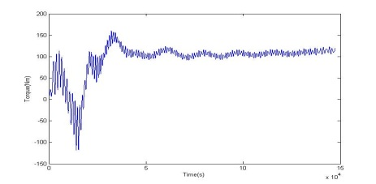

**Fig.10c Torque**

**LOAD 2(15 Kw 400V 50Hz)**

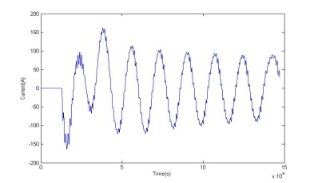

**Fig.10d stator current**

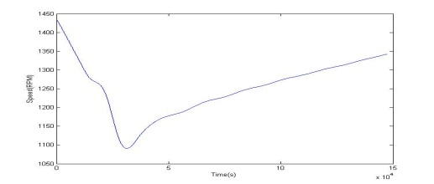

**Fig.10e Rotor speed**

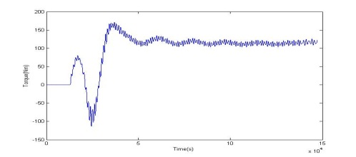

**Fig.10f Torque**

**LOAD 3(15 Kw 400V 50Hz)**

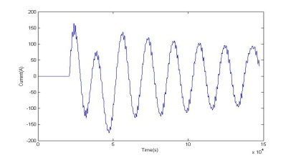

**Fig.10g Stator current**

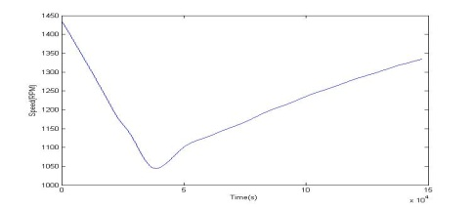

**Fig.10h Rotor speed**

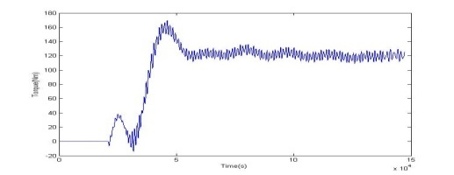

**Fig.10i Torque**

The Fig (4) shows the simulation diagram for PV/Wind/Battery hybrid energy system. In normal condition the battery is charged by the excess amount of voltage from the photovoltaic system through the breaker. When photovoltaic system cannot able to supply voltage to load then the breaker will open and battery discharges the stored energy to load. The simulation results for 15kW load are shown in Fig (10a), Fig (10b) and Fig (10c). If the load is 15kW then the individual system (PV or Wind or Battery) can be able to supply the load. But when the load increases the voltage gets decreases. To avoid these problem additional sources is required to compensate the voltage sag and load requirements this strategy is shown in Table.1. In this paper to rectify the problem circuit breakers are used in each system. If suppose voltage decreases in one system due to the input parameters, then two sources are added to supply.

The program to combine two or more resources are written in user define function block. To show the varying load conditions three loads are considered with each load of 15 kW. At first the 15 kW load is considered and the load characteristics are analyzed, then after 0.015 seconds the load 2 of 15 kW is added by closing the corresponding circuit breaker and the load characteristics are shown in Fig (10d), Fig (10e) and Fig (10f). Then after 0.02 seconds the load 3 of 15kw is added by closing the corresponding circuit breaker, the load characteristics are analyzed and shown in Fig (10g), Fig (10h) and Fig (10i). When the circuit breaker of load 2 and load 3 is in open condition it does not draws current from the source.

**4.2 Analysis of PV/wind/diesel hybrid system**

**Load 1(15 Kw 400V 50Hz)**

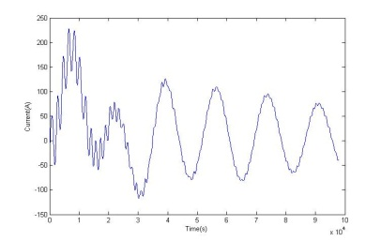

**Fig.11a Stator current**

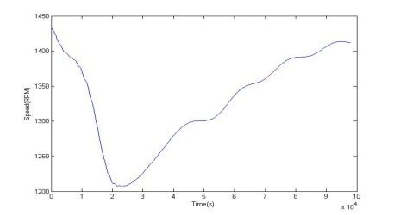

**Fig.11b Rotor speed**

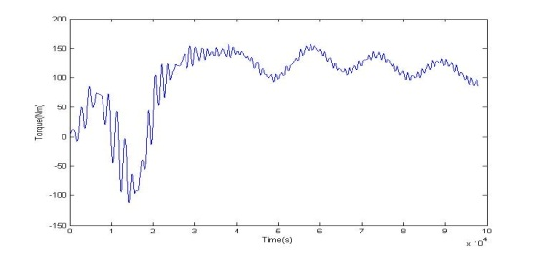

**Fig.11c Torque**

**LOAD 2(15 Kw 400V 50Hz)**

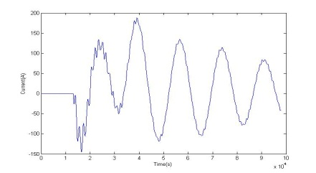

**Fig.11d Stator current**

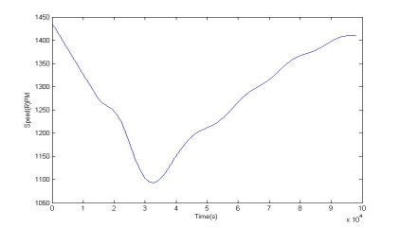

**Fig.11e Rotor speed**

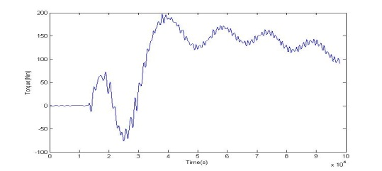

**Fig.11f Torque**

**LOAD 3(15 Kw 400V 50Hz)**

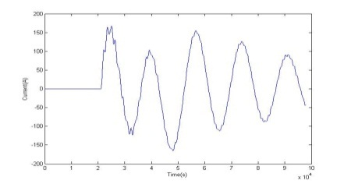

**Fig.11g Stator current**

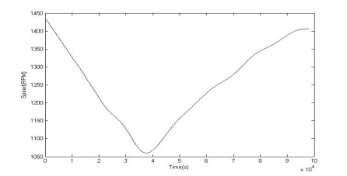

**Fig.11h Rotor speed**

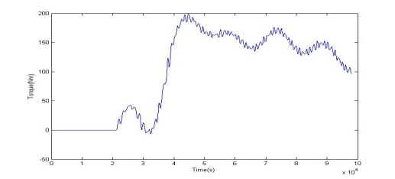

**Fig.11i Torque**

The Fig (5) shows the simulation diagram for PV/Wind/Diesel hybrid energy system. The simulation results for 15kW load are shown in Fig (11a), Fig (11b) and Fig (11c). If the load is 15kW then the individual system (PV or Wind or Diesel) can able to supply the load. This hybrid energy system also works like the above system but instead of battery as a backup source here the diesel is considered as the backup source. Under varying load conditions the characteristics of the hybrid energy systems are analyzed by adding two or more loads using circuit breaker. The simulation results by adding load 2 is shown in Fig (11d), Fig (11e) and Fig (11f) and for load 3 is shown in Fig (11g), Fig (11h) and Fig (11i).

**4.3 Analysis of PV/wind/battery/diesel hybrid system**

**LOAD 1(15 Kw 400V 50Hz)**



**Fig.12a Stator current**



**Fig.12b Rotor speed**



**Fig.12c Torque**

**LOAD 2(15 Kw 400V 50Hz)**



**Fig.12d Stator current**



**Fig.12e Rotor speed**

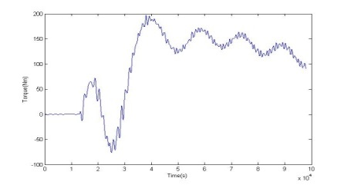

**Fig.12f Torque**

**LOAD 3(15 Kw 400V 50Hz)**



**Fig.12g Stator current**



**Fig.12h Rotor speed**

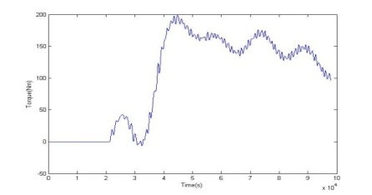

**Fig.4.3i Torque**

The Fig (6) shows the simulation diagram for PV/Wind/Diesel/Battery hybrid energy system. The simulation results for load 1 are shown in Fig (12a), Fig (12b) and Fig (12c). If the load is 15kW then the individual system (PV or Wind or Diesel or Battery) can able to supply the load. This hybrid energy system also works like the above system but battery and diesel both are considered as the backup source. Under varying load conditions the characteristics of the hybrid energy systems are analyzed by adding two or more loads using circuit breaker. The simulation results by adding load 2 is shown in Fig (12d), Fig (21e) and Fig (12f) and for load 3 is shown in Fig (12g), Fig (12h) and Fig (12i).

**6. CONCLUSION**

The loadcharacteristics and efficiency of threedifferent hybrid energy systems under varying load conditions are compared and analyzed using Mat lab/Simulink. From the simulation results we can conclude that PV/Wind/Diesel/Battery hybrid energy system is efficient and best hybrid system.

**7. REFERENCES**

1. T. Kranthi Kumar, Asha Tulasi&Smaranika Swain “Hybrid wind diesel energy system using Mat lab simulation”, IJESIT, ISSN: 2319-5967, Volume 2, Issue 5, September 2013.
2. S.Krishnaveni, M.Balachandar&R.Lakshmi(2014) “Hybrid PV/WIND system modeling and its control in grid connected mode”, IJETT, ISSN:2231-5381, Volume 17, Number 1.
3. AparnaPachori, Payalsuhane ”Design and modeling of standalone hybrid power system with matlab/Simulink”, IJSRMS, ISSN:2349-3771, Volume 1, Issue 2.
4. Eduard muljadi, senior member,IEEE. “Hybrid energy system with controlled energy storage” in 2013.
5. James.T;“A novel converter topology for standalone hybrid PV/wind/battery power system using MATLAB/SIMULINK”. Energy and control (ICPEC), 2013 international conference.
6. Kassem.A.M; AbdelAziz.”Reactive power control for voltage stability of standalone hybrid wind/diesel power system”2014/IET conference.