MOTORIZED INSURANCE WITH GROUP OF DATA ANALYSIS

# RV KAVYA , S.Malini,Mca., Mphil.,

*1(MCA, ADHIYAMAAN COLLEGE OF ENGINEERING (Autonomous), Hosur)*

*2(MCA, ADHIYAMAAN COLLEGE OF ENGINEERING (Autonomous), Hosur)*

*Corresponding Author:* [*kavyagowda323255@gmail.com*](mailto:kavyagowda323255@gmail.com)

**Abstract:** Storing a policy of commercial and non-commercial vehicles. So, the policies are generated from different kind of authorized companies. In these applications the branch master can analyse what is the status of issued policies. The analysis is depended on issued data policy, starting date, ending date of policy and also to manage the next intent policies, so far a kind of activities in branches are handled by excels and paper work by this work, lakh of data losing and had problem with filter of existing customers. This application is based on web technology, we have one more portal for collect number of information of vehicles and insurance companies. Storing and accessing essential information related to insurance policies, including policy holder details, coverage terms, and effective data. This module serves as a reference point for users to quickly retrieve policy- specific information.In addition to the core modules focused on insurance policy management, our student project includes a Renewal Date Reminder module to ensure timely renewal of policies on an annual basis. The Renewal Date Reminder module is designed to streamline the renewal process and mitigate the risk of policy lapses by proactively notifying policyholders and administrators of upcoming renewal deadlines. Prior to the renewal date, the system generates personalized notifications to remind policyholders of the impending deadline. These notifications can be sent via email, SMS, or through the system's dashboard, depending on user preferences.

***Key Word****:* ***Neural Networks ; Convolutional Neural Networks (CNN) ; Image Processing ;Optical Character Recognition (OCR) ; MNIST Dataset***

1. **Login Branch Master**

# Once the user can view the web page they can should be login with the username and password.

* User name

# Password

## Registration

### Registration:

User fills the particular fields in the registration form and fill the form and click register button.In registration form if you click the back button it would directly goes to the Loginform.

* Branch Name
* Branch Master Name
* Mobile Number

1 | Page

* Email-Id
* Address

### Insurance/Policy Info:

A detailed overview of individual insurance policies, including coverage limits, deductibles, and additional riders. Users can review and update policy details as needed, facilitating efficient management of insurance contracts.

* Client Contact
* Insurance Plans
* Policy Number
* Policy Start Date and End Date
* Product
* Category, Policy type, IDV NCB

### General Policy Details:

A centralized repository for storing and accessing essential information related to insurance policies, including policyholder details, coverage terms, and effective dates. This module serves as a reference point for users to quickly retrieve policy-specific information.

* Partner Category
* Partner Name
* Login id

### Vehicle Info:

It focuses on capturing and organizing information pertaining to insured vehicles. Users can input vehicle details such as make, model, year, and VIN (Vehicle Identification Number), enabling accurate tracking of insured assets.

* Reg No, Make, Model, Body type, Chassis No, Year of Month, Reg Date, Seats
* GVW (Gross Vehicle Weight)
* CC (Cubic Capacity)

### Premium Info:

It dedicated to managing premium payments associated with insurance policies. Users can view payment history, upcoming due dates, and payment amounts, facilitating timely premium renewals and preventing policy lapses.

* Total ODP (Own Damage Premium)
* Total TP (Third Party)
* CPT (Compulsory Personal Accident)
* Drive PA

### File Upload:

To facilitate document management within the system. Users can upload and attach relevant documents such as insurance certificates, vehicle registration forms, and accident reports directly to their respective policies, ensuring all necessary paperwork is easily accessible and securely stored.

* Live Policy
* RC Copy,KYC

**RESULT**

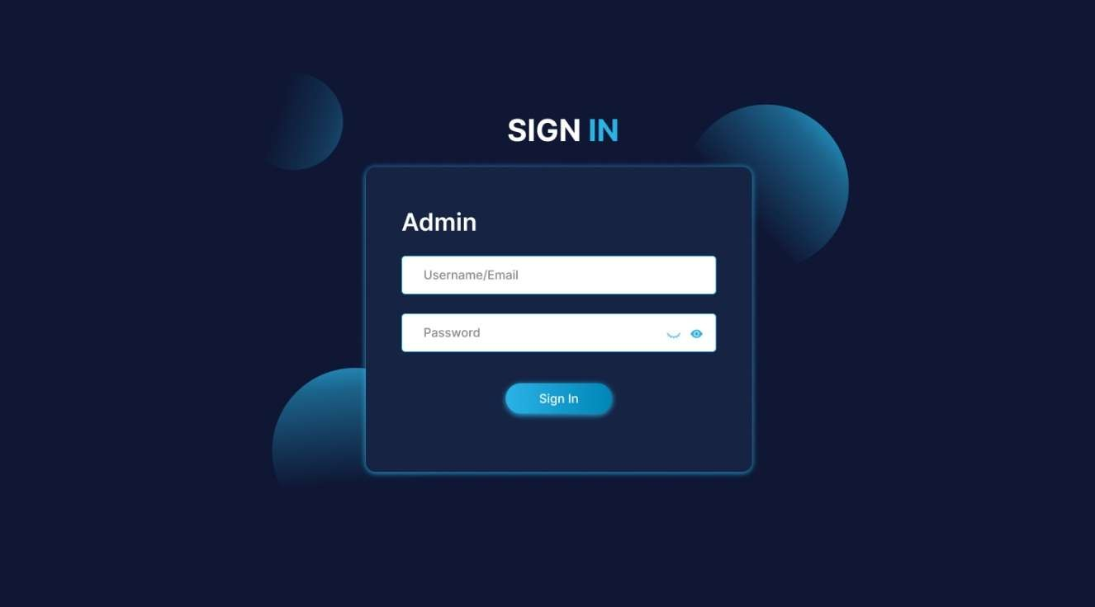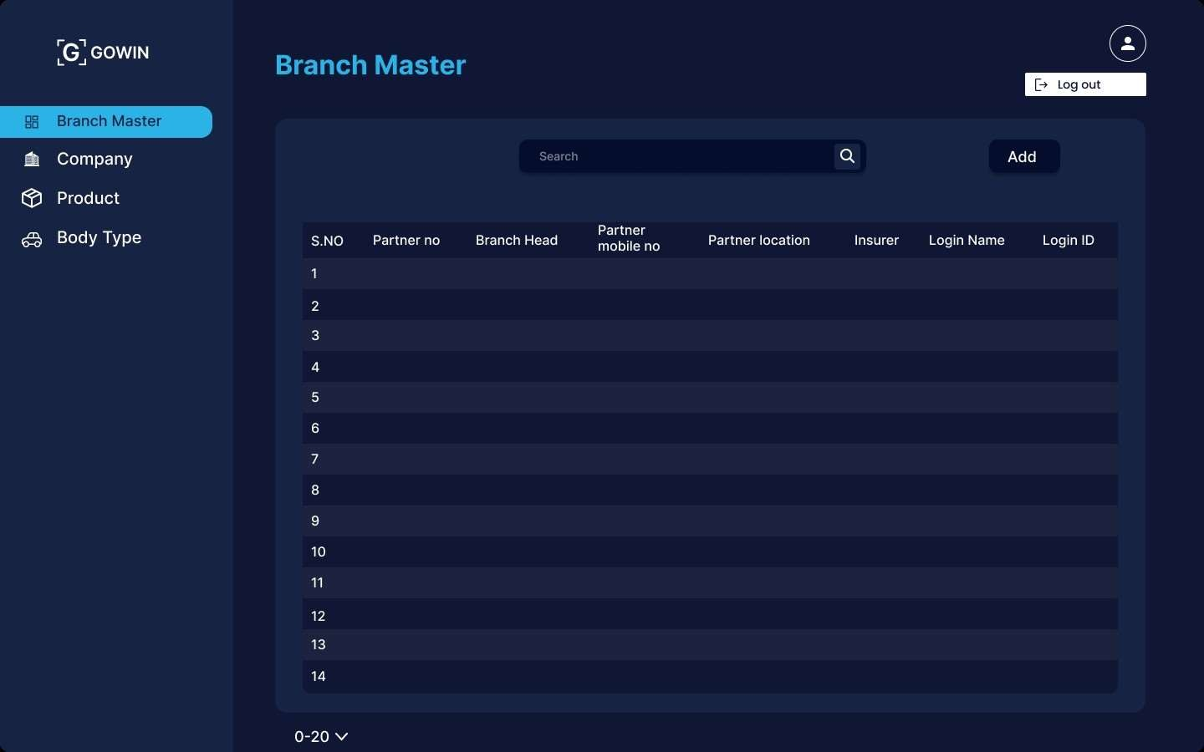

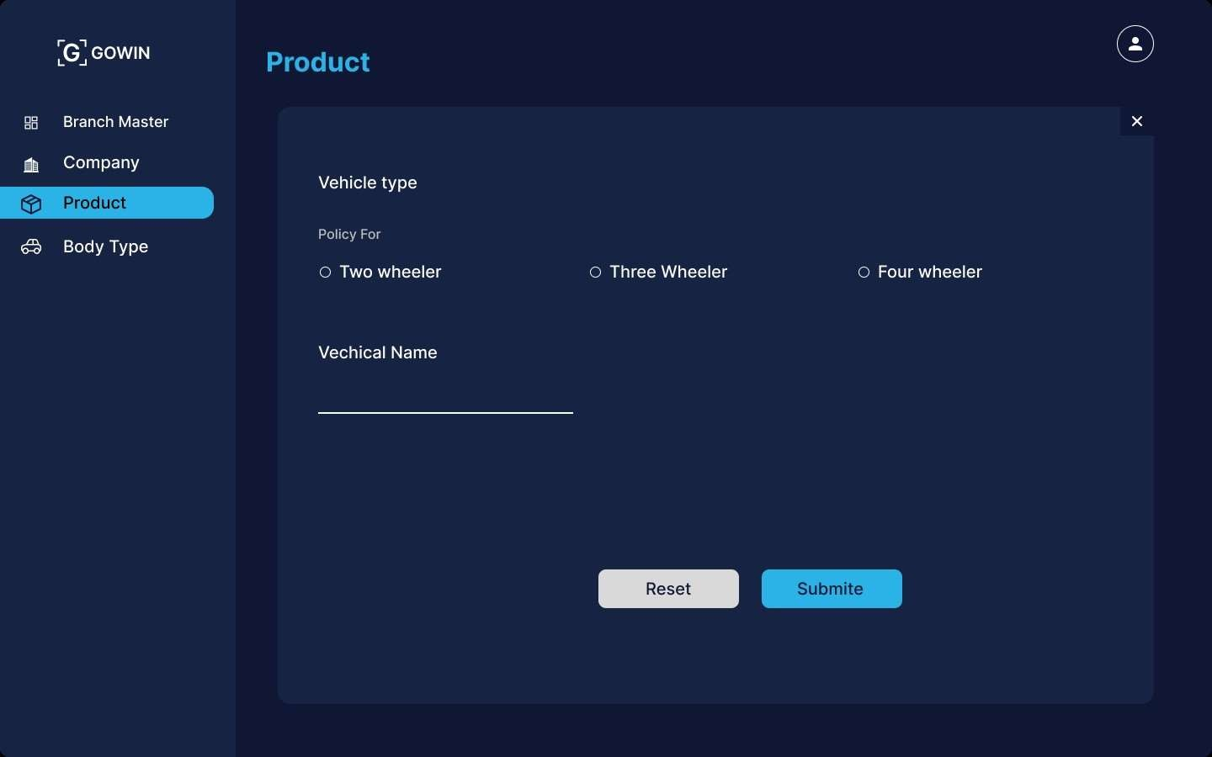

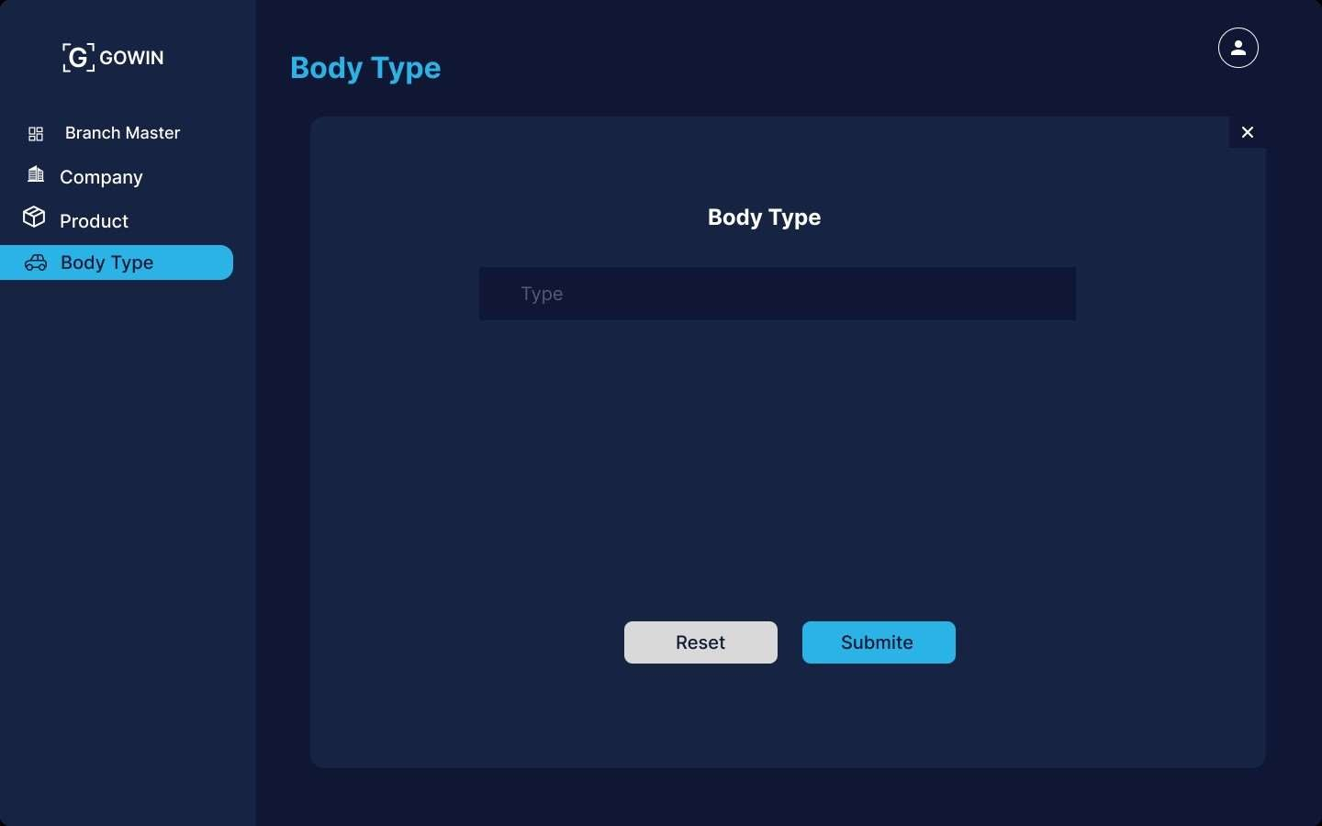

## References

1. https://[www.avenga.com/magazine/data-and-analytics-in-insurance/](http://www.avenga.com/magazine/data-and-analytics-in-insurance/)
2. https://[www.mckinsey.com/industries/financial-services/our-insights/data-and-analytics-key-to-future-of-](http://www.mckinsey.com/industries/financial-services/our-insights/data-and-analytics-key-to-future-of-) insurance-underwriting
3. https://www2.deloitte.com/us/en/insights/industry/financial-services/insurance-data-strategic-asset.html
4. https://[www.xenonstack.com/insights/data-analytics-in-insurance](http://www.xenonstack.com/insights/data-analytics-in-insurance)
5. https://[www.accenture.com/us-en/insights/insurance/insurance-industry-outlook](http://www.accenture.com/us-en/insights/insurance/insurance-industry-outlook)
6. https://[www.oecd-ilibrary.org/finance-and-investment/global-insurance-market-trends-2023_24106825](http://www.oecd-ilibrary.org/finance-and-investment/global-insurance-market-trends-2023_24106825)
7. https://github.com/theshreyansh/Insurance-Data-Analysis
8. https://home.treasury.gov/system/files/311/FIO%20Annual%20Report%202023%209292023.pdf
9. https://[www.precedenceresearch.com/insurance-analytics-market](http://www.precedenceresearch.com/insurance-analytics-market)
10. https://[www.pwc.com/gx/en/industries/financial-services/insurance/insurance-2023-and-beyond.html](http://www.pwc.com/gx/en/industries/financial-services/insurance/insurance-2023-and-beyond.html)