**Enhanced Chemistry Lab Learning Management System - ECLLMS**

1Dr S Prakash ,2Shanjai R, 3Muhil R, 4Nathish Surya M

Head of the Department, Sri Shakthi Institute of Engineering and Technology

Student, Sri Shakthi Institute of Engineering and Technology

Student, Sri Shakthi Institute of Engineering and Technology

Student, Sri Shakthi Institute of Engineering and Technology

________________________________________________________________________________________________________

***Abstract :***  An innovative platform called the "Enhanced Chemistry Lab Learning Management System (ECLLMS)" was created to change the conventional chemistry laboratory experience into a dynamic and interesting learning environment. Under the motto "A teacher for a student," ECLLMS provides individualized support, thorough safety instructions, dynamic experiments, and educators-only guidance to solve the inadequacies of traditional teaching techniques. The cutting-edge Doubt Clearance Module, which uses artificial intelligence (AI) and a unique database to respond to student questions and concerns in real-time, is one of the main features of ECLLMS. Students can get immediate help and clarification on experiment-related concerns from the Doubt Clearance Module's chat application, which is powered by sophisticated natural language processing (NLP) algorithms. By utilizing an AI-driven approach, students can overcome conceptual obstacles and get a deeper understanding of chemistry fundamentals by receiving precise and efficient solutions. Moreover, the Doubt Clearance Module's unique database improves the system's flexibility and reactivity. The ECLLMS makes sure that students receive timely, pertinent support that is catered to their individual requirements and learning objectives by constantly updating and growing its knowledge base. This individualized method encourages critical thinking abilities and self-directed learning in addition to increasing student confidence and engagement. All things considered, ECLLMS is a big step forward in chemistry education, providing a comprehensive way to improve the learning and teaching process in lab environments. ECLLMS fosters a lifetime excitement for scientific inquiry and discovery by enabling students to overcome obstacles, explore concepts, and thrive in their chemistry studies with its revolutionary Doubt Clearance Module.

***Index Terms* – Chemistry, lab experiment, teaching system, web-based application, student module, teacher module, interactive platform, streamlined learning.**

# **Introduction**

In the rapidly evolving landscape of education, traditional classroom models are facing increasing scrutiny for their limitations in meeting the diverse learning needs of students. In response to these challenges, the "One Student One Teacher" project emerges as a visionary initiative poised to revolutionize the educational paradigm. Rooted in the principles of personalized guidance, mentorship, and tailored instruction, this project aims to establish a symbiotic learning environment where each student is paired with a dedicated teacher. Through the implementation of a sophisticated web-based platform, students gain direct access to their designated teacher, facilitating seamless communication, feedback exchange, and collaborative learning experiences. By leveraging advanced technologies and innovative pedagogical methodologies, the project endeavors to address the multifaceted needs and preferences of students while empowering teachers to deliver personalized support and guidance. This introduction provides a glimpse into the rationale, objectives, and key components of the "One Student One Teacher" approach, setting the stage for a comprehensive exploration of its potential impact on educational outcomes and the broader landscape of learning.

# **Problem Statement**

The existing approach to teaching chemistry is characterized by a reliance on static textbooks, one-size-fits-all lectures, and limited opportunities for active engagement and inquiry-based learning. As a result, students often struggle to grasp abstract concepts, apply theoretical knowledge to real-world scenarios, and develop critical thinking skills essential for success in the field of chemistry. Furthermore, disparities in access to quality instructional resources, laboratory facilities, and teacher expertise exacerbate existing inequalities in academic achievement and scientific literacy among students from diverse backgrounds.

Moreover, the transition to remote and hybrid learning environments in response to the COVID-19 pandemic has highlighted the urgent need for flexible, technology-enhanced solutions that can facilitate seamless communication, collaboration, and assessment in virtual classrooms. However, existing Learning Management Systems (LMS) often lack specialized features and functionalities tailored to the unique requirements of chemistry education, hindering their effectiveness in delivering personalized instruction and supporting inquiry-based learning experiences.

The problem statement, therefore, centers on the following key challenges:

**Limited Interactivity and Engagement:** Traditional methods of chemistry instruction fail to provide opportunities for active student engagement, inquiry-based learning, and hands-on experimentation, leading to disinterest and disengagement among learners.

**Inadequate Personalization and Differentiation:** Current Learning Management Systems lack specialized features for adapting instruction to individual learning styles, preferences, and proficiency levels, resulting in a one-size-fits-all approach that fails to meet the diverse needs of students.

Accessibility and Equity: Disparities in access to quality instructional resources, laboratory facilities, and teacher expertise create barriers to learning for students from underprivileged backgrounds, exacerbating existing inequalities in academic achievement and scientific literacy.

**Adaptability to Remote Learning Environments:** The COVID-19 pandemic has underscored the importance of flexible, technology-enhanced solutions that can facilitate effective teaching and learning in virtual classrooms, yet existing LMS platforms often lack specialized features for supporting remote chemistry instruction.

# **Existing Solution**

In the realm of chemistry education, several existing solutions offer enhanced learning experiences through the integration of technology and pedagogy. These solutions cater to diverse learning styles, promote active engagement, and facilitate comprehensive understanding of chemical concepts. Here are some examples:

**Chemistry Simulation Platforms:**

Platforms such as ChemCollective, ChemReaX, and PhET Interactive Simulations provide interactive simulations and virtual experiments that allow students to explore chemical phenomena in a controlled, risk-free environment. These simulations offer hands-on learning experiences, enabling students to visualize abstract concepts, manipulate variables, and observe real-time reactions. By engaging students in experiential learning, chemistry simulation platforms promote deeper understanding of chemical principles and encourage inquiry-based exploration.

**Online Chemistry Courses and MOOCs:**

Massive Open Online Courses (MOOCs) offered by platforms like Coursera, edX, and Khan Academy provide access to high-quality, self-paced chemistry courses taught by renowned instructors from leading universities and institutions. These courses cover a wide range of topics, from introductory chemistry to advanced specializations, and incorporate multimedia resources, interactive quizzes, and peer-to-peer discussion forums. Additionally, many MOOCs offer certificates of completion or academic credit, making them valuable resources for students seeking flexible, accessible, and affordable chemistry education.

**Chemistry Tutoring and Homework Help Services:**

Online tutoring platforms and homework help services, such as Tutor.com, Chegg Study, and Khan Academy's Homework Help, offer personalized assistance and support to students struggling with chemistry concepts or assignments. These services provide on-demand access to qualified tutors, subject matter experts, and interactive learning resources, enabling students to receive real-time feedback, clarification, and guidance. Additionally, many tutoring platforms offer adaptive learning technologies and diagnostic assessments to identify students' areas of weakness and tailor instruction accordingly.

**Digital Textbooks and Multimedia Resources:**

Digital textbooks and multimedia resources, such as those available on platforms like Pearson, McGraw-Hill, and OpenStax, offer interactive learning materials, animations, videos, and adaptive quizzes that supplement traditional textbook content. These resources provide dynamic, multimedia-rich experiences that cater to diverse learning styles and preferences, allowing students to engage with complex chemical concepts in interactive and immersive ways. Furthermore, many digital textbooks offer features such as built-in assessments, study guides, and multimedia glossaries to enhance comprehension and retention.

**Collaborative Learning Platforms and Communities:**

Collaborative learning platforms and communities, such as Google Classroom, Microsoft Teams, and Slack, facilitate communication, collaboration, and knowledge sharing among students and instructors. These platforms offer features such as discussion boards, group projects, file sharing, and real-time messaging, enabling students to collaborate on assignments, share resources, and seek assistance from peers and instructors. By fostering a sense of community and collaboration, these platforms enhance student engagement, motivation, and learning outcomes in chemistry education

# **Literature Survey**

A literature review gives a summary of current research, studies, and publications on the Enhanced Chemistry Lab Learning Management System. While the model's response is based on information accessible until September 2021, it is critical to do an up-to-date literature study to acquire the most recent research in the subject. A brief summary of the important areas that a literature review on this issue may cover is provided below:

**Technology Integration in Chemistry Education:** Explore research on the integration of technology in chemistry education, such as the use of web-based platforms, virtual simulations, and interactive tools for teaching and learning chemistry lab activities. Investigate the effects of technology integration on student involvement, understanding, and performance in chemistry instruction.

**Interactive and Immersive Learning Approaches:** Look at research that looks into the usefulness of interactive and immersive learning methodologies in chemistry education, such as virtual reality (VR) and augmented reality (AR). Examine the advantages of combining VR and AR to recreate chemical lab environments and give students virtual hands-on experiences.

**Personalized and Adaptive Learning:** Examine research on personalized and adaptive learning techniques in chemistry education, such as the customization of information, feedback, and learning routes to meet the requirements and preferences of individual students. Investigate research on the application of adaptive learning algorithms and intelligent tutoring systems to give personalized recommendations and advice for chemistry lab tasks.

You can acquire useful insights into the present status of research and practices connected to technology-enhanced chemistry lab experiment instruction by performing a thorough literature review. This will aid in the creation and improvement of the Chemistry Lab Experiment Teaching System, ensuring that it is in line with the most recent innovations and best practices in the area.

# **Proposed Solution**

The proposed solution entails the development and implementation of an Enhanced Chemistry Learning Management System (ECLMS), a comprehensive platform designed to address the challenges plaguing traditional chemistry education. The ECLMS will incorporate specialized curriculum materials, interactive resources, and personalized instruction to enhance student engagement, comprehension, and retention of complex concepts. Through adaptive learning technologies and data analytics, the ECLMS will tailor learning pathways to individual student needs and proficiency levels, providing targeted interventions and customized learning experiences. Moreover, the platform will facilitate interactive engagement and collaborative learning through features such as discussion forums, group projects, and virtual peer-to-peer interaction. Real-time feedback and assessment tools will enable teachers to monitor student progress, identify areas for improvement, and provide timely support. Prioritizing accessibility and equity, the ECLMS will ensure inclusivity for all learners, regardless of their backgrounds or abilities, through multilingual support, offline access options, and compatibility with diverse devices and connectivity levels. Comprehensive professional development and support services will be offered to educators to facilitate effective implementation and utilization of the platform. By integrating these features and resources, the ECLMS has the potential to revolutionize chemistry education, empowering students to succeed in the field and pursue future careers in science and technology

# **Executive Summary**

The Enhanced Chemistry Lab Learning Management System is a complete web-based tool developed to revolutionize chemistry lab experiment teaching and learning. This novel approach overcomes the shortcomings of old techniques by providing an integrated platform that improves student engagement, delivers personalized learning experiences, and simplifies experiment administration for instructors. The system is divided into two modules: one for students and one for teachers.

The system provides a user-friendly interface via which students may access a selected selection of chemical lab experiments. Each experiment is supported by goals or learning objectives, and students can navigate through step-by-step processes provided in a sequential order. To accommodate diverse learning styles, the system includes an aural learning option, which allows students to listen to the experiment being read out in a variety of voices. This participatory and approachable method improves comprehension and engagement.

The teacher module provides teachers with tools for effective experiment management. Teachers may search through a complete collection of experiments, create new experiments with clear methods and goals, and simply delete experiments that are no longer relevant or need updating. For safe and scalable data administration, the system employs a MySQL database, ensuring dependable preservation of experiment details.

The Enhanced Chemistry Lab Learning Management System’s key features include interactive navigation, auditory learning choices, user authentication, role-based access management, and a responsive design that is compatible with a wide range of devices and browsers.

The Enhanced Chemistry Lab Learning Management System strives to bridge the gap between theory and practice by leveraging technology and delivering a comprehensive solution, creating a dynamic and engaging platform for students to improve their comprehension of chemistry lab experiments. Similarly, it provides effective experiment management tools to professors, easing administrative duties and maintaining up-to-date information. This game-changing approach has the potential to redefine chemistry education by making it more engaging, accessible, and successful for students and teachers.

# **Business Viability**

A combination of critical variables contributes to the Enhanced Chemistry Lab Learning Management System’s substantial commercial viability. To begin with, there is a significant market need for novel educational solutions in the field of chemistry education. Educators and students alike are looking for dynamic and engaging platforms that bridge the gap between academic notions and actual implementation. By meeting this desire, the system provides a complete and user-friendly solution that meets the market's increasing needs.

One of the system's distinguishing aspects is its distinct value proposition. It gives a personalized learning experience that accommodates diverse learning styles by including interactive step-by-step procedures, audio learning alternatives, and customizable voices. This innovative value proposition distinguishes it from existing approaches and solutions, making it an appealing alternative for both students and instructors.

Additionally, the technology provides considerable cost and time benefits for instructors. It simplifies experiment management operations by offering a centralized platform for storing, retrieving, and updating experiment details. Teachers no longer have to waste time organizing physical materials or looking for experiment resources. Physical resource reductions may also result in cost savings for educational institutions.

The Enhanced Chemistry Lab Learning Management System has numerous income potentials. Subscription licenses are available for educational institutions to utilize the programme. As an additional paid option, premium features or material can be provided. Customization possibilities can be made available to institutions with special needs. Collaborations with educational publishers or content providers to incorporate their materials into the system can potentially result in money.

Overall, the Enhanced Chemistry Lab Learning Management System has a high level of economic viability because of its capacity to meet market needs, unique value proposition, cost and time savings, scalability, accessibility, possible income streams, and long-term sustainability. The system has the potential to make a substantial contribution in the field of chemistry education while also offering a valuable economic opportunity by efficiently satisfying the demands of students and instructors.

# **Advantages**

The Enhanced Chemistry Lab Learning Management System enhances student learning by offering an interactive and immersive platform. Students may actively engage with the experiments through step-by-step processes, interactive navigation, and audio learning alternatives, resulting in a deeper knowledge and enhanced memory of the topics. This strategy encourages a more dynamic and interesting learning environment.

By adapting to various learning styles and preferences, the system prioritizes personalized learning. Auditory learners can benefit from an alternate way of understanding with adjustable voices and the opportunity to listen to experiments being read aloud, while visual learners can follow along with the step-by-step directions. This personalized approach guarantees that students may study in the manner that best meets their unique needs, therefore improving their overall learning experience.

Another significant benefit of the system is improved accessibility. Because it is web-based, students and teachers may access it from a variety of devices and places. This adaptability allows for remote learning, allowing students to conduct experiments and access instructional materials outside of the typical classroom environment. It is especially useful for students who may be limited by geography or logistics, allowing them to connect with the learning content and participate in lab activities.

Scalability of the system helps to reduce costs for educational institutions. Its web-based architecture enables it to be deployed across many classrooms and support a greater student population without requiring new physical resources. This scalability eliminates the need for expensive lab supplies, chemicals, and equipment, potentially saving educational institutions money.

In laboratory research, safety is of the utmost importance, and the system addresses this by providing precise step-by-step protocols and safety measures. Students may read and study safety rules, ensuring that correct safety measures are followed throughout lab research. This focus on safety fosters a safe learning environment for pupils.

Overall, the Enhanced Chemistry Lab Learning Management System provides a number of benefits, including improved learning experiences, personalized learning options, improved accessibility, efficient experiment management, scalability, cost savings, safety promotion, up-to-date content, integration potential, and data analytics capabilities. These benefits lead to a more interesting, effective, and efficient method of teaching and learning chemical lab activities.

# **Modules**

The Enhanced Chemistry Lab Learning Management System combines multiple modules to give a complete and effective platform for students and teachers alike. The user authentication and role management module provides secure access by allowing students and teachers to log in with the proper permissions. The student module includes a list of experiments with goals or learning objectives, full experiment pages with step-by-step methods, interactive navigation for an organized learning experience, and aural learning choices with configurable voices. Educators may manage experiments in the teacher module by reviewing, choosing, creating, amending, and removing experiments, ensuring that the experiment repository is organized and up to date.

For effective data administration, including experiment details and student information, the system employs a MySQL database. Integration with other systems and analytics tools improves the operation of the system and gives insights into student performance and engagement. Administrators can also use system administration functions to handle user accounts, settings, backups, and other administrative activities. These modules, when combined, provide the backbone of the Chemistry Lab Experiment Teaching System, allowing for experiment management, secure access, data management, and system administration.

# **Output**

**Teacher Module:**

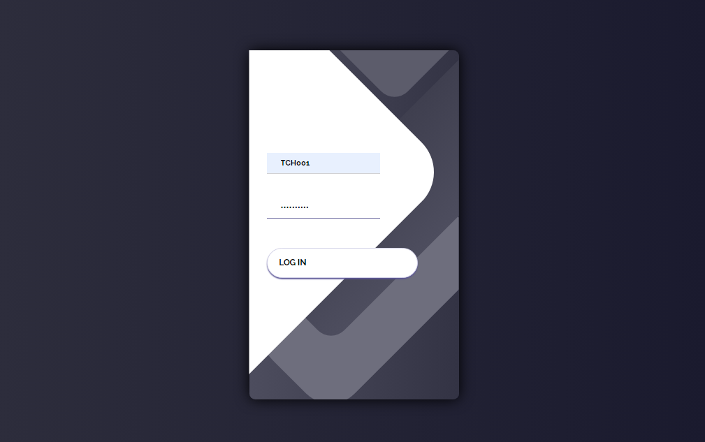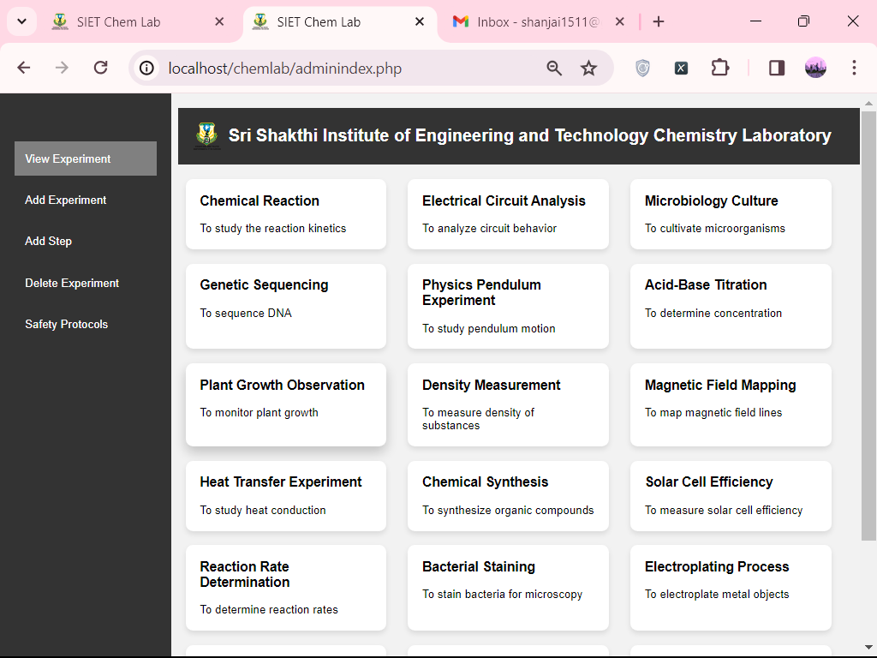

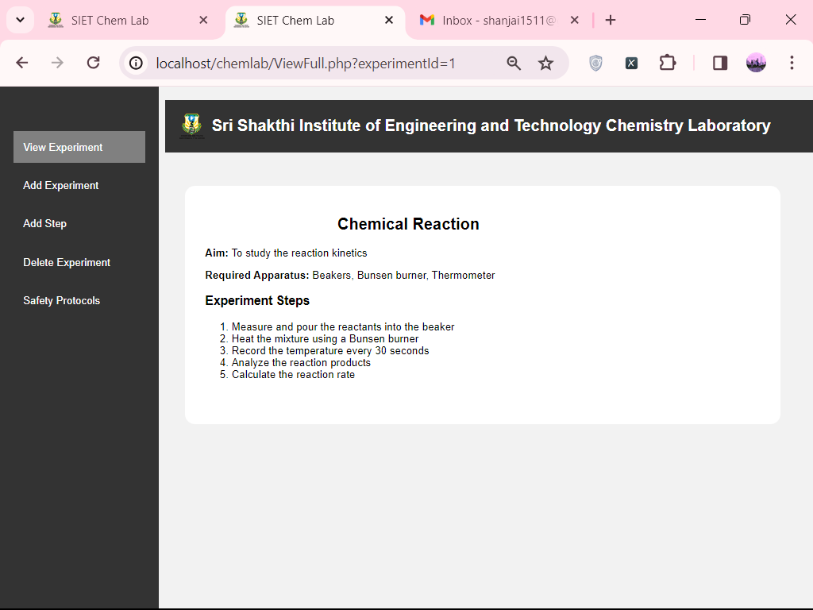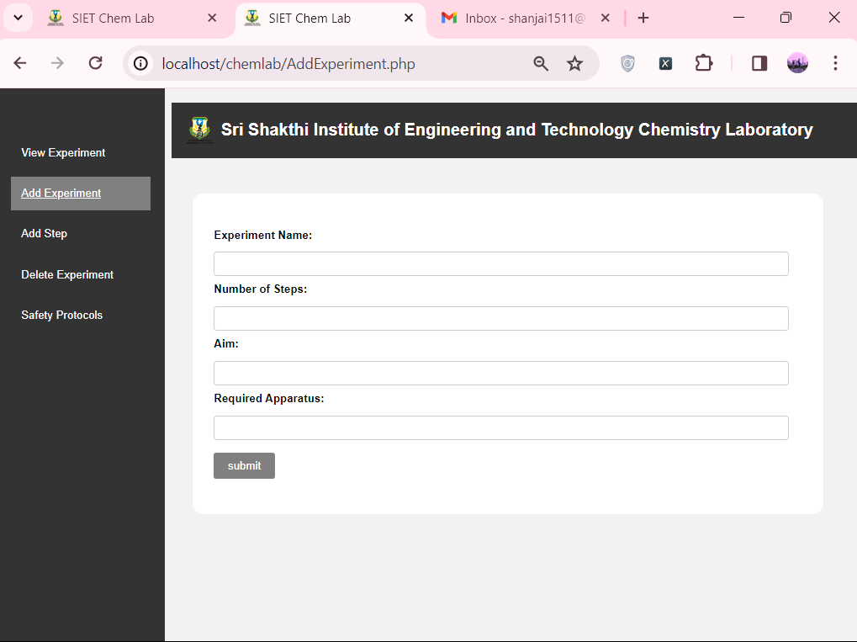

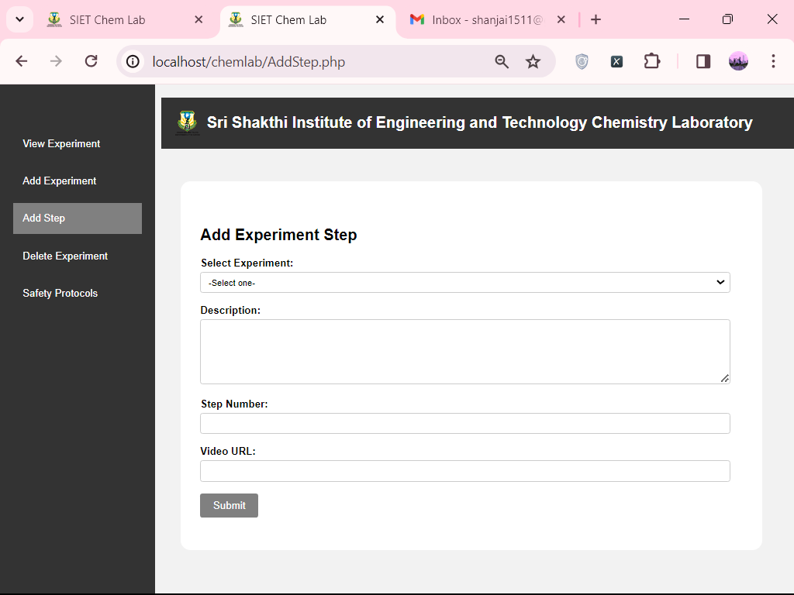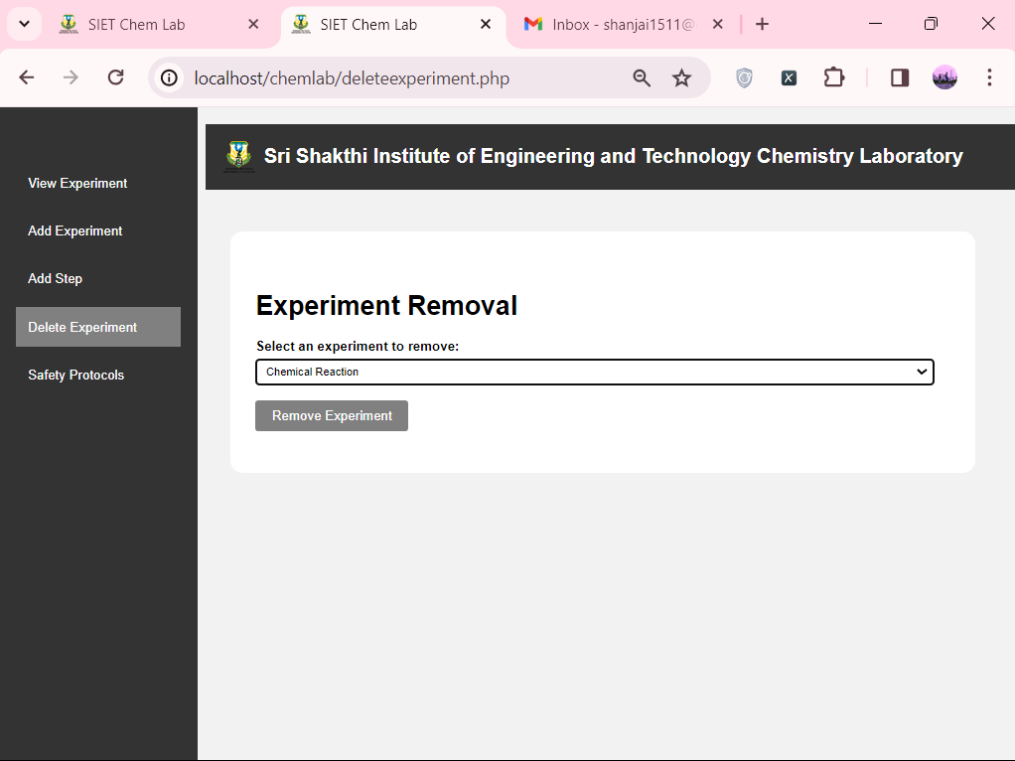

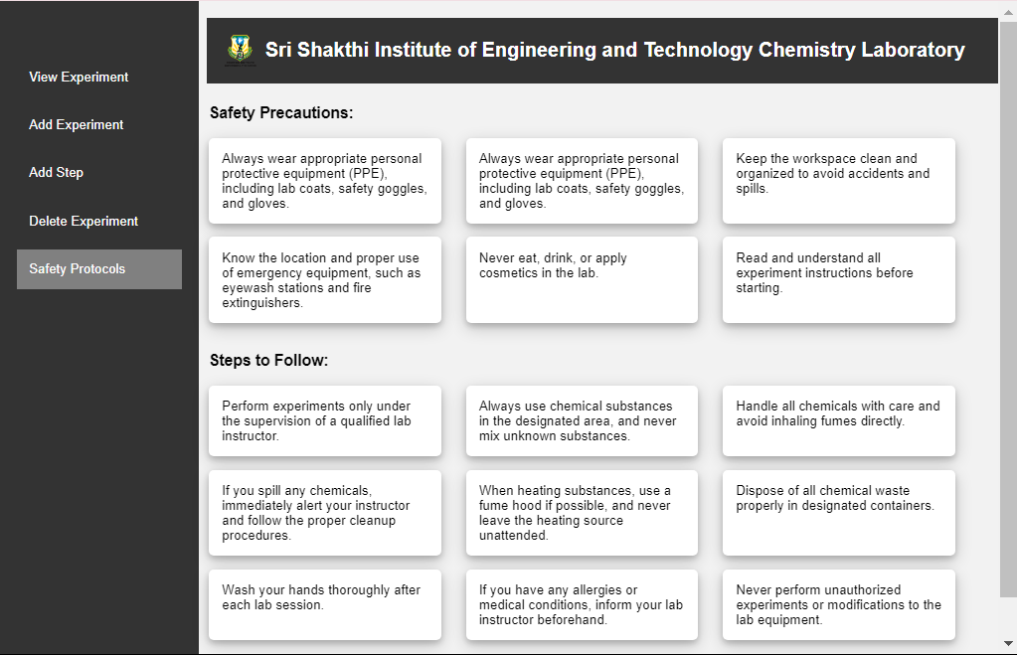

**Student Module:**

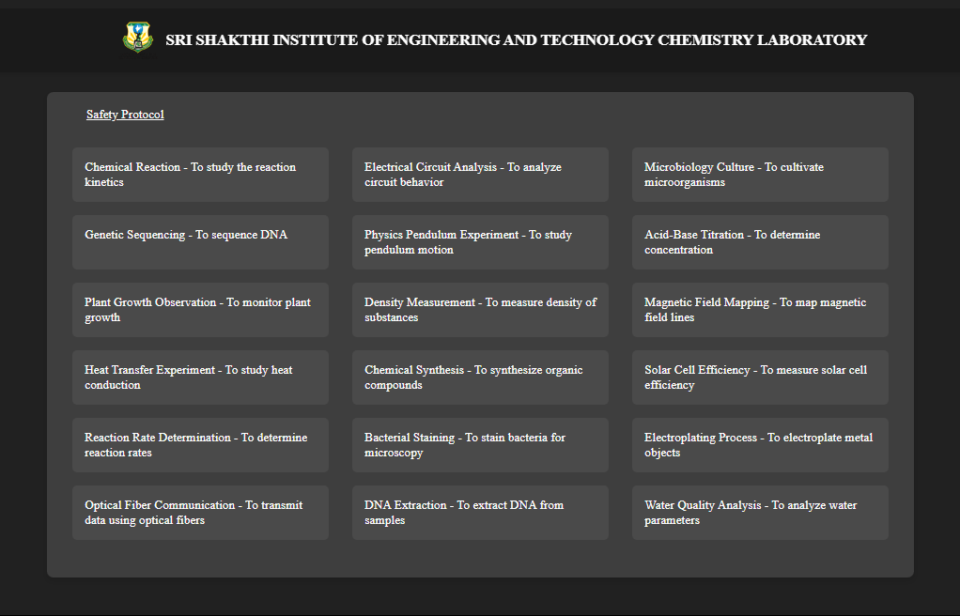

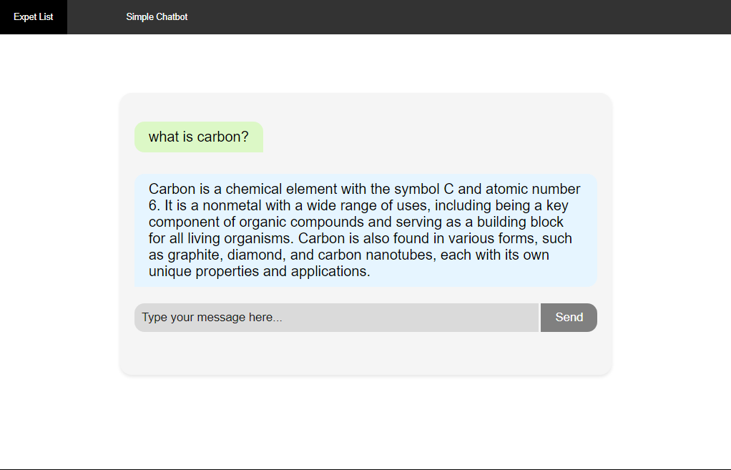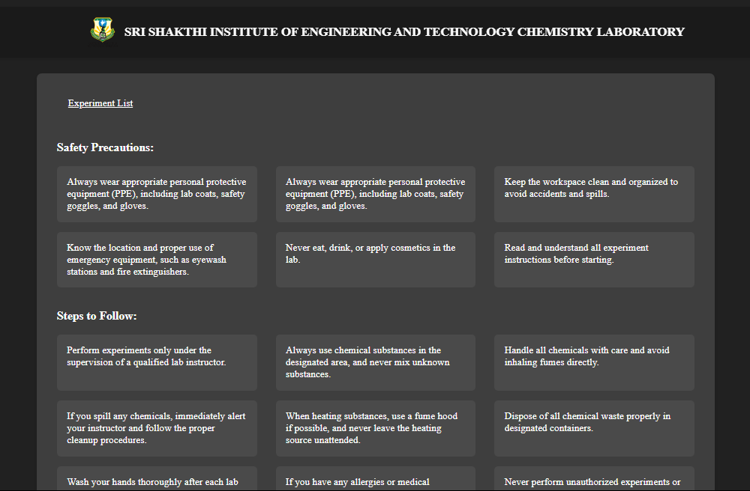

# **Conclusion**

The Enhanced Chemistry Lab Learning Management System is a significant development in chemistry education, providing an innovative and comprehensive method for teaching and studying chemistry lab experiments. The system uses technology to give students dynamic, accessible, and personalized learning experiences while facilitating experiment administration for instructors. The system engages students with a user-friendly interface, thorough experiment methods, interactive navigation, and auditory learning possibilities via its student module. These features accommodate various learning styles and encourage active engagement, which improves students' knowledge and recall of the subject matter.

The system provides a centralized platform for experiment administration for teachers, providing quick access to experiment details, the development of new experiments, and rapid updates. This improves instructional delivery by streamlining administrative chores, saving time, and ensuring up-to-date information.

The system's scalability, interoperability with a variety of devices and browsers, and possibility for interaction with other educational tools make it a versatile and adaptable solution. Its future capabilities, such as virtual reality integration, augmented reality upgrades, and gamification features, promise to make learning even more interesting and immersive.

# **Acknowledgment**

We would like to thank everyone who has contributed to the creation and success of the Enhanced Chemistry Lab Learning Management System. This project would not have been possible without their invaluable assistance and experience.

We would like to thank our project supervisor Dr S Prakash first and foremost for their direction, support, and insightful input throughout the project. Their skill and devotion have been critical in determining the system's direction and ensuring its instructional value.

We would also want to thank the teaching staff and students that took part in the user testing and offered helpful input. Their participation and helpful recommendations have tremendously aided in the system's refining and enhancement.

We would also want to thank our development team, which included Shanjai R, Muhil R, and Nathish Surya M. Their unwavering efforts, technical competence, and collaborative attitude were critical in creating, developing, and implementing the system's numerous modules and features.

# **References**

**[1]** "Chemistry Education: Best Practices, Opportunities, and Trends" by Javier García-Martínez and Elena Serrano-Torregrosa

**[2]** International Conference on Chemistry Education (ICCE)

**[3]** ERIC (Education Resources Information Center)