**Early-Stage Detection of Autism Spectrum Using**

**Machine Learning**

Sneha A P1 , M. B. Anandaraju2 , Anusha M N3 , Prashanth H V4, Sneha K R5,and Varshini D B6

1 Assistant Professor, Dept. of ECE, BGS Institute of Technology, Adichunchanagiri University, B.G Nagara, Karnataka, India

2,3,4,5 Dept. of ECE, BGS Institute of Technology, Adichunchanagiri University, B.G Nagara, Karnataka.

snehapgowda19@gmail.com 1 mb.anandaraju@gmail.com 2 anushamn23@gmail.com3 prashanthpreethu3@gmail.com 4

snehagowda191@gmail.com 5 [varshinidb25@gmail.com](mailto:varshinidb25@gmail.com) 6

**Abstract.** Chemical imbalance Range Problem Autism Spectrum Disorder is a neurodevelopmental issue characterized by challenges in friendly cooperation, correspondence, and tedious behaviors. Early diagnosis of ASD is crucial for effective intervention and support. This project proposes an innovative approach to automate the detection of autism using machine learning techniques of two different types, implemented in Google Collab. It contains four different ASD datasets representing various age groups (Toddlers, Adolescents, Children, and Adults) and initially preprocesses the datasets. The dataset utilized for training and testing is sourced from Kaggle, providing a diverse and comprehensive set of features for robust model development. The work centers the nitty gritty component significance examination which can direct the decision-production of medical services experts while screening ASD cases.

**Keywords:** *Autism spectrum disorder, machine learning classification, feature*

*scaling, feature selection technique.*

1 Introduction

Chemical imbalance Range Problem (ASD) is a neurodevelopmental condition related with emotional wellness that starts starting period of life, influencing an individual's social connections and collaboration issues. ASD has confined and rehashed behavioral designs, and the word range incorporates an extensive variety of symptoms and force. Despite the fact that there is no practical answer for ASD, brown-nosely early mediation and legitimate clinical consideration will have a massive effect in a youngster's improvement to zero in on working on a kid's ways of behaving and abilities in correspondence. All things considered, the distinguishing proof and analysis of ASD are truly troublesome and refined, utilizing conventional social science. Ordinarily, Au-tism is generally regularly analyzed at around two years old and can likewise be di-agnosed later, in light of its seriousness. An assortment of treatment procedures are availa-ble to identify ASD as fast as could be expected. These symptomatic methodology aren't al-ways generally utilized practically speaking until a serious possibility creating ASD. Diagnosing mental irregularity range tangle ASD can be maddening considering how there is no clinical starter, similar to a blood test, to take apart the issue. Specialists take a gander at the youth's create mental history and lead to make an assurance. ASD might a portion of the time at any point be recognized at 18 months mature enough or more energetic. By age 2, a finding by a cultivated proficient can be seen as strong. Nevertheless, various children don't triumph ultimately a last assurance until much more settled. Certain people are not dissected until they are adolescents or adults. This concede infers that people with ASD presumably will not get the early help they with requiring. Diagnosing jokes with ASD anyway exactly on schedule as possible might be basic to guarantee young people get the organizations and supports. hi need to show up at their most extreme capacity. There are a couple of stages in this cycle. A plausibility investigation includes a definite evaluation of the need, worth and common sense of a p frameworks improvement. Feasibility examination n shapes the straightforward choices at urgent focuses during the developmental process as we decide if it is functionally, financially and in fact reasonable to continue with a specific strategy. Feasibility examination can be utilized in every one of the moves toward evaluate the monetary, specialized and functional ability to continue with specific exercises. A frameworks development project is probably going to be functionally plausible on the off chance that it addresses the 'issues' and assumptions for the association The nature and level of client contribution in the turn of events and implementation of the framework; immediate and roundabout effects of the new framework on work rehearses; Expected execution and results of the new framework contrasted and the current framework; Preparing necessities and other change the executives techniques; and 'compensation' periods (in this manner compromise between long haul association advantages and transient in efficiencies during framework advancement and execution). A possibility examination typically includes an exhaustive evaluation of the monetary (esteem), specialized (reasonableness), and operation need parts of a proposition.

**2 Problem Statement**

The issue tended to in this study spins around Mental imbalance Range Disorder (ASD), a neurodevelopmental condition essentially affecting people's day to day routines. Despite the challenges associated with completely eradicating ASD, there is a recognized need for effective early interventions to mitigate its severity. The specific problem under consideration is the development of a robust framework for evaluating different (ML) procedures to empower the early discovery of ASD. The goal is to assess the performance of different ML algorithms and Feature Scaling (FS) strategies on diverse datasets representing different age groups (Toddlers, Adolescents, Children, and Adults). The study aims to identify the most effective ML algorithms and FS techniques for accurate ASD classification, considering various statistical evaluation metrics. Additionally, the research explores the importance of specific attributes in predicting ASD risk through detailed Feature Selection Techniques (FSTs). Ultimately, the objective is to contribute insights that guide healthcare practitioners in decision-making during ASD screening and offer a promising alternative to existing approaches for early detection

**3 Literature survey**

The study conducted in [1] examines the location of ASD in advanced grown-ups with the commitment of Move Learning. A high characterization exactness was accomplished with respect to a Peruse (80.50%) and a Hunt (81%) task demonstrating the way that our strategy could be viewed as a promising instrument in regards to programmed ASD recognition. ASD recognition. Advanced Chemical imbalance Discovery in Grown-ups is altogether troublesome contrasted and early Mental imbalance Range Problem (ASD) finding with serious side effects. ASD conclusion is typically accomplished by conduct instruments depending on abstract rather on genuine standards, while propels in research demonstrate cutting - edge strategies for early evaluation, for example, eye-following innovation, AI, Web of Things (IoT), and other appraisal apparatuses.

The study conducted in [2] utilizes the most notable AI methods to separate between mentally unbalanced individuals and solid controls. For instance, the Help Vector Machine Classifier, K-Closest Neighbor Classifier, and Irregular Woods Classifier have been used for grouping. Mental imbalance is one of a kind among the various cerebrum problems in that it regularly influences children very early on. For individuals with chemical imbalance, the most troublesome component is ex-squeezing their feelings and feelings to other people. Mental imbalance range jumble (ASD) is one more name for chemical imbalance is an ongoing formative disability, troublesome and complicated, set apart by repeating activities, non-verbal communication, and absence of focus. ASDs have changing levels of side effects and seriousness.

This study [3] presents The review utilizes a Gaussian Blend Model (GMM) ap-proach to dissect discourse in clinical evaluations, accomplishing 89% exactness in distinguishing portions containing youngster, specialist, parent, development commotions, and concurrent discourse, and 74.5% precision in advisors' discourse. Applied to 34 clinical appraisals utilizing ADOS. It Accomplished 89% precision in distinguishing kids' discourse segments .and 74.5% exactness in recognizing youngsters' and advisors' discourse sections.

This study [4] assesses Chemical imbalance Range Issue (ASD), a neuro-jumble influencing cooperation and correspondence. It investigates the utilization of machine get the hang of ing procedures like Gullible Bayes, Backing Vector Machine, Strategic Regression, KNN, Brain Organization, and Convolutional Brain Organization for anticipating and examining ASD issues in youngsters, youths, and grown-ups.

This study [5] The review expects to recognize a kid's powerlessness to Chemical imbalance Range Dis-request (ASD) in its beginning phases, improving finding. Strategic Relapse favorable to vides the most noteworthy exactness for the dataset. Current indicative strategies depend on clinical tests, however prescient models utilizing models like SVM, RFC, NB, LR, and KNN are utilized. It Expects to recognize in the event that a youngster is powerless to ASD in its beginning phases. Strategic Relapse gives the most elevated precision to the chose dataset.

**4 Methodology**

In this project, we will use a dataset containing information about childrens with Autism-Spectrum Disorder.

Detecting autism spectrum disorder (ASD) using machine learning algorithms involves the application of computational models to analyze patterns and features in data related to individuals with and without ASD. The architecture for such a system typically consists of several key components:

Data Collection:

Gathering relevant data is crucial for training and evaluating the model. This data may include behavioral observations, medical history, neuroimaging data, and other relevant information. Datasets should be diverse and well-balanced to ensure the model generalizes well across different populations.

Data Preprocessing:

Cleaning and preprocessing the data is important to handle missing values, outliers, and standardize the data for better model performance. Techniques such as normalization, scaling, and handling imbalanced data can be applied during this stage.

Model Selection:

Choosing an appropriate machine learning model is crucial. Common models for ASD detection include:

Support Vector Machines (SVM).

Random Forests.

Neural Networks.

Decision Trees.

Logistic Regression.

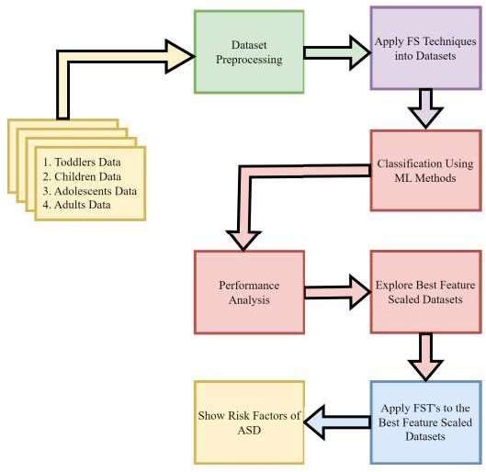

Fig1 : Block Diagram of Autism Spectrum Disorder

We gather the four ASD datasets (Babies, Teenagers, Kids, and Grown-ups) from the openly accessible vaults like Kaggle. As a matter of some importance, the datasets are gathered, and afterward the preprocessing is achieved through the missing qualities. The Mean Worth Ascription (MVI) strategy is utilized to credit the missing potential gains of the dataset. Then, the out and out component values are changed over totally to their practically identical numerical characteristics. The component scaled datasets are then grouped including different ML organizement techniques as referred to. Looking at the game plan consequences of the classifiers on ASD datasets, the best-performing gathering technique is perceived. Highlight choice method is applied to choose ideal elements from the accessible datasets for expectation, better AI based chemical imbalance range jumble forecast model is suggested that predicts chemical imbalance with better precision and work on the performance.

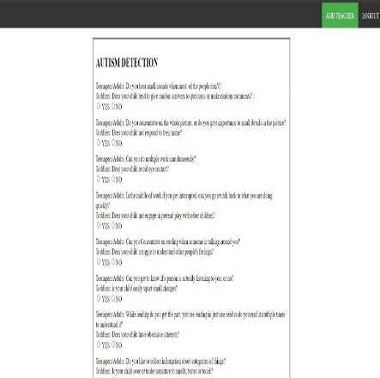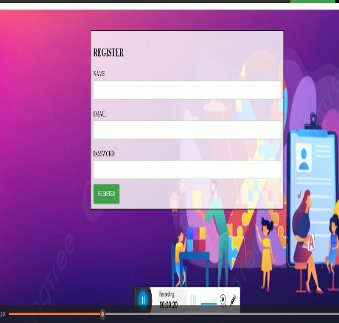 **5 Results and Discussion**

figure 5.1 : Login Page for ASD Figure 5.2 : Question for Detecting ASD

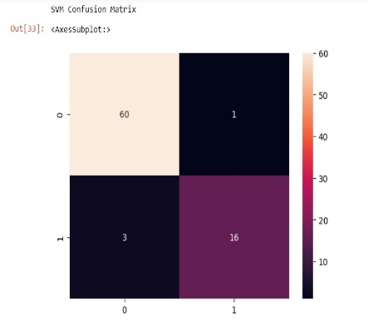

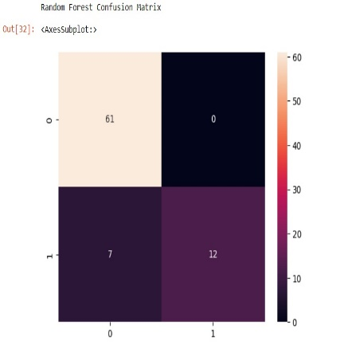

Figure 5.3: SVM Confusion Matrix Figure 5.4 : Random Forest Matrix

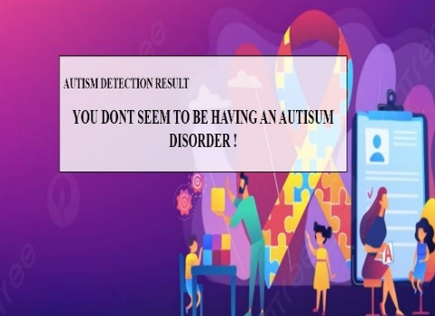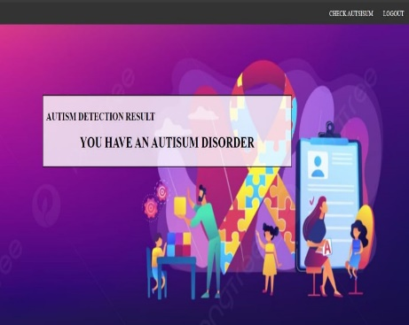

# Figure 5.5: Result for having ASD Figure 5.6:Result for not having ASD

# The software appears as systematic tool for managing and predicting Autism Spectrum Disorder. It begins with an initial welcome screen.offering options such as 'Home' and 'User', providing a user-friendly interface for navigation. Page Upon selecting the 'User' option, individuals are directed to a page on which they may choose to log in with existing credentials or registeration page as new users by providing necessary details like username and password mail id . Once logged in, users access a dedicated section where user can entry input details relevant data for the system to estimate the possibility of developing Autism Spectrum Disorder.This likely involves entering information includes medical history, symptoms, and possibly biological metrics.The system then processes,and generate a prediction regarding the whether ASD is present or not, which is displayed to the user. This article intended to give significant and careful ASD screening models to help watchmen and very familiar people quickly dissect their young people's condition. Tragically, a couple of families and grown-up patients don't have satisfactory data on ASD secondary effects, so cases of mental irregularity range mix are not overseen early. Electronic thinking and simulated intelligence are used at this point in most living districts, and their use in the field of clinical finding adds to a leading push toward. exploratory results on the used datasets associated with adolescents, teenagers, and little children show that the brain networks model yielded the best execution results contrasted with the other AI models utilized in this paper concerning prescient power, responsiveness, and explicitness.

**Refrences**

[1] M. Bala, M. H. Ali, M. S. Satu, K. F. Hasan, and M. A. Moni, ‘‘Efficient machine learning models for early stage detection of autism spectrum disorder,’’ Algorithms, vol. 15, no. 5, p. 166, May 2022.

[2] D. Pietrucci, A. Teofani, M. Milanesi, B. Fosso, L Putignani, F. Messina,G. Pesole, A. Desideri, and G. Chillemi, ‘‘Machine learning data analysis highlights the role of parasutterella and alloprevotella in autism spectrum.disorders,’’ Biomedicines, vol. 10, no. 8, p. 2028, Aug. 2022.

[3] R. Sreedasyam, A. Rao, N. Sachidanandan, N. Sampath, and S. K. Vasudevan,‘‘Aarya—A kinesthetic companion for children with autism spectrum disorder,’’ J. Intell. Fuzzy Syst., vol. 32, no. 4, pp. 2971–2976, Mar. 2017.

[4] J. Amudha and H. Nandakumar, ‘‘A fuzzy based eye gaze point estimation approach to study the task behavior in autism spectrum disorder,’’ J. Intell. Fuzzy Syst., vol. 35, no. 2, pp. 1459–1469,Aug. 2018.

[5] H. Chahkandi Nejad, O. Khayat, and J. Razjouyan ,“Software developmentof an intelligent spirography test system for neurological disorder detection and quantification,’’ J. Intell. Fuzzy Syst., vol. 28, no. 5, pp. 2149–2157, Jun. 2015.

[6] F. Z. Subah, K. Deb, P. K. Dhar, and T. Koshiba, ‘‘A deep learning approach to predict autism spectrum disorder using multisite resting-state fMRI,’’ Appl. Sci., vol. 11, no. 8, p. 3636, Apr. 2021.

[7] K.-F. Kollias, C. K. Syriopoulou-Delli, P. Sarigiannidis, and G. F. Fragulis,‘‘The contribution of machine learning and eye-tracking technology in autism spectrum disorder research: A systematic review,’’ Electronics, vol. 10, no. 23, p. 2982, Nov. 2021.

[8] I. A. Ahmed, E. M. Senan, T. H. Rassem, M. A. H. Ali, H. S. A. Shatnawi,S. M. Alwazer, and M. Alshahrani, ‘‘Eye tracking-based diagnosis and early detection of autism spectrum disorder using machine learning and deep learning techniques,’’ Electronics, vol. 11, no. 4, p. 530, Feb. 2022.

[9] P. Sukumaran and K. Govardhanan, ‘‘Towards voice based prediction and analysis of emotions in ASD children,’’ J. Intell. Fuzzy Syst., vol. 41, no. 5, pp. 5317–5326, 2021

[10] S. P. Abirami, G. Kousalya, and R. Karthick, ‘‘Identification and exploration of facial expression in children with ASD in a contact less environment,’’ J. Intell. Fuzzy Syst., vol. 36, no. 3, pp. 2033–2042, Mar. 2019.

[11] M. D. Hossain, M. A. Kabir, A. Anwar, and M. Z. Islam, ‘‘Detecting autism spectrum disorder using machine learning techniques,’’ Health Inf. Sci. Syst., vol. 9, no. 1, pp. 1–13, Dec. 2021.

[12]C. Allison, B. Auyeung, and S. Baron-Cohen, ‘‘Toward brief ‘red flags’for autism screening: The short autism spectrum quotient and the short quantitative checklist in 1,000 cases and 3,000 controls,’’ J. Amer. Acad.Child Adolescent Psychiatry, vol. 51, no. 2, pp. 202–212, 2012.

[13] F.Thabtah,F. Kamalov, and K. Rajab, ‘‘A new computational intelligence approach to detect autistic features for autism screening,’’ Int. J. Med. Inform., vol. 117, pp. 112–124, Sep. 2018.

[14] M. M. Ali, B. K. Paul, K. Ahmed, F. M. Bui, J. M. W. Quinn, M. A. Moni, ‘‘Heart disease prediction usingSupervised machine learning algorithms: Performanceanalysis and comparison,’’ Comput. Biol. Med., vol. 136, Sep. 2021, Art. no. 104672.

[15] E. Dritsas and M. Trigka, ‘‘Stroke risk prediction witmachine learning techniques,’’ Sensors, vol. 22,no. 13, p. 4670, Jun. 2022.

[16] V. Chang, J. Bailey, Q. A. Xu, and Z. Sun, ‘‘Pima Indians diabetes mellitus classification based on machine learning (ML) algorithms,’’ Neural Compute. Appl., early access, pp. 1–17, Mar. 2022.

[17] F. Thabtah, ‘‘Machine learning in autistic spectrum disorderbehavioral research: A review and ways forward,’’ Inform. Health Social Care, vol. 44, no. 3, pp. 278–297, 2018.

[18] K. S. Omar, P. Mondal, N. S. Khan, M. R. K. Rizvi, and M.N. Islam.‘‘A machine learning approach to predict autism spectrum disorder,’’ in Proc. Int. Conf. Electro., Compute**r** Communication. Eng. (ECCE), Feb. 2019, pp. 1–6.

[19] H. Abbas, F. Garberson, E. Glover, and D. P. Wall, ‘‘Machine learning approach for early detection of autism by combining questionnaire and home video screening,’’ J.Amer. Med. Informat. Assoc., vol. 25, no. 8, pp. 1000–1007, 2018.

[20] K. L. Goh, S. Morris, S. Rosalie, C. Foster, T. Falkmer, andT. Tan‘‘Typically developed adults and adults with autism spectrum disorder classification using centre of pressure measurements,’’ in Proc.IEEE Int. Conf. Acoust., Speech Signal Process. (ICASSP), Mar. 2016, pp. 844–848.

[21] A. Crippa, C. Salvatore, P. Perego, S. Forti, M. Nobile, M. Molteni, and I. Castiglioni, ‘‘Use of machine learning to identify children with autism and their motor abnormalities,’’ J. Autism Develop. Disorders, pp. 2146–2156, 2015