LUNG TUMOR CLASSIFICATIONS USING CNN

Dr.Praveena R Associate professor Dept.ECE

Muthayammal Engineering College Rasipuram , India [praveena.r.ece@mec.edu.in](mailto:praveena.r.ece@mec.edu.in)

A Harish Reddy Dept:ECE

Muthayammal Engineering College Rasipuram , India [aharishreddy21@gmail.com](mailto:aharishreddy21@gmail.com)

S Mahesh Bharath

*Dept. ECE*

Muthayammal Engineering College Rasipuram, India [maheshbharath9966@gmail.com](mailto:maheshbharath9966@gmail.com)

CH Venkata Dinesh Dept.: ECE

Muthayammal Engineering College Rasipuram, India [venkatadinesh320@gmail.com](mailto:venkatadinesh320@gmail.com)

***Abstract*—T The lung malignancy conclusion is the example of lung tissues or biopsy. This strategy can improve the exactness and proficiency for lung disease location. The point of this examination is to plan a lung malignant growth discovery framework dependent on investigation of minuscule picture of biopsy utilizing advanced picture preparing. The proposed framework is first perused the picture of biopsy tests. Tiny lung biopsy pictures are in RGB design which is changed over into dark scale pictures analysis for VGG16 algorithm . Dim scale pictures are dissected for surface extraction utilizing the Gray Level Co-Occurrence Matrix (GLCM) technique used to acquire surface parameters of differentiation, relationship, vitality, and homogeneity highlights and Gray Level Run Length Matrix (GLRLM) strategy used to get parameters of SRE, GLN, RLN and RP highlights. Pictures are characterized into two classes of malignant growth and non-disease utilizing Convolutional Neural Network (CNN) calculation.**

***Keywords—lung cancer, VGG16,CNN, Classifications, Image predations CNN,VGG algorithm grayscale (****key words****)***

1. INTRODUCTION (*HEADING 1*)

This framework looks at the consequence of the precision of the Gray Level Co-event Matrix (GLCM) and Gray Level Run Length Matrix (GLRLM) method. This system has been connected to different restorative applications, for example, the Detection of tuberculosis microbes in minuscule sputum pictures, Malaria recognition causing period of plasmodium falciparum, Detection of lung malignancy protests in CT sweep, and Analysis of infinitesimal sputum tests for lung disease. Conclusion of lung malignancy with Naïve Bayes grouping has been performed by Gray Level Co-Occurrence Matrix (GLCM) and Gray Level Run Length Matrix (GLRLM) technique. Lung malignant growth is one of the commonest tumors in the industrialized world, and people with this grave malady must arrangement with the physical impacts as well as with the psychosocial viewpoints. Lung malignant growth is an ailment of strange cells increasing and developing into a tumor. Among various sorts of malignant growth the lung disease is the most forceful and best practice to its exact anticipation is the assurance of the flow phase of the infection

1. EASE OF USE
2. *Lung Tumor Analsysis:*

A standout amongst the most vital and troublesome errands a specialist needs to do is the location and finding of harmful lung knobs from x-beam picture's outcome. Given that lung disease is one of the normal malignant growths around the world, the ramifications of concentrating on personal satisfaction just as survival require to be comprehended. Early location is the most essential for decreasing the demise because of lung malignant growth. The early location of the lung malignant growth is a difficult issue, because of both the structure of the disease cells and the recolored techniques which are utilized in the planning of the sputum cells.

1. *Objective of Gray Level Co-event Matrix (GLCM) &*

The lung malignant growth conclusion is the example of lung tissues or biopsy. This technique can improve the precision and productivity for lung disease discovery. The point of this exploration is to plan a lung disease identification framework dependent on examination of tiny picture of biopsy utilizing advanced picture preparing. Minuscule lung biopsy pictures are in RGB group which is changed over into dim scale pictures.

c*. VGG16*

a convolutional neural network model that's used for image recognition. It's unique in that it has only 16 layers that have weights, as opposed to relying on a large number of hyper-parameters ImageNet Large Scale Visual Recognition Challenge (ILSVRC) is an annual computer vision competition. Each year, teams compete on two tasks. The first is to detect objects within an image coming from 200 classes, which is called object localization. The second is to classify images, each labeled with one of 1000 categories, which is called image classification. VGG 16 was proposed by Karen Simonyan and Andrew Zisserman of the Visual Geometry Group Lab of Oxford University in 2014 in the paper “VERY DEEP CONVOLUTIONAL NETWORKS FOR LARGE- SCALE IMAGE RECOGNITION” VGG-16 was one of the

best performing architectures in the ILSVRC challenge 2014.It was the runner up in the classification task with a top-

5 classification error of 7.32% (only behind GoogLeNet with a classification error of 6.66%). It was also the winner of localization task with 25.32% localization error

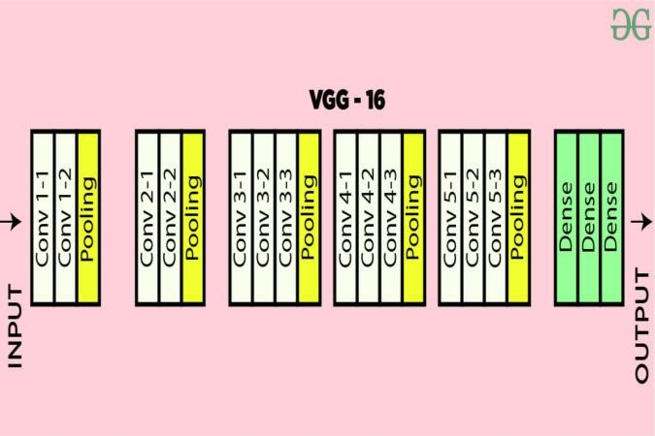

1. CLASSICATIONS FOR LUNG CANCER

Dim scale pictures are broke down for surface extraction utilizing the Gray Level Co-Occurrence Matrix (GLCM) technique used to get surface parameters of difference, connection, vitality, and homogeneity highlights and Gray Level Run Length Matrix (GLRLM) strategy used to acquire parameters of SRE, GLN, RLN and RP highlights. Pictures are grouped into two classes of malignancy and non-disease utilizing Convolutional Neural Network (CNN) calculation. This framework looks at the consequence of the precision of the Gray Level Co-event Matrix (GLCM) and Gray Level Run Length Matrix (GLRLM) technique.

One of the initial phases in lung malignant growth analysis is examining of lung tissues or biopsy. These tissue tests are then minutely investigated. This system is stepped through once imaging examinations show the nearness of malignant growth cells in the chest. A medicinal pro should do careful perception and precise investigation in identifying lung malignancy in patients. Thus, there is requirement for a framework that is skilled for identifying lung malignant growth consequently from minuscule pictures of biopsy.

1. *OBJECTIVE*

Lung malignant growth finding utilizing lung tissue test infinitesimal examination has some shortcoming. One of them is that specialist still depends on emotional visual perception. The strategy can improve the exactness and effectiveness for lung malignant growth identification. The point of this examination is to plan a lung malignancy recognition framework dependent on investigation of infinitesimal picture of biopsy utilizing advanced picture handling.

* + *Gray Level Co-Occurrence Matrix (GLCM)*
  + Minuscule pictures of biopsy are include separated with the Gray Level Co-Occurrence Matrix (GLCM) and Gray Level Run Length Matrix (GLRLM) technique and characterized utilizing Convolutional Neural Network (CNN).”.
  + This strategy is executed to recognition both ordinary and dangerous lung of biopsy tests. The location procedure utilized the Otsu thresholding division technique on the RGB shading channel, and the distinguishing proof calculation utilized with plasmodium double qualities as its info.

Imelemationd for CNN layer Convolutional Layers.

* + The examination builds up an arrangement of lung malignant growth discovery dependent on the investigation of minuscule biopsy pictures utilizing the system of advanced picture preparing. The system for picture handling incorporate changing over RGB pictures into dim scale, separating surface qualities, and grouping.”.

*B.TUMOR STAGE DETECTION*

Dataset from Iraq-Oncology Teaching Hospital/National Center for Cancer Diseases (IQ-OTH/NCCD) lung cancer dataset was collected in the above-mentioned specialist hospitals over a period of three months in fall 2019..

The dataset contains 3 classes they are:

* Begin case (120)
* malignant case (561)
* Normal case (416):

ℓ∑−∑−ℓ− 

Note Suppose that we have some N×N

square neuron layer which is followed by our convolutional layer. If we use an m×m filter ω, our convolutional layer output will be of size (N−m+1)×(N−m+1). In order to compute the pre-nonlinearity input to some unit xℓij in our layer, we need to sum up the contributions (weighted by the filter components) from the previous layer cells: “Equation (1) is . . .”

1. *Data Preprocessing*
   * Downloaded the MRI image of brain with various pixel rate and make it all standard for all with size of 224 x224 pixel and convert that to NumPy array to feed into KERAS model then flatten it and gave to model .
   * The Human lungs are the organs of respiration and each lung consists of pulmonary lobes which are separated by the fissures.
   * The fissure that separates its own pleural cover of each lung
   * CT or X-ray scan is more appropriate for showing the detailed information of the parts of human body and it is used for various applications such as detection, classification, etc
   * Implement the segmentation and classification algorithms to detect lung diseases with severity levels
   * Researchers are trying to improve clinical practice in mental health by using deep learning models. For example, there are ongoing academic studies about understanding the effects of mental illness and other disorders on the brain by using deep neural networks. Researchers say that trained deep learning models can provide better results in some areas compared to standard machine learning models
   * Be Usage of deep learning models has gained importance with the global CANCER DISEASES (IQ-

OTH/NCCD) LUNG CANCER DATASET WAS

COLLECTED outbreak.

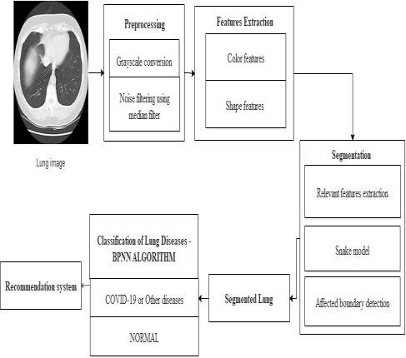

* + early detection of Cancer Diseases (IQ-OTH/NCCD) lung cancer dataset was collected
  + The analyzing of Chest X-ray (CXR) Chest CT images
  + There predicting intensive care unit admission

1. TUMER DETECTIONS

Minute lung biopsy pictures are in RGB design which is changed over into dim scale pictures. Dark scale pictures are examined for surface extraction utilizing the Gray Level Co- Occurrence Matrix (GLCM) technique used to get surface parameters of differentiation, relationship, vitality, and homogeneity highlights and Gray Level Run Length Matrix (GLRLM) strategy used to acquire parameters of SRE, GLN, RLN and RP highlights..

1. *GREY LEVEL SURFACE MATRIX*

**The Pictures are characterized into two classes of disease and non-malignant growth utilizing Convolutional Neural Network (CNN) calculation. This framework thinks about the aftereffect of the exactness of the Gray Level Co-event Matrix (GLCM) and Gray Level Run Length Matrix (GLRLM) technique.**).

* 1. *For papers In spite of the fact that the first CNN calculation yields great outcomes for fragmenting clamor free pictures, it neglects to section pictures tainted by commotion, anomalies and other imaging antique. Picture quality and exactness is the center elements of this task, picture quality evaluation just as progress are relying upon the upgrade arrange where low preprocessing methods is utilized dependent on CNN and highlight extraction..*
  2. *For papers The distinguishing proof procedure utilized here has four calculations of Sequential Minimal Optimization (SMO), J48 Decision Tree, Logit Boost, and Naive Bayes.*
     1. *Selection:* The most astounding exactness is recorded for the Logit Boost division process, with a precision of 98%.*.*
     2. *This system has been connected to different therapeutic applications, for example, the location of tuberculosis microbes in minuscule sputum pictures, intestinal sickness identification causing period of plasmodium falciparum, discovery of lung malignant growth protests in CT output, and investigation of tiny sputum tests*

*for lung diseaseDeletion: Delete the author and affiliation lines for the extra authors.*

1. *Identify the Headings*

Gather the dataset which is known as the activity of recovering a picture or organizer of pictures. The picture comes as the RGB picture. Preparing process is first assemble the gathering of pictures from the specific organizer.

1. *Figures*
2. *Positioning Figures and Tables:* Imaging plays a vital role in the diagnosis of lung cancer, with the most common modalities including chest radiography, CT, PET, magnetic resonance imaging (MRI), and radionuclide bone scanning, but in this work, we primarily used CT images for analysis. X-Ray imaging will show most lung tumors, but CT is used because it is more sensitive in finding tumor size and the presence of lymph node metastases. Efficient lung segmentation technique helps to raise the accuracy and higher decision confidence value of any lung abnormality identification system.*.*

TABLE I. TABLE TYPE STYLES

|  |  |  |  |
| --- | --- | --- | --- |
| **Table Head** | **Table Column Head** | | |
| ***Table column subhead*** | ***ANALYSI S*** | ***PREDCTI ONS*** |
| CANC  ER | IMAGE DATA SET  PRECTIONS | 95% | 98% |

a. Sample of a Table footnote. (*Table footnote*)

Fig. 1. Example of a figure caption. (*figure caption*)

Figure Labels: CT image can be input to the system. The user has to select the required lung frame image for further processing. Then each image is resized to 256*256. Then implement a median filter to remove noises from lung images. The median filter is a nonlinear digital filtering technique, often used to remove noise from an image or signal

ACKNOWLEDGMENT

Feature learning comprises a set of algorithms to transform labeled or unlabeled data to a new space, where it can capture the parameters and patterns of variation by disentangling the hidden features. Features are learned through supervised and unsupervised learning schemes.

REFERENCES

Lung malignant growth is a standout amongst the most widely recognized and savage infections on the planet. [1]. Identification of lung disease in its beginning time is the key of its fix [2 When all is said in done, measures for beginning time lung malignant growth analysis [3]

The lung pictures are transferred to conclusion the lung malignant growth. Attractive Resonance Images utilized in the biomedical to distinguish and envision better subtleties in the inward structure of the body.

Biomedical imaging and restorative picture handling that assumes an essential job for biopsy pictures has now turned into the most testing field in building and innovation. In this module, client can enter the MRI picture with different size

and different sorts. Pictures are transferred as prepared and testing sets[4]. , CT scan requires several steps with image processing, nodule masking, classification then need to confirm cancer this process will reduce the confidence of the finding cancer cells and finalizing cancer [5]. Challenges offer the opportunity to bring out the collective talents of scientific communities that would not normally subject their algorithms for performance comparison using a blinded-independent reference dataset.

For papers . The primary aim of this work is to develop an advanced computer-aided diagnosis (CAD) system using deep learning algorithms that will extract data from CT scan images [6].

1. B.V. Ginneken, B. M. Romeny and M. A. Viergever, “Computer-aided diagnosis in chest radiography: a survey”, IEEE, transactions on medical imaging, vol. 20, no. 12, (2022).
2. K. Kanazawa, Y. Kawata, N. Niki, H. Satoh, H. Ohmatsu, R. Kakinuma, M. Kaneko, N. Moriyama and K. Eguchi, “Computer-aided diagnosis for pulmonary nodules based on helicalCT images”, Compute. Med. Image Graph, vol. 22, no. 2(2022),pp. 157-167.
3. D. Lin and C. Yan, “Lung nodules identification rules extraction with neural fuzzy network”, IEEE, Neural Information Processing, vol. 4,(2022).
4. B. Zhao, G. Gamsu, M. S. Ginsberg, L. Jiang and L. H. Schwartz, “Automatic detection of small lung nodules on CT utilizing a local density maximum algorithm”, journal of applied clinical medical physics, vol. 4, (2021).
5. A. El-Baz, A. A. Farag, PH.D., R. Falk, M.D. and R. L. Rocco,M.D.,“detection, visualization, and identification of lung abnormalities in chest spiral CT scans: phase I”, Information Conference on Biomedical Engineering, Egypt (2022).
6. Linda G. Shapiro and G.C. Stockman., Computer Vision: Theory and Applications. 2001: Prentice Hall.