**WOMEN SAFETY & SECURITY SYSTEM**

**USING GPS AND GSM**

**N SaiLakshmi Kumari*1, Juttada Roopa*2, Betha Venkata Raja Narayana Reddy*3 ,Kummitha Mahindhra Reddy*4,Maradabudi Sandeep*5**

*\*1 Assistant Professor, Department of ECE, Dr. Lankapalli Bullayya College of Engineering, Visakhapatnam, Andhra Pradesh, India. nslkumari@lbce.edu.in*

*\*2,3,4,5Department of ECE, Dr. Lankapalli Bullayya College of Engineering, Visakhapatnam, Andhra Pradesh, India. roopajuttada04@gmail.com,rajabreddy7902@gmail.com,mahindrareddykummitha5@gmail.com,sandeepmaradabudi123@gmail.com*

**ABSTRACT**

*The Women’s Safety System Using GSM 800L and GPS NEO-6M with Arduino Uno is designed to enhance personal security through real-time tracking and emergency alerts. It integrates GSM and GPS modules with an Arduino Nano to send distress messages and share location details at the press of a button. The device is compact, cost-effective, and easy to use, ensuring ease of access for women in need. However, While effective in urban areas, the system’s performance may be affected by network limitations in remote locations. Future improvements may include smartphone integration and IoT-based tracking for enhanced safety*.

**KEYWORDS*:*** *Women’s Safety, GSM 800L, GPS NEO-6M, Arduino Uno, Emergency Alert System, Real-Time Tracking, Embedded Systems, Personal Security.*

**I.** **INTRODUCTION**

Women’s safety is a growing global concern due to rising incidents of harassment and violence, necessitating technology-driven safety solutions for security in public places, workplaces, and homes. This project, Women’s Safety System using GSM 800L and GPS NEO-6M with Arduino Uno, aims to provide a compact, user-friendly device that enables women to seek help during emergencies through GPS tracking, GSM communication, and an emergency alert system. The system utilizes an Arduino Uno microcontroller, a GPS module for real-time location tracking, and a GSM module for sending distress messages via SMS and calls. When the emergency button is pressed, the device retrieves the user’s coordinates and sends them to predefined contacts while activating a buzzer to alert nearby people. An LCD provides status updates to ensure the user is informed about the device’s operation. Powered by a rechargeable Li-ion battery and a voltage regulator, the system is designed for continuous and reliable use. By leveraging advancements in embedded systems and IoT technology, this project offers an affordable, portable, and effective security solution to enhance women’s personal safety.

**II. METHODOLOGY**

The Women’s Safety System is designed using GSM 800L, GPS NEO-6M, and an Arduino Uno microcontroller to provide real-time location tracking and emergency alerts. The system integrates essential hardware components, including a GPS module for tracking the user’s location and a GSM module for sending distress messages via SMS and calls. The push buttons instantly trigger alerts, ensuring quick assistance during emergencies.

The software development involves programming the Arduino Nano using the Arduino IDE, utilizing the Tiny GPS++ library for processing GPS data, and Software Serial for module communication. When the emergency button is pressed, the system retrieves the user’s coordinates and sends an SMS with a Google Maps link to predefined contacts. Another button triggers a voice call to ensure an immediate response. The system undergoes rigorous testing in different environments to evaluate GPS accuracy, SMS delivery speed, and power efficiency. Its compact design and affordability make it a reliable personal security solution.

**ARDUINO UNO**

The Arduino Uno serves as the system's main controller. It processes push button inputs, communicates with the GSM and GPS modules, and executes programmed instructions. Input-output should indeed be hyphenated. The Arduino is programmed using the Arduino IDE, which enables efficient control of the system’s functions.

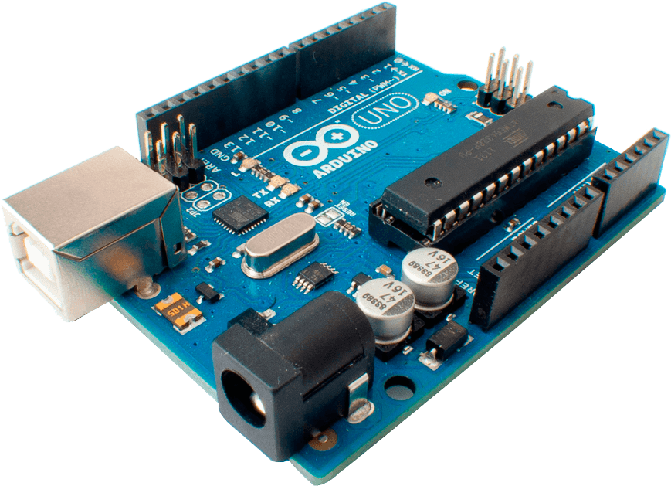

Figure 1: Arduino Uno

**GSM 800L MODULE**

The GSM 800L module enables the system to send SMS alerts and calls to predefined emergency contacts. It supports quad-band communication, ensuring compatibility with most global GSM networks. When a distress button is pressed, the Arduino sends a command to the GSM module, triggering an SMS alert with location coordinates or initiating a call to emergencycontacts. However, the module requires a strong network signal and a SIM card to function effectively.

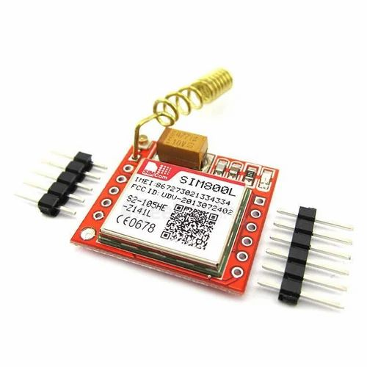

Figure 2: GSM 800L

**GPS NEO-6m**

The system utilizes the GPS NEO-6M module, which provides accurate latitude and longitude coordinates. This module continuously monitors the user’s location and relays the data to the Arduino, sending the information via SMS through the GSM module. The GPS module provides location accuracy within 2.5 meters. A backup battery allows the module to retain its last known location, enabling faster satellite acquisition upon restart.

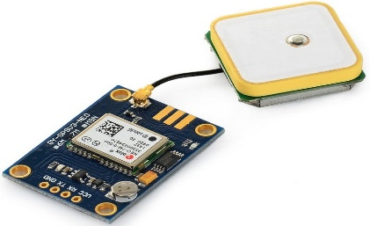

Figure 3: GPS Neo-6m

**PUSH BUTTON**

The push buttons act as the primary user interface, allowing the individual to send an emergency alert with a single press. One button is programmed to send an SMS with location details and make a call automatically. These buttons ensure a quick and hassle-free activation of the safety mechanism.

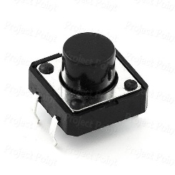

Figure 4: Push Button

**16*2 LCD DISPLAY**

The 16x2 LCD module can display up to 16 characters per row on its two-line screen. This type of display is frequently integrated with an Arduino Uno to provide real-time system updates, alerts, or even GPS data. When the device is powered on, the LCD helps convey critical information to users.

. 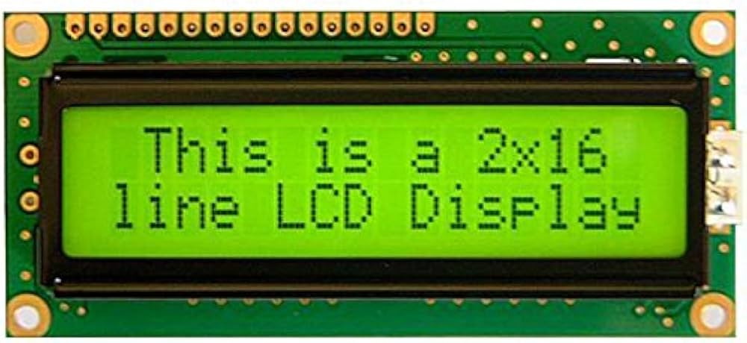

Figure 5: LCD Display

**BUZZER**

The buzzer is a crucial component of the Women’s Safety System. It provides an audible alert in the range of 85-100 dB, making it effective in noisy environments. Pressing the distress button activates the buzzer, immediately alerting people nearby. This immediate response enhances security by drawing attention to the distress situation.

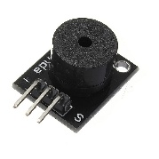

Figure 6: BUZZER

**III. WORKING**

The Women’s Safety System operates using GSM, GPS, Arduino Nano, push buttons, an LCD, and a buzzer to provide real-time tracking and emergency alerts. When powered on, the Arduino Nano initializes all components, including the GSM 800L module for communication and the GPS NEO-6M module for location tracking. The LCD shows system status updates, such as "System Ready" or "Searching for GPS." Once the GPS module establishes a satellite connection, The system is ready to trigger emergency alerts. The user can press one of the two push buttons, each performing a different function. Pressing the first button retrieves real-time GPS coordinates and sends an SMS alert with a Google Maps location link to predefined contacts via the GSM module. The second button automatically dials an emergency contact, allowing direct communication for immediate help.

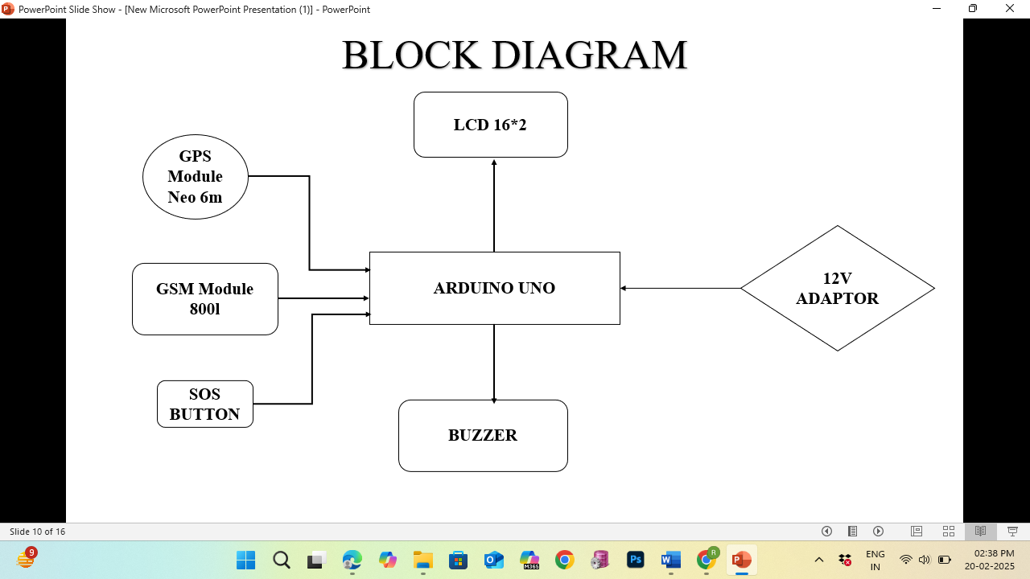

Figure 7: CIRCUIT DIAGRAM

Additionally, the system includes a buzzer, which produces a loud alarm when an emergency is triggered, alerting people nearby. This feature helps deter attackers by drawing immediate attention to the situation. The device is powered by a 12V supply, with a DC-DC buck converter ensuring a stable and efficient 5V output for all components. The system is tested in various environments to verify GSM connectivity reliability and GPS tracking accuracy.

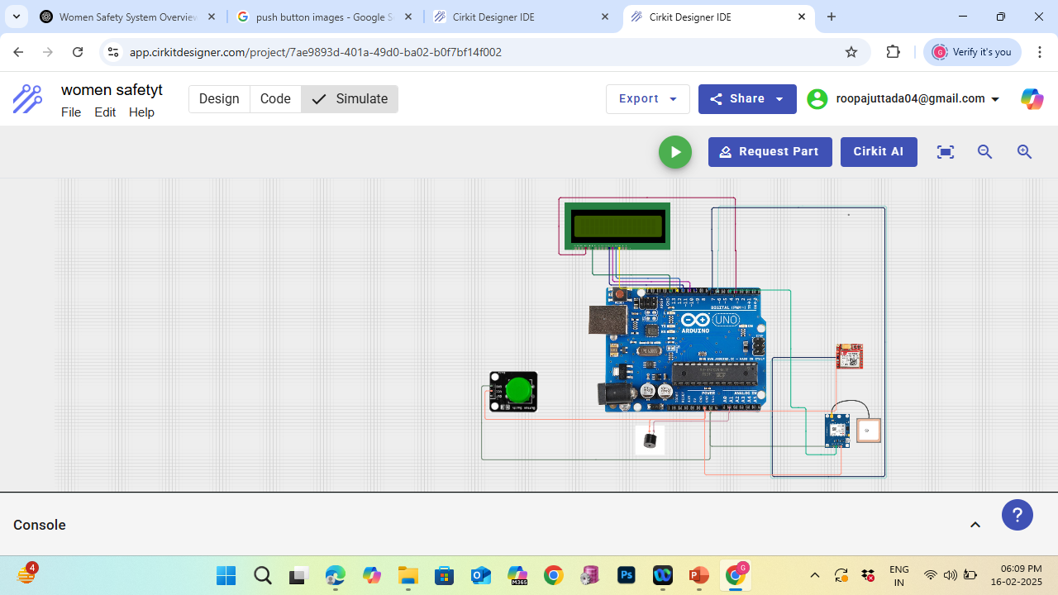

Figure 8: CIRCUIT DESIGN

**IV. RESULTS AND DISCUSSION**

The Women’s Safety System was successfully tested, demonstrating its ability to provide real-time tracking and emergency alerts using GSM and GPS technologies. When the emergency button was pressed, the system accurately retrieved the user’s GPS location and sent an SMS with a Google Maps link to predefined contacts, while also initiating an automatic voice call. The buzzer produced a loud alarm, effectively drawing attention in emergencies, and the LCD provided clear status updates. However, GPS signal delays in indoor environments and GSM network issues in low-coverage areas were noted as minor limitations. Future improvements, such as dual-network GSM support, IoT-based tracking, and enhanced GPS connectivity, could further optimize the system’s reliability. Overall, this project demonstrates a cost-effective and efficient solution for enhancing women’s safety, highlighting the potential of embedded technology in security applications, making it a practical and scalable solution.

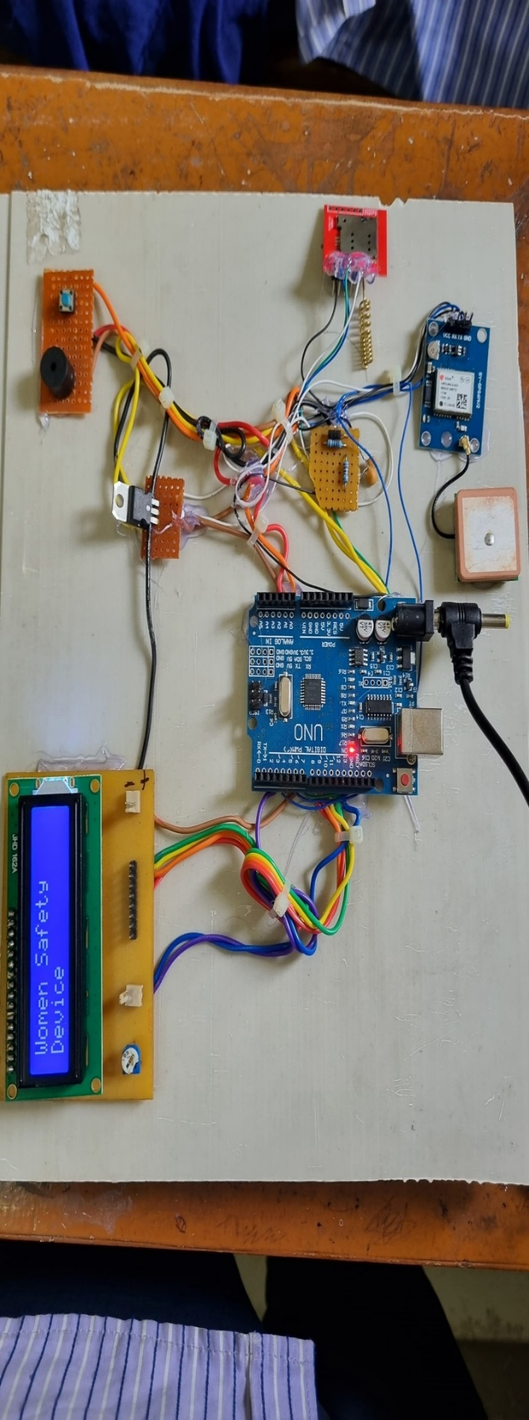

Figure 9: OUTPUT

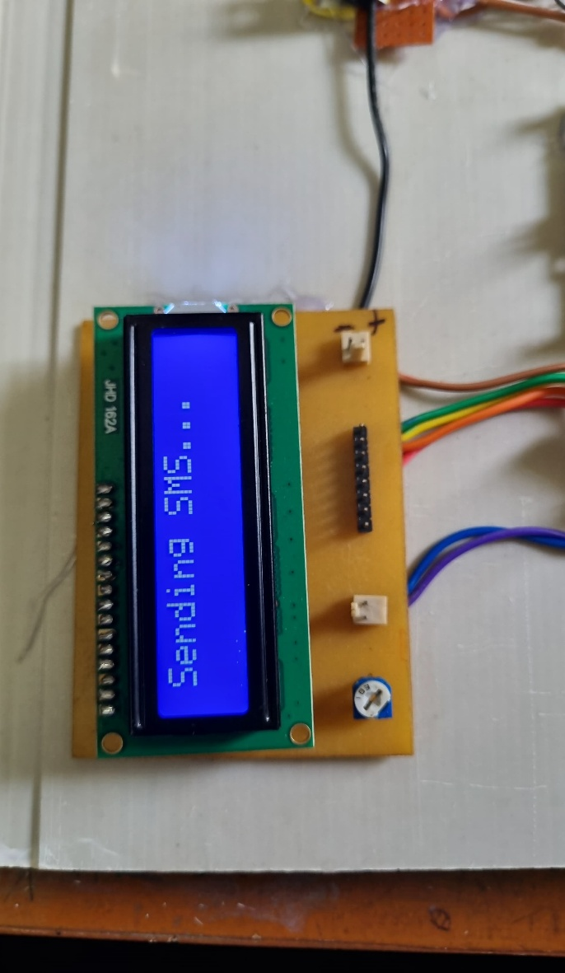

Figure 10: SENDING SMS

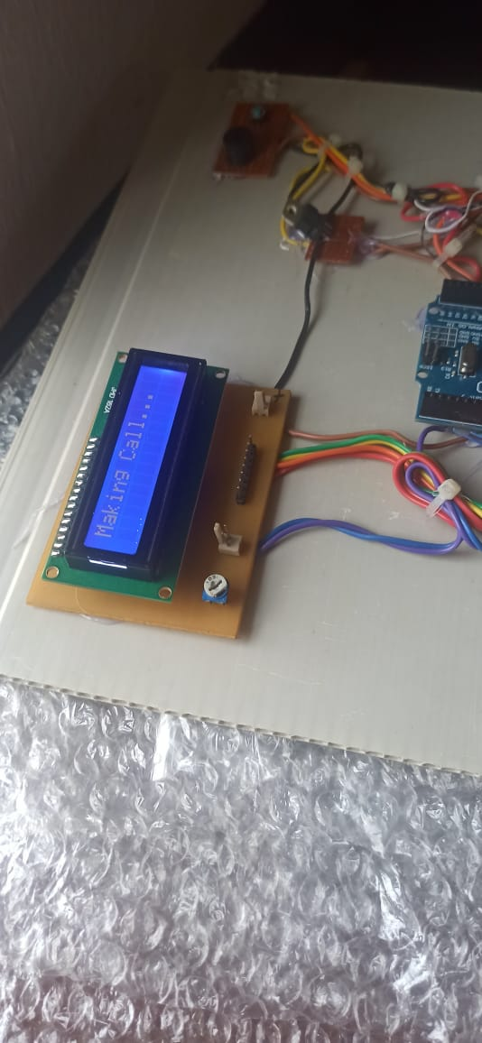

Figure 11: MAKING CALL

**V.** **CONCLUSION**

The Women’s Safety System integrates GSM, GPS, Arduino Nano, push buttons, an LCD, and a buzzer to provide a reliable and cost-effective personal security solution. The system effectively tracks the user’s real-time location and sends emergency alerts via SMS and voice calls, ensuring quick assistance during distress emergencies. The buzzer function enhances safety by drawing attention, while the LCD provides real-time status updates. However, minor limitations such as GPS signal delays in indoor environments and GSM network issues in low-coverage areas were observed. However, the system performed well in most real-world scenarios. Future improvements, including IoT-based tracking, smartphone app integration, and advanced power management, can further enhance its effectiveness. Overall, this project demonstrates a cost-effective and efficient solution for enhancing women’s safety, highlighting the potential of embedded technology in security applications. making it a practical and scalable solution for women's safety.

**VI. REFERENCES**

[1] Raj Kamal, Microcontrollers: Architecture, Programming, Interfacing and System Design, Pearson Education India, 2nd Edition, 2011.

[2] Fakhrul Islam, Md. Amanullah M. T. Oo, Salahuddin Azadl, "Women Safety Devices Using GSM and GPS Technologies," IEEE, 2013.

[3] The Microchip Website. [Online]. Available: [https://www.microchip.com](https://www.microchip.com/).

[4] Roshani Shingrut, Shubham Shelar, Dakshata Mokal, Shekar Mhatre, "IoT-Based Women Safety System Using GPS & GSM," International Journal of Engineering Research & Technology (IJERT), Vol. 9, Issue 2020.

[5] Tarlochan Sidhu, S., Xu, Zhihan, "Detection of Incipient Faults in Wireless Communication Systems," IEEE Transactions on Power Delivery, Vol. 25, No. 3, 2010.