**Osteoporosis: Properties, Types, Diagnostics, and Treatments Review**

**Abstract**

Osteoporosis is a prevalent bone disease characterized by low bone mass and deterioration of bone tissue, which increases fracture risk, especially in the elderly. The condition affects both genders but is more common in women post-menopause. This review provides an overview of osteoporosis, covering its properties, types, and underlying causes. We also discuss current diagnostic methods, treatment options, and emerging therapies. Additionally, we explore potential applications in healthcare, including screening, management, and education. Finally, we highlight the importance of further research in the field to develop better diagnostic tools and treatment strategies.

**Introduction**

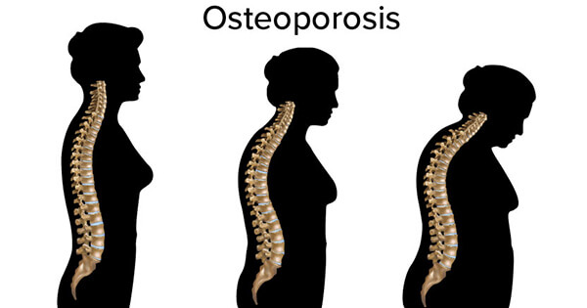

Osteoporosis is a systemic skeletal disorder marked by compromised bone strength, leading to an increased risk of fractures. It is a major health concern, particularly for older individuals, with significant morbidity and mortality associated with hip, spine, and wrist fractures. The disorder is often silent, with no symptoms until a fracture occurs.

**Properties of Osteoporosis:**

1. **Bone Mineral Density (BMD**): Osteoporosis is characterized by reduced bone mineral density, as measured by dual-energy X-ray absorptiometry (DXA) scans.

2. **Bone Microarchitecture**: The disease involves a deterioration of bone quality, including changes in bone microarchitecture, which affects bone strength.

3. **Bone Turnover**: Imbalances in bone remodeling (resorption and formation) contribute to bone loss and fragility.

4. **Fracture Risk**: Individuals with osteoporosis are at a higher risk of fractures, particularly in the hip, spine, and wrist.

**Types of Osteoporosis**

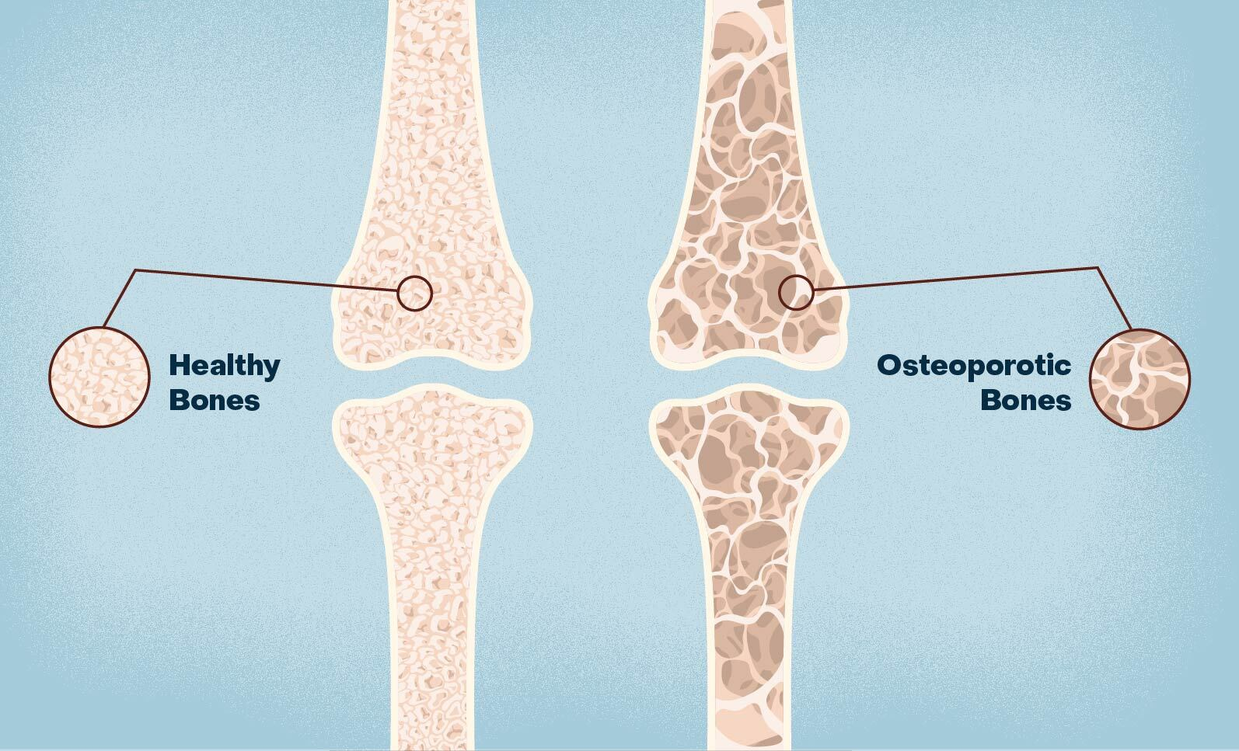

1. **Primary Osteoporosis**: This type occurs naturally with aging and can be further classified as:

- Type I (Postmenopausal Osteoporosis): Occurs in women around menopause, associated with a decrease in estrogen levels.

- Type II (Senile Osteoporosis): Develops in both men and women over age 70 and is associated with a general decline in bone formation.

2. **Secondary Osteoporosis**: This type arises from underlying medical conditions such as endocrine disorders (e.g., hyperthyroidism), gastrointestinal diseases (e.g., celiac disease), or medication use (e.g., glucocorticoids).

**Discussion**

Osteoporosis is a complex condition influenced by various genetic, hormonal, and lifestyle factors. The primary risk factors include advanced age, female gender, low body weight, family history, smoking, excessive alcohol consumption, and insufficient calcium and vitamin D intake. Other risk factors include sedentary lifestyle, certain medications, and specific medical conditions.

**Prevention and Management:**

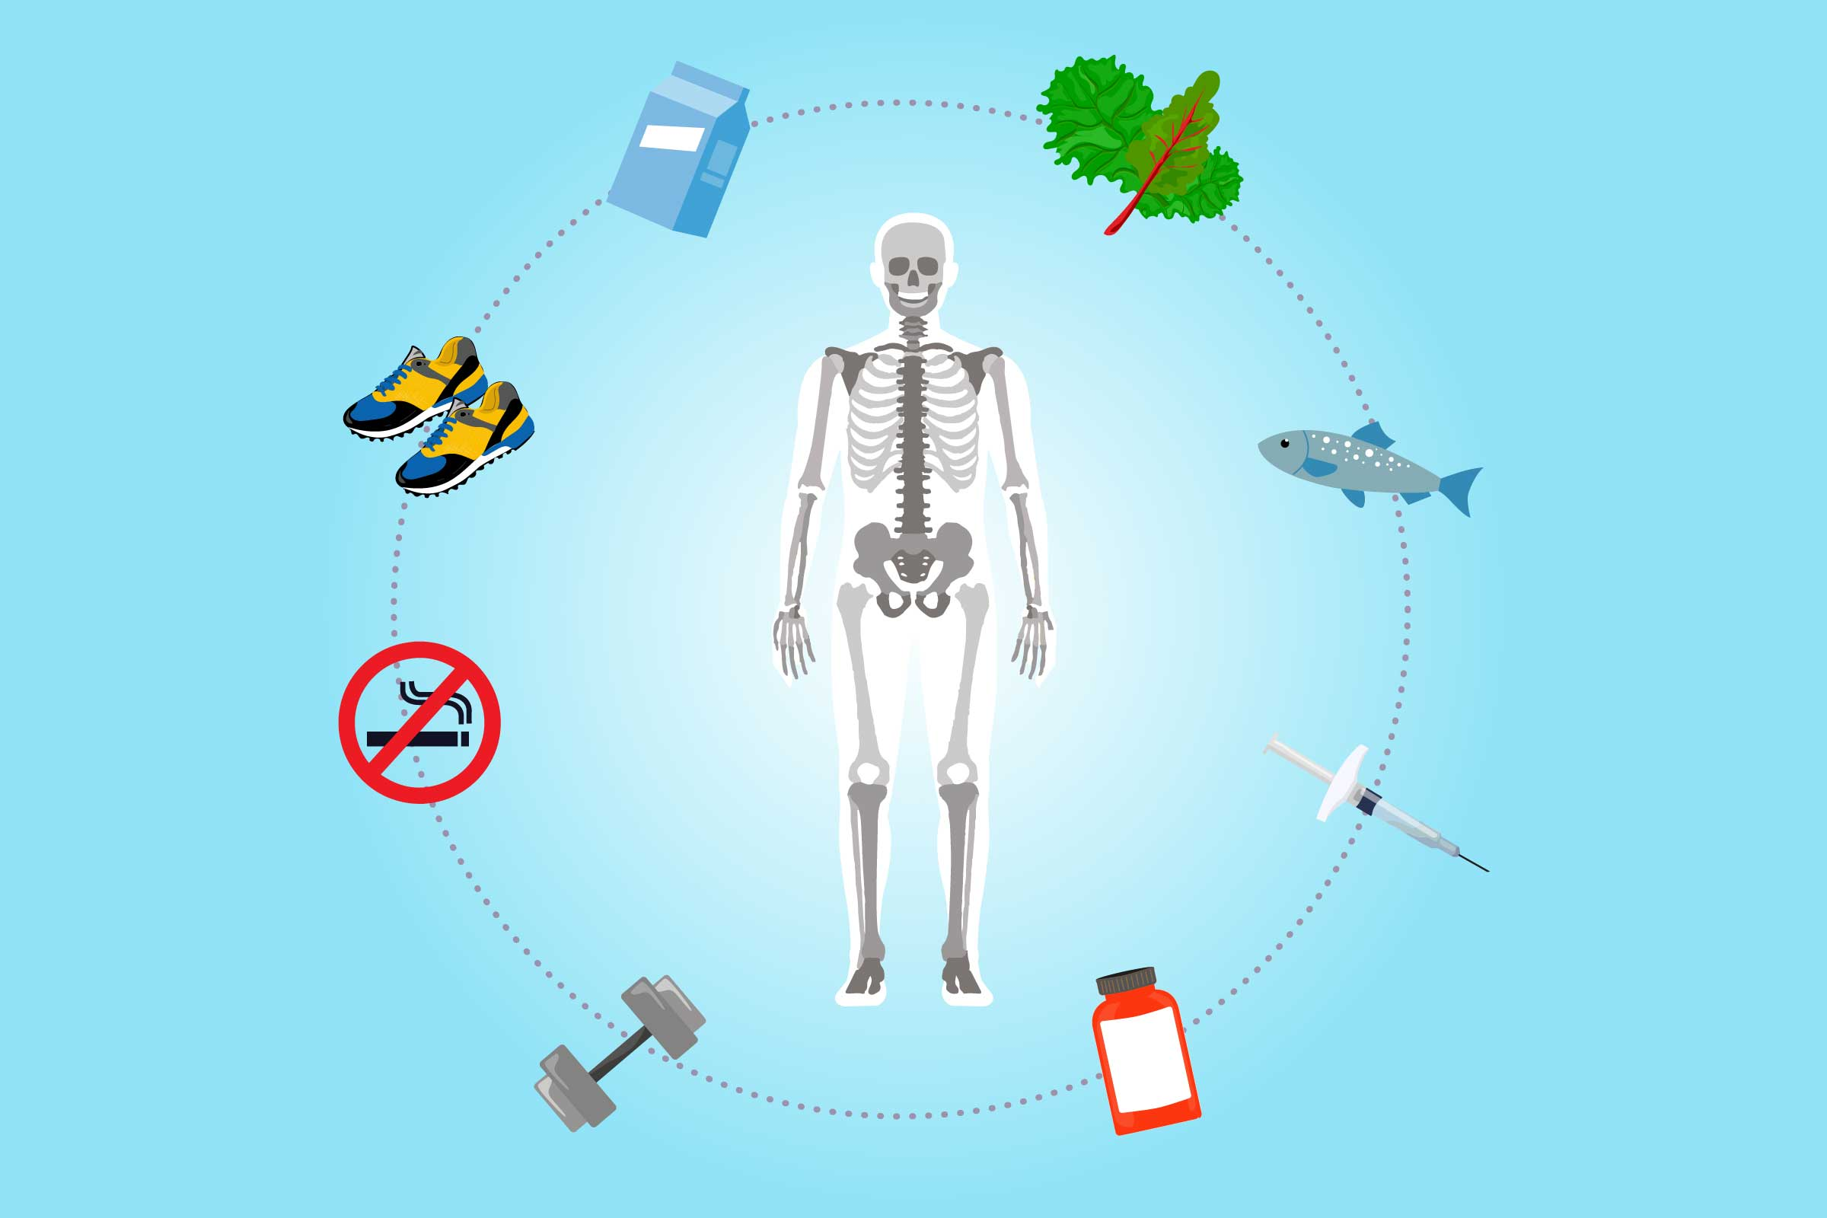

1. **Lifestyle Modifications**: Encouraging regular weight-bearing and resistance exercises, optimizing calcium and vitamin D intake, and promoting smoking cessation and moderate alcohol consumption can aid in preventing osteoporosis.

2. **Pharmaceutical Interventions**: Medications for osteoporosis include bisphosphonates, denosumab, teriparatide, and selective estrogen receptor modulators (SERMs), which help increase bone density and reduce fracture risk.

3. **Diagnostic Methods**: Dual-energy X-ray absorptiometry (DXA) is the gold standard for assessing bone mineral density and diagnosing osteoporosis. Other imaging techniques, such as quantitative computed tomography (QCT) and peripheral DXA (pDXA), may also be used.

4. **Emerging Therapies**: Research is ongoing into new treatments, such as sclerostin inhibitors and other targeted therapies, which offer the potential for more effective management of osteoporosis.

**Applications**

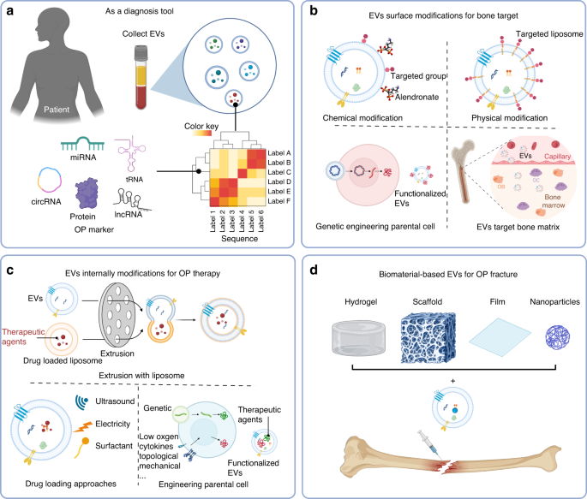

1. **Screening and Early Detection**: Routine screening, particularly for individuals at higher risk, allows for early diagnosis and intervention to prevent fractures and improve outcomes.

2. **Treatment and Management**: Customized treatment plans combining lifestyle changes and medications are essential for managing osteoporosis and minimizing fracture risk.

3. **Patient Education and Awareness**: Educating patients and the general public about osteoporosis risk factors, prevention strategies, and available treatments is critical for reducing its impact.

4. **Research and Innovation**: Continued research into the molecular mechanisms of osteoporosis can lead to novel treatments and improved diagnostic techniques.

**Conclusion**

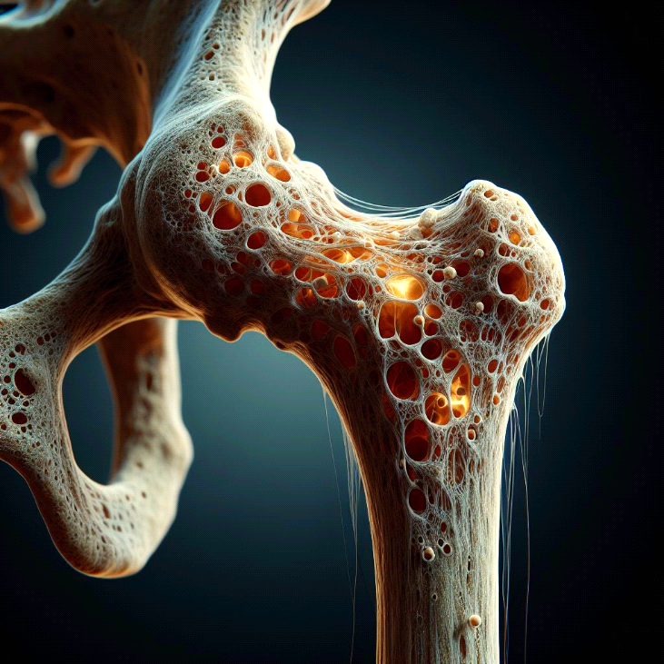

Osteoporosis is a significant public health issue that affects millions worldwide, particularly older adults and postmenopausal women. The condition can lead to severe morbidity and mortality due to fractures. Effective prevention and management strategies, including lifestyle modifications, pharmacological treatments, and emerging therapies, are essential for reducing the disease's impact. Increasing awareness and education about osteoporosis are key components of addressing this global health problem.

**References**

1. Kanis, J. A., et al. (2019). "Executive summary of the European guidance on the diagnosis and management of osteoporosis in postmenopausal women." Osteoporosis International, 30(1), 3-44.

2. Cummings, S. R., & Melton, L. J. (2002). "Epidemiology and outcomes of osteoporotic fractures." The Lancet, 359(9319), 1761-1767.

3. Cosman, F., et al. (2014). "Clinician's Guide to Prevention and Treatment of Osteoporosis." Osteoporosis International, 25(10), 2359-2381.

4. Rizzoli, R., et al. (2014). "Challenges in the management of osteoporosis and fractures." Osteoporosis International, 25(12), 2607-2616.

5. Black, D. M., & Rosen, C. J. (2016). "Postmenopausal Osteoporosis." The New England Journal of Medicine, 374(3), 254-262.

6. Colón-Emeric, C., & Saag, K. G. (2006). "Osteoporotic fractures in older adults." Best Practice & Research Clinical Rheumatology, 20(4), 695-706.

7. Johnell, O., & Kanis, J. A. (2005). "Epidemiology of osteoporotic fractures." Osteoporosis International, 16(2), S3-S7.

8. Reid, I. R., et al. (2014). "Pharmacological management of osteoporosis in postmenopausal women: The Endocrine Society’s clinical practice guideline." The Journal of Clinical Endocrinology & Metabolism, 99(3), 989-1009.

9. Cosman, F., et al. (2011). "Osteoporosis." American Journal of Medicine, 124(3), 182-193.

10. Sambrook, P., & Cooper, C. (2006). "Osteoporosis." The Lancet, 367(9527), 2010-2018.

11. Eastell, R., et al. (2016). "Diagnosis of osteoporosis: current approaches and future strategies." Osteoporosis International, 27(4), 1285-1297.

12. Watts, N. B., et al. (2010). "International Society for Clinical Densitometry official positions." Journal of Clinical Densitometry, 13(3), 239-246.

13. Camacho, P. M., et al. (2012). "American Association of Clinical Endocrinologists Medical Guidelines for Clinical Practice for the Diagnosis and Treatment of Postmenopausal Osteoporosis." Endocrine Practice, 18(Suppl 3), 1-42.

14. Fink, H. A., et al. (2012). "Osteoporosis: update on screening and management." Medical Clinics of North America, 96(6), 1137-1152.

15. Palacios, S., & Osorio, A. (2015). "Risk factors for osteoporosis." Osteoporosis and Sarcopenia, 1(3), 144-149.

16. Harvey, N. C., & Cooper, C. (2014). "Osteoporosis: a lifecourse approach." Journal of Bone and Mineral Research, 29(9), 1917-1925.

17. Ferrari, S., et al. (2012). "Osteoporosis in young adults: pathophysiology, diagnosis, and management." Osteoporosis International, 23(12), 2735-2748.

18. Cauley, J. A., et al. (2012). "Risk factors for osteoporosis-related fractures in men." Osteoporosis International, 23(3), 747-756.

19. Raisz, L. G. (2005). "Pathogenesis of osteoporosis: concepts, conflicts, and prospects." Journal of Clinical Investigation, 115(12), 3318-3325.

20. Seeman, E., & Delmas, P. D. (2006). "Bone quality—the material and structural basis of bone strength and fragility." New England Journal of Medicine, 354(21), 2250-2261.

21. Baron, R., & Kneissel, M. (2013). "WNT signaling in bone homeostasis and disease: from human mutations to treatments." Nature Medicine, 19(2), 179-192.

22. Silverman, S. L. (2009). "Selecting patients for osteoporosis treatment: whom should we treat?" Nature Reviews Rheumatology, 5(9), 441-446.

23. Ebeling, P. R. (2014). "Secondary causes of osteoporosis." Endocrinology and Metabolism Clinics, 43(2), 351-372.

24. Cooper, C., et al. (1992). "Determinants of bone density in normal women: risk factors for future osteoporosis." BMJ, 304(6823), 1308-1311.

25. Pittenger, M. F., & McKay, R. D. (2001). "Multipotent adult mesenchymal stem cells and their potential as cellular therapy." Trends in Molecular Medicine, 7(5), 259-264.

26. Johnell, O., & Kanis, J. A. (2006). "An estimate of the worldwide prevalence and disability

associated with osteoporotic fractures." Osteoporosis International, 17(12), 1726-1733.

27. Singer, F. R. (2011). "Vitamin D deficiency: a worldwide problem with health consequences." American Journal of Medicine, 124(4), 261-262.

28. Dennison, E. M., & Cooper, C. (2000). "Osteoporosis in older people: epidemiology, causes and interventions." The Lancet, 355(9221), 797-802.

29. Compston, J. E. (2011). "Epidemiology and special presentations of osteoporosis." Journal of Endocrinological Investigation, 34(7), 598-602.

30. Looker, A. C., & Melton, L. J. (2010). "Diagnosis and classification of osteoporosis." Endocrinology and Metabolism Clinics, 39(2), 379-388.