IOT BASED ACCIDENT AND ANALYSIS SYSTEM USING EDGE

COMPUTING

**MS. P. DEVI 1, R. DHINESH² , A. GNANAPRAKASH³ , V.S. VIDHYA SAGAR4**

*1Assistant Professor,2,3,4UG students, Department of ECE Sri Ramakrishna Institute of Technology, Coimbatore, India*

E-mail id: 1 [devi.ece@srit.org,](mailto:devi.ece@srit.org)2[dhinesh.2004@srit.org ,](mailto:dhinesh.2004@srit.org)3[gnanaprakash.2004@srit.org,](mailto:gnanaprakash.2004@srit.org)

4[vidhya.2004@srit.org](mailto:vidhya.2004@srit.org)

# Abstract- The increasing number of road accidents and their associated consequences necessitate the development of advanced systems for timely detection and analysis. This paper proposes an Internet of Things (IOT)-based Accident Detection and Analysis System that leverages Edge Computing for real-time processing and decision-making. The system integrates smart sensors, edge devices, and cloud infrastructure to create a comprehensive framework for efficient accident detection and analysis. The proposed IOT-based Accident Detection and Analysis System enhances road safety by enabling quick response to accidents and providing valuable insights for preventive measures. The integration of edge computing optimizes resource utilization, minimizes latency, and enhances the overall efficiency of the system. This research contributes to the evolving field of smart transportation systems, addressing the critical need for advanced technologies accident detection and analysis.

## І. INTRODUCTION

The Internet of Things (IOT) has completely changed how we gather and use data across a range of industries, providing previously unheard-of chances to enhance productivity, safety, and decision-making. IOT- based solutions are a potent instrument for accident analysis and prevention in the field of transportation and road safety. These systems use real-time data from sensors and devices positioned in cars, on the road, and in the environment to identify possible threats and respond quickly to reduce them. The combination of edge computing and IOT is one of the most recent developments in this sector.

The term "edge computing" describes the practise of processing and analysing data closer to the source, which in this case entails analysing data locally on gateways or on edge devices itself as opposed to transferring all of the data to a central cloud server. This technique improves the overall efficiency of the system and decreases latency, which makes it especially useful for real-time accident investigation and prevention. Edge computing-based IOT-based accident analysis systems are a potential new technology that can aid in increasing safety in a range of applications. These systems can assist in lowering the frequency and severity of accidents by gathering data about them using sensors and

Internet of Things (IOT) devices, and then employing edge computing to analyse this data in real time.

An Internet of Things (IOT) accident analysis system that leverages edge computing collects accident data in real time from sensors and other IOT devices, then applies edge computing to search for patterns and trends in the data. Hazards can be identified and mitigated, and by doing so, future accidents can be avoided and reaction times in the event that an accident does occur can be improved.

"Edge computing" is a distributed computing paradigm that brings data processing and storage closer to data sources, such as Internet of Things devices. This offers accident analysis systems various advantages, including.

Decreased latency: Edge computing can reduce accident analysis latency by processing data locally as opposed to sending it to a central cloud server.

## PROBLEM STATEMENT

Each year, road accidents result in millions of deaths and injuries, making them a serious public health concern. Nowadays, there are a lot of road accidents.

Delays can occur because current accident detection systems frequently rely on human intervention to report events. Furthermore, conventional accident analysis techniques may not be able to offer timely insights into the causes and effects of accidents, and they may be costly and time-consuming.

In order to overcome these obstacles, an Internet of Things (IoT)-based accident analysis system can offer precise and timely accident data.

A system like this might make use of a range of Internet of Things sensors, including GPS, accelerometers, and gyroscopes, to identify collisions and gather information on their location and intensity. After that, this data might be sent for analysis to a central cloud-based platform.

## PROPOSED SYSTEM

The first step is to gather data about the surroundings. Numerous sensors, including MQ3 sensors, eye blink sensors, speed sensors, and fuel detection sensors, can be used for this. The information gathered, including the cars' speeds and the time of day, should be pertinent to the accident analysis.

Processing the data at the network's edge is the next stage. This implies that instead of being transferred to a central cloud server, the data is processed near to the point of collection. This enables the system to react to an incident fast, which is vital for real-time accident analysis.

Accident detection is then achieved by using the data that has been gathered and processed at the network's edge. Numerous algorithms, including machine learning algorithms, can be used to do this. The algorithms ought to be able to recognise the patterns—like an abrupt change in speed or direction—that point to an accident.

The system can analyse the data to identify the cause of an accident once it has been noticed. By identifying the causes of accidents, this knowledge can be used to increase road safety.

## IV BLOCK DIAGRAM

The block diagram below can be used to demonstrate proposed system.

The suggested system's block diagram is displayed in figure 3.7.1. This system makes use of alcohol sensors and eye blink sensors. These sensors detect the driver's level of drowsiness when operating a car.

An alcohol sensor will detect whether or not the driver has consumed alcohol while operating a motor vehicle. The node MCU is connected to these sensors. A part of the node MCU module called ESP8266, which has a few unique features, is utilised to send information to the officers online or over the cloud.

To convey the information about the fire, it is somewhat necessary to have an internet connection. There are three ways to utilise this ESP8266: as a client, similar to Wi-Fi; as a server, similar to hotspots; or, in a third mode, simultaneously serving as both a client and a server.

In this way, a chain reaction involving numerous systems can be established. The node MCU has been damped with the programme. The MCU is linked to the cloud via this node. XAMPP (X-Operating system, Apache, Mysql, PHP, Perl) software will be used to develop the webpage. Using MySQL, a database will be created.

Python, Java, and C++ will be used for the backend. CSS will also be used for front- end development using HTML. Edge computing is used to connect the hardware to the webpage. Web pages store the data from the alcohol and eye blink sensors. Police officers and RTOs, among others, may keep an eye on this portal.

## V RESULT

The system has been assembled, and the sensor readings have been verified. The terminal is used to run the main programme, which is written in embedded C. As soon as the code is executed, the programme reads sensor signals, executes each line, and produces outputs based on the criteria specified in the code.

The eye blink sensor will detect drowsiness in the driver during the collision, and data will be retained. Additionally, the alcohol sensor will identify and retain data if the driver drank alcohol prior to the collision.

Consequently, every piece of data collected and archived by every sensor is sent to the webpage. The online page will indicate if the motorist felt sleepy or had drank alcohol.

The Speed push button will indicate the speed of the vehicle at the time of accident.Police officers and members of the road safety team can keep an eye on it.

# Fig 1 : Block Diagram

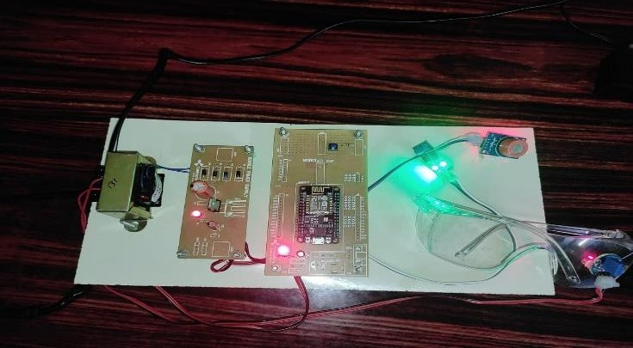

**Fig 2 : Final setup of the IOT based accident analysis system using edge computing.**

The whole design and set up of the project, including hardware components are shown in the figure 3.

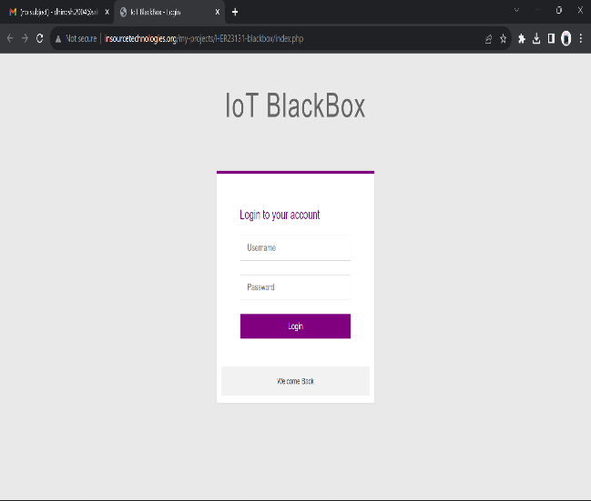

# Fig 3 : Login page

Figure 3 shows the login Page of the website in which the data’s of the driver will be monitored.

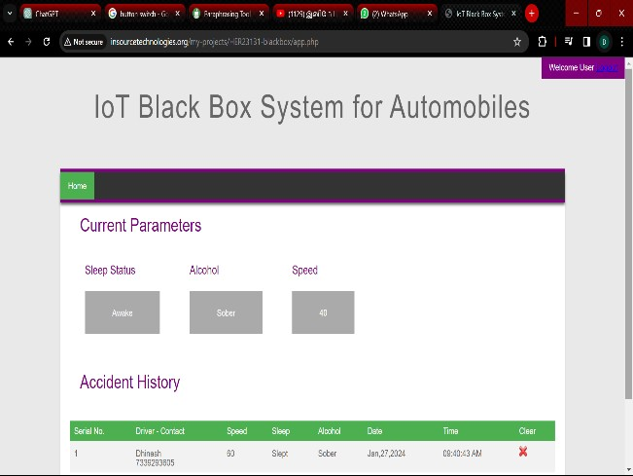

# Fig 4 : Monitoring Page

Figure 4 shows the monitoring page of the work where the real time data and the history of the accident will be shown.

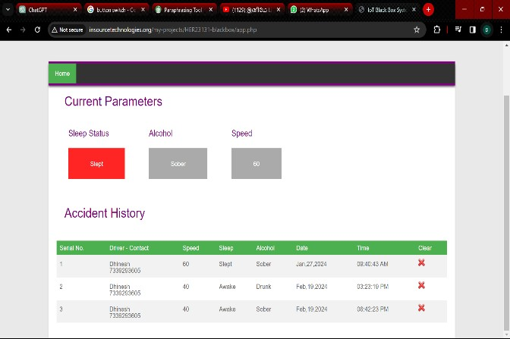

# Fig 5 : Sleeping status

Figure 5 shows whether the driver slept during the accident or not. If driver slept it will indicated in the webpage.

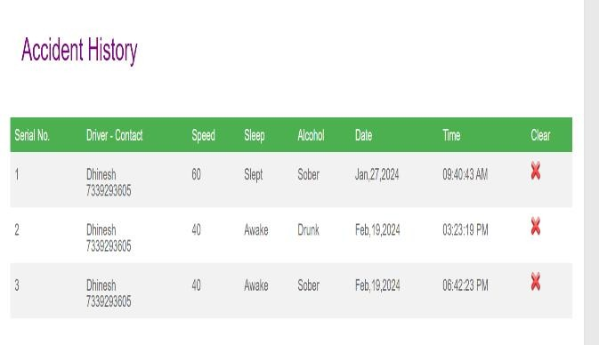

# Fig 6 : Accident History

Figure 6 shows the history of the accident along with accurate time . Detailed report will be displayed in the webpage .

## CONCLUSION

We conclude that an edge computing-based Internet of Things accident analysis system has the potential to completely change how we respond to accidents. This system can give first responders vital information about the accident site, including the number of victims, the extent of their injuries, and the kind of aid they require, by utilising edge computing to process data from IoT sensors in real time. First responders can use this information to focus their efforts and potentially save lives.

Data on accident causes can also be gathered via the Internet of Things-based accident analysis system. Afterwards, new safety protocols can be created using this data to stop incidents before they start.

All things considered, edge computing-based IoT- based accident analysis systems have the power to completely change how we react to and avoid accidents. We can increase the effectiveness of these systems and their positive social impact by tackling the aforementioned issues and investigating novel uses.

## REFENCES

1. N. Selvam, M. Sampath, J. S. Madhavan, T. Sharmitha and D. S. Mugesh, "IoT based Smart Communication System for Accident Prevention," 2023 5th International Conference on Smart Systems and Inventive Technology (ICSSIT), Tirunelveli, India, 2023.
2. G. Pradeepkumar, P. Vijayakumar, N. Chandrasekaran, C. Rohith Bhat, C. Senthilkumar and N. S. Kumar, "Safe Transportation System using IoT based Alcohol Detection," 2023 7th International Conference on Intelligent Computing and Control Systems (ICICCS), Madurai, India, 2023.
3. I. A. Jahan, I. Arafat Jamil, M. S. Hossain Fahim, A. Sabiha Huq, F. Faisal and M. Nishat, "Accident Detection and Road Condition Monitoring Using Blackbox Module," 2022 Thirteenth International Conference on Ubiquitous and Future Networks (ICUFN), Barcelona, Spain, 2022.
4. A. A. Alsahlawi and M. A. Mangoud, "IoT based vehicle blackbox for enhanced safety standards," 6th Smart Cities Symposium (SCS 2022), Hybrid Conference, Bahrain, 2022.
5. G. S. Rathod, R. C. Tipale and K. Jajulwar, "Intelligent Accident Detection and Alerting System based on Machine Learning over the IoT Network," 2022 International Conference on Futuristic Technologies (INCOFT), Belgaum, India, 2022.
6. C. Nandagopal, P. Anisha, K. G. Dharani and N. Kuraloviya, "Smart Accident Detection and Rescue System using VANET," 2022 International Conference on Sustainable Computing and Data Communication Systems (ICSCDS), Erode, India, 2022.
7. M. M. Rahman, A. Z. M. T. Kabir, S. Z. Khan, N. Akhtar, A. Al Mamun and S.M. Hossain, "Smart Vehicle Management System for Accident Reduction by Using Sensors and An IoT Based Black Box," 2021 8th International Conference on Electrical Engineering, Computer Science and Informatics (EECSI), Semarang, Indonesia, 2021.
8. N. Kumar, D. Acharya and D. Lohani, "An IoT-Based Vehicle Accident Detection and Classification System Using Sensor Fusion," in IEEE Internet of Things Journal, vol. 8, no. 2, pp. 869-880, 15 Jan.15, 2021.
9. P. Karmokar et al., "A Novel IoT based Accident Detection and Rescue System," 2020 Third International Conference on Smart Systems and Inventive Technology (ICSSIT), Tirunelveli, India, 2020.
10. M. Kaur, J. Malhotra and P. D. Kaur, "A VANET-IoT based Accident Detection and Management System for the Emergency Rescue Services in a Smart City," 2020 8th International Conference on Reliability, Infocom Technologies and Optimization (Trends and Future Directions) (ICRITO), Noida, India, 2020.

.