Website for Online Election System

**Sanjay Palani S, Sowndharya A, Sreeja G, Ms.M.Sathya**

Department of Information Technology, Bachelor of Technology, Sri Shakthi Institute of Engineering and Technology (Autonomous) Coimbatore-641062

# ABSTRACT

The goal of this article is to present the design and execution of an online voting system that will improve the election process's accessibility, security, and efficiency. The integrity and confidentiality of votes cast are guaranteed by the proposed system, which makes use of secure web technologies and contemporary cryptography techniques. Real-time result tabulation, end-to-end encryption, and user authentication are important features. Regardless of their level of technical expertise, voters may easily traverse the platform thanks to the user-friendly design of the system. Strong safeguards are also put in place to guard against fraud and guarantee voters' confidentiality, answering worries about the possibility of cyberattacks and illegal access. The online voting system has undergone extensive testing and review, and the results show that it significantly outperforms traditional voting systems in terms of voter participation rates, convenience, and accuracy.

**INTRODUCTION**

An online election system makes use of contemporary technology to provide a more efficient, easily accessible, and safe way to hold elections. An effective voting system can raise voter turnout and convenience by allowing voters to cast their ballots from any location with internet access. It can also lower the price of recruiting workers, printing ballots, and establishing and maintaining polling places.Every election system's design must prioritize security. Robust procedures must be put in place by online election systems to safeguard against cyberattacks, guarantee voter anonymity, and uphold the integrity of the electoral process. To overcome these issues, technologies like multi-factor authentication, blockchain, and end-to-end encryption are frequently used.

**OBJECTIVE**

This essay's goal is to investigate the creation, application, and effects of an online voting system and this study specifically attempts to:

1.Examine the technical structures and safety precautions that can be used to guarantee the privacy and accuracy of the online voting procedure.  
2.Consider the possible financial savings, higher voter turnout, and enhanced effectiveness of online voting systems.  
3.Examine the risks and difficulties that come with voting online, such as concerns about cybersecurity, accessibility, and digital literacy.  
4.Provide a thorough analysis of case studies and current online election system deployments in order to pinpoint best practices and lessons discovered.

# LITERATURE SURVEY

Many studies have been conducted on the implementation of online election systems, revealing both the possible advantages and the inherent difficulties. The shortcomings of traditional voting systems are highlighted by earlier work, especially with regard to accessibility, expense, and logistical complexity.The foundation for investigating digital alternatives which offer more efficiency and voter engagement was laid by these investigations.

The topic of security is prevalent in the literature, with many scholars concentrating on the technical defenses required to keep online voting systems safe from cyberattacks. suggest cryptographic procedures to protect the privacy of voters and the fairness of the voting process. Furthermore, there has been a lot of discussion about how to improve online voting security and transparency using blockchain technology.

A realistic perspective on the adoption of online election systems is offered via case studies from different nations. Numerous studies have focused on Estonia, a leader in this sector; Vassil and Weber describe the development of the country's online voting system and the security precautions taken. The Estonian model shows how a little country like Estonia can successfully implement digital voting while preserving system integrity and public confidence.

# METHODOLOGY

A multifaceted strategy integrating theoretical research, technological development, and practical application is the process for designing an online election system. First, a thorough examination of the current online and traditional voting systems is done in order to determine their advantages, disadvantages, and potential areas for development. Determining the system requirements security, usability, accessibility, and scalability, among others comes next. In order to guarantee that the system satisfies the requirements of all stakeholders voters, election officials, and security specialists the design process makes use of user-centered design concepts. To improve security and guarantee voter anonymity, important technological elements including blockchain technology, multi-factor authentication, and cryptographic protocols are combined. System prototypes are created and put through extensive testing, which includes security testing to find and fix vulnerabilities and usability testing with a variety of user groups. Pilot projects are carried out in controlled settings in order to get input and make required modifications. To assess the efficacy and dependability of the system, data from these pilots are reviewed in conjunction with simulations of different election scenarios. Ultimately, a thorough framework is developed for the online election system's implementation and upkeep, which includes specific procedures for voter education, system monitoring, and potential threat response. An online election system that is reliable, safe, and easy to use will be developed using this evidence-based, iterative process, which may successfully assist the democratic process.

**EXISTING METHOD**

The primary goals of current approaches to online election systems are security, accessibility, and transparency. Estonia's i-Voting system is among the most well-established ones. It ensures a high degree of security and trust by utilizing both national ID cards and mobile IDs for voter authentication. To ensure the integrity and privacy of votes, the system uses digital signatures and end-to-end encryption. Blockchain technology is another well-liked strategy, as seen by a number of test programs in the US and Switzerland. Due to its decentralized structure, blockchain offers an unchangeable record of votes, improving transparency and lowering the possibility of manipulation.A variety of cryptographic protocols are also used to protect voter anonymity and enable vote counts to be verified, including homomorphic encryption and zero-knowledge proofs. Furthermore, a lot of people employ multi-factor authentication techniques to protect voter access. Comprehensive voter education programs and user-friendly interfaces are two ways that usability is addressed. It is standard procedure to evaluate the systems in controlled contexts prior to full-scale deployment through pilot studies and phased implementations. Together, these techniques seek to establish an online voting environment that is safe, open, and inclusive in order to increase public confidence in the political process.

**DISADVANTAGES**

Cybersecurity Risks: A variety of cyberthreats, such as malware, DDoS attacks, and hacking, can compromise online election systems. The election process's integrity may be jeopardized, and public confidence in the system may be damaged by these dangers.

Digital Divide: Some voters do not have equal access to technology or the level of digital proficiency needed to cast an online ballot. Certain groups may become disenfranchised as a result of this, mainly the elderly, people with low incomes, and people living in remote areas.

Challenges with Authentication: In an online setting, it can be more difficult to verify that every voter is who they say they are. Voter authentication techniques that are both safe and effective, such biometrics or multi-factor authentication, can be challenging to deploy globally and are still vulnerable to manipulation or fraud.

Privacy Concerns: It can be difficult to protect voters' privacy while still guaranteeing the validity of the vote. Inadequate handling of this may give rise to worries over vote confidentiality and the possibility of coercion or vote-buying.

Technical Failures: Because online election systems rely on technology, they may encounter problems with hardware, software, or network outages. Such blunders have the potential to sabotage the electoral process, postpone outcomes, and erode public trust.

**PROPOSED METHOD**

To guarantee a safe, open, and easily accessible voting process, the suggested approach for an online election system combines cutting-edge security features, a user-friendly design, and a strong infrastructure. By employing blockchain technology, the method generates an unchangeable record of votes, augmenting transparency and thwarting any potential for manipulation. Voter authentication ensures that only eligible voters are able to cast ballots by combining biometric verification and multi-factor authentication. Voter anonymity is preserved using end-to-end encryption, which protects the secrecy and integrity of votes. With user-centric design, the system includes thorough voter education and easily navigable interfaces to cater to a wide range of demographics. Initiatives like installing safe voting kiosks in public spaces and giving technical support are put into practice to overcome the digital divide. Comprehensive testing, including as stress tests and pilot programs, guarantees security and dependability in a range of situations.

**SYSTEM REQUIREMENTS**

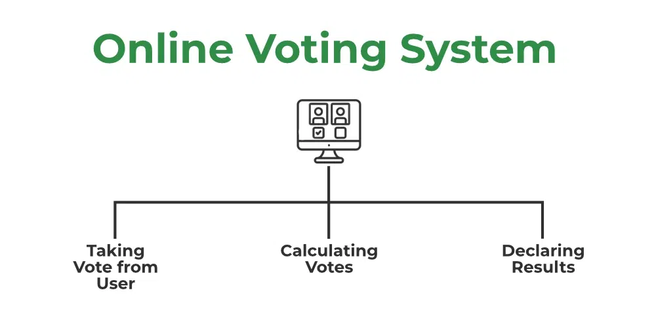

.

Figure:1.1

# Software Requirements:

* + HTML.
  + CSS.
  + JAVASCRIPT.
  + PHP.
  + BOOTSTRAP.
  + XAMPP
  + MYSQL

**Module Description**

1. USER LOGIN:

* A login generally requires the user to enter to two piece of information first a username and a password.

1. USER SIGN UP

* Sign up is an action to register themselves for a new account that consist of username and password.

1. SUBMIT VOTES

* The user can vote their favourite parties and votes will submitted and result will be released on the spot.

**LOGIN PAGE**

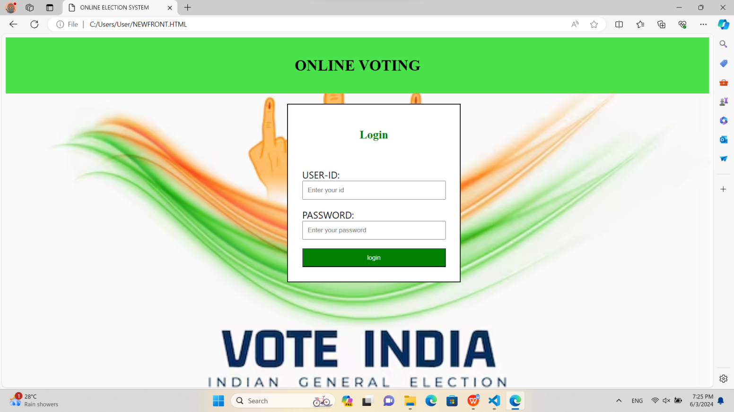

Figure:1.2

**SIGN UP PAGE**

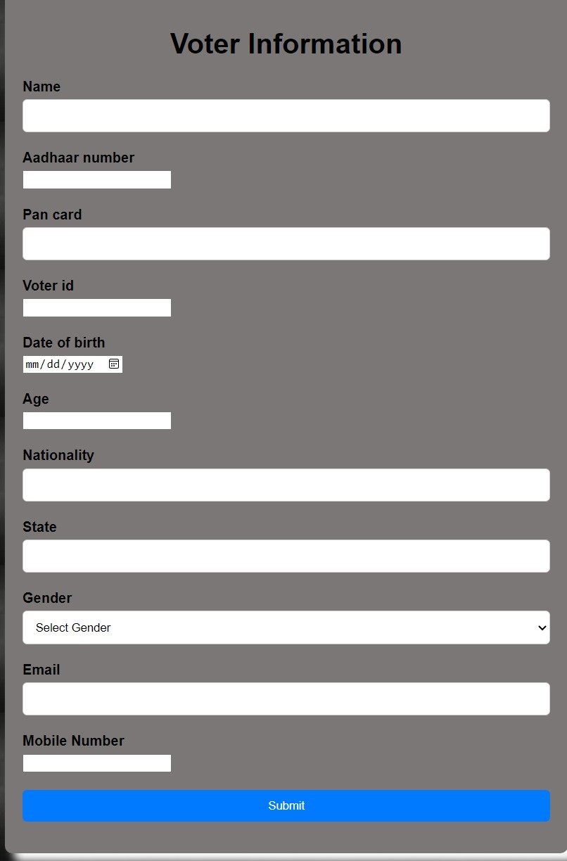

Figure:1.3

**SUBMIT VOTES**

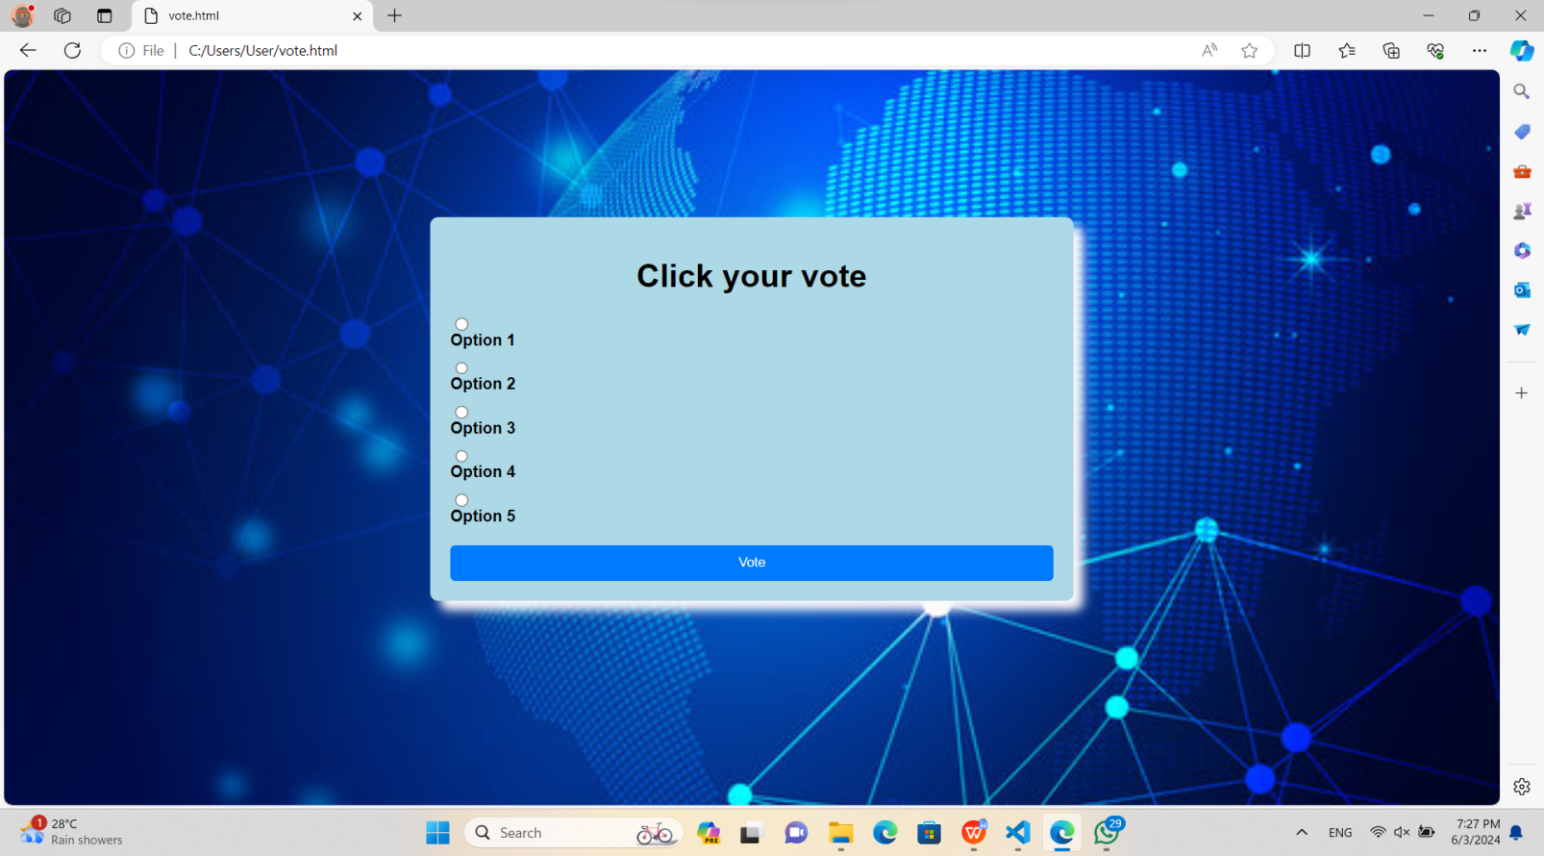

Figure:1.4

# CONCLUSION

In conclusion,to sum up, there is a great deal of potential for improving the effectiveness, accessibility, and security of the voting process through the creation and deployment of an online election system. End-to-end encryption, multi-factor authentication, and blockchain are examples of cutting-edge technology that can be used to build a reliable system that solves many of the problems with conventional voting procedures. Voter anonymity, vote integrity, and general openness are given top priority under the proposed approach, which will increase public trust in the democratic process. Even with possible obstacles like the digital divide and cybersecurity hazards, they can be reduced with careful planning, rigorous testing, and extensive voter education. Online election systems are a forward-thinking strategy for preserving democratic values in the contemporary day as civilizations continue to embrace digital innovation.

# REFERENCES

[1] “Online Voting,” postnote – a publication of the U. K. Parliamentary Office of Science and Technology.

[2] “Internet Voting: Will it Spur or Corrupt Democracy?,” Lance J. Hoffman, Technical Report, Computer Science Department, The George Washington University, Washington.

[3] Electronic Voting – Evaluating the Threat,” Michael Ian Shamos, International Conference on Computers, Freedom, and Privacy, Burlingame, California.

[4] “Security Considerations for Remote Electronic Voting,” Aviel D. Rubin, Communications of the ACM.

[5] “Electronic Voting,” Encyclopedia of Computers and Computer History, prepared by Lorrie Faith Cranor and edited by Raul Rojas.

[6] The "Handbook of Electronic Voting" edited by Jordi Barrat, Mário J. Silva, and Melanie Volkamer.

[7] “Evaluating Voting Technology,” Douglas W. Jones, Testimony before the United States Civil Rights Commission.

[8] Secure Electronic Voting" by Dimitris A. Gritzalis and Antonio

[9] “e-Voting Security Study,” E-Democracy Consultation, U. K. Cabinet Office.

[10]  **"**E-Voting Case Law: A Comparative Analysis" edited by Ardita Driza Maurer and Jordi Barrat