**Soft Starter For DC Motor with Speed Control by PWM Method**

Utkarsh Goundaje, Ganesh Dhulugade, Abhjeet Sontakke, Prof. S. S. Manjare

*Student, Dept. of Electrical Engineering, D.K.T.E Society’s Textile and Engineering Institute, Ichalkaranji, India Asst. Prof. Dept. of Electrical Engineering, D.K.T.E Society’s Textile and Engineering Institute, Ichalkaranji, India*

***Abstract****:*

# This report presents the design and development of a soft start system for DC motors, with speed control using pulse width modulation (PWM) technology... Soft starters are crucial in industrial applications where the abrupt start-up of motors can cause mechanical stress, increased maintenance, and decreased equipment lifespan. The proposed system uses advanced PWM technology to ensure smooth and controlled avigation, ensuring a gentle start for the DC motor. The integration of PWM allows for precise speed regulation, enhancing the overall efficiency of the motor operation.

## Introduction:

Conventional techniques for starting and controlling the speed of a DC shunt motor use some type of current limiting element such as resistors. At standstill, the EMF is zero and the only resistance that describes the current flow is the armature circuit resistance, which is quite small for all types of DC motors. If a DC motor is started with full supply voltage across this terminal, a very large current will flow which can damage the motor and cause the winding to heat up. Therefore, it is necessary to limit the current to a safe value at start-up.

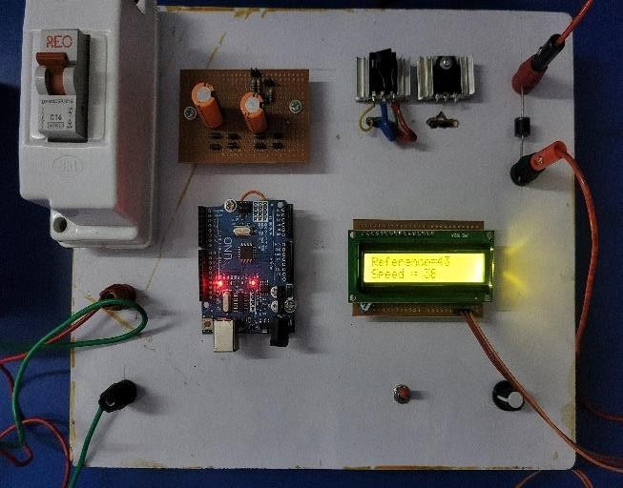Conventional techniques for starting and controlling the speed of a DC shunt motor use some type of current limiting element such as resistors. At standstill, the EMF is zero and the only resistance that describes the current flow is the armature circuit resistance, which is quite small for all types of DC motors. If a DC motor is started with full supply voltage across this terminal, a very large current will flow which can damage the motor and cause the winding to heat up. Therefore, it is necessary to limit the current to a safe value at start-up.

The most effective way to safeguard your devices is by enabling soft start (or soft start-up/starter) Soft starters offer a solution to this problem by taking advantage of the minimal power loss of power converters compared to traditional methods, and smooth starting with speed control is possible. The proposed design uses a microcontroller that generates pulse width modulation (PWM) signals that are applied to the BUCK converter when an external hardware interrupt such as a push signal occurs.

## Literature Review:

Soft starters are crucial components in industrial applications,ensuring smooth and controlled acceleration of motors. This literature review explores the foundational principles, recent advancements, and practical applications of soft starters in diverse industries. Soft starters are employed to mitigate the issues associated with abrupt motor starts, including mechanical stress and power surges. The basic operating principles, such as voltage ramp, current limit, and torque control, form the foundation for understanding the functionality of soft starters. Various soft starter configurations cater to specific motor and application requirements. Voltage ramp soft starters are widely used for their simplicity, while more advanced options like current limit and torque control soft starters offer precise control and are suitable for specific industrial contexts.

Soft starters contribute significantly to energy efficiency by reducing the inrush current during motor starts. This results in cost savings and improved system reliability. Studies and real world examples demonstrating energy efficiency gains due to soft starters are essential for understanding their economic impact. Effective control strategies are crucial for optimizing the performance of soft starters. Proportional-Integral-Derivative (PID) control, fuzzy logic control, and other advanced strategies play a vital role in achieving smooth acceleration and deceleration, thereby extending the lifespan of motor.

The integration of soft starters with industrial automation systems is a growing trend. Exploring how soft starters contribute to Industry 4.0 principles, such as predictive maintenance and data-driven decision-making, can provide a glimpse into the future of motor control systems.

## Components Used:

**1.DC Shunt Motor:-**

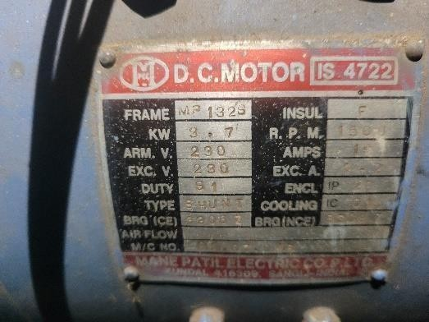

A DC shunt motor is a direct current (DC) motor with two windings connected in parallel. The field winding is connected in parallel with the armature. The shunt winding is made from many turns of small copper wire Since they are connected in parallel, the armature and field windings are exposed to the same supply voltage

The Dc motor used in this project was available in the electrical machine lab. The motor specifications are given below.

Armature voltage : 230V, Kw rating: 3.7KW, Current rating: 18 Amp,RPM: 1500,Class of Insulation: F

**2.IGBT:-**

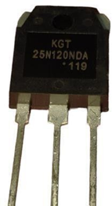

The 25N120 is a high voltage, high current IGBT that can switch up to 1200V and 50A. It is made using NPT (Non-Punch Through) trench technology, which results in very low switching loss and low saturation voltage, making it suitable for use in low voltage switching driver designs and achieving comparatively high efficiency for itsswitching range. It has a very low gate saturation gate voltage of 2V, making it suitablefor use in the design of low voltage side drivers. This IGBT is ideal for resonant and soft- switching applications.

**3.Arduino Uno**

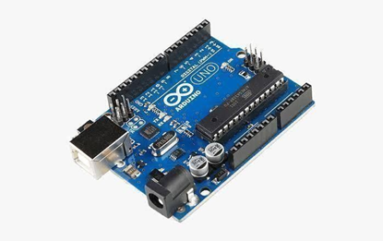

Arduino Uno is an open-source microcontroller board based on the Microchip ATmega328P microcontroller and developed by Arduino.cc. The board is fitted with a set of digital input and analog / output (I / O) pins connected to various expansion boards (shields) and other circuits. The board has 14 Digital pins, 6 Analog pins, and is programmed with Arduino IDE (Integrated Communication Area) on a USB type B. It can be supplied with a USB cable or 9-volt external battery. Hardware is distributed under the Creative Commons Attribution Share-Alike 2.5 license and chosen to mark the first release of Arduino Software.

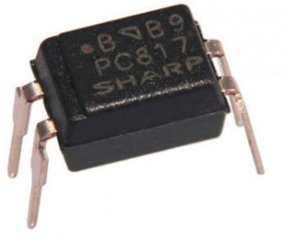**4.IGBT Driver:-**

The desired isolation and coupling between low voltage microcontroller and high voltage MOSFET is provided through pc817 opto coupler driver circuit

An optocoupler is a semiconductor device that allows an electrical signal to be transmitted between two isolated circuits. Two parts are used in an optocoupler: an LED that emits infrared light and a photosensitive device that detects light from the LED. Both parts are contained within a black box with pins for connectivity. The input circuit takes the incoming signal, whether the signal is AC or DC, and uses the signal to turn on the LED.

**5.LCD:-**

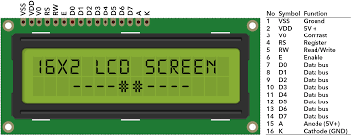

16*2 LCD is used to display the reference speed and actual speed of motor . A liquid crystal display (LCD) is a flat-panel display or other electronically modulated optical device that uses the light modulating properties of liquid crystals

## Methodolgy:

## 

**Soft Starter working: -**In the circuit diagram shown above the 230V supply is given for both transformers. This voltage is then stepped down to 9v and converted to dc supply and it is given as input to the Arduino UNO. The 230v DC supply is given to the input side of the model. IGBT is Used as buck converter and the gate pulse is given through the Arduino microcontroller.

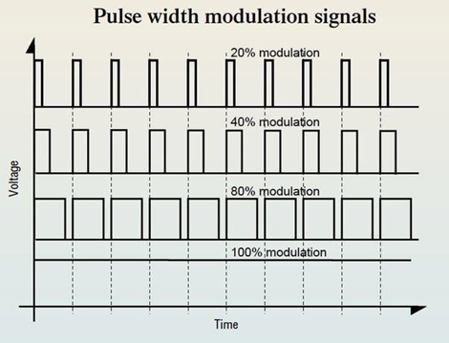

**Output of the buck converter can be given as Vo=D*Vin**

Where, Vo=Output voltage

D=Duty Cycle=Ton+Toff Vin=Input Voltage

The Duty cycle is equals to Ton+Toff so the voltage level depends on the Ton time of the thyristor The Arduino processor have 255bits of pulse width modulation pins. When we set the reference speed with the help of knob which is shown on the LCD display then the pulse width modulation bits increases with the delay of 50miliseconds per bit.Then according to reference speed the voltage increases or decreases with the delay so the motor will start with soft start.

***Simulation Results:***

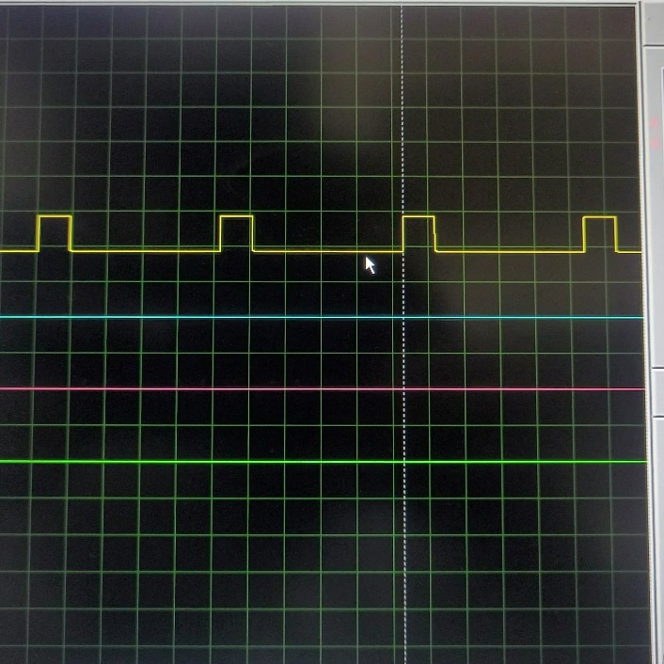Simulation software used:-Proteus 8

The results of a pulse width modulation (PWM) simulation in Proteus.

1. **Time Domain Waveforms**: Proteus typically displays waveforms over time. You should expect to see a square wave for the PWM signal. The duty cycle of this square wave will determine the width of the pulses.
2. **PWM Frequency**: Look for the frequency of the PWM signal. This frequency is determined by the system's clock or the settings you've specified in your simulation.
3. **Duty Cycle**: This represents the ratio of the pulse width to the total period. It's usually expressed as a percentage. For instance, if the pulse is high for 75% of the period, the duty cycle is 75%.

By analyzing these aspects of the simulation output, you can gain a comprehensive understanding of how your PWM circuit behaves under different conditions in Proteus.

# Conclusion:

# The simulation of a DC motor soft starter provides valuable insights into the performance and behavior of the system under various conditions. Through the simulation process, several key observations and conclusions can be drawn:

# The simulation allows us to verify the effectiveness of the soft start mechanism in gradually ramping up the voltage or current supplied to the DC motor. By observing the motor's response during the starting phase, we can ensure that the soft starter successfully limits the initial inrush current and minimizes mechanical stress on the motor.

# During the soft start process, transient phenomena such as voltage spikes or current surges may occur. Through simulation, we can analyze these transient effects and ensure that they remain within acceptable limits, preventing damage to the motor and associated circuitry.

# Simulation enables us to evaluate the soft starter's ability to detect and respond to fault conditions such as overcurrent, overvoltage, or overload situations. By implementing appropriate protection mechanisms, we can safeguard the motor and control system from potential damage or failure.

# Through iterative simulation runs with varying parameters, we can assess the sensitivity of the soft starter's performance to changes in factors such as ramp-up time, acceleration profile, and load characteristics. This helps in fine-tuning the design to accommodate different operating conditions and requirements.

# In conclusion, the simulation of a DC motor soft starter serves as a valuable tool for design validation, performance optimization, and risk mitigation. By systematically analyzing the simulation results, we can ensure the robustness, efficiency, and reliability of the soft starter system, ultimately contributing to the overall success of the motor control application.

# Reference:

* Electrical Discharge Machine Soft Start Using Pic By [Siti Azurah Ibrahim](https://www.google.co.in/search?sca_esv=584961557&hl=en&sxsrf=AM9HkKljAgYf6J64BKZ-ZWS0aKyanpyXGQ%3A1700798460680&q=inauthor%3A%22Siti%2BAzurah%2BIbrahim%22&tbm=bks) · 2010
* Electrical Drives Principles, Planning, Applications, Solutions By [Jens](https://www.google.co.in/search?sca_esv=584961557&hl=en&sxsrf=AM9HkKmC9LnilHsnjOdL-XyoSRRVT1Tchw%3A1700798763736&q=inauthor%3A%22Jens%2BWeidauer%22&tbm=bks) [Weidauer,](https://www.google.co.in/search?sca_esv=584961557&hl=en&sxsrf=AM9HkKmC9LnilHsnjOdL-XyoSRRVT1Tchw%3A1700798763736&q=inauthor%3A%22Jens%2BWeidauer%22&tbm=bks) [Richard Messer](https://www.google.co.in/search?sca_esv=584961557&hl=en&sxsrf=AM9HkKmC9LnilHsnjOdL-XyoSRRVT1Tchw%3A1700798763736&q=inauthor%3A%22Richard%2BMesser%22&tbm=bks) · 2014
* Speed Control of DC Motor Using PWM [Sahithi Priya Alloju](https://papers.ssrn.com/sol3/cf_dev/AbsByAuth.cfm?per_id=4819902), Kakatiya Institute of Technology & Science, Warangal : June 17, 2021
  + <https://www.ourpcb.com/dc-motor-soft-start.html>
  + [https://www.softstartrv.com/how-to-soft-start-a-dc-motor/ -](https://www.softstartrv.com/how-to-soft-start-a-dc-motor/#%3A~%3Atext%3DSoft%20starting%20a%20DC%20motor%20has%20many%20advantages.%2Cdamage%20due%20to%20rapid%20acceleration)

[:~:text=Soft%20starting%20a%20DC%20motor%20has%20many%20advantage](https://www.softstartrv.com/how-to-soft-start-a-dc-motor/#%3A~%3Atext%3DSoft%20starting%20a%20DC%20motor%20has%20many%20advantages.%2Cdamage%20due%20to%20rapid%20acceleration) [s.,damage%20due%20to%20rapid%20acceleration.](https://www.softstartrv.com/how-to-soft-start-a-dc-motor/#%3A~%3Atext%3DSoft%20starting%20a%20DC%20motor%20has%20many%20advantages.%2Cdamage%20due%20to%20rapid%20acceleration)

* + <https://en.wikipedia.org/wiki/Motor_soft_starter>
  + <https://www.eevblog.com/forum/beginners/soft-start-a-d-c-motor/>
  + <https://iopscience.iop.org/article/10.1088/1757-899X/602/1/012017/pdf>
  + <https://ieeexplore.ieee.org/document/7038740>