Design and development of poultry farming based on iot

Vishnu MS

Senthil Kumar V Santhosh G

---------------------------------------------------------------------***---------------------------------------------------------------------

**Abstract -** *With the enormous growth in population, the demand for very high quality poultry products will tend to increase. To meet this demand and increase the yield, monitoring the environment of the farm to keep a check on the health of poultry birds is of paramount importance. The aim of this paper is to design an embedded system for a smart poultry farm with the implementation of I o T. By watching different environmental parameters of a poultry farm and taking suitable actions with the help of actuators, we are able to convert a ‘traditional poultry farm’ into a smart poultry farm’. The main idea is to increase the production and make it moreeasy for the farm owners by providing a clean and healthy environment for the poultry-birds, ensuring better management of the farm through automation and sending real-time updates about the status of the farm to the operator.* ***Key Words*: Poultry farm, real-time monitoring, Io**

# INTRODUCTION

Agriculture is a main source of livelihood for millions of individuals around the globe. The increase in population has led to an exponential increase in the demand for food supply as well as better quality of food. The outbreak of a disease in a farm can have a dangerous effect on the production. Hence it is important for the farms to maintain a proper healthy conditions to avoid any unprecedented outbreak of disease.

Traceability and biosecurity protocols for food quality have been implemented by various countries to avoid such disasters. Agriculturists and researchers are developing new methods to increase the yield and decrease the cost of superior food quality production [1].

Poultry farming revolves around the raising of birds for the production of meat and eggs. Chicken and eggs are rich sources of protein and are widely consumed throughout the world. The poultry sector is one of the fastest growing sectors in animal husbandry. If proper hygienic environmental conditions are not provided to the poultry birds, it can be harmful for their digestive and respiratory systems. Thus the climate of the farm plays a vital role in the growth and breeding of birds in the poultry farms [2].

The traditional poultry farms depend mainly on human labour for various activities like controlling of methane and ammonia gas emanation from bacterial decomposition, maintaining of temperature within standard levels, timely feeding of birds etc which results in inefficient farm management and unhygienic conditions. Ideally, poultry farms should be clean, dry and have sufficient ventilation with optimum temperature and humidity. With an increased level of awareness regarding the safety of food-products and a high demand for better quality food, it is imperative for the farms to have a proper disease free and hygienic environment which can help in protecting the birds from getting infected with deadly diseases like avian flu.

Hence, real-time monitoring of environmental conditions for a poultry farm is crucial and it demands a good level of research. This paper presents a novel approach to monitor different environmental conditions in a poultry farm such as humidity, temperature, light intensity and ammonia gas concentration. By monitoring these parameters in real-time and taking suitable actions with the help of actuators, we are able to convert a ‘traditional poultry farm’ into a ‘smart poultry farm’. The smart poultry farm is implemented with the aid of IoT. The proposed system will help to increase the productivity by providing a hygienic and safe environment for the breeding of poultry-birds, ensuring better management of the farm through automation and sending real-time updates about the status of the farm to the operator.

# BACKGROUND

Various researchers have put forward different implementations of smart farm management. Siwakorn Jindarat and Pongpisitt Wuttidittachotti [3] have shown how a smart farm monitoring can be implemented using a Raspberry Pi and an Arduino. All sensors for monitoring the environmental conditions of the farm are connected to Arduino which transfers the data to Raspberry Pi via UART. The Raspberry Pi controls actuators like light and fan, sends pictures captured using a camera module to a web browser as well as sends notification alerts n a smart phone. S. Arunkumar and N. MohanaSundaram [4] have used GSM technology to get updates about the status of the farm. Parameters like ammonia gas content, temperature in the farm and weight of the food supplied to the birds are sensed using appropriate sensors and the data is shown in a

webpage. A fire sensor is used to detect the outbreak of an accident.

| **|** |
| --- |

Md. Mahfujul Islam et al. [5] have proposed a smart poultry farm with features like fire protection, anti-stealth and storing the data in a website for further analysis. The system is implemented using an Arduino Uno, a GSM module, a Wi-Fi module along with various sensors to measure temperature, humidity, light intensity and the presence of toxic gases. The ThingSpeak platform is used for real-time data monitoring and data acquisition. Kadam Anaji Sitaram et al. [6] have shown how IoT can be used for automation of manual jobs in the farm like supply of food and water as well as waste management. The methane gas obtained from the chicken manure is used to produce electricity can be used to charge a battery. A web-based system is used for far monitoring with the help of a GPRS module connected to an Arduino Uno R3.

Jake Astill et al. [7] have shown how smart sensors can collect real-time data in a poultry farm and how data analytics can be used to make intelligent decisions with the help of the big data generated. In this way a precision livestock farming can be implemented. Muhammad Osama Akbar et al. [8] have discussed about the state-of-the-art framework in order to help farmers to increase the milk production level in a dairy farm. This includes the use of smart sterilizers, robotic milking, activity and behavior observation of the cattle as well as monitoring their body temperature. Luís Nóbrega et al. [9] have shown how animal monitoring in a farm can be implemented with IoT technology. The SheepIT cloud platform is used for performing data analytics based on the animal sensor data and inform the farmers about situations like attack from predators. Geetanjali, A.Choukidar and N.A.Dawande [10] have used a combination of wireless sensor network and GPRS to monitor different environmental conditions in a poultry farm. The Raspberry Pi acts as the main hub for connecting all the sensors and the values recorded by all the sensors are published in a webpage.

# EXISTING SYSTEM

The traditional poultry farms are more dependent on manpower and are quite tedious to manage. Some of the disadvantages of the traditional poultry farms are as follows:

1. The different sections of the farm cannot be monitored in a single dashboard.
2. The system has no provision for management of gases like methane and ammonia, the excess of which affects the health of chickens and diminishes the egg production.
3. There is no provision to regulate the temperature and humidity of the farm. High temperature is one of the most crucial environmental stressor in a poultry farm and can cause great losses in terms of production. In a similar way, the air should not be too dry or moist. The traditional farms are undoubtedly inefficient in maintaining the optimum temperature and humidity inside the farm.
4. Activities like supply of water is done manually and no automation is involved.
5. There is no mechanism of sending updates about the status of the farm to the operator which the operator is not physically present in the farm.
6. The presence of trained staff is required which makes the system costly. Due to inefficient management of the farm and unhygienic condition, the outbreak of an infection can incur huge medication costs.

# PROPOSED SYSTEM

The smart poultry farm greatly enhances the traditional farm by making it fully automated and sending timely feedback to the operator as and when required. Its advantages over the existing system are as follows:

1. A single dashboard is available for real-time monitoring of the farm as well as control of actuators wirelessly from anywhere in the world.
2. Different sensors are available for real-time monitoring of hazardous gases in the farm like ammonia and methane. Proper ventilation is available whenever the level of these gases is high.
3. The temperature and humidity in the farm can be monitored and suitable actuators are available to maintain their optimum level.
4. Water supply to the farm is fully automated.
5. Real time updates are sent to the farm owners about the status of the farm.
6. No trained staff is required. With intelligent data monitoring and data collection, the system provides almost ideal condition for the breeding of poultry birds, which reduces the overall cost of farm management drastically.

# DESIGN OF THE PROPOSED SYSTEM

The system can be divided into three sub-units as follows:

1. Sensing/Monitoring Unit: First, the sensing or monitoring unit will continuously monitor the values of the parameters, namely, temperature, humidity, ammonia and methane gas concentration, light intensity and water level (inside the tank). With the aid of IoT, the data received from the respective sensors can be monitored wirelessly from anywhere in the world and will be stored in cloud.
2. Control Unit: Next is the control unit which would allow the farm managers to control actuators like heater, fogger, exhaust fan, light and water pump based on the sensed parameters. There will be two modes of operation, manual and automated. The automated mode of operation would enable the system to intelligently take decisions for controlling the actuators.
3. Feedback Unit: Lastly, the operator would be informed timely about the environmental conditions thus monitored as well as if any of the actuators is switched on/off automatically during the automated mode of operation.

The system is described with the help of the flowchart shown in figure 1.

microcontroller receives the command and the specific actuator is controlled. 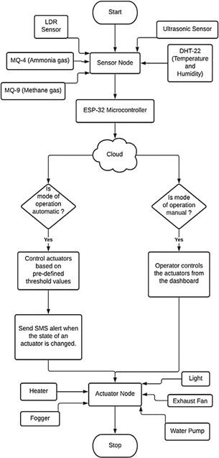

1. If the user turns the automate switch to on-state, the microcontroller will compare the readings of the sensors with pre-defined threshold values.
2. Now, based on the pre-defined values, it sends a command to the actuator-node to turn an actuator on/off.
3. If the state of an actuator is thus changed automatically by the system without the user’s intervention, an alert message will be sent to the user’s registered mobile number through SMS, which will specify which actuator’s state has been changed and the value of which parameter has exceeded.

# SYSTEM IMPLEMENTATION

The environmental parameters of the poultry farm are monitored with various sensors connected to the sensing and monitoring unit. The sensors implemented in the hardware design are as follows:

1. DHT-22: for measuring the temperature and humidity accurately.
2. MQ-4: for measuring ammonia gas concentration level.
3. MQ-9: for measuring methane gas concentration level.
4. LDR Sensor: for measuring the light intensity.
5. Ultrasonic Sensor: for measuring the level water in tanks which supply water to the drinkers.

All the above sensors are connected to the ESP-32 microcontroller which acts as the main hub for receiving all the data from the sensors. In a similar way, the actuators are connected in order to take suitable actions based on the sensed parameters. The actuators to be used includes:

1. Heater and fogger: for controlling the temperature and the humidity.
2. Exhaust fan: for proper air circulation when the farm is too hot and humid, or when the level of harmful gases, namely ammonia and methane exceed their limit.
3. Light source or a bulb: when light intensity is below the threshold value.
4. Water pump: for supply of water when the tanks are about to be empty.

The microcontroller ESP-32 receives data from all the

**Fig -1**: Flowchart depicting overall operation of the respective sensors as well as connects to an IoT platform for system. publishing data to the IoT dashboard. The readings of these

sensors are displayed in an online IoT platform so that the

The overall design approach of the system can be environmental conditions can be monitored from anywhere summarized as follows:

1. In the dashboard of the IoT platform the user has to in the word.

The actuators can be controlled wirelessly using virtual select the mode of operation (which by default is set to switches from the dashboard. There is one additional switch manual mode).

1. Under manual mode, the user needs to assess whether to transfer the mode of operation from manual to automate mode (or vice-versa). Finally, the feedback unit would send the value of any parameter has crossed the safety limit.
2. If so, the user controls the actuators with the help of the notifications to the operator’s smartphone via SMS whenever the system operates in the automate mode and the virtual switches present on the dashboard. In this way state of any of the actuators is automatically changed by the the user is able to remotely send a command to the system. microcontroller to change the state of an actuator. The

For sending SMS notifications to the farm owners, applets are made using the IFTTT (If this, then that) platform. This tool allows us to customize our applets based on the given condition. 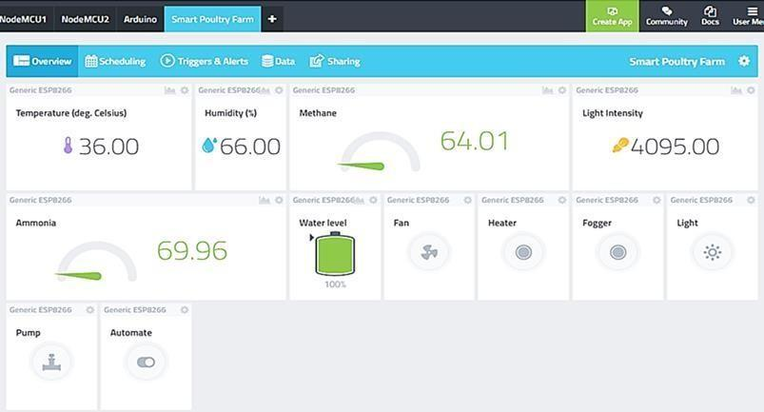

# RESULTS

All the sensors and actuators connectors to the ESP-32 microcontroller are kept attached to a box for making a prototype of the system as shown in figure 2.

The IoT dashboard displays the readings of all the sensors and also contains the virtual switches to control the actuators as shown in figure 3. All the readings of the sensors are stored in the database of the IoT platform can be downloaded as an Excel file., as shown in figure 4. This can be used for future reference and further analysis. We can

also download the history of data from the last 10 minutes to

**Fig -3**: Dashboard of the IoT platform for monitoring the 1 hour, 1 day and so on. values obtained from the sensors.



**Fig -2**: The hardware setup.

The dashboard can also be visualized from a smartphone, as shown in figure 6, which makes it more easily accessible.

| **Fig -5**: SMS received during automate mode of operation. | [4] | Communications, and Control Technology (I4CT) (pp. 284-288). IEEE.  Arunkumar, S. & Mohanasundaram, N.. (2018). “Smart |
| --- | --- | --- |

**8. CONCLUSION** 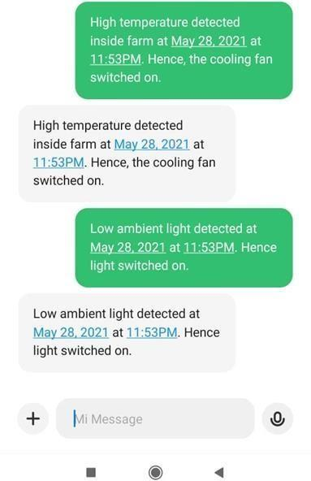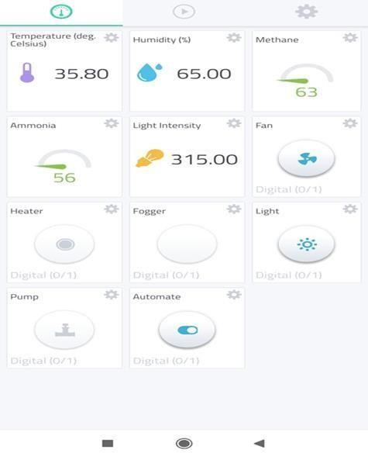

This paper has devised an innovative solution for smart poultry farming. It not only monitors the environmental conditions of the farm in real-time but can also automate activities like water supply. Besides it provides both the manual and automate modes of operation which can be used alternatively. The history of data is stored in cloud which can be used for future reference. In this way, the system provides an efficient and cost-effective solution for poultry farm management.

# REFERENCES

1. Goud, K. S., & Sudharson, A. (2015). “Internet based smart poultry farm”, Indian journal of science and technology, 8(19), 1.
2. Hitimana, E., Bajpai, G., Musabe, R., & Sibomana, L. (2018). “Remote monitoring and control of poultry farm using IoT techniques”, International Journal of Latest Technology in Engineering, Management& Applied Sci., 7(5), 87-90.
3. Jindarat, S., & Wuttidittachotti, P. (2015, April). “Smart farm monitoring using Raspberry Pi and Arduino”. In

2015 International Conference on Computer,

poultry farming”. International Journal of Innovative Technology and Exploring Engineering. 8. 289-291.

1. Islam, M. M., Tonmoy, S. S., Quayum, S., Sarker, A. R., Hani, S. U., & Mannan, M. A. (2019, January). “Smart poultry farm incorporating GSM and IoT”. In 2019 International Conference on Robotics, Electrical and Signal Processing Techniques (ICREST) (pp. 277-280). IEEE.
2. Sitaram, K. A., Ankush, K. R., Anant, K. N., & Raghunath, B.

R. (2018, December). “Iot based smart management of poultry farm and electricity generation”. In 2018 IEEE International Conference on Computational Intelligence and Computing Research (ICCIC) (pp. 1-4). IEEE.

1. Astill, J., Dara, R. A., Fraser, E. D., Roberts, B., & Sharif, S. (2020). “Smart poultry management: Smart sensors, big data, and the internet of things”. Computers and Electronics in Agriculture, 170, 105291.
2. Akbar, M. O., Ali, M. J., Hussain, A., Qaiser, G., Pasha, M., Pasha, U., ... & Akhtar, N. (2020). “IoT for Development of Smart Dairy Farming”. Journal of Food Quality, 2020.
3. Nóbrega, L., Tavares, A., Cardoso, A., & Gonçalves, P. (2018, May). “Animal monitoring based on IoT technologies”. In 2018 IoT Vertical and Topical Summit on Agriculture-Tuscany (IOT Tuscany) (pp. 1-5). IEEE.
4. Geetanjali, A. C., & Dawande, N. A. (2017). “A Survey on

Smart Poultry Farm Automation and Monitoring System''. International Journal of Innovative Research in Science, Engineering and Technology, 6(3), 4806-4809.

**Fig -6**: Sensor measurements shown in smartphone.