 

**ANTI COLLISION CAR SYSTEM USING**

**MICRO CONTROLLER**

**A PROJECT REPORT**

***Submitted by***

**VISHWAKSENAN.N (913120105046)**

**SELVAMURUGAN.M (913120105029)**

***In partial fulfillment for the award of the degree***

***of***

**BACHELOR OF ENGINEERING**

***in***

**ELECTRICAL AND ELECTRONICS ENGINEERING**

**VELAMMAL COLLEGE OF ENGINEERING AND TECHNOLOGY,**

**MADURAI-625 009**

**ANNA UNIVERSITY::CHENNAI 600 025**

**MAY 2024**

## ANNA UNIVERSITY: CHENNAI 600 025

## BONAFIDE CERTIFICATE

Certified that is report **“ANTI COLLISION CAR SYSTEM USING MICRO CONTROLLER”** is the Bonafide work of **VISHWAKSENAN.N(913120105046)** and **SELVAMURUGAN.M (913120105029)** who carried out the project under my supervision.

##### SIGNATURE SIGNATURE

**Dr.A.SHUNMUGALATHA, M.E., Ph.D., Dr.T.Chandrasekar M.E , Ph.D**

##### Dean(Academics)&

##### Head of the Department Associate Professor

Electrical and Electronics Engineering, Electrical and Electronics Engineering, Velammal College of Engineering and Velammal College of Engineering and Technology, Technology,

Madurai–625009. Madurai –625009.

Certified that the candidate was examined on the Viva-Voce Examination held at Velammal College of Engineering and Technology, Madurai on .

**INTERNAL EXAMINER EXTERNAL EXAMINER**

**ACKNOWLEDGEMENT**

First of all we thank the Almighty for strengthening us throughout the project and helping us to complete it successfully.

We find immense pleasure to convey our sincere thanks to our honorable Principal **Dr.P.ALLI ,** for providing necessary facilities in carrying out our project work in our campus.

We would like to express our hearty thanks to our Dean(Academics) & Head of the Department **Dr.A.SHUNMUGALATHA, M.E., Ph.D.,** for her constant encouragement.

We take this opportunity to express our sincere and heartfelt thanks to our guide, **Dr.T.Chandrasekar M.E., Ph.D.,** for his patient guidance, timely suggestion technical and moral support and the immense part of his dedication in completing the project work successfully.

We express our special thanks to other staff members of our department, the non-teaching staff and our friends who assisted us, by their support and encouragement.

We also express our special thanks to our Parents who have sacrificed greatly in our education and welfare. We thank all those who have helped directly and indirectly in doing this project and bringing out this successful report.

**ABSTRACT**

Automotive vehicles are increasingly being equipped with collision avoidance and warning systems for predicting the potential collision with an external object, such as another vehicle or a pedestrian. Upon detecting a potential collision, such systems typically initiate an action to avoid the collision and/or provide a warning to the vehicle operator.

This system consists of a distance-measuring system based on ultrasonic sound utilizing the ATMEGA 328 microcontroller and transmits a burst of ultrasonic sound waves towards the target and then receives the corresponding echo. An ultrasonic sound sensor is used to detect the arrival of the echo to the system. The time taken for the ultrasonic burst to travel the distance from the system to the subject and back to the system is accurately measured by the microcontroller. It also provides a warning signal to the driver if the distance between vehicle and obstacle crosses a particular limit. It also monitors the speed of the vehicle and if the speed limit is exceeded it is informed to the driver. The speed limit for different class of vehicles is set by authorities at different.

**LIST OF CONTENTS**

|  |  |  |
| --- | --- | --- |
| **CHAPTER NO.** | **TITLE** | **PAGE NO.** |
|  | **ACKNOWLEDGEMENT** | **iii** |
|  | **ABSTRACT** | **iv** |
|  | **LIST OF CONTENTS** | **v** |
|  | **LIST OF FIGURES** | **vii** |
|  | **LIST OF ABBREVATION** | **x** |
| **1** | **INTRODUCTION** | **1** |
|  | 1.1 GENERAL | 1 |
|  | 1.2 OBJECTIVE | 2 |
|  | 1.3 EXISTING METHOD | 2 |
| **2** | **LITERATURE SURVEY** | **3** |
|  | 2.1 Automatic head-on anti-collision system for vehicles using wireless communication | 3 |
|  | 2.2 The Design of Car Reversing Anti-Collision Warning System | 4 |
|  | 2.3 Arduino-Based Real-Time Obstacle Detection in Vehicles Using Proximity Sensors | 5 |
|  | 2.4 Automated anti-collision system for automobiles | 6 |
| **3** | **PROPOSED SYSTEM** | **7** |
|  | 3.1 DESCRIPTION | 7 |
|  | 3.2 BLOCK DIAGRAM DESCRIPTION | 8 |
|  | 3.3 ADVANTAGES | 8 |
| **4** | **MODULE DESCRIPTION** | **9** |
|  | 4.1 POWER SUPPLY | 9 |
|  | 4.2 TRANSFORMER | 10 |
|  | 4.3 ARDUINO UNO CONTROLLER | 10 |
|  | 4.4 KEYBOARD ENCODER | 17 |
|  | 4.5 BUZZER | 18 |
|  | 4.6 LCD DISPLAY | 19 |
| **5** | **RESULTS AND DISCUSSION** | **20** |
|  | 5.1 RESULTS | 20 |
|  | 5.2 COST ESTIMATION | 21 |
| **6** | **CONCLUSION** | **22** |
| **7** | **REFERENCES** | **23** |

**LIST OF FIGURES**

|  |  |  |
| --- | --- | --- |
| **FIGURE**  **NO.** | **DESCRIPTION** | **PAGE**  **NO.** |
| 3.1.1 | Block diagram of the proposed system | 7 |
| 4.1.1 | Regulator block | 10 |
| 4.2.1 | Transformer | 10 |
| 4.3.1 | Arduino Board | 12 |
| 4.4.1 | Keyboard encoder | 18 |
| 4.5.1 | LCD Display | 19 |
| 4.8.1 | Pin diagram of LM324 | 23 |
| 4.10.2 | Block diagram of LCD | 29 |
| 5.1.1 | Implemented Prototype | 20 |
| 5.1.2 | LCD displaying the information for car’s opposite object/vehicle distance and speed | 20 |
| 5.1.3 | Buzzer | 28 |

**LIST OF ABBREVATION**

* **PCB -** Printed Circuit Board
* **PWM -** Pulse width Modulator
* **LCD -** Light Crystal Display
* **UI** - User Interface
* **IC -** Integrated chip
* **IT -** Information Technology
* **USB -** Universal Serial Bus
* **LED -** Light Emitting Diode

**CHAPTER 1**

**INTRODUCTION**

**1.1 GENERAL**

.

The ever-increasing number of vehicles on our roads translates to a growing risk of collisions. Distractions, sudden stops, and miscalculated distances are just a few factors that can lead to devastating accidents. Advanced Driver-Assistance Systems (ADAS) are emerging as a beacon of hope, offering technological solutions to enhance road safety.

This project embarks on the creation of a foundational Anti-Collision System powered by the Atmega328 microcontroller, a popular choice for its ease of use and affordability. This system will leverage sensors to act as the car's eyes, constantly scanning for obstacles in its path. By processing sensor data, the microcontroller will trigger real-time warnings, alerting the driver to potential dangers.

This project focuses on designing and implementing an anti-collision system using a microcontroller. The system will employ sensors to detect obstacles and calculate their distance from the vehicle. Based on this information, the system will activate warning signals or automatic braking mechanisms to prevent collisions. By developing this system, we aim to showcase the practical application of microcontrollers in enhancing vehicle safety. Moreover this project has the potential to contribute significantly to advancement of intelligent transportation systems, making our roads safer for everyone.

* 1. **OBJECTIVE**

An Anti-collision kit is used to prevent road accidents. The Microcontroller(Atmega328) continuously monitors the vehicle parameters and stores the data on a protected digital memory card and in the cloud and show it on LCD display. The proposed model actively detects any sudden vehicle accident and alerts the emergency services to that location when an accident is detected. The system will update the information whenever an abnormal system event happens.

**1.3 EXISTING METHOD**

An Anti collision car system using a microcontroller typically involves sensor to detect obstacles and a microcontroller to process this information and control the car’s movements.

Ultrasonic sensors,radar,lidar or cameras can be used for detection and microcontroller analyzes the data to determine if there is a potential collision,triggering actions like braking or steering to avoid it .The specifies can vary depending on the design and complexity of the system.

**CHAPTER 2**

**LITERATURE SURVEY**

**Title: Automatic head-on anti-collision system for vehicles using wireless communication ,**  **IEEE Xplore International Symposium on Robotics and Manufacturing Automation (ROMA)**

**Year: 2014**

**Author: Abdelrahman Zaroug; M.K.A. Ahamed Khan; Niranjan Debnath**

A model of an anti-collision system for vehicles was designed, in a way that to avoid head-on collisions only. Two small motorized cars were built. Each car consists of Arduino microcontroller, ultrasonic sensor module, RF module and two DC geared motors. Each car is driven by a couple of DC motors from the rear end while the front is only a castor. As a form of differentiation each car was given the name of its Arduino controller which are Mega car, and Leonardo car. The controller of each car measures the distance ahead continuously using the ultrasonic module and checks the measured distance against the respective car's ahead distance through the wireless module. If the received distance found to be less than 40cm for the Leonardo car and less than 50cm for the Mega car then the two cars will stop their movement completely as if there is an impending collision in reality.

# Title: The Design of Car Reversing Anti-Collision Warning System, IEEE Xplore Fourth International Conference on Computational Intelligence and Communication Networks

# Year: 2012

# Author: [Xiaomei Yan](https://ieeexplore.ieee.org/author/37088135085); [Wenhua Gao](https://ieeexplore.ieee.org/author/37088135155)

Based on the principle of ultrasonic ranging, this paper introduces a kind of reverse collision warning system, the AT89C51 single chip being the core of control. The system starts automatically under the control of the controller, when the car is reversing. Probe Installed in the rear bumper sends ultrasonic. When it encounters obstacle an echo signal is generated. The controller processes the echo signal to determine the location of obstructions, so that this system alarms when it reaches the set distance. Temperature compensation and least squares method are also used to amend distance in data processing to reduce the inaccuracy. Experiments show that the measured data is accurate between 30~500 cm. The automobile reversing radar system is high in reliability, simple in peripheral circuit, and practical for use and so on

# Title: Arduino-Based Real-Time Obstacle Detection in Vehicles Using Proximity Sensors, IEEE Xplore International Conference on Advances in Computation, Communication and Information Technology (ICAICCIT)

# Year: 2024

# Author: Meenu Gupta; Rakesh Kumar; Sunaina Das; Rohan Sharma; Ahmed J. Obaid

Vehicle collision is currently one of the major problems for fatal traffic accidents where people lose their lives. To avoid this issue, intelligent vehicles pay more attention to people. The current anti-collision vehicles are lacking with the black path follower, and it is a high risk of loss of human lives. Nowadays, one of the evolving technologies in the automotive sector is detecting obstacles using anti-collision vehicle systems. In the automobile sector, an anti-collision system is a safety system that automatically prevents collision among cars and objects. In this work, a microcontroller-based automated car anti-collision system is proposed. The proposed system is skilled at spotting obstacles using a precise distance sensor, alerting the driver when a collision is imminent, and automatically applying the brakes via an actuator, when necessary, without the driver's assistance. The proposed system will automatically stop the vehicle in case the driver avoids the collision as the system monitors the vehicle's condition continuously. This system can safeguard drivers from mishaps and lower accidental death rates because it is user-friendly and adaptable. This mechanism can be used in any automobile vehicle as it’s a prudent system.

# Title: Automated anti-collision system for automobiles, IEEE XPlore Conference on Electrical, Computer and Communication Engineering (ECCE)

# Year: 2017

# Author: Tasneem Sanjana; Kazi Ahmed Asif Fuad; Mehrab Masayeed Habib; Ahmed Amin Rumel

Automated anti-collision system by detecting obstacles for automobile industry is one the emerging technologies nowadays. An automated vehicle anti-collision system is an automobile safety system which prevents collision among cars and objects automatically. In this paper, we have discussed about implementation of the prototype of our designed microcontroller based automated car anti-collision system. Our system specializes in detecting obstacles by sharp distance sensor and alerts within close distance of collision and hereafter brakes automatically by actuator in critical distance without the help of driving person. If somehow driver fails avoiding the collision, this system will automatically stop the vehicle as it monitors the condition of the vehicle continuously. So it is a user friendly and versatile system which can prevent road accidents, reduce the rate of accidents as well as accidental death of human life. It can be used in any kind of automobile vehicle as it's a cost effective system.

**CHAPTER 3**

**PROPOSED SYSTEM**

**3.1 DESCRIPTION**

A proposed system for Anti collision car system using microcontroller might involve advanced sensor technologies like LiDAR or computer vision, integerated with machine learning algorithms for more accurate detection and decision making. The microcontroller would process data from these sensors in real time to access surrounding environment. Additionally connectivity features could allow for communication between vehicles to enhance collision avoidance strategies.

**MICRO**

**CONTROLLER**

**ATMEGA328**

**MOTOR**

**WHEELS**

**BUFFER**

**ALARM**

**CIRCUIT**

**SPEED**

**REGULATE**

**CKT**

**ULTRASONIC**

**RECEIVER**

**ULTRASONIC**

**TRANSMITTER**

**KEY BOARD**

**OBJECT**

**LCD**

Fig 3.1.1 Block diagram

**3.2 BLOCK DIAGRAM DESCRIPTION**

Sensor Module: This module comprises various sensors such as ultrasonic sensors, LiDAR, radar, or cameras, which detect obstacles and provide data to the microcontroller.

Microcontroller Unit (MCU): The MCU processes the data received from the sensor module and executes control algorithms to make decisions regarding the car's movements.

Decision-making Algorithm: This algorithm, often implemented within the MCU, interprets sensor data to determine potential collision risks and calculates appropriate actions to avoid collisions.

Actuator Control: The MCU sends commands to actuators such as motors, servos, or brakes to execute the desired actions, such as steering, braking, or accelerating.

Communication Interface (Optional): In advanced systems, there might be communication modules like Wi-Fi, Bluetooth, or cellular connectivity to enable communication between vehicles or with infrastructure for enhanced collision avoidance strategies.

Power Supply: Provides the necessary power to all components of the system, ensuring continuous operation.

**3.3 WORKING**

The system employs ultrasonic sensors to detect objects in the car’s vicinity. These sensor continuously scan the opposite of object/vehicle and provide input to the microcontroller. This sensor transmits signal to the object through transmitter. The microcontroller processes the data received from the sensors receiver in real time. It calculates distance nearby objects relative to the car. Based on the processed sensor data, the microcontroller predicts potential collision scenarios. It analyzes factors such as speed, distance and direction of movement to assess the risk of collision with each detected object. The microcontroller makes decision to prevent collision based on predefined algorithms and rules. It may trigger warnings to the driver, such as buzzer to take evasive action. In advanced systems, the microcontroller may automously control the car’s speed,steering or braking to avoid collisions. This can include features like automatic emergency braking or lane departure prevention. Key encoder represents like engine on & off and speed increase & decrease buttons. First turn on engine and increase the speed gradually(upto 70 kmph), when an object/vehicle occurs infront of a car at particular distance it alerts the driver and reduce automatically the car’s speed and stop it.

Overall the anti-collision car system using a microcontroller acts as a proactive safety mechanism,leveraging sensor data and intelligent decision making to minimize the risk of accidents caused by collisions with other vehicles or obstacles. It can displays the action through LCD display.

**ADVANTAGES**

* Increased Road Safety.
* Reduced strain on engines, thereby increasing the life of engine

**CHAPTER 4**

**MODULE DESCRIPTION**

**4.1 POWER SUPPLY**

It is an electronics unit. This is used to give regulated power to any electronics system. This power supply circuit is designed to get regulated output DC voltage. The 9 volt transformer, step down the main voltage (230v) into 9 volts. The secondary voltage of transformer is rectified using bridge rectifier. The rectifies unidirectional DC is smoothed by 1000mf filter capacitor. The smooth DC is then fed to the three terminal +ve regulator called 7805 to get 5v DC supply.

Description:

1. Transformer: This block consist step-down transformer for our required ratings.
2. Rectifier: This block consist diode based rectifier circuit.
3. Filter circuit: This block consist capacitor based filter circuit.
4. Regulator: This block consists +ve (and) –ve three terminal regulators

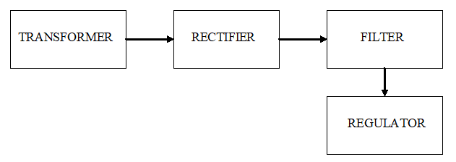

Fig 4..1 .1 Regulator block

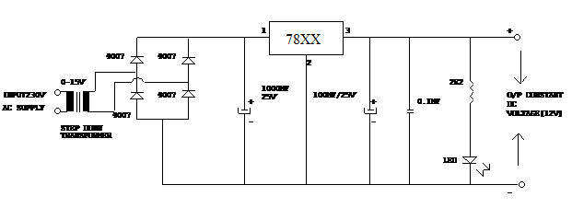

**4.2 TRANSFORMER**

The transformer, in a simple way, can be described as a device that steps up or steps down voltage. In a step-up transformer, the output voltage is increased, and in a step-down transformer, the output voltage is decreased. The step-up transformer will decrease the output current, and the step-down transformer will increase the output current to keep the input and output power of the system equal.

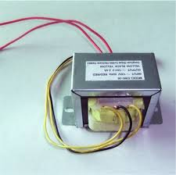

Fig. 4.2.1 Transformer

**4.3 RECTIFIER**

A rectifier circuit converts an AC voltage into a pulsating DC voltage. This is accomplished by using one or more diodes because diodes conduct current in only one direction.

**Types :**

**Half-wave Rectifier :**

The transformer (T1) isolates the household voltage and also steps down the household voltage to a more useful voltage level. The diode lets current flow into the load in only one direction. The load current is unidirectional; therefore, it has a significant dc component(or average value).

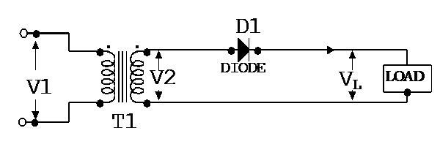

Deducing full-wave rectified voltage. In the Full wave rectifier, Dc component is larger than ripple.

USEFUL FORMULAS:

VL(DC) = 0.637V2

VL(AC) = 0.307V2

%RIPPLE = VL(AC)/VL(DC) = 48.2%

RIPPLE FREQUENCY = 2 x SUPPLY FREQUENCY

**Full-wave bridge rectifier :**

The full-wave bridge rectifier circuit requires four diodes. The transformer has only one secondary winding.

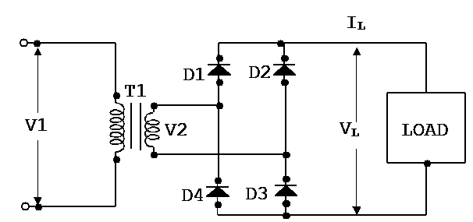

When V2 is positive, diodes D1 & D3 conduct current through the load. Diodes D2 and D4 block current flow. When V2 is negative, diodes D2 and D4 conduct current through the load. Diodes D1 and D3 block current flow. The full-wave bridge rectifier fully utilizes the transformer winding during both half cycles.

USEFUL FORMULAS:

VL(DC) = 0.637V2

VL(AC) = 0.307V2

%RIPPLE = VL(AC)/VL(DC) = 48.2%

RIPPLE FREQUENCY = 2 x SUPPLY FREQUENCY

**4.4 FILTER**

The 121% ripple in the output of the half-wave rectifier and 48% in the full-wave rectifier is more than can be normally tolerated. In the full wave filtering, wherein the frequency of the ripple is 100Hz for a 50Hz ac line voltage. This is an advantage where either an inductor is used to prevent the passage of the ripple current(due to its high inductive reactance to ac but quite low resistance to dc), or a capacitor is used to ‘short’ the ripple to ground but leave the dc to appear at the output. Various combinations of L and C are also used.

**4.5 VOLTAGE REGULATOR**

The simplest regulator is a large capacitor in parallel with the load. The capacitor stores DC voltage while the load voltage increases to its peak value. The capacitor converts the pulsating DC voltage of a rectifier into a smooth Dc load voltage.

Two important parameters of a capacitor regulator are its working voltage and its capacitance. The working voltage must be atleast equal to no-load output voltage of power supply. The capacitance determines the amount of ripple that appears on the Dc output when current is drawn from the circuit. The amount of ripple decreases with increase in capacitance.

**4.6 PWM**

It consists of High current NPN Darlington transistor pairs. All units feature common emitter, open collector output. Pulse width modulation (PWM) is a power technique for controlling analog circuit with a processor’s digital outputs. PWM is employed in a wide variety of application, ranging form measurement and communications to power control and conversion.It is used to drive load and speed control of the motor.

Pulse Width Modulation (PWM) is a technique to generate low frequency output signals from high frequency pulses. Rapidly switching the output voltage of an inverter leg between the upper and lower DC rail voltages, the low frequency output can be thought of as the average of voltage over a switching period

Fig 4.6.1 Circuit diagram of MJE 3055

PWM is employed in a wide variety of application, ranging form measurement and communications to power control and conversionIt consists of High current NPN Darlington transistor pairs. All units feature common emitter, open collector outputs.To maximize their effectiveness, these units contain suppression diodes for inductive loads and appropriate emitter base resistors for leakage. .It has a series base resistor to each Darlington pair, thus allowing operation directly with TTL or CMOS operating at supply voltages of 5.0V.Applications requiring sink currents beyond the capability of a single output may be accommodated by paralleling the outputs.

**4.7 ARDUINO UNO CONTROLLER**

The Arduino Uno is a microcontroller board based on the ATmega328. It has 14 digital input/output pins (of which 6 can be used as PWM outputs), 6 analog inputs, a 16 MHz crystal oscillator, a USB connection, a power jack, an ICSP header, and a reset button. It contains everything needed to support the microcontroller; simply connect it to a computer with a USB cable or power it with a AC-to-DC adapter or battery to get started. The Uno differs from all preceding boards in that it does not use the FRDI USB-to-serial driver chip. Instead, it features the Atmega8U2 programmed as a USB-to-serial converter.

Some of it’s features are:

* Microcontroller : ATmega328
* Operating Voltage : 5V
* Input Voltage (recommended) : 7-12V
* Input Voltage (limits) : 6-20V
* Digital I/O Pins : 14 (of which 6 provide PWM output)
* Analog Input Pins : 6
* DC Current per I/O Pin : 40mA
* DC Current for 3.3V Pin : 50mA
* Flash Memory : 32 KB of which 0.5 KB used by bootloader.
* SRAM : 2KB
* EEPROM : 1KB
* Clock Speed : 16 Mhz

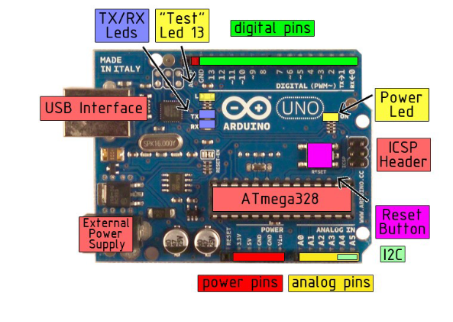

Fig. 4.7.1 Arduino board

The Arduino Uno can be powered via the USB connection or with an external power supply. The power source is selected automatically.

External (non-USB) power can come either from an AC-to-DC adapter (wall-wart) or battery. The adapter can be connected by plugging a 2.1mm center-positive plug into the board’s power jack. Leads from a battery can be inserted in the Gnd and Vin pin headers of the POWER connector.

The board can operate on an external supply of 6 to 20 volts. If supplied with less than 7V, however, the 5V pin may supply less than five volts and the board may be unstable. If using more than 12V, the voltage regulator may overheat and damage the board. The recommended range is 7 to 12 volts.

The power pins are as follows:

* **VIN.** The input voltage to the Arduino board when it’s using an external power source (as opposed to 5 volts from the USB connection or other regulated power source). You can supply voltage through this pin, or, if supplying voltage via the power jack, access it through this pin.
* **5V.** The regulated power supply used to power the microcontroller and other components o the board. This can come either from VIN via an on-board regulator, or be supplied by USB or another regulated5V supply.
* **3V3.** A 3.3 V supply generated by the on-board regulator. Maximum current draw is 50mA.
* **GND.** Ground pins.

**MEMORY:**

The Atmega328 has 32KB of flash memory for storing code (of which 0.5 KB is used for the boot loader); It has also 2KB of SRAM and 1 KB of EEPROM.

**Input And Output:**

Each of the 14 digital pins on the Uno can be used as an input or output, using pin Mode(), digital Write(), and digital Read() functions. They operate at 5 volts. Each pin can provide or receive a maximum of 40mA and has an internal pull-up resistor (disconnected by default) of 20-5- KOhms. In addition, some pins have specialized

functions:

* **Serial: 0 (RX) and 1(TX).** Used to receive (RX) and transmit (TX) TTL serial data. These pins are connected to the corresponding pins of the ATmega8U2 USB-to-TTL Serial chip.
* **External Interrupts: 2 and 3.** These pins can be configured to trigger an interrupt on a low value, arising or falling edge, or a change in value.
* **PWM: 3,5,6,9,10, and 11.** Provide 8-bit PWM output with the analog Write() function.
* **SPI: 10 (SS), 11 (MOSI), 12 (MISO), 13 (SCK).** These pins support SPI communication, which, although provided by the underlying hardware, is not currently included in the Arduino language.
* **LED: 13.** There is a built-in LED connected to digital pin 13. When the pin is HIGH value, the LED is on, when the pin is LOW, it’s off.

The Uno has 6 analog inputs, each of which provide 10 bits of resolution (i.e. 1025 different values). By default they measure from ground to 5 volts, though is it possible to change the upper end of their range using the AREF pin and the analog Reference() function. Additionally, some pins have specialized

functionality:

* **I2C: 4 (SDA) and 5 (SCL).** Support I2C (TWI) communication using the Wire library.
* **AREF.** Reference voltage for the analog inputs. Used with analog Reference().
* **Reset.** Bring this line LOW to reset the microcontroller. Typically used to add a reset button to shields which block the one on the board.

Characteristics:

The maximum length and width of the Uno PCB are 2.7 and 2.1 inches respectively, with the USB connector and power jack extending beyond the former dimension. Three screw holes allow the board to be attached to a surface or case. Note that the distance between digital pins 7 and 8 is 160 mil (0.16’’), not an even multiple of the 100 mil spacing of the other pins.

Features:

* Advanced RISC Architecture
* 131 Powerful Instructions- Most Single Clock Cycle Execution
* 32 x8 General Purpose Working Registers
* Fully Static Operation
* Up to 20 MIPS Throughout at 20 MHz
* On-chip 2-cycle Multiplier
* High Endurance Non-volatile Memory Segments

ATMEGA:

The ATmega48PA328P AVR is supported with a full suite of program and system development tools including: C Compilers, Macro Assemblers, Program Debugger/Simulators, In-Circuit Emulators, and Evaluation kits.

Pin description of ATMEGA:

**VCC**

1 supply voltage.

**GND**

Ground

**Port B (PB&:0) XTAL!/XTAL2/TOSC1/TOSC2**

Port B is an 8=bit bi-directional I/O port with internal pull-up resistors (selected for each bit). The Port B output buffers have symmetrical drive characteristics with both high sink and source capability. As inputs, Port B pins that are externally pulled low will source current if the pull-up resistors are activated. The Port B pins are tri-stated when a reset condition becomes active, even if the clock is not running. Depending on the clock selection fuse settings, PB6 can be used as input to the inverting Oscillator amplifier and input to the internal clock operating circuit. Depending on the clock selection fuse settings, PB7 can be used as output from the inverting Oscillator amplifier.

If the Internal Calibrated RC Oscillator is used as chip clock source, PB7..6 is used as TOSC2..1 input for the Asynchronous Timer/Cpunter2 if the AS2 bit in ASSR is set.

**Port C (PC5:0)**

Port C is a 7-bit bi-directional I/O port with internal pull-up resistors (selected for each bit). The PC5..0 output buffers have symmetrical drive characteristics with both high sink and source capability. As inputs, Port C pins that are externally pulled low will source current if the pull-up resistors are activated. The port C pins are tri-stated when a reset condition becomes active, even if the clock is not running.

**PC6/RESET**

If the RSDTISBL Fuse is programmed, PC6 is used as an I/O pin. Note that the electrical characteristics of PC6 differ from those of the other pins of Port C. If the RSTDISBL Fuse is un programmed, PC6 is used as a Reset input. A low level on this pin for longer than the minimum pulse length will generate a Reset, even if the clock is not running. The Shorter pulses are not guaranteed to generated a Reset.

**Port D (PD7:0)**

Port D is an 8-bit bi-directional I/O port with internal pull-up resistors (selected for each bit). The Port D output buffers have symmetrical drive characteristics with both high sink and source capability. As inputs, Port D pins that are externally pulled low will source current if the pull-up resistors are activated. The Port D pins are tri-stated when a reset condition becomes active, even if the clock is not running.

**AVCC**

AVCC is the supply voltage pin for the A/D Converter, PC3:0. And ADC7:6. It should be externally connected to VCC, even if the ADC is not used. If the ADC is used, it should be connected to VCC a low-pass filter. Note that PC6..4 use digital supply voltage, VCC.

**AREF**

AREF is the analog reference pin for the A/D Converter.

**ADC7:6 (TQFP and QFN/MLF Package Only)**

In the TQFP and QFN/MLF package, ADC7:6 serve as analog inputs to the A/D converter. These pins are powered from the analog supply and serve as 10-bit ADC channel

**PIN DIAGRAM**

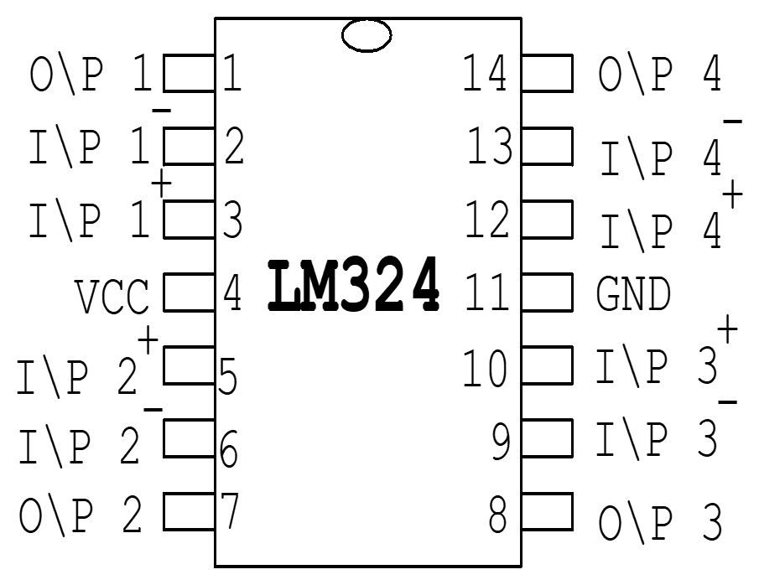

Fig 4.8.1 Pin Diagram of LM324

**4.8 555 TIMER**

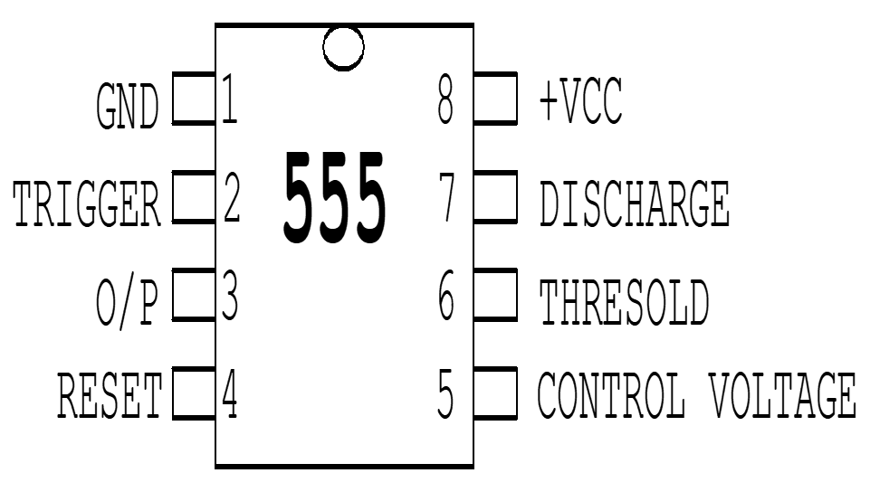

**INTRODUCTION:**

The 555 timer is a highly stable device for generating accurate time delay or oscillation. The 555 timer contains two 555 timers and is a 14 pin o/p. A single 555 timer can provide time delay ranging from microseconds to hours. The 555 timer can be used with supply voltage in the range of +5v to +18v and can drive load upto 200mA. Various application include oscillator, pulse generator, ramp and square wave generator, mono-shot multivibrator, burglar alarm, traffic light control and voltage monitor

**OPERATION**:

555 timer consist of three 5k-2 internal resistor acts as voltage divider, providing bias voltage of (2/3vcc) to the upper comparator (UC) and (1/3vcc) to the lower comparator (LC), where Vcc is the supply voltage. Since these two voltages fix the necessary comparator threshold voltage, they also aid in determining timing interval. It is possible to vary time by applying a modulation voltage to the control voltage input terminal.

In the stable state, the output q of the control flip flop is HIGH. This makes the output Low because of power amplifier, which is basically an inverter. A negative going trigger pulse is applied to pin2 and should have its dc level greater than the threshold of the lower comparator (i.e. Vcc/3). At the negative going edge of the trigger, as the trigger passes through (Vcc/3), the output of the lower comparator goes HIGH and sets the FF. During positive cycle, when the threshold voltage passes through (2/3Vcc), the output of the upper comparator goes HIGH and resets the FF.

The reset input provides a mechanism to reset the FF in a manner, which overrides the effect of any instruction coming to FF from lower comparator. Which reset is not used, it is returned to Vcc. The transistor Q2 serves as a buffer to isolate the reset input from the FF and transistor Q1.

In this mode operation the timer acts as a one shot. The external timing capacitor Ct is held initially discharged by the transistor inside the timer. Upon application of a negative pulse to pin2, the flip-flop is set which releases the short circuit across the external capacitor and driver the output high. The voltage across the capacitor, now rises exponentially with the time constant RtCt. When the voltage across the comparator resets the flip-flop which in turn, discharges the capacitor rapidly and drives the output to its low state. The circuit resets in this state till the arrival of the next pulse.

**A STABLE OPERATION**:

The external capacitor charges through RA and RB and discharges through Rb only. Thus the duty cycle may be set precisely by the ratio of these two resistors. In this mode of operation, the capacitor charges and discharges between 1/2Vcc and 2/3Vcc. As in the triggered mode, the charge and discharge time and hence the frequency is independent of supply voltage.

**BISTABLE OPERATION**:

555 timers can also function as bistable flip flop in such application as TTL compatible drivers.

**MONO STABLE OPERATION**:

555 timers can also function as monostable flip flop in such application as timer.

**4.9 KEYBOARD ENCODER**

Keyboard encoder IC to generate BCD code for every key passing. It is a keyboard entry device to Binary coded decimal encoder. It is a part of our project system’s input device. It contains 18 pins IC 74C922, press button assembly having 12 nos. Of buttons. For every button press parallel BCD output goes to micro controller. This will be interlocked with the input card entry device with password facility as a security point of view. It contains 18 pins IC 74C922, press button assemble having 12 nos. Of buttons. After inserting the input card entry, necessary car desk’s password numbers have to be pressed on the press button assembly. For every button press parallel BCD output goes to micro controller via pins nos: 1,2,17 and 18 of IC 74C922. IC74C922 operates under crystal frequency of 4MHZ.

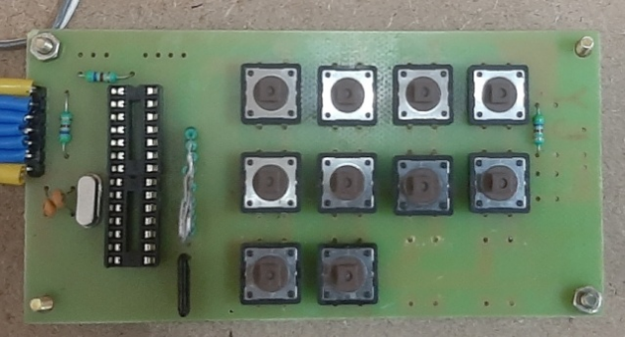

Fig. 4.9.1 Keyboard Encoder

**4.10 BUZZER**

The piezoelectric type uses the piezoelectric ceramic’s piezoelectric effect and pulse current to make the metal plate vibrate and generate sound. This kind of buzzer is made with a resonance box, multi resonator, piezoelectric plate, housing, impedance matcher, etc. Some of the buzzers are also designed with LEDs. The multi resonator of this mainly includes ICs and transistors. Once the supply is given to this resonator, it will oscillate and generated an audio signal with 1.5 to 2 KHz. The impedance matcher will force the piezoelectric plate to produce sound.

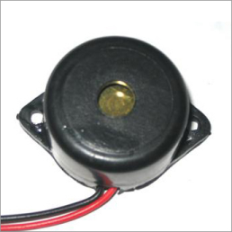

Fig. 4.5.1 Buzzer

**4.11 LCD DISPLAY**

LCD is essentially used for expose the information. Here we are using 2x16 LCD. It is used to display numbers, texts and graphics. This is in contrast to LEDs, which are limited to numbers and characters. The LCDs are fragile with only a few millimeter thickness. Since the LCDs utilize less power, the y are efficient with low power electronic circuits, and can be charged for long terms. The LCDs don’t provoke light and so light is needed to read the display. The LCDs have long lasting life and a wide operating temperature range.

An LCD consists of two Glass Panels, with the liquid crystal material sandwiched in between them. The inner surface of the Glass plates is coated with transparent electrodes which define the character, symbols or patterns to be displayed. Polymeric layers are present in between the electrodes and the liquid crystal, which makes the liquid crystal molecules to maintain a defined orientation angle.

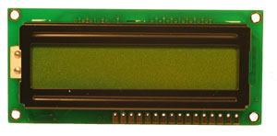

Fig. 4.11.1 LCD Display



Fig 4.11.2 Block diagram of LCD

**CHAPTER 5**

**RESULTS AND DISCUSSION**

**5.1 RESULTS**

Thus the Vehicle distance detection using Ultrasonic sensors and Micro Controller is successfully explained and implemented. This model helps to avoid road accidents and increases the stability of the vehicle.

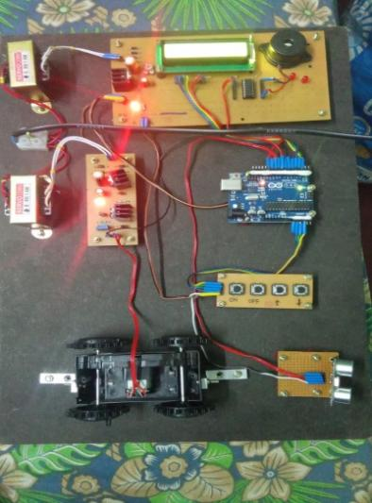

Fig. 5.1.1 Implemented Prototype

**OUTPUT:**

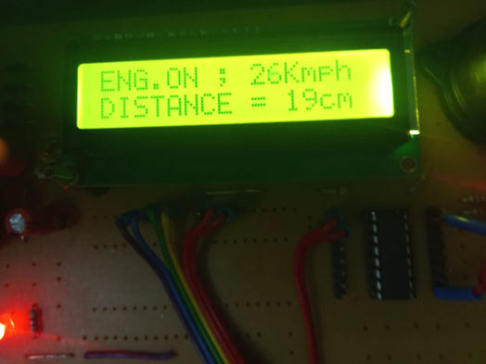 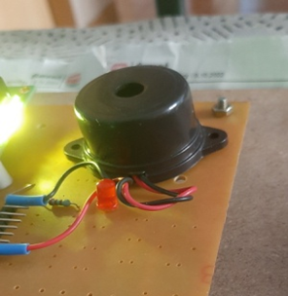

Fig 5.1.2 Fig 5.1.3

**5.2** **COST ESTIMATION**

|  |  |
| --- | --- |
| **COMPONENTS** | **COST** |
| ARDUINO UNO | 1000 |
| Ultrasonic sensor | 1300 |
| PWM | 4000 |
| Keyboard to BCD encoder | 150 |
| ULN Driver | 300 |
| Buzzer | 100 |
| Dc motor | 300 |
| LCD display | 2500 |
| Wooden base and others | 1500 |
| **TOTAL** | **8000 (appx.)** |

**CHAPTER 6**

**CONCLUSION**

This project on **“ULTRASONIC SENSOR BASED DISTANCE MEASUREMENT WITH COLLISION & ACCIDENT AVOIDANCE SYATEM INCLUDING DYNAMIC SPEED GOVERNOR** is working fire, getting the parameter envisaged during the conceptual stage. During the design, as well as during the construction, greater care has been put in to avoid hiccups at the final stage. The PCB layouts were prepared with at most care to incorporate the circuits in a modular manner. The circuit is made as simple as to our knowledge. Also components and cost. It was a very interesting process of developing the prototype, stage by stage and testing the same. We have to go through fairly large pages of data related to the components etc. It was a useful and fulfilling assignment to get the project completed in time. This gave as a sense of satisfaction and accomplishment

**CHAPTER 7**

**REFERENCES**

[1] X. Xiong, M. Wang, Y. Cai, L. Chen, H. Farah and M. Hagenzieker, "A forward collision avoidance algorithm based on driver braking behavior", Accident Analysis and Prevention, vol. 129, pp. 30-43, 2019

[2] Sandeep Thorat, Sanket Thorve, Jaydatta Upase and Agampal Singh Dhupar, "Design and Implementation of Automatic Emergency Braking System", International Journal of Current Engineering and Technology INPRESSCO E-ISSN 2277-4106 P-ISSN 2347-5161, March 2016

[3] D. Setiady, O. Wahyunggoro and P. Nugroho, "Design of automatic braking system using interval type-2 fuzzy logic system", Journal of Physics: Conference Series, vol. 1373, no. 1, 2019.

[4] Automated anti-collision system for automobiles, IEEE;Tasneem Sanjana; Kazi Ahmed Asif FuadAmerican International University Bangladesh, Dhaka, Dhaka District, BD; Mehrab Masayeed Habib; Ahmed Amin Rumel ,10.1109/ECACE.2017.7913024

[5] Research on Intelligent Anti-collision System for Automobile Driving Based on Machine Vision, Honghua Zao, Xiaolan Gao Published in: 2023 International Conference on Mechatronics, IoT and Industrial Informatics (ICMIII),DOI:10.1109/ICMIII58949.2023.00105

[6] An Adaptive Anti-Collision Protocol Based on Collision Tree for RFID Systems of IoT Published in: 2018 10th International Conference on Communication Software and Networks (ICCSN) Qinshu Liu,Jie Xu,Le Yang, DOI: 10.1109/ICCSN.2018.8488298

[7] A Smart Anti-Collision System for Car Doors, Jahnavi Chinthaguntla; Srinivasa Rao Gummadi; Gunteiah Upputuri; Jayanth Tulluri; Niharika Dharavath, Published in: 2023 Innovations in Power and Advanced Computing Technologies (i-PACT), DOI: 10.1109/i-PACT58649.2023.10434554