**EVALUATION OF ANTHELMINTIC ACTIVITY OF CAESALPINIA PULCHERRIMA LEAF EXTRACT BY IN-SILICO AND IN-VITRO STUDIES**

**Indrapati Mamatha1, Saadana Yekkaldev2, Sk. Sushma Taj**

1. Assistant Professor, department of pharmaceutical chemistry, Joginpally B.R. Pharmacy College, Hyderabad.
2. Student of Joginpally B.R. Pharmacy College, Hyderabad.
3. Assistant Professor, department of pharmaceutics, Joginpally B.R. Pharmacy College, Hyderabad.

Corresponding author: Indrapati Mamatha, 770292508, mamatha6101@gmail.com

**Abstract:**

The Greek term for "helminthes" means "worm." Human-infecting parasites fall into one of two categories: keepsakes or heirlooms. Heirlooms are parasites that have been passed down from African ancestors, while souvenirs are parasites that humans have picked up from animals through migration, evolution, and agricultural activities. These helminthic infections are the most prevalent human infectious agents in poor nations. The helminthic parasite affects around 2 billion people worldwide, or more than 25% of the total population. It is a big problem in developing nations, particularly for young people. Therefore, the goal of the current study was to extract the plant's active ingredients and test the crude extract's anti-helminthic properties. In this study, we worked on the ceasalpenia pulcherima plant with a focus on natural remedies for the treatment of helmintiasis. The chief scientist of Sri Konda Laxman Telangana State Horticulture University, Floriculture Research Station, Rajndranagar, authenticated the true nature of the plant. Water and ethanol were utilized in the extraction procedure. To find out what chemicals are in the alcoholic extract, a screening test is performed on it. The flavonoid test on the extract came out positive. Using Albendazole as the prescribed medication, the anthelmintic action was carried out on Indian earthworms. In Indian earth worms, we found that alcoholic extract exhibits good antihelmintic action. By Insilco studies we found the interaction of flavanoids with antihelmentic proteins.

**Key words:** Helminthes, ceasalpenia pulcherima, flavonoids, extractioin, in silico study.

**Introduction:**

**Plant profile: Caesalpinia Pulcherrima**

**CLASSIFICATION:**

Kingdom: Plantae Order: Fabales Family: Fabaceae

Subfamily: Caesalpinioideae Genus: Caesalpinia

Species: Caeaslpinia Pulcherrima

It is a [shrub](https://en.wikipedia.org/wiki/Shrub) growing to 3 m tall. In climates with few to no frosts, this plant will grow larger and is semievergreen. In Hawaii this plant is evergreen and grows over 5 m tall. Grown in climates with light to moderate freezing, plant will die back to the ground depending on cold, but will rebound in mid- to late spring. This species is more sensitive to cold than others. The [leaves](https://en.wikipedia.org/wiki/Leaf) are bipinnate, 20–40 cm long, bearing three to 10 pairs of pinnae, each with six to 10 pairs of leaflets 15–25 mm long and 10–15 mm broad. The [flowers](https://en.wikipedia.org/wiki/Flower) are borne in [racemes](https://en.wikipedia.org/wiki/Raceme) up to 20 cm long, each flower with five yellow, orange, or red petals. The [fruit](https://en.wikipedia.org/wiki/Fruit) is a [pod](https://en.wikipedia.org/wiki/Legume) 6–12 cm long.[18]

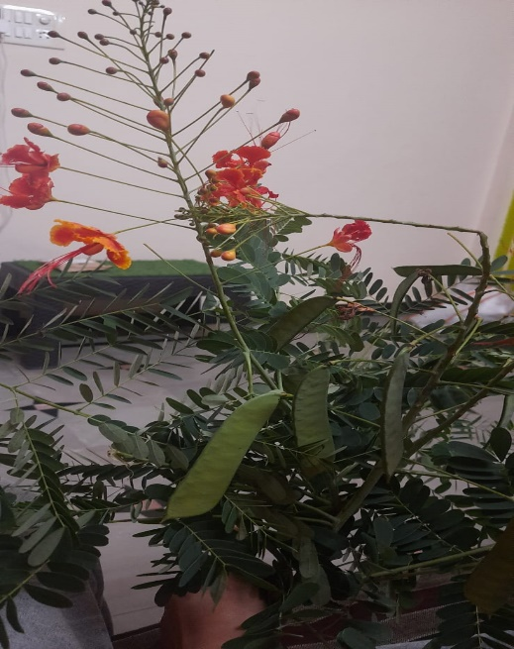The Pride of Barbados is an evergreen shrub or small tree that is a member of the Fabaceae or legume family. It is originally from Mexico and the Caribbean and has beautiful showy orange-red flowers, fern-like leaves, and prickles on its stems and branches. It is the national flower of Barbados [19]

**Chemical constituents:**

Various Phytoconstituents have been isolated from the various parts of Caesalpinia Pulcherrima Linn. Caesalpinia pulcherrima is rich source of polyphenols, Flavonoids [20]

**Pharmacological actions:** Antioxidant Activity, Anticancer Activity, Immunosuppressive Activity, Antidiabetic Activity, Anti-Inflammatory Activity, Anti-Microbial Activity, Vaso relaxing Effect, Abortifacient , Cathartic [20]

**MATERIALS** **AND** **METHODS**

**Materials:** Plant material, Grinder, beakers, soxlet apparatus, Whattman Filter paper, funnel, rotary evaporator, china dish, desiccators, Petridishes, Indian Earthworms.

Plant material:

The leaves of Caesalpinia Pulcherrima were collected from local areas of Ranga Reddy, Hyderabad, India. The plant material was collected during morning hours. They were authenticated, by Dr.P.Prasanth, Principal scientist (Horti and Head) Sri Konda Laxman Telagana state Horticultural University, Floricultural Research Station, ARI ,Rajendra Nagar, Hyderabad - 500030, India.

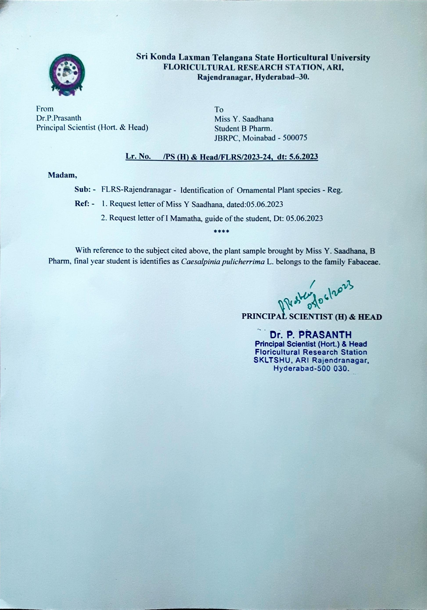

**Chemicals Used:** 99.9% Ethanol was collected from lab needs, Hyderabad, Telangana.

Methods: plant extraction is done by maceration and Soxhletion process. Anthelmintic activity was determined by molecular docking study (Auto dock & discovery studios) to identify compounds having maximum activity against Tubulin Colchicine protein & in vitro studies were carried out on Indian earthworm

Preparation of extract :

The sufficient amount of plant materials was collected and brought to the laboratory and washed thoroughly [3times] with clean tap wate . After that, it was air dried completely under shade area. The resulting powder was sieved, weighed and stored in clean stopper bottles and kept in dry place until the extraction process was started. In plant prepartion, extraction is first crucia step. The powdered plant material was prepared and kept in dried place were subjected to 99.9% Ethanol as solvent using cold maceration and soxhlet extraction technique.

Ethanol was the most preffered solvent based on the access to the alcohols and general solvent and most perferred solvent for plant extraction possibly owing to its polar nature that ensure the release of several bioactive compounds from the plants. It has been proven that high polarity solvents should be used to extract different bioactive compounds with high accuracy. Fruitful results of active compound in plant mainly depend upon the solvent used for herbal formulation.

The powdered specimen was then subjected to extraction using 99.9% Ethanol by cold maceration and soxlet extraction technique.A total of 300g of the powdered material was separately soaked and then followed by soxlet extraction where the plant material was properly wrapped within the filer paper [Whatman No.1] with ethanol in R.B flask at 70℃ for 72 hrs. Then, the extract was

again filtered using filter paper and was extracted using Rotary Evaporator, to evaporate Ethanol at 60℃wit 60 RPM and kept in hot air oven to obtain pure crude extract .The extract were taken weighed to know the yield of plant and recored .

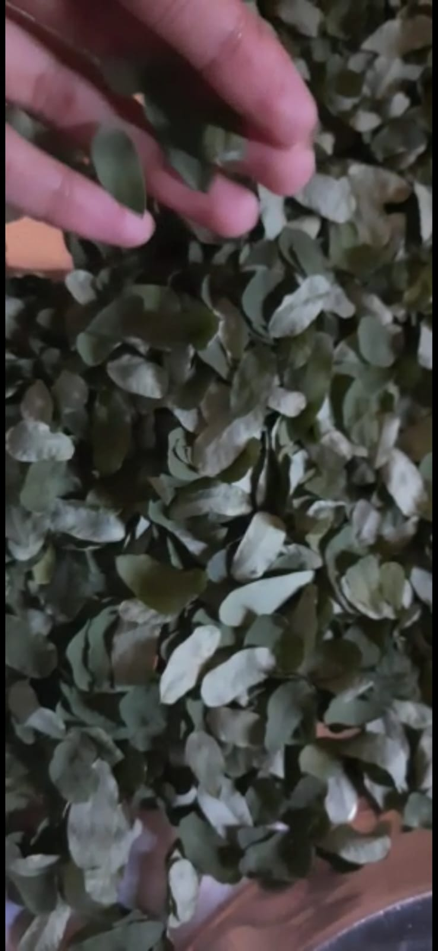 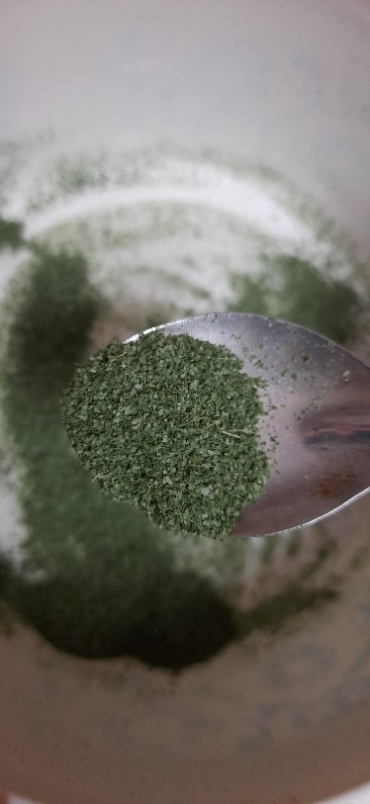

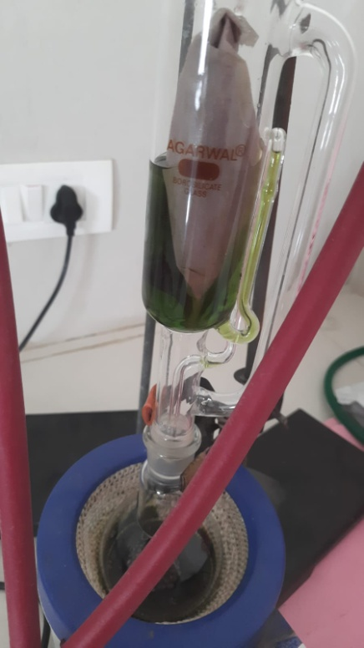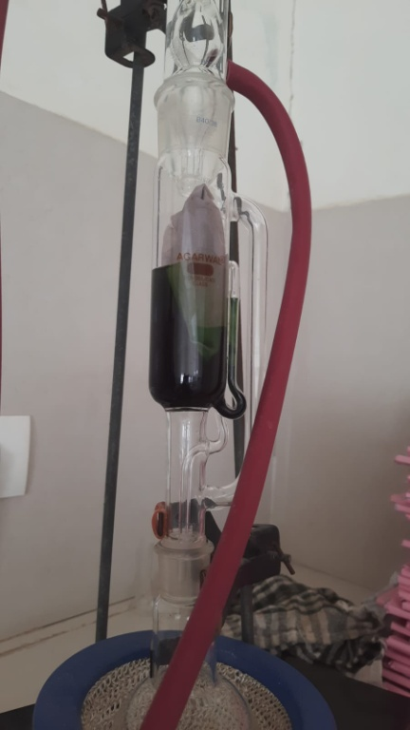

Soxhlet Extraction of C.pulcherrima Leaves by ethanol

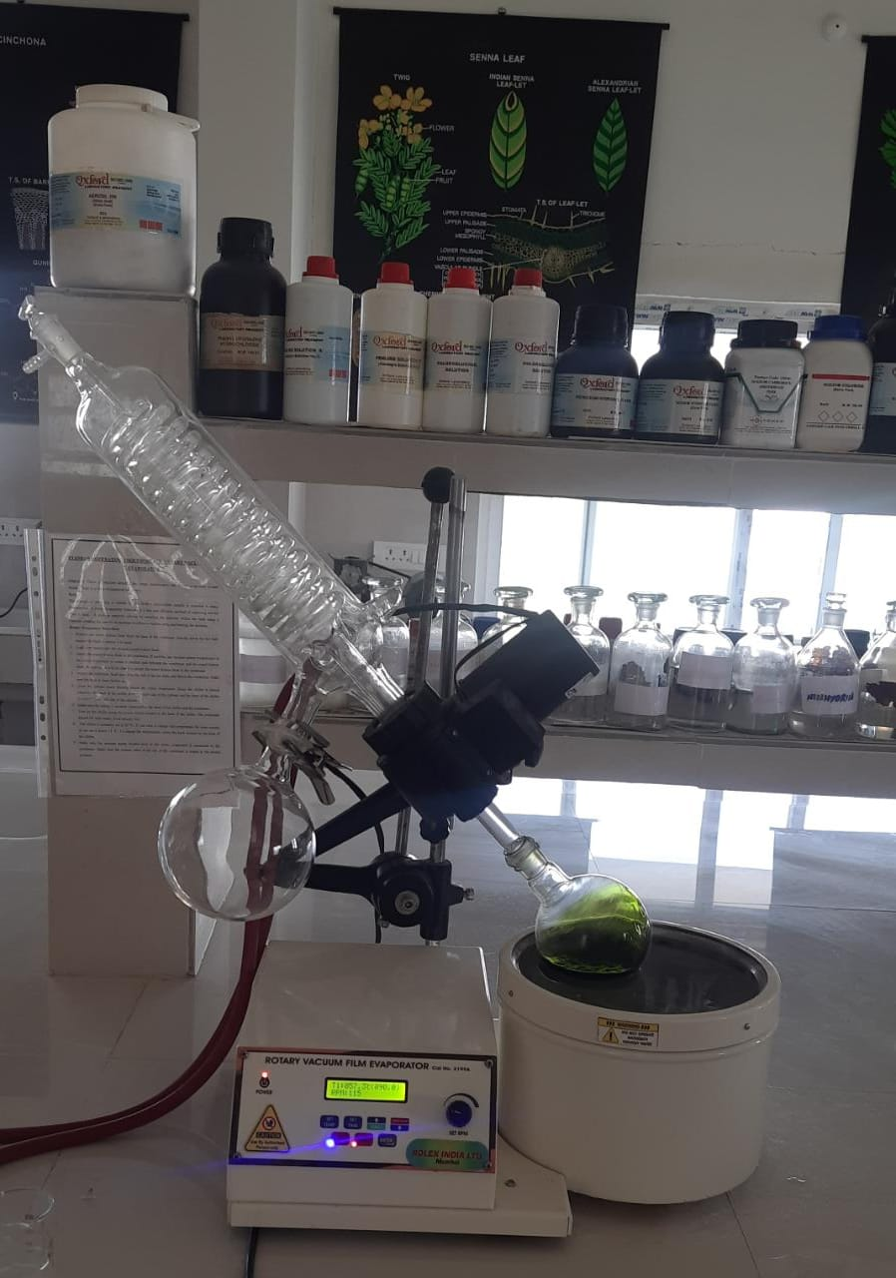

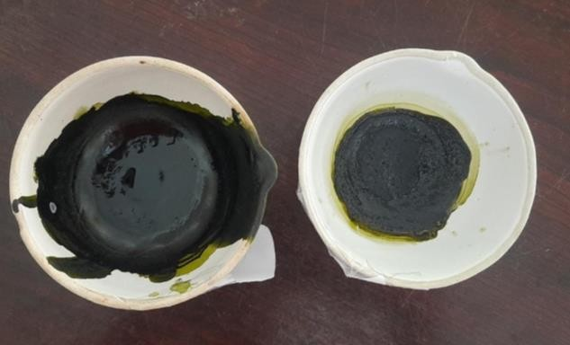Rotary vaccum evaporator

**Phytochemical study:**

Phytochemical analysis:

Preliminary phytochemical screening of aqueous and ethanolic extracts of Caesalpinia Pulcherrima leaves was performed for the detection of the Constituents that were responsible for the activity.

**1 Test for alkaloids:**

To the extracts dilute hydrochloric acid was added and filtered. The filtrate was treated with various alkaloid reagents. [61]

a) Mayer’s test:

When the filtrate was treated with Mayer’s reagent, Potassium Mercuric iodine solution, appearance of cream colored precipitate indicated the presence of alkaloid. [61]

b) Dragendorff’s test:

When the filtrate was treated with Dragendroff’s reagent, potassium bismuth iodine solution, appearance of orange brown precipitate indicated the presence of alkaloids. [61]

c) Hager’s test:

The filtrate when treated with Hager’s reagent, picric acid, appearance of yellow color precipitate indicated the presence of alkaloids. [61]

2 **Test for Carbohydrates**:

Small quantities of the extracts were dissolved in 4ml of distilled water filtrated. The filtrate was subjected to following tests.

a) Fehling’s test:

The extracts were treated with Fehling solution A and B. The appearance of reddish brown color precipitate indicated the presence of reducing sugars. [61]

b) Benedict’s test:

The extracts were treated with Benedict’s reagent; the appearance of reddish orange color precipitate indicates the presence of reducing sugars. [61]

3 **Test for Steroids:**

a) Liebermann Burchard test:

The extracts were treated with 3ml of acetic anhydride, few drops of glacial acetic acid followed by a drop of concentrated sulphuric acid. Appearance of bluish green color indicated the presence of steroids. [61]

b) Salkowski’s test:

The extracts were treated with 3ml of acetic anhydride, concentrated sulphuric acid drops. Appearance of yellow color indicated the presence of steroids. [61]

4 **Test for Tannins**:

a) The extracts were treated with 10% lead acetate solution. Appearance of white precipitate indicated the presence of tannins. [61]

b) The extracts were treated with aqueous bromine solution. Appearance of white color precipitate indicated the presence of tannins. [61]

7.3.5 Test for Phenolic compounds:

a) The extracts were treated with neutral ferric chloride solution. Appearance of violet color indicated the presence of phenolic compounds. [61]

b) The extracts were treated with 10% sodium chloride solution. Appearance of cream color indicated the presence of phenolic compounds. [61]

**5. Test for Flavonoids:**

a) Zinc hydrochloride test:

To the test solution, add a mixture of zinc dust and concentrated hydrochloric acid. It gives red color after few minutes. [61]

b) Shinoda’s test:

The extracts were dissolved in alcohol to which few magnesium turnings were added followed by concentrated HCl drop wise and heated. Appearance of magenta color shows the presence of flavonoids. [61]

6 .**Test for Glycosides:**

When a pinch of the extracts were treated with glacial acetic acid and few drops of ferric chloride solution, followed by the addition of concentrated sulphuric acid, formation of red ring at the junction of two liquids indicates the presence of glycosides. [61]

7. **Test for Saponins:**

Foam test:

About 1ml of the extracts were diluted to 20ml with distilled water and shaken well in a test tube. The formation of foam in the upper part of the test tube indicated the presence of saponins. [61]

8.**Test for Fixed oils:**

Mix 1ml of 1% copper sulphate solution and 5 drops of the extract. Then add 5 drops of 10% sodium hydroxide solution. A clear blue colour solution was obtained which indicates the presence of fixed oils.[61]

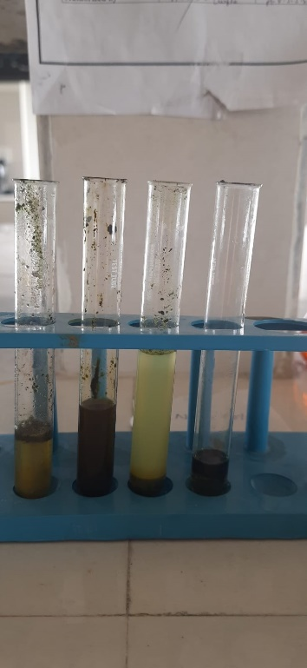

**Identification test of flavonoids**

**In silico molecular docking study**

For molecular docking study, Autodock is used to predict the potent active compound of Caesalpinia pulcherima against the active site of TUBULIN COLCHICINE enzymes.

**Protein and Ligand Preparation:**

In case of the protein preparation, the 3D structure of TUBULIN-COLCHICINE receptor was obtained from the Protein Data Bank (PDB: 1SAO). Afterward, the structure was prepared and refined using the protein preparation wizard [Discovery studios] [Biovia] where charges and bond orders were assigned, hydrogens were added to the heavy atoms, selenomethionines were converted to methionine, and all waters portion were removed. On the othe hand, certain thiol and hydroxyl groups were reoriented, and amide groups of asparagines, glutamine, and imidazole ring of histidines, protonation states of histidines, glutamic acidand aspartic acids were optimized at neutral pH.

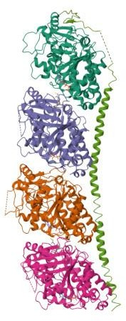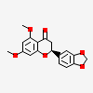

**Protein : TUBULIN-COLCHICIN Ligand**

5,7-dimethoxy-3’4’-methylenedioxyflavanone, was the ligand selected by collected literature review. Molecular Formula is C18H16O6. Molecular weight: 328.3g/mol. Computed by pub chem release 2021.05.07. It is natural product found in Caesalpinia Pulcherriama [63].Ligand optimization or refined using chem draw3D.

**Result & discussion**:

PRELIMINARY PHYTOCHEMICAL ANALYSIS:

The results of preliminary phytochemical screening is present in Table 3.Qualitative Phytochemical studies wrew performed on ethanolic and aqueous extract of Caesalpinia Pulcherrima leaves using suitable chemicals and reagents to confirm the presence of phenolics, steroids, flavonoids, lipids, and tannins.

|  |  |  |
| --- | --- | --- |
| Phytochemical constituents | Aqueous extract | Ethanolic extract |
| Carbohydrates | - | + |
| Phenols | + | - |
| Glycosides | + | - |
| Alkaloids | + | - |
| Flavonoids | + | - |
| Tannins | + | - |
| Steroids | - | + |

“+” indicates the presence “-“ indicates the absence **Table 3**

INSILICO STUDIES :

in this study, compound isolated from Caesalpinia pulcherima leaves were isolated for molecular docking study and the results shown in the table. Molecular docking showed that has the best docking score against TUBULIN COLCHICINE which is -7.37kcal/mol. Interactions between ligand and protein have been presented below

|  |  |
| --- | --- |
| Binding Energy | -7.37 |
| Ligand efficiency | -0.31 |
| Inhib constant | 3.94 |
| Inhib constant units | uM |
| Intermol energy | -8.27 |
| Vdw_ hb_ deolv_energy | -8.4 |
| Electrostatic _energy | 0.13 |
| Total internal | 0.48 |
| Torsionsl energy | 0.89 |
| Unbound energy | 0.48 |
| Filename | dock.dlg |
| clRMS | 0.0 |
| refRMS | 158.26 |
| rseed1 | None |
| rseed2 | None |

Table-2: Molecular Docking results of ligand and protein .The binding score was found to be -7.37kcal/mol

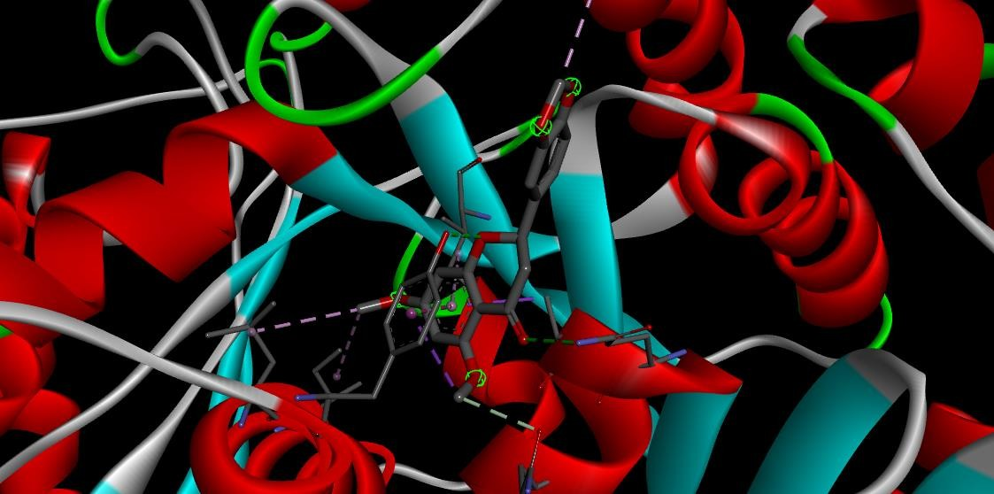

**3D Molecular Docking of Protein and Ligand**

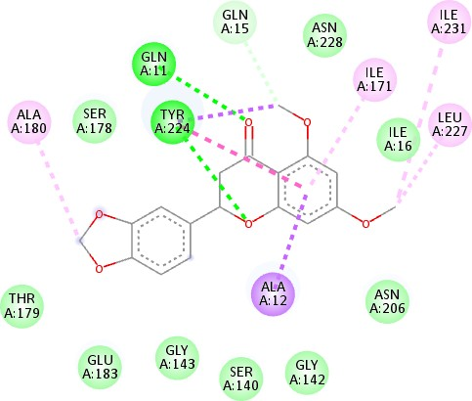

Docking results of 5,7-dimethoxy-3’4’-methylenedioxyflavanone with TUBULIN- COLCHICINE enzyme [PDB:1SAO] for anthelmintic activity .The colors indicate the residue.Interactions with the protein are marked with lines between ligand and protein residues.

**In-vivo studies :**

The shade dried leaves of Caesalpinia pulcherrima were pulverized into coarse particles and extracted with absoulte ethanol and distilled water using soxhlet extractor for 72 hrs and extract with absoulte extarct by cold maceration for 72hrs. Both the aqueous and ethanol extracts were concerated in rotary evaporator at temperature less than 45℃ and preserved in desiccator for further use. The yeild for ethanolic extract and aqueous extract were 49.6% and 46.08%, respectively. The preliminary phytochemical analyis were carried out to find phtoconstituents presnt in crude extract.

Indian earthworm Pheretima posthuma were collected , the average size of earthworm being 6- 8cm. They were washed with tap water to remove adhering dirt and soil particles.

Breifly, 10ml formulations containing three different concentarions, each of crude aloholic extract of leaf [5,10,15ml] were prepared and six earthworms were placedin it. Both the test solution and standard drug solution were freshly prepared and time for paralysis was noted when no movement of any sort could be observed except when the worms were vigorously shaken. The time of death of worms was recorded after ascertaining that the worms neither moved when shaken vigorously nor when dipped in warm water at 50℃. A maximum time period of 120mins was ascertained for the paralyzing as well as death time of pheretima posthuma worms. Albendazol was used as reference standard with distilled water as the vehicle control.

From the observations made, a dose dependent paralytic effect much earlier and the time of death was observed in Table 5. Although ethanolic extarct appeared to be more effective for worms.Evaluation of anthelmintic was compared with standard Albendozole. The Ethanolic extract of leaf of Caesapinia Pulcherrima, caused paralysis at 08.20 mins and time of death at 24 mins for pheretima posthuma and standard drud Albendazole showed 25.00 and 40 mins, respectively.

The anthelmintic Activity of Ethanolic Extract of Ceasalpinia Pulcherrima leaf on Indian Earthworm pheretima posthuma was indicated in table:5 as follows

|  |  |  |  |
| --- | --- | --- | --- |
| Groups | Concentrations [mg/ml] | Pheretima Posthuma | |
| Paralyzing time [mins] | Death time [mins] |
| Distilled Water | NA | NA | NA |
| Ethanoloic Extarct of C.Pulcherrima leaf | 5  10  15 | 8:20mins 7:00mins 3:20 mins | 24mins 20mins 16mins |
| Albendazol | 10mg | 5mins | 18mins |

Table: 3 Anthelmintic activity of ethanolic extract of Ceasalpinia pulcherrima leaf

The anthelmintic Activity of Ethanolic Extract of Ceasalpinia Pulcherrima leaf on Indian Earthworm pheretima posthuma was indicated in graph -1 as follows

30

25 24

20

20

18

16

15

15

10

10

5

5

5

0 0

0

8:20

7:00

3:20

0

0

Distilled water Ethanolic Extract

of

Albendazole

Concentrations

Paralysis time [mins]

Death time[mins]

Graph:1 Anthelmintic activity of ethanolic extract of Caesalpinia Pulcherrima leaf on Indian Earthworm Pheretima Posthuma

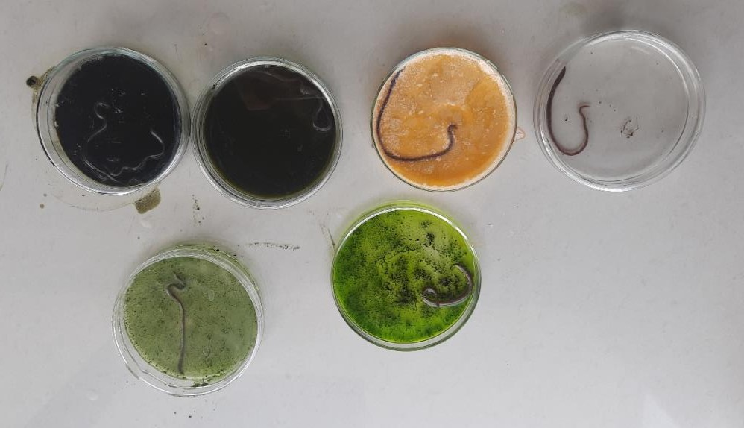

Anthelmintic action of drug on different concentrations

DISCUSSION

The Problem of anthelmentic activity resistance, toxicity and the increasing concern over the presence of drug residues in animal product has led to a renewal of interest in the use of plant based drugs. Plant materials evaluated in the current study has been identified from various sources to serve as anthelmintic agent by traditional healers of. The invivo test using free living stages of parasitic nematodes offer a means of evaluating the anthelmintic activity of new plant compounds [63]. In vitro techniques are preferred to in vivo methods due to their low cost, simplicity, and rapid turnover [64]. Plant-derived natural products have gained attention as a potential source of new therapeutic agents. The medicinal properties of plants have been investigated due to their potent pharmacological activities, low toxicity, and economic viability. Moreover, most of the clinically active drugs are from natural products which indicate the importance of drugs having natural sources in drug discovery process. So, it is essential to study the medicinal plants so that the discovery of active natural products ingredient can be identified for healing diseases and then the identified active ingredients could be synthesized in the laboratory[64]. Helminths infection is considered to be a significant problem in human and animals that leads to a chronic and devastating disease which ultimately leads to death and also causes drug resistance to other diseases. To prevent infection of helminths, there is a need for studies focusing on natural products such as medicinal plants which give new bioactive compounds having no or fewer side effects, easily available to the peoples of developing countries and more importantly, they have the best compatibility with human physiology than conventional drugs

In the current study, a significant association was noted between graded concentartions of the extract, the exposure test time interval and mortality of the earthworm.

Considerable experimental data from earthworm studies haveshown tha ethanolic extract of Ceasalpinia Pulcherrima leaf exposure produces pronounced anthelemintic activity. This experimental model is an suitable one to evaluate the potential of new anthelinitic agents with an anthelmintic effect.Hence the focus of the present work was to evaluate the effect and possible mechanism underlined.

In the present study, showed 100% efficacy of the plant extract of leaves of Caeasalpinia Pulcherrima against the earthworms at the concentration of 15mg/ml which was the highest efficacy value and was comparable with the standard anthelmintic,Albendazole.administration of ethanolic extract of Ceasalpinia Pulcherrima had significantly shown its anthelimintic action in dose dependent manner.The whole plant of Cesalpinia Pulcherrima is documented to possess medicinal properties antitumour (Che et al., 1986, Patel et al., 1997) and antimicrobial properties (Ragasa et al, 2002). Some differences on the percentage yield of these extract materials among the plants might be due to the difference on the nature of plant species, chemical composition differences of the extracts, different environmental conditions which create differences in phytochemical constitution, and harvest time. Furthermore, the solvents and test protocols used during extraction promote difference in concentrations and classes of secondary bioactives present in extract.

Our current study concludes that EECPL has been found to possess significant anthelmintic potential in a dose-dependent manner. This activity may be due to the presence of bioactive phytoconstituents such as alkaloids, tannins, flavonoids and saponins and also a considerable amount of condensed tannins. Some of these phytoconstituents such as alkaloids, tannins, phenols etc. may be responsible for the significant anthelmintic activity. Here, alkaloids can produce paralysis by acting on the central nervous system (CNS) whereas tannins and polyphenols selectively bind to free proteins present in the GI tract (gastrointestinal tract) and eventually cause mortality. On the other hand, the anthelmintic efficacy of saponins is due to its membrane permeabilising property. The anthelmintic activity of the EECPL may be due to a single compound or combined effect of these phytochemicals.

Administration of 5ml concentrations of ethanolic extarct of Caesalpinia pulcherrima leaf had paralysis time of 8:20 mins and death time was 24mins.Administration of 10ml concentrations of ethanolic extarct of Caesalpinia pulcherrima leaf had paralysis time of 7:00 mins and death time was 20mins.Administration of 5ml concentrations of ethanolic extarct of Caesalpinia pulcherrima leaf had paralysis time of 3:20 mins and death time was 16mins.

All the concentrations are compared with stanadard Albendazole drug 10 mg, where the paralysis time was 5 mins and death time was 18 mins.

As far as traditional approach is considered “one drug, one target” theory of drug design is used, in contradictory network pharmacology which aims to explore the correlation of drugs and diseases, based on the multi-targeted therapy. Docking study was carried out to find the affinity as well as orientation of the selected active component by docking them against the selected receptors.

We have also evaluated the molecular docking of some compounds to demonstrate the collaboration between compounds and protein at the molecular level, which enables us to portray the conduct of molecule of those compounds in the coupling site of targeted proteins and to illustrate the biochemical process of the anthelminthic activity. From the result (as shown in Table4), it is concluded that [-7.37kcal/mol] showed the significant docking scores. From the result of docking study, it is clear that these compounds especially Caesalpinia Pulcherrima leaves extract can be a good candidate for new anthelmintic agent.

**CONCLUSION**

From the present Investigation,

The preliminary phytochemical estimation done shown the presence of alkaloids, phenols, Glycosides, Flavonoids, tannins. EECPL exhibited a dose-dependent and statistically significant anthelmintic activity on Indian earthworm .The best concentration of MEPSS for anthelmintic activity compare with reference standard albendazole(10 mg/mL) . On the other hand, our molecular docking study shows that has the best fitness score of − 7.37 kcal/mol with TUBULIN-COLCHICINE enzyme with the chemical constituents in the leaf.

Results of the present study confirmed potential anthelmintic activity of *Caesalpinia Pulcherrima* leaf extract and all compounds were found to be effective in computer aided drug design models.

From above discussion we can assume that this plant can play a prominent role for anthelmintic activity. We can suggest *CaesalpiniaPulcherrima* for further research to amend the activity of anthelmintic for better effect.

**References:**

1. https://en.wikipedia.org/wiki/Anthelmintic

2. Hotez PJ, Brindley PJ, Bethony JM, King CH, Pearce EJ, Jacobson J. Helminth infections: the great neglected tropical diseases. The Journal of clinical investigation. 2008 Apr:118(4):1311-21. doi: 10.1172/JCI34261. Epub     [[PubMed PMID: 18382743]](http://www.ncbi.nlm.nih.gov/pubmed/18382743)

3. Cox FE. History of human parasitology. Clinical microbiology reviews. 2002 Oct:15(4):595-612     [[PubMed PMID: 12364371]](http://www.ncbi.nlm.nih.gov/pubmed/12364371)

4. Jourdan PM, Lamberton PHL, Fenwick A, Addiss DG. Soil-transmitted helminth infections. Lancet (London, England). 2018 Jan 20:391(10117):252-265. doi: 10.1016/S0140-6736(17)31930-X. Epub 2017 Sep 4     [[PubMed PMID: 28882382]](http://www.ncbi.nlm.nih.gov/pubmed/28882382)

5. Novianty S, Dimyati Y, Pasaribu S, Pasaribu AP. Risk Factors for Soil-Transmitted Helminthiasis in Preschool Children Living in Farmland, North Sumatera, Indonesia. Journal of tropical medicine. 2018:2018():6706413. doi: 10.1155/2018/6706413. Epub 2018 Apr 4     [[PubMed PMID: 29849666]](http://www.ncbi.nlm.nih.gov/pubmed/29849666)

6. Helminths, Soil-Transmitted CDC Yellow Book 2023 Travel-Associated Infections & Diseases. Author(s): Mary Kamb, Sharon Roy

7. https://www.verywellhealth.com/helminths-5207511

# 8. World Halth Organisation: Soil-transmitted helminth infections 18 January 2023

9. https://www.researchgate.net/publication/352899770_Helminthiasis

# 10. NIH Soil-transmitted helminth infections

[Peter Mark Jourdan](https://pubmed.ncbi.nlm.nih.gov/?term=Jourdan+PM&cauthor_id=28882382)[1](https://pubmed.ncbi.nlm.nih.gov/28882382/#full-view-affiliation-1), [Poppy H L Lamberton](https://pubmed.ncbi.nlm.nih.gov/?term=Lamberton+PHL&cauthor_id=28882382)[2](https://pubmed.ncbi.nlm.nih.gov/28882382/#full-view-affiliation-2), [Alan Fenwick](https://pubmed.ncbi.nlm.nih.gov/?term=Fenwick+A&cauthor_id=28882382)[3](https://pubmed.ncbi.nlm.nih.gov/28882382/#full-view-affiliation-3), [David G Addiss](https://pubmed.ncbi.nlm.nih.gov/?term=Addiss+DG&cauthor_id=28882382)[4](https://pubmed.ncbi.nlm.nih.gov/28882382/#full-view-affiliation-4)

# 11. Helminths: Pathogenesis and Defenses. [Derek Wakelin](https://pubmed.ncbi.nlm.nih.gov/?term=Wakelin+D&cauthor_id=21413312) & [Samuel Baron](https://pubmed.ncbi.nlm.nih.gov/?term=Baron+S%5BEditor%5D)

# 12. Helminth infections and intestinal inflammation

[Li Jian Wang](https://pubmed.ncbi.nlm.nih.gov/?term=Wang+LJ&cauthor_id=18777588)[1](https://pubmed.ncbi.nlm.nih.gov/18777588/#full-view-affiliation-1), [Yue Cao](https://pubmed.ncbi.nlm.nih.gov/?term=Cao+Y&cauthor_id=18777588), [Hai Ning Shi](https://pubmed.ncbi.nlm.nih.gov/?term=Shi+HN&cauthor_id=18777588)

13. https://www.ncbi.nlm.nih.gov/pubmed/1531789314

# 14. Drug Discovery Using Chemical Systems Biology: Repositioning the Safe Medicine Comtan to Treat Multi-Drug and Extensively Drug Resistant Tuberculosis

Sarah L. Kinnings, Nina Liu, Nancy Buchmeier ,Peter J. Tonge, Lei Xie,Philip E. Bourne

15. Roberts E, Magis A, Ortiz JO, Baumeister W, Luthey-Schulten Z. Noise contributions in an inducible genetic switch: a whole-cell simulation study. PLoS Comput Biol. 2011 Mar;7(3):e1002010. doi: 10.1371/journal.pcbi.1002010. Epub 2011 Mar 10.

16. https://mpkb.org/home/patients/assessing_literature/in_vitro_studies

17.https://www.sciencedirect.com/topics/neuroscience/molecular-docking#:~:text=Molecular%20docking%20is%20the%20study%20of%20how%20two,a%20protein%20%28enzyme%29%20interacts%20with%20small%20molecules%20%28ligands%29.

18. Frisch, J.D. & Frisch, C.D., *Aves Brasileiras e Plantas que as atraem*, São Paulo: Dalgas Ecotec, 2005, 398, [ISBN](https://en.wikipedia.org/wiki/ISBN_(identifier)) [978-85-85015-07-7](https://en.wikipedia.org/wiki/Special:BookSources/978-85-85015-07-7)

19. https://plants.ces.ncsu.edu/plants/caesalpinia-pulcherrima/

20. https://pubmed.ncbi.nlm.nih.gov/21572651/

21. Eisenmann D. M. Wnt signaling. WormBook. 2005; 1551.

22. H. Rabiu and M. Subhashish. Investigation of invitro anthelmintic activity of Azadirachta indica leaves. International Journal of Drug Development and Research. 2011; 3(4): pp. 94 –100.

23. Borkar VS, Gangurde HH, Gulecha VS, Bhoyar PK, Mundada AS. Evaluation of

in vitro anthelmintic activity of leaves of Butea monosperma. International

Journal of Phytomedicine. 2010; 2: pp. 31 – 35.

24. In VitroAnthelmintic Effects of Medicinal Plants Usedin Czech RepublicJan Urban,1Ladislav Kokoska,2Iva Langrova,3and Jana Matejkova4. Pharmaceutical Biology2008, Vol. 46, Nos. 10–11, pp. 808–813

25. In vitro anthelmintic activity of Fenugreek seeds extract against Pheritima posthuma. Chandrashekhar D. Khadse*, Rajendra B. Kakde, Int. J. Res. Pharm. Sci. Vol-1, Issue-3, 267-269, 2010

# 26. In-vitro anthelmintic activity of Coleus aromaticus root in Indian Adult Earthworm

Author links open overlay panelArshad Hussain, Anuj SKumar Sonkar, Md. Parwez Ahmad, Shadma Wahab

27.https://www.sciencedirect.com/science/article/abs/pii/S0367326X08000269#preview-section-references

28. https://www.mdpi.com/2076-2615/12/19/2718

29.https://www.sciencedirect.com/science/article/abs/pii/S0378874121006218#preview-section-references

30. https://www.ncbi.nlm.nih.gov/pmc/articles/PMC4973903/

31. https://www.ncbi.nlm.nih.gov/pmc/articles/PMC8198815/

32. https://www.ncbi.nlm.nih.gov/pmc/articles/PMC8243676/

33. https://www.mdpi.com/2306-7381/9/3/129

34. https://www.ncbi.nlm.nih.gov/pmc/articles/PMC9822243/

35. https://www.ncbi.nlm.nih.gov/pmc/articles/PMC7204145/

36. https://www.ncbi.nlm.nih.gov/pmc/articles/PMC5557511/

37. https://www.ncbi.nlm.nih.gov/pmc/articles/PMC3068120/

38. https://www.ncbi.nlm.nih.gov/pmc/articles/PMC5749317/

39. https://www.ncbi.nlm.nih.gov/pmc/articles/PMC9265098/

40. https://www.ncbi.nlm.nih.gov/pmc/articles/PMC6805354/

41. https://www.ncbi.nlm.nih.gov/pmc/articles/PMC6805354/

42. https://www.ncbi.nlm.nih.gov/pmc/articles/PMC6805354/

43. https://www.sciencedirect.com/science/article/abs/pii/S0014489407000434

44.https://link.springer.com/article/10.1007/s00436-013-3541-x?error=cookies_not_supported&code=6e17a569-3368-4e60-87ab-655758ba04fc

45.https://www.researchgate.net/profile/Ibrahim-Al-Shaibani/publication/242284043_Anthelmintic_Activity_of_Fumaria_parviflora_Fumariaceae_against_Gastrointestinal_Nematodes_of_Sheep/links/56afc64108ae9f0ff7b291cd/Anthelmintic-Activity-of-Fumaria-parviflora-Fumariaceae-against-Gastrointestinal-Nematodes-of-Sheep.pdf

46. https://www.mdpi.com/154464

47.https://www.researchgate.net/profile/Muhammad-Akhtar-11/publication/237256326_In_Vitro_Inhibitory_Effects_of_Sorghum_bicolor_on_Hatching_and_Moulting_of_Haemonchus_contortus_Eggs/links/0f31752fb026a2ec9f000000/In-Vitro-Inhibitory-Effects-of-Sorghum-bicolor-on-Hatching-and-Moulting-of-Haemonchus-contortus-Eggs.pdf

48. https://ecommons.aku.edu/pakistan_fhs_mc_bbs/242/

49. https://www.sciencedirect.com/science/article/pii/S0378874105004125

50. https://www.sciencedirect.com/science/article/pii/S030440170800607

51.https://www.researchgate.net/profile/Prasanth-Dintakurthi/publication/344869136_Anthelmintic_activity_of_Mansoa_alliacea_against_Pheretima_posthuma_In_vitro_and_In_silico_approach/links/5f953240a6fdccfd7b7d688a/Anthelmintic-activity-of-Mansoa-alliacea-against-Pheretima-posthuma-In-vitro-and-In-silico-approach.pdf

52. https://www.sciencedirect.com/science/article/pii/S0166685118300860

53. https://fjps.springeropen.com/articles/10.1186/s43094-021-00218-2

54. https://clinphytoscience.springeropen.com/articles/10.1186/s40816-018-0077-8

# 55. Synthesis, in vitro antioxidant, anthelmintic and molecular docking studies of novel dichloro substituted benzoxazole-triazolo-thione derivatives. R.V. Satyendra,  K.A. Vishnumurthy, H.M. Vagdevi, K.P. Rajesh, H. Manjunatha, A. Shruthi

56. https://pubmed.ncbi.nlm.nih.gov/21453994/

57. https://clinphytoscience.springeropen.com/counter/pdf/10.1186/s40816-018-0077-8.pdf

58.https://www.researchgate.net/publication/364189953_Discovery_of_new_herbal_anthelmintics_from_artemisia_annua_l_via_in_silico_molecular_docking_and_in_vivo_extract_application

59. https://www.phytojournal.com/archives/2020/vol9issue1/PartU/9-1-247-509.pdf

60.https://link.springer.com/article/10.1007/s12039-020-1737-z?error=cookies_not_supported&code=9174f961-8433-4cb7-b8cd-e5c0720c8c9a

61. B. Haritha priyanka, L. Spandana et al. Hypoglycemic and antidiabetic activity of

aqueous extract of leaves of alangium salvifolium in alloxan induced diabetic rats.

Journal of Pharmacy Research. 2010; 3(7): pp. 1032.

62. https://pubmed.ncbi.nlm.nih.gov/18673129/