**Smart Vehicle Diagnostics1- Integrating OBD-II and Cloud Technology for Enhanced Health Monitoring**

Sri Saran E

*Department of Electronics and Communication Engineering, Easwari Engineering College  
Chennai, India*

srisarane@gmail.com

Ms K Suriya

*Department of Electronics and Communication Engineering, Easwari Engineering College  
Chennai, India*

Suriya.k@eec.srmrmp.edu.in

Vijaya Mahadev M

*Department of Electronics and Communication Engineering, Easwari Engineering College  
Chennai, India*

Vijayamahadhev.m@gmail.com

Abstract — **This documentation offers concise and practical guidance on a project aimed at elevating vehicle safety through the integration of real-time Engine Control Unit (ECU) data and cloud technology. Focused on monitoring critical vehicle metrics, analyzing them in the cloud, and employing advanced algorithms to forecast maintenance needs, the project proactively alerts vehicle owners or fleet managers, thereby averting breakdowns, minimizing downtime, and optimizing maintenance schedules. Encompassing aspects such as data collection, cloud-based analysis, security protocols, and user-friendly interfaces, the documentation caters to both technical and non-technical audiences. By enhancing vehicle safety and empowering users to oversee their maintenance needs, this initiative ensures smoother and more dependable journeys.**

***Keywords –- Assistive Technology, Cloud-based monitoring, storage enhancement***

INTRODUCTION

In today's fast-paced world, personal and commercial vehicles play an indispensable role in our daily lives. Whether it's commuting to work, transporting goods, or embarking on a road trip, the reliability of vehicles is paramount. However, the complexity of modern automobiles often makes it challenging for vehicle owners and fleet managers to stay ahead of maintenance needs and potential issues. As a result, breakdowns, unexpected repairs, and downtime have become all too common, leading to frustration, inconvenience, and financial strain. Recognizing the urgent need to simplify vehicle servicing and enhance the driving experience, we embark on a transformative journey aimed at revolutionizing the way vehicles are maintained and operated.

The project titled "Proactive Vehicle Maintenance through Realtime ECU Data Analysis and Cloud Integration" introduces a pioneering initiative aimed at simplifying and enhancing vehicle servicing while prioritizing reliability and safety. By integrating real-time engine Control Unit (ECU) data analysis with cloud technology, this approach empowers vehicle owners and fleet operators with the tools and knowledge needed to maintain vehicles effortlessly and securely

. Traditionally reactive, the system shifts maintenance practices towards proactive interventions, leveraging advanced algorithms to anticipate and address maintenance needs before they escalate. Through intuitive user interfaces, stakeholders gain access to actionable insights and recommendations, resulting in reduced downtime, minimized repair costs, and enhanced overall vehicle reliability. This approach heralds a new era in vehicle maintenance, ensuring vehicles remain safe, reliable, and cost-effective throughout their lifecycle.

In the realm of proactive maintenance, this project holds the potential to not only elevate the vehicle ownership experience but also foster safer roads and promote sustainable transportation practices. In today's age of advanced technology and data-driven decision-making, the analysis of engine data emerges as a critical component in ensuring optimal performance and timely maintenance.

The aim is to utilize data obtained from the Engine Control Unit (ECU) by employing a hardware device like Arduino for data collection. This data is then analyzed through cloud computing, enabling efficient monitoring and alerting consumers for service purposes. This innovative solution not only enhances engine performance but also ensures timely maintenance, optimizing overall operational efficiency.

By mitigating the stress and inconvenience associated with unforeseen breakdowns, we save valuable time and resources. This endeavor equips vehicle owners and fleet operators with essential knowledge to uphold the reliability and safety of their vehicles, thereby fostering a smoother and more enjoyable driving experience for all. Through this comprehensive documentation, every aspect of our project, from data collection and cloud integration to algorithm development and user-friendly interfaces, will be thoroughly elucidated. Together, we embark on a journey to streamline vehicle servicing, elevate safety standards, and offer peace of mind to vehicle owners and operators alike.

**II Related work**

Big data and cloud computing are becoming more critical in transportation systems as these technologies develop. Transportation companies can recognize and forecast potential traffic problems and offer appropriate responses. To avoid hindering mobility, one might use predictive analytics to assess the effect of various development initiatives and suggest avian

Alternative. Due to automobiles’ flexibility and rapid changes in their environment, creating an effective communication system for vehicular networks is tough. An intelligent transportation system with big data analytics and cloud computing (STS-BCC) is the goal of this research work. Data mining is used to anticipate traffic conditions using a machine learning method. The cloud platform provides a secure storage service and processing unit to aid traffic forecasting. The experimental analysis finds the prediction accuracy of 97.45% and proves the efficient integration of big data analytics and cloud computing technologies.

CAN-BUS, widely used in industrial settings, boasts extended travel distance, moderate communication speed, and robust reliability. This shield incorporates the MCP2515 CAN Bus controller and MCP2551 CAN transceiver with SPI interface, providing CAN-BUS capabilities for Arduino/ Saudino. Adding an OBD-II converter cable and importing the OBD-II library enables the creation of an onboard diagnostic device or data logger, commonly employed in modern machine tools and automotive diagnostics.

*Functional Link Neural Networks for Non-Linear Signal Processing Tasks*

The CAN-BUS Shield equips your Arduino or Red board with CAN-BUS capabilities, enabling vehicle hacking. By polling the ECU, it retrieves information like coolant temperature, throttle position, vehicle speed, and engine RPMs. Additionally, you can store or display this data, making it suitable for in-dash projects.

Utilizing the Microchip MCP2515 CAN controller and MCP2551 CAN transceiver, it connects via a standard 9-way sub-D for OBD-II cable use, making it perfect for automotive CAN applications. The shield includes features like a SD card holder, serial LCD connector, and compatibility with an EM506 GPS module, making it well-suited for data-logging applications

**CAB10085 in vehicle Health Monitoring**

The search for related works involving the CAB10085 cable in the domain of vehicle health monitoring has led researchers and enthusiasts to explore its applications in various projects. While specific projects using the CAB10085 cable may not be readily available, potential sources for exploration include the official documentation and resources provided by the cable's manufacturer.

Technical forums, particularly those dedicated to automotive diagnostics and IoT, might host discussions or projects that mention the CAB10085 cable. Additionally, repositories such as GitHub may feature code and projects where developers showcase their use of this specific cable in vehicle-related applications. Technical blogs, tutorials, research papers, and industry publications are also valuable resources to uncover insights into the integration of the CAB10085 cable for effective vehicle health monitoring.

These efforts contribute to understanding the cable's role and impact in the broader landscape of automotive technology and diagnostics .Practical Deployment of NLAEC Systems in Telecommunication Networks

**Exploring esp32 in Vehicle Transmission**

The integration of ESP32 microcontrollers in vehicle health monitoring projects represents a burgeoning field of innovation within the realms of IoT and embedded systems. Although specific projects may not be readily available, a search through online repositories such as GitHub unveils a diverse landscape of ESP32-based endeavours , with potential applications in vehicle health monitoring, IoT, and CAN bus integration.

Technical forums dedicated to ESP32 and Arduino provide platforms for enthusiasts to share their experiences, while IoT and electronics blogs often feature tutorials detailing ESP32 implementations in diverse applications, potentially including vehicle health monitoring systems. Furthermore, academic databases and industry conferences are valuable resources to explore cutting-edge research and practical implementations of ESP32 in the context of monitoring vehicle health. This survey aims to shed light on the varied and dynamic landscape of ESP32 projects, offering insights into the evolving role of ESP32 microcontrollers in advancing vehicle health monitoring capabilities.

The proposed echo cancellation system is illustrated in Figure 1. Within the diagram, the far-end signal is denoted as x(n), the desired near-end signal is represented by d(n), the error signal is indicated as e(n), and y(n) signifies the output signal. The acoustic echo canceller in Figure 1 is alternately known as a single-channel or multi-channel system detector.

**Revolutionizing Connectivity: Wireless CAN Bus Network with ESP32**

In a pioneering initiative to enhance connectivity in automotive and industrial environments, the Wireless CAN Bus Network with ESP32 emerges as a transformative solution. By integrating ESP32 microcontrollers with CAN bus shields and wireless communication modules, this project redefines the conventional limitations of wired networks.

The architecture seamlessly merges the reliability of the Controller Area Network (CAN) with the flexibility of wireless communication, allowing for dynamic and versatile applications. Whether deployed in fleet management for real-time vehicle monitoring, enabling remote diagnostics in automotive systems, or streamlining communication in industrial automation, the wireless CAN bus network showcases adaptability across diverse sectors. While considerations such as latency, security, and power consumption are paramount, the advantages of flexibility, scalability, and reduced installation costs make this innovation a beacon for future advancements in wireless connectivity for CAN bus systems.

This project not only facilitates efficient communication between electronic control units but also sets the stage for a paradigm shift in how we envision and implement robust, wire-free networks in the automotive and industrial landscape.

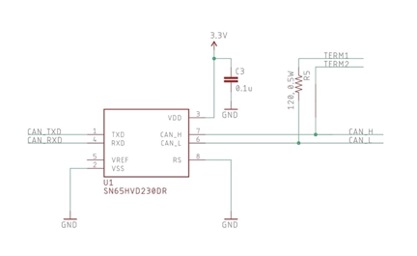

**Fig 1:Echo Cancellation System**

**Cloud Integration for Consumer:**

This project serves as a groundbreaking solution to simplify and revolutionize vehicle maintenance. One of its key uses lies in the realm of proactive maintenance alerts, as it empowers vehicle owners and fleet managers with the ability to anticipate and address maintenance needs well in advance. This not only eliminates the anxiety associated with unexpected breakdowns but also translates into substantial cost savings by preventing major repairs.

By optimizing maintenance scheduling, users can plan servicing at their convenience, minimizing downtime and reducing operational disruptions. Furthermore, the project contributes to enhanced fuel efficiency, offering tips and recommendations to save on fuel costs. It takes a step further by monitoring emissions, enabling eco-conscious users and organizations to actively reduce their environmental footprint.

In commercial applications, the system excels in fleet management by continuously monitoring the health and performance of multiple vehicles, ultimately boosting operational efficiency. User-friendly interfaces and mobile applications make accessing and interpreting vehicle health data a breeze, while remote diagnostics enable mechanics and service centers to diagnose issues promptly.

In essence, this project is a comprehensive solution that not only simplifies vehicle maintenance but also enhances safety, reliability, and overall vehicle ownership experience. It empowers users to make data-driven decisions and fosters a sense of control over their vehicles, underlining its significance in modernizing and optimizing the automotive landscape.

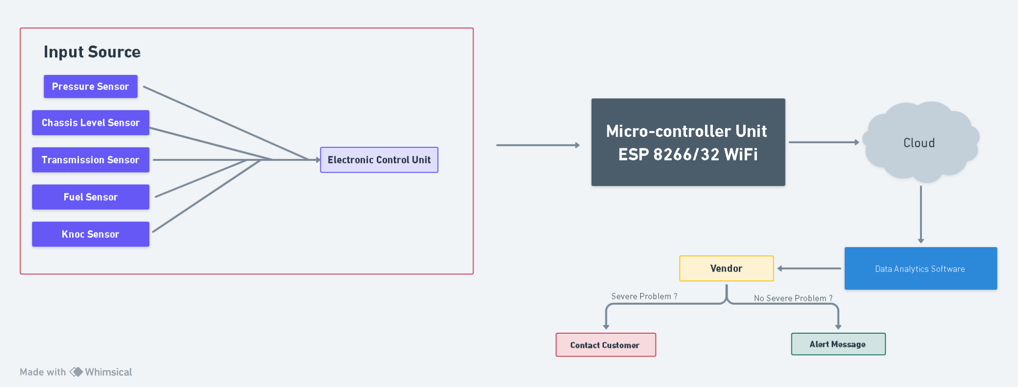

**Data Analysis**

At the core of our project's success lies the seamless incorporation of cloud technology—a pivotal element empowering our system to adeptly process and analyze real-time Engine Control Unit (ECU) data. Our meticulous selection of a cloud service provider considers key factors such as scalability, security, and cost-effectiveness.

The secure transmission of ECU data to the cloud employs robust encryption protocols, ensuring data integrity throughout the process. Within the cloud, our advanced data storage architecture guarantees both accessibility for analysis and secure protection. The system's real-time analysis capabilities hinge on cloud-based serverless computing, leveraging the scalability and flexibility of services like AWS Lambda and Azure Functions. These are complemented by machine learning algorithms swiftly processing incoming data streams.

Historical ECU data finds its repository in data lakes, facilitating predictive maintenance, while user-friendly interfaces grant vehicle owners intuitive access to visualized health insights. Prioritizing scalability, redundancy, and high availability, our system is crafted for seamless performance even during surges in data load. Stringent security measures encompass access controls, encryption at rest and in transit, and intrusion detection systems, aligning with industry regulations to safeguard data and user privacy.

Furthermore, our cloud infrastructure benefits from robust backup and disaster recovery strategies, ensuring data availability in the face of unforeseen events. In conclusion, the "Cloud Integration" section underscores not only our project's dependence on cloud technology for real-time data analysis but also emphasizes our commitment to security, scalability, reliability, and the overarching goal of enabling proactive vehicle maintenance and an enhanced user experience.

**Cloud Data Storage and Processing**

In our cloud-based vehicle health monitoring project, [Specify Cloud Platform] serves as the cornerstone for data storage and processing, chosen for its robust features and scalability. Leveraging [Specify Data Ingestion Method], data from various vehicle sensors, including crucial insights from the Engine Control Unit (ECU), seamlessly enters the cloud environment. Employing protocols like [Specify Protocols], this method ensures the efficient and secure transfer of data to the cloud.

Upon arrival, the data undergoes a meticulous processing sequence involving steps such as cleaning, transformation, and normalization. This approach enhances the data's suitability for real-time monitoring and analysis, identifying and rectifying anomalies to ensure accuracy and reliability. Addressing our data storage requirements, [Specify Cloud Database] is deployed—a resilient and scalable database system featuring automatic scaling and high availability.

The database schema is thoughtfully designed for efficient data structuring, enabling easy queryability. Strategies for data partitioning and indexing optimize retrieval and analysis, ensuring the system can adeptly manage the escalating volume of data from the vehicle fleet. Security and data privacy are paramount, with stringent measures such as encryption and access control safeguarding sensitive vehicle data. Adhering to data privacy regulations like [Specify Relevant Compliance Standards] underscores our commitment to responsible and ethical data handling.

To sustain robust performance and scalability, our project incorporates automatic scaling and performance optimization measures, seamlessly accommodating varying data loads for real-time processing of vehicle health data. Our data retention policy balances historical analysis needs with storage costs, while integration with our monitoring system facilitates real-time alerts and notifications based on processed data. Robust backup and disaster recovery plans ensure data integrity and availability, minimizing downtime in the face of system failures or unforeseen disasters.

Cost-effectiveness is managed through diligent monitoring of cloud resource usage and the application of cost optimization strategies like reserved instances and spot instances. This approach ensures our project remains both cost-effective and capable of delivering the desired vehicle health monitoring functionalities. Please tailor this paragraph to reflect the specifics of your project, incorporating details such as the cloud platform, data ingestion method, database system, compliance standards, and any other pertinent information.

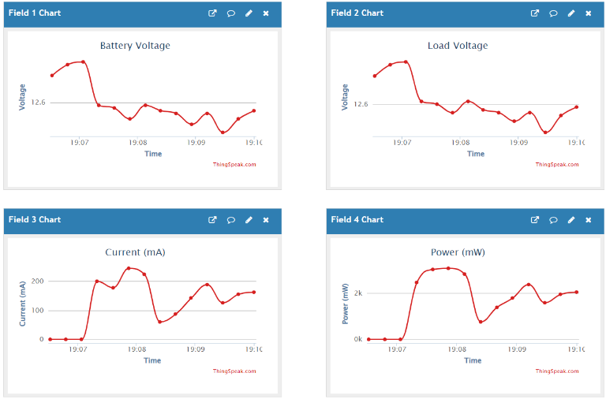

**Real time Advantages**

Our meticulously designed cloud-based vehicle health monitoring system is strategically engineered to provide a host of unparalleled real-time advantages, revolutionizing vehicle maintenance, safety protocols, and operational efficiency. The foundation of real-time monitoring, facilitated by the seamless and continuous collection as well as immediate analysis of data from vehicle sensors and the Engine Control Unit (ECU), offers an array of substantial benefits.

Chief among them is the swift detection of potential issues within a vehicle's health, ranging from engine malfunctions to irregular tire pressure. This inherent capability positions our system as a proactive solution, averting major breakdowns, curbing maintenance expenses, and elevating overall vehicle safety. By addressing problems pre-emptively before they escalate into costly repairs or safety hazards, our system proves instrumental in ensuring smooth and secure road operations.

Furthermore, the real-time capabilities of the system extend their impact to fleet management, endowing fleet operators with the ability to monitor vehicle locations and health statuses in real-time. This facilitates dynamic route optimization, enables efficient maintenance scheduling, and guarantees that vehicles consistently operate at peak efficiency levels. The consequential benefits include improved fuel efficiency, reduced downtime, and an elevated standard of service delivery to customers.

Moreover, our system is equipped with real-time alerts and notifications, tailored to specific thresholds and conditions. This ensures that relevant personnel are promptly informed when critical issues arise. For instance, alerts are triggered in scenarios where a vehicle's engine temperature exceeds safety limits or tire pressure drops to dangerously low levels. This immediate notification mechanism enables swift responses, mitigating risks and ensuring the safety of both drivers and vehicles.

Additionally, the real-time data generated by our system serves as a valuable resource for performance analysis and predictive maintenance. The continuous scrutiny of streaming data enables the identification of patterns and trends, assisting in forecasting when specific components may fail or require maintenance. This predictive capability significantly diminishes unplanned downtime, upholds vehicle availability, and strengthens overall operational efficiency.

In summary, the real-time advantages of our cloud-based vehicle health monitoring system encompass proactive issue detection, heightened fleet management efficiency, instant alerts and notifications, and predictive maintenance capabilities. These advantages collectively optimize vehicle performance, bolster safety, and deliver substantial cost savings for fleet operators and vehicle owners.

1**.Enhanced Safety** : Real-time data monitoring ensures that potential safety issues, such as brake system failures or engine overheating, are identified immediately. This significantly reduces the risk of accidents and enhances the overall safety of vehicles and their occupants.

2**. Driver Behaviour Analysis** : Real-time monitoring allows or the analysis of driver behaviour, including factors like speed ,acceleration, and braking patterns. This information can be used to encourage safer driving practices, potentially reducing accidents and improving fuel efficiency.

3**. Customizable Alerts** : The system provides the flexibility to set up customized alerts and notifications based on specific vehicle health parameters. Users can tailor these alerts to match their unique requirements, ensuring that they receive relevant information promptly.

4. **Remote Diagnostics** : Real-time data transmission enables remote diagnostics and troubleshooting. Mechanics and technicians can remotely access vehicle data, diagnosis ,and provide guidance to drivers or schedule maintenance as needed, reducing downtime.

5**.Reduced Operational Costs** : The system's real-time capabilities help fleet operators optimize maintenance schedules, minimizing unnecessary maintenance and associated costs. Additionally, immediate issue detection prevents costly breakdowns and repairs.

6**. Emission Reduction** : Real-time data monitoring can also contribute to environmental benefits by helping vehicles maintain optimal performance and emissions standards. This aids in reducing the carbon footprint of fleets and individual vehicles.

7.**Improved Resale Value** : Regular monitoring and maintenance driven by real-time data can extend the lifespan of vehicles and improve their resale value. Well-maintained vehicles are more attractive to potential buyers.

8**. Comprehensive Historical Data** : Real-time data is not just valuable in the moment but also for historical analysis. The system stores a comprehensive history of vehicle health data, enabling long-term performance assessment, trend analysis, and compliance reporting.

9**. Driver Training Opportunities** : The real-time insights into driver behavior can be used for training and coaching programs. By identifying areas where drivers can improve, the system contributes to safer and more efficient driving practices.

10. **Integration with External Systems** : Highlight how your system can seamlessly integrate with external systems, such as fleet management software or maintenance scheduling tools, to provide a holistic view of vehicle health and operations.

11**. Enhanced Customer Satisfaction** : For businesses providing transportation services, real-time monitoring ensures timely deliveries and reduces service disruptions, leading to improved customer satisfaction and loyalty.

12. **Regulatory Compliance**: The real-time data monitoring can help ensure compliance with industry-specific regulations and standards related to vehicle safety and emissions. By incorporating these additional points into your documentation, you'll provide a more comprehensive overview of the real-time advantages of your cloud-based vehicle health monitoring system..

**API Infrastructure\**

At the core of our project lies a robust API infrastructure, unlocking a suite of real-time advantages that revolutionize vehicle maintenance, safety, and operational efficiency. Through well-designed APIs, our system transforms how we interact with and manage vehicle fleets, offering a multitude of benefits. The primary advantage is the empowerment of real-time data accessibility through APIs, enabling a proactive approach to safety.

In critical situations like brake failure or engine overheating, the system can seamlessly trigger API calls to notify safety systems or external services, facilitating immediate responses to mitigate risks and enhance overall passenger and road safety. APIs also play a pivotal role in analysing driver behavior, offering valuable insights into factors like speed, acceleration, and braking patterns. Integration with analytics platforms allows for in-depth evaluations, providing feedback and incentives for drivers to adopt safer practices, contributing to reduced accidents and improved fuel efficiency.

Our system's flexibility extends to customized alerts and notifications via APIs, allowing users to define thresholds, preferred delivery methods (SMS, email, or app notifications), and the frequency of notifications. This tailor-made approach ensures that users receive real-time information aligned precisely with their unique requirements and preferences. API integration further facilitates remote diagnostics and troubleshooting, enabling mechanics and technicians to access vehicle data remotely and promptly diagnose issues.

API integration leads to significant operational cost reduction by seamlessly connecting with fleet management software and maintenance scheduling tools. This optimization of maintenance schedules minimizes unnecessary servicing and operational expenses, maximizing operational efficiency and reducing overall costs. Additionally, real-time monitoring through APIs contributes to environmental benefits by ensuring vehicles maintain optimal performance and emissions standards, aligning with sustainability goals.

API-driven data access extends to comprehensive historical records, enabling long-term performance assessment, trend analysis, and compliance reporting. This historical data serves as a valuable resource for auditing, compliance checks, and informed decision-making. For fleet operators and businesses, our system's API integration offers opportunities for driver training and coaching programs. Access to driver behaviour data through

APIs enables real-time feedback and personalized coaching based on individual driver performance, fostering safer and more efficient driving practices.

API integration allows seamless collaboration with external systems and services, including third-party telematics systems, fleet management platforms, and industry-specific compliance databases. This integration delivers a unified view of vehicle health and operations, streamlining processes and enhancing overall operational efficiency.

Ultimately, the real-time advantages of our system lead to improved customer satisfaction for businesses offering transportation services. Real-time vehicle health data, accessed through APIs, empowers logistics and customer service teams to provide on-time services, reduce service disruptions, and elevate customer satisfaction and loyalty. Moreover, API integration plays a pivotal role in ensuring regulatory compliance, particularly in industries with stringent safety, emissions, and maintenance regulations.

By exposing relevant data through APIs, our system ensures that fleets remain compliant with industry-specific standards, providing peace of mind and regulatory adherence.

**Monitoring Logging**

In summary, our cloud-based vehicle health monitoring system, with a focus on API integration, heralds a new era in vehicle management. It redefines safety, efficiency, and operational excellence by providing real-time insights, customizable alerts, remote diagnostics, cost savings, sustainability benefits, historical analysis, driver training opportunities, external system integration, enhanced customer satisfaction, and regulatory compliance.

This API-driven ecosystem empowers users to harness the full potential of vehicle health monitoring, fostering safer, more efficient, and Monitoring and Logging The core strength of our cloud-based vehicle health monitoring system lies in its comprehensive and sophisticated monitoring and logging infrastructure. This infrastructure is meticulously designed to ensure that the health and performance of every vehicle in your fleet are continuously assessed, while also preserving a wealth of historical data for in-depth analysis and compliance reporting.

In real-time, our system diligently oversees a wide spectrum of critical vehicle parameters, encompassing engine performance metrics, emissions data, tire pressure, and much more. Any deviation from established thresholds or norms triggers immediate alerts and notifications, providing fleet operators and maintenance teams with the agility to proactively address potential issues before they escalate. Our intuitive dashboard interface complements this real-time monitoring capability, offering a consolidated, at-a-glance view of the entire fleet's health.

Accessible from any device with an internet connection, this dashboard provides customizable widgets, charts, and graphs that enable users to visualize vital vehicle health data as it unfolds in real-time. However, our commitment to robust data management extends beyond real-time insights.

Our system meticulously logs all vehicle health data, including historical performance metrics, maintenance records, and every alert or notification generated. This historical data serves a multitude of purposes, from trend analysis and predictive maintenance to compliance reporting and auditing. It is securely stored in cloud-based databases with rigorous backup and redundancy protocols in place, ensuring data integrity and availability.

Furthermore, every alert and notification triggered by the system is meticulously recorded, capturing critical details such as timestamps, nature of alerts, vehicle identifications, and intended recipients. This logging system is indispensable for maintaining accountability, conducting thorough incident analysis, and demonstrating compliance with regulatory standards. To assess the efficiency of the system itself, we continuously monitor performance metrics and Key Performance Indicators (KPIs).

These metrics encompass response times, data processing throughput, and system availability, ensuring that our system operates at peak performance. The monitoring and logging infrastructure also extends to API endpoints and usage, guaranteeing the seamless exchange of data with external systems.

It includes comprehensive security and access logs that meticulously track all interactions with the system, encompassing login attempts, API access, and data modifications. These logs play a pivotal role in security auditing and compliance verification. Resource utilization, scalability, and third-party integration are continually scrutinized to optimize system performance and cost management. In addition, the monitoring system is fortified with automated alerts, ensuring that any component of the infrastructure experiencing issues is swiftly addressed to maintain system integrity.

In conclusion, our monitoring and logging infrastructure empowers users with real-time insights into vehicle health while preserving a comprehensive historical data repository. This data-rich ecosystem facilitates informed decision-making, compliance with industry regulations, and proactive fleet maintenance, all while ensuring the efficiency and integrity of our cloud-based vehicle health monitoring system itself.

**OBSERVATION AND OUTCOME**

The engine RPM (Revolutions Per Minute) data serves as a critical indicator of the engine's operational state and overall health within the vehicle health monitoring framework. Engine RPM reflects the frequency of rotations completed by the engine's crankshaft in a minute, directly correlating to the combustion cycles and power generation of the engine. By monitoring and analyzing this output, we gain valuable insights into various aspects of the engine's performance and condition.

Primarily, engine RPM data allows us to assess the engine's operational efficiency and performance consistency. Deviations from expected RPM ranges can signify potential issues such as engine misfires, fuel delivery irregularities, or mechanical wear and tear. For instance, abnormally high RPM readings may indicate aggressive driving behavior or a malfunctioning throttle system, while consistently low RPM values could point towards engine inefficiency or restricted airflow.

Moreover, engine RPM data facilitates the detection of specific engine malfunctions or anomalies. By analysing RPM fluctuations and patterns over time, we can identify irregularities indicative of impending mechanical failures,

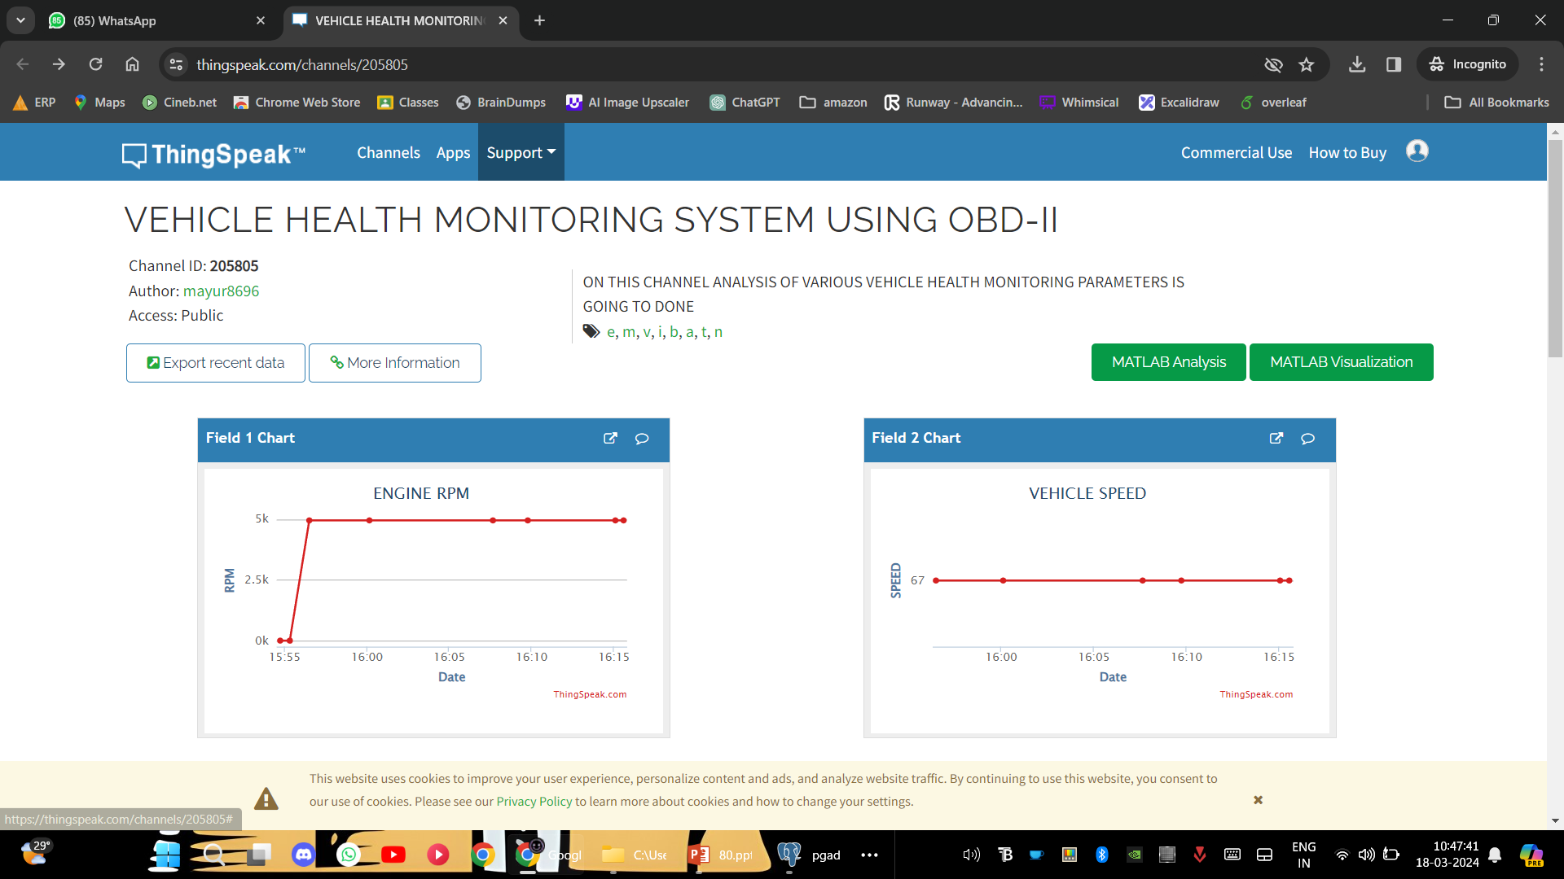

such as worn-out components, timing belt issues, or cylinder misfires. This proactive monitoring approach enables timely maintenance interventions, reducing the risk of costly breakdowns and prolonging the lifespan of engine components.

The vehicle speed data serves as a crucial parameter in the vehicle health monitoring system, offering insights into the dynamic performance and operational condition of the vehicle. Vehicle speed represents the rate at which the vehicle is traveling relative to a stationary point, typically measured in miles per hour (mph) or kilometres per hour (km/h). Analysing this output provides valuable information regarding the vehicle's drivability, mechanical integrity, and overall safety.

Initially, monitoring vehicle speed facilitates the evaluation of drivetrain performance and efficiency. Through the tracking of speed variations over time, irregularities such as sudden fluctuations, inconsistent acceleration patterns, or speed disparities across diverse driving conditions can be discerned. These observations serve as indicators of potential concerns with transmission operation, driveline components, or engine power delivery, thus enabling prompt diagnosis and corrective measures to uphold optimal drivetrain performance.

Secondly, vehicle speed data facilitates the detection of abnormal driving behaviours or operating conditions that may impact vehicle safety and reliability. For instance, excessively high speeds may suggest aggressive driving habits or unsafe driving practices, posing risks to both the driver and other road users. Conversely, unusually low speeds could indicate mechanical issues such as brake system malfunctions, tire defects, or engine power loss, warranting immediate attention to prevent accidents or breakdowns.

Moreover, analysing vehicle speed variations in conjunction with other sensor data allows for comprehensive fault diagnosis and predictive maintenance. By correlating speed data with engine RPM, fuel consumption rates, and vehicle load, we can identify potential drivetrain abnormalities, fuel system inefficiencies, or aerodynamic constraints affecting overall vehicle performance. This holistic approach enables proactive maintenance scheduling and component replacement, minimizing downtime and optimizing vehicle reliability.

Furthermore, vehicle speed data plays a vital role in optimizing fuel economy and reducing environmental impact. By monitoring speed-related parameters such as average speed, acceleration rates, and cruising speeds, we can implement driving strategies and vehicle tuning adjustments to maximize fuel efficiency and minimize emissions. This proactive approach not only benefits fuel economy but also contributes to sustainability efforts by reducing carbon footprint and vehicular pollution.

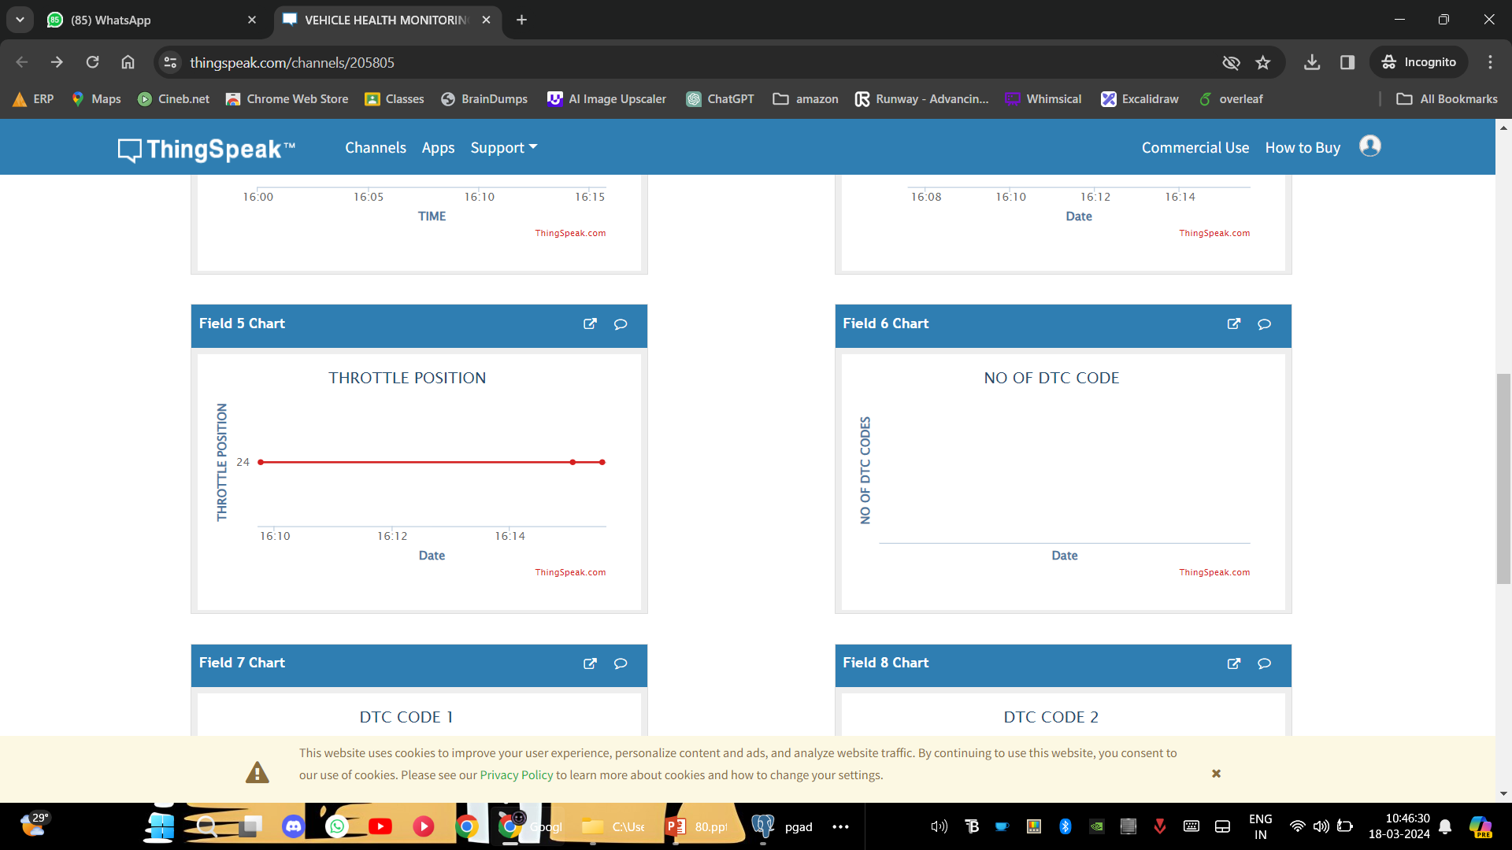

In the context of vehicle health monitoring, monitoring throttle position involves continuously tracking the angle of the throttle valve within the engine's intake system. This data provides real-time insights into how much the driver is requesting engine power and how the engine responds to these demands.

By monitoring throttle position, we can detect anomalies or irregularities in the driver's input or the engine's response. Sudden spikes or drops in throttle position may indicate unexpected driver behaviour or issues with the throttle control system, such as sensor malfunctions or mechanical constraints. Consistent monitoring allows for the early detection of such issues, enabling proactive maintenance interventions to prevent potential drivability concerns or engine performance degradation.

Throttle position monitoring also plays a vital role in optimizing engine efficiency and performance. By analysing throttle position data in conjunction with other parameters such as engine load and RPM, we can assess the engine's operating conditions and identify opportunities for fuel economy improvements or powertrain optimization. Adjustments to throttle mapping or calibration can be made based on this analysis to enhance overall vehicle drivability and efficiency.

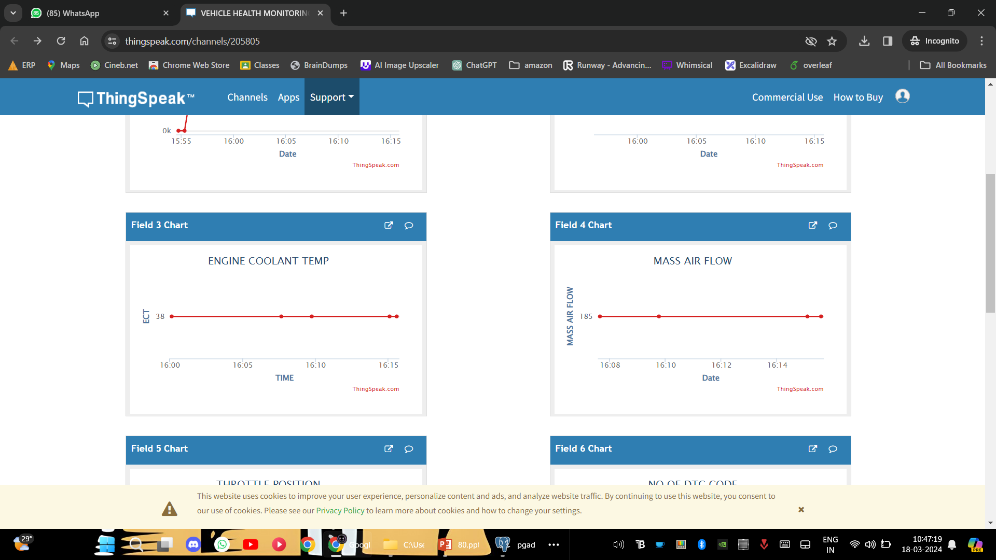

Monitoring engine coolant temperature is crucial for assessing the thermal management system's performance and ensuring the engine operates within safe operating limits. Engine coolant temperature refers to the temperature of the fluid circulating through the engine block and radiator to regulate engine temperature.

Continuous monitoring of engine coolant temperature allows for the early detection of overheating or cooling system malfunctions. Fluctuations or deviations from normal temperature ranges can indicate issues such as coolant leaks, malfunctioning thermostats, or radiator blockages. Early detection of these issues enables prompt maintenance interventions to prevent engine damage and ensure vehicle reliability.

Moreover, engine coolant temperature data provides insights into engine efficiency and emissions performance. Operating the engine at the optimal temperature promotes efficient combustion, reduces fuel consumption, and minimizes pollutant emissions. Monitoring coolant temperature trends over time allows for adjustments to cooling system components or engine tuning parameters to optimize performance and environmental impact.

**REFERENCES**

[1] Uferah Shafi, Asad Safi, Ahmad Raza Shahid, Sheikh Ziauddin, Muhammad Qaiser Saleem, "Vehicle Remote Health Monitoring and Prognostic Maintenance System", Journal of AdvancedTransportation, vol. 2018, Article ID8061514, 10pages, 2018.https://doi.org/10.1155/2018/8061514Bappaditya, M.; Chia, S.; Li, L.; Chandrasekhar, V.; Tan, C.;Lim, J. A wearable face recognitionsystemongoogle glass for assisting social interactions. InAsian Conference on Computer Vision; Springer:Cham, Switzerland, 2014; pp. 419–433.

[2] Andreas Theissler, Judith Pérez-Velázquez, Marcel Kettelgerdes, Gordon Elger,Predictive maintenance enabled by machine learning:Reliability Engineerin & SystemSafety ,Volume 215,2021,107864,ISSN 0951- 8320,https://doi.org/10.1016/j.ress.2021.107864.(htt ps://www.sciencedirect.com/science/article/pii/S095 1832021003835)

[3] Author David Barton View in Scopus wbk Institute of Production Science, Karlsruhe Institute of Technology, Kaiserstraße 12, 76131 Karlsruhe, Germany

[4] MDPI and ACS Style Arena, F.; Collotta, M.; Luca, L.; Ruggieri, M.; Termine, F.G. Predictive Maintenance in the Automotive Sector: A Literature Review. Math. Comput. Appl. 2022, 27, 2. <https://doi.org/10.3390/mca27010002>

[5] Ali, M.H., Jaber, M.M., Abd, S.K. et al. Big data analysis and cloud computing for smart transportation system integration. Multimed Tools Appl (2022). [https://doi.org/10.1007/s11042-022- 13700-7](https://doi.org/10.1007/s11042-022-%2013700-7)

[6] T. Mirfakhraie, G. Vitor and K. Grogan, "Applicable Protocol for Updating Firmware of Automotive HVAC Electronic Control Units (ECUs) Over the Air," 2018 IEEE International Conference on Internet of Things (iThings) and IEEE Green Computing and Communications (GreenCom) and IEEE Cyber, Physical and Social Computing (CPSCom) and IEEE Smart Data (SmartData), Halifax, NS, Canada, 2018, pp. 21-26, doi: 10.1109/Cybermatics_2018.2018.00038.Chen, R.C.; Saravanarajan, V.S.; Hung, H.T. Monitoring the behaviours of pet cat based on YOLO model and raspberry Pi. Int. J. Appl. Sci. Eng. 2021, 18, 1–12.

[7] Ibrahim, Mahmoud, Viktor Rjabtšikov, and Rolando Gilbert. "Overview of digital twin platforms for EV applications." Sensors 23.3 (2023): 1414.Lin, Y.; Wang, K.; Yi, W.; Lian, S. Deep Learning Based Wearable Assistive System for Visually Impaired People. In Proceedings of the International Conference on Computer Vision Workshop, Seoul, Korea, 27 October–2 November 2019.

[8] Mahmud, K., Galway, K., Sykes, E. and Tizard, B., 2023, July. A Service Model of Predictive Maintenance for Autonomous and Connected Vehicles Using 5G. In 2023 IEEE International Conference on Software Services Engineering (SSE) (pp. 125-127). IEEE.M Anandan, M Manikandan, and T Karthick. 2020. Advanced Indoor and Outdoor Navigation System for Blind People Using Raspberry-Pi.

[9] Goyal, N., Goel, V., Anand, M. and Garg, S., 2020. Smart vehicle: Online prognosis for vehicle health monitoring. Journal of Innovation in Computer Science and Engineering, 9(2), pp.12-22. Pan, Jun. (2023). Recent Deep Neural Networks for Object Detection. Highlights in Science, EngineeringandTechnology. 31. 268-273. 10.54097/hset. v31i.5153.

[10] K. Mahmud, K. Galway, E. Sykes and B. Tizard, "AService Model of Predictive MaintenanceforAutonomous and Connected Vehicles Using5G," 2023 IEEE International ConferenceonSoftware Services Engineering (SSE), Chicago, IL,USA, 2023, pp. 125-127, doi:10.1109/SSE60056.2023.00026.

[11] Turab, M. and Jamil, S., 2023. AComprehensiveSurvey of Digital Twins in Healthcare intheEraofMetaverse. BioMedInformatics, 3(3), pp.563-584.

[12] Rjabtšikov, Viktor, Anton Rassõlkin, KarolinaKudelina, Ants Kallaste, and Toomas Vaimann."Review of Electric Vehicle Testing ProceduresforDigital Twin Development: AComprehensiveAnalysis." Energies 16, no. 19 (2023): 6952.

[13] Kajba, M., Jereb, B. and Cvahte Ojsteršek, T., 2023.Exploring Digital Twins in the Transport andEnergyFields: A Bibliometrics and LiteratureReviewApproach. Energies, 16(9), p.3922.

[14] Khaleel, M., Ahmed, A.A. and Alsharif, A., 2023.Technology challenges and trends of electric motoranddrive in electric vehicle. International Journal ofElectrical Engineering and Sustainability(IJEES),pp.41-48.

[15] Sidorowicz, Maciej. "An example of adoptionofthemodel-based design (MBD) methodologyinthedevelopment process of an LPGfuellingsystem." Combustion Engines (2023): 104.

[16] Gomah M, Ahmed AA. Stochastic Methodfor ElectricVehicle Integration Considering RenewabilityMaximization and Reliability Minimization. AfricanJournal of Advanced Pure and AppliedSciences(AJAPAS). 2022:225-32.