**ASSESSING THE EFFICIENCY OF LAST-MILE DELIVERY STRATERGIES OF ECOM EXPRESS**

**Surya Elangovan, Madhiarasi**

(MBA STUDENT JERUSALEM COLLEGE OF ENGINEERING, CHENNAI

Email : Suryaelangovan99@gmail.com)

(ASSISTANT PROFESSOR MBA, JERUSALEM COLLEGE OF ENGINEERING, CHENNAI

Email : smadhi.dms@gmail.com)

**ABSTRACT**

The research work aims to study and analyze the efficiency of last-mile delivery strategy of Ecom Express. This research studies the delivery agent’s relationship with the customer and the accessibility of customer’s location and the attitude of delivery agent towards the delivery policy of Ecom Express. The research design used for this study is descriptive in nature. The descriptive study helps the researcher to find out various characteristics from the sample size of 102. The statistical tool used includes percentage analysis, Chi square, Anova and weighted average.

**INTRODUCTION**

Last mile delivery is the final leg of the ecommerce supply chain that physically connects brands with consumers through the delivery of the purchase. Goods are transported from a warehouse or a distribution center and arrive either at a consumer’s home, business, or office. For the shipper, last-mile delivery is the most complex and expensive part of the product’s journey. The goal of superior last-mile delivery is to enable every delivery to reach its destination every time, on time, accurately, efficiently, and sustainably.

Last mile delivery is the only touchpoint between a customer and a brand. The front door has become the new storefront. Giving consumers the products they want is important but delivering a cohesive experience from order-to-delivery is now the holy grail for retailers worldwide. It is a crucial component of delivering a world-class brand experience and keeping consumers brand-loyal.

Last mile delivery is the final step in the supply chain, where goods are transported from a transportation hub or warehouse to the customer's location. Here's how it typically works:

**Order Placement:** The customer places an order online or through a mobile app. The retailer or logistics company receives the order and processes it.

**Order Fulfillment:** The order is picked, packed, and prepared for shipment at the warehouse or fulfillment center. The shipment is then loaded onto a delivery vehicle, such as a truck or van.

**OBJECTIVE OF THE STUDY**

**PRIMARY OBJECTIVE:**

To assess the efficiency of last-mile delivery strategy.

**SECONDARY OBJECTIVE:**

• To analyse the relationship between delivery agent and customer.

• To identify the difficulties in reaching the location of the customer.

• To analyse the delivery agent attitude towards the delivery policy.

**SCOPE FOR THE STUDY**

• To analyse the efficiency of strategies used in last-mile delivery.

• To analyse the customer and delivery agent relationship.

• To identify the accessibility of the customer location.

• To analyse the attitude of delivery agent towards the delivery policy.

# NEED FOR THE STUDY

* To understand the level of efficiency of last-mile delivery based on overall parameters.
* If the last-mile delivery strategies are efficient then only the organization can function smoothly and increases its productivity.
* If customers are satisfied with the delivery process of the delivery agent , they will create positive feedback.

# LIMITATION FOR THE STUDY

* The sample size chosen for the questionnaire was only 102 and that may not represent the true picture of the investors’ perception about the life insurance investments.
* There is a lack of face-to-face interaction with respondents.
* The selection of people for the questionnaire will be done on the basis of snowball sampling, so few response may be not true to their knowledge and experience.
* Resource constraint.
* Time constraint.

**REVIEW OF LITERATURE**

## **Anon., 2016.** Honeywell annual report, Washinton: Honeywell International Inc... Anon., n.d. Statista –The portal for statistics.

* **Deutsch, Y. & Golany, B., 2018.** A parcel locker network as a solution to the logistics last mile problem. International Journal of Production Research.

## **Ding, Z., 2013.** Evaluating Different Last Mile Logistics solutions : A case study of SF Express, China. E., T. et al., 2015. Electronic Commerce: A Managerial and Social Networks Perspective.

* **Prentice Hall. Edwards, J. B., McKinnon, A. C. & Cullinane, S. L., 2010.** Comparative analysis of the carbon footprints of conventional and online retailing: A “last mile” perspective. International Journal of Physical Distribution & Logistics Management.
* **Ewedairo, K., Chhetri, P. & Jie, F., 2018.** Estimating transportation network impedance to last-mile delivery: A Case Study of Maribyrnong City in Melbourne. The International Journal of Logistics Management.
* **Gevaers, R., Voordea, E. V. d. & Vanelslandera, T., 2014.** Cost Modelling and Simulation of Last-mile Characteristics in an Innovative B2C Supply Chain Environment with Implications on Urban Areas and Cities. s.l., Procedia - Social and Behavioural Sciences.

**RESEARCH METHODOLOGY**

Research methodology guides the entire research process, from identifying research questions or problems to presenting the findings to the wider community. The chosen research methodology depends on the nature of the study, the type of data required, and the scope of the research project.

# RESEARCH DESIGN

Descriptive research is a research method used to try and determine the characteristics of a population or particular phenomenon. A sample of 105 respondents is taken in this study and the required data has been collected.

# COLLECTION OF DATA

**PRIMARY DATA**

Primary data is gathered through methods such as surveys, experiments, observations, interviews, or direct measurements. This type of data is valuable because it provides researchers with firsthand and up-to-date information that is directly relevant to their research objectives.

**SECONDARY DATA**

This data can come from a wide variety of sources, including research studies, government reports, academic publications, market research, and more.

**ANALYSIS**

**PERCENTAGE ANALYSIS FOR GENDER OF THE RESPONDENTS**

**TABLE NO 1 GENDER OF THE RESPONDENTS**

|  |  |  |  |  |  |
| --- | --- | --- | --- | --- | --- |
| **Gender** | | | | | |
|  | | Frequency | Percent | Valid Percent | Cumulative Percent |
| Valid | Male | 75 | 71.4 | 71.4 | 71.4 |
| Female | 30 | 28.6 | 28.6 | 100.0 |
| Total | 105 | 100.0 | 100.0 |  |

**CHART OF GENDER OF THE RESPONDENTS**

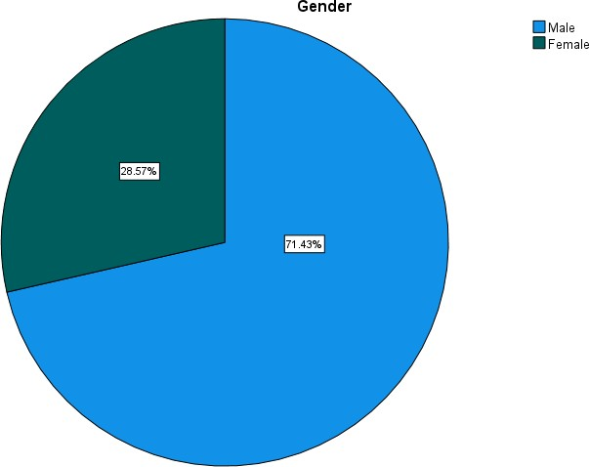

**INFERENCE:**

As the table shows the majority of the respondents are male with the percentage of 72% as shown in the Pie chart.

**PERCENTAGE ANALYSIS FOR MONTHLY INCOME OF THE RESPONDENT**

**TABLE NO 2 MONTHLY INCOME OF THE RESPONDENT**

|  |  |  |  |  |  |
| --- | --- | --- | --- | --- | --- |
| **Monthly Income** | | | | | |
|  | | Frequency | Percent | Valid Percent | Cumulative Percent |
| Valid | 12000 to 15000 | 32 | 30.5 | 30.5 | 30.5 |
| 15000 to 20000 | 54 | 51.4 | 51.4 | 81.9 |
| Above 20000 | 19 | 18.1 | 18.1 | 100.0 |
| Total | 105 | 100.0 | 100.0 |  |
|  |  |  |  |  |  |

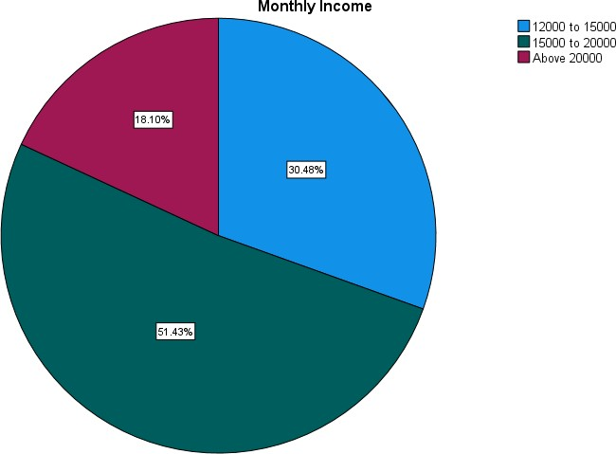**CHART OFMOPNTHLY INCOME OF THE RESPONDENT**

# INFERENCE:

## As shown in the table majority of the respondents are having income between 15,000 to 20,000 per month with the percentage of 51% as shown in the Pie chart.

**PERCENTAGE ANALYSIS FOR EDUCATIONAL QUALIFICATION**

**TABLE NO 3 EDUCATIONAL QUALIFICATION OF THE RESPONDENT**

|  |  |  |  |  |  |
| --- | --- | --- | --- | --- | --- |
| **Educational Qualification** | | | | | |
|  | | Frequency | Percent | Valid Percent | Cumulative Percent |
| Valid | Higher Secondary | 28 | 26.7 | 26.7 | 26.7 |
| Diploma | 27 | 25.7 | 25.7 | 52.4 |
| Undergraduate | 35 | 33.3 | 33.3 | 85.7 |
| Others | 15 | 14.3 | 14.3 | 100.0 |
| Total | 105 | 100.0 | 100.0 |  |

**CHART OF EDUCATIONAL QUALIFICATION OF THE RESPONDENT**

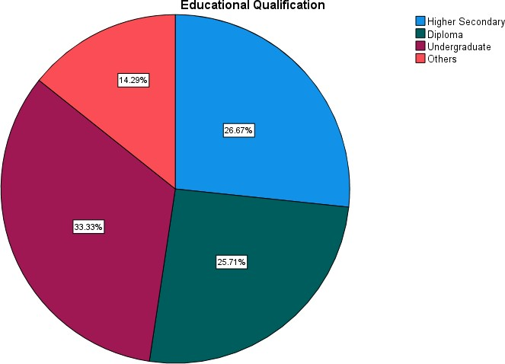

# INFERENCE:

In the shown table the respondents have the educational qualification of

27% Higher Secondary

26% Diploma

33% Undergraduate.

**PERCENTAGE ANALYSIS FOR ACCESSIBILITY OF CUSTOMER LOCATION OF THE RESPONDENTS**

**TABLE NO 4 ACCESSIBILITY OF CUSTOMER LOCATION OF THE RESPONDENTS**

|  |  |  |  |  |  |
| --- | --- | --- | --- | --- | --- |
| **Does the customer's location is easily accessible?** | | | | | |
|  | | Frequency | Percent | Valid Percent | Cumulative Percent |
| Valid | Yes | 102 | 97.1 | 97.1 | 97.1 |
| No | 3 | 2.9 | 2.9 | 100.0 |
| Total | 105 | 100.0 | 100.0 |  |
|  |  |  |  |  |  |

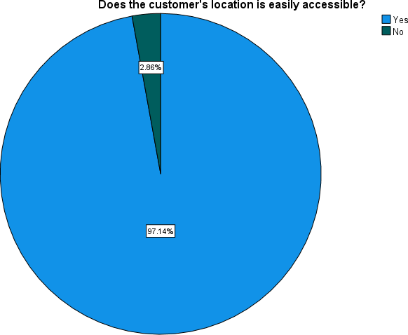**CHART OF ACCESSIBILITY OF CUSTOMER LOCATION OF THE RESPONDENTS**

# INFERENCE:

As shown in the table majority of the respondents get accessibility to the customer’s location with the percentage of 97% as shown in the Bar chart.

**CHI-SQUARE ANALYSIS**

To find out the association between the educational qualification and customer feedback.

**H0:** There is no significance difference between educational qualification and customer feedback.

**H1:** There is a significance difference between educational qualification and customer feedback.

**TABLE NO 5 CHI-SQUARE ANALYSIS**

|  |  |  |
| --- | --- | --- |
| **Test Statistics** | | |
|  | Educational Qualification | How much the regular customer values your service and gives feedback? |
| Chi-Square | 7.876a | 45.590a |
| df | 3 | 3 |
| Asymp. Sig. | .049 | .000 |
| a. 0 cells (0.0%) have expected frequencies less than 5. The minimum expected cell frequency is 26.3. | | |

**INFERENCE**

From the above table, we can find that the significant value is 0.000, which is less than table value 0.05, so the Null hypothesis is rejected and Alternative hypothesis is accepted.

Therefore, there is a significance difference between educational qualification and customer feedback.

**ANOVA**

To find out the association between the marital status and feedback carried towards superior & managers.

**H0:** There is no significance difference between the marital status and feedback carried towards superior & managers.

**H1:** There is a significance difference between the marital status and feedback carried towards superior & managers.

**TABLE NO 6 ANOVA**

|  |  |  |  |  |  |
| --- | --- | --- | --- | --- | --- |
| **ANOVA** | | | | | |
| Marital status | | | | | |
|  | Sum of Squares | df | Mean Square | F | Sig. |
| Between Groups | 2.508 | 2 | 1.254 | 5.885 | .004 |
| Within Groups | 21.739 | 102 | .213 |  |  |
| Total | 24.248 | 104 |  |  |  |

**INFERENCE**

The above table shows that the one-way ANOVA was conducted to identify influence of marital status and feedback carried towards superior & managers. It consists of different marital status of group members. The significant value p=0.001 so, there is no significant difference between the marital status and feedback carried towards superior & managers. The result shows that marital status have no effect on feedback carried towards superior & managers.

**CORRELATION**

To find out the relationship between experience and employee’s satisfaction. **H0:** There is no relationship between experience and employee’s satisfaction. **H1:** There is a relationship between experience and employee’s satisfaction.

**TABLE NO 7 CORRELATION**

|  |  |  |  |
| --- | --- | --- | --- |
| **Correlations** | | | |
|  | | Years of Experience | How much are you satisfied with the Ecom Express delivery policy? |
| Years of Experience | Pearson Correlation | 1 | .324** |
| Sig. (2-tailed) |  | .001 |
| N | 105 | 105 |
| How much are you satisfied with the Ecom Express delivery policy? | Pearson Correlation | .324** | 1 |
| Sig. (2-tailed) | .001 |  |
| N | 105 | 105 |
| **. Correlation is significant at the 0.01 level (2-tailed). | | | |

**INFERENCE**

From the above table, we can find that the significant value is 0.001, which is less than table value 0.05, so the Null hypothesis is rejected and alternate hypothesis accepted.

Therefore, there is a relationship between experience and employee’s satisfaction.

**FINDINGS**

* As the table shows the majority of the respondents are male with the percentage of 72% as shown in the Pie chart.
* As shown in the table majority of the respondents are having income between 15,000 to 20,000 per month with the percentage of 51% as shown in the Pie chart.
* In the shown table the respondents have the educational qualification of 27% Higher Secondary, 26% Diploma, 33% Undergraduate.
* As shown in the table majority of the respondents get accessibility to the customer’s location with the percentage of 97% as shown in the Bar chart.
* From the above table, we can find that the significant value is 0.000, which is less than table value 0.05, so the Null hypothesis is rejected and Alternative hypothesis is accepted. Therefore, there is a significance difference between educational qualification and customer feedback.
* The above table shows that the one-way ANOVA was conducted to identify influence of marital status and feedback carried towards superior & managers. It consists of different marital status of group members. The significant value p=0.001 so, there is no significant difference between the marital status and feedback carried towards superior & managers. The result shows that marital status have no effect on feedback carried towards superior & managers.
* From the above table, we can find that the significant value is 0.001, which is less than table value 0.05, so the Null hypothesis is rejected and alternate hypothesis accepted. Therefore, there is a relationship between experience and employee’s satisfaction.

**SUGGESTON**

Last mile delivery is the most important stage in the logistics field, as it involves the final delivery stage of the whole process of the business. The most important person who plays a vital role in this stage is the delivery agent of the organization as he represents the whole organization to the customer. So, when the delivery agent address himself properly and professionally the whole delivery process will be efficient. Form this study, we can derive that the delivery agent as a good relationship with the customers and the organization. This study mainly concentrates on the delivery agent relationship with the customer, accessibility of location of the customer and the attitude of the delivery agent towards Ecom Express delivery policy and the changes in it. This study shows that the delivery agent are well behaved with the customers and has a good relationship with them and the location is moderately accessible. And the delivery policy of Ecom Express is somewhat accepted by the delivery agent.

**CONCLUSION**

Last mile delivery is the final leg of the ecommerce supply chain that physically connects brands with consumers through the delivery of the purchase. Goods are transported from a warehouse or a distribution center and arrive either at a consumer’s home, business, or office. For the shipper, last-mile delivery is the most complex and expensive part of the product’s journey. The goal of superior last-mile delivery is to enable every delivery to reach its destination every time, on time, accurately, efficiently, and sustainably. Last mile delivery is the only touchpoint between a customer and a brand. The front door has become the new storefront. Giving consumers the products they want is important but delivering a cohesive experience from order-to-delivery is now the holy grail for retailers worldwide. It is a crucial component of delivering a world-class brand experience and keeping consumers brand-loyal.

**REFERENCE**

* <https://www.researchgate.net/publication/335421916_A_Strategic_Model_to_Improv> [e_the_Last_Mile_Delivery_Performance_in_E-commerce_Parcel_Delivery](https://www.researchgate.net/publication/335421916_A_Strategic_Model_to_Improve_the_Last_Mile_Delivery_Performance_in_E-commerce_Parcel_Delivery)
* <https://blog.mitsde.com/what-is-last-mile-logistics-and-why-is-it-crucial/>
* <https://www.emarketer.com/insights/last-mile-delivery-shipping-explained/>
* <https://fareye.com/what-is-last-mile-delivery>
* <https://fastercapital.com/content/Last-mile-Delivery--Improving-Efficiency-with-> [FPO-Strategies.html](https://fastercapital.com/content/Last-mile-Delivery--Improving-Efficiency-with-FPO-Strategies.html)
* <https://scholar.google.com/>
* <https://www.emerald.com/insight/content/doi/10.1108/IJPDLM-02-2019-> [0048/full/html](https://www.emerald.com/insight/content/doi/10.1108/IJPDLM-02-2019-0048/full/html)