**Stock Price Prediction**

**Vikrant Vikram, Satyam Dubey, Satyam Rai , Shivam Dubey**

* CSE, ITM Gida

** CSE, ITM Gida

*** CSE, ITM Gida

***Abstract*-** *Stock price prediction serves as a fundamental tool for informed financial decision- making This project presents a web-based platform for different users that uses Recurrent Neural Networks (RNNs) to predict stock price. The platform integrates historical stock data encompassing opening and closing prices, high and low prices, and trading volume. A comprehensive preprocessing pipeline is established, encompassing data cleaning, normalization, and feature selection. RNN architectures, including Long Short-Term Memory (LSTM) and Gated Recurrent Units (GRUS), are employed to capture intricate temporal patterns essential for accurate prediction. The trained RNN is a model which incorporated into a web interface, allowing users to input stock symbols and obtain real-time predictions. The system's performance is evaluated by using metrics such as Mean Absolute Error (MAE), Mean Squared Error (MSE), and Root Mean Squared Error (RMSE). This web-based application demonstrates the efficacy of RNNs in stock price prediction and provides an accessible and interactive tool for investors and traders to enhance their financial strategies.*

***Keywords***- ***Prediction, Stock Price Prediction Model, Desktop version.***

1. INTRODUCTION

A

ny kind of prediction is difficult task, especially where the future is very volatile. The stock market

is highly volatile and unpredictable by nature. Therefore, investors are always taking risks in hopes of making some profit. People want to invest in stock market and expect profit from their investments in stocks. That contain factors that influence stock price, such as supply and demand, market trends, the global economy, corporate results, historical price, public sentiments, sensitive financial information, popularity (such as good and bad news related to the company), all of which may result in the increase or decrease in the

number of buyers and sellers etc. Even though someone may analyze a lot of factors, it is still difficult to achieve the better performance in the stock market and to predict the future price.

1.How we can predict day-before stock prices using only their historical price data?

2.How we can validate the results for the developed model? In this study, a Recurrent Neural Network with Long Short-Term Memory (LSTM) is used by the machine learning technique to analyze and predict the future stock prices based on their historical price.

1. RELATED WORK

With the advancement of new technology and statistical tools, many scholars have explored ways to predict the stock prices. In 1997, prior knowledge and neural networks were used to predict the stock price. Later, a genetic algorithm approach and a support vector machine was introduced to predict stock prices. Lee introduced a stock price prediction using reinforcement learning. In 2008, Chang used a TSK-type fuzzy rule- based system for stock price prediction. In year 2009, Tsai used a hybrid machine learning algorithm to predict the prices of stock. Over time, the scholars predicted the stock prices using different kinds of machine learning algorithms such as deep learning, extreme machine learning and applied econometric approach using machine learning. In year 2015, AM Rather proposed a hybrid model composed of two model (1) i linear and (2) non linear. The non-linear model was a recurrent neural network. They found though this approach that it was the non-linear model, the recurrent neural network, that gave a satisfactory prediction of stock prices. In 2018, popular machine learning algorithms such as pattern graphs, convolutional neural networks, artificial neural networks, recurrent neural networks were used to predict stock prices.

1. FUNCTIONALITY

To create a stock price prediction project for Google and Tesla stocks, we can follow the project design mentioned earlier. Here's a step-by-step guide on how to work on this project specifically for Google stock:

1. Project Inception and Planning: Define the specific objectives: Specify what you want to achieve with both the stock price prediction, such as predicting the daily closing price or predicting the prices for next quarter.

Scope: Decide the scope of your project, e.g., predicting stock prices for the next month or quarter. Success criteria: Define what you consider a successful prediction. It could be achieving a certain level of accuracy or beating a baseline model.

Data sources: Identify reliable sources for Google stock price data as well as for Tesla stock price data, such as Tesla Finance or Google Finance.

Timeline and task breakdown: Create a project plan that outlines tasks, deadlines, and responsibilities.

1. Data Collection and Preprocessing:
2. Collect historical stock price data for both stocks, including opening price, closing price, high, low, and volume. (Fig. 1, Fig. 2)
3. Preprocess the data:

Handle missing values, if any. Normalize or standardize the data.

Create input sequences and target values for the RNN. Generate additional features (e.g., moving averages, RSI) as needed.

Split the data into training, validation, and test sets. (Fig. 3, Fig.4)

1. Model Selection and Development:

Now we choose LSTM and will define the model structure, including the number of layers, units, and dropout rates and setting up hyperparameter tuning experiments to optimize the model as seen in (Fig. 5).

1. Training and Evaluation:

Train the RNN model on the training dataset using historical stocks data.

Monitor training progress and evaluate the model's performance using the validation data.

Use appropriate loss functions and evaluation metrics (e.g., MSE, MAE, RMSE).

We have Implemented early stopping of up to 100 epochs to prevent overfitting.

Visualize training and validation loss curves.

1. Model Testing:

Test the trained model on a dedicated test dataset that we have set aside to assess its generalization performance.

1. Visualization and Interpretation:

Visualize the model's predictions against actual stock prices.

Interpret the model's predictions and assess its ability to capture market trends specific to Google. (Fig. 6)

1. SYSTEM ARCHITECTURE

A recurrent neural network (RNN) is a class of advanced artificial neural network (ANN) which involves directed cycles in the memory. One main goal of the recurrent neural networks is the ability to build on earlier types of networks with fixed-size input vectors and output vectors. In a recurrent neural network (RNN); connections between nodes form a directed graph along a sequence which allows exhibiting dynamic temporal behavior for a time sequence. Suppose one wants to predict the next word in a sentence or to predict the next day stock price etc. by using Machine Learning. The simplest form has an input layer which receives the input, a hidden layer where the activation is applied and an output layer where one finally receives the output. In more complex forms, where 8 multiple hidden layers are present, the input layer receives the input, the first hidden layer applies its activations, these activations are sent to the next hidden layer, and each successive layer’s activations are sent through the layers to finally produce the output. Each hidden layer has its own weights and bias. For this, every layer behaves independently and, unless they have same weights and bias, these hidden layers cannot be combined with one another layer. So, a recurrent neuron stores the state of a previous input and combines it with the current input, thereby preserving some relationship of the current input with the previous input design

For each data in X:

The stock price data downloaded must undergo comprehensive preprocessing and uniform normalization to ensure it is scaled consistently across the entire dataset.

Top of Form

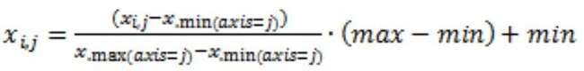

Data preprocessing. . For the input data matrix X, for

1. IMPLEMENTATION

This model is based on Machine Leaning Concept like LSTM and various Phyton Libraries like Npm, pandas, Sequential, Dense, Layout and LSTM have been used in order to provide better UI and UX.

Early project implementation are mentioned below:

* + Collect Google and Tesla historical stock price data, including opening price, closing price, high, low, and volume.
  + Preprocess the data.
  + Model Selection and Development.
  + Training and Evaluation.
  + Model Testing.
  + Visualization and Interpretation.

V.2 Minimum Requirement Specifications

The implementation of this project of done in the system with following specifications and software.

Hardware:

* Processor: Pentium IV 2.4 GHz
* Hard disk: 60 GB
* RAM: 1 GB
* Monitor: 15’’ Colour
* CD Drive: LG52X
* Keyboard: Logitech 110 Keys
* Mouse: Logitech Mouse

Software:

* Operating System: Windows 7
* Coding: Visual Studio Code
* Browser: Microsoft Internet Explorer

Environment: Node.Js

*Programming Language used:*

* Python
* Packages used: npm, pandas, Sequential, Dense, Layout and LSTM

*Early Version of Project:*

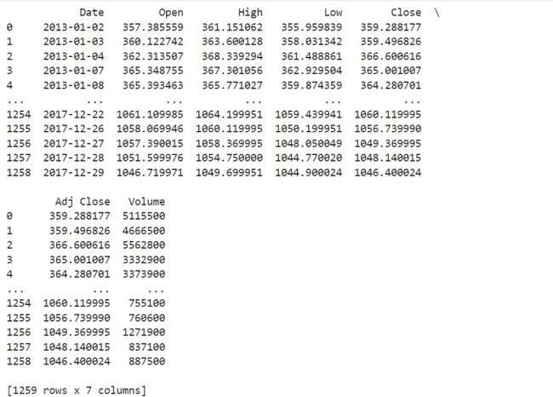

# Fig 1. Google Historical Data

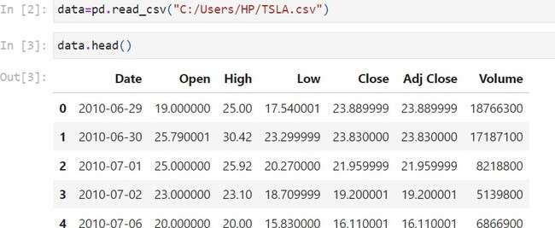

**Fig 2. Tesla Historical Data**

# Fig 3. Train set, Test set for Google stocks

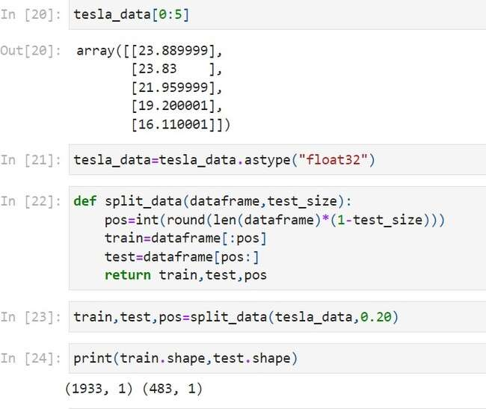

**Fig 4. Train set, Test set for Tesla stocks**

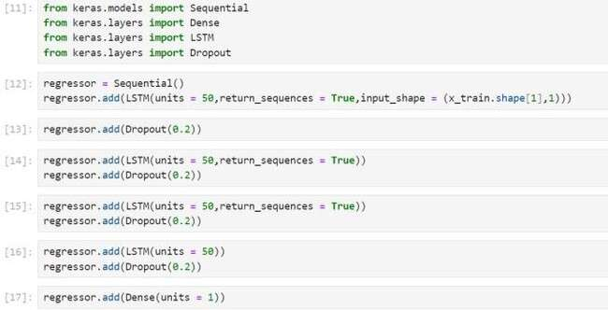

**Fig. 5 Implementing LSTM and defining model structure**

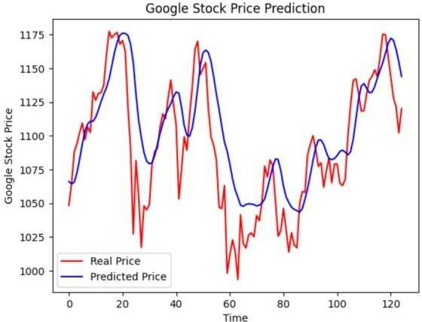

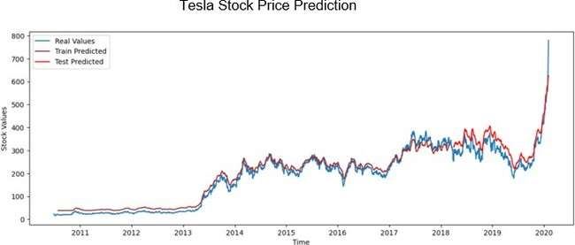

# Fig 6. Visualizing the predictions

1. FUTURE SCOPE

To further improve the performance of RNN-based stock price prediction, future research could explore incorporating additional data sources, such as news sentiment neural network architectures, such as attention mechanisms and Transformer models, could also be investigated. Additional features like moving averages and relative strength index (RSI) contributed to the model's performance by providing more information for prediction. Future work could also involve incorporating sentiment analysis of news related to these companies, considering global economic indicators, or exploring other deep learning architectures for improved accuracy.

1. RESULTS AND DISCUSSIONS

Even though there are many models already available in the market which serve the similar purpose of Predicting the Stock Price, this model will be providing some more Efficiency on the top which have not been implemented yet or have been poorly implemented in the past. By combining experience from the past and knowledge from the present we have proposed an idea for this model which has the potential of predicting the Google as well as Tesla stock price. This feature will not only provide investors to see the prediction for stock prices but also for Beginners it will be a great model to see for predicting market share Price.

1. CONCLUSION

In conclusion, this project successfully developed an RNN-based model for Google stock price prediction that met the predefined performance criteria. However, it is essential to acknowledge that stock price prediction remains a complex and challenging task with many external variables that influence market movements but although we have developed a prediction model for google price stocks.

ACKNOWLEDGMENT

*We acknowledge websites such as Wikipedia, Google and several other forums and our honorable teacher for support and information provided.*

REFERENCES

1. ZAREMBA W, SUTSKEVER I, VINYALS O. RECURRENT NEURAL NETWORK REGULARIZATION[J]. ARXIV PREPRINT ARXIV:1409.2329, 2014.
2. SI J, MUKHERJEE A, LIU B, ET AL. EXPLOITING

TOPIC BASED TWITTER SENTIMENT FOR STOCK PREDICTION

1. STOCK PRICE MOVEMENT PREDICTION WITH LSTM NEURAL NETWORK// 2017 (ICJNN)
2. [HTTPS://WWW.GEEKSFORGEEKS.ORG/INTRODUCTION](https://www.geeksforgeeks.org/introduction-to-recurrent-neural-network/)

[-TO-RECURRENT-NEURAL-NETWORK/](https://www.geeksforgeeks.org/introduction-to-recurrent-neural-network/)

1. [HTTPS://IEEEXPLORE.IEEE.ORG/DOCUMENT/9623206](https://ieeexplore.ieee.org/document/9623206)