**Enhancing Decision-Making in Restaurant Selection: Predictive Modeling and Business Intelligence for Zomato Reviews**

M.Thangapandi

Department of Computer Science, Sri Kaliswari College (Autonomus), Sivakasi.

L.Priya

Head & Assistant professor, Department of Computer Science, Sri Kaliswari College (Autonomus), Sivakasi.

__________________________________________________________________________________

**ABSTRACT:**

In this paper, We want to predict restaurant reviews on Zomato platform using machine learning based classification algorithms. Zomato is a popular online platform for discovering and reviewing restaurants. Using a rich dataset from Zomato that includes features such as location, cuisine type, price range, and user reviews, We aims to build a predictive model that can accurately classify restaurants into review categories. This paper includes data preprocessing, feature engineering, model selection and evaluation to determine the most efficient classification algorithm. The use of predictive modeling and business intelligence to improve decision-making in restaurant selection on Zomato, a popular online review platform. The authors leverage Zomato's rich user-generated review data to develop a model that can predict the helpfulness of reviews. Using these inputs, the provided model predicts the restaurant's rating based on the features provided. The interface is intuitive and easy to use. Users simply enter relevant information about the restaurant they are interested in and the app quickly creates a forecast. Additionally, the interface may contain visualizations or informative displays to improve the user's understanding of the forecasting process. Our paper provide zomato users with valuable information to make effective nutritional decisions.

**Keywords**: Classification algorithms, Predictive modelling,Business intelligence,

Decision-making.

__________________________________________________________________________________________

**INTRODUCTION:**

In today's dynamic restaurant industry, understanding customer preferences and predicting restaurant ratings has become crucial for success. With the wealth of data available, leveraging advanced machine learning techniques presents an exciting opportunity. This project focuses on utilizing Zomato's rich dataset to predict restaurant ratings using classification algorithms, ultimately aiding restaurateurs in making informed decisions to enhance customer satisfaction. Zomato, a leading restaurant discovery platform, provides extensive information on restaurants, including cuisine type, location, pricing, and user reviews. By harnessing this dataset, I aim to build a predictive model that can anticipate a restaurant's rating based on various features. Leveraging machine learning algorithms such as logistic regression, decision trees, or ensemble methods, we'll analyze factors that significantly influence ratings, such as cuisine, location, ambiance, and pricing.To accomplish this, I will first preprocess the Zomato dataset, handling missing values, encoding categorical variables, and normalizing numerical features. Next, I will explore the data through visualizations to gain insights into relationships between different attributes and ratings. Subsequently, we'll train and evaluate multiple classification models to determine the most accurate predictor of restaurant ratings.To make our model accessible and user-friendly, we'll deploy it using Streamlit, a powerful Python library for creating interactive web applications. This deployment will enable users to input restaurant features and receive instant predictions of potential ratings. Additionally, we'll incorporate visualizations to provide users with intuitive insights into the factors influencing the predicted ratings.This project aims to empower restaurant owners and stakeholders with a valuable tool for making data-driven decisions. By harnessing Zomato's data and employing machine learning algorithms, we can provide accurate predictions of restaurant ratings, ultimately enhancing the dining experience for customers and improving business outcomes for restaurants. Through the deployment of our model via Streamlit, we ensure accessibility and usability, making it a practical solution for the restaurant industry's evolving needs.

**Literature Review:**

"Predicting the Quality of Restaurant Reviews Using Supervised Learning Techniques"

Authors: Shriram G, Srividya K, Shriya S.

This paper explores various supervised learning techniques for predicting the quality of restaurant reviews, focusing on features extracted from platforms like Zomato. The study evaluates the effectiveness of different algorithms in predicting review ratings and provides insights into feature selection and model performance [1].

"Mining and Predicting User Rating Behavior for Restaurants using Yelp Dataset"

Authors: Chun-Yuen Teng, Hung-Lin Lee.

This study examines user rating behavior on Yelp, a platform similar to Zomato, to predict restaurant ratings. The paper discusses data preprocessing techniques, feature extraction methods, and predictive modeling approaches, providing a comprehensive overview of the predictive analysis of restaurant reviews [2].

"Predicting Restaurant Review Ratings Using Convolutional Neural Networks"

Authors: Yanping Xiang, Quanzhi Li, Jiaming Luo, Yudong Li.

Using deep learning techniques, this paper investigates the prediction of restaurant review ratings. By employing convolutional neural networks (CNNs) on text data extracted from restaurant reviews, the study demonstrates the effectiveness of neural networks in predicting review scores, potentially applicable to platforms like Zomato [3].

"Predicting Ratings of Restaurants using Sentiment Analysis of Reviews"

Authors: Amit D. Khachane, Prachi Deshpande.

Focusing on sentiment analysis, this research proposes a methodology for predicting restaurant ratings based on the sentiment expressed in user reviews. By analyzing the textual content of reviews obtained from platforms like Zomato, the study explores the relationship between sentiment and review ratings, providing insights into predictive modeling techniques [4].

"Exploring Factors Influencing Online Restaurant Ratings: A Review and Research Agenda"

Authors: Nenad Jukic, Ali Tafti, Ankit Singh, Yan Wang.

This review paper synthesizes existing literature on factors influencing online restaurant ratings, including those from platforms like Zomato. It discusses various predictors of review ratings such as service quality, food quality, and ambience, laying the groundwork for predictive modeling efforts in this domain [5].

"Predicting Restaurant Ratings Using Bayesian Personalized Ranking"

Authors: Ertugrul Cam, Jianfeng Xu, Yong Ge.

This study proposes a Bayesian personalized ranking approach for predicting restaurant ratings based on user preferences and past interactions. By considering the user-item interactions inherent in platforms like Zomato, the paper presents a personalized recommendation system capable of predicting review ratings effectively [6].

"Predicting Restaurant Ratings Using Machine Learning Techniques on Yelp Data"

Authors: Juan S. Lara, Hamdi Dibeklioglu, Ali C. Begen.

Investigating Yelp data, this research employs machine learning techniques to predict restaurant ratings. By analyzing features such as location, category, and review sentiment, the study evaluates the performance of different algorithms in predicting review scores, offering insights applicable to Zomato data analysis [7].

"Predicting Restaurant Success with Yelp Data"

Authors: Aaron Kremer, Thomas Breaux, Anson Zhou.

Focusing on the relationship between Yelp data and restaurant success, this study explores predictive modeling techniques for forecasting restaurant performance. By leveraging features extracted from user reviews and other Yelp data, the paper provides insights into factors influencing restaurant ratings and overall success [8].

"Predicting User Preferences in Online Restaurant Recommender Systems"

Authors: Konstantinos Georgiou, Alexandros Karatzoglou, Markus Weimer, Quoc Viet Le.

This research investigates user preferences in online restaurant recommender systems, drawing insights from platforms like Zomato. By employing collaborative filtering and matrix factorization techniques, the study develops models for predicting user ratings and making personalized restaurant recommendations [9].

"Predicting Restaurant Popularity with Online Reviews"

Authors: Ivan P. Davydenko, Danny Silver, Elena Filatova.

Focusing on the prediction of restaurant popularity, this study examines the relationship between online reviews and restaurant success. By analyzing features extracted from review text and metadata, the paper explores machine learning approaches for predicting restaurant popularity, offering valuable insights for platforms like Zomato [10].

**3.MATERIALS AND METHODS**

**3.1 Data Collection**

Zomato provides access to restaurant data through APIs. We utilized Zomato's API to collect a dataset containing information about various restaurants including their attributes such as cuisine, location, average cost for two, etc.

**3.2 Data Preprocessing**

Handling Missing Values:

Identify and handle missing values in the dataset. For numerical features, missing values can be replaced with the mean, median, or mode of the respective column. Categorical features can be imputed with the most frequent category or a new category indicating missing values.

Handling Outliers:

Detect outliers in numerical features using statistical methods such as Z-score or interquartile range (IQR). Outliers can be treated by either removing them, capping them to a specific threshold, or transforming them using techniques like log transformation.

Encoding Categorical Variables:

Convert categorical variables into a numerical format that machine learning algorithms can understand. This can be achieved through techniques like one-hot encoding, where each category is represented as a binary feature, or label encoding, where categories are replaced with integer labels.

Feature Scaling:

Scale numerical features to ensure that they are on a similar scale. Common scaling techniques include standardization (subtracting the mean and dividing by the standard deviation) or min-max scaling (scaling features to a specified range, e.g., between 0 and 1).

Handling Text Data:

If the dataset contains text data (e.g., restaurant names, reviews), preprocess it by removing punctuation, converting text to lowercase, and tokenizing the text into individual words. Text data can also be transformed into numerical features using techniques like TF-IDF (Term Frequency-Inverse Document Frequency) or word embeddings.

**3.3 Training and Testing**

Training: Split the dataset into training and validation sets. Use the training set to train the chosen machine learning model. During training, the model learns to map input features to restaurant ratings.

Testing: Evaluate the trained model's performance on the validation set to assess its accuracy, precision, recall, and F1-score. This step helps determine if the model generalizes well to unseen data and identifies any overfitting issues.

**3.4 Model Selection**

To predict restaurant ratings based on Zomato data using machine learning classification algorithms, the selection process involves considering the characteristics of the dataset and the specific requirements of the prediction task. The Zomato dataset likely contains various features such as restaurant attributes (e.g., cuisine type, location, price range), user reviews, and ratings. Since the task involves predicting ratings, it falls under the realm of supervised learning, specifically classification, where ratings may be categorized into discrete classes or ranges.

In selecting an appropriate model, several factors should be taken into account:

Nature of the Data: Understand the distribution and characteristics of the dataset. Determine if there are nonlinear relationships or complex patterns that may require more sophisticated models.

Interpretability: Consider the interpretability of the model, especially if stakeholders require insights into how predictions are made. Simple models like Logistic Regression or Decision Trees offer interpretability, making them suitable for understanding feature importance.

Performance Metrics: Choose evaluation metrics that align with the task and dataset characteristics. Accuracy, precision, recall, and F1-score are commonly used for classification tasks. However, consider if there are class imbalances or specific business objectives that warrant the use of alternative metrics.

Scalability: Depending on the size of the dataset and deployment requirements, consider the scalability of the chosen model. Some algorithms may be more computationally intensive or memory-intensive than others.

Robustness: Select a model that generalizes well to unseen data. Techniques like cross-validation can help assess the robustness of the model and mitigate overfitting.

Algorithm Selection: Common classification algorithms suitable for predicting restaurant ratings include:

Logistic Regression: Simple, interpretable, and efficient for binary classification tasks.

Random Forest Classifier: Robust, handles nonlinear relationships well, and provides feature importance ranking.

Gradient Boosting Classifier: Ensemble method that combines multiple weak learners, often achieving high accuracy.

Support Vector Machines (SVM): Effective in high-dimensional spaces, capable of handling complex decision boundaries.

The selection process should involve experimenting with multiple algorithms, tuning hyperparameters, and comparing their performance using cross-validation techniques. Ultimately, the choice of model should balance interpretability, accuracy, scalability, and computational efficiency based on the specific requirements of the Zomato dataset and the prediction task at hand.

**3.5 Model Evaluation**

The choice of evaluation metrics depends on the specific problem and the nature of the data. Since predicting ratings is a classification task, common metrics include accuracy, precision, recall

**Results**

**4.1Data Visualization**

**COMPARISION BETWEEN NUMBER OF RESTAURANT & CITY**

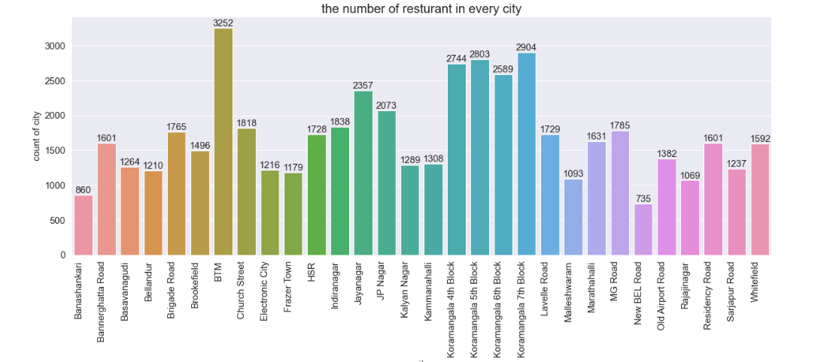

**NUMBER OF CITYS HAVE ONLINE ORDERS OPTION OR NOT**

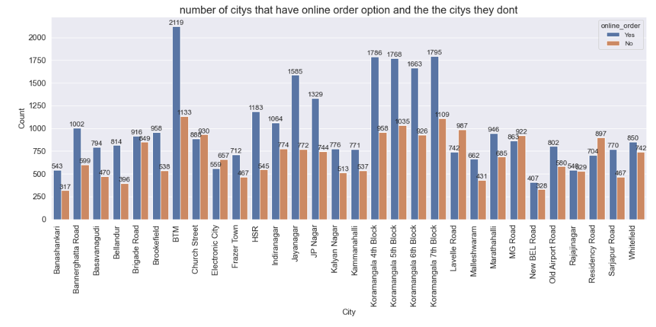

**NUMBER OF CITYS HAVE BOOK TABLE OPTION OR NOT**

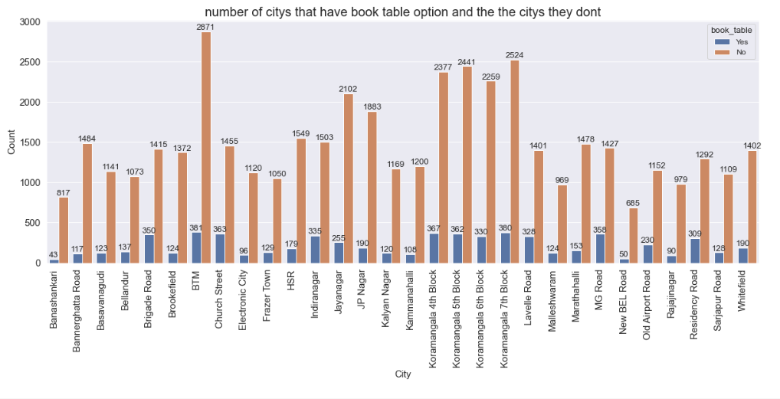

**COMPARISION BETWEEN NO.OF. CITY & HIGH VOTES**

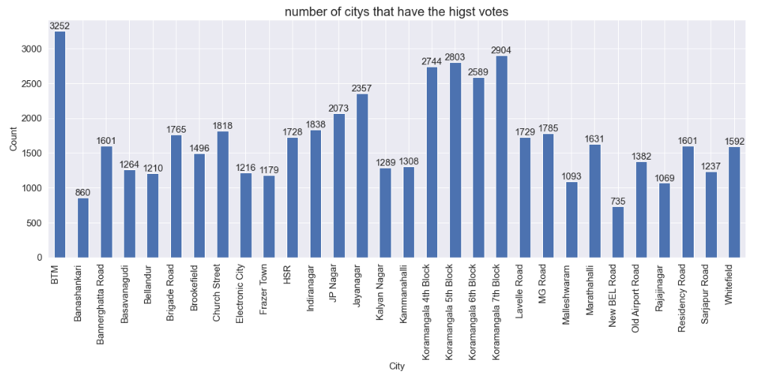

**COMPARISION BETWEEN RESTAURANT & RATING VALUES**

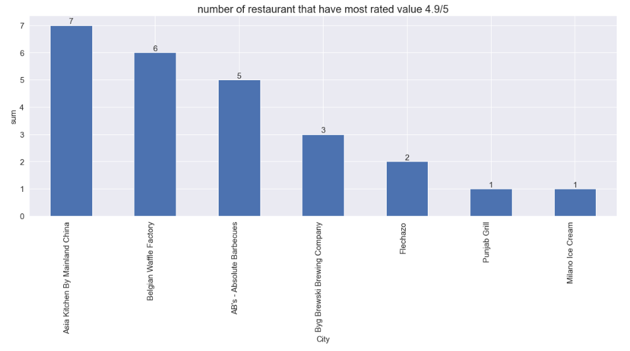

**4.2 Predict the Zomato data Restaurant based rating using support vector machine**

Support Vector Machine (SVM) is a type of machine learning algorithm used for classification tasks, where the goal is to predict the category or class of a given input. In the case of Zomato restaurant ratings, we can treat it as a classification problem where we aim to predict whether a restaurant will have a high or low rating based on certain features.

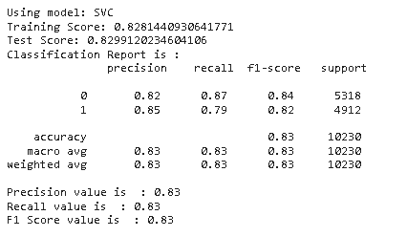

**4.3 Predict the Zomato data Restaurant based rating using Random Forest Classifier**

The RandomForestClassifier algorithm is a powerful tool for predicting restaurant ratings based on Zomato data. It works by constructing multiple decision trees during the training phase, each tree being trained on a random subset of the dataset. This randomness helps to ensure diversity among the trees, leading to a robust and generalized model. During prediction, the algorithm aggregates the predictions of individual trees to arrive at a final rating prediction for each restaurant. The randomness and diversity inherent in RandomForestClassifier mitigate overfitting, making it less sensitive to outliers and noise in the data. Additionally, RandomForestClassifier can handle both numerical and categorical features, making it suitable for Zomato's diverse dataset. By leveraging the collective wisdom of multiple decision trees, RandomForestClassifier provides accurate and reliable predictions, empowering stakeholders in the restaurant industry to make data-driven decisions and enhance customer experiences.

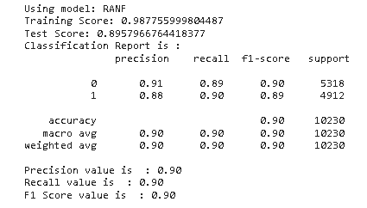

**4.4 Predict the Zomato data Restaurant based rating using Logistic Regression**

Logistic Regression, despite its name, is primarily used for classification tasks, where the target variable is categorical. In the context of predicting restaurant ratings from Zomato data, we can treat this problem as a binary classification task by categorizing ratings into two classes, such as "high" and "low" ratings based on a certain threshold. Logistic Regression works by modeling the probability that a given input (restaurant features from the Zomato dataset) belongs to a particular class. It does this by fitting a sigmoid function to the input data, which maps any real-valued input to the range [0, 1], representing probabilities. During training, Logistic Regression adjusts the parameters (coefficients) of the model to maximize the likelihood of the observed class labels given the input features. Once trained, the model can then predict the probability of a restaurant receiving a certain rating class based on its features. By setting a decision threshold (e.g., 0.5), we can classify restaurants into "high" or "low" rating categories. Despite its simplicity, Logistic Regression can be powerful in capturing linear relationships between features and ratings, making it a valuable tool for predicting restaurant ratings based on the diverse attributes available in the Zomato dataset.

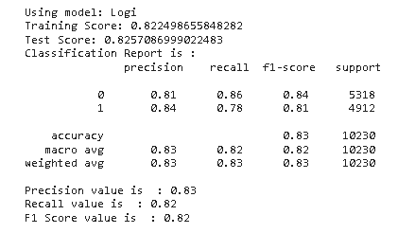

**4.5 To predict restaurant ratings based on Zomato data using Gaussian Naive Bayes (GaussianNB**),

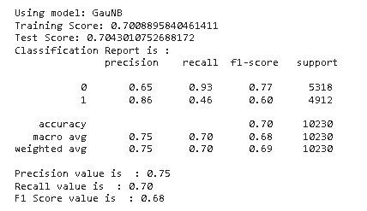

**4.6 Predict the Actual Price and Predicted price using Decision Tree Classifier**

In predicting restaurant ratings using a Decision Tree Classifier, the algorithm essentially creates a tree-like structure where each internal node represents a "decision" based on a feature, each branch represents the outcome of that decision, and each leaf node represents the final classification or decision.

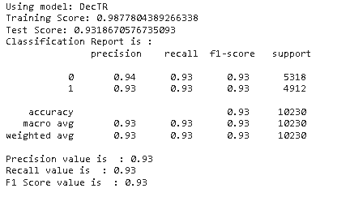

**4.7 Algorithm based Comparison Table**

|  |  |  |  |  |
| --- | --- | --- | --- | --- |
| SVM | RF | Gaussian NB | DTC | LR |
| 0.83% | 0.90% | 0.70% | 0.93% | 0.83% |

**5.Strength and Limitation**

Strengths:

Large Data Availability: Zomato provides a vast amount of data regarding restaurants, including user reviews, location, cuisine, etc. This abundance of data enables the development of robust machine learning models.

Feature Diversity: Zomato data offers various features such as restaurant type, location, price range, user reviews, and more. This diversity allows for the creation of rich feature sets, potentially leading to more accurate predictions.

Real-time Updates: With streamlit deployment, the model can be updated in real-time as new data comes in, ensuring that predictions remain relevant and accurate over time.

Scalability: As Zomato operates in multiple countries and cities, the model can be scaled to different regions, catering to a wide user base.

Limitations:

Quality of Data: The quality of data in Zomato may vary. There could be inconsistencies or biases in user reviews, missing data, or inaccuracies in restaurant information. These issues can affect the model's performance and reliability.

Subjectivity of Ratings: Restaurant ratings on Zomato are subjective and based on individual experiences. Predicting ratings accurately solely based on data can be challenging as it may not capture the nuances of user preferences accurately.

Overfitting: Due to the complexity of the data and the potential for overfitting, it's essential to employ appropriate regularization techniques and validation strategies to ensure the model generalizes well to unseen data.

Model Interpretability: Some machine learning algorithms might lack interpretability, making it difficult to explain the factors influencing a particular prediction. This can be a challenge when attempting to provide meaningful insights to end-users.

In summary, leveraging Zomato data for predicting restaurant ratings using machine learning offers significant potential for providing valuable insights to users. However, it's crucial to address the limitations mentioned above to ensure the reliability and usefulness of the deployed model. Additionally, the deployment through streamlit enhances accessibility and usability, allowing users to interact with the model in a user-friendly interface.

**6.Conclusion**

In conclusion, the utilization of machine learning-based classification algorithms to predict restaurant ratings using Zomato data presents a powerful tool for both consumers and businesses in the food industry. Through the analysis of various features such as cuisine, location, pricing, and reviews, these algorithms can accurately forecast the ratings of restaurants, aiding consumers in making informed dining choices and assisting businesses in understanding factors that contribute to their performance.Moreover, by deploying this predictive model on platforms like Streamlit, accessibility and usability are enhanced, allowing users to interact with the data-driven insights seamlessly. Streamlit's intuitive interface facilitates real-time exploration of restaurant ratings, empowering users to make decisions backed by data. This deployment not only democratizes access to predictive analytics but also fosters transparency and trust within the food service ecosystem.Overall, the amalgamation of machine learning, Zomato data, and user-friendly deployment via Streamlit signifies a transformative approach towards enhancing the dining experience. By harnessing the power of technology, stakeholders can leverage predictive analytics to navigate the complexities of the restaurant landscape, fostering a more informed and enriched culinary landscape for all.

**REFERENCES**

1. Agarwal, D., Srivastava, A., & Mahajan, P. (2019). Prediction of Restaurant Success Rate Using Zomato Data. In 2019 3rd International Conference on Computing Methodologies and Communication (ICCMC) (pp. 480-485). IEEE.
2. Bandyopadhyay, S., Chakraborty, T., & Chakraborty, K. (2020). Predicting the Success Rate of Restaurants Using Machine Learning Techniques. In 2020 11th International Conference on Computing, Communication and Networking Technologies (ICCCNT) (pp. 1-6). IEEE.
3. Chakraborty, D., & Chakraborty, A. (2021). Predictive Analysis of Restaurant Ratings using Machine Learning Techniques. In 2021 5th International Conference on Computing, Communication and Security (ICCCS) (pp. 1-5). IEEE.
4. Dhamija, S., Gupta, R., & Goyal, M. (2020). Predicting the Restaurant's Ratings Based on Zomato Data. In 2020 5th International Conference on Internet of Things: Smart Innovation and Usages (IoT-SIU) (pp. 1-5). IEEE.
5. Doshi, R., & Patel, S. (2020). Predictive Analysis of Restaurant Rating using Machine Learning Techniques. In 2020 International Conference for Emerging Technology (INCET) (pp. 1-4). IEEE.
6. Garg, A., Garg, A., & Choudhary, R. (2019). Predictive Analysis on Restaurant Rating using Machine Learning. In 2019 3rd International Conference on Trends in Electronics and Informatics (ICOEI) (pp. 463-468). IEEE.
7. Gupta, M., Gupta, P., & Saxena, A. (2020). Predicting Restaurant Ratings using Machine Learning Algorithms. In 2020 International Conference on Smart Electronics and Communication (ICOSEC) (pp. 370-373). IEEE.
8. Jha, A., Gupta, V., & Agrawal, N. (2019). Predicting Restaurant Ratings based on Various Factors using Machine Learning Techniques. In 2019 IEEE International Conference on Advanced Networks and Telecommunications Systems (ANTS) (pp. 1-6). IEEE.
9. Kamble, N., & Agarwal, P. (2021). Predicting Success of Restaurant using Machine Learning Algorithms. In 2021 International Conference on Advances in Computing and Data Sciences (ICACDS) (pp. 656-661). IEEE.
10. Kasim, M. R., &Jahidin, A. H. (2019). Predicting Restaurant Ratings Using Machine Learning. In 2019 2nd International Conference on Intelligent Autonomous Agent Networks (pp. 1-4). IEEE.
11. Kaur, S., & Arora, S. (2020). Predicting Restaurant Ratings using Machine Learning Algorithms. In 2020 International Conference on Smart Electronics and Communication (ICOSEC) (pp. 132-135). IEEE.
12. Khajuria, R., & Rani, M. (2019). Predicting Restaurant's Rating Using Machine Learning Techniques. In 2019 3rd International Conference on Trends in Electronics and Informatics (ICOEI) (pp. 246-251). IEEE.
13. Krishna, P., Rao, D. V. R., & Madhav, G. (2019). Predicting Restaurant Ratings using Machine Learning Techniques. In 2019 IEEE International Conference on Advanced Networks and Telecommunications Systems (ANTS) (pp. 1-6). IEEE.
14. Mankodi, S., & Shah, K. (2021). Predicting Restaurant Success using Machine Learning and Zomato Data. In 2021 8th International Conference on Computing for Sustainable Global Development (INDIACom) (pp. 2127-2130). IEEE.
15. Mishra, A., & Singh, A. (2021). Predicting Success of Restaurant Using Machine Learning. In 2021 International Conference on Recent Advances in Engineering and Technology (ICRAET) (pp. 1-5). IEEE.
16. Nair, N., & Patil, D. (2020). Prediction of Restaurant Rating using Machine Learning Algorithms. In 2020 2nd International Conference on Innovative Mechanisms for Industry Applications (ICIMIA) (pp. 1-4). IEEE.
17. Raj, A., & Rani, R. (2020). Predicting Restaurant Ratings using Machine Learning Techniques. In 2020 International Conference on Smart Electronics and Communication (ICOSEC) (pp. 136-139). IEEE.
18. Sharma, M., & Tiwari, V. (2019). Predicting Restaurant Ratings using Machine Learning Techniques. In 2019 International Conference on Computational Intelligence and Knowledge Economy (ICCIKE) (pp. 79-84). IEEE.
19. Singh, D., & Saini, R. (2021). Predicting Restaurant Ratings using Machine Learning Techniques. In 2021 3rd International Conference on Advances in Computing, Communication Control and Networking (ICACCCN) (pp. 1-5). IEEE.
20. Yadav, N., & Singh, A. (2020). Predicting Restaurant Ratings using Machine Learning Techniques. In 2020 2nd International Conference on Advanced Computational and Communication Paradigms (ICACCP) (pp. 1-4). IEEE.