I2C BASED REAL TIME-CLOCK COLLEGE BELL AUTOMATION

Dr. Altaf C, Mohammed Haris Khan [1], Mohammad Imran [2], Syed Ameen Uddin Ali[3],

Mohammed Khaja Pasha Junaid [4]

Students and Associate Professor of Department of Electronics and Communication Engineering, Lords Institute of Engineering and Technology,

**Abstract**

The College Bell Automation System is a smart solution designed to automate the ringing of bells in educational institutions, ensuring precise and timely management of daily schedules. Utilizing an ESP32 microcontroller, the system integrates advanced timekeeping and control features to replace traditional manual bell systems. This project focuses on enhancing the efficiency of school operations by automating bell rings according to a predefined schedule, which can be easily modified through a web interface or mobile application. The ESP32's connectivity options enable remote updates and synchronization with internet time servers for accuracy. This system not only reduces the need for manual intervention but also improves punctuality and organization within the institution. Additionally, the system is scalable, allowing for integration with multiple bells across different locations, and customizable to meet the specific needs of any educational environment. The College Bell Automation System represents a cost-effective, reliable, and future-proof approach to managing school timetables, contributing to a more disciplined and structured academic environment.

**Introduction**

In educational institutions, maintaining punctuality and organization is crucial for smooth operations and effective learning. One of the fundamental components in achieving this is the reliable management of bell schedules, ensuring timely transitions between classes and activities throughout the day. Traditional methods of bell scheduling often rely on manual intervention or basic timer circuits, which can be prone to inaccuracies and require frequent adjustments. By leveraging RTC modules via I2C communication, colleges can implement sophisticated bell automation systems that offer programmable scheduling, automatic adjustments for seasonal time changes, and centralized control over bell ringing sequences. These capabilities not only streamline administrative tasks associated with bell management but also enhance overall operational efficiency and reliability.

This introduction sets the stage for exploring how I2C-based RTC technology revolutionizes college bell automation, offering a scalable and dependable solution tailored to the dynamic scheduling needs of educational institutions. The following sections will delve deeper into the technical aspects, benefits, and implementation considerations of integrating I2C-based RTC systems for efficient and effective college bell automation.

**Literature Review:**

This Project takes over the task of Ringing the Bell in schools and Colleges. It replaces the Manual Switching of the Bell in schools and Colleges. Here we are going to employ ESP32 microcontroller. esp32 microcontroller has inbuilt EEPROM in which timings can be stored. Once the timings are loaded in RTC it automatically ticks every second. The PIC microcontroller reads the data from the RTC via I2C bus and compares it with the pre stored ones. If the value matches the controller initiates the buzzer. The exact timing will be displayed on the LCD and we also provide the keypad to change the timings. we are using IOT module to provide the flexibility by controlling the circuit using a smartphone.

Survey on Automated College Bell System

An automated college bell system is a modern solution designed to replace traditional manual bell systems in educational institutions. This system is primarily aimed at improving the efficiency and accuracy of signalling the start and end of classes, breaks, and other scheduled activities within a college. The implementation of such systems involves the use of hardware (such as microcontrollers, relays, and speakers) and software (for scheduling and control). Below is a literature review summarizing key findings and research related to automated college bell systems**.**

**Advantages of Automated Bell Systems:**

* Consistency and Accuracy: Automated systems ensure that bells ring at exactly the same time every day, minimizing disruptions caused by human error.
* Reduced Labor Costs: Once installed, these systems require minimal human intervention, reducing the need for dedicated personnel to manage the bell system.
* Customization: The schedule can be easily modified to accommodate special events, holidays, or changes in the academic timetable.
* Energy Efficiency: Some systems are designed to operate efficiently, minimizing electricity usage, especially when compared to older, mechanical systems

**Proposed System**

A proposed system for an automated college bell system would aim to enhance the efficiency, accuracy, and flexibility of the bell-ringing process while addressing the limitations of existing systems. Below is a detailed outline of what a proposed modern, fully automated college bell system might look like.

1. System Overview

The proposed system is a fully automated, IoT-enabled college bell system designed to manage and control the ringing of bells across the college campus. This system would be centralized, allowing administrators to schedule and manage bell timings through a user-friendly interface. The system would incorporate advanced technologies such as microcontrollers, real-time clocks, cloud connectivity, and integration with other campus management systems.

2. **Key Features**

* **Centralized Control**: A web-based or mobile application interface allows administrators to configure, monitor, and adjust the bell schedule remotely from any device with internet access.
* **Real-Time Clock (RTC) Integration**: The system uses an RTC module to maintain accurate timing, ensuring that the bell rings at the exact scheduled time, regardless of power outages or network issues.
* **IoT Integration**: The system is part of the college’s IoT ecosystem, enabling it to communicate with other systems (such as lighting, HVAC, and security systems) for coordinated operations.
* **Cloud Connectivity**: Data related to the bell schedule, logs, and system status is stored in the cloud, allowing for easy access, backup, and real-time updates.

In the suggested system, we will use Solar based charging system for providing the power to charge the vehicle. It employs a microcontroller-based sensor-monitoring and controlling system, as well as operation control. Through this sensors and circuit efficient monitoring and controlling can be done. The system uses IOT based monitoring for the power monitoring. The charging units and the amount of charge the EV vehicle is holding is maintained in the IOT Application.

**Block Diagram:**

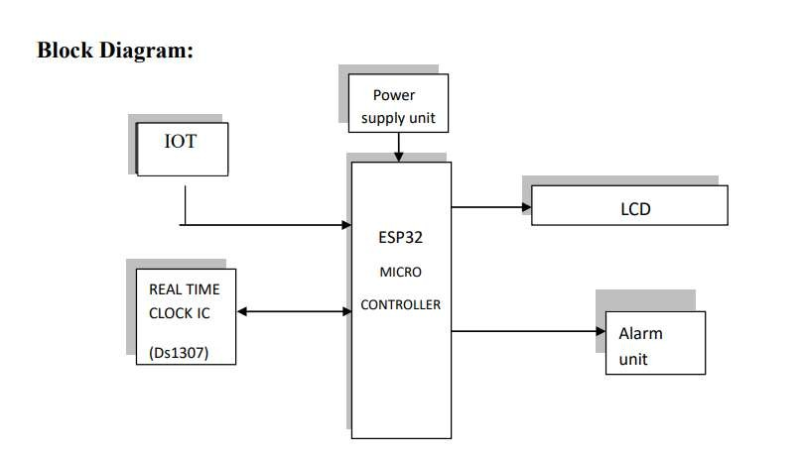

Fig 1- Block diagram for Inter integrated Circuits (I2C) Based Real Time Clock for College Bell Automation

**Hardware Components:**

**Power Supply:**

The power supply section is responsible for delivering a stable +5V required for the components to function. The IC LM7805 is used to provide a constant +5V output. The process begins with an AC voltage supply, typically 220V, which is connected to a transformer that steps down the voltage to the desired DC level. A diode rectifier then converts this AC voltage into a full-wave rectified output. This rectified voltage is initially smoothed using a capacitor filter to produce a DC voltage, though it may still contain some ripple or AC variations. A voltage regulator circuit eliminates these ripples and maintains a steady DC output, regardless of fluctuations in the input voltage or changes in the connected load. This regulation is typically achieved using a standard voltage regulator IC

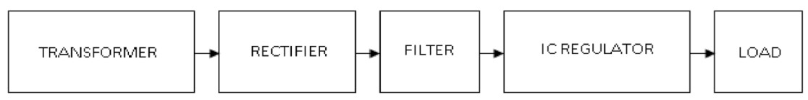

Fig 2**-**Block diagram of power supply

**Esp32 Module:**

The ESP32 module is a cost-effective, low-power system-on-chip (SoC) microcontroller with integrated Wi-Fi and Bluetooth capabilities. Developed by Espressif Systems, it is widely used in applications such as Internet of Things (IoT) devices, wearable electronics, and embedded systems. The ESP32 features dual-core processors operating at speeds of up to 240 MHz, along with various built-in peripherals, including touch sensors, analog-to-digital converters (ADCs), and pulse width modulation (PWM) controllers. Additionally, it supports multiple communication protocols, including Wi-Fi, Bluetooth, and Ethernet, making it a versatile choice for connected applications.

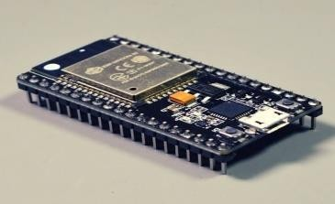

Fig**:** Esp32 Module

**Voltage Sensor:**

This sensor is used to monitor, measure, and analyze voltage levels in a system. It can detect both AC and DC voltage. The sensor takes voltage as input and provides various output signals, including switches, analog voltage signals, current signals, and audible alerts. Some sensors generate sine or pulse waveforms, while others produce outputs such as Amplitude Modulation (AM), Pulse Width Modulation (PWM), or Frequency Modulation (FM). The accuracy of these sensors often relies on a voltage divider for precise measurement..

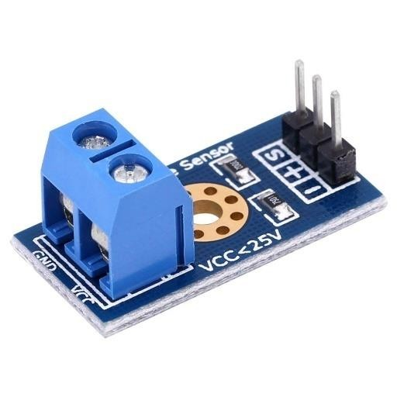

Fig 4**-**voltage sensor

1. This sensor consists of input and output sections. The input side has two pins: a positive pin and a negative pin, which are connected to the corresponding positive and negative terminals of the sensor. Similarly, the device's positive and negative terminals are linked to the sensor's respective terminals. The output section of the sensor typically includes a supply voltage (VCC), ground (GND), and an analog output signal.
2. **Resistive Type Sensor**: This sensor primarily consists of two circuits: a voltage divider and a bridge circuit. The resistor acts as the sensing element in these configurations. In a voltage divider circuit, the input voltage is distributed across two resistors—one acting as a reference and the other as a variable resistor. When a voltage supply is applied, the output voltage is determined by the resistance values within the circuit. Any changes in voltage can be detected and amplified for further processing.
3. **Capacitive Type Sensor**: This type of sensor consists of an insulator positioned between two conductors. When powered with a 5V supply, current flows through the capacitor, causing electron displacement within it. The change in capacitance corresponds to variations in voltage. Additionally, the capacitor can be connected in series to enhance measurement accuracy..

**Current Sensor:**

A current sensor is a device designed to detect and convert current into a measurable output voltage. This output voltage is directly proportional to the current flowing through the monitored path. The resulting voltage signal can be used to display the measured current on an ammeter, regulate systems for control purposes, or store data for further analysis in a data acquisition system. This defines the primary function of a current sensor.

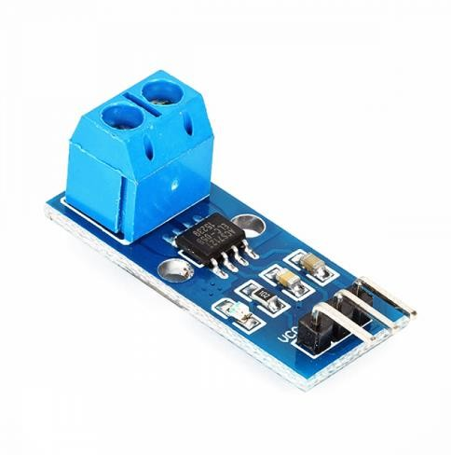

Fig 5**:** Current sen[sor](https://creativecommons.org/licenses/by-nc/3.0/)

**Relay:**

A relay is an electromechanical switch that operates automatically, performing ON and OFF functions without human intervention. A general representation of a double-contact relay is shown in the figure. Relays are commonly used in applications where a low-power signal needs to control a circuit while maintaining complete electrical isolation between the control and controlled circuits. They are also useful for controlling multiple circuits with a single signal.

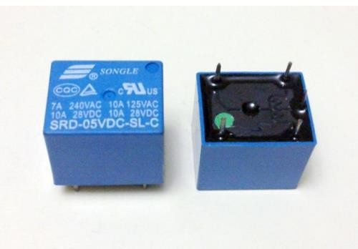

Fig 6**-** Relay

**REAL TIME CLOCK:**

A relay is an electromechanical switch that operates automatically, performing ON and OFF functions without human intervention. A general representation of a double-contact relay is shown in the figure. Relays are commonly used in applications where a low-power signal needs to control a circuit while maintaining complete electrical isolation between the control and controlled circuits. They are also useful for controlling multiple circuits with a single signal.

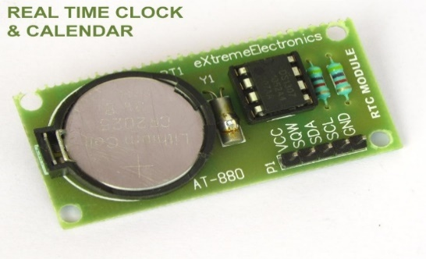

Fig-7 RTC IC

**Liquid crystal display:**

The most commonly used character-based LCDs are built on Hitachi's HD44780 controller or other compatible versions like the HD44580. In this tutorial, we will explore character-based LCDs, their interfacing with different microcontrollers, various communication modes (8-bit and 4-bit), programming techniques, and unique tricks to enhance their functionality. These simple yet powerful LCDs can add a fresh and dynamic look to your applications.

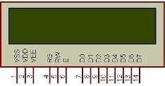

Fig 8 Character LCD type HD44780 Pin diagram

**Alarm Unit:**

A beeper or buzzer is an audio signaling device that can be electromechanical, piezoelectric, or mechanical in type. Its primary function is to convert electrical signals into sound. Typically powered by a DC voltage, buzzers are commonly used in timers, alarm systems, printers, computers, and other alerting devices. Depending on its design, a buzzer can produce various sounds, including alarms, music, bells, and sirens.

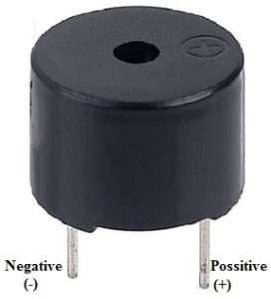

Buzzer

**Result:**

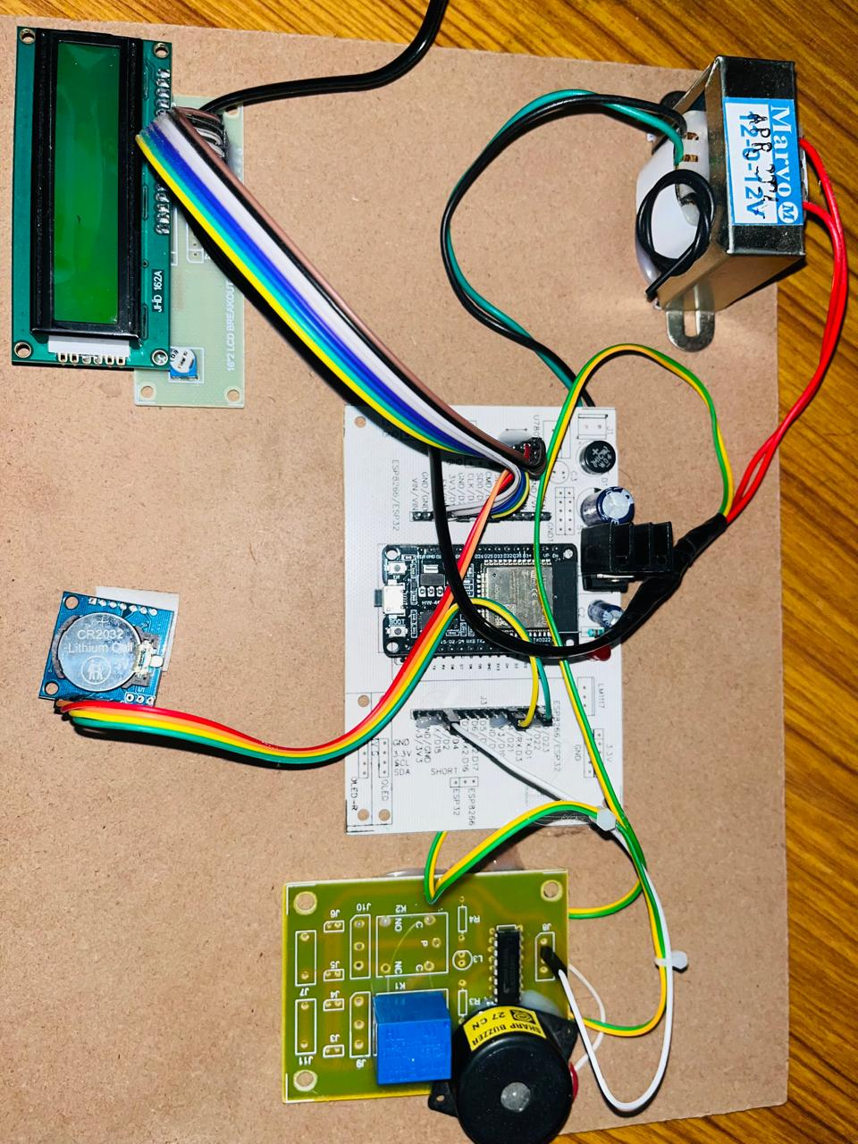

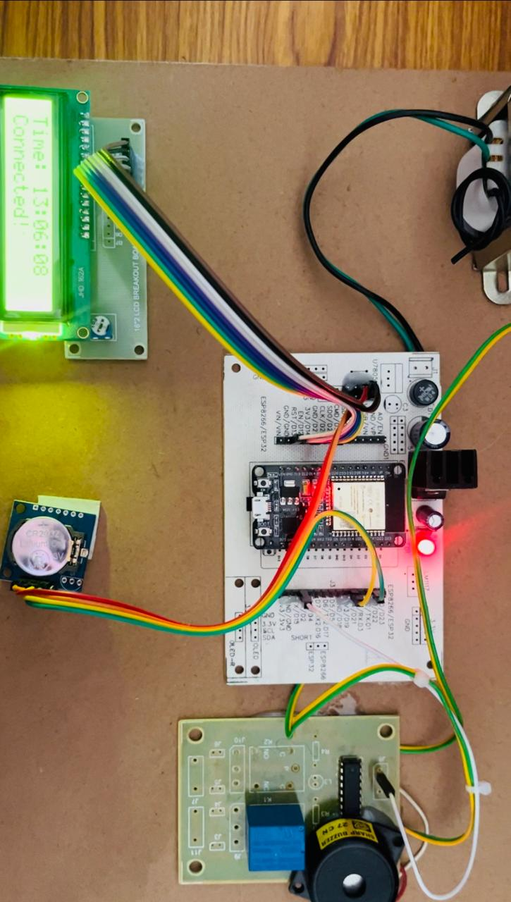

Fig **10-**Hardware kit

**Result:**

A college automated bell system using an ESP32 microcontroller automatically rings bells according to a predefined schedule. The ESP32 controls a relay that activates the bell at the scheduled times. It can be programmed or updated via Wi-Fi, with the option to synchronize time using RTC for accuracy. The system can also be manually overridden and expanded to control multiple bells or integrate additional sensors. This setup enhances efficiency by automating the bell-ringing process.

Simplified Scheduling: The ESP32-based college automated bell system simplifies the process of managing school schedules by automating bell ringing according to a set timetable. This reduces the need for manual intervention and ensures that the schedule is consistently followed.

Accurate Timing: The system provides precise and consistent bell ringing by utilizing the ESP32’s internal clock or synchronizing with internet time servers via NTP. This ensures that the bells ring exactly on time, enhancing punctuality throughout the institution.

**Conclusion:**

In conclusion, the college automated bell system using an ESP32 microcontroller offers a reliable and efficient solution for automating bell schedules. By leveraging the ESP32's capabilities, the system ensures precise time management and ease of configuration through a web interface or mobile app. The integration of a relay module for bell control and the ability to expand the system for multiple bells or additional features make it highly adaptable to various institutional needs. This project reduces manual intervention, improves time management, and contributes to a more organized and timelier environment in the college.

Cost-Effective and Scalable: The automated bell system built with the ESP32 microcontroller is a cost-

effective solution that can be easily scaled to meet the needs of any educational institution. Its flexibility and ease of programming make it suitable for both small and large campuses, providing a consistent and accurate way to manage daily schedules.

Enhanced Operational Efficiency: Implementing an automated bell system significantly enhances the operational efficiency of a college. By automating the bell-ringing process, the system reduces the burden on staff and ensures that classes and breaks begin and end precisely on time, promoting better time management and discipline.

**Reference:**

1. Arduino. Arduino, n.d. Web. Accessed on 12-01-2017.
2. Anand Nayyar and Er. Vikram Puri, “A Review Of Arduino’s Board’s, Lilypad’s And

Arduino Shields”, International Conference on Computing for Sustainable Global Development (INDIACom), Electronic ISBN: 978-9-38054421-2, Pages 1485–1492, 2016.

1. Sajjan V., Altaf C., Mounagurusamy, M., Begum, S., “Analysis On an AI Based Sustainable Development Goals for People with Disabilities through Advanced Digital Technologies”, International Conference on Advanced Computing and Communication Systems, ICACCS 2022, pp. 1348–1352, 2022.
2. Altaf C, Dr.Shah Aqeel Ahmed “Analysis of an Efficient Routing Protocol for Mobile AD-HOC Networks”, Innovative Computing, Intelligent Communication and Electrical System (ICSES 2021), 24 - 25 September, 2021.
3. Arshad Ali, M.A.H. Farquad, C Atheeq, Altaf C, “Quantum Encryption Algorithm based on Rail Fence Mechanism to Provide Data Integrity”, Engineering, Technology & Applied Science Research.
4. Dr. C. Atheeq, Dr. Layak Ali, Dr. Altaf C, Mr. Aleem Mohammad, “Mitigating Man-in-the-Middle Attack in UAV Network using Authentication mechanism based on Chaotic Maps” International Conference on Advances in Emerging Trends in Computer Applications-2023 in Taylor and Francis Series.
5. Dr. Altaf C, Dr. Shanila Mahreen, Dr. C. Atheeq, Shaista Khanam, “Strengthening UAV Network Security: Advanced Authentication-Based Intrusion Detection System” International Conference on Advances in Emerging Trends in Computer Applications-2023 in Taylor and Francis Series.
6. Mohammad Khaja Nizamuddin, Syed Raziuddin, Farheen Mohammed, C. Atheeq, Ruhiat Sultana, “Harnessing AI for Real-time Health Monitoring and Intervention Mechanisms”, Engineering, Technology & Applied Science Research, Vol 4, No 4, pp. 15553-15558, 2024.
7. Mohammad Khaja Nizamuddin, Zunaira Begum, C. Atheeq, Ruhiat Sultana, Ahsan Saud Qadri, “Cloud Computing Framework for Vehicle Multimedia with Dynamic Priority-based Efficient Resource Allocation”, SSRG International Journal of Electrical and Electronics Engineering, Vol 11, No 6, pp. 22-30, 2024.
8. Ahsan Saud Qadri Syed, C. Atheeq, Layak Ali, Mohammad Tabrez Quasim, “Α Chaotic Map-based Approach to Reduce Black Hole Attacks and Authentication Computational Time in MANETs”, Engineering, Technology & Applied Science Research, Vol 14, No 3, pp. 13909-13915, 2024.
9. C. Atheeq, Zameer Gulzar, Mana Saleh Al Reshan, Adel Sulaiman, Hani Alshahrani, and Asadullah Shaikh, “Securing UAV Networks : A Lightweight Chaotic-Frequency Hopping Approach to Counter Jamming Attacks”, IEEE Access, Vol 12, 2024.
10. C Atheeq, Ruhiat Sultana, Syeda Asfiya Sabahath, Murtuza Ahmed Khan Mohammed, “Advancing IoT Cybersecurity: Adaptive Threat Identification with Deep Learning in Cyber-Physical Systems”, Engineering, Technology & Applied Science Research, Vol 14, No 2, pp. 13559-13566, 2024.
11. C. Atheeq, Altaf C, Mohammad Mohammad, Mohammed Aleem, “An Effective Mechanism to Mitigate Packet Dropping Attack from MANETs using Chaotic Map based Authentication Technique”, Recent Patents on Engineering, Volume 18, Number 3, pp. 66-76(11), 2024.
12. Hashmi, S.S., Abdul, A.M., Mohammad, A.A.K., Atheeq, C., Chinapaga, R., “Advancing Secure Mobile Cloud Computing: A Chaotic Maps-Based Password Key Agreement Protocol”, Ingenierie des Systemes d'Information, Vol 28, No 6, pp. 1669-1678, 2023. (SCOPUS)
13. Maxim Integrated Products Inc.,”DS3231 Extremely Accurate I2C-Integrated RTC/TCXO/Crystal” DS3231 Datasheet, 2015.
14. iteadstudio.com. “HC-05 Bluetooth module” Datasheet, Accessed on 06.18.2010.
15. Zx Lee, 4x4 matrix keypad, Personal blog on Electronics and Programming, 24-07-2013. Web.

Accessed on 01-02-2017. Atmel Corporation“Two wire automotive serial EEPROM” AT24C08A/16A Datasheet, 2004.

1. Fried, Limor. “Monochrome OLED Breakouts.” Adafruit. n.d. Web. Accessed on 30-01-2017.
2. https://learn.adafruit.com/monochrome-oled-breakouts
3. Abyash Gautam, Deepak Rasaily and Sejal Dahal, ”Microcontroller Controlled Automated College

Bell”, International Journal of Engineering.

1. Trends and Technology (IJETT), Volume 32, Issue 4, Pages 184-187, February 2016.
2. Sheenu Choudhary, Shrikant and Priyanka Sharma, “Automatic college bell system”, International Journal of scientific research and
3. management (IJSRM), Volume 2, Issue 3,Pages 668-673, 2014.
4. [10] Shweta Butoliya, Nupur Shal, Snehal Girhepunje, Aakanksha Rannaware, Prerna

Baddalwar and Vaishali Badwe, ”Microcontroller based

1. automatic college bell with monitoring system”, International Journal of Advanced Research in Computer Engineering & Technology (IJARCET), Volume 4, Issue 2, Pages 401-404,