AN INTELLIGENT IRRIGATION CONTROL SYSTEM

USING IOT.

Md Khaja Pasha1 , Mohammed Baqtiar Hussain2, Mohd Abdul Quddoos3, Md Faisal4, Samaleti Ajay5,

Assistant professor1, Student2,3,4,5 ,Department of Electronics and Communication Engineering,

Lords Institute of Engineering and Technology, Hyderabad, Telangana, India-500091

## ABSTRACT:

An adequate water supply is important for plant growth. When rainfall is not sufficient, the plants must receive additional water from irrigation. Irrigation is the artificial application of water to land to assist in the production of crops. The success of irrigation depends on the selection of the most proper irrigation method as per the conditions and planning, projecting and establishing. A good knowledge of soil moisture can lead to higher yields, better quality crops. Here we are going to develop an intelligent irrigation control using moisture sensor.

The proposed system consists of a network of sensors and actuators that collect data on soil moisture, temperature, humidity, and weather conditions. This data is transmitted to a central control unit that uses algorithms to make decisions about when and how much water to be irrigated. The system is designed to be energy-efficient and cost effective, using a regular power source to operate. The system provides several benefits over traditional irrigation systems. It reduces water wastage and conserves water resources, resulting in improved crop yields and reduced costs. The system is easy to install, operate, and maintain, and can be customized to suit specific crops and soil types.

Overall, the proposed IoT-based smart irrigation system is a significant improvement over traditional irrigation systems, providing a sustainable and efficient solution for agriculture. The system's scalability, energy efficiency, and customizability make it a viable option for farmers looking to adopt new technology to improve their irrigation systems. First it reduce water wastage and conserves water resources by only irrigating when needed. This, in turn, results in improved crop yields and reduced costs. Second, the system is easy to install, operate, and maintain.

# INTRODUCTION :

Agriculture is the unquestionably the largest livelihood provider in India. With rising population, there is a need for increased agricultural production. In order to support greater production in farms, the requirement of the amount of fresh water used in irrigation also rises. Currently, agriculture accounts 83% of the total water consumption in India. Unplanned use of water inadvertently results in wastage of water. This suggests that there is an urgent need to develop systems that prevent water wastage without imposing pressure on the farmers. Over the past 15 years, farmers started using computers and software systems to organize their financial data and keep track of their transactions with third parties and also monitor their crops more effectively.

In the Internet era, where information plays a key role in people’s lives, agriculture is rapidly becoming a very data intensive industry where farmers need to collect and evaluate a huge amount of information from a diverse number of devices (eg., sensors, faming machinery etc.) in order to become more efficient in production and communicating appropriate information, it is viable to create devices that can monitor the soil moisture content and accordingly irrigating the fields or the landscape as an when needed.

Plants not only add a natural beauty to our surroundings but also provide us with oxygen, which is essential for our survival. However, maintaining healthy plants requires proper care, including providing them with adequate water, sunlight, and nutrients. While plants require low maintenance, taking care of them becomes challenging when we are away from our homes for extended periods. In such scenarios, plants may wither, die or become susceptible to diseases due to the lack of proper watering. To address this issue, we propose an automatic irrigation system that can water plants automatically and maintain their health, even when we are not around.

## LITERATURE REVIEW :

### IoT Based Smart Irrigation System, Srishti Rawal (2017)

A system to monitor moisture levels in the soil was designed and the project provided an opportunity to study the existing systems, along with their features and drawbacks. The proposed system can be used to switch on/off the water sprinkler according to soil moisture levels thereby automating the process of irrigation. Information from the sensors is regularly updated on a webpage using GSM-GPRS SIM900A modem through which a farmer can check whether the water sprinklers are ON/OFF at any given time. Also, the sensor readings are transmitted to a Thing speak channel to generate graphs for analysis.

### Arduino Based Smart Irrigation System Using Iot, R.Nandhini, S.Poovizhi, Priyanka Jose, R.Ranjitha, Dr. S.Anila (2017) :

The main objective of this smart irrigation system is to make it more innovative, user friendly, time saving and more efficient than the existing system. Measuring four param- eters such as soil moisture, temperature, humidity and pH values and the system also includes intruder detecting system. Due to server updates farmer can know about crop field nature at anytime, anywhere.

### Smart Irrigation System, R.Suresh (2014) :

This paper mentioned about using automatic microcontroller-based rain gun irrigation system in which the irrigation will take place only when there will be intense requirement of water that save a large quantity of water. These systems bring a change to management of field resource where they developed a software stack called Android is used for devices that include an operating system, middleware and key applications. The Android SDK provides the tools and APIs necessary to begin developing applications on the Android platform using the Java programming language. Mobile phones have almost become an integral part of us serving multiple needs of humans.

## PROPOSED SYSTEM :

Using this system it automatically pours the water to the dry land without the help of farmers. Here we use moisture sensor to identify the moisture level of soil. The sensor detail is given to the LM358 comparator. The comparator compares the given input to the reference input and produces some voltage variations. This voltage variation is then given to the microcontroller unit and it controls the relay according to the given input. If the land gets dry means the controller switch ON the motor to spread the water throughout the land, otherwise it is in the OFF state. The relays are used to drive the motor. LCD display used here is to indicate the moisture level of the soil continuously. The soil moisture sensor senses the amount of moisture content in the soil. The controller board transfers the control over the system to the relay module which is responsible for switching operations. The relay module ensures proper irrigation of the field turning it on when the value of moisture is below the threshold value and turns off the supply when the moisture content is sufficient for the crop or plant thereby preventing under irrigation or over irrigation. The state of the relay module is indicated by the LED.

The proposed system also incorporates additional features such as the use of a rain sensor and ultrasonic sensor to prevent overwatering and protect plants from animals. These features enhance the efficiency and effectiveness of the system, promoting optimal plant growth and yield. Overall, the proposed IoT-based smart irrigation system is an excellent example of how technology can be used to address real-world problems and promote sustainability in agriculture.

## Block Diagram :

**Fig 1-Block diagram of Intelligent Irrigation Control System Using IoT**

## Hardware Components:

**Power Supply:**

The power supply section is responsible for providing a stable +5V to the circuit components. The **LM7805 voltage regulator IC** is used to maintain a constant +5V output.

The process begins with an **AC voltage source** (typically 220V) connected to a **transformer**, which steps down the voltage to the required DC level. A **diode rectifier** then converts this AC voltage into a full-wave rectified signal. This rectified voltage is initially smoothed using a **capacitor filter**, reducing fluctuations and producing a DC output.

However, this DC output may still contain some ripple or variations. To eliminate these inconsistencies, a **voltage regulator circuit**, such as the LM7805, is used. This regulator ensures a stable +5V output by filtering out ripples and maintaining the same voltage level, even if the input voltage fluctuates or the load changes. This reliable voltage regulation is essential for the proper functioning of electronic circuits.

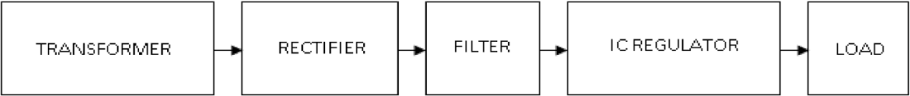

**Fig 2-Block diagram of power supply**

## Transformer :

Transformers are devices that efficiently convert AC electricity from one voltage level to another with minimal power loss. They function exclusively with AC, which is one of the reasons why mains electricity is supplied in AC form.

There are two main types of transformers:

* **Step-up transformers** increase voltage.
* **Step-down transformers** decrease voltage.

In most power supply systems, a **step-down transformer** is used to lower the high mains voltage (230V in India) to a safer, lower voltage suitable for electronic circuits and appliances.

## Rectifier :

There are multiple ways to connect diodes to create a rectifier for converting AC to DC. The **bridge rectifier** is the most commonly used method, as it efficiently produces a **full-wave rectified DC output**.

A **full-wave rectifier** can also be built using just two diodes in combination with a **center-tap transformer**, though this method is less common today due to the affordability and efficiency of modern diodes.

Alternatively, a **single diode** can function as a rectifier, but it only utilizes the **positive half** of the AC waveform, resulting in **half-wave rectification**, which is less efficient for most applications.

## Voltage Regulators :

Voltage regulators are a widely used class of integrated circuits (ICs) designed to provide stable voltage outputs. These ICs incorporate essential components such as a **reference source, comparator amplifier, control device, and overload protection** within a single unit.

Voltage regulators are available in different types, including:

* **Fixed positive voltage regulators**
* **Fixed negative voltage regulators**
* **Adjustable voltage regulators**

They can support a wide range of **load currents**, from a few hundred milliamperes to several amperes, making them suitable for applications with power ratings ranging from milliwatts to tens of watts.

## ESP32 Module :

The **ESP32 module** is a cost-effective, low-power **system-on-chip (SoC) microcontroller** with integrated **Wi-Fi and Bluetooth** capabilities. Developed by **Espressif Systems**, it is widely used in applications such as **Internet of Things (IoT) devices, wearable electronics, and embedded systems**.

The ESP32 features **dual-core processors** operating at speeds of up to **240 MHz** and includes a variety of built-in peripherals such as **touch sensors, analog-to-digital converters (ADC), and pulse-width modulation (PWM) controllers**. Additionally, it supports multiple communication protocols, including **Wi-Fi, Bluetooth, and Ethernet**, making it a highly versatile microcontroller.

One of the most important aspects of the ESP32 is its **pin configuration**. The module has **38 pins**, categorized into different types such as **power pins, ground pins, general-purpose input/output (GPIO) pins, ADC pins, DAC pins**, and more. Understanding the functionality of these pins is essential for maximizing the ESP32’s capabilities in various projects.

**Moisture Sensor :**

The **Soil Moisture Sensor Module** is designed to detect soil moisture levels or determine the presence of water around the sensor, helping plants signal when they need watering. Simply insert the module into the soil and adjust the **on-board potentiometer** to fine-tune its sensitivity for accurate readings. This sensor is ideal for **automated irrigation systems, gardening projects, and smart agriculture applications**.

**Fig 3-ESP32 Module**

The **Soil Moisture Sensor Module** outputs a **HIGH or LOW logic signal** depending on whether the soil moisture level is above or below the threshold set by the **on-board potentiometer**. This allows for automated plant care, effectively letting plants "communicate" their needs—**"Hey, I’m thirsty! Please water me."**

### ****How Soil Moisture Sensors Work****

Soil moisture sensors measure the **volumetric water content** in soil. Since directly measuring soil moisture through **gravimetric methods** requires extracting, drying, and weighing soil samples, these sensors use indirect techniques. They detect moisture levels by measuring properties such as:

* **Electrical resistance**
* **Dielectric constant**
* **Neutron interaction**

The relationship between these measured properties and actual soil moisture levels must be **calibrated** and can vary based on environmental factors like **soil type, temperature, and electrical conductivity**.

### ****Applications & Advanced Techniques****

* **Remote Sensing**: Microwave radiation reflections are affected by soil moisture, making them useful for hydrology and agricultural studies.
* **Portable Probes**: Farmers and gardeners can use handheld devices for real-time soil moisture monitoring.

While most soil moisture sensors estimate **volumetric water content**, another class of sensors measures **water potential**, which indicates how strongly water is held within the soil.

**Fig 4- Moisture Sensor**

## Relay ULN2003:

A **relay** is an **electromechanical switch** that automatically performs **ON and OFF operations** without human intervention. It allows a **low-power signal** to control a circuit while maintaining **electrical isolation** between the control and controlled circuits.

Relays are commonly used in applications where:

* A **low-power signal** needs to control a **high-power circuit**.
* **Multiple circuits** must be controlled using a **single signal**.

A general representation of a **double-contact relay** is shown in the figure, illustrating its ability to switch between two different connections efficiently.

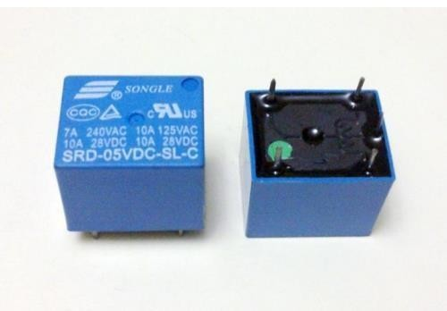

### Fig 5- RelayULN2003

**Working of relay :**

A **relay** typically consists of an **inductor coil, a spring (not shown in the figure), a swing terminal,** and two high-power contacts:

* **Normally Closed (NC) contact** – connected when the relay is OFF.
* **Normally Open (NO) contact** – connected when the relay is ON.

The relay operates using an **electromagnet** that moves the **swing terminal** between the **NC and NO contacts**:

* **When the relay is OFF** (no power to the inductor coil), the **spring holds the swing terminal** in contact with **NC**, keeping the circuit closed in its default state.
* **When power is applied**, current flows through the **inductor coil**, generating a **magnetic field** that pulls the **swing terminal** towards the **NO contact**, closing the circuit at NO.
* **When power is turned OFF**, the **spring resets the swing terminal** back to NC, restoring its original state.

This mechanism allows a relay to **control high-power circuits** using a **low-power input signal** effectively.

## Comparator LM358 :

A **relay** consists of several key components:

* **Inductor coil** – generates a magnetic field when powered.
* **Spring** (not shown in the figure) – returns the relay to its default state.
* **Swing terminal** – moves between contacts.
* **High-power contacts**:
  + **Normally Closed (NC)** – connected when the relay is OFF.
  + **Normally Open (NO)** – connected when the relay is ON.

### ****How a Relay Works****

1. **Relay OFF (No Power to Coil)**:
   * The **spring keeps the swing terminal connected to NC**, maintaining the circuit’s default state.
2. **Relay ON (Power Applied to Coil)**:
   * Current flows through the **inductor coil**, generating a **magnetic field**.
   * This **magnetic force pulls the swing terminal to the NO contact**, switching the circuit.
3. **Relay Turns OFF (Power Removed)**:
   * The **magnetic field disappears**, and the **spring returns the swing terminal to NC**, restoring the default state.

This **electromagnetic switching mechanism** allows relays to efficiently **control high-power circuits using low-power input signals**, making them essential in automation, control systems, and electrical protection circuits.

4o

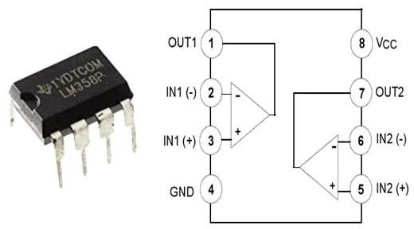

**Fig 6- Comparator LM358**

## LCD Display :

The most commonly used **character-based LCDs** are built around the **Hitachi HD44780 controller** or other compatible variants like the **HD44580**. These LCD modules are widely used due to their simplicity and ease of interfacing with microcontrollers.

### ****Overview of Character LCDs****

Character-based LCDs are electronic display modules that utilize **liquid crystals** to generate visible text or symbols. One of the most popular types is the **16×2 LCD**, which features:

* **16 characters per line** across **2 lines** (hence, 16×2).
* Each character is displayed within a **5×7 pixel matrix**, allowing clear representation of alphanumeric characters.

### ****What You'll Learn****

This tutorial will cover:

* **Interfacing character LCDs** with various microcontrollers.
* **Different communication modes** (8-bit and 4-bit interfaces).
* **Programming techniques** for LCDs.
* **Customization tricks** to enhance the visual appeal of your projects.

By mastering these concepts, you can **unlock the full potential** of these simple yet powerful LCD modules, adding a polished look to your applications.

4o

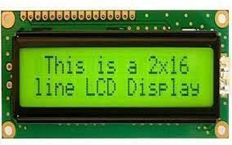**.**

**Fig 7- LCD Display**

## Table 1-Pin Description of LCD.

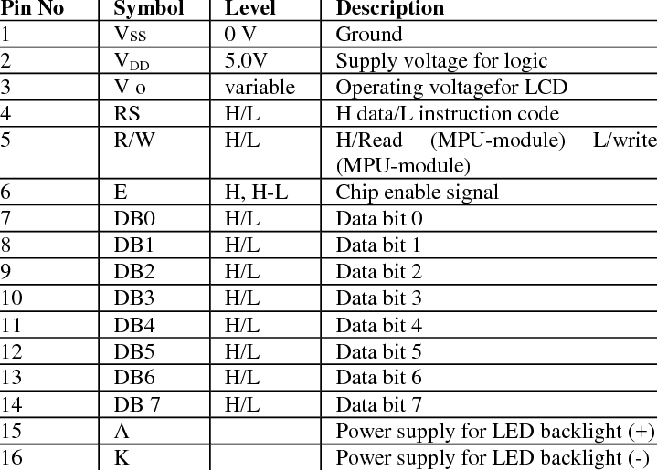

**Motor (Pump) :**

A **pump** is a device designed to move **fluids (liquids and gases)** or **slurries** through mechanical action, typically converting **electrical energy into hydraulic energy**.

### ****Applications of Pumps****

Pumps are widely used in various industries, including:

* **Water Management**: Pumping water from wells, aquarium filtration, pond aeration, and irrigation.
* **Automotive Industry**: Used in water-cooling systems, fuel injection, and lubrication.
* **Energy Sector**: Essential for **pumping oil, natural gas**, and operating **cooling towers** in HVAC systems.
* **Medical Field**: Applied in **biochemical processes**, medicine manufacturing, and artificial body parts such as **artificial hearts** and **penile prostheses**.

### ****Multi-Stage Pumps****

When a pump has **multiple pump mechanisms** working in series to **increase pressure** and improve performance, it is referred to as a **multi-stage pump**. These are commonly used in high-pressure applications such as **boiler feed systems and water supply networks**.

Pumps play a crucial role in **industrial, domestic, and medical applications**, ensuring the efficient transport of fluids across various systems.

### Working of Motor Pump :

A **submersible water pump** is designed to **extract water from the ground** using the principles of **hydrodynamics**. It operates efficiently while being fully submerged in water, making it ideal for applications such as **wells, boreholes, and drainage systems**.

### ****Key Components & Working Principle****

A submersible water pump consists of three main parts:

1. **Electric Motor** – Powers the pump by rotating the impeller.
2. **Impeller** – A set of curved vanes or blades arranged in a circular pattern.
3. **Housing** – Encases the motor and impeller, directing water flow efficiently.

### ****How It Works****

1. The **electric motor** drives the **impeller**, causing it to spin rapidly.
2. As the impeller rotates, it creates a **low-pressure zone** at the center, drawing water into the pump.
3. The **centrifugal force** generated by the spinning impeller pushes the water outward, increasing pressure.
4. This **pressure differential** forces water **up through the discharge pipe**, lifting it from the ground.
5. The **pump housing** ensures efficient water movement, guiding it toward the **discharge outlet**.

### ****Advantages of Submersible Water Pumps****

* **High efficiency** due to direct water immersion.
* **No priming required**, as the pump is already submerged.
* **Quieter operation** compared to surface pumps.
* **Prevents cavitation**, a common issue in traditional pumps.

These pumps are widely used for **domestic, agricultural, and industrial water extraction**, ensuring reliable and efficient water transport.

# RESULT :

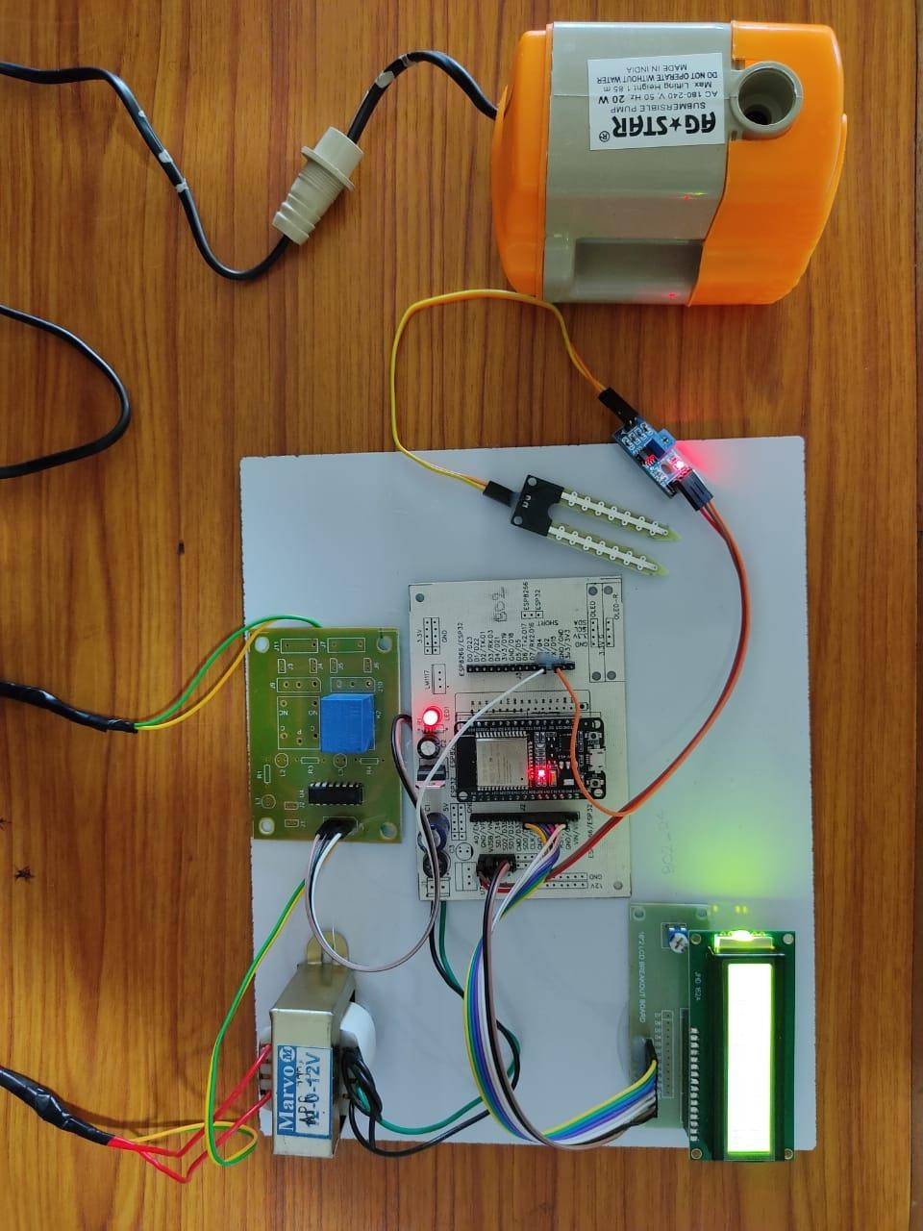

### Fig 9-Hardware Kit

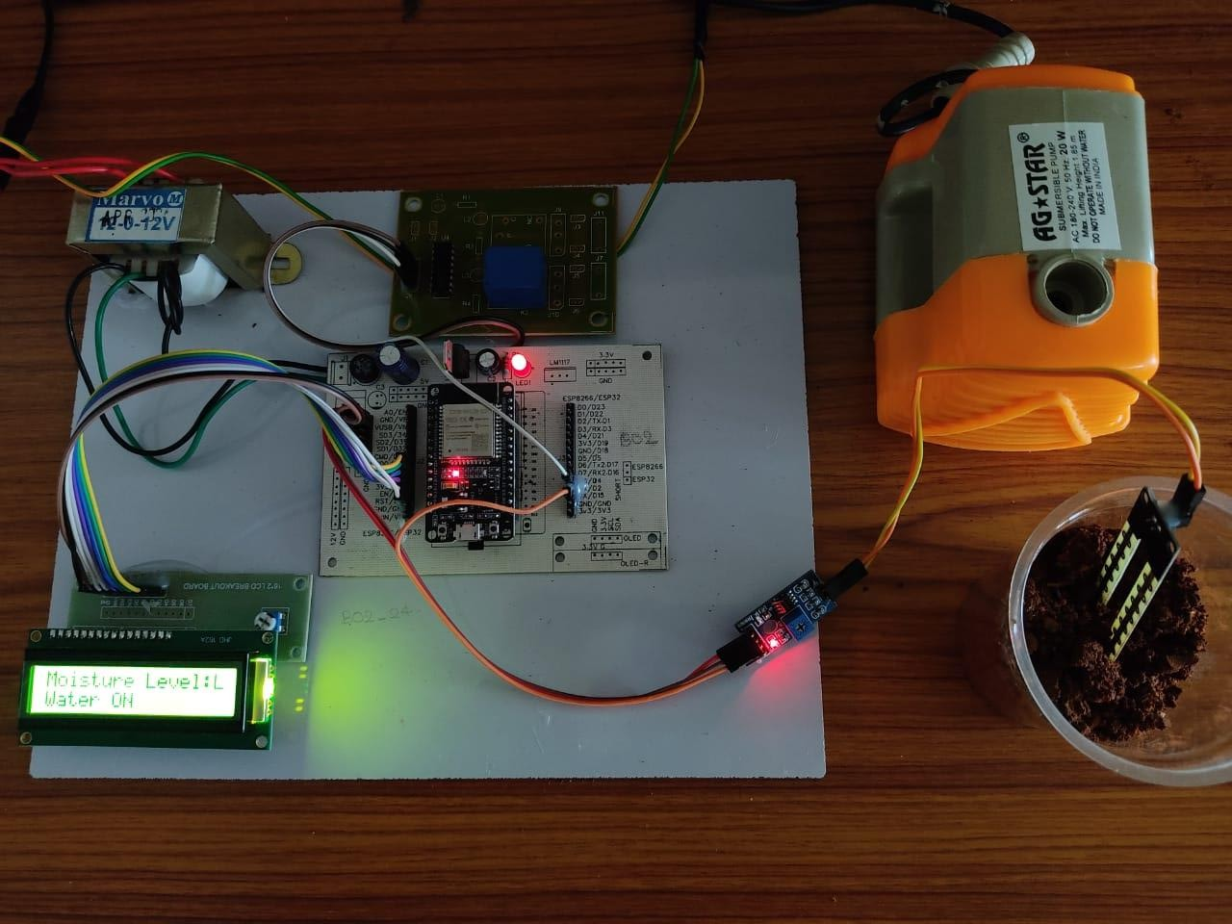

**Fig 10-Power Supply to Haedware Kit**

**RESULT :**

The successful implementation of the An Intelligent Irrigation Control System Using Moisture Sensor and ESP32.

### Yielded the following results:

**Automatic Irrigation Control :**

### The system autonomously controlled the water pump by monitoring soil moisture levels detected by the moisture sensor. This eliminated the need for manual watering, ensuring that the soil remained adequately hydrated at all times.

### LCD Display for Real-Time Monitoring :

### The LCD display presented real-time soil moisture data, indicating both the current moisture level and system status. This feature enabled users to easily monitor soil conditions at a glance without accessing the control unit.

### Stable System Operation :

### The ESP32 operated reliably, providing uninterrupted monitoring and control of the irrigation system.

### Effective Data Processing :

### The ESP32 efficiently processed sensor data and executed real-time control commands, automatically activating or deactivating the pump based on soil moisture levels.

### Reliable Relay Switching :

### The relay unit effectively controlled the water pump, ensuring the irrigation system responded accurately to the moisture sensor's signals.

### User-Friendly Interface :

### The LCD display and straightforward control logic made the system user-friendly and accessible, even for individuals with limited technical knowledge.

### Successful Sensor Integration :

The moisture sensor and LM358 comparator were seamlessly integrated, delivering precise soil moisture readings that the ESP32 utilized to regulate the irrigation pump.

### Scalability :

### The system proved to be scalable, allowing for the addition of more sensors or pumps with minimal modifications to the core setup.

### Low Power Consumption :

# The system functioned efficiently with low power consumption, relying on a stable 12V power supply to minimize energy usage and operational costs.

# CONCLUSION :

The project **“AN INTELLIGENT IRRIGATION CONTROL SYSTEM USING IOT”** has been successfully designed, developed, and tested. It integrates various hardware components, each carefully selected and positioned to ensure optimal functionality. By utilizing advanced ICs and modern technology, the system has been effectively implemented.

A smart irrigation system was designed to monitor soil moisture levels and automate the watering process. The system automatically turns the water pump on or off based on real-time soil moisture data, reducing the manual effort required for irrigation—one of the most time-consuming tasks in farming. This approach prevents both over-irrigation and under-irrigation, reducing the risk of crop damage and promoting efficient water use.

The project demonstrates how IoT and automation can significantly enhance agricultural practices. By integrating additional features such as a rain sensor and an ultrasonic sensor, the system prevents overwatering and protects crops from potential animal interference. These enhancements further improve the system’s efficiency, ensuring optimal plant growth and yield.

In conclusion, this IoT-based smart irrigation system offers a practical solution to the challenges faced in traditional irrigation methods. It not only optimizes water resource management but also contributes to sustainable agricultural practices, making it a valuable innovation for modern farming.

REFERENCE:

1. International Journal of Recent Trends in Engineering & Research (IJRTER) Volume 03, Issue 03; March - 2017 [ISSN: 2455-1457]
2. J. Cong, M. Huang, and Y. Zou, "Accelerating Deep Neural Networks with Specialized Hardware," *IEEE Transactions on Computer-Aided Design of Integrated Circuits and Systems*, vol. 37, no. 8, pp. 1510-1521, Aug. 2018. doi: 10.1109/TCAD.2018.2808810.
3. N. Domala and G. Sasikala. “Low power flipped voltage follower current mirror with improved input output impedances.”. Sadhana, 46:1–11, 2021. DOI: https://doi.org/10.1007/s10470-023-02205-4..
4. N. Jouppi et al., "In-Datacenter Performance Analysis of a Tensor Processing Unit," *Proceedings of the 44th Annual International Symposium on Computer Architecture (ISCA)*, Toronto, ON, 2017, pp. 1-12. doi: 10.1145/3079856.3080246.
5. S. Han, H. Mao, and W. J. Dally, "Deep Compression: Compressing Deep Neural Networks with Pruning, Trained Quantization and Huffman Coding," *International Conference on Learning Representations (ICLR)*, San Juan, Puerto Rico, May 2016. [Online]. Available: <https://arxiv.org/abs/1510.00149>.
6. D. Shin, J. Park, and M. Pedram, "A Power-Aware Neural Network Training System Using Dynamic Voltage Scaling," *IEEE Transactions on Very Large Scale Integration (VLSI) Systems*, vol. 25, no. 4, pp. 1153-1162, April 2017. doi: 10.1109/TVLSI.2016.2633988.
7. A. Krizhevsky, I. Sutskever, and G. E. Hinton, "ImageNet Classification with Deep Convolutional Neural Networks," *Communications of the ACM*, vol. 60, no. 6, pp. 84-90, 2017. doi: 10.1145/3065386.
8. N. Domala, G. Sasikala, and N. Raj.Low volt-age high bandwidth FVF current mirror using quasifloating self-cascode output stage.Analog In-teg. Circ. Signal Process,:1–13,2023 DOIhttps://doi.org/10.1007/s10470-023-02205-4
9. S. Liang, Y. Du, S. Song, and H. Shen, "Low-Power and High-Throughput VLSI Architecture for Neural Network Processing," *IEEE Transactions on Signal Processing*, vol. 68, pp. 2306-2316, May 2020. doi: 10.1109/TSP.2020.2974728.
10. C. Zhang et al., "Optimizing FPGA-Based Accelerator Design for Deep Convolutional Neural Networks," *Proceedings of the 2015 ACM/SIGDA International Symposium on Field-Programmable Gate Arrays*, Monterey, CA, USA, 2015, pp. 161-170. doi: 10.1145/2684746.2689060.
11. N. Domala and G. Sasikala.Low voltagequasi floating gate current mirror with im-proved output impedance.Int. J. Public Sec-tor Perform. Manag,10:499–512, 2022.DOI: [10.1504/IJPSPM.2022.126404](https://dx.doi.org/10.1504/IJPSPM.2022.126404)
12. N. Raj, A.K. Singh, and A.K. Gupta. Low power highoutput impedance high bandwidth QFGMOS currentmirror.Microelectron. J,45:1132–1142, 2014. DOI <https://doi.org/10.1016/j.mejo.2014.05.005>
13. N.Domala, Gsasikala, A Low Input Impedance Wide Bandwidth Flipped Voltage Follower Current Mirror, Indian Journal of Engineering & Materials Sciences Vol. 30, August 2023, pp. 622-628 DOI: 10.56042/ijems.v30i4.365.
14. P. A. Kumar, S. Tamil, and N. Raj. “Low voltage improved impedance wide bandwidth current mirror.”. International Journal of Information Technology, 13:2411–2417, 2021. DOI: https://doi.org/10.1007/s41870-021-00785-w.