# **World Electricity Analysis: Trends, Challenges, and Future Prospects**

Shweta Shukla1, Noorul Islam2,Avinash Kumar3, Vaibhav Yadav4, Megha Saraf5

*1-5Department of Electrical Engineering, Meerut Institute of Engineering and Technology, Meerut, India*

|  |  |
| --- | --- |
|  | ***Abstract: Electricity is a fundamental driver of economic growth, technological advancement, and societal progress. Understanding electricity generation, consumption, and losses on a global scale is crucial for improving energy efficiency, promoting sustainability, and forecasting future trends. This paper presents a comprehensive analysis of global electricity generation, distribution, and consumption patterns using diverse datasets. The study covers various aspects, including electricity production from renewable and non-renewable sources, energy losses during transmission and distribution, urban-rural electricity accessibility, and emerging global energy trends. The findings underscore significant disparities in electricity access, the gradual but essential transition toward renewable energy, and the persistent challenges in achieving global energy sustainability.***  ***Key Word****:* ***Electricity Generation, Renewable Energy, Power Consumption, Energy Losses, Sustainability.*** |

1. **Introduction**

Electricity plays an essential role in the development and sustainability of modern societies. As a cornerstone of technological advancement, economic growth, and quality of life, its availability and distribution are critical to various sectors, from industrial production to healthcare and education. Over the years, global electricity consumption has surged, driven by rapid urbanization, technological innovations, and the increasing digitalization of economies. According to the International Energy Agency (IEA), global electricity demand is expected to grow by 2.1% per year on average between 2019 and 2040, outpacing overall energy demand [1]. This trend highlights both the expanding reliance on electricity and the pressing need for sustainable energy solutions.

However, the world’s electricity sector faces several challenges that hinder its ability to meet growing demands while reducing environmental impact. Traditional energy sources, such as coal, natural gas, and oil, have dominated electricity generation for decades, contributing to air pollution and climate change. In response to these issues, there has been a global shift toward renewable energy sources, including solar, wind, hydro, and geothermal power, which are seen as vital components in achieving long-term sustainability. According to the IEA (2021), renewable now account for almost 29% of global electricity generation, and this share is projected to grow as nation’s transition to low-carbon economies.

Despite the significant advancements in renewable energy technologies, challenges remain [3]. These include issues related to the intermittency of renewable sources, the need for improved energy storage solutions, and the economic and technical barriers to transitioning away from fossil fuels in some regions [4-7]. Additionally, the rapid growth in electricity demand, combined with geopolitical uncertainties and infrastructure limitations, further complicates the global electricity landscape [8-13]. As countries strive to balance the need for reliable electricity supply with the imperative of minimizing environmental impacts, understanding the key trends, challenges, and future prospects of global electricity systems becomes crucial [14-19].

This paper aims to provide an in-depth analysis of the global electricity landscape, identifying current trends in electricity generation, distribution, and consumption, as well as the challenges that the sector faces in achieving sustainability. Furthermore, it will explore future prospects and innovations in the electricity industry, focusing on emerging technologies and policy frameworks that may shape the future of global electricity systems.

1. **Data And Methodology**

This section outlines the sources of data and the methodology used in the study.

### ****Data Sources****

The study uses several datasets from trusted and reputable organizations. Each dataset focuses on a different aspect of the energy sector, and collectively, they provide a comprehensive picture of the global energy landscape:

1. **World Bank & IEA (International Energy Agency)**:

These datasets provide global statistics on electricity production and consumption. The data would typically cover:

* + Total electricity production and consumption by country or region.
  + Growth rates, trends, and historical data for electricity use.
  + Projections for future energy needs.

These datasets allow for comparisons across countries and regions and track how electricity consumption patterns evolve   
 globally.

1. **IRENA (International Renewable Energy Agency)**:

This data focuses specifically on renewable energy. It provides:

* + The share of renewable energy in total electricity production.
  + Trends over time regarding the growth of renewable sources like wind, solar, hydro, and biomass.
  + Insights into regional or country-specific adoption of renewable energy technologies.

IRENA data helps analyze how renewable energy adoption is progressing on a global scale.

1. **National Grid Data**:

This dataset provides specific data on electricity distribution, typically at a national level.

* + It includes information on how electricity is transmitted from power plants to end-users.
  + It also looks at electricity losses that occur during transmission and distribution, as electricity often dissipates due to inefficiencies in the system.

This data is essential for analyzing the infrastructure and challenges faced by countries in maintaining and expanding   
electricity grids.

1. **Urban-Rural Electricity Reports**:

This dataset looks at electricity access across different geographical areas:

* + Urban areas (cities) and rural areas (outskirts or remote regions).
  + It would measure the percentage of the population with access to electricity in these areas and explore any disparities between urban and rural electricity distribution.

This helps understand the equity and reach of electricity access.

### b. ****Data Cleaning and Preprocessing****

Before analyzing the data, the raw datasets need to be cleaned and preprocessed to ensure they are ready for analysis. Here's how it's done:

1. **Python (Pandas, NumPy)**: These are Python libraries commonly used for data manipulation and analysis.
   * **Pandas**: Provides tools to clean, process, and organize datasets (e.g., handling missing values, data type conversions).
   * **NumPy**: Used for numerical operations, especially for mathematical or statistical operations across large datasets.
2. **Power BI**: After the data is cleaned, it is visualized using Power BI, which helps create interactive dashboards.
   * These dashboards allow users to view and explore data visually (e.g., graphs, charts) and gain insights quickly.
3. **Handling Missing Values**:
   * **Interpolation Techniques**: Missing data can occur for various reasons. Interpolation is a method of estimating missing values by using nearby data points. This ensures that the dataset remains complete and accurate for analysis.
4. **Identifying Anomalies**:
   * **Statistical Analysis**: Statistical methods (such as outlier detection, regression analysis, or standard deviation calculations) are used to spot anomalies in the data. These anomalies could indicate errors in data collection or represent significant but rare events that need further investigation.

### c. Analytical Approach

Once the data is cleaned, the following analytical methods are applied to derive insights from the datasets:

1. **Trend Analysis**:
   * This involves studying how electricity generation and consumption patterns have evolved over time (year-by-year).
   * It helps to identify:
     + Whether global electricity consumption is rising or falling.
     + How the energy mix (renewables vs. non-renewables) is changing over time.
     + The impact of policy changes, technological advancements, or global events on electricity trends.
2. **Geospatial Analysis**:
   * This looks at the spatial distribution of electricity access across different areas:
     + **Urban vs. Rural**: This analysis compares electricity access in urban areas (cities) vs. rural areas (more remote or less developed regions). Often, rural areas might have lower electricity access due to infrastructure challenges.
     + Geographic data might include heat maps or regional breakdowns to show where access is most or least available.
3. **Efficiency Metrics**:
   * This focuses on how efficient the energy system is, particularly in terms of the **losses** that occur during electricity transmission and distribution.
   * Losses can happen due to resistance in wires, poor infrastructure, or outdated equipment. Analyzing these inefficiencies can reveal areas where improvements are needed.
   * **Energy Losses**: This could involve comparing the amount of energy generated versus the amount actually delivered to end-users to calculate efficiency and loss ratios.
4. **Comparative Analysis**:
   * This involves comparing the share of **renewable vs. non-renewable** energy in electricity generation.
   * By comparing renewable sources (like solar, wind, and hydro) with non-renewable sources (like coal, oil, and natural gas), the study can assess the transition towards a cleaner energy grid.
   * This can help policymakers or stakeholders understand the progress towards sustainability goals.
5. **Results And Discussion**

### Global Electricity Generation and Consumption Trends

* Europe & Central Asia has the highest energy production, followed by Sub-Saharan Africa and Latin America & the Caribbean.
* North America and South Asia exhibit significantly lower energy production levels.
* Differences in energy output are influenced by infrastructure, resource availability, and investments in power generation.

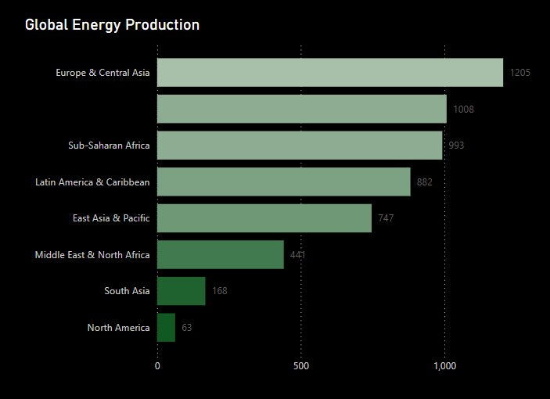

Figure 1: Energy production across regions

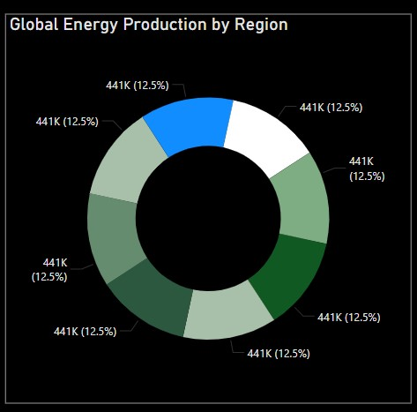

Figure 2: Regional Energy Distribution

* The donut chart shows an equal proportional representation (12.5%) of energy production across regions.
* However, the bar chart reveals actual disparities, with certain regions contributing far more than others
* Variations in energy output highlight the impact of regional energy policies, industrial demands, and renewable energy adoption.

### b. Renewable vs. Non-Renewable Energy Transition

* **Renewable Energy Growth:** Solar and wind energy are growing at an annual rate of 12-15%, with Europe leading the adoption.
* **Coal and Gas Dependence:** Despite the push for renewable energy, fossil fuels still contribute around 60% of global electricity production.
* **Hydroelectric Power:** Large-scale hydropower projects continue to provide substantial electricity generation, particularly in South America and Asia.
* **Nuclear Energy:** While some countries phase out nuclear power, others expand their nuclear capacity to meet carbon neutrality goals.

### c. Urban vs. Rural Electricity Access

* **Urban Electrification:** Nearly 100% access in most developed regions, but reliability issues persist.
* **Rural Electrification Challenges:** In Sub-Saharan Africa and parts of South Asia, nearly 20% of the population still lacks access to electricity.
* **Decentralized Energy Solutions:** Off-grid solar, microgrids, and hybrid energy systems are emerging as viable solutions for remote areas.

### d. Energy Losses and Efficiency

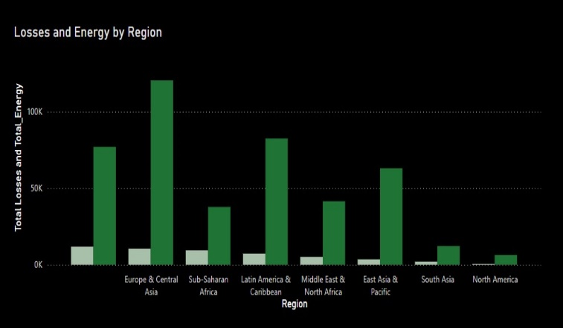

Figure 3: Total Losses and Energy Generation

The above figure shows the Total Losses and Energy Generation

* **Europe & Central Asia** and **Latin America & the Caribbean** exhibit relatively high total energy production but moderate losses.
* **Sub-Saharan Africa** and **East Asia & Pacific** display significant energy production with corresponding high losses.
* **North America** records the lowest losses and total energy values, indicating a highly efficient power transmission system.
* **Middle East & North Africa** and **South Asia** show moderate energy production with noticeable losses.

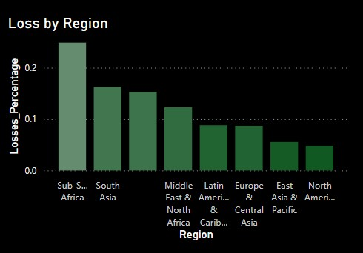

Figure 3: **Loss Percentage by Region**

**In the above figure we have Loss Percentage by Region**

* **Sub-Saharan Africa** has the highest loss percentage, exceeding 20%, signifying critical inefficiencies likely due to inadequate infrastructure and high levels of electricity theft.
* **South Asia** also demonstrates significant losses, estimated at 15-20%.
* **Middle East & North Africa, Latin America & the Caribbean** regions experience moderate losses in the range of 10-15%.
* **Europe & Central Asia, and East Asia & Pacific** have relatively lower losses.
* **North America** reports the lowest loss percentage, indicative of a robust and technologically advanced grid infrastructure.

Transmission and distribution losses vary across regions:

* **Developed nations**: Losses are around **5-8%** due to advanced grid infrastructure.
* **Developing nations**: Losses exceed **15-20%**, often due to outdated transmission networks and theft.

## IV. Future Prospects and Recommendations

1. **Investment in Renewable Energy:** Governments should enhance policies to promote large-scale solar, wind, and hydroelectric power projects.
2. **Smart Grid Implementation:** AI and IoT-driven smart grids can optimize energy distribution, reduce losses, and enhance demand-response management.
3. **Rural Electrification Programs:** Expanding off-grid renewable energy solutions can bridge the electricity access gap in developing regions.
4. **Energy Storage Innovations:** Battery storage technologies, such as lithium-ion and solid-state batteries, are critical for stabilizing renewable energy supply.
5. **Carbon Capture and Storage (CCS):** Implementing CCS technology can mitigate the environmental impact of fossil fuel power plants.
6. **Policy and International Collaboration:** Cross-border energy trade and collaborative research can drive sustainable energy transitions worldwide.

## V. Conclusion

This research provides a detailed analysis of global electricity trends, highlighting the urgent need for sustainable energy transitions. While renewable energy adoption is increasing, disparities in electricity access and grid inefficiencies persist. Addressing these challenges requires technological advancements, policy reforms, and international collaboration. Future work will focus on predictive modeling of energy demand and integration of AI-driven energy management systems.

## Acknowledgment

The authors acknowledge the support of data sources such as the International Energy Agency, World Bank, National Renewable Energy Laboratory, and the International Renewable Energy Agency for providing valuable datasets that contributed to this research.

**References**

[1] International Energy Agency (IEA). (2020). *World Energy Outlook 2020*. International Energy Agency.

[2] International Energy Agency (IEA). (2021). *Renewables 2021: Analysis and Forecast to 2026*. International Energy Agency.

[3] International Energy Agency, “World Energy Outlook 2023”.  
[4] World Bank, “Global Electricity Access Report.”  
[5] International Renewable Energy Agency, “Renewable Energy Statistics 2023.”  
[6] U.S. Energy Information Administration, “Electricity Generation and Consumption Trends.”

[7] Harish V, Kumar A. A review on modeling and simulation of build-ing energy systems. Renewable Sustainable Energy Rev 2016; 56:1272–92.doi: 10.1016/j.rser.2015.12.040.

[8] Wei Y, Zhang X, Shi Y, Xia L, Pan S, Wu J, et al. A review of data-driven approachesfor prediction and classification of building energy consumption. Renewable Sustainable Energy Rev 2018; 82:1027–47. doi: 10.1016/j.rser.2017.09.108.

[9] Yildiz B, Bilbao JI, Dore J, Sproul AB. Recent advances in the analysis of residential electricity consumption and applications of smart meter data. Appl Energy2017; 208:402–27. doi:10.1016/j.apenergy.2017.10.014.

[10] Zhou K, Yang S. Understanding household energy consumption behavior: thecontribution of energy big data analytics. Renewable Sustainable Energy Rev2016; 56:810–19. doi: 10.1016/j.rser.2015.12.001.

[11] Hong T, Pinson P, Fan S, Zareipour H, Troccoli A, Hyndman RJ. Probabilistic energyforecasting: global energy forecasting competition 2014 and beyond. Int J Forecast2016;32(3):896–913. doi: 10.1016/j.ijforecast.2016.02.001.

[12] Hong T, Fan S. Probabilistic electric load forecasting: a tutorial review. Int J Forecast 2016;32(3):914–38. doi: 10.1016/j.ijforecast.2015.11.011.

[13] Kalogirou S. Artificial neural networks in renewable energy systems applications:a review. Appl Energy 2001.

[14] Kalogirou S. Applications of artifcial neural-networks for energy systems. Appl Energy 2000:17–35.

[15] Kalogirou S. Applications of artifcial neural networks in energy systems - a review.Energy Convers Manage 1998:1073–87.

[16] Hippert HS, Pedreira CE, Souza RC. Neural networks for short-term load forecasting: a review and evaluation. IEEE Trans Power Syst 2001;16(1):44–55.doi:10.1109/59.910780.

[17] Weron R. Modeling and forecasting electricity loads and prices: a statistical approach. Chichester England and Hoboken NJ: John Wiley & Sons; 2006.

[18] Liu Y, Yu S, Zhu Y, Wang D, Liu J. Modeling, planning, application and management

of energy systems for isolated areas: a review. Renewable Sustainable Energy Rev 2018; 82:460–70. doi: 10.1016/j.rser.2017.09.063.

[18] Chicco G. Overview and performance assessment of the clustering methods for electrical load pattern grouping. Energy 2012;42(1):68–80.doi: 10.1016/j.energy.2011.12.031.

[19] Suganthi L, Samuel AA. Energy models for demand forecastingareview. Renewable Sustainable Energy Rev 2012;16(2):1223–40.doi: 10.1016/j.rser.2011.08.014.