Research On Smart Baby Cradle Using Sensor Technology

**Shubhangi Roshan Katakwar                                           Assistant Prof. Sunil Vasant Kuntawar**

**Department of Electronics & Telecommunication,              Department of Electronics & Telecommunication,**

**BIT college, Ballarpur.                                                           BIT college, Ballarpur.**

Shubhangikatakwar2396@gmail.comsunilkuntawar22@gmail.com

**ABSTRACT—**

A support is a gadget intended to assist infants with nodding off, utilizing a delicate side-to-side shaking movement. Be that as it may, it requests impressive actual exertion from guardians to produce this swinging movement physically. Moreover, consistent oversight is expected to screen the child's exercises when they are set inside the support. In the contemporary period of mechanical headway, guardians regularly wrestle with a horde of difficulties in offsetting their expert obligations with the sustaining needs of their kids.

Our paper means to resolve the common issues looked by guardians by presenting an inventive IoT-based Savvy Support Observing Framework. The key goal is to ease the nurturing difficulties by making an answer that guides in the consistent observing of babies. The Shrewd Support includes a mechanized swinging component set off by the recognition of a child's crying sound. Moreover, it consolidates an inherent camera to give ceaseless reconnaissance, engaging guardians with an improved capacity to watch out for their kid. To accomplish this usefulness, we have consistently incorporated parts like Arduino, sound sensors, wetness sensors, and the swinging system, among other electronic components, into the customary support plan. This overhauled arrangement offers increased productivity and unwavering quality as well as outperforms the capacities of traditional supports, giving guardians an additional viable method for really focusing on their newborn children.

KEYWORDS: IoT Innovation, Brilliant Child Support.

I. INTRODUCTION

In ongoing many years, a significant movement pattern, especially among ladies in the labor force, has seen people rush to metropolitan regions looking for further developed work possibilities. This peculiarity is particularly trying for double pay couples, where the two accomplices are utilized, prompting challenges in designating adequate time and care for their babies. The Coronavirus pandemic exacerbated these difficulties as remote work became common, escalating the sensitive harmony between proficient responsibilities and nurturing obligations. This battle turned out to be much more articulated when babies became sick, requiring steady observing and possibly compelling guardians to disappear from work. This effects the profession directions of guardians as well as puts huge weight on them. The combination of mechanical advancement with the major texture of childcare presents an amazing chance to rethink nurturing elements in the computerized time.

Our proposed Shrewd Support Framework, a demonstration of this harmonious connection among innovation and providing care, consistently incorporates a variety of sensors and insightful instruments to establish a sustaining climate for babies.

In light of the squeezing need to facilitate the difficulties related with observing and sustaining youngsters, our paper presents a state of the art arrangement: a robotized Shrewd Support Framework utilizing IoT innovation. This framework is explicitly intended to help guardians in productively observing their youngsters, whether they are working or at home. Through the execution of this IoT-based savvy support framework, our point is to allow guardians the inner serenity that comes from realizing their youngster is being really focused on and checked successfully. This,

thusly, empowers them to all the more likely explore the harmony between their expert and nurturing liabilities. By embracing this mechanical jump in childcare, we imagine a scene where guardians never again need to think twice about proficient yearnings for their kids' prosperity. All things considered, they can walk certainly realizing that their newborn children are getting extreme attention to detail and consideration, while they keep on contributing seriously to their professions and society in general.

As we explore the perplexing territory of innovation, the Savvy Support Framework fills in as a guide — a demonstration of the amicable mixture of mechanical resourcefulness and sympathetic providing care, making ready for a more adjusted, engaged, and sustaining future for the two guardians and their esteemed little ones.

II. LITERATURE Survey

1. Symon, Aslam Forhad et al. In this the creator presents a child checking framework for occupied guardians with the goal that they can guarantee the legitimate consideration and wellbeing of their children. This framework can recognize the child's movement and sound; particularly crying and video result of the child's current position can be shown on a presentation screen with the goal that the mother or another mindful individual can watch the child while away from the person in question.

2. S. Brangui, et. al, In this paper the creator plans to expand on the current related work and recommends an upgraded commotion dropping framework for an exhaustive observing and control to beat the sound contamination and make the child rooms more agreeable. The proposed framework plan and execution are talked about and the comparing parts are point by point with their associations. Furthermore, a draft cost assessment is introduced.

3. Prof. A.D. Anjikar, et. al, In this paper the creator planned a programmed child rocker having a commotion sensor to distinguish child cry. The objective of this system is to structure a clever baby support with various features which helps in really looking at the youngsters and updates the newborn child's status to gatekeepers.

4. Yang Hu; Weihua Gui et. al, In this paper the creator proposed a framework for changing the bassinet influencing degree by the sensor signals. The bassinet is comprised of a versatile influencing gadget and other sensor organization. To further develop the family the board and lessening the youthful guardians' Work force, another child bassinet is made.

a.

Marie R. Harper, et. al, In this paper the creator designed a den adjusted to be shaken through an application. A bassinet or support adjusted to be shaken naturally by an oscillatory, activity engine having a similar impact as would be accomplished by a mother shaking a bunk containing a baby, the lodging being significantly upheld at each end thereof to a help rack and stand. The lower part or lower part of the den is adjusted to be operable associated with the engine. The engine likewise incorporates a controlling, responding implies for movement

1. Gim Wong, ET. Al, In this paper the creator introduced an Electronic gadget that can be connected to ordinary vitally mounted type bunk. The current gadget is electronically impelled and might be associated with a regular lodging which is frequently physically shaken by going back and forth on the foot or headboard to give the slight shaking activity wanted. The gadget is ideally impelled by a child's voice got by a mouthpiece or receivers and the periodicity and span of the shaking might be changed inside limits. It can likewise be set into movement by manual incitation of a switch.

2. Chau-Kai-Hsieh, et. al, In this paper the creator proposed a child cry recognizer which incorporates an enhancer circuit for enhancing a got sound sign. This paper presents the plan and execution of another native minimal expense E-Child Support that swings consequently when child cries, for this it has a cry dissecting framework which distinguishes the child cry voice and in like manner the support swings till the child quits crying.

3. Amrita Ebenezer et. al, In this paper the creator gives a way to deal with plan a child support comprising of a cry breaking down framework which identifies child cry. Our undertaking is a clever methodology in planning a programmed support swinging framework for helping newborn child care. This hardware can be chiefly utilized in the medical clinics to give help to the attendant in dealing with the newborn child or at home to screen the child while the parent is working and the child is under the consideration of sitters.

4. Amin Shaikh1, et. al, In this paper the creator proposed this support framework. There's a longing for an item that overcomes this issue among guardians and child. This support framework is proposed to help these guardians so they'll take magnificent consideration of their child from distant areas.

5. Sarah Ahmed Alswedani1 et. al, The creator in this examination paper gives critical consideration on recognizing child cry, all the more precisely, by coordinating four-sub modules in the cry grouping process including voice investigation, face picture examination, body signal examination, lastly choice combination.

6. N. Saude and P. A. H. Vardhini, This paper presents IoT based brilliant frameworks that go about as child support observing frameworks for connected or working guardians so they can oversee appropriately, and furthermore for legitimate consideration and wellbeing of the baby. Guardians can perceive the child's development, sound like crying and video result of the child's current position and movement will be noticeable on a screen so the parent or any individual can watch the newborn child even while away from the child. This support framework is valuable for observing or identifying development and crying states of the youngster consequently.

7. H. M. Ishtiaq Salehin, et al. In this paper, they are utilizing an exceptionally effective and easy to understand innovation to carry out programmed swinging of the child bassinet with sound discovery of the child crying utilizing sound sensor and playing bedtime song through speakers. The dampness sensor has been utilized to realize the diaper's dampness level, and notices have been shipped off guardians with specific circumstances through versatile calls and instant messages. A website page utilizing HTML and CSS has been created, where guardians/watchmen can manage the child continuously. At last, the framework will recognize in the event that the child is in the support utilizing the face acknowledgment method.

8. M. P. Joshi and D. C. Mehetre, This paper presents the plan of Savvy Support which supports such video checking. This support swings naturally on location of child cry sound. Likewise it enacts bell and gives cautions on telephone if-first, child cry go on till explicit time which implies presently support can't deal with endlessly child needs private consideration and second, assuming the sleeping cushion in the support is wet. This support has a programmed pivoting toy for child's diversion.

9. W. A. Jabbar, et al. In this paper, the writer planned a framework, which comprises of a Hub Miniature Regulator Unit (NodeMCU) Regulator Board that is taken advantage of to assemble the information read by the sensors and transferred through Wi-Fi to the AdaFruit MQTT server. The proposed framework takes advantage of sensors to screen the child's indispensable boundaries, like surrounding temperature, dampness, and crying. A model of the proposed child support has been planned utilizing Nx Siemens programming, and a red meranti wood is utilized as the material for the support. The framework engineering comprises of a child support that will naturally swing utilizing an engine when the child cries. Guardians can likewise screen their infants' condition through an outside web camera and switch on the children's song toy situated on the child support remotely by means of the MQTT server to engage the child.

10. Gare, Harshad Suresh, et al. In this paper, the creator is proposing a computerized support framework which will associate with the parent's versatile for sending ready messages. Sound sensor will be joined to support so that it will take input sound of child just, it will close the movement to be proceeded according to the scope of sound in decibels, on the off chance that the sound is more than specific sum, framework will naturally begin swinging the support, in the event that child still not languid or stop cry ready will ship off the guardians. Movement sensor that is PIR sensor will recognize the movement it is utilized for security reason and in perspective of any peril, assuming there is as well, much movement distinguished alarm will ship off the guardians. Wet sensor is utilized for check that the child has pee? Assuming any sort of wetness is identified it will send the alarm message to the guardians. There will be two temperature sensors utilized that are DHT11 and LM35, DHT 11 will check the temperature of the entire room and LM 35 sensor will quantify temperature of the body, and it will caution the parent assuming there is an immense change.

11. N. L. Pratap, et al. In this paper, the creator proposed a framework, a brilliant support with a robotized child checking framework was created. The S.ODI board is utilized for connecting the sensors and actuators. The child checking framework is joined to the support with the goal that a hatchery sort of climate will be made for the child. The child observing framework screens the child 24×7. The deliberate boundaries in regards to the child's wellbeing like temperature, heartbeat rate, soddenness on the child bed will be shown in the versatile application. Assuming the recorded readings show any anomalies, the vital activities like controlling temperature, turning on or off the fan, setting up the support's development, and playing music for the child will be taken. In the event that the readings appear to be strange, the overseer alongside the guardians will receive an alarm message. The movement and stance status of the newborn child can be observed utilizing movement Eye operating system.

12. Prusty, Vedanta, Abhisek Rath, et al. In this paper, By utilizing the ideas of Web of Things, Implanted Frameworks and Cloud Innovation, the creator means to construct a savvy framework that can be gainfully utilized for proficient kid care and the board. In this paper they have zeroed in on the kid's security and cleanliness issues in order to bring the kid up in a decent and sound climate.

13. V. P. Hotur, et al. In this paper, the creator presents a support that incorporates a MP3 player for relieving music, temperature locator and bed wet sensor implanted into ESP32 wroom (microcontroller) stage. Accessibility of high velocity web works with utilizing IoT stage easily, and any equivocalness caused to the baby will be accounted for to guardians as SMS by means of GSM. Anticipation for kid misuse is likewise taken care in our model.

14. Kumar, V. Suresh, Lokaiah Pullagura, et al. This paper presents the thought of a savvy support, which empowers for

granting the impelling development of the den in a smooth shaking movement

15. Gim Wong, ET. Al, In this paper the creator introduced an Electronic gadget that can be connected to ordinary vitally mounted type bunk. The current gadget is electronically incited and might be associated with a regular lodging which is frequently physically shaken by moving back and forth on the foot or headboard to give the slight shaking activity wanted. The gadget is ideally impelled by a child's voice got by a receiver or mouthpieces and the periodicity and term of the shaking might be changed inside limits. It can likewise be set into movement by manual incitation of a switch.

16. Chau-Kai-Hsieh, et. al, In this paper the creator proposed a child cry recognizer which incorporates a speaker circuit for enhancing a got sound sign. This paper presents the plan and execution of another native minimal expense E-Child Support that swings consequently when child cries, for this it has a cry investigating framework which distinguishes the child cry voice and in like manner the support swings till the child quits crying.

17. Amrita Ebenezer et. al, In this paper the creator gives a way to deal with plan a child support comprising of a cry breaking down framework which identifies child cry. Our venture is a clever methodology in planning a programmed support swinging framework for helping newborn child care. This gear can be essentially utilized in the medical clinics to give help to the attendant in dealing with the newborn child or at home to screen the child while the parent is working and the child is under the consideration of sitters.

18. Amin Shaikh1, et. al, In this paper the creator proposed this support framework. There's a longing for an item that overcomes this issue among guardians and child. This support framework is proposed to help these guardians so they'll take magnificent consideration of their child from far off areas.

19. Sarah Ahmed Alswedani1 et. al, The creator in this examination paper gives huge consideration on identifying child cry, all the more precisely, by coordinating four-sub modules in the cry arrangement process including voice investigation, face picture investigation, body signal examination, lastly choice combination.

20. N. Saude and P. A. H. Vardhini, This paper presents IoT based brilliant frameworks that go about as child support observing frameworks for connected or working guardians so they can oversee appropriately, and furthermore for legitimate consideration and security of the baby. Guardians can perceive the child's development, sound like crying and video result of the child's current position and movement will be noticeable on a screen so the parent or any individual can watch the newborn child even while away from the child. This support framework is helpful for observing or identifying development and crying states of the youngster consequently.

21. H. M. Ishtiaq Salehin, et al. In this paper, they are utilizing an exceptionally productive and easy to understand innovation to execute programmed swinging of the child bassinet with sound identification of the child crying utilizing sound sensor and playing bedtime song through speakers. The mugginess sensor has been utilized to realize the diaper's dampness level, and warnings have been shipped off guardians with specific circumstances through versatile calls and instant messages. A site page utilizing HTML and CSS has been created, where guardians/watchmen can regulate the child continuously. At long last, the framework will distinguish in the event that the child is in the support utilizing the face acknowledgment procedure.

22. M. P. Joshi and D. C. Mehetre, This paper presents the plan of Brilliant Support which supports such video checking. This support swings consequently on discovery of child cry sound. Additionally it actuates ringer and gives alarms on telephone if-first, child cry go on till explicit time which implies currently support can't deal with endlessly child needs

individual consideration and second, assuming the sleeping pad in the support is wet. This support has a programmed pivoting toy for child's diversion.

23. W. A. Jabbar, et al. In this paper, the writer planned a framework, which comprises of a Hub Miniature Regulator Unit (NodeMCU) Regulator Board that is taken advantage of to accumulate the information read by the sensors and transferred by means of Wi-Fi to the AdaFruit MQTT server. The proposed framework takes advantage of sensors to screen the child's imperative boundaries, like surrounding temperature, dampness, and crying. A model of the proposed child support has been planned utilizing Nx Siemens programming, and a red meranti wood is utilized as the material for the support. The framework design comprises of a child support that will naturally swing utilizing an engine when the child cries. Guardians can likewise screen their children's condition through an outside web camera and switch on the bedtime song toy situated on the child support remotely by means of the MQTT server to engage the child.

24. Gare, Harshad Suresh, et al. In this paper, the creator is proposing a computerized support framework which will associate with the parent's portable for sending ready messages. Sound sensor will be connected to support so that it will take input sound of child just, it will finish up the movement to be proceeded according to the scope of sound in decibels, in the event that the sound is more than specific sum, framework will naturally begin swinging the support, on the off chance that child still not lethargic or stop cry ready will ship off the guardians. Movement sensor that is PIR sensor will identify the movement it is utilized for security reason and in perspective of any peril, assuming there is as well, much movement identified alarm will ship off the guardians. Wet sensor is utilized for check that the child has pee? Assuming any sort of wetness is identified it will send the alarm message to the guardians. There will be two temperature sensors utilized that are DHT11 and LM35, DHT 11 will check the temperature of the entire room and LM 35 sensor will gauge temperature of the body, and it will caution the parent in the event that there is a colossal change.

25. N. L. Pratap, et al. In this paper, the creator proposed a framework, a brilliant support with a robotized child observing framework was created. The S.ODI board is utilized for connecting the sensors and actuators. The child observing framework is joined to the support with the goal that a hatchery sort of climate will be made for the child. The child observing framework screens the child 24×7. The deliberate boundaries in regards to the child's wellbeing like temperature, heartbeat rate, moistness on the child bed will be shown in the portable application. Assuming that the recorded readings show any irregularities, the essential activities like controlling temperature, turning on or off the fan, setting up the support's development, and playing music for the child will be taken. Assuming that the readings appear to be unusual, the guardian alongside the guardians will receive an alarm message. The movement and stance status of the newborn child can be checked utilizing movement Eye operating system.

26. Prusty, Vedanta, Abhisek Rath, et al. In this paper, By utilizing the ideas of Web of Things, Implanted Frameworks and Cloud Innovation, the creator plans to fabricate a shrewd framework that can be gainfully utilized for productive kid care and the board. In this paper they have zeroed in on the youngster's security and cleanliness issues to bring the kid up in a decent and sound climate.

27. V. P. Hotur, et al. In this paper, the creator presents a support that incorporates a MP3 player for calming music, temperature finder and bed wet sensor implanted into ESP32 wroom (microcontroller) stage. Accessibility of rapid web works with utilizing IoT stage easily, and any uncertainty caused to the baby will be accounted for to guardians as SMS through GSM. Avoidance for kid misuse is likewise taken care in our model.

28. Kumar, V. Suresh, Lokaiah Pullagura, et al. This paper presents the thought of a shrewd support, which empowers for

this sort of video checking to be completed on a newborn child. A baby's shout sets off the robotized swinging of this support, which starts when the sensor recognizes it. Likewise, assuming that the child's cry endures for a drawn out timeframe, the device sets off a ringer and sends an instant message to the telephone, flagging that the support is at this point not fit for dealing with the newborn child and that the child needs human help assuming the support's bedding is wet. This support is furnished with a programmed turning toy for the child's diversion, which lessens the probability of an infant crying over the course of the day.

29. Ullah, Ahsan, and Afzal Hossain. In this paper, the creator presents a framework which is a programmed music framework that will be enacted when the child's crying level is distinguished while the child is in the swing, which will assist with halting the child's crying. The model of the proposed framework has been created and tried to demonstrate its viability concerning cost and straightforwardness and to guarantee secure activity to empower youngster nurturing anyplace and whenever over the organization.

30. S. Durga, S. Itnal, K. Soujanya, et al. Here in this paper, the creator proposed a calculation which can successfully screen the children from distance and here a particular calculation is proposed. Here the proposed plan comprises of NodeMCU (Hub Microcontroller unit) and the breadboard and furthermore the sensors which are utilized for gaining the information. Here the proposed plan comprises of NodeMCU (Hub Microcontroller unit), the breadboard and furthermore the sensors which are utilized for getting the information. Here the boundaries are crying, dampness and surrounding temperature.

31. R. Sonia, S. M. Jayadeva, et al. In this paper, the creator focuses on the development of a savvy support. This support is planned utilizing different information components, yield components, a regulator module, and a portable application. The information components comprise of a temperature sensor, a sound sensor or a microphone,a dampness sensor, and a music player. The result components incorporate the engine and The regulator utilized in this study is the NodeMCU module. Distributed storage is additionally utilized and it is given by the Arduino Part programming. The sensors in the shrewd support start recording applicable boundaries like temperature, stickiness, and sound when it is turned on. The data is then transferred to the cloud The information is then handled in the cloud for examination. In the event that for sure the kid's temperature is over the protected reach, the client gets an admonition. Dampness levels above ordinary recommend that the newborn child has peed. The child crying will be kept in the amplifier. The result components are invigorated because of the sensor's information. On the off chance that the child has a high fever or needs to go to the washroom, the application will tell the parent.

32. Chauhan, Harsha, Deepali Gupta, et al. In this paper, the creator have proposed an answer in light of IoT and BT for observing the newborn children or babies. This proposed arrangement will assist with decreasing the weight of guardians and medical care staff by empowering the highlights of safety and alert frameworks.

33. Wadhokar, Nisha, and Balasaheb Tarle. In this paper, the creator extends the embodiment of a Savvy Child Support, achieved by coordinating unmistakable highlights, i.e., support swing. The information read by the sensors are accumulated by the fostered framework's Hub Miniature Regulator Unit (NodeMCU) Regulator Board and transferred by means of Wi-Fi to the Blynk server. The proposed framework model is manufactured and tried to demonstrate its viability in effortlessness and to guarantee safe activity to empower the child nurturing anyplace and whenever through the organization. The framework screens what is happening and environmental factors successfully.

34. Perumal, Vigneshwaran. et al. In this paper, the creator proposed a support framework which will be carried out with sensors and handled by ARDUINO. With the assistance of these sensors an Arduino can screen the child in the support framework. The proposed new plan framework carried out in the conventional support framework makes it more helpful to use for caring moms.

# III. METHODOLOGY

Newborn children or babies need parent's consideration 24x7, in this cutting edge period, guardians are engaged with firm abuse, office mature and individual manipulate. In this way, they will not have the option to deal with their youngsters. Consequently, in this paper we proposed a Brilliant child support utilizing sensor innovation. This is an IoT based paper.

In this paper we involved Arduino Uno as a microcontroller, organizing an organization of sensors including the LM393 Wet Sensor for pee location, a sound sensor for cry acknowledgment, a camera module for visual observing, and a DHT11 sensor for temperature control. LM393 Comparator IC wet sensor which will distinguish the child's pee in the support and a sound sensor, when the child will cry, the notice will be shipped off Blynk Application. What's more, we utilized a camera module which will show the child in the support. And furthermore a high force servo engine, with the assistance of servo engine mother can move child support. Another component in this is that here we utilized a DHT11 sensor which is utilized to identify the temperature. The framework guarantees ideal temperature and moistness levels inside the support. by and large giving thorough consideration to newborn children and empowering guardians to satisfy proficient commitments with inward feeling of harmony.

# BLOCK DIAGRAM

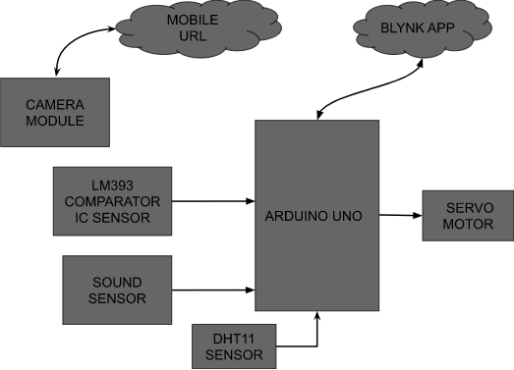

**DESCRIPTION**

In the above graph we have involved Arduino Uno as a microcontroller. As a result gadget we have utilized the servo engine. What's more, in input gadgets we have utilized DHT11 Sensor, Sound Sensor, LM393 Comparator IC Sensor, a Camera Module associated with the microcontroller. Also, we have utilized the blynk application to show every one of the notices.

# FLOW CHART

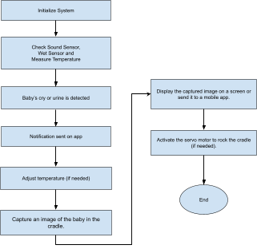

**CIRCUIT DIAGRAM**

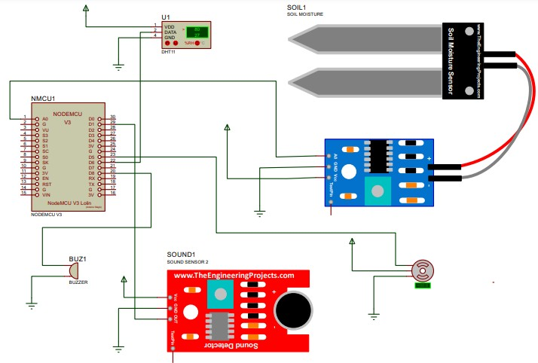

# WORKING

The "Smart Baby Cradle Using Sensor Technology" paper aims to provide parents with a comprehensive infant monitoring solution. It utilises various components, including sound sensors, LM393 comparator IC, ESP32 camera module, MG996R servo motor, Arduino Uno, and a mobile application powered by Blynk. The paper initiates by initialising its components, and sensors such as the sound sensor, LM393 IC, and DHT11 sensor collect data, monitoring the baby's temperature, detecting sounds indicative of the baby's crying, and identifying diaper wetness through the comparator IC. The camera module captures the baby's movements and images, which are transmitted to the Arduino Uno. All these parameters are then displayed in real-time on the Blynk mobile application, allowing parents to monitor their baby's well-being. In response to the baby's crying, the servo motor activates, gently rocking the cradle to soothe the baby. This system offers a user-friendly and effective solution for infant care and monitoring.

# SYSTEM REQUIREMENT HARDWARE REQUIREMENT

1. Arduino Uno
2. Sound Sensor
3. LM393 Comparator IC Sensor
4. Servo Motor
5. Camera Module
6. Temperature Sensor

# SOFTWARE REQUIREMENT

1. Arduino IDE
2. Blynk App

# IMPLEMENTATION

**EXPERIMENTAL SETUP**

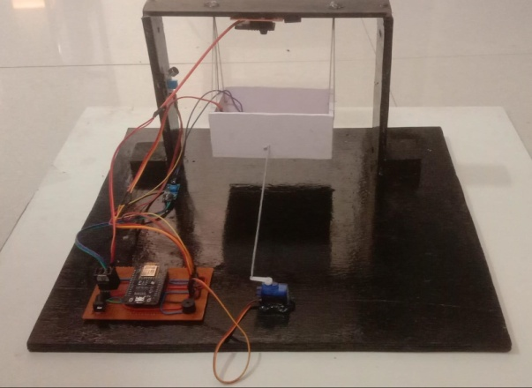

# SIDE VIEW

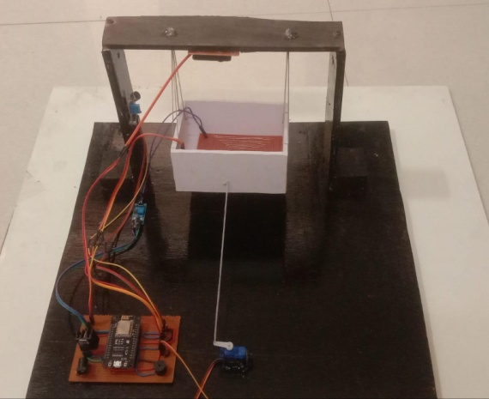

**TOP VIEW OF SETUP**

# Fig. shows the experimental setup of the system

**RESULT**

The "Smart Baby Cradle Using Sensor Technology" paper has been executed successfully, meeting its predefined objectives with remarkable outcomes. The Blynk mobile application serves as a robust platform, enabling parents to monitor crucial parameters essential for the baby's well-being. These include real-time tracking of the baby's temperature, sound levels in the vicinity, and even the detection of urine. The integration of the paper with the Blynk app underscores its effectiveness in providing seamless access to comprehensive data, enhancing the ease of use for parents. Through the Blynk mobile application, parents gain not only valuable insights into their baby's current status but also the ability to view images of their infant. The incorporation of visual data further enhances the monitoring capabilities, contributing to a holistic tool that empowers parents to stay closely connected with their baby's health and comfort.

For a more detailed understanding, visual representations within the Blynk app offer a clear glimpse into the monitored parameters. These images provide a visual breakdown, illustrating how parents can effortlessly navigate and interpret the real-time data on the baby's temperature, ambient sound levels, and the system's capability to detect urine. Overall, the successful implementation of this paper, coupled with the intuitive Blynk mobile application, presents a robust solution for parents seeking a comprehensive and user-friendly tool to oversee and ensure their baby's well-being.

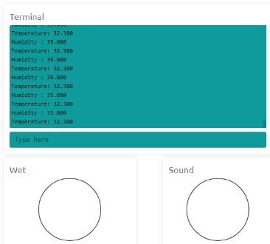

# PARAMETER: TEMPERATURE AND HUMIDITY

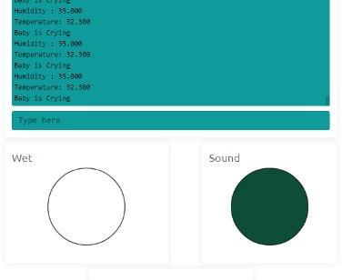

**PARAMETER: SOUND DETECT AFTER BABY IS CRYING**

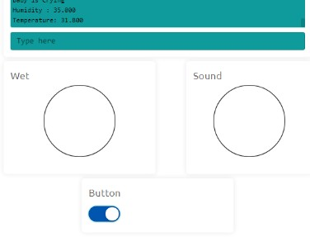

# PARAMETER: BUTTON GET ON MANUALLY BY BLYNK APP

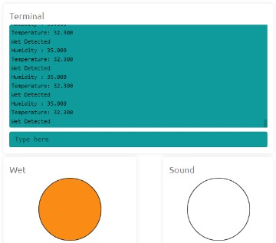

**PARAMETER: WET IS DETECTED**

# CONCLUSION

The advent of the Internet of Things (IoT) has ushered in a new era of intelligence for devices. A smart cradle, integrated with a baby monitoring system leveraging IoT, has been conceptualised and crafted. This innovative system is designed to track crucial parameters of a baby, including their crying condition, humidity levels, and ambient temperature. The utilisation of IoT technology has significantly expanded the scope of information that can be transmitted over the internet, offering remote access to parents or caregivers. The incorporation of a camera module in the cradle enables meticulous monitoring of the baby within a defined area, capturing continuous insights into their movements. This paper harnesses IoT technology to monitor the baby's activities, with related notifications promptly transmitted to mobile applications. This technological marvel not only elevates the efficiency of baby monitoring but also augments the support system available to parents and caregivers. The captured insights, conveyed through the integration of IoT and cutting-edge sensor technology, pave the way for a more informed and responsive approach to nurturing infants. Furthermore, the symbiotic relationship between IoT and the smart cradle embodies an ethos of adaptability, catering to the evolving needs of modern parenting in an increasingly interconnected world.

In essence, this paper underscores the profound implications of IoT-driven innovation in revolutionising infant care practices. It heralds a future where technology seamlessly intertwines with caregiving, promising not just convenience but also an invaluable sense of security and empowerment for parents, fostering a nurturing environment where the well-being of infants remains at the forefront.

# FUTURE SCOPE

The future trajectory of the Smart Baby Cradle Using Sensor Technology paper is poised for transformative advancements. This involves the incorporation of cutting-edge sensors and artificial intelligence to enable a more thorough infant monitoring system with predictive capabilities. The paper's horizon extends towards facilitating remote medical consultations and tailoring caregiving approaches through advanced technology. Its global expansion aims to ensure widespread accessibility and sustainability, with a continuous commitment to enhancing data security and privacy. Collaborative efforts with experts and ongoing research initiatives will unlock the full potential of this technology, providing parents with an ever-evolving and effective tool for nurturing and safeguarding the well-being of their infants. In essence, the paper is set to redefine the landscape of modern childcare.

# REFERENCE

1. Symon, Aslam Forhad et al. “Design and development of a smart baby monitoring system based on Raspberry Pi and Pi camera.” 2019 4th International Conference on Advances in Electrical Engineering (ICAEE) (2019): 117-122.
2. S. Brangui, M. El Kihal and Y. Salih-Alj, "An enhanced noise cancelling system for a comprehensive monitoring and control of baby environments", 2020 International Conference on Electrical and Information Technologies (ICEIT), pp. 404-409, 2020.
3. Prof. A.D. Anjikar, Arshad, Khan Pathan, Pranjal R. Dandekar, “GENERAL IDEA ABOUT SMART BABY CRADLE” in

International Journal of Innovative Computer Science & Engineering Volume 4 Issue 1; JanuaryFebruary-2020

1. Yang Hu; Weihua Gui; , “Adaptive Sway Control for Baby Bassinet Based on Artificial Metabolic Algorithm” School of Information Science and Engineering, Central South University, China. 2019.
2. Marie R. Harper; La Mirada; Maxine R. Blea; , “Automatically rocking baby cradle”, US 3769641, Date of Patent: Nov. 6,2019.
3. Gim Wong, “Automatic baby crib rocker” US 3952343, Date of Patent: Apr. 27, 2019.