**“Revolutionizing Payment Ease: Unleashing the Power of Central Bank Digital Currency (CBDC) in India”**

Dr. Ayush Kumar1, Laxmi Shanker Gupta2

**ABSTRACT**

Digital currencies, or cryptocurrencies, are gaining popularity. Some national central banks are contemplating digital currencies to address these issues and accelerate the cashless society transition. A Central Bank Digital Currency (CBDC) is a nation's official currency and central bank liabilities in digital form. Nine companies appear to be working with the Reserve Bank of India (RBI) on the Central Bank Digital Currency pilot plan. You may recognise IDFC First Bank, HDFC Bank, State Bank of India, and ICICI Bank. Indian digital currency, the Digital Rupee, will be tested by the Reserve Bank of India on November 1, 2022. On October 31, 2022, the government agency in charge of the project stated that this pilot endeavour will facilitate secondary market transactions involving government securities. The RBI has chosen nine financial institutions to pilot the Digital Rupee. Bank of Baroda, State Bank of India, Union Bank of India, ICICI Bank, HDFC Bank, Kotak Mahindra Bank, IDFC First Bank, YES Bank, and HSBC are notable financial institutions. This study seeks to understand the growth of Central Bank Digital Currency (CBDC) in India, taking into account its global adoption to speed up transactions, improve security, and reduce physical currency production costs.



1 Assistant Professor, Department of Commerce, Mahatma Gandhi Kashi Vidyapith. Email .id: [bliss.ayush31@gmail.com](mailto:bliss.ayush31@gmail.com)

2 Research Scholar, Department of Commerce, Mahatma Gandhi Kashi Vidyapith. Email .id: [laxmishankergpt21@gmail.com](mailto:laxmishankergpt21@gmail.com)

**INTRODUCTION**

The Currency serves three main purposes:

1. as a medium of exchange for goods and services;
2. as a unit of accounting measurement; and
3. as a store of value.

It is possible to gauge the fluidity of a country's financial system by looking at its foreign exchange reserves. Money holds a significant value for people, far beyond the actual worth of the paper it’s printed on, due to its universal acceptance and societal importance. Since confidence in the currency is primarily dependent on the activities of the government and the central bank, keeping that confidence intact is crucial to successful currency management. Although the Indian rupee has undergone inflation, it has never faced a confidence crisis. Despite the widespread availability of non-cash payment methods made available by technological advancements, demand for banknotes and coins has remained consistently high. Currency demand is sensitive to many factors, some of which are difficult to foresee. Due to problems with financial exclusion and the development of the underground money market, cash is still commonly used. Customers' low account utilisation and increasing reliance on cash are contributing factors, however. Distance from home to nearest bank, petrol prices, opportunity cost of commute time, and bureaucracy all play a role. From June 2019 to June 2020, the total amount of banknotes in circulation increased by 22%, reaching a total of Rs. 26,356 billion.

**LITERATURE REVIEW**

(Ahmed H. Elsayed, Aug 2022) CBDCs' financial, economic, and environmental impacts are generally neglected. The impact of Central Bank Digital Currencies (CBDCs) on various aspects of monetary policy, including transmission, the use of traditional and unconventional monetary tools, forward guidance, inflation targeting, financial and price stability, as well as the central banks' role as lenders of last resort, is not yet fully understood. Important areas of research include exploring the connections between monetary policies and CBDCs fiscal, and prudential policy and the effects of CBDCs on liquidity generation and cross-border spillovers. CBDCs' social and ethical impacts, privacy issues, and technological and environmental limits are also significant. CBDC research is crucial to understanding these important challenges and educating financial institutions, politicians, and the public on their history and potential solutions.

(Tripathi, 2022) CBDC, a relatively new concept in today's market, holds immense potential but also significant risks that must be mitigated. It is expected that implementing CBDC will increase financial inclusion and allow for more effective fiscal and monetary policy activities. India's forward-thinking government and central bank, the RBI, deserve praise for their early adoption of blockchain technology, which may provide the country an edge in a number of fields. Given the current state of knowledge in the decentralised money and digital currency realms, this is a challenging endeavour. To ensure a smooth rollout, it will be essential to have specialised experts on hand not just during the CBDC creation phase, but at every step of the process.

(Mello, 2021) This article analyses emerging market currencies. This model prioritises payment mechanism to satisfy different anonymity demands. In this monopolistically competitive financial business, borrowing and lending rates may move oppositely. Adjusting model parameters allows us to analyse the Brazilian economy. According to our analysis, widespread adoption of digital currencies may reduce cash and bank deposit use. Digital money might restrict lending and output in Brazil, where banks are already dealing with liquidity shortages, slowing economic development and lowering living standards. We suggest changing digital currency interest rates to balance them.

(Kumari, 2021) Digital payment options are growing in India, but cash is still widely used. CBDC will likely never replace CIC due to its size. As a compromise, CBDC in India would require cash. CBDC may initially make up 1–2% of the money supply to track its use. Technology should be used to promote cash because simpler transactions may increase its acceptance. The success of CBDC in India depends on trustworthy technology and a secure environment. CBDC may replace all digital payment systems worldwide. However, if cyber security threats grow, no domestic digital transaction platform will survive. CBDC must slowly expand while maintaining high safety and security standards to succeed. CBDC users can access government subsidies and benefit programmes more easily, transact anonymously, and avoid intermediary financial institutions. Saving money creation and cash management resources motivates central banks. CBDC also offers novel fiscal policy enforcement methods. CBDC helps counter money laundering and terrorism by tracing money's origin and destination. CBDC appears to be better than cash and may replace paper bills and metal coins.

(Roussou, 2019) This research aims to fill a need left by the explosive growth of digital currencies by examining the factors that affect their widespread adoption and use in regular transactions. Results reveal that while perceived security and utility have direct impacts on the commercial adoption of digital currencies, compatibility with existing values has indirect effects. Businesses need to quickly adapt to the changing financial landscape so they can evaluate the merits and drawbacks of digital currencies and be ready for their widespread adoption as the preferred method of payment.

(Saikia, B. K,2022) argues that the implementation of Central Bank Digital Currencies (CBDCs) with built-in transparency and the capability for international transfers through technology-based currency presents a significant challenge for central banks. To improve CBDC initiatives, global collaboration is essential.

Davoodalhosseini (2022), In a recent study conducted by an analysis was conducted on a hypothetical situation wherein brokers had the option to utilise cash and CBDC , both of which are currencies produced by central banks. CBDC exhibits a non-linear relationship between interest-bearing and non-interest-bearing characteristics. However, the possession of CBDC incurs certain costs. In relation to these two payment modalities, the researcher establishes a conceptual framework for optimising welfare through monetary policy. It is posited that cash and CBDC can be seen as near-perfect substitutes in the majority of transactions.

Auer and Boehme (2020), This research delves into the balance between centralized architecture and distributed ledger technology (DLT), specifically comparing account-based systems with token-based systems. It evaluates how central bank digital currencies (CBDCs) can enhance cross-border payment modernization. The CBDC pyramid is categorized into four stages, representing key design choices. The analysis of various CBDC designs includes evaluating the legal framework and defining the roles of central banks and private businesses.

**RESEARCH METHODOLOGY**

This research uses qualitative methods to explore the potential future developments of Central Bank Digital Currencies (CBDCs) in India. The study includes a case analysis of the implementation of the Digital Rupee in India, gathering information from various sources such as firsthand accounts, reports from the RBI , scholarly journals, and news articles to expand the research scope.

**Background of Electronic Payment system:**

The evolution of electronic payment systems has witnessed several significant milestones since its beginning, showing substantial progress over time. The following are some important landmarks in the history of E-payment systems:

* **Credit cards:** The first credit card was issued in the 1950s, and it enabled cardholders to make purchases on credit and pay off the balance of those transactions over a period of time.
* **Automated Teller Machines**, also known as ATM, have been around since the late 1960s. These machines enable customers to take cash from their bank accounts whenever and wherever they choose.
* **Electronic Fund Transfers (EFT):** During the 1970s, the technology that enables businesses to electronically move money from one bank account to another was first developed.
* **Internet banking:** In the 1990s, clients were given the ability to manage their accounts and make payments via the Internet banking system that was made available to them.
* **E-commerce:** Towards the end of the 1990s, e-commerce began to gain popularity, and firms started to accept payments via internet channels.
* **Mobile payments:** Mobile payments became possible with the development of smartphones, and consumers were able to make payments using their mobile devices. Payments made with contactless technology were first made available in the middle of the 2000s. These payments enabled customers to pay for goods and services by simply tapping their credit cards or mobile devices on a payment terminal.
* **Cryptocurrencies:** In the late 2000s, people were able to make peer-to-peer exchanges without requiring middlemen by using cryptocurrencies like Bitcoin, which were released at about the same time.
* **Central Bank Digital Currencies (CBDCs**): More recently, central banks have begun to investigate the concept of CBDCs, which are digital currencies produced and supported by central banks. CBDCs fall under the category of "cryptocurrencies."

**Milestone in the E-payment system:** the development of E- payment system is presented in the following Figure 1:

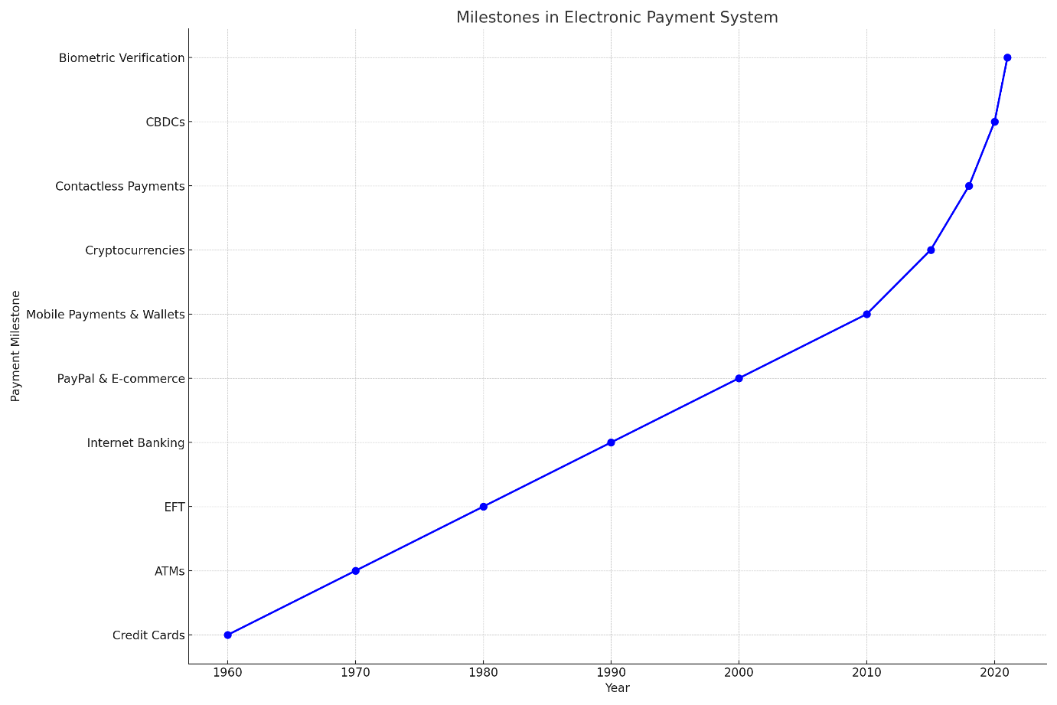**Figure 1: *Graphical representation of Evolution in Electronic Payments Systems***

The development of electronic payment systems, which in turn has made it simpler and more comfortable for individuals to complete financial transactions.

* A country’s central bank creates and supports a digital currency known as a CBDC . To improve financial inclusion, increase payment efficiency, and lessen the need for bank intermediaries, the concept of a CBDC has grown in popularity in recent years. This study examines many aspects of the e-rupee, including its pros and cons, effect on monetary policy, effects on financial stability, effects on privacy, and effects on security. One of the most significant benefits of the rupee is its e-ability to increase financial inclusion, particularly for individuals and small businesses in unbanked or rural areas that lack access to conventional banking services. The e-rupee has the potential to streamline banking processes and cut down on fees. Though e-rupee could have some drawbacks. The hazards of cyberattacks, the transmission of monetary policy, and regulatory oversight have all increased recently. The RBI needs to take all of these risks into account when formulating new rules and safety precautions.

1. Increased financial inclusion, more efficient payments, and less reliance on bank intermediaries are just a few of the possible advantages of the e-rupee.
2. Greater regulatory difficulties, greater cyber-attack risks, and increased monetary policy transmission risks are only a few of the potential downsides of the e-rupee.
3. Considerations for monetary policy transmission in light of the e-rupee's potential effects on the currency.
4. Possible effects of the e-rupee on financial stability, such as how it might affect banking intermediaries and monetary policy transmission, as well as the broader stability of the financial system.
5. Possible effects of the e-rupee on privacy and security, such as how it might affect people's personal information and the safety of the financial system.

**The RBI's implementation of the digital e-rupee may provide the following advantages:**

* The e-rupee can give a digital alternative to cash transactions, lowering the costs and hurdles of using conventional banking services, hence increasing financial inclusion. People and enterprises in remote or underbanked areas, who may not have access to regular banking services, may benefit greatly from this. The e-rupee can help increase people's use of banking services by serving as a digital substitute.
* The e-rupee can make transactions quicker and more efficient, cutting down on the time and money spent on conventional banking services. This has the potential to lower costs and increase availability of financial services for all.
* The e-rupee can serve as a digital alternative to traditional bank accounts, potentially lowering the need for middlemen in monetary exchanges. This can help make financial services more available and inexpensive to more people by increasing their speed and efficiency.
* The e-rupee can offer a digital alternative to monetary transactions, which can help to lessen the dangers and cut down on the costs normally associated with using currency. The e-rupee has the potential to streamline financial processes, lowering the barriers to entry for those who might not otherwise have access to such services.

The RBI launched the e-rupee as a CBDC , which could increase the nation's financial accessibility. Such digital currencies can enable quicker and more streamlined transactions, potentially diminishing the hurdles and expenses linked to conventional banking. For those residing in rural or less banked areas, who might rely heavily on cash and lack traditional banking access, the e-rupee presents a valuable digital option. It offers a safer, more cost-effective method for currency dealings, boosting financial stability and security. Additionally, the e-rupee can serve as a digital counterpart to traditional bank accounts, which is particularly beneficial for those lacking standard banking services. This could enhance transaction speed and reduce costs, making financial tools more attainable for everyone. However, the rollout of the e-rupee necessitates robust regulations and education to ensure widespread accessibility, particularly for those less familiar with banking. It's crucial to prioritize aspects like data privacy and security to ensure that the e-rupee truly promotes comprehensive financial inclusion.

**Concerns in adoption of E-rupee:** it has introduced by the RBI as a CBDC , comes with several concerns:

* **Regulatory Complexities:** Implementing the e-rupee demands a robust regulatory framework. Ensuring it adheres to safety standards and remains resistant to illicit financial activities like money laundering or terrorism financing will be a challenge. The Reserve Bank will need to craft, enforce, and regularly update these regulations effectively.
* **Cybersecurity Threats:** Being a digital currency, the e-rupee is vulnerable to digital threats such as hacking or malware. The bank would need to allocate substantial resources to fortify the currency against such cyber threats.
* **Monetary Policy Concerns:** The introduction of the e-rupee might influence the dynamics of monetary policy, affecting areas like inflation and interest rates. The bank must carefully gauge these potential impacts and adjust its strategies accordingly.
* **Data Privacy Issues:** The digital nature of the e-rupee means accumulating vast amounts of personal and transactional data. This raises concerns regarding data security and privacy. Proactive measures would be essential to prevent data misuse and breaches.

However, it's essential to juxtapose these challenges with the e-rupee's potential advantages, such as broader financial accessibility, enhanced transaction efficiency, and diminished dependency on traditional banking intermediaries. The RBI adoption of launching the e-Rupee, a CBDC, could have multifaceted implications on India's monetary policy and financial ecosystem. While its full impact remains to be seen, especially as its design and deployment are determined, various potential outcomes have been theorized:

**Benefits of adopting e-Rupee:**

* **Impact on interest rates:** It is possible that the e-Rupee will have an impact on the movement of interest rates; this is something that should not be discounted. RBI would need to do an investigation of the way this digital currency interacts with the various monetary tools that are already in existence, such as open market operations, to effectively govern these rates.
* **Concerns Raise Its Head Regarding Inflation**: There is a chance that the e-Rupee will have some kind of bearing on the level of inflation. Without the interaction of this instrument with other instruments, such as quantitative easing, it would be hard to effectively regulate inflation.
* **Impacts on Liquidity**: The launch of the e-Rupee may have the potential to cause a change in the liquidity environment, which will necessitate a reassessment of the systems that govern liquidity.
* **Impact on monetary policy transmission**: Transmission of Monetary Policy The introduction of the e-Rupee may have an impact on the effectiveness with which monetary policy is communicated to the public.

The possible implications of the e-rupee for financial stability are not completely known and may vary depending on how the e-rupee is created and put into use. On the other hand, the following are some potential implications that have been considered:

* **Impact on Bank Intermediation:**  The e-rupee, in its capacity as a CBDC, may influence the way banks mediate financial transactions. It is possible that this will diminish the requirement for banks to function as intermediates in financial transactions. This may result in a drop in profitability for banks as well as a change in the way financial transactions are mediated.
* **Impact on the transmission of monetary policy**: The e-rupee, in its capacity as a CBDC, may influence the transmission of monetary policy. To guarantee that monetary policy is properly delivered, it is possible that the RBI will need to assess how the e-rupee will interact with the various tools now in place for conducting monetary policy, such as interest rates.
* **Effect on the financial system's stability:** The e-rupee, in its capacity as a CBDC, may have some bearing on the degree to which the financial system is unshakeable. To guarantee that the financial system continues to be stable, the RBI might need to assess how the e-rupee will interact with the many tools that are already in place for maintaining financial stability, such as macroprudential policies.
* **Impact on Financial Inclusion**: The e-rupee, in its capacity as a CBDC, may influence the availability of financial services. It's possible that it might enhance access to financial services for those who don't have bank accounts or don't have enough of them, but it could also increase the dangers of cyber assaults, which could put the privacy and safety of financial and personal information at risk.

It is essential to keep in mind that the possible ramifications of the e-rupee for the country's financial stability are likely to be complicated, and that these ramifications may shift over time as the e-rupee is introduced and develops. In addition, the RBI and other interested parties should keep conducting research on and keeping a close eye on the development of the e-Rupee. This will allow them to gain a comprehensive understanding of the e-Rupee's ramifications and to make decisions regarding its implementation that are based on accurate information.

**Privacy and Security concerns of CBDC:**

* **Impact on personal privacy and data protection:** CBDC would necessitate the collecting and storage of extensive individual financial and identity information. Data privacy and security issues may arise because of this. To prevent identity theft and other misuses of personal information, it is crucial that the RBI implements stringent data privacy and security safeguards.
* **Negative effects on financial system security:**  due to the e-rupee's status as a CBDC. This could involve any type of cybercrime, from hacking to spreading malware. To safeguard the e-rupee and India's financial system against cybercriminals, the RBI would have to spend money on cutting-edge security measures.
* **Impact on financial frauds:** “The e-rupee, as a Centrally Managed Digital Currency, would be at risk of financial fraud. Money laundering and the financing of terrorism are two possible outcomes. Strong anti-money laundering and countering the financing of terrorism measures would be required by the RBI.”
* **The E-rupee's status** “as a CBDC necessitates a strong technical infrastructure to ensure its proper operation. The success of the e-rupee will depend on investments in technology and infrastructure by the RBI.”

The e-rupee's possible ramifications for privacy and security are nuanced and may develop over time if the currency is used and refined. The RBI and other interested parties should keep studying and keeping tabs on the e-rupee's progress so that they can fully grasp its consequences and implement it sensibly.

**The Worldwide use and Implementation of CBDC:**

In the present year of 2021, numerous central banks worldwide have been engaged in the examination of the viability of central bank digital currencies (CBDCs), while only a limited few have successfully initiated their implementation. Here, however, we present a compilation of statistics pertaining to the extensive implementation and ramifications of Central Bank Digital Currencies (CBDCs) on a global scale:

1. In 2020, a survey conducted by the Bank for International Settlements (BIS) showed that 80% of the surveyed central banks were involved in CBDC activities. Additionally, more than a third of these central banks were in an advanced stage of development in their CBDC initiatives.
2. Since 2019, the Digital Yuan, a virtual currency, has been the subject of experimental experiments by the People's Bank of China (PBOC). According to estimates from the People's Bank of China, the digital yuan has been used in a significant number of transactions, exceeding 4 million, with a total value surpassing $160 million.
3. The European Central Bank (ECB) is contemplating the possibility of releasing a digital euro, although a final decision has not been made yet.
4. The Swedish Riksbank, the country's central bank, is looking at the feasibility of an E-krona but has not made a final decision.
5. The Eastern Caribbean Central Bank has begun testing a fully digital Eastern Caribbean dollar, which is scheduled for release in 2022.
6. Many central banks recognize the potential advantages of CBDCs, such as improved financial inclusion and enhanced payment efficiency. In spite of this widespread optimism, many people point out that there are also hazards and hurdles to consider.

**Comparison of Indian CBDC with Global Retail CBDC**

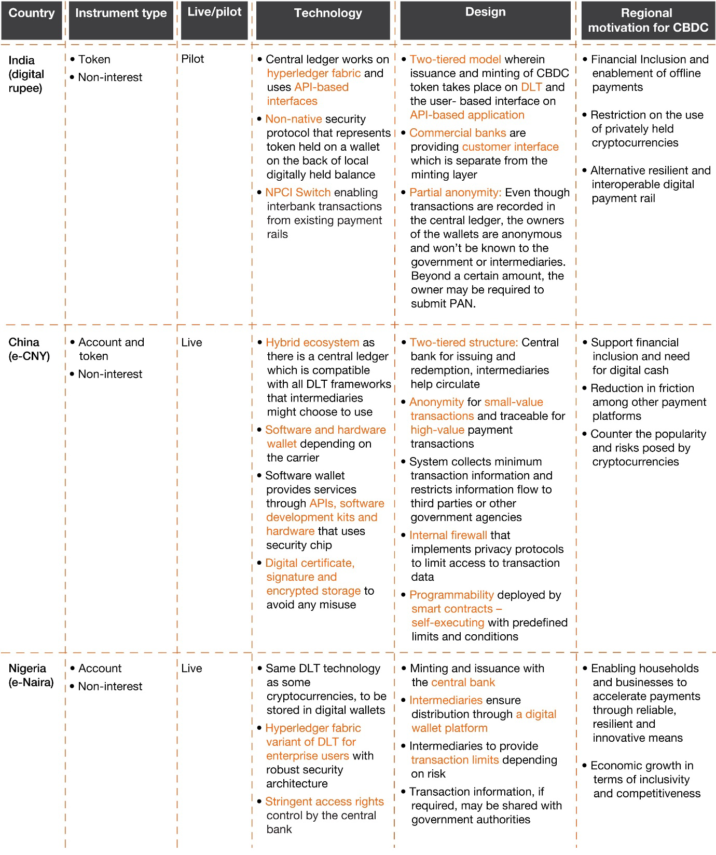

*Source:* (*Future of Digital Currency in India*, n.d.)

It's worth noting that CBDCs have just begun to be put into practise, and that their effects are currently being researched and analysed. Their utility and effect in the real world may turn out to be different than anticipated.

**CONCLUSION:**

In conclusion, the RBI is investigating the promising initiative of e-Rupee, which is a CBDC. Individuals who are currently unbanked or underbanked may be more likely to participate in the financial system if they have access to a digital form of money, such as the e-Rupee. It has the potential to enhance safety, lessen transaction costs, and speed things up. However, there are obstacles that must be taken into account in rolling out e-Rupee. The adoption of e-Rupee has the potential to upend the current financial system and reduce the need for those services. The safety of the e-Rupee would also need to be guaranteed by investing heavily in IT infrastructure and cyber defences. There is also the potential for privacy and government monitoring issues to arise from using e-Rupee.

The RBI should keep looking into issuing a CBDC, and if it does, it should take every safety measure possible to minimise risks and increase benefits. In order to get the government and private sector to set up the necessary infrastructure and procedures for e-Rupee, public education regarding the pros and cons of a CBDC may be in order.

The e-Rupee could significantly alter the financial and economic landscape of India, but any moves should be made cautiously and after a thorough examination of the potential outcomes.

# **REFERENCES**

Agur, I. A. (2019). Designing Central Bank Digital Currencies . *IMF Working Papers*.

Ahmed H. Elsayed, &. M. (Aug 2022). Central bank digital currencies: An agenda for future research. . *Research in International Business and Finance.*

Andolfatto, D. (2018). Assessing the impact of central bank digital currency on private banks. *FRB St. Louis Working Paper*.

Barrdear, J. a. (2016). The Macroeconomics of Central Bank Issued Digital Currencies. *Bank of England Staff Working Paper*.

Chiu, J. D. (2019). Bank market power and central bank digital currency: Theory and quantitative assessment. . *Available at SSRN 3331135.* .

Committee on Payments and Market Infrastructure., M. C. (2018). Central Bank Digital Currencies. *Bank for International Settlements.* .

Committee, I.-m. (2019). Report of the Committee to propose specific actions to be taken in relation to Virtual Currencies. *Ministry of Finance, Government of India.* .

Cukierman, A. (2019). Welfare and political economy aspects of a central bank digital currency. *Working Paper, Centre for Economic Policy Research*.

Darbha, S. &. (2020). Privacy in CBDC technology. *Bank of Canada.* .

Davoodalhosseini, S. M. (2021). Central bank digital currency and monetary policy. *Journal of Economic Dynamics and Control.*

Didenko, A. a. (2021). Central Bank Digital Currencies: A Potential Response to The Financial Inclusion Challenges of the Pacific Issues in Pacific Development. *Asian Development Bank. Mandaluyong, Philippines.* .

Ferrari, M. M. (2020). The international dimension of a central bank digital currency. *VoxEU.Org, Center for Economic Policy Research.* .

India., P. T. (2021). RBI internal panel working on model of central bank's digital currency, decision very soon: Deputy Governor B P Kanungo. *Economic Times*.

India., R. B. (2021). Payment and Settlement Systems in India: Journey in the second decade of the Millennium .

Infrastructures., C. o. (2016). Fast payments – Enhancing the speed and availability of retail payments. *Bank for International Settlements.* .

Ioanna Roussou, E. S. (2019). An empirical study on the commercial adoption of digital currencies. . *Information Systems and e-Business Management .* .

Kumari, J. M. (2021). Central Bank Digital Currency (CBDC) Can it Replace Notes and Coins in India. . *International Journal of Management.*

Mello, J. M.-A. (2021). Central Bank Digital Currency in Brazil. . *SSRN.* .

Rodrik, D. (2005). Growth strategies. *Handbook of economic growth*.

Roussou, I. E. (2019). An empirical study on the commercial adoption of digital currencies. *Information Systems and e-Business Management.* .

Saran, S. (2020). China’s digital currency moves. *Business Standard.*

Singh, B. K. (2019). Crypto Currencies/Blockchain and the Banking System. . *The Journal of Indian Institute of Banking and Finance.* .

Tripathi, S. C. (2022). An Empirical Analysis of Potential Central Bank Digital Currency Adoption Procedure By Indian Government And Its Implications. *An International Peer Reviewed, Open Access & Multidisciplinary Journal.*

Saikia, B. K. (2022).Digital Currency and Buoyancy in Indian Economy: Issues and Challenges.

An Approach Towards Central Bank Digital Currency, 247.

Nikhil, M. S., Atreya, N. V., Kumar, H. M., Priyadharshini, B., & Ramya, S. (2023). A Systematic Study of Central Bank Digital Currency. In *Advances in business information systems and analytics book series* (pp. 331–342). <https://doi.org/10.4018/979-8-3693-2193-5.ch022>

Davoodalhosseini, S. M. (2022). Central Bank Digital Currency and monetary policy.

Journal of Economic Dynamics and Control, 142, 104150.

Auer, R., & Böhme, R. (2020). The technology of retail Central Bank Digital Currency.

BIS Quarterly Review, March.

Future of digital currency in India. (n.d.).

PwC. <https://www.pwc.in/research-and-insights-hub/future-of-digital-currency-in-india.html#:~:text=CBDC%20initiative%20in%20India&text=As%20of%20February%202023%2C%20this,wallets%20to%20the%20end%20users>.