Level Process Station Control Using ALE111 Communictaion Module

Sivasankar S, Sneha M, Pranesh Raj K,Athappan V

Electronics and Instrumentation Engineering, Kumaraguru College of Technology

*Chinnavedampatti,Coimbatore-641 049*

[sivasankar.20ei@kct.ac.in](mailto:sivasankar.20ei@kct.ac.in)

[sneha1.20ei@kct.ac.i](mailto:sneha1.20ei@kct.ac.in)n

praneshraj.20ei@kct.ac.in

athappan.v.eie@kct.ac.in

**Abstract**— **A noteworthy example of the technological evolution is the ALE111, a cutting-edge system equipped with advanced functionalities designed to monitor the status of field wireless devices. One of its key features is the implementation of bumpless output, a capability that ensures seamless transitions and adjustments in the control process. Remarkably, the ALE111 enables wireless process control, a capability traditionally associated with wired control systems utilizing 4-20 mA signal communication.This wireless paradigm not only introduces a new level of flexibility but also contributes to the overall enhancement of process control reliability. The ALE111 goes a step further by incorporating redundant configurations, a strategic approach that adds an extra layer of reliability to the system. By doing so, potential points of failure are mitigated, and the overall robustness of the process control system is substantially improved.**

Keywords— ALE111 Communication Module,Ethernet,Level Process Station,Vnet,Field Control Station,HIS,Data Acquisition Card

1. Introduction

In recent years, the demand for control systems incorporating wireless communications has experienced a significant surge within the process control market. This trend is primarily attributed to the notable advantages these systems offer, particularly in terms of eliminating the need for power and communication wiring for field instruments. The resulting benefits include a reduction in both initial and maintenance costs, as well as the facilitation of easy installation processes.

The proposed idea is to develop an Intelligent Controller for a Non-Linear Process using Machine Learning. The Conical Tank Level Process Station which is good example of Non-Linear Process system is available in the Process Dynamics and Control Laboratory of our Department. This Process will exhibit Non-Linear characteristics for the Level control system and will be difficult to achieve better control for the level inside the tank by simple feedback controller. Hence, we intend to design an Intelligent controller to control this Non-Linear process using Reinforced Learning in Machine Learning platform. Developing one such Intelligent controller for a Non-Linear Process system will facilitate the learning community to understand the dynamic characteristics of Non-linear process and the need to develop an appropriate controller to achieve the desired Conical Tank Level Control System. Thus, the design and development of one such controller will also facilitate the peer group to understand the overall performance of the entire process control system and its importance in achieving an efficient and intelligent controllers that is been implemented in the Process.

1. OBJECTIVES

* The main objective of this project is to monitor and control the Level process plants in the department aboratory
* It involves fetching the real time process variable data from each process plant and communicating the process data through a common communication protocol via Ethernet medium
* Identifying trends and fluctuations while constantly reading data from the input sensors help us understand their liability of the particular equipment over a specific runtime helping in identifying faults and risks at an early stage

1. METHODOLOGY

Level Control helps to determine the measurements and control of liquid level. One can raise and lower water to preset levels using manual control and auto-tuning methods. The Level process station can be invariably classified under three heads i) Level Process Station Mainframe ii) Data Acquisition Card iii) Process Control Software. The mainframe is a metal structure placed in an open area. It consists of a bottom plate with a reservoir tank, a pump and a plumbing fixture. The frame consists of a plate, level transmitter, I / P converter, control valve, process tank and cabinet. The cabinet picks up DC power outages, an overhead wide acquisition system and a disconnected system and an inlet connector for large AC pipelines. The main air in the inlet is passed through the filter section, leaving the dirt in the bowl. When the knob is properly adjusted, the spring operates on the diaphragm which makes the main valve allow for a second fresh air at a certain pressure exit. Exit pressure is returned to the diaphragm through the feedback hole to lower the diaphragm to maintain the set pressure. The standard transmitter consists of a level investigation and a conditional signal section. The level probe is made up of two straight cylinders. At any moment, water enters the central cylinder, acting as a di-electric medium. The water level rises, and the power probe level also increases. The change in power is directly proportional to the change in level. Voltage variation is connected to the AC power gauge bridge. The output of the bridge is part of the AC millivolt signal. The AC signal is converted to DC with an accurate adjuster. Redesign output has high unwanted high-end signals. It is filtered through a lowpass filter and amplified at (4-20) Ma.

1. COMPONENTS USED
2. **HIS:** Host Interface System. This is the device that connects the DeviceNet network to the main control system.
3. **ENG:** Engineering station. This is the device used to configure and monitor the DeviceNet network.
4. **Vnet:** Virtual network. This is a logical grouping of devices on the DeviceNet network.
5. **FCU:** Fan coil unit. This is a type of HVAC device that is used to control the temperature of a room.
6. **HE:** Heat exchanger. This is a device that is used to transfer heat from one fluid to another.
7. **SyCon:** System controller. This is the device that controls the overall operation of the HVAC system.
8. **ALE111:** Address label encoder. This is a device that assigns addresses to devices on the DeviceNet network.
9. **ALD112:** Address label decoder. This is a device that receives addresses from the ALE111 and forwards them to the appropriate devices on the DeviceNet network.
10. **Switching HUB:** Ethernet hub. This device is used to connect multiple Ethernet devices to the same network.
11. **Ethernet:** Ethernet cable. This type of cable is used to connect Ethernet devices to each other.
12. **Discrete I/O:** Discrete input/output. This is a type of input/output that is used to control devices that have two states, such as on/off.
13. **Photoelectric device:** A photoelectric device is a sensor that detects the presence or absence of an object by measuring the amount of light that is reflected off of it.
14. **Proximity switch:** A proximity switch is a sensor that detects the presence or absence of an object without making physical contact with it.
15. **Drive:** An electric motor drive is a device that controls the speed and torque of an electric motor.

The DeviceNet network is connected to the Ethernet hub using a DeviceNet to Ethernet bridge. This allows the DeviceNet network to be accessed by other devices on the Ethernet network, such as the engineering station.

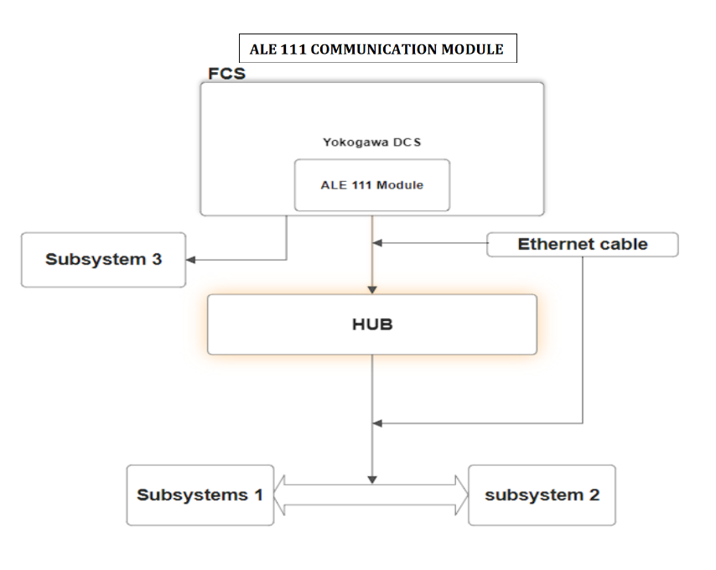

Fig. 1 Hardware Design

1. SIMULATION ANALYSIS

A Functional block diagram in Fig. 2 was designed to determine the integration of Level Process Station which has been controlled by the PID Controller.

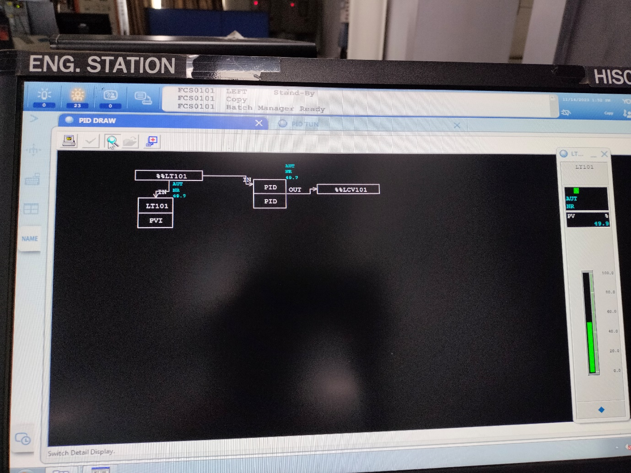Fig. 2 Functional Block Diagram

1. HMI DESIGN

A Level Process Station configuration utilizing an OPC Server, an ALE111 communication module, and associated cables. At the core of the system is an OPC Server installed on a personal computer (PC). This OPC Server serves as a communication interface, facilitating the exchange of data between different components of the process control system.Connected to the OPC Server is an ALE111 communication module, establishing a link through a twisted pair cable. The ALE111 module, acting as a bridge in the communication network, plays a pivotal role in wirelessly connecting the OPC Server to the Level Process Station. The use of a twisted pair cable for this connection ensures a reliable and efficient data transfer between the OPC Server and the ALE111 module.The Level Process Station is intricately integrated into the system through a PROFIBUS DP cable, creating a robust and standardized communication channel. PROFIBUS DP is a widely adopted industrial communication protocol that allows seamless connectivity between field devices and the central control system. This cable facilitates the exchange of process data, enabling the OPC Server to both read and write information to the Level Process Station.

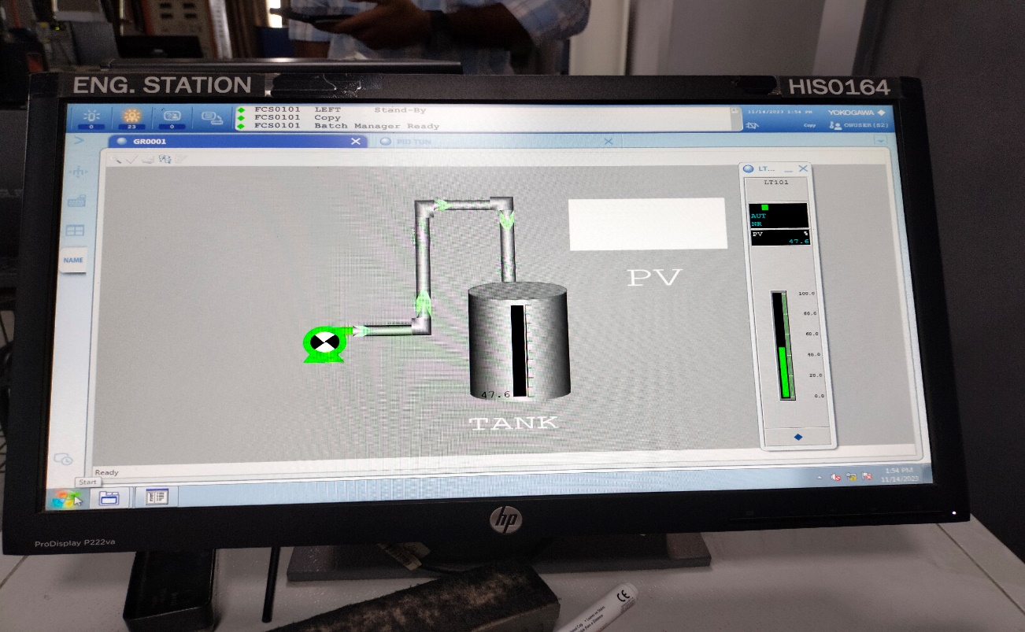

Fig. 3 HMI Design

1. OUTPUT

Fig. 2 shows the output we derived from the PID design

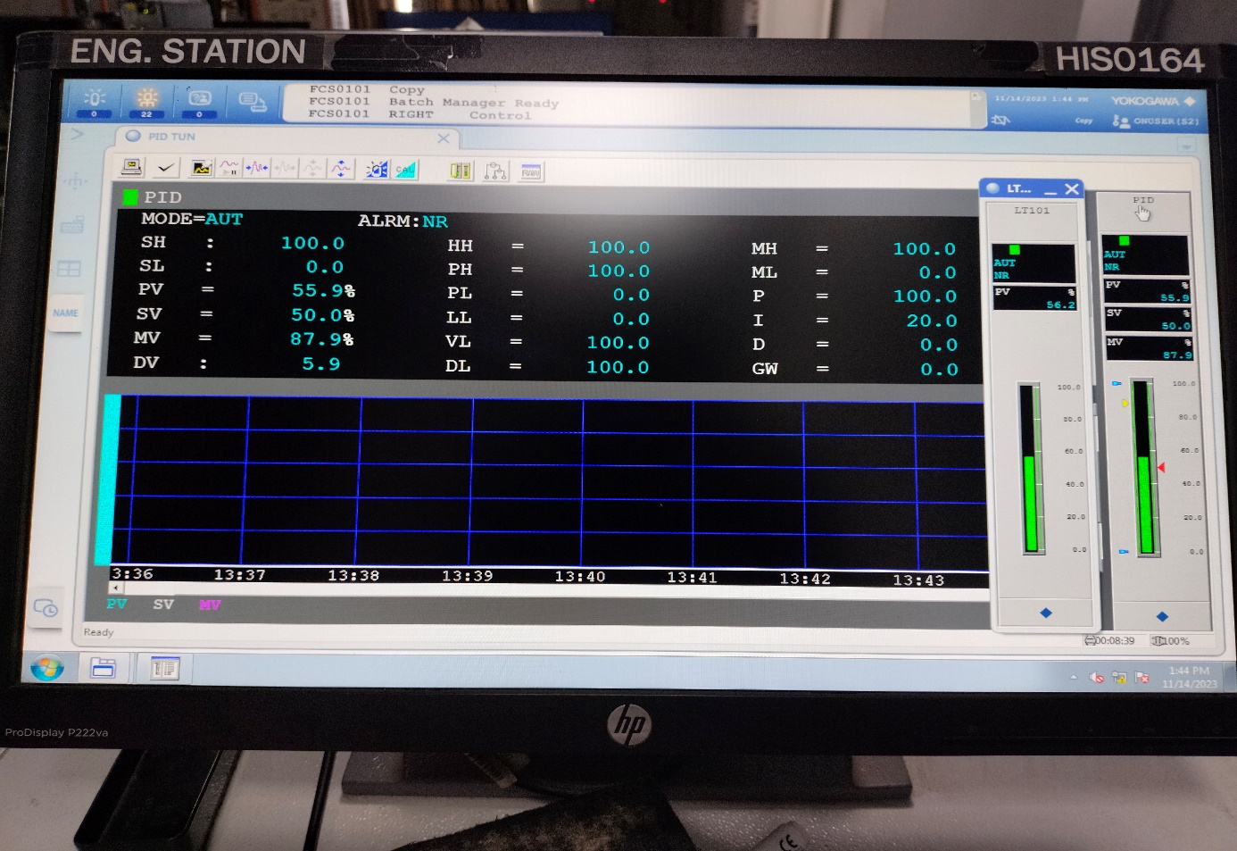

Fig. 4 Output of PID

1. Conclusions

Wireless control systems, like those utilizing the ALE111 communication module, eliminate the need for power and communication wiring for field instruments. This reduction in infrastructure requirements leads to lower initial and maintenance costs.The ALE111 communication module is noted for its capability to achieve bumpless output and process control wirelessly. This functionality is a departure from conventional wired control systems that typically rely on 4-20 mA signal communication.The module incorporates functions for monitoring the status of field wireless devices. This ensures compatibility and effective integration with other wireless components in the field.The utilization of redundant configurations enhances the reliability of process control. Redundancy provides backup options in case of failures, minimizing downtime and improving overall system reliability.

Acknowledgment

We would like to acknowledge and our warmest thanks to our mentor Athappan V, SaravanaBalaji M, Ranganathan S, Mthuramalingam E, who made this work possible. Their guidance and advice carried us through all the stages of writing my project. I would also like to thank my department members for letting our defense be an enjoyable moment and for your brilliant comments and suggestions,thanks to you.

References

1. MacGregor, J. F., & Kourti, T. . Statistical process control of multivariate processes. Control engineering practice, 3(3), 403-414.
2. Brigham, F. R., & Laios, L. . Operator performance in the control of a laboratory process plant. Ergonomics, 18(1), 53-66.
3. Christofides, P. D., Davis, J. F., El‐Farra, N. H., Clark, D., Harris, K. R., & Gipson, J. N. (2017). Smart plant operations: Vision, progress and challenges. AiChE journal, 53(11), 2734-2741.
4. Hogg, D. N., Folles, K. N. U. T., Strand-Volden, F., & Torralba, B. . Development of a situation awareness measure to evaluate advanced alarm systems in nuclear power plant control rooms. Ergonomics, 38(11), 2394-2413.
5. Paulus, S., & Mahlein, A. K. (2020). Technical workflows for hyperspectral plant image assessment and processing on the greenhouse and laboratory scale. GigaScience, 9(8), giaa090.
6. Hlava, J., & Šulc, B. (2018). Advanced modelling and control using a laboratory plant with hybrid processes. IFAC Proceedings Volumes, 41(2), 14636-14641.
7. Lind, M. Multilevel flow modelling of process plant for diagnosis and control. Risø National Laboratory.
8. *Seborg, D. E., Edgar, T. F., Mellichamp, D. A., & Doyle III, F. J. (2016). Process dynamics and control. John Wiley & Sons.*
9. Smith, C. A., & Corripio, A. B. (2015). Principles and practices of automatic process control. John wiley & sons