**HIERARCHICAL ALIGNMENT WITH POLAR CONTRASTIVE LEARNING FOR NEXT-BASKET RECOMMENDATION**

1Prof. C. Sathish, 2Vinnarasu D, 3Arun Kumar S, 4Gowtham M and 5Santhosh V

1Assistant Professor, Department of Information Technology

2,3,4,5 Department of Information Technology,

Er. Perumal Manimekalai College of Engineering, Hosur, India

***Abstract*:**

Next-basket recommendation methods focus on the inference of the next basket by considering the corresponding bas- ket sequence. Although many methods have been developed for the task, they usually suffer from data sparsity. The number of inter- actions between entities is relatively small compared to their huge bases, so it is crucial to mine as much hidden information as possible from the limited historical interactions for prediction. However, the existing methods mainly just treat the next-basket recommendation task as a single-view sequential prediction problem, which leads to the inadequate mining of the information hidden in multiple views, and the mining of other patterns in the historical interactions is neglected, thus making it difficult to learn high-quality representa- tions and limiting the recommendation effect. To alleviate the above issues, we propose a novel method named HapCL for next-basket recommendation, which mines information from multiple views and patterns with the help of polar contrastive learning. A hier- archical module is designed to mine multiple patterns of historical interactions from different views at two levels. In order to mine self- supervised signals, we design a polar contrastive learning module with a novel graph-based augmentation approach. Experiments on three real-world datasets validate the effectiveness of HapCL.

*Keywords : Next-basket recommendation, contrastive learning, multi-head, distribution alignment*

**I. INTRODUCTION**

With the rapid development of the Internet, the number of entities involved has exploded. In many scenarios, users need to search through a large number of items to find the one that fits their needs, but it is impossible for them to go through all of items. In order to help users find the target item quickly, recommendation systems came into being. Recommendation systems try to mine useful information from the historical interactions and match items for users based on the mined information [1], [2], [3]. Hence, the time that users spend in finding their target items is saved greatly. The next-basket recommendation task, which aims to infer several items that the target user interacts with in the next basket based on the corresponding basket sequence, has drawn increasing attention [3], [4], [5], [6]. Its success is mainly due to the fact that the order of user interaction over a period of time does not necessarily follow a strict chronological order, which is also an important difference between next-basket recommendation and sequential recommendation [7], [8], [9], [10], [11]. However, a common issue in recommendation methods is data sparsity [12], [13], [14]. The number of interactions between users and items is relatively small compared to their huge bases, which results in insufficient data for learning various representations, e.g., basket representations, in recommendation methods. It is crucial to make full use of the limited historical interactions. Some recommendation methods attempt to mine self- supervised signals from the original data and employ contrastive learning to help recommendation models with learning high- quality representations. Since the data form of the historical interactions, which is time-aware, is not as easy to be augmented as images, the augmentation approaches in next-basket recommendation remain to be explored. More specifically, Fig. 1 shows a basket sequence consists of three baskets with various sizes.

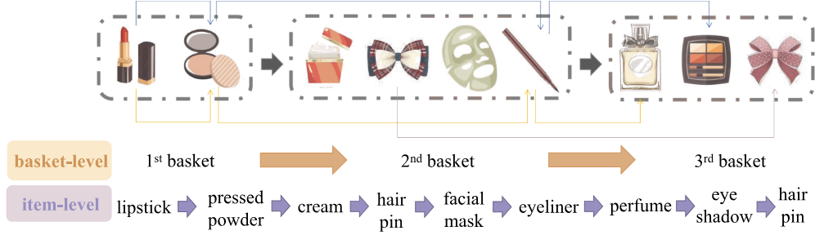

Figure 1 Example of the historical interactions in the basket sequence

The order of items in every basket has no strict precedence, i.e., the order of items in every basket can be changed. The augmentation approaches, e.g., rotation, do not apply to time- aware data. In addition, the existing time-aware, mainly concentrate on the sequential pattern of the historical interactions in a single view, which results in the inadequate mining of the information hidden in multiple views, and the mining of other patterns, e.g., graph pattern, in the historical interactions is neglected. Take the sequence that is shown in Fig. 1 for example, the lipstick and pressed powder in the first basket and the eyeliner in the second basket are all cosmetics. Sequential pattern mining pays attention to the view of category, so that it tends to recommend eye shadow in the following basket. But from the view of interest, the buying of the cosmetics can also imply the user attaches importance to appearance, where the perfume matches the preference too. And from the view of consumability, cosmetics and skin care.

**II. RELATED** **WORK**

In this section, we briefly review three tasks related to our work, namely graph-based recommendation, next-basket recommendation and contrastive learning.

***A. Graph-Based Recommendation***

Graph is a form of data which can represent the association between nodes through the connection between them, which well fits the association between entities in recommendation. Some works have realized the consistency, and as deep neural networks have proven to be powerful in data mining in recent years, they have proposed some graph-based deep learning methods that model the association between entities by graph and learn representations for nodes in graph for recommendation.

***B. Next-Basket Recommendation***

With the assumption that the shopping preference of users and the correlation between items are often reflected in the order of the historical interactions, temporal recommendation methods are proposed to mine the sequential pattern hidden in interactions and make recommendation based on it. Temporal recommendation can be divided into two main categories according to the units of sequences: sequential recommendation which aims at recommending next item based on the item sequence and basket recommendation which aims at recommending next basket based on the basket sequence. Note that the baskets in basket sequences consist of several items, and have no fixed size. Although the units of sequences in these two tasks are different, the solutions for them share many similarities.

***C. Contrastive Learning***

Although deep learning has achieved great success in various fields in recent years, the issue of data sparsity still plagues many deep models. In the recommendation field, the interaction data between users and items is relatively small compared to their huge bases, but it requires a lot of labeled data to train the large number of parameters in deep models, e.g., historical interactions. The conflict between the supply of labeled data and the demand of models requires us to make full use of the limited historical interactions and mine as much information as possible. Contrastive learning, which mines self-supervised signals from unlabeled data by constructing contrastive pairs, has been widely used in some fields for alleviating the issue caused by sparse data.

**III. THE PROPOSED METHOD**

In this section, we first formalize the next-basket recommendation problem. Then, we represent an overview of the proposed HapCL method, followed by describing the two main modules of this method, i.e., Hierarchical Alignment for Next-basket Recommendation and Graph-based Polar Contrastive Learning. Finally, the multi-task learning strategy is described.

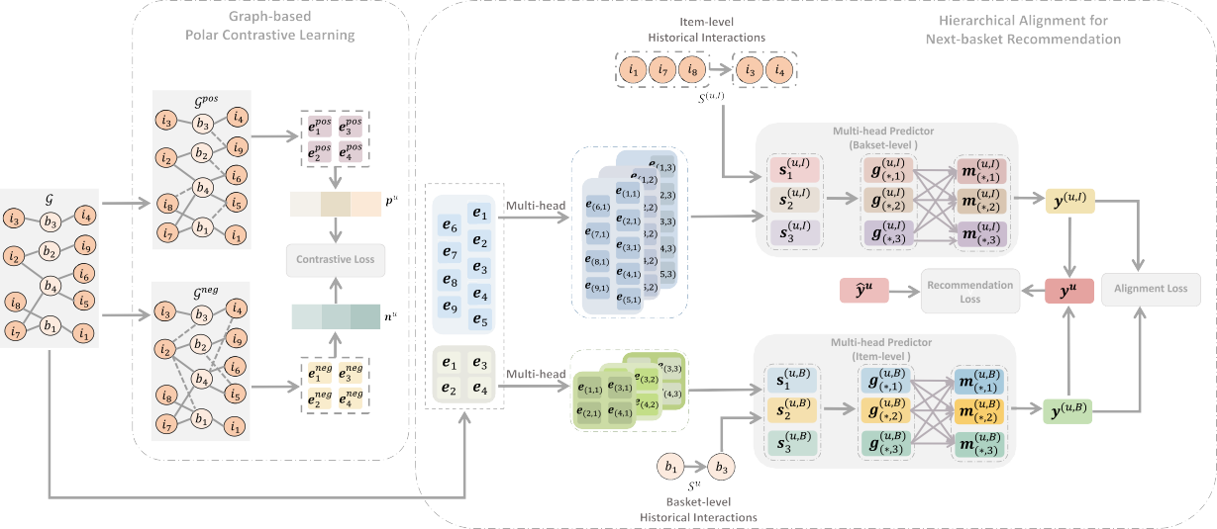

Figure 2 An overview of the architecture of the proposed HapCL method

In order to mine as much information as possible from the historical interactions, and alleviate the issues caused by data sparsity, we propose the HapCL method as shown in Fig. 2. The method models historical interactions by a weighted bipartite graph to mine graph pattern, and designs a module with hierarchical framework to mine sequential pattern at basket-level and item-level. At both levels, every sequence is encoded to multiple representations to explore hidden information from different views. With the expectation that predictions at different levels can help supervise each other, distribution alignment is applied to put a constraint on them. Furthermore, we design a novel graph-based augmentation approach to construct positive augmentations and negative augmentations of baskets for polar contrastive learning, which is an auxiliary task to help with mining self-supervised signals and learning high-quality representations of baskets and items for recommendation.

1. Hierarchical Alignment for Next-Basket Recommendation
2. Hierarchical Multi-Head Predictor
3. Distribution Alignment
4. Graph-Based Polar Contrastive Learning
5. Multi-Task Learning

**IV. EXPERIMENTS**

In this section, we conduct extensive experiments on three real-world datasets to evaluate the effectiveness of the proposed HapCL method. The experiments are designed to answer the following research questions: RQ1. How does the proposed HapCL method perform compared to the state-of-the-art baselines in the next-basket recommendation task? RQ2. Whether the different components of the HapCL method benefit the performance? RQ3. Can the polar contrastive pairs provide stronger selfsupervised signals for the HapCL method? RQ4. How do the key hyper-parameters, i.e., the number of additional edges in augmentation K, the number of graph convolution layers L and the number of heads in multi-head H, affect the performance?

We adopt three real-world datasets in our experiments, namely Beauty,1 Grocery2 and Tafeng.3 Beauty and Grocery consist of the interactions of subcategory “Beauty” and subcategory “Grocery” on Amazon, which is a famous e-commercial platform, respectively. And TaFeng contains the transaction data of a Chinese grocery store. Following [3], which is a well-known next-basket recommendation method, the users and the items with less than 10 interaction records are discarded for all datasets. We generate a basket sequence for each user by sort the corresponding interactions according to the timestamp, and filter out the sequences with length fewer than 3.

To verify the effectiveness of the HapCL method, we compare it against the following eight baselines: POP is a non-personalized method which recommends items with the greatest number of the historical interactions for each user. GRU4Rec [31] introduces recurrent neural network to model sequential information hidden in the historical interactions. STAMP [32] is a short-term memory priority model, which captures general interests of users from the long-term memory of a session context, and captures current interests from the short-term memory. SASRec [16] is a self-attention based model, which can not only capture long-term semantics, but also make prediction based on relatively few actions with an attention mechanism. NextItNet [33] consists of a stack of holed convolutional layers, and it can learn representation from both short-range and long-range item dependencies. LightSANs[7] extracts a constant number of latent interests by the low-rank decomposed self-attention, and generates the context-aware representation by making use of itemto-interest interaction. CLEA [4] designs a denoising generator to extract items relevant to the target item automatically, and proposes a two-stage anchor-guided contrastive learning to guide relevance learning. Beacon [3] encodes baskets with a correlation matrix to take into account the relative importance of items and correlations among item pairs. SINE [34] attempts to infer the set of concepts for each user adaptively, and predict current intention of users. GCSAN [1] is a graph-based method which utilizes graph neural network to capture local dependencies and selfattention mechanism to learn long-range dependencies for prediction. These baselines can be divided into three groups based on the type of technology involved: (1) the traditional methods that do not consider sequence relationships, i.e., POP; (2) the methods focusing on sequential pattern, i.e., GRU4Rec, STAMP, SASRec, NextItNet, LightSANs, CLEA and Beacon; (3) the methods that introduce graph structure to facilitate sequence modeling, i.e., SINE and GCSAN.

Making use of the order of the historical interactions would help the methods mine more information from the limited historical interactions, and facilitate the modeling of relationship between baskets and items. The methods focusing on sequential pattern and the methods that introduce graph structure show better performance than the traditional method that ignores time information of the historical interactions. Specifically, POP achieves the worst performance due to underutilization of data. The performance improvement tends to be much larger on Beauty than that on Grocery and Tafeng. And Beauty is a relatively sparse dataset, while Grocery and Tafeng are relatively dense. The results imply that the proposed method could alleviate the issue of data sparsity. Note that the Tafeng dataset contains the largest average size of baskets, the largest average length of basket sequences and the fewest items among the three datasets. And all the methods tend to show the best performance on the Tafeng dataset, while Beauty at the other extreme, which confirms that data sparsity would lead to poor performance.

**V. CONCLUSION**

Since sparse data impedes the performance of recommendation methods, it is necessary to facilitate the mining of the limited historical interactions. The existing next-basket recommendation methods mostly neglect the fact that the information of the historical interactions is hidden in multiple views, and treat the next-basket recommendation task as a single-view sequential prediction problem. In this paper, we propose a novel method that combines hierarchical alignment with polar contrastive learning for next-basket recommendation (named HapCL). The historical interactions are modeled by a weight bipartite graph for information propagation and aggregation. And a module with hierarchical framework is designed to mine information from multiple views at two levels, i.e., basket-level and item-level. The probabilities inferred at the two levels are aligned and integrated into the final prediction. In order to mine self-supervised signals from the original data, we design a novel graph-based augmentation approach for constructing polar contrastive pairs. Extensive experiments on three real-world datasets validate the effectiveness of the proposed HapCL method in mining more information for the next-basket recommendation task.

**References:**

1. C. Xu et al., “Graph contextualized self-attention network for session- based recommendation,” in Proc. 28th Int. Joint Conf. Artif. Intell., 2019, pp. 3940–3946.
2. C. Wang, W. Xi, L. Huang, Y. Zheng, Z. Hu, and J. Lai, “A BP neural network based recommender framework with attention mechanism,” IEEE Trans. Knowl. Data Eng., vol. 34, no. 7, pp. 3029–3043, Jul. 2022.
3. D. Le, H. W. Lauw, and Y. Fang, “Correlation-sensitive next-basket recommendation,” in Proc. 28th Int. Joint Conf. Artif. Intell., 2019, pp. 2808–2814.
4. Y. Qin, P. Wang, and C. Li, “The world is binary: Contrastive learning for denoising next basket recommendation,” in Proc. 44th Int. ACM SIGIR Conf. Res. Develop. Inf. Retrieval, 2021, pp. 859–868.
5. X. Wang, D. Wang, C. Xu, X. He, Y. Cao, and T. Chua, “Explainable reasoning over knowledge graphs for recommendation,” in Proc. 33rd AAAI Conf. Artif. Intell., 31st Innov. Appl. Artif. Intell. Conf., 2019, pp. 5329–5336.
6. F. Yu, Q. Liu, S. Wu, L. Wang, and T. Tan, “A dynamic recurrent model for next basket recommendation,” in Proc. 39th Int. ACM SIGIR Conf. Res. Develop. Inf. Retrieval, 2016, pp. 729–732.
7. X. Fan, Z. Liu, J. Lian, W. X. Zhao, X. Xie, and J. Wen, “Lighter and better: Low-rank decomposed self-attention networks for next-item recommendation,” in Proc. 44th Int. ACM SIGIR Conf. Res. Develop. Inf. Retrieval, 2021, pp. 1733–1737.
8. M. M. Tanjim, C. Su, E. Benjamin, D. Hu, L. Hong, and J. J. McAuley, “At- tentive sequential models of latent intent for next item recommendation,” in Proc. ACM Web Conf., 2020, pp. 2528–2534.
9. Q. Cui, S. Wu, Q. Liu, W. Zhong, and L. Wang, “MV-RNN: A multi-view recurrent neural network for sequential recommendation,” IEEE Trans. Knowl. Data Eng., vol. 32, no. 2, pp. 317–331, Feb. 2020.
10. K. Zhou et al., “S3-rec: Self-supervised learning for sequential recom- mendation with mutual information maximization,” in Proc. 29th ACM Int. Conf. Inf. Knowl. Manage., 2020, pp. 1893–1902.
11. X. Zheng, M. Wang, R. Xu, J. Li, and Y. Wang, “Modeling dynamic missingness of implicit feedback for sequential recommendation,” IEEE Trans. Knowl. Data Eng., vol. 34, no. 1, pp. 405–418, Jan. 2022.
12. Y. Chen, Z. Liu, J. Li, J. J. McAuley, and C. Xiong, “Intent contrastive learning for sequential recommendation,” in Proc. ACM Web Conf., 2022, pp. 2172–2182.