**Software Defined Radio: A Basic Hardware Realization of SDR Receiver**

Pranay Prashant Vaidya1, Jyoti M Waykule 2, Kirtiraj Sardesai3 , Apurva Patil4

*1,2,3,4(Electronics Engineering, Sanjay Ghodawat University, Atigre, Maharashtra, India)*

|  |  |
| --- | --- |
| How to cite this paper: Pranay Prashant Vaidya1, Jyoti M Waykule2, Kirtiraj Sardesai3 , Apurva Patil4 , “Software Defined Radio: A Basic Hardware Realization of SDR Receiver”  IJIRE-VXIX,YYYY  Copyright © 2023 by author(s) and  5th Dimension Research Publication  This work is licensed under the Creative Commons Attribution International License  (CC BY 4.0). <http://creativecommons.org/licenses/by/4.0/> | ***Abstract:*** *This paper aims to provide a general overview of SDRs, their history, need, basic operation and benefits, along with a basic hardware realization of SDR receiver using Arduino Nano microcontroller. Software Defined Radio or SDR is one of the most important technologies and is essential for a modern wireless communication system. SDRs are known for their versatility as they can be customised to operate on any frequency band, or can have different implementations of modulation and demodulation schemes and different communication standards in the same device. This is done by using reconfigurable and reprogrammable hardware and robust and powerful software. SDRs are easy to manufacture, are multi-functional, compact, power efficient and easy to upgrade.*  ***Key Word****:**Software Defined Radio, SDR, SDR receiver, Hardware Realisation of SDR.* |

1. **Introduction (11 Bold)**

Before the advent of SDRs, Radio communications systems used to communicate using one or two signals operating at different frequencies. The main drawback of this system was that different groups of people using different types of Radio communication systems could not communicate with each other. This would pose as a major challenge during times like war where good communication is the key to any strategy. A possible solution to this problem is to make communication systems that are based on software programmable radios.

The term ‘Software Radios’ was coined by Joseph Mitola III in his seminal paper [1]. Before SDR, radio developers used to build system particularly tailored for specific applications. The SDR systems, on the other hand, are more general purpose, means one platform supports multiple signals of different frequencies. Due to this, the need for systems with unique configurations is greatly reduced as compared to radios that are completely hardware dependent. SDRs have a much larger range of applications which are configurable via software.

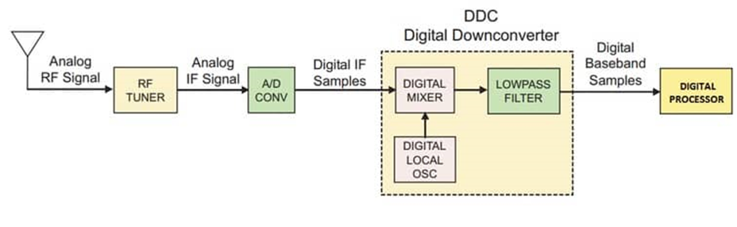

**Fig 1: Simplified Block Diagram of a Software Defined Radio Receiver**

Overall, SDR technology has revolutionized the way radio communication systems are designed and implemented. By replacing traditional hardware with software, SDR systems offer flexibility, re-configurability, and cost savings, while also maintaining high performance and reliability through quality hardware components.

**II. Literature Survey**

**What are SDRs?**

There are many different interpretations of how one defines a SDR. Some of these, as proposed by researchers in the field, include “Software Based Radio” [2], “Reconfigurable Radio” or “Flexible Architecture Radio” [3]. The definition of SDR according to the SDR Forum [4]: “SDR provides software control of a variety of modulation techniques, wideband or narrow band operation, communications security functions (such as hopping) and waveform requirements of current and evolving standards over a broad frequency range.”

**Structure and Operation of a Basic SDR receiver**

A Basic Block Diagram of SDR is in Fig 1. In an SDR system, the hardware typically consists of an antenna, a radio frequency (RF) front-end, an analog-to-digital converter (ADC), a digital down converter (DDC) and a Digital Signal Processor (DSP).

The RF front-end is responsible for tuning the radio signal to a specific frequency, filtering out unwanted signals, and amplifying the signal before it is digitized by the ADC. The ADC converts the analog radio signal into a digital signal that is passed through the DDC. Here, the digital signal is then converted to a lower frequency signal at a lower sampling rate. The resulting digital baseband signal can be then decoded or demodulated by the digital signal processing software to yield the audio signal.

The Fig 2 shows the schematic diagram of SDR receiver using Arduino Nano.

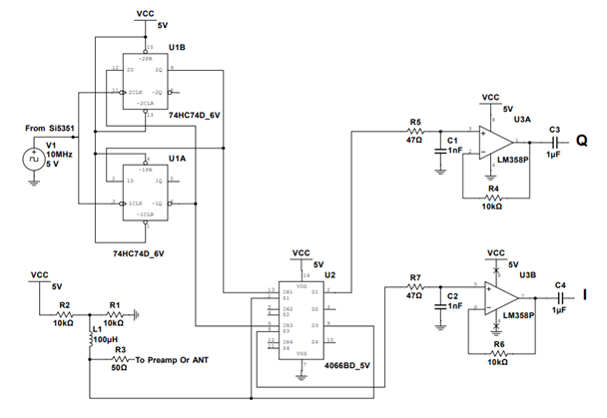

**Fig 2: Schematic Diagram of SDR Receiver using Arduino Nano**

**Benefits of SDRs**

SDRs thrive in the commercial market because of following benefits:

* Low Manufacturing Cost
* Flexibility
* Multi-functionality
* Compactness
* Ease of upgrades

**Applications of SDRs**

SDRs are commonly used in:

* Spectrum Monitoring
* Radar
* GPS/GNSS
* IOT
* Trading sector
* Medical sector
* Testing and measurement applications

**III. Hardware Realization**

**Components and Connections**

* **Arduino Nano:**

The Arduino Nano is microcontroller. It offers the same specs and robustness of Arduino Uno board, with the form factor being small.

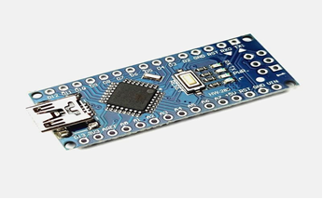

**Fig 3: Arduino Nano**

The Arduino Nano board was choosen for its compatibility with the Arduino ecosystem, allowing for a wide range of libraries and resources to be utilized in conjunction with the Si5351.

* **Si5351A:**

The Si5351A is a variable frequency oscillator that can be interfaced and programmed with Arduino boards. It can generate three different frequencies in the range of 2.5 KHZ to 200 MHZ consecutively. The Si5351A clock generator was selected for its high frequency accuracy and stability, ensuring precise timing control in the project, used as a local oscillator in project.

* **74HC74D IC:**

The 74HC74D flip-flop component was selected for its reliable and robust functionality, providing stable state storage and sequential logic capabilities, used as a 90° Phase shifter in circuit.

* **4066BD IC:**

4066BD analog switch provides a compact and reliable solution for routing and switching analog signals in the project, hence it is used as a mixer in circuit.

**LM358P IC:**

LM358P operational amplifier was selected due to its versatile and widely recognized functionality in various analog applications, used as a Low Pass Filter in circuit.

**Final Result:**

The following figures show the final project and output.

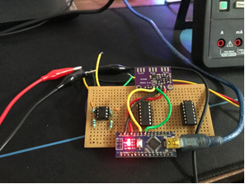

**Fig 5: Software Defined Radio receiver circuit**

Fig 5 shows the circuit of a SDR receiver circuit. Here:

* Si5351A clock generator is interfaced directly with arduino nano board. It is used as a local oscillator in project.
* Si5351A is then connected to the 74HC74D flip-flop component. 74HC74D is used as a 90° Phase shifter in circuit
* A 4066BD analog switch is used as a mixer in circuit. It provides a compact and reliable solution for routing and switching analog signals in the project.
* LM358P operational amplifier is used as a low pass filter, after which we get the final result.
* Fig 6 shows a digital oscilloscope. It is used to test the SDR receiver circuit output.

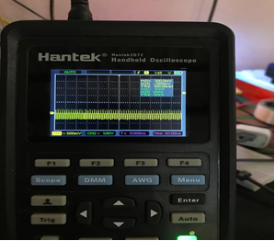

**Fig 6: Oscilloscope reading of the SDR output during testing of the circuit**

* Fig 7 shows the Waterfall diagram of the receiver, A Function Generator is used at 30 MHz to generate a temporary signal. Both devices are placed at a distance of 5 to 10 cm, and the output is as shown in the Waterfall diagram.

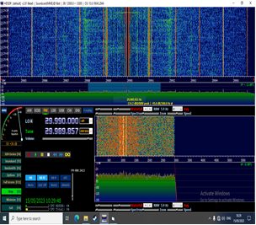

**Fig 7: Waterfall diagram of the received signal at a different frequency**

1. **Conclusion**

The concept of Software Defined Radio is one of the most important aspect of modern communication system infrastructure. One can argue that SDRs have become the de facto industry standard.

In this paper, we have attempted to put forward the importance of a SDR by pointing out the history, need, benefits and applications of SDRs, along with a hardware realization of a basic SDR receiver.

**References**

1. J. Mitola III, “Software radios - survey, critical evaluation and future directions,” in Telesyst. Conf., 1992. NTC-92., National, May 1992, pp. 13/15–13/23.
2. W. Tuttlebee, Software Defined Radio: Enabling Technologies. Chichester: Wiley, 2002.
3. P. B. Kenington, RF and Baseband Techniques for Software Defined Radio. Boston: Artech House, 2005.
4. Software Defined Radio Forum. (2007, Oct) SDR Forum. [Online]. Available: http://www.sdrforum.org