* **TITLE:** ‘COMPUTATIONAL FLUID DYNAMICS ANALYSIS OF HEAT TRANSFER ENHANCEMENT USING NOTCHED ARRAY CONFIGURATIONS’
* **AUTHORS: 1*.*** *Prof. Dr. Nafees Khan* , **2.** *Khwaja Izhar Ahmad ,* **3*.*** *Haris Khan ,* **4.** *Fazal Khan ,* **5.** *Pratik Hadke ,* **6.** *Manish Waghmare*
* **ABSTRACT:**  Many of the engineering applications are subjected to high temperature and thermal stresses. In order to cool those fins are used to dissipate the heat from the surfaces. Fins are generally used to increase the heat transfer rate from the system to the surroundings. By doing computational flow analysis of cooling fins, it is helpful to know about the heat dissipation rate. In this analysis, the fins are modified by putting different types of notches and are of same material. The proposed work is mainly focused on the Computational Fluid Dynamics. Analysis for various fin configurations &amp; the analysis of heat transfer coefficient for the notched fin array.
* **Keywords**: Computational Fluid Dynamics (CFD), Notched Fin Array, Heat Transfer rate, Heat Transfer Coefficient
* **INTRODUCTION :** Many times in actual practice we need to increase the rate of heat transfer from smaller areas, in such a cases we need to use the different types of fins. Use of fins also causes the reduction in the temperature driving forces in the system. The use of fins have multiple effects on the performance parameters of heat transfer & fluid flow like pressure drop & hear transfer coefficient. It is necessary to analyze the performance specifically the effect on heat transfer rate. In this project work the different types and combinations of notched fin arrays are analyzed with respect to the shape of notches such as rectangular notch, triangular notch, combination etc.

It is observed from the literature survey done, that the notched array combinations are used for the heat transfer enhancement in various applications. The notched array geometries are used for both the natural & forced convection. Due to its varied applications it is found necessary to analyze the notched array combinations by using simulation tool, as numerically there are no correlations available for it & experimental analysis is costly & time consuming both. The current work is focused on CFD simulations for analyzing the notched array application for heat transfer enhancement.

Objectives of the project work:

1.CFD analysis of plane rectangular fin array.

2.CFD analysis of notched fin array.

3.To validate CFD methodology results using experimental data.

4.To analyze the heat transfer enhancement for notched array

**CASE 1: CFD Simulation of Plain Rectangular Fins Array**

**Specifications of Plain Fin:**

**Geometry:**



Number of Fins: 11

Fin Material: Aluminium

Heat Flux: 100 V & 1.018 Amp

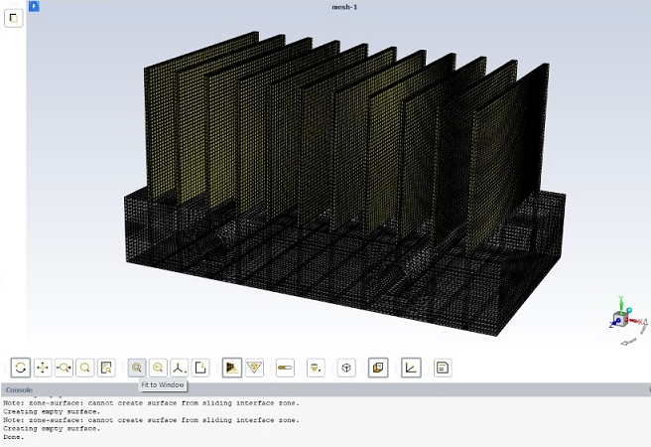

Figure 2: Geometry & Meshing of Plain Rectangular Fin Array

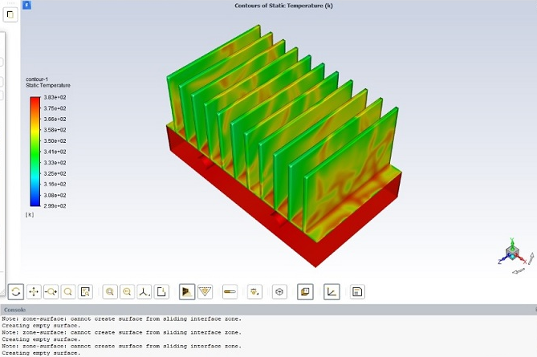

Figure 3: Static Temperature Contours of Plain Rectangular Fin Array

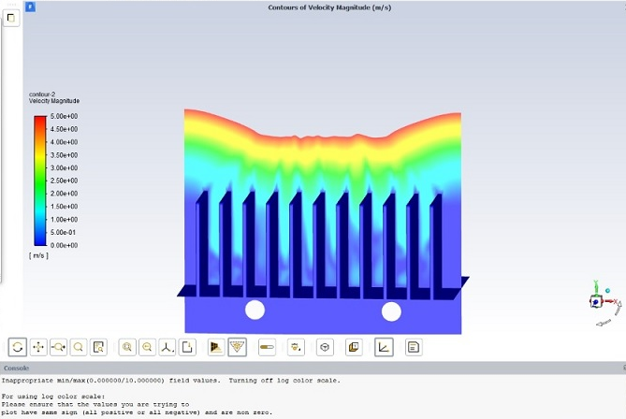

Figure 4: Velocity Contours of Plain Rectangular Fin Array

The CFD results are required to be compared with the experimental data & validated accordingly. After validation of CFD model it can further be applied to the other combinations of notched fin array having triangular notch, square notch, combination of triangular notch & square notch.

* **Calculations for experimentation:**

Voltage (V) = 100 Volts, Current (I) = 1.018 Amp

Heat Flux (Q) = VI = 101.8 W

Heat loss in conduction = Qcond = 0.25 x Q = 25.45 W

Heat transfer by convection = Qconv = Q – Qcond = 76.35 W

Average exposed area for heat transfer = A = 0.0906 m2

Ambient temperature = Tambient = 24oC

Average temperature = Taverage = 111 oC

By Newtons Law of Cooling = Qconv = havg x A x (Taverage - Tambient)

Average Heat transfer coefficient = havg = Qconv / A x (Taverage - Tambient)

havg = 9.68 W/m2K

* **Calculations for CFD model:**

Voltage (V) = 100 Volts, Current (I) = 1.018 Amp

Heat Flux (Q) = VI = 101.8 W

Heat loss in conduction = Qcond = 0.25 x Q = 25.45 W

Heat transfer by convection = Qconv = Q – Qcond = 76.35 W

Average exposed area for heat transfer = A = 0.0906 m2

Ambient temperature = Tambient = 24oC

Average temperature = Taverage = 104 oC

By Newtons Law of Cooling = Qconv = havg x A x (Taverage - Tambient)

Average Heat transfer coefficient = havg = Qconv / A x (Taverage - Tambient)

havg = 10.53 W/m2K

By comparison of the results from CFD analysis with the experimental results it is found that the percentage errors in average temperature & heat transfer coefficients are as follows;

The percentage error in Taverage = 6.3 %

The percentage error in havg = 8.045 %

As the percentage errors in the heat transfer parameters are well below the acceptable range of 15% to 20%, the CFD model is validated.

The same CFD model can further be applied to the combination of various notched array for carrying out the analysis.

**CASE 2: CFD Analysis of Rectangular Fins Array with Triangular Notch**

**Specifications of Triangular Notch Fin:**

**Geometry:**

** **

Number of Fins: 11

Fin Material: Aluminium

Heat Flux: 100 V & 1.018 Amp

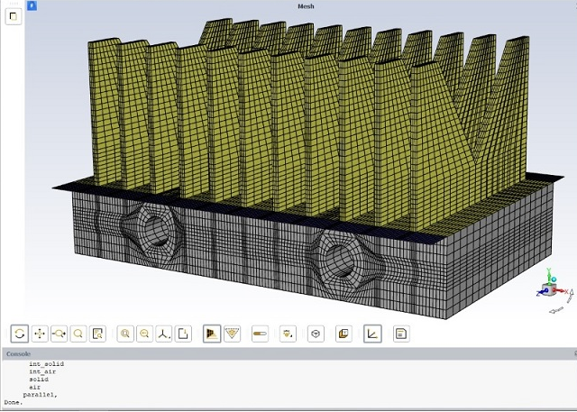

Figure 6: Geometry & Meshing of Triangular Notched Fin Array

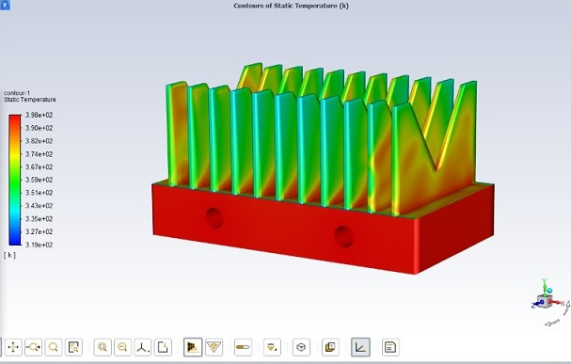

Figure 7: Static Temperature Contours of Triangular Notched Fin Array

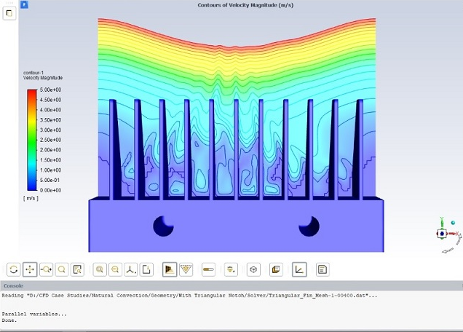

Figure 8: Velocity Contours of Triangular Notched Fin Array

* **RESULTS & DISCUSSIONS**

Results for various cases are as tabulated below:

**Table 1: (Case 1) Plain Rectangular Fins Array**

|  |  |  |  |
| --- | --- | --- | --- |
| Tavg (oC)  (Experimental) | Tavg (oC)  (CFD Analysis) | havg (W/m2K)  (Experimental) | havg (W/m2K)  (CFD Analysis) |
| 111 | 104 | 9.68 | 10.53 |
| % error in Tavg: 6.73 % | | % error in havg: 8.04 % | |

**Table 2: (Case 2) Rectangular Fins Array with Triangular Notch**

|  |  |  |  |
| --- | --- | --- | --- |
| Tavg (oC)  (Experimental) | Tavg (oC)  (CFD Analysis) | havg (W/m2K)  (Experimental) | havg (W/m2K)  (CFD Analysis) |
| 118 | 114 | 11.17 | 11.66 |
| % error in Tavg: 3.50% | | % error in havg: 4.25% | |

* **CONCLUSION:**

Experimental & CFD analysis is carried out for the rectangular fins with various notch configurations & also for a combination with alternate arrangement. CFD analysis using ANSYS Fluent is carried out to study the temperature distribution and to visualize the flow distribution with velocity profiles across the fins. The CFD results for average temperature & average heat transfer coefficient are in close agreement with the experimental results & the percentage error in the CFD results are well within acceptable limits of 15 to 20 %, with an actual range of 1.5 % to 10 % & hence validated.