# ANALYSIS AND DESIGN OF HIGH-RISE (G +12) BUILDING USING STAAD PRO

Dr. PUSALA KODANDA RAMA RAO1, KOPPULA SIVA RAMA KRISHNA REDDY2, POLAGANI TEJ SAI3, MATHANGI BHARAT KUMAR4, MURARI NAVEEN KUMAR5, PAMARTHI VARUN6

*1(CIVIL ENGINEERING, SR GUDLAVALLERU ENGINEERING COLLAGE, INDIA)*

*2(CIVIL ENGINEERING, SR GUDLAVALLERU ENGINEERING COLLAGE, INDIA)*

*3(CIVIL ENGINEERING, SR GUDLAVALLERU ENGINEERING COLLAGE, INDIA)*

*4(CIVIL ENGINEERING, SR GUDLAVALLERU ENGINEERING COLLAGE, INDIA)*

*5(CIVIL ENGINEERING, SR GUDLAVALLERU ENGINEERING COLLAGE, INDIA)*

*6(CIVIL ENGINEERING, SR GUDLAVALLERU ENGINEERING COLLAGE, INDIA)*

*KOPPULA SIVA RAMA KRISHNA REDDY:* [*21485A0119@GECGUDLAVALLERUMIC.IN*](mailto:21485A0119@GECGUDLAVALLERUMIC.IN)

# ABSTRACT:

High rise building is the most frequently used word in all most all construction activities especially in rapidly growing cities in terms of development and population.

National Building Code (NBC) defines a high-rise as “All buildings 15 m or above in height (a building more than 4 storeys).

The employment opportunities and facilities offered by the developing cities makes people to migrate towards urban areas which create the land scarcity for both Industrial and residential occupants. To satisfy the needs considering the future demand of habitable area and efficient use of land without expanding the boundaries of the cities makes people to choose high rise building it also facilitates with stunning views less noise pollution etc.

STAAD is a popular structural analysis application known for analysis, diverse applications of use, Interoperability, and time-saving capabilities. STAAD helps structural engineers perform 3D structural Analysis and design for both steel and concrete structures. It ensures on-time and cost-effective Completion of steel, concrete, timber, aluminium, and cold-formed steel structures and designs, Regard less of complexity.

We conclude that in this study we consider plot area 70 m x 24 m of g+12 Building consisting of 72 flats located kesarapalli near vijayawada Located in zone 3. we are going to analyse the high rise building for shear force and bending moments and design of critical sections of slab staircase footing by considering various loads such as with and without wind load, imposed load, dead loads.

**Keywords**: high rise building, wind load, STAAD pro

# INTRODUCTION

Now a days tall or multi-storey buildings has gain very much importance, because in metro cities there is a rapid increase in population with limited land. All people require good accommodations, aesthetic, comfort and safety. Thats the reason for increase in construction of multi-storey buildings.

Structural design of multi-storey buildings is basically worried with safety during ground motion, serviceability what’s more, potential for monetary misfortune. Design of structures using Limit State method Design the members are designed for the limiting bending moment and serviceability limits, hence the structures are left with minimum reserve energy. Earthquake will cause more severe effect on tall buildings compare to small buildings. Due to earthquake asymmetrical buildings will damage more than symmetrical buildings. In case of high-rise structures horizontal loads produce develop high lateral displacements which is not desirable for the occupants and the structure itself.

The enormous increase in population and scarcity of land makes the people to move from rural areas to urban paces and construction of multi-storied buildings in small areas is being common now-a-days. Functional designing of the building has become very important and the requirements vary from one building to another. Every Civil Engineer should know the usage of the buildings by contacting the people and basic principles of designing of the R.C.C structures. This is project is intended at Analysing and designing the multi-storey structure using STAAD. PRO V8i and STAAD. ETC. In this project, we adopted limit state method of analysis and design the structural members manually and using STAAD.PRO.V8i and STAAD.ETC. Manually design is done for particular beam, column and slab by using IS456:2000 and loads are dead load, imposed load and external load considered according to IS 875:1987 (PART III). It is then checked in STAAD.PRO.V8i and STAAD.

Few standard problems also have been solved to show how STAAD. Pro can be used in different cases. These typical problems have been solved using basic concept of loading, analysis, condition as per IS code. These basic techniques may be found useful for further analysis of problems.

**OBJECTIVES**

1.To analyse the multi-storey high-rise building consists of 12 floors using STAAD Pro.

2.To obtain the results of Maximum shear force and Maximum bending Moment for beams, Maximum axial force for columns and beams.

3.To design the critical structural members of beam, column, slab, footing and staircase using IS 456-2000 & SP-16.

# LITERATURE REVIEW

* Ibrahim, et.al (April 2019)1: Design and Analysis of Residential Building(G+4): After analysing the G+4 story residential building structure, conducted that the structure is rate in loading like dead load, live load, wind load and seismic loads. Member dimensions (Beam, column, slab) are assigned by calculating the load type and its quantity applied on it. Auto CAD gives detailed information at the structure members length, height, depth, size and numbers, etc. STADD Pro. has a capability to calculate the program contains number of parameters which are designed as per IS 456: 2000. Beams were designed for flexure, shear and tension and it gives the detail number, position and spacing breif..
* Dunnala Lakshmi Anuja, et.al (2019)2: Planning, Analysis and Design of Residential Building(G+5) By using STAAD Pro: Frame analysis was by STAAD-Pro. Slab, Beams, Footing and stair-case were design as per the IS Code 456-2000 by LSM. The properties such as share deflection torsion, development length is with the IS code provisions. Design of column and footing were done as per the IS 456-2000 along with the SP-16 design charts. The check like oneway shear or two-way shear within IS Code provision. Design of slab, beam, column, rectangular footing and staircase are done with limit state method. On comparison with drawing, manual design and the geometrical model using STADD Pro. 3

Mr K. Prabin Kumar, et.al (2018)3: A Study on Design of Multi-Storey Residential Building: They used STADD Pro. to analysis and designing all structure member and calculate quantity of reinforcement needed for concrete section. Various structure action is considered as members such as axial, flexure, shear and tension. Pillar are delineated for axial forces and biaxial ends at the ends. The building was planned as per IS: 456- 2000

* Deevi Krishna Chaitanya, et.al (January, 2017)4: Analysis and Design of a (G+6) Multi-Storey Building Using STAAD Pro: They used static indeterminacy methods to calculate numbers of unknown forces. Distributing known fixed and moments to satisfy the condition of compatibility by Iteration method. Kanis method was used to distribute moments at sucessire joints in frame and continues beam for stability of members of building structure. They used the designing software STADD Pro. which reduced lot of time in design, gives accuracy.
* R. D. Deshpande, et.al (June, 2017)5: Analysis, Design and Estimation of Basement+G+2 Residential Building: They found that check for deflection was safe. They carried design and analysis of G+2 residential building by using E-Tabs software with the estimation of building by method of center line. They safely designed column using SP-16 checked with interaction formula.

# DETAILS OF THE PROJECT:

1. Type of Building - G+12 HIGH-RISE residential building
2. Number of storey -12 storeys
3. Types of foundation - Pile foundation
4. Height of building **-** 24 m from G.L
5. Total gross area of the building - 1670 sq.m
6. Column Size - 1200X300 mm,

1000X300 mm,

800X300 mm,

600X300 mm &

500X300 mm

1. Beam Size - 300X630 mm

300X500 mm

1. Interior wall thickness – 230 mm
2. Exterior wall thickness – 300 mm
3. Storey height – 3 m
4. Number of flats per storey – 12
5. Total number of flats –144

13 Name of the building – Hemadurga realtors

14. Location – Kesarapalli, Vijayawada

**PLAN:**

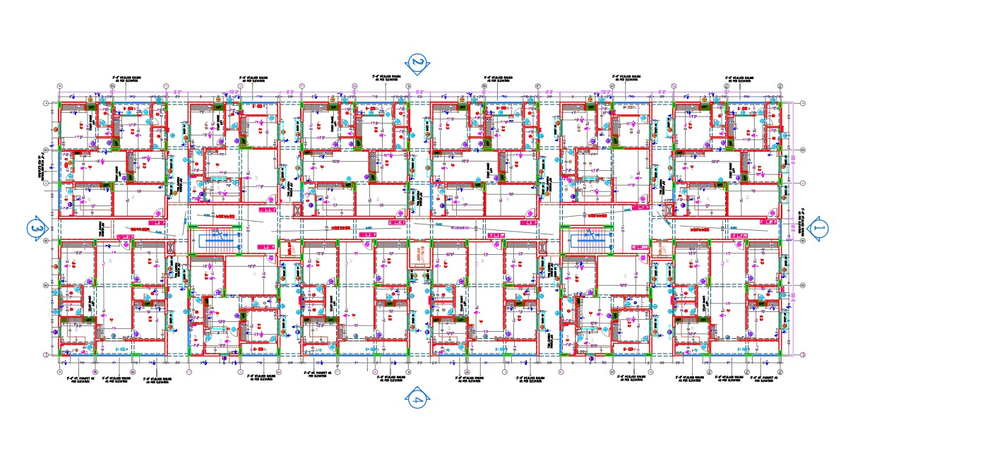

**BEAM COLUMN LAYOUT:**

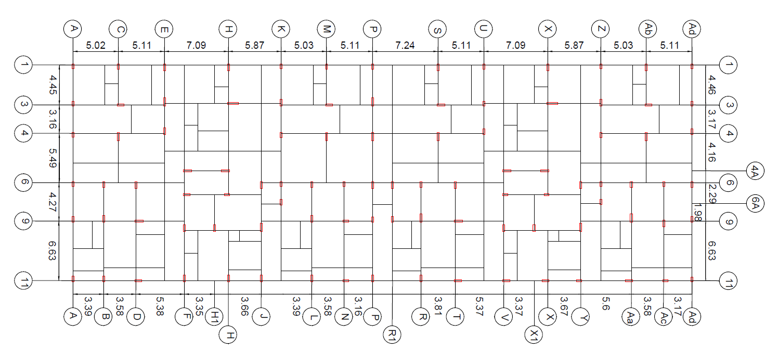

1. **ANALYSIS AND DESIGN USING STAAD PRO**

The following are the major steps for obtaining results for staad pro

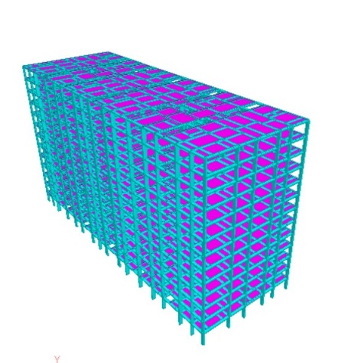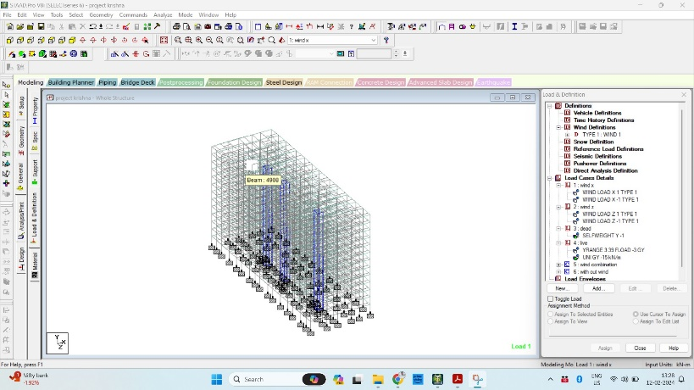**Step 1: CREATION OF PANEL**

**Step 2: ASSIGNING SUPPORTS**

**Step 3: ASSIGNING LOADS & COMBINATIONS**

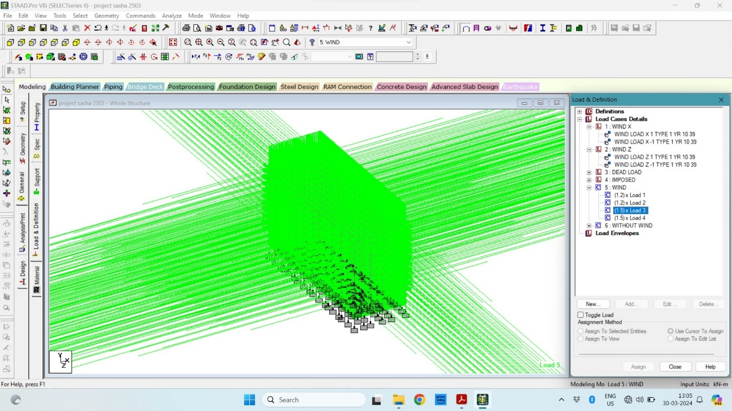

DEAD LOAD: 9 KN/m, LIVE LOAD: 18 Kn/m

WIND LOAD: 2 KN/m at the top of the building

1. **ANALYSIS RESULTS:**

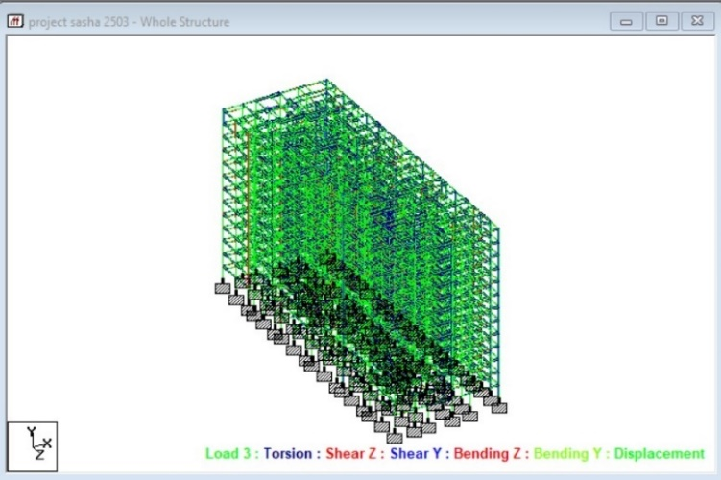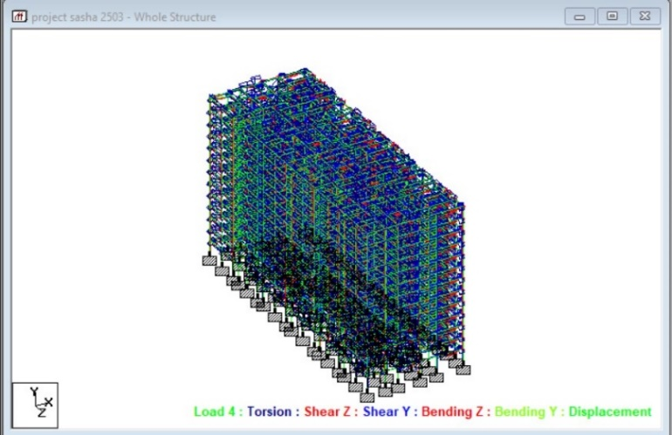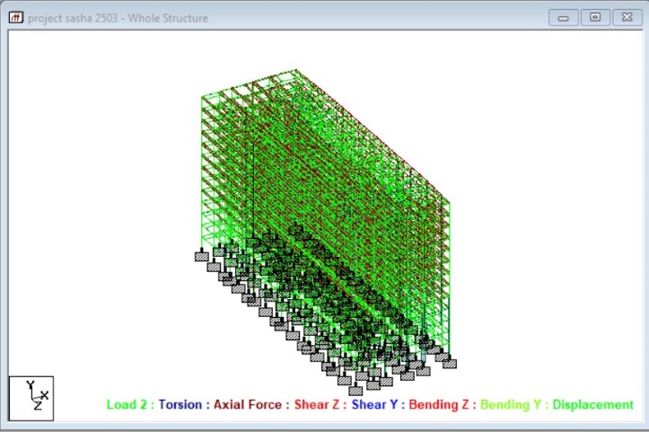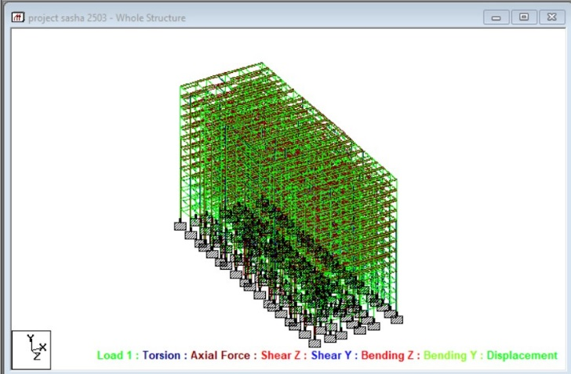

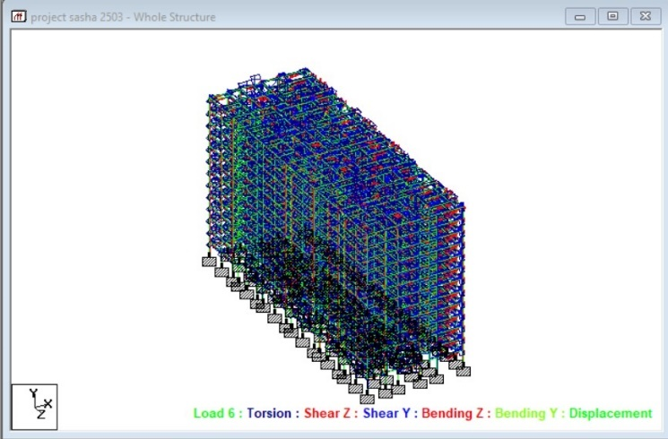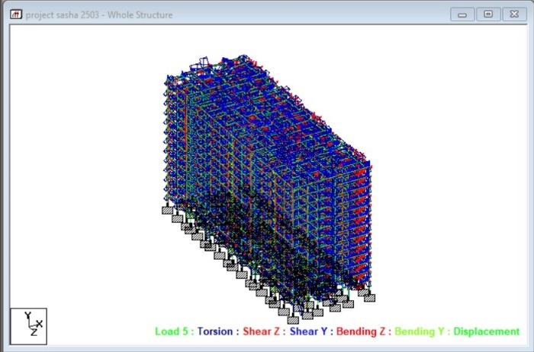

**BEAM MAXIMUM MOMENTS:**

**TABLE NO. 1:** BEAM MAXIMUM BENDING MOMENTS

|  |  |  |  |  |  |  |  |  |
| --- | --- | --- | --- | --- | --- | --- | --- | --- |
| **L/C** | **Beam** | **Node A** | **Length**  (m) |  | **d**  (m) | **Max My**  (kNm) | **d**  (m) | **Max Mz**  (kNm) |
| 5:WIND | 347 | 2 | 3.000 | Max +ve | 3.000 | 41.538 |  |  |
|  |  |  |  | Max -ve | 0.000 | -19.822 | 3.000 | -3.808 |
|  | 348 | 3 | 3.000 | Max +ve | 3.000 | 6.638 | 3.000 | 24.326 |
|  |  |  |  | Max -ve | 0.000 | -4.917 | 0.000 | -15.674 |
|  | 349 | 4 | 3.000 | Max +ve | 3.000 | 33.665 | 3.000 | 19.292 |
|  |  |  |  | Max -ve | 0.000 | -13.998 | 0.000 | -12.481 |
|  | 350 | 5 | 3.000 | Max +ve | 3.000 | 14.212 | 0.000 | 4.027 |
|  |  |  |  | Max -ve | 0.000 | -4.423 | 3.000 | -14.061 |
|  | 351 | 6 | 3.000 | Max +ve | 3.000 | 7.436 | 3.000 | 30.977 |
|  |  |  |  | Max -ve |  |  | 0.000 | -17.980 |
|  | 352 | 7 | 3.000 | Max +ve | 3.000 | 14.403 | 0.000 | 17.034 |
|  |  |  |  | Max -ve | 0.000 | -7.906 | 3.000 | -39.295 |
|  | 353 | 8 | 3.000 | Max +ve | 0.000 | 9.981 | 3.000 | 16.237 |
|  |  |  |  | Max -ve | 3.000 | -22.230 | 0.000 | -10.643 |
|  | 354 | 11 | 3.000 | Max +ve | 0.000 | 2.473 |  |  |
|  |  |  |  | Max -ve | 3.000 | -4.959 | 3.000 | -22.891 |
|  | 355 | 12 | 3.000 | Max +ve | 0.000 | 16.243 | 3.000 | 69.242 |
|  |  |  |  | Max -ve | 3.000 | -22.931 | 0.000 | -40.226 |
|  | 356 | 16 | 3.000 | Max +ve | 3.000 | 14.613 |  |  |
|  |  |  |  | Max -ve | 0.000 | -5.294 | 3.000 | -3.085 |
|  | 357 | 17 | 3.000 | Max +ve | 0.000 | 13.540 | 3.000 | 31.821 |
|  |  |  |  | Max -ve | 3.000 | -11.110 | 0.000 | -18.058 |
|  | 358 | 18 | 3.000 | Max +ve | 3.000 | 2.182 | 0.000 | 38.164 |
|  |  |  |  | Max -ve | 0.000 | -1.440 | 3.000 | -97.001 |
|  | 359 | 27 | 3.000 | Max +ve | 0.000 | 16.670 |  |  |
|  |  |  |  | Max -ve | 3.000 | -35.212 | 0.000 | -2.557 |
|  | 360 | 28 | 3.000 | Max +ve | 0.000 | 17.023 | 3.000 | 22.243 |
|  |  |  |  | Max -ve | 3.000 | -31.580 | 0.000 | -13.876 |
|  | 361 | 35 | 3.000 | Max +ve | 0.000 | 6.536 |  |  |
|  |  |  |  | Max -ve | 3.000 | -11.946 | 3.000 | -11.576 |
|  | 362 | 36 | 3.000 | Max +ve | 0.000 | 15.992 | 3.000 | 40.458 |
|  |  |  |  | Max -ve | 3.000 | -2.239 | 0.000 | -22.998 |
|  | 363 | 37 | 3.000 | Max +ve | 0.000 | 0.720 | 0.000 | 43.779 |
|  |  |  |  | Max -ve | 3.000 | -2.234 | 3.000 | -129.576 |
|  | 364 | 43 | 3.000 | Max +ve | 0.000 | 8.651 | 0.000 | 3.555 |
|  |  |  |  | Max -ve | 3.000 | -14.143 | 3.000 | -12.261 |
|  | 365 | 52 | 3.000 | Max +ve | 3.000 | 23.322 | 3.000 | 3.208 |
|  |  |  |  | Max -ve | 0.000 | -10.667 | 0.000 | -3.997 |
|  | 366 | 97 | 3.000 | Max +ve | 0.000 | 12.476 | 3.000 | 14.406 |
|  |  |  |  | Max -ve | 3.000 | -15.070 | 0.000 | -10.654 |
|  | 367 | 101 | 3.000 | Max +ve | 3.000 | 77.721 | 3.000 | 20.897 |
|  |  |  |  | Max -ve | 0.000 | -21.172 | 0.000 | -14.319 |
|  | 368 | 104 | 3.000 | Max +ve | 3.000 | 4.929 | 0.000 | 15.596 |
|  |  |  |  | Max -ve | 0.000 | -2.704 | 3.000 | -55.479 |
|  | 369 | 116 | 3.000 | Max +ve | 3.000 | 30.253 | 3.000 | 19.073 |
|  |  |  |  | Max -ve | 0.000 | -15.247 | 0.000 | -12.631 |
|  | 370 | 118 | 3.000 | Max +ve | 3.000 | 26.064 | 3.000 | 34.142 |
|  |  |  |  | Max -ve | 0.000 | -12.655 | 0.000 | -87.948 |

**BEAM MAXIMUM SHEAR FORCES:**

**TABLE NO.2:** BEAM MAXIMUM SHEAR FORCE

|  |  |  |  |  |  |  |  |  |
| --- | --- | --- | --- | --- | --- | --- | --- | --- |
| **L/C** | **Beam** | **Node A** | **Length**  (m) |  | **d**  (m) | **Max Fz**  (kN) | **d**  (m) | **Max Fy**  (kN) |
| 5:WIND | 347 | 2 | 3.000 | Max +ve | 0.000 | 20.453 | 0.000 | 0.992 |
|  |  |  |  | Max -ve |  |  |  |  |
|  | 348 | 3 | 3.000 | Max +ve | 0.000 | 3.852 |  |  |
|  |  |  |  | Max -ve |  |  | 0.000 | -13.333 |
|  | 349 | 4 | 3.000 | Max +ve | 0.000 | 15.887 |  |  |
|  |  |  |  | Max -ve |  |  | 0.000 | -10.591 |
|  | 350 | 5 | 3.000 | Max +ve | 0.000 | 6.212 | 0.000 | 6.029 |
|  |  |  |  | Max -ve |  |  |  |  |
|  | 351 | 6 | 3.000 | Max +ve | 0.000 | 2.161 |  |  |
|  |  |  |  | Max -ve |  |  | 0.000 | -16.319 |
|  | 352 | 7 | 3.000 | Max +ve | 0.000 | 7.437 | 0.000 | 18.776 |
|  |  |  |  | Max -ve |  |  |  |  |
|  | 353 | 8 | 3.000 | Max +ve |  |  |  |  |
|  |  |  |  | Max -ve | 0.000 | -10.737 | 0.000 | -8.960 |
|  | 354 | 11 | 3.000 | Max +ve |  |  | 0.000 | 3.413 |
|  |  |  |  | Max -ve | 0.000 | -2.477 |  |  |
|  | 355 | 12 | 3.000 | Max +ve |  |  |  |  |
|  |  |  |  | Max -ve | 0.000 | -13.058 | 0.000 | -36.489 |
|  | 356 | 16 | 3.000 | Max +ve | 0.000 | 6.636 | 0.000 | 0.929 |
|  |  |  |  | Max -ve |  |  |  |  |
|  | 357 | 17 | 3.000 | Max +ve |  |  |  |  |
|  |  |  |  | Max -ve | 0.000 | -8.217 | 0.000 | -16.626 |
|  | 358 | 18 | 3.000 | Max +ve | 0.000 | 1.207 | 0.000 | 45.055 |
|  |  |  |  | Max -ve |  |  |  |  |
|  | 359 | 27 | 3.000 | Max +ve |  |  |  |  |
|  |  |  |  | Max -ve | 0.000 | -17.294 | 0.000 | -0.030 |
|  | 360 | 28 | 3.000 | Max +ve |  |  |  |  |
|  |  |  |  | Max -ve | 0.000 | -16.201 | 0.000 | -12.040 |
|  | 361 | 35 | 3.000 | Max +ve |  |  | 0.000 | 2.638 |
|  |  |  |  | Max -ve | 0.000 | -6.161 |  |  |
|  | 362 | 36 | 3.000 | Max +ve |  |  |  |  |
|  |  |  |  | Max -ve | 0.000 | -6.077 | 0.000 | -21.152 |

## **DESIGN DETAILS**

### BEAMS &COLUMNS DESIGN SUMMARY

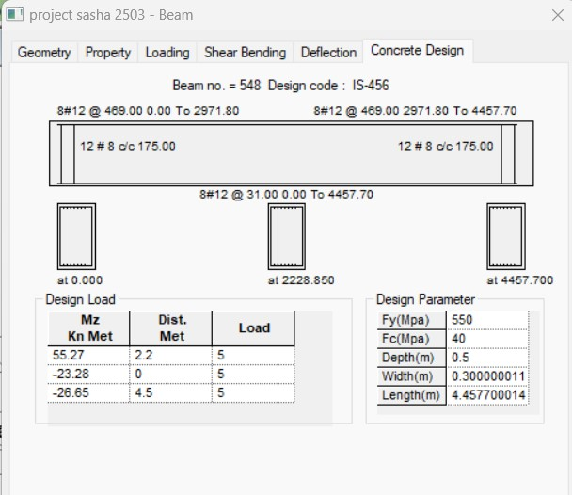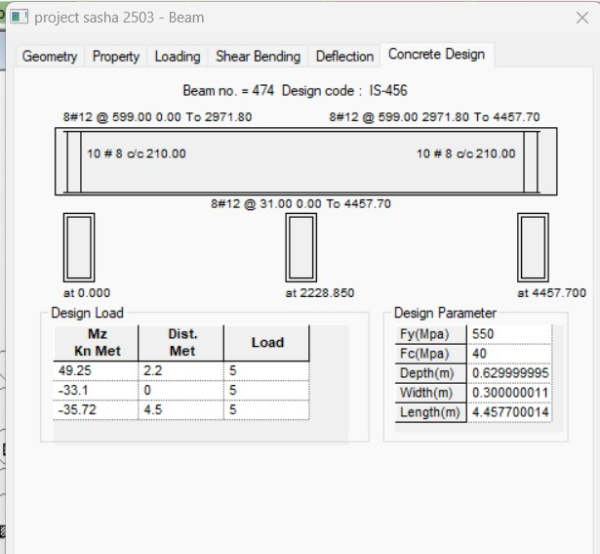

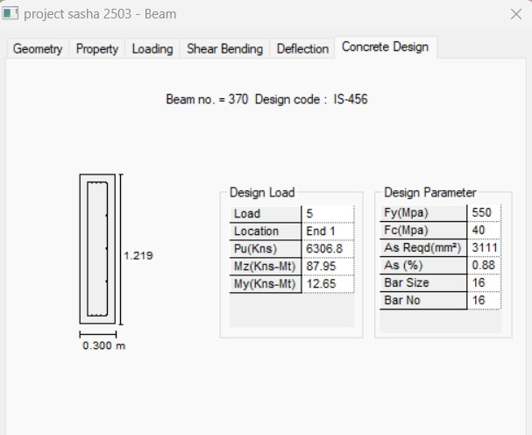

## **COMPARISION**

|  |  |  |  |  |  |  |  |  |  |
| --- | --- | --- | --- | --- | --- | --- | --- | --- | --- |
|  |  |  | **STAAD PRO DESIGN** | | | **MANUAL DESIGN** | | |  |
| **S. No** | **MEMBER TYPE** | **SIZE OF**  **MEMBER**  **mm** | **ɸ OF BAR**  **mm** | **No. OF BARS** | **Ast**  **mm2** | **ɸ OF BAR**  **mm** | **No. OF BARS** | **Ast**  **mm2** | **%** |
| 1 | COLUMN | 1200x300 | 12 | 20 | 3770 | 20 | 12 | 3600 | 5 |
| 2 |  | 900x300 | 12 | 16 | 2415 | 20 | 9 | 2700 | -11 |
| 3 |  | 760x300 | 12 | 12 | 1360 | 20 | 9 | 2280 | -40 |
| 4 |  | 600x300 | 12 | 12 | 1360 | 16 | 10 | 1800 | -25 |
| 5 |  | 530x300 | 12 | 12 | 1360 | 16 | 8 | 1590 | -15 |
| 6 | BEAM | 300x630 | 8 | 12 | 900 |  |  | 810 | 12 |
| 7 |  | 300x500 | 8 | 12 | 900 |  |  | 810 | 12 |
| 8 | SLAB | 5000x4600 |  |  | 1065 |  |  | 839 | 25 |
| 9 | STAIR CASE | 1200x4740 |  |  | 864 |  |  | 1240 | -40 |

**NOTE:**

**+** sign indicates **STAAD** **PRO VALUE > MANUAL VALUE**

**-** sign indicates **STAAD** **PRO VALUE < MANUAL VALUE**

## **CONCLUSIONS**:

1. By Using STADD Pro., analysis and design of multistorey building is easier and quick process than manual process.
2. Proposed size of the beam and column can be safely used in the structure.
3. The structure is safe in shear bending and deflection.
4. There is no hazardous effect on the structure due to wind load on the structure.
5. The proposed structure is stable and structurally defined using various loads and combination.
6. The deflection value is more in WL (Wind Load) condition.
7. The area of steel reinforcement Ast various from -40% to 25%.
8. To know the behavior of the structure by applying various loads like dead load, live load, wind load and seismic load by using staad.pro. And also find out the Shear forces, displacement, bending and reactions of structure.
9. By using staad pro, we performed dynamic analysis. So that, the results obtained in Staad pro is more effective as compared to analysis and design performed by theoretical method.
10. **REFERENCES:**
11. Limit State Design of Reinforced concrete, B.C. Punmia, Ashok Kumar Jain and Arun Kumar Jain, 2007, Laxmi Publications.
12. Design of Reinforced concrete Structures, S. Ramamrutham and R.Narayana, Dhanpat Rai publishing Co (P) Ltd.
13. Theory of structures by Dr. S. Ramamrutham and R. Narayan, Dhanpat Rai Publications.
14. Design and Analysis of Residential Building(G+4), Ibrahim, et.al (April 2019).
15. IS:456-2000:- Indian Standard PLAIN AND REINFORCED CONCRETE- CODE OF

PRACTICE (Fourth Revision).

6.15-875(PART-1):-1987 Indian Standard CODE OF PRACTICE FOR DESIGN LOADS (OTHER THAN EARTHQUAKE) FOR BUILDINGS AND STRUCTURES PART I DEAD LOADS-UNIT WEIGHTS OF BUILDING MATERIALS AND STORED MATERIALS.

1. IS-875(PART-2): 1987 Indian Standard CODE OF PRACTICE FOR DESIGN LOADS (OTHER THAN EARTHQUAKE) FOR BUILDINGS AND STRUCTURES PART 2 IMPOSED LOADS.
2. SP-16: DESIGN AIDS FOR REINFORCED CONCRETE TO IS: 456-1978
3. Indian Standard CODE OF PRACTICE FOR DESIGN AND CONSTRUCTION OF PILE FOUNDATIONS PART II UNDER-REAMED PILES (First Revision) IS: 2911 (Part III)-1980.