**A Comprehensive Web-Based Solution Using Django Framework and SQLite Database**

Alan C Mathew1 , Akshay Suresh2 , Amal Mathew Biju3, Sheril Shaji4, Betty Mary Jacob5

*1234UG Scholar, 5Assistant Professor*

*1,2,3,4,5Department of Computer Science and Engineering*

*1,2,3,4,5St. Thomas College of Engineering & Technology, Chengannur, Kerala, India*

|  |
| --- |
| ***Abstract:*** *In* *today's competitive job market, universities play a crucial role in preparing students for successful careers. A well-designed placement cell website serves as a vital bridge between students and potential employers, facilitating seamless communication and fostering employment opportunities. This paper presents the abstract of such a website, aimed at enhancing student employability. The placement cell website offers a user-friendly interface, providing students with easy access to a myriad of resources such as job listings, internship opportunities, and career guidance materials. Employers, on the other hand, can efficiently browse through student profiles and post job openings, creating a dynamic ecosystem for talent acquisition. The website incorporates tools for interview preparation, and skill assessment, empowering students to present themselves effectively in the job market. Furthermore, the website alerts students with relevant job opportunities based on their qualifications and preferences. This personalized recommendation system enhances the efficiency of the job search process, increasing the likelihood of successful placements. To foster collaboration between academia and industry, the website facilitates communication between students, alumni, faculty members, and potential employers through forums, webinars, and networking events. This collaborative environment promotes knowledge sharing, mentorship, and professional development, ultimately enriching the overall student experience.*  ***Key Word****:**College Placement, Digital Solution, Automation, Django, SQLite, Student Engagement, Mock Tests.* |

1. **INTRODUCTION**

In the contemporary landscape of employment, the symbiotic relationship between educational institutions and the professional realm underscores the significance of effective placement mechanisms. This paper introduces a pioneering placement cell website tailored to augment student employability. Serving as a pivotal bridge between aspiring graduates and prospective employers, the platform embodies a multifaceted approach to career advancement.

At its core, the website offers a user-centric interface, facilitating seamless access to a diverse array of resources and support services. Through personalized profiles, students can showcase their skills and experiences, while employers can peruse job listings and connect with potential talent. Leveraging sophisticated algorithms, the platform provides tailored recommendations, optimizing the match between students and job opportunities.

Moreover, the website fosters a collaborative ecosystem by nurturing interactions among students, alumni, faculty, and industry professionals. Through forums, webinars, and networking events, it cultivates a culture of mentorship and knowledge exchange, bolstering the professional development of individuals.

By amalgamating technological innovation with a human-centric approach, this placement cell website endeavours to empower students with the tools, guidance, and networks necessary to navigate the dynamic landscape of the contemporary job market with confidence and efficacy.

1. **SYSTEM ARCHITECTURE**

Website is built upon a robust architecture utilizing the Django web framework and SQLite database, offering scalability, flexibility, and ease of development. The system architecture encompasses:

1. Model-View-Template (MVT) design pattern.
2. Django apps for modularization and code organization.
3. ORM layer for seamless interaction with the SQLite database.
4. Integration of third-party libraries and APIs for extended functionality.

**Django Framework**

Django is a high-level Python web framework that encourages rapid development and clean, pragmatic design. It provides a robust set of tools and libraries for building web applications efficiently. In the context of WEB'Q, Django serves as the backbone of the system, handling various aspects such as URL routing, database interaction, authentication, and template rendering.

**Model-View-Controller (MVC) Architecture**

Django follows the Model-View-Controller (MVC) architectural pattern, although in Django terminology, it's often referred to as Model-View-Template (MVT). This architecture separates the application logic into three interconnected components:

1. *Model*: Models represent the data structure of the application. In WEB'Q, Django's Object-Relational Mapping (ORM) maps the application's data models to the SQLite database tables. Each module (Placement Officer, Staff, Student, Company) has its own set of models representing entities such as users, companies, job postings, and applications.
2. *View*: Views contain the logic for processing user requests and generating responses. In WEB'Q, views are implemented as Django views, which handle HTTP requests and return HTTP responses. Views interact with models to retrieve or manipulate data and render templates to produce HTML output.
3. *Template*: Templates are used to generate HTML pages dynamically. Django's template engine allows developers to write HTML templates with embedded Python code, enabling the presentation layer to be separated from the application logic. Templates in WEB'Q are used to create user interfaces for different modules, including login pages, profile views, job listings, and application forms.

**Database Management with SQLite**

SQLite is a lightweight, serverless relational database management system that is well-suited for small to medium-sized web applications. SQLite serves as the backend database for storing and retrieving data related to users, companies, job postings, applications, and other entities. Django's ORM abstracts the database access layer, allowing developers to work with high-level Python objects rather than writing raw SQL queries. This simplifies database management and enhances portability, as SQLite databases are self-contained and can be easily migrated across different environments.

**Application Structure**

The application structure in Django follows a convention-over-configuration approach, where developers adhere to predefined naming conventions and directory structures to organize their code effectively. The application is divided into several Django apps, each responsible for a specific functional area or module (e.g., authentication, placement officer, staff, student, company). This modular structure promotes code reusability, maintainability, and scalability.

**Integration of Third-Party Libraries and APIs**

Django allows seamless integration of third-party libraries and APIs to extend the functionality of web applications. In website, various third-party packages may be utilized for tasks such as user authentication (e.g., Django Allauth), email notifications (e.g., Django SMTP), and data visualization (e.g., Django Chart.js). Additionally, APIs may be integrated to enable features such as geolocation-based job searches or integration with external assessment platforms for mock tests.

1. **FUNCTIONALITIES**

This paper presents a detailed exploration of the functionalities embedded within website, a sophisticated web-based platform designed to revolutionize college placement cell management. Tailored for placement officers, staff, students, and companies, website offers a comprehensive suite of features aimed at streamlining processes, fostering transparency, and enhancing engagement among stakeholders.

**Placement Officer Module**

1. *Company Approval*: Placement officers can review and approve companies seeking to conduct placements on campus, ensuring alignment with institutional standards.
2. *Job Posting Management:* Placement officers can create, modify, and remove job postings, effectively disseminating opportunities to students.
3. *Application Review:* Placement officers have access to a centralized dashboard for reviewing job applications, facilitating efficient processing and decision-making.

**Fig. 1** TPO Profile

Login

View Companies

Approve Company

View Students

Logout

View Staffs

**Staff Module**

1. *Data Entry*: Staff members can enter and update placement-related data, ensuring accuracy and completeness of information.
2. *Report Generation*: Staff members can generate comprehensive reports on placement statistics, company engagement, and student performance to inform decision-making.
3. *Communication* *Tools*: Staff members have access to communication tools such as email templates and messaging functionalities to facilitate seamless interaction with stakeholders.

**Fig.2** Staff Profile

Register

Login

View Students

View Companies

Logout

**Student Module**

1. *Profile Creation*: Students can create detailed profiles showcasing their qualifications, skills, experiences, and career aspirations.
2. *Job Application:* Students can browse job listings, apply for positions, and track the status of their applications in real-time.
3. *Mock Test Participation:* Students can enhance their preparedness for placements by participating in mock tests covering aptitude, technical skills, and interview readiness.
4. *Update Profile:* Students can update their certificates and their details.

**Fig. 3** Students Profile

Register

Login

View Companies

Apply Jobs

Logout

Update Profile

Attend Mock Interviews

**Company Module**

1. *Request Submission*: Companies can submit requests for approval to conduct placements on campus, providing essential details about their organization and job requirements.
2. Job Posting: Approved companies can post job openings targeting specific roles or skill sets, reaching a vast pool of talented students.
3. Applicant Profile Viewing: Companies can view detailed profiles of applicants who have applied for their job openings, enabling informed decision-making during recruitment.

**Fig. 4** Companies Profile

Register

Login

View Students

Add Company Details

Send Mail

Logout

**Automated Alerts**

1. *Email Notifications:* Eligible students receive automated email notifications about relevant job openings posted by approved companies, ensuring timely access to opportunities.
2. **RESULT ANALYSIS**

**Effectiveness Assessment**

1. *User Feedback*: Feedback sessions were conducted with placement officers, staff, students, and companies to gather insights into their experience with website. Overall, users reported increased efficiency, streamlined processes, and improved communication facilitated by the platform.
2. *Performance Metrics:* Key performance indicators such as application processing time, job posting approval time, and user engagement metrics were monitored to assess the efficiency and responsiveness of the website. Preliminary results indicate a notable reduction in turnaround times and an uptick in user engagement levels.

**Usability Evaluation**

1. *User Interface (UI):* The UI design of website was evaluated based on principles of usability, accessibility, and aesthetics. Usability testing sessions were conducted with representative users to identify areas for improvement and refinement. Feedback from users was generally positive, with commendations for intuitive navigation, clear layout, and user-friendly interactions.

**Impact Assessment**

1. *Stakeholder Satisfaction:* Surveys and interviews were conducted to gauge stakeholder satisfaction levels and assess the perceived impact of website on placement operations. Placement officers, staff, students, and companies expressed satisfaction with the platform's functionality, reliability, and convenience.
2. *Improved Outcomes:* Preliminary data analysis suggests that website has contributed to improved placement outcomes, including higher placement rates, increased company engagement, and enhanced student participation in placement activities.

**Future Directions**

1. *Continuous Improvement:* Based on the results of the analysis, iterative refinements and enhancements will be made to website to address user feedback, optimize performance, and introduce new features and functionalities.
2. *Scalability and Expansion:* Plans are underway to scale up website to accommodate larger user bases and expand its reach to additional colleges and universities. Collaboration with academic institutions and industry partners will be pursued to foster ecosystem growth and sustainability.
3. *Research and Innovation:* Further research and innovation initiatives will be pursued to leverage emerging technologies such as machine learning, data analytics, and artificial intelligence to enhance the predictive capabilities and personalized experiences.

**Fig. 5** Home Page

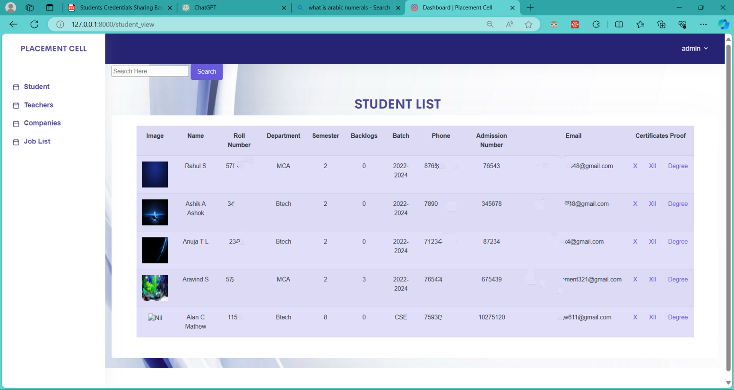

**Fig. 6** Job approval(admin)

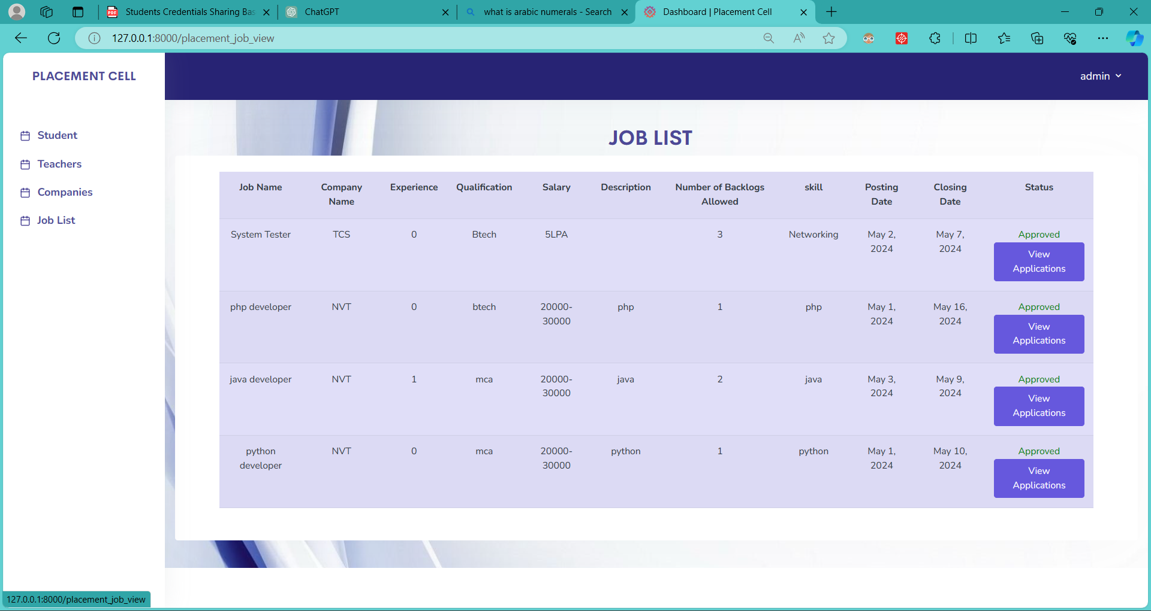

**Fig. 7** Job lists for eligible students (student interface)

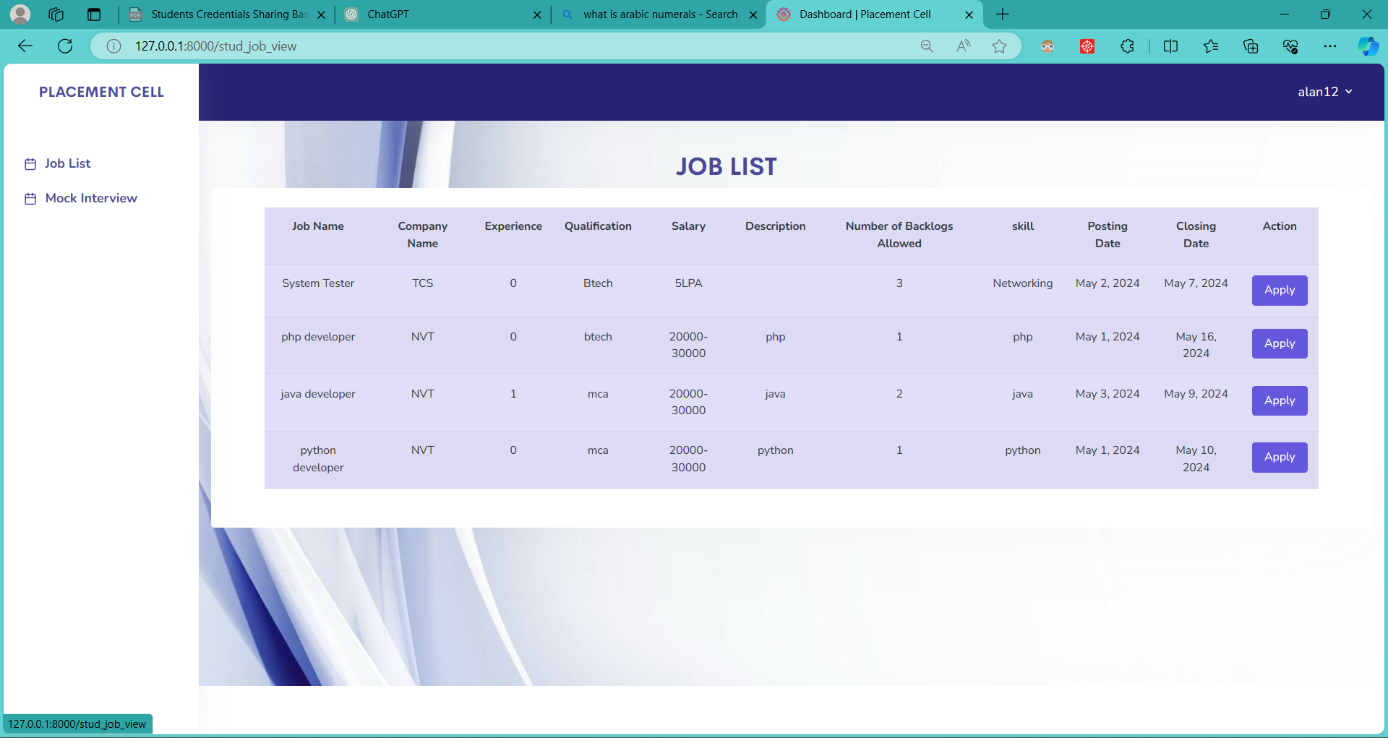

**Fig. 8** Mock Tests for students (student interface)

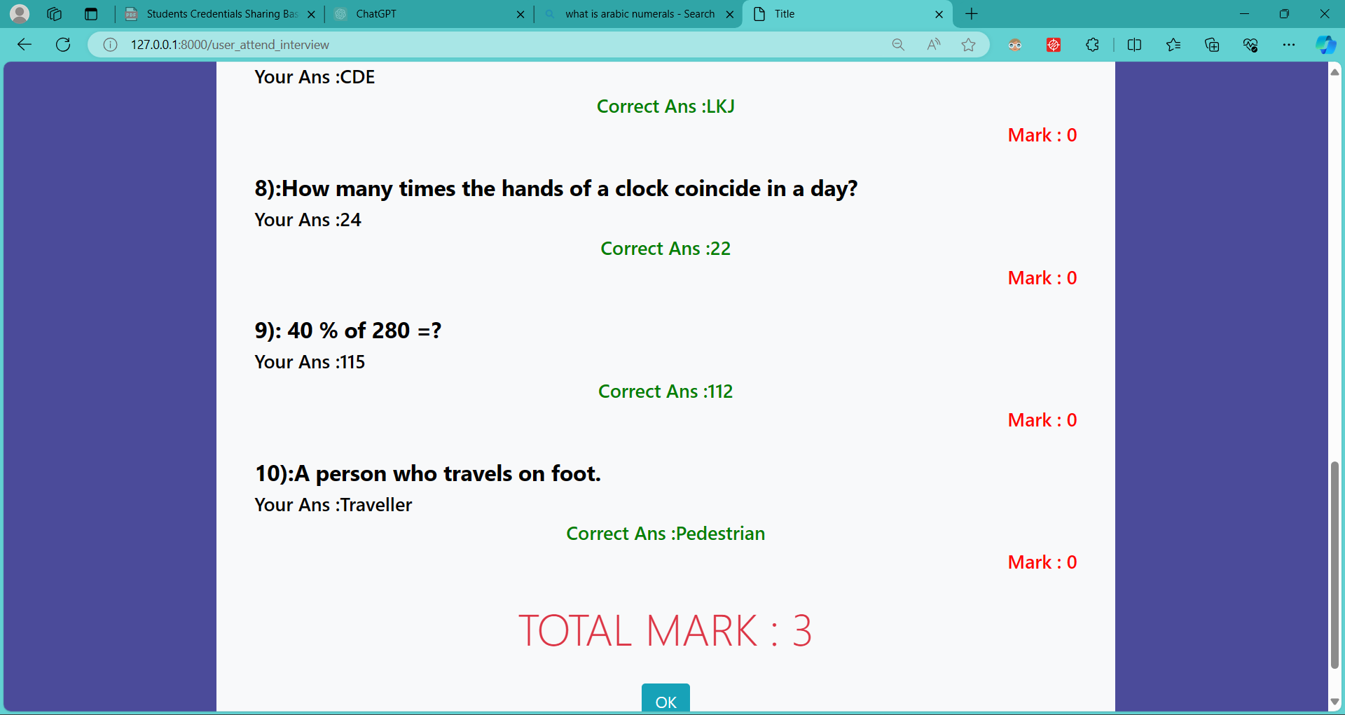

1. **CONCLUSION**

In the journey of developing and implementing the website, a transformative platform for college placement cell management, innovation, collaboration, and dedication have been paramount. Built on the Django framework and SQLite database, the website has streamlined processes, improved communication, and delivered tangible benefits across all stakeholders. The result analysis confirms the websites effectiveness, usability, and positive impact on placement operations. Accelerated application processing, increased company engagement, and higher placement rates underscore its success. Looking forward, the website will continue to evolve through continuous improvement, scalability, and innovation. As a beacon of digital innovation in higher education, it symbolizes progress and opportunity, empowering students, institutions, and employers alike.

**ACKNOWLEDGEMENT**

We are grateful to Almighty God for providing us with the means to successfully finish our project. We truly value the motivation, assistance, and direction provided by everyone who has helped to make the Project a success.   
We also would especially like to thank Dr. Shyjith M B, Head of the Department of Computer Science Engineering, for all of his help and support during the Project. We are deeply grateful to Mr. Jasion Mathew John, Assistant Professor in the Department of Computer Science and Engineering, who spearheaded the research and provided timely suggestions and motivation.  
We also truly appreciate the guidance and support we received from Mrs. Betty Mary Jacob, Assistant Professor, Department of Computer Science and Engineering. We have to express our gratitude to the panellists for their advice and viewpoints during the project presentation. Finally, and perhaps most importantly, we would like to thank our friends and family for being a constant source of inspiration for us while we prepared for the Project.

**REFERENCES**

1. Aswathappa K," *Human Resource Management",* Tata McGraw Hill, sixth edition,2011.
2. Amit Dar et al., " *Skill Development in India the Vocational Education and Training System*", Human Development Unit South Asia Region the World Bank. 5-10, 2006.
3. Archana Mantri, Sunil Dutta et al., "*imbedding soft skills in technical studies: The problem-based learning way*", The Indian Journal of Technical Education, Vol. 30, pp. 79-83, 2007.
4. Gunderloy, Jorden BPB Publications (2000) - “*Mastering SQL Server*”.
5. Luke Welling and Laura Thomson (5th Edition) - “*PHP and MySQL WebDevelopment*”.
6. Roger S. Pressmen, T. Mc. GH. – *Software Engineering (Theoretical Approach).*
7. Thereon Willis Worx publications (2000) - “*Beginning SQL Server*”.
8. Bach, B., Freeman, E., Abdul-Rahman, A., Turkay, C., Khan, S., Fan, Y., Chen, M., 2022. *Dashboard design patterns.* arXiv preprint. doi:https://doi.org/10.48550/arXiv.2205.00757.
9. Bloom, G., Alsulami, B., Nwafor, E., Bertolotti, I.C., 2018. *Design patterns for the industrial Internet of Things.* Paper presented at the 2018 14th IEEE International Workshop on Factory Communication Systems (WFCS).
10. Burns, B., Oppenheimer, D., 2016. *Design patterns for container-based distributed systems.* Paper presented at the 8th USENIX Workshop on Hot Topics in Cloud Computing (HotCloud 16).
11. Guest, W., Wild, F., Di Mitri, D., Klemke, R., Karjalainen, J., Helin, K., 2019. *Architecture and design patterns for distributed, scalable augmented reality and wearable technology systems.* Paper presented at the 2019 IEEE International Conference on Engineering, Technology and Education (TALE).
12. Haq, M. S., Anwar, Z., Ahsan, A., Afzal, H., 2017. *Design pattern for secure object-oriented information systems development.* Paper presented at the 2017 14th International Bhurban Conference on Applied Sciences and Technology (IBCAST).
13. Heer, J., Agrawala, M., 2006. *Software design patterns for information visualization.* IEEE Trans. Visual. Comput. Graph. 12 (5), 853–860.
14. Hussain, S., Keung, J., Sohail, M.K., Khan, A.A., Ilahi, M., 2019*. Automated framework for classification and selection of software design patterns. Appl. Soft Comput. 75, 1–20.*
15. Joshi, B., 2016. *Beginning solid principles and design patterns for asp.net developers.* Springer, New York, NY, USA. JSF, 2022. Java Server Faces (JSF). Retrieved from http://www.javaserverfaces.org/.
16. Juneau, J., 2013*. Introducing Java EE 7: a look at what’s new.* Apress, New York, NY, USA.
17. Lu, Q., Xu, X., Bandara, H. D., Chen, S., Zhu, L., 2021. *Patterns for blockchain-based payment applications.* Paper presented at the 26th European Conference on Pattern Languages of Programs.
18. Malik, Z. H., Munir, T., Ali, M., 2020. *UI design patterns for flight reservation websites.* Paper presented at the Future of Information and Communication Conference.
19. Martínez-Fernández, S., Bogner, J., Franch, X., Oriol, M., Siebert, J., Trendowicz, A., Wagner, S., 2022. *Software engineering for AI-based systems: a survey*. ACM Trans. Software Eng. Methodol. 31 (2).
20. Mayvan, B.B., Rasoolzadegan, A., Yazdi, Z.G., 2017. *The state of the art on design patterns: A systematic mapping of the literature.* J. Syst. Software 125, 93–118.
21. Mythily, M., Nambiar, R., Prabhavathy, K., Joseph, I.T., 2019. *A design pattern structure specification to extract statistical report*. Int. J. Innov. Technol. Exploring Eng. 8 (10), 3066–3070.
22. PrimeTek, 2022. PrimeFacses: *Leading provider of open-source UI component libraries. Retrieved from* https://www.primefaces.org/showcase/.