# IoT Based Automatic Waste Segregation and Monitoring System

# Krishnapriya S1 Aneesh Babu A K1 Aswin Kavil Biju1 Abidha Abdul Karim Rawther2 Bejoy Antony3

*1 B.Tech, Electronics and Communication, St.Thomas College of Engineering And Technology, Chengannur, India*

*1 B.Tech, Electronics and Communication, St.Thomas College of Engineering And Technology, Chengannur, India*

*1 B.Tech, Electronics and Communication, St.Thomas College of Engineering And Technology, Chengannur, India*

*2 Assistant Professor, Department of ECE St.Thomas College of Engineering And Technology, Chengannur, India*

*3 Associate Professor, Department of ECE St.Thomas College of Engineering And Technology, Chengannur, India*

***Abstract****: One of the major issues for environmental hazard is the continuous accumulation of waste. As the world’s population continues to rise, garbage is dumped at one place, mixing different types of wastes. In India, the total generated waste is expected more than 1,50,000 metric tons per day. People spill waste along roadsides, and the people in charge of the model do not collect it regularly. This automated waste segregation bin is a project to make it more efficient, these rapid technological advancements have resulted in a low initial cost. This application proposes IoT-based smart segregation and management which segregates wastes as dry, metallic and wet waste with the help of sensors like IR sensor, Ultrasonic sensors, Inductive proximity sensors, Soil Moisture sensors. The microcontroller consists of a Wi-Fi module along with the Arduino that can take place in an effectively closed manner. Arduino controls the functions of the sensors and servo motors. The entire waste process, including level and separation, is monitored and controlled by configurable IO sensors, reducing open degradation of organic waste and thus the growth of microorganisms. In the proposed system it divides the waste into dry waste, metal waste and metal waste. This application is an effective method for the waste management and segregation process. By using a cloud server, the data collected by the Arduino can easily be viewed by an authority. The data will be based on the garbage filling level. So, there is no need to check the waste filling level manually.*

***Key Words:*** *Automatic Waste Segregation and Monitoring System, IoT based technology, sensor-based working, Real time monitoring system, cost-effectiveness.*

1. **Introduction**

The current waste segregation methods lack effectiveness as it is manually done. When the domestic household waste is considered, the disposal method includes collection of waste by the government authorities at the door step of the people. But most of the time the waste is not segregated properly, which effects the further segregation stages in a negative manner. Untreated waste become a breeding point for many harmful microorganisms. When waste is not segregated, hazardous materials may end up in landfills or even in the environment, leading to soil, water, and air pollution.

We present an effective system for the above purpose which segregates waste automatically utilizing various sensors and a microcontroller. When waste is thrown inside the dustbin, IR sensor will sense the waste. Waste is divided into dry, wet and metal. Another sensor will sense the garbage category. As per the algorithm used, if the waste is metallic then the mechanism will bring the metal collecting bin below the tray and with the help of servo motor the waste will fall into the metal bin. The proposed system presents a simple and an effective method to segregate waste completely removing human intervention in the segregation stage. When the waste is segregated into basic streams such as wet, dry and metallic, the waste has a higher potential of recovery and consequently recycled and reused.

1. **Proposed System**

The proposed method includes a comprehensive block diagram summarising each constituent component of the system. The system includes various sensors for the effective detection of dry, wet and metallic wastes.

1. **Block diagram**

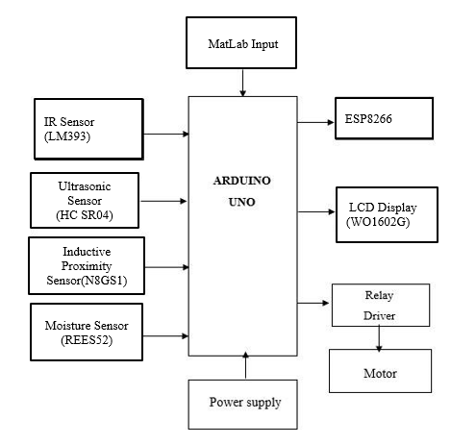

**Figure 1:** Block diagram of the System

The major component of the system is Arduino UNO microcontroller board and. All the input and output elements are connected to the Arduino UNO. The sensors used in the Automatic Waste Segregation and Monitoring System are Moisture sensor, Ultrasonic sensor, IR sensor and Inductive Proximity sensor. These sensors send their input to the Arduino and based on the data it will control the working of the servo motor and LCD display. All the connections are depicted in the above block diagram. A relay driver is used provide the power to the servo motor used in the system. Here the inputs to the Arduino UNO are from the sensors like IR Sensor, Ultrasonic Sensor, Moisture Sensor and Inductive Proximity Sensor.

1. **Circuit diagram**

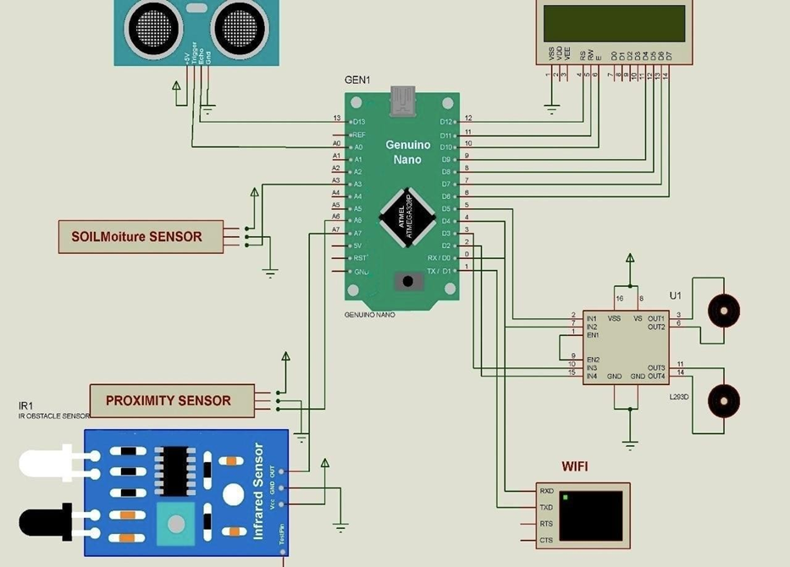

The automatic waste segregation system circuit integrates various components to streamline the process. Beginning with the sensors, the Infrared (IR) sensor detects the presence of waste, Moisture Sensor gauges soil moisture to identify organic waste, and the Inductive Proximity Sensor identifies metallic waste items. The LCD Display visually communicates information about the waste segregation process. A Relay acts as a switch to control the operation of the Servo Motor, which physically separates the waste into different bins

The Arduino serves as the central controller, receiving inputs from the sensors and making decisions based on programmed logic, ultimately controlling the Servo Motor and Relay. The ESP8266 facilitates internet connectivity, enabling remote monitoring or data logging if required. Power connections (VCC and GND) for each component must be established, and signal pins from the sensors should be connected to appropriate digital or analog pins on the Arduino. The programming on the Arduino is crucial, as it interprets sensor data, makes decisions, and executes actions to automate the waste segregation process effectively.

**III. Working**

Arduino UNO has the major role in our system. A metal detector, IR sensor and a moisture sensor are connected to the Arduino board where IR and moisture sensor are connected on the digital pin. The moisture sensor is being attached with servo motor 1 and work as an opening of the slot on collector trash an ADC is connected along with wet sensor to get the output signal in dc form. A metal detector is connected to the analog pin. The two servo motors are connected to the digital side carrying a major role in the selection of the corresponding waste bin and the rest will function to support for opening and closing top. Three separate waste bins are used to segregate wet, metal and other waste correspondingly which are connected over motor. ADC is attached corresponding to the metal detector where it produces analogue signal which have to be converted in to digital signal inside the UNO board and uses external power source instead of batteries because the servo motor 2 which is used to rotate the dust bin requires high voltage. So by the use of adapter plugged in can serve the power required as the moisture sensor is not good enough to supply. There is a main collecting trash with an opening controlled by servo motor for initial collection of waste.

When a waste is thrown into the bin, the sensors fixed on the surface detects the type of the waste. If a metal waste is thrown it entangles in the magnetic field of the inductive proximity sensor. This will given as input to the Arduino and the corresponding bin will collect the metal waste. Similarly, moisture sensor will detect the presence of wet waste and IR sensor will detect the presence of dry waste. Ultrasonic sensor will measure the garbage level inside the bin. IoT module is used to provide internet connectivity to the system. This system will send the real time information about the garbage level through this provided Wi-Fi connectivity.

**IV. Implementation**

1. **Hardware implementation**
2. **Define requirements**

Clearly mark the requirements of your waste segregation and monitoring system. Determine the specifications of the parameters you want to monitor (such as waste level, quantity, types of waste etc.), where the sensors will be placed, and what actions should the sensors take.

1. **Select sensors**

Choose appropriate sensors for monitoring the type of waste dumped. Consider factors such as accuracy, reliability, power consumption, and compatibility and durability with IoT platforms.

1. **IOT platform selection**

Choose an IoT platform that supports data collection, storage, analysis, and visualization. Popular IoT platforms include AWS IoT, Microsoft Azure IoT, Google Cloud IoT, and open-source platforms like Arduino IoT Cloud or ThingsSpeak. Here we use ThingSpeak IoT platform

1. **Hardware Setup**

Install sensors at the accurate locations for waste monitoring. Connect the sensors to microcontrollers equipped with Wi-Fi or cellular connectivity for data transmission.

1. **Data Transmission**

Implement a communication protocol (e.g., MQTT, HTTP, CoAP) to transmit data from sensors to the IoT platform securely and safely. Consider using encryption and authentication mechanisms to ensure data privacy and integrity.

1. **Data Storage and Processing**

Set up data storage and processing pipelines on the IoT platform to handle and respond to the incoming sensor data. This may involve using databases (e.g., SQL, NoSQL) for data storage and analytics services for real-time processing.

1. **Visualization and Dashboard**

Develop a user interface to visualize the data of dumped wastes. This could include graphs, charts and maps. Make the interface accessible via web or mobile applications for easy monitoring and visualization.

1. **Software implementation**

Embedded C programming is utilized for implementing microcontroller coding and Wi-Fi module program. The code is focused on analyzing and processing sensor values based on specified conditions to monitor the type of waste thrown into the bin using various sensors and actuators in an Arduino-based system.

1. **Installing Required Libraries**

The code incorporates libraries for communicating with hardware components such as the LCD, different sensors, and communication modules. It also includes declarations for multiple global variables that hold sensor data and system statuses.

### **IoT interference**

Utilizing the cloud platform ThingSpeak, graphical representation of sensor parameters can be implemented. ThingSpeak enables real-time data collection and visualization using its capabilities. Data collection can be securely sent to the cloud for analysis and visualization through MATLAB. Triggered actions based on received data can also be implemented. ThingSpeak provides RESTful and MQTT APIs for seamless data communication. It is compatible with a variety of devices such as Arduino, ESP8266/ESP32 WiFi modules, Raspberry Pi, and more.

**V. Conclusion**

This Project represents a significant leap forward in the evolution of waste management practices. Through the integration of advanced technologies such as inductive proximity sensors, IR sensors, and dispersed water sensors, coupled with the versatile ESP8266 module, the project offers a comprehensive solution with far-reaching benefits. The precision achieved in waste segregation not only enhances recycling efforts but also aligns with global sustainability goals by reducing landfill waste and promoting a circular economy. Real-time monitoring and data-driven decision-making empower waste management authorities to optimize resource allocation, resulting in cost efficiency and reduced environmental impact. The project's incorporation of remote monitoring and control capabilities facilitates proactive management, allowing for immediate issue resolution and adaptability to changing waste generation patterns. The associated mobile apps and web interfaces enhance public awareness and engagement, fostering a sense of responsibility within the community and promoting sustainable waste disposal practices. Moreover, the scalability, adaptability, and over-the-air update capabilities of the ESP8266 ensure the project's longevity and relevance. The system stands not only as an innovative solution to current waste management challenges but also as a resilient and forward- thinking framework ready to evolve with the dynamic demands of urban landscapes. In essence, the IoT-based automatic waste segregation and monitoring bin project transcends the conventional boundaries of waste management. It embodies technological innovation, environmental stewardship, and community involvement, setting a benchmark for smart city initiatives. As municipalities increasingly recognize the need for sustainable urban living, this project stands as a beacon, illuminating the path towards a cleaner, more efficient, and technologically advanced future in waste management.

**References**

[1] *Aksan Surya Wijaya; Zahir Zainudheen ,“Design of a smart waste bin for smart waste management” 5th International Conference on Instrumentation and Control 2017*

[2] *Mohammed Zubair; Yash Mathur ,“Smart Waste Bin: Mechanical and AI Based Waste Segregation“ 2nd International Conference on Artificial Intelligence and Smart Energy 2022*

[3] *Ahammed Mohammed; Yara El Sayed , “Intelligent Trash Bin for Smart Cities” 1st International Conference on Advanced innovations in Smart cities 2023*

[4] *Sinthiya, Nusrat Jahan, Tanvir Ahmed Chowdhury, and A. K. M. Haque, "Artificial Intelligence Based Smart Waste Management—A Systematic Review" Computational Intelligence Techniques for Green Smart Cities 2022*

[5] *Devi, RS Sandhya, V. R. Vijaykumar, and M. Muthumeena , "Waste segregation using deep learning algorithm." International Journal of Innovative Technology and Exploring Engineering 2018*

[6] *V J Aleena, Kavya Balakrishnan, T. B. Rosmi, K. Swathy Krishna, S. Sreejith, and T. D. Subha. "Automatic waste segregator and monitoring system." Journal of Microcontroller Engineering and Applications 2016*

[7] *https://circuitdigest.com/article/servo-motor-working-and-basics Basics of servo motors*

[8] *https://www.elprocus.com/soil-moisture-sensor-working-and-applications/ Applications of soil moisture sensors*

[9] *https://www.semanticscholar.org/paper/The-Design-and-Implementation-of-Smart-Trash-Bin- Samann/43790b85dc57a320babd7eae028724fb954e4ea0 Pdf link of implemented work of a smart bin*

[10] *https://www.electronicwings.com/arduino/esp8266-wifi-module-interfacing-with-arduino-uno*

*explanation of Wi-Fi interfacing Arduino*