**Blockchain-Enabled Agricultural Relief System**

NIKITA Y. KAPADNIS [1], NIKITA V. PAWAR [2], VIRAJ V. MANE [3],

CHAITANYA V. PARASKAR [4]

*1(Associate Prof. Department of Computer Engineering, Pune Institute of Computer Technology (PICT), Pune, Maharashtra, India)  
2(Department of Computer Engineering, Pune Institute of Computer Technology (PICT), Pune, Maharashtra, India)  
3(Department of Computer Engineering, Pune Institute of Computer Technology (PICT), Pune, Maharashtra, India)*

*4(Department of Computer Engineering, Pune Institute of Computer Technology (PICT), Pune, Maharashtra, India)*

***Abstract:*** In arid agricultural regions, farmers face considerable challenges stemming from drought and the limitations of traditional crop insurance mechanisms. This paper proposes a conceptual framework for a blockchain-based drought fund system designed to enhance agricultural risk management. By harnessing distributed ledger technology, this approach envisions a transparent, efficient, and decentralized method of providing financial support during adverse weather events.

The proposed system would utilize smart contracts to automate fund allocation and distribution based on realtime meteorological data, aiming to minimize delays and ensure timely financial relief for affected farmers. This framework suggests a shift from farmers being passive participants in conventional insurance schemes to becoming active stakeholders in fund governance, thus promoting a collaborative approach to financial risk management.

We explore the potential effectiveness of this conceptual system, focusing on anticipated benefits such as cost reduction, faster claims processing, and improved trust within farming communities. Preliminary insights indicate that implementing blockchain infrastructure could significantly lower operational costs and enhance the resilience of agricultural stakeholders.

This paper outlines the envisioned system architecture, including potential blockchain consensus mechanisms, and dis-cusses anticipated challenges related to data integration and user adoption. We conclude with a strategic roadmap for the conceptual deployment of this drought fund system, highlighting its transformative potential for agricultural risk management in the context of climate change and increasing weather variability

***Key Word:***Agricultural Risk Management, Smart Con-tracts, Drought Relief Fund, Decentralized Finance

1. **Introduction**

Agribusiness is a vital global industry, contributing significantly to health, nutrition, and economic stability. However, despite its importance, agriculture remains one of the least digitized sectors. Much of the information generated on farms is not efficiently transmitted off-farm, as it is often produced or processed in a way that complicates low-cost, reliable data sharing. This lack of digitization severely restricts agricultural productivity and supply chain efficiency.

Modern supply chains, powered by integrated information systems, help organizations optimize resources, speed up market access, add value, and cut costs. Agriculture, however, is highly sensitive to climate changes, impacting production costs, delivery, and quality, especially in developing economies where small-scale farmers dominate. Severe weather events like droughts and heavy rainfall increase the fragility of agricultural supply chains, causing crop and livestock losses, financial strain, and, in some cases, forced relocation for farmers.

Smallholder farmers can boost resilience by pooling re-sources to lower costs, access financial services, and negotiate better rates. Crop insurance is another vital tool for managing climate risks like floods and droughts, offering financial protection. However, traditional insurance poses challenges, particularly for small farmers, due to high costs, limited accessibility, and a lack of transparency, which fosters distrust. Additionally, the claims process is often slow and complicated, as insurers must verify claims before payouts, causing delays and increasing administrative costs.

The agriculture sector is in need of advanced technologies like blockchain, IoT, cloud computing, and big data to address these challenges. Each of these technologies offers potential solutions to problems such as food security, traceability, data management, and fraud prevention. For example, agronomists are using blockchain and IoT technologies to enhance crop productivity. Blockchain, in particular, has gained traction in agricultural applications such as weather crisis management, smart agriculture, and improving supply chain transparency. As a decentralized and immutable ledger system, blockchain ensures secure, transparent transactions without the need for intermediaries.

In this paper, we focus on leveraging blockchain technology to improve access to crop insurance for smallholder farmers. By utilizing blockchain’s decentralized, transparent, and se-cure infrastructure, we aim to create a reliable and efficient crop insurance system that enhances accessibility for farmers while ensuring timely payouts. Blockchain’s integration with smart contracts allows for automated insurance claim processing, based on real-time weather data, significantly reducing the risk of fraud and eliminating the need for human intervention in verifying claims.

The traditional agricultural insurance model faces two major challenges: insurance fraud, due to information asymmetry and moral hazard, and policyholders’ losses due to basis risk. Blockchain offers a transformative solution by introducing transparency, reducing fraud risks, and enabling trust among all stakeholders. When combined with smart contracts, blockchain can deliver reliable, low-cost, and efficient insurance processes

1. **Literature Survey**

**A. Blockchain-Based Crop Index Insurance in Agricultural Supply Chain**

The paper ”Blockchain-Based Approach for Crop Index Insurance in Agricultural Supply Chain” proposes using blockchain technology and smart contracts to enhance transparency, reduce costs, and speed up claim processing in crop insurance. By eliminating intermediaries and automating claims with smart contracts, the system offers a more afford-able solution for farmers, especially in low-income regions, while mitigating fraud through blockchain’s immutable ledger. The system’s integration of real-time weather data further im-proves reliability. The study emphasizes blockchain’s potential to revolutionize crop insurance, particularly for smallholder farmers in developing countries facing climate-related risks.

**B. Application of Asset Tokenization, Smart Contracts and Decentralized Finance in Agriculture**

Mahmoud Tarhini’s paper ”Application of Asset Tokenization, Smart Contracts and Decentralized Finance in Agri-culture” explores how asset tokenization and decentralized finance (DeFi) can transform agricultural operations. By tokenizing agricultural assets such as crops and land, farmers can engage in peer-to-peer trading, raise funds, and obtain micro-insurance, bypassing intermediaries. This approach reduces transaction costs, enhances transparency, and democratizes access to global capital. The study emphasizes the potential for blockchain to streamline agricultural insurance and finance, making these systems more efficient and resilient.

1. **Blockchain Technology in Agri-Food Value Chain Management**

The paper ”Blockchain Technology in Agri-Food Value Chain Management” reviews the applications of blockchain in enhancing transparency, security, and efficiency in the food supply chain. It identifies four key uses: traceability, information security, manufacturing optimization, and sustainable water management. However, the study also highlights six major challenges in implementing blockchain in this sector, including storage limitations, privacy issues, regulatory barriers, high costs, and the need for skilled personnel. The paper suggests that overcoming these challenges is crucial for the widespread adoption of blockchain in agri-food value chains.

**D. Blockchain and Edge Computing in Agricultural Supply Chains**

The paper ”Blockchain and Edge Computing Technology Enabling Organic Agricultural Supply Chain” presents a framework that combines blockchain and edge computing to address trust issues in the organic agricultural sector. It focuses on improving transparency, data processing speed, and cost-efficiency, particularly for small and medium-sized farms. By leveraging blockchain’s immutability and edge computing’s efficiency, the framework ensures reliable traceability of organic products. The authors also propose an improved consensus mechanism to enhance information flow among stakeholders, ultimately aiming to rebuild consumer trust and make traceability more accessible in developing countries.

**E. State Government Fund Allocation and Tracking System Over Blockchain**

This paper proposes a blockchain-based platform to enhance transparency and efficiency in state government fund allocation systems. By utilizing blockchain’s immutable ledger, crypto-graphic encryption, and consensus mechanisms, the platform ensures secure fund management, prevents data tampering, and automates fund disbursal through smart contracts. This system improves accountability, enhances public trust, and streamlines the process of government fund management, offering a secure and efficient solution for managing public funds.

1. **Government Fund Distribution and Tracking System Using Blockchain Technology**

The paper addresses corruption in government fund distribution through a blockchain-based system that ensures transparency with cryptographic hashes, timestamps, and an immutable ledger. It employs AES encryption for metadata and SHA-1 for key generation, with a third party Auditor (TPA) verifying transactions. The proposed system outperforms existing solutions in terms of encryption and data transfer speeds, particularly for larger files, providing a robust and secure method for tracking government funds and preventing fraud.

1. **Proposed Solution**

**A. Stakeholders (Refer Fig. 1)**

a) **Farmer**: The primary beneficiary of the system who operates at the grassroots level, cultivating crops and seeking financial protection against weather-related crop damages. Farmers interface with the system by registering their details, crop information, and land data, making them eligible for insurance coverage under the program. They represent the end-users who stand to benefit from quick, transparent claim settlements based on weather triggers.

b) **Crop Insurance Provider**: An institutional entity responsible for underwriting and managing crop insurance policies. They assess risks, set premium rates, and define pol-icy terms based on historical data, crop types, and Geographical locations. These Providers can be Public Sector Entities (e.g. LIC), Private Sector Entities (e.g. Reliance General) or Government Agencies

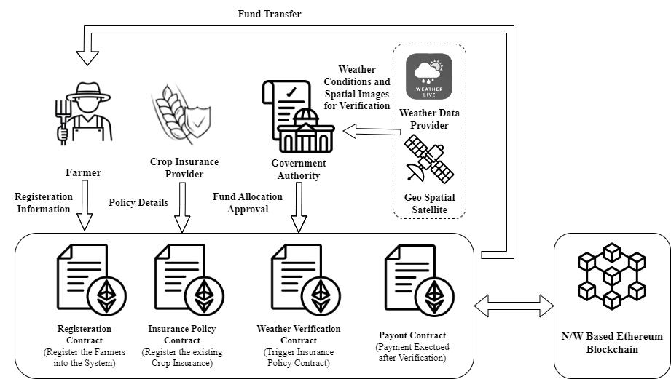

Fig. 1. System overview of a private blockchain-based crop index solution using Ethereum smart contracts and decentralized storage system

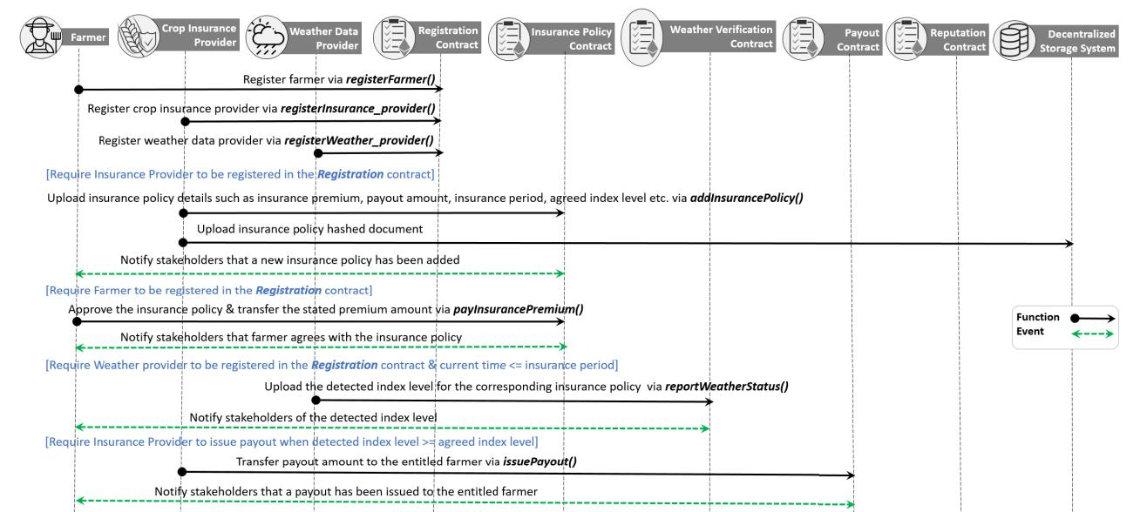

Fig. 2. Sequence diagram showing the sequence of events occuring between stakeholders.

c) **Government Regulatory Authority**: A regulatory and supervisory body that oversees the entire crop insurance ecosystem. They play a crucial role in fund allocation, policy approval, and ensuring fair practices. The authority validates and approves insurance schemes, monitors program implementation, and often provides subsidies or financial support to make insurance more affordable for farmers. They act as a bridge between private insurers and public welfare.

d) **Weather Data Provider**: It is a publicly available Weather forecasting API, which provides weather related data for a specific geographic location. Examples of such weather data providers are ChainLink, IBM Weather Channel, etc. We have used OpenWeather API to obtain real time weather data, as well as the recorded data for past dates. This data serves as an objective, third-party source for verifying weather conditions that trigger insurance payouts, eliminating the need for manual onsite verification.

e) **Geo-Spatial Satellite**: A crucial technological com-ponent that provides earth observation capabilities through space-based sensors and imaging systems. These satellites capture high-resolution imagery of agricultural lands, enabling precise monitoring of crop health, growth patterns, and damage assessment. We have used Sentinel-2C Satellite to obtain the Geo spatial data.

f) **Ethereum Smart Contracts**: A smart contract is a code created to automate functions according to the terms and conditions set by network stakeholders. In this case, it functions as a virtual agent to verify transactions without intervention from third parties. We propose a system of five smart contracts, each dedicated to a specific task. The registration contract targets registering all stakeholders in the same network, while the insurance policy contract deals with the automation of insurance policy decisions based on adverse weather events. The weather verification contract focuses on providing real-time weather data, and the payout contract rolls out payouts to farmers during extreme weather conditions. Lastly, the reputation smart contract ranks the insurers based on their credibility, clarity, premium competitiveness, and how fast they are able to process payouts.

g) **Blockchain Network**: The technological backbone of the entire system, providing a decentralized, immutable, and transparent infrastructure for executing and recording all trans-actions and contracts. The Ethereum blockchain enables smart contracts that automatically execute insurance policies, verify weather conditions, and process payouts based on predefined conditions. This reduces manual intervention, eliminates fraud, and ensures quick, transparent settlements while maintaining a permanent record of all transactions and agreements.

**Algorithm 1 Registering Stakeholders into the Network**

Require: farmer EA, insurance provider EA, weather data provider EA

Modifier: OnlyOwner

Register Farmer, Insurance provider & Weather data provider in the Registration contract

Broadcast successful registration of stakeholder via event

1. if new stakeholder is registered then

Add new EA to respective stakeholder array

1. else

Notify owner that EA is already in use

* 1. end if

**Algorithm 2 Establishing Insurance Policy Contract**

Require: policy number, insurance premium, insurance period, payout amount, index level

Modifier: onlyInsuranceProvider

Insurance provider deploys the Insurance Policy contract

Insurance provider uploads the insurance details

Broadcast new insurance policy via event

Modifier: only Farmer

1. if farmer agrees with uploaded insurance policy then Farmer transfers insurance premium amount to Insurance provider
2. end if

**Algorithm 3 Issuing Payouts**

Require: insurance policy address, policy number, farmer EA

Modifier: onlyWeatherProvider

Weather data provider deploys Weather Verification con-tract

1. if current time <= insurance period in Insurance policy contract then

Upload new weather index levelNotify all stakeholders of new weather update via event

1. end if

Modifier: onlyInsuranceProvider

Insurance provider deploys Payout contract

1. if new weather index level >= index level in Insurance policy contract then

Transfer payout amount to entitled registered farmer

1. else

Revert transaction

1. end if

**B. Algorithms for Smart Contracts**

a) Registration Smart Contract (Refer Algorithm 1): This smart contract is deployed by the owner of the system. The contract is implemented once and is used to store all the stakeholder addresses. Each stakeholder in the system is identified by using the Ethereum Address (EA) which is 20-byte identifier. Thus, it is used to register the EA of farmers, insurance providers, and weather data providers. Furthermore, it is used by other smart contracts to validate the identity of registered stakeholders in the network through the use of their EA.

b) Insurance policy smart contract (Refer Algorithm 2): The registered insurance provider uploads insurance policies to this contract. Each insurance policy is identified by its own EA and contains details such as policy number, insurance premium, insurance period, payout amount, weather index level, hashed file of the insurance terms and conditions, etc. Additionally, an event is triggered to notify all stakeholders in the network whenever a new policy is added or updated. Furthermore, the smart contract allows the registered farmer to make a decision on the proposed policy, and in the event that the farmer agrees to commit to the policy, an amount equal to the premium fee is transferred from the farmer’s account to the entitled insurance provider account accordingly.

c) Payout smart contract (Refer Algorithm 3): This contract is dedicated for rolling out payout to entitled farmers. It does so by comparing the detected index level with the index level stated in the insurance policy. If the index level rises above the stated value in the insurance then the registered insurance provider automatically transfers the payout amount to the entitled farmer’s account.

1. **Conclusion**

The proposed blockchain-based drought fund system rep-resents a significant advancement in agricultural risk management, particularly for small-scale farmers in drought-prone regions. Through the implementation of smart contracts and decentralized technology, this system addresses several critical challenges in traditional crop insurance mechanisms:

* Enhanced Transparency: The blockchain infrastructure ensures complete transparency in fund allocation and distribution, building trust among farmers, insurance providers, and regulatory authorities.
* Automated Claims Processing: Smart contracts enable automatic verification of weather conditions and subsequent claim processing, significantly reducing the time between adverse weather events and compensation disbursement.
* Cost Efficiency: By eliminating intermediaries and automating processes, the system substantially reduces operational costs, making insurance more accessible to small-scale farmers.
* Data Integrity: The integration of reliable weather data providers and geospatial satellites ensures accurate, tamper-proof data for claim verification, minimizing the risk of fraud.
* Stakeholder Empowerment: The system transforms farmers from passive insurance recipients to active participants in the risk management process, promoting greater engagement and understanding of insurance mechanisms.

1. **Future Scope**

While the proposed system offers significant improvements to agricultural risk management, several potential areas for future development and enhancement have been identified:

* Integration of advanced weather prediction models and machine learning algorithms.
* Development of more sophisticated smart contract capabilities to handle complex insurance policies based on real-time risk assessment.
* Extension of the system to cover additional agricultural risks beyond drought and floods.
* Implementation of advanced data analytics for improved risk assessment.
* Development of standardized protocols and governance frameworks in collaboration with regulatory bodies to ensure compliance and wider adoption.

**References**

1. T. Q. Nguyen, A. K. Das, and L. T. Tran, “NEO smart contract for drought-based insurance,” in Proc. IEEE Can. Conf. Electr. Comput. Eng. (CCECE), May 2019, pp. 1–4.
2. Omar, I.A., Jayaraman, R., Salah, K., Hasan, H.R., Antony, J. and Omar, M., 2023. Blockchain-Based Approach for Crop Index Insurance in Agricultural Supply Chain. IEEE Access, 11, pp.118660-118675.
3. Jambhulkar, S.S. and Ratnaparkhi, V.P., 2020. Government fund distribution and tracking system using Blockchain technology. Interna-tional Journal of Emerging Technologies and Innovative Research, 7(9), pp.1379-1387.
4. Tarhini, M., 2021. Application of asset tokenization, smart contracts and decentralized finance in agriculture. Revista de Studii Financiare, 6(10), pp.152-163.
5. Zhao, G., Liu, S., Lopez, C., Lu, H., Elgueta, S., Chen, H. and Boshkoska, B.M., 2019. Blockchain technology in agri-food value chain management: A synthesis of applications, challenges and future research directions. Computers in industry, 109, pp.83-99.
6. Hu, S., Huang, S., Huang, J. and Su, J., 2021. Blockchain and edge computing technology enabling organic agricultural supply chain: A framework solution to trust crisis. Computers & Industrial Engineering, 153, p.107079.
7. Naik, S.M.R., Banu, S.S., Manasa, N.L., Sudha, G.H. and Sultana, H.S., State Government Fund Allocation & Tracking System over Blockchain.
8. J. Lin, Z. Shen, A. Zhang, and Y. Chai, “Blockchain and IoT based food traceability for smart agriculture,” in Proc. 3rd Int. Conf. Crowd Sci. Eng., Jul. 2018, pp. 1–6.
9. N. Jha, D. Prashar, O. I. Khalaf, Y. Alotaibi, A. Alsufyani, and S. Alghamdi, “Blockchain based crop insurance: A decentralized insurance system for modernization of Indian farmers,” , vol. 13, no. 16, p. 8921, Aug. 2021.
10. H. M. Kim and M. Laskowski, “Agriculture on the blockchain: Sutainable solutions for food, farmers, and financing,” in Supply Chain Revolution. Richmond, VA, USA: Barrow Books, 2018.
11. H. Kantur and C. Bamuleseyo, “How smart contracts can change the insurance industry: Benefits and challenges of using blockchain technology,” Ph.D. dissertation, Jonk¨oping¨ Int. Bus. School, Jonk¨oping¨ Univ., Sweden, 2018. [Online]. Available: https://urn.kb.se/resolve?urn=urn:nbn:se:hj:diva-39899.
12. M. Schaffer,¨ M. D. Angelo, and G. Salzer, “Performance and scalability of private Ethereum blockchains,” in Proc. Int. Conf. Bus. Process Manage. Cham, Switzerland: Springer, 2019, pp. 103–118.
13. A. J. Pagano, F. Romagnoli, and E. Vannucci, “Implementation of blockchain technology in insurance contracts against natural hazards:A methodological multi-disciplinary approach,” Environ. Climate Technol., vol. 23, no. 3, pp. 211–229, Dec. 2019.
14. H. Patel and B. Shrimali, “AgriOnBlock: Secured data harvesting for agriculture sector using blockchain technology,” ICT Exp., vol. 9, no. 2, pp. 150–159, Apr. 2023.
15. Shahrukh, R.H., Rahman, T. and Mansoor, N., 2023, April. Aid Nexus: A Blockchain-Based Financial Distribution System. In World Conference on Information Systems and Technologies (pp. 131-144). Singapore: Springer Nature Singapore.
16. J. Davis, “Peer to peer insurance on an Ethereum blockchain,” Dynamis Whitepaper, Feb. 2018. [Online]. Available: https://dynamisapp.com/whitepaper.pdf.
17. ] Antonios Litke, Dimosthenis Anagnostopoulos, Theodora Varvarigou, ”Blockchains for Supply Chain Management: Architectural Elements and Challenges towards a Global Scale Deployment”, MDPI January 2019.
18. Hawlitschek, F., Notheisen, B. and Teubner, T., 2018. The limits of trust-free systems: A literature review on blockchain technology and trust in the sharing economy. Electronic commerce research and applications, 29, pp.50-63.
19. Huckle, S., Bhattacharya, R., White, M. and Beloff, N., 2016. Internet of things, blockchain and shared economy applications. Procedia computer science, 98, pp.461-466.
20. ] Apoorva Mohite, Ajay Acharya, ”Blockchain for government support following utilizing Hyperledger”, IEEE Transactions on Fuzzy Systems, April 2018.