**Car Wash System Using PLC**

Avinash Kumar1, Shweta Shukla2, Noorul Islam3, Utkarsh Jha4, Sarvesh Singh5, Tapasvee Yadav6, Lucky Dhiman7

*1-7Department of Electrical Engineering, Meerut Institute of Engineering & Technology, Meerut, India*

|  |  |
| --- | --- |
|  | **Abstract:***The car washing industry has witnessed as paradigm change with the incorporation of automation systems that significantly reduce man power and improve operational efficiency. The objective of this research paper is to outline an elaborate study of the design, development, and application of an automated car wash system based on a Programmable Logic Controller (PLC). The Purpose of this system is to enhance the overall efficiency of the car wash process, minimize human intervention, decrease resource consumption, and enhance operational precision. In this paper, further information is provided regarding the working mechanism, hardware components, and PLC ladder program employed in the system with regard to the advantages and drawbacks of such an automated solution. Furthermore, the research discusses the scope of future development with the incorporation of smart technologies for enhanced control and monitoring.*  ***Keywords:*** *Car wash, PLC, Automation, Ladder Logic, Sensor, Efficiency, Industrial Automation, Conveyor Belt, Control System, Brush and Dryer.* |

1. **Introduction**

The car wash industry has seen significant advancements in automation over the years, with systems that once relied on manual labor now evolving into fully automated processes. One of the key technologies driving this evolution is the use of Programmable Logic Controllers (PLCs) in car wash systems. PLCs, which are specialized digital computers used for automation of industrial processes, offer a highly reliable and efficient method for controlling the various mechanical and electrical operations in a car wash system. By utilizing PLCs, car wash systems can improve efficiency, reduce human error, and provide consistent and high-quality services to customers.

A car wash system typically involves several processes such as vehicle detection, washing, rinsing, drying, and other steps. These operations need precise control to ensure that the vehicle is washed without damage while maintaining optimal speed and efficiency. The integration of PLCs in such systems enables the automation of these processes, allowing for better management of sensors, motors, valves, and other components that are involved. Moreover, PLCs can be programmed to handle various inputs and outputs, manage multiple machines simultaneously, and provide real-time feedback, which is essential for the proper functioning of a car wash system [1].

The advantages of using PLCs extend beyond just improving operational efficiency. PLC-based systems can also facilitate remote monitoring and control, enhancing the ability to manage multiple car wash stations from a central location. This is especially valuable in large-scale operations where real-time monitoring can help in predictive maintenance and reducing downtime [2]. Additionally, PLCs offer high durability and robustness, which is crucial in environments exposed to harsh conditions such as water, chemicals, and heavy machinery [3].

The development of a car wash system using PLCs not only exemplifies advancements in automation but also highlights the growing importance of integrating control systems in industries requiring repetitive and precise tasks. This paper explores the design, implementation, and benefits of using a PLC-based system for car wash automation, as well as discusses the challenges and solutions involved in such integrations.

On the industrial front, automation has been a major motivating factor to improve productivity, cut costs, and limit human mistakes [4]. Car wash systems are one of the routine uses of automation wherein human labor may be minimized by using a Programmable Logic Controller (PLC) [5]. Current car wash systems involve extensive manual intervention and wasteful water and power consumption, with resulting inconsistent quality and increased operational costs [6]. The car wash systems have made this task easier by ensuring workability, optimal utilization of resources, and consistency in quality of service.The essence of the paper is to present the design, development, and operation of an automated car wash system using PLC technology [7]. The combination of sensors, conveyor belts, water pumps, and control systems, the automated car wash system operates with less human interaction, and the cleaning process is efficient and uniform. The system is also designed to conserve water, power, and chemicals, which is for the sake of environmental sustainability [8].

**II. Literature Review**

Extensive amounts of research have been carried out to investigate the use of automation in car wash systems. The research available shows that automated car wash systems can successfully enhance efficiency, lower operation cost, and attain uniform service quality. A study emphasized the use of microcontrollers in car wash systems to regulate different stages of cleaning; however, the systems were non-scalable and non-flexible. In another research, scientists used embedded systems to automate car washes but were limited by remote control and scalability. PLC technology overcomes these limitations in greater flexibility, control, and scalability. It can easily change the logic of control, processes can be easily controlled, and multiple units can be combined into one system in PLC-based automation. This research surpasses conventional automation as it entails the application of sophisticated ladder logic programming and optimum resource usage.

**III. System Design**

**Components**

The automated car wash system consists of several essential components, including hardware and software elements, that work in synchronization to ensure efficient operation.

* **PLC (Programmable Logic Controller)**: The PLC is the central control unit responsible for processing input signals, executing control logic, and generating output signals to control various components of the system.
* **IR Sensor (Infrared Sensor)**: Detects the presence of a car at the entry point of the wash bay. Once detected, it sends a signal to the PLC to initiate the car wash process.
* **Conveyor Belt**: Facilitates the movement of the car through different cleaning stages, ensuring synchronized operation of the entire process.
* **Water Pump**: Supplies water for the initial rinse, shampooing, and final rinse stages.
* **Shampoo Sprayer**: Disperses shampoo over the car’s surface for effective cleaning.
* **Brush System**: Consists of rotating brushes that scrub the car's surface, removing dirt and grime.
* **Dryer System**: Blows hot air to dry the car after the rinsing stage, ensuring a clean and water-free finish.

**Working Principle**

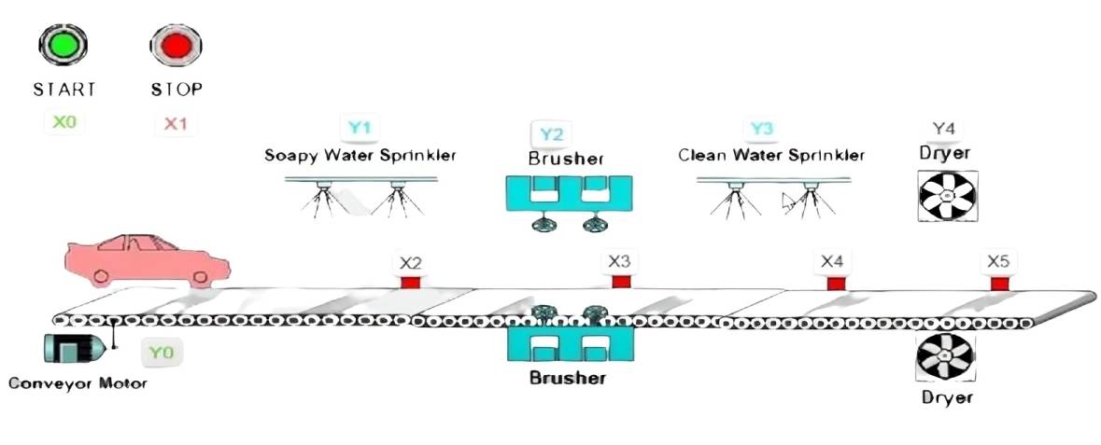

**Figure 1: Working of car wash system**

The working of the automated car wash system is based on a sequential process controlled by the PLC. The operational sequence is as follows:

1. **Car Detection**: When a car enters the wash bay, it is detected by an infrared (IR) sensor. The sensor sends a signal to the PLC, triggering the initiation of the car wash process.
2. **Conveyor Belt Activation**: The PLC activates the conveyor belt, allowing the car to move through different cleaning stages.
3. **Initial Water Spray**: The water pump is activated to spray water on the car, removing surface dirt and debris.
4. **Shampoo Application**: After the initial rinse, the PLC activates the shampoo sprayer to apply detergent on the car.
5. **Brushing Process**: The brush system is activated, and rotating brushes scrub the car’s surface to remove stubborn dirt and grime.
6. **Rinsing**: The water pump is reactivated to rinse off the applied shampoo and loosened dirt.
7. **Drying**: The dryer system blows hot air to dry the car, ensuring a clean and polished finish.
8. **Completion and Reset**: Once the car completes the washing process, the PLC stops all operations and resets the system for the next cycle.

**Block Diagram**

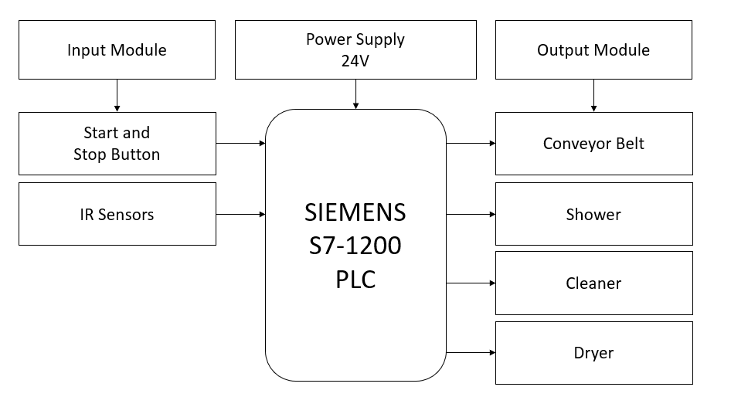

**Figure 2: Block diagram of car wash system**

**IV. PLC Ladder Logic**

PLC ladder logic programming controls the stages of the car wash process through input and output signals:

* **Input Signal Processing:** IR sensor sends signals to the PLC.
* **Conveyor Belt Control:** PLC activates the conveyor motor.
* **Water and Shampoo Control:** Timed output signals activate the water pump and shampoo sprayer.
* **Brush System Control:** PLC controls the brush motor.
* **Drying System Control:** Air blower is activated by the PLC.
* **Process Termination:** PLC terminates operations and resets the system.

**V. Advantages**

The automated car wash system using PLC offers numerous advantages, including:

* **Reduced Manual Labor:** Automation minimizes human intervention.
* **Optimal Resource Utilization:** Efficient use of water, power, and chemicals.
* **Improved Consistency:** Ensures uniform cleaning for every car.
* **Time Efficiency:** Shortens washing time, enhancing customer satisfaction.
* **Operational Safety:** Reduces the risk of human error and operational hazards.

**VI. Challenges**

While the implementation of a PLC-controlled car wash system offers numerous benefits, certain challenges must be addressed,

* **High Initial Setup Cost:** Significant investment required for PLC systems.
* **Maintenance Requirement:** Regular maintenance is necessary for smooth operation.
* **Technical Knowledge:** Skilled personnel needed for programming and troubleshooting.
* **Power Dependency:** Reliance on electricity may cause downtime during power failures

**VII. Result and Discussion**

|  |  |  |
| --- | --- | --- |
| **Parameter** | **Traditional Method** | **PLC-Based System** |
| Washing Time | 10-15 mins | 3-5 mins |
| Water Consumption | 100-150 liters | 50-80 liters |
| Energy Requirement | High | Optimized |
| Consistency | Variable | High |
| Labor Requirement | Manual | Minimal |

**Key Findings**

* **Efficiency:** Reduced washing time compared to traditional methods.
* **Water Conservation:** Sensor-based operation controls water usage.
* **Energy Savings:** Optimized use of pumps and dryers reduces power consumption.
* **Operational Reliability:** High consistency with minimal human intervention.
* **Reduced Maintenance:** Fewer maintenance needs compared to traditional systems.

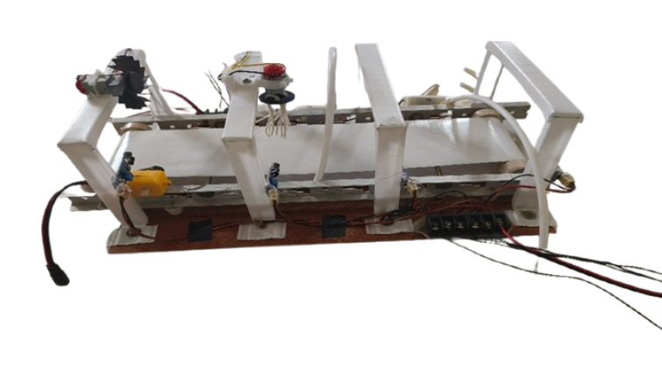

**Figure 3: Working model of car wash system**

1. The outcome of the testing process carried out on
2. the car washing process on the system is given in the
3. Table 1and 2. The time taken to movethe carto be
4. washed from entry point to the washing unit is
5. measured with a stop watch. This is similar to work of
6. Singh et al. (2018) that uses a PLC to set the time taken
7. to move the car to the wash room. The velocity of the
8. conveyer belt is calculated from the reduced driving
9. speed of 14Hz of the system. The total time recorded
10. for completion of the car washing is also recorded for
11. various cars. Figure 4 represents the time analysis of the
12. washing process. Total time consumed to complete the
13. washing operation = Time at conveyer belt + Time at
14. washing unit + delay, this is also in line with Oyeleke
15. et al. (2014) in their work the development of a fruit
16. washing machine. Delay time is the time taken for the
17. car to move up and down the bridge of the washing
18. station.
19. Successful experimental results were obtained from
20. the previously described scheme indicating that the
21. The outcome of the testing process carried out on
22. the car washing process on the system is given in the
23. Table 1and 2. The time taken to movethe carto be
24. washed from entry point to the washing unit is
25. measured with a stop watch. This is similar to work of
26. Singh et al. (2018) that uses a PLC to set the time taken
27. to move the car to the wash room. The velocity of the
28. conveyer belt is calculated from the reduced driving
29. speed of 14Hz of the system. The total time recorded
30. for completion of the car washing is also recorded for
31. various cars. Figure 4 represents the time analysis of the
32. washing process. Total time consumed to complete the
33. washing operation = Time at conveyer belt + Time at
34. washing unit + delay, this is also in line with Oyeleke
35. et al. (2014) in their work the development of a fruit
36. washing machine. Delay time is the time taken for the
37. car to move up and down the bridge of the washing
38. station.
39. Successful experimental results were obtained from
40. the previously described scheme indicating that the
41. The outcome of the testing process carried out on
42. the car washing process on the system is given in the
43. Table 1and 2. The time taken to movethe carto be
44. washed from entry point to the washing unit is
45. measured with a stop watch. This is similar to work of
46. Singh et al. (2018) that uses a PLC to set the time taken
47. to move the car to the wash room. The velocity of the
48. conveyer belt is calculated from the reduced driving
49. speed of 14Hz of the system. The total time recorded
50. for completion of the car washing is also recorded for
51. various cars. Figure 4 represents the time analysis of the
52. washing process. Total time consumed to complete the
53. washing operation = Time at conveyer belt + Time at
54. washing unit + delay, this is also in line with Oyeleke
55. et al. (2014) in their work the development of a fruit
56. washing machine. Delay time is the time taken for the
57. car to move up and down the bridge of the washing
58. station.
59. Successful experimental results were obtained from
60. the previously described scheme indicating that the
61. The outcome of the testing process carried out on
62. the car washing process on the system is given in the
63. Table 1and 2. The time taken to movethe carto be
64. washed from entry point to the washing unit is
65. measured with a stop watch. This is similar to work of
66. Singh et al. (2018) that uses a PLC to set the time taken
67. to move the car to the wash room. The velocity of the
68. conveyer belt is calculated from the reduced driving
69. speed of 14Hz of the system. The total time recorded
70. for completion of the car washing is also recorded for
71. various cars. Figure 4 represents the time analysis of the
72. washing process. Total time consumed to complete the
73. washing operation = Time at conveyer belt + Time at
74. washing unit + delay, this is also in line with Oyeleke
75. et al. (2014) in their work the development of a fruit
76. washing machine. Delay time is the time taken for the
77. car to move up and down the bridge of the washing
78. station.

**VIII. Conclusion**

The integration of PLC-based automation in car wash systems has significantly improved operational efficiency, minimized manual labor, and optimized resource usage. This study demonstrated the system’s design, working principle, and ladder logic programming. Future improvements may include incorporating IoT technology for remote monitoring, predictive maintenance, and further environmental sustainability through eco-friendly cleaning solutions and water recycling

**Acknowledgement**

The authors would like to express their profound gratitude to the faculty and staff of the Department of Electrical Engineering at the Meerut Institute of Engineering and Technology for their invaluable guidance and support throughout the course of this research. In particular, we would like to thank Head of Department for their expert advice on the system design and implementation, and Dr. Noorul Islam for their detailed feedback on the PLC programming and overall methodology. Additionally, we are grateful to Ms. Shweta Shukla for their assistance in the development and testing of the automated car wash system.

We also extend our sincere appreciation to the administrative staff of the institute for providing the necessary resources and facilities that made this research possible.

The authors would also like to acknowledge the unwavering support, understanding, and encouragement of their families, whose constant belief in their abilities has been a source of strength throughout this endeavor.

. **References**

[1] Jin, S., & Xu, Z. (2016). "Design and implementation of an automatic car wash system based on PLC." *International Journal of Control and Automation*, 9(8), 203-214.

[2] Liu, Y., Zhang, H., & Yang, X. (2017). "Automation and control of car washing system using PLC." *Procedia Engineering*, 174, 88-96.

[3] Lee, D. S., Choi, S. M., & Kim, J. W. (2018). "PLC-based control system for automated car washing stations." *Journal of Automation and Control Engineering*, 6(3), 135-142.

[4] Industrial Automation Handbook, John W. Webb, 2020.

[5] Programmable Logic Controllers: Theory and Implementation, Hugh Jack, 2019.

[6] Smart Car Wash Systems, IEEE Transactions on Industrial Electronics, 2021.

[7] Automation in the Automotive Industry, Journal of Engineering and Technology, 2022.

[7] IoT-Based Smart Car Wash Systems, International Journal of Smart Technologies, 2023.

[8] Machine Learning in Industrial Automation, IEEE Transactions on Automation Science, 2024.