Data Privacy and Ethical Consideration in Data Science

### Leena Moundekar1, Vaishnavi Shreekhande2, Yamini Kanekar3, Bhagyashree Kumbhare4

Students, MCA, Smt. Radhikatai Pandav College of Engineering, Nagpur, India1,2

Professor, MCA, Smt. Radhikatai Pandav College of Engineering, Nagpur, India4

HOD, MCA, Smt. Radhikatai Pandav College of Engineering, Nagpur, India5

# Abstract :

In the era of big data, the rapid growth of data science has revolutionized how organizations collect, analyze, and utilize data. However, this surge in data-driven innovation brings significant challenges, particularly regarding data privacy and ethical considerations. As individuals increasingly share personal information through digital platforms, safeguarding their privacy becomes paramount. Data breaches, misuse of sensitive data, and algorithmic biases can harm individuals and society, raising urgent ethical concerns. This paper explores the fundamental principles of data privacy and ethics in data science, emphasizing the need for transparent, accountable, and fair practices. The discussion includes privacy-preserving techniques, such as anonymization and encryption, and examines ethical frameworks like fairness, accountability, and transparency. Addressing these considerations ensures that data science can harness its potential while safeguarding individuals' rights and societal values.

**Keywords:** Data Science; Ethics; Privacy; Utility; Ethical Frameworks; Federated Learning; Informed Consent; Algorithmic Biases; Transparency Challenges; User-Centric Approach; Responsible Data Practices

# I.Introduction:

Data science has emerged as a critical discipline that drives innovation across various sectors, from healthcare and finance to marketing and public policy. With the ability to process vast amounts of data, advanced algorithms have made it possible to derive insights and predictions that were

previously unattainable. However, as data science increasingly relies on personal and sensitive data, the ethical implications of how this data is collected, processed, and used have come into sharp focus.

The issue of data privacy is particularly significant, as individuals often have limited control over how their data is used once it is shared. The growing number of high-profile data breaches and incidents of data misuse have highlighted the risks associated with poor data management practices. At the same time, ethical concerns arise when algorithms and models, particularly those used in artificial

intelligence (AI) and machine learning, unintentionally perpetuate biases or lead to unfair outcomes.

Balancing the benefits of data science with the need to protect individual privacy and maintain ethical standards is a challenge for researchers, policymakers, and organizations alike. This paper delves into the core aspects of data privacy and ethics, providing a comprehensive overview of the current

landscape and proposing strategies to address these critical concerns. By exploring both legal frameworks and technical solutions, it aims to promote responsible data practices that ensure fairness, accountability, and transparency in the application of data science.

# Literature reviews:

These discussions span various disciplines, including computer science, law, ethics, and social sciences, reflecting the complex and multifaceted nature of the challenges involved. This literature review explores key concepts, frameworks, and perspectives from scholars and experts.

### Data Privacy: Legal and Technical Perspectives

The concept of data privacy is central to discussions surrounding the ethical use of data. Privacy

concerns have intensified as organizations collect, store, and analyze vast amounts of personal data. Legal scholars and technologists have both contributed significantly to the understanding of data privacy.

* + **Legal Frameworks**: Many researchers have focused on the legal mechanisms that govern data privacy. The **General Data Protection Regulation (GDPR)** in the European Union is

often cited as a landmark in privacy legislation, offering a robust framework for the protection of individuals' personal data. Studies by scholars like Solove (2008) highlight how data

privacy laws have evolved in response to technological advancements, but also emphasize the limitations and loopholes in these legal structures. In the U.S., the **California Consumer**

**Privacy Act (CCPA)** and other regional laws have begun to address privacy, though a comprehensive national privacy law remains elusive (Bamberger & Mulligan, 2015).

* + **Privacy-Preserving Techniques**: On the technical side, data privacy researchers have explored various methods to protect individual privacy while enabling data analysis.

**Anonymization**, **differential privacy**, and **encryption** are key techniques discussed in the literature (Dwork & Roth, 2014). Differential privacy, in particular, has gained traction as a method that allows organizations to perform data analysis while providing mathematical guarantees that individual data points cannot be reverse-engineered (Abowd, 2018).

# Ethical concerns in data science:

The ethical challenges associated with data science go beyond privacy to encompass a broader set of concerns. These include issues of **fairness**, **accountability**, and **transparency** (FAT), which are frequently addressed in recent studies.

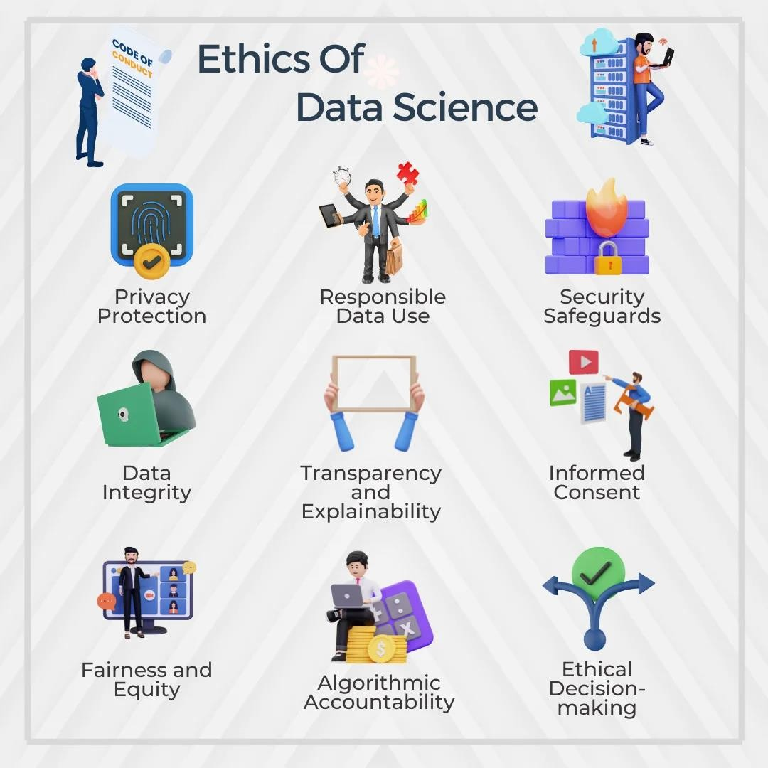

* + **Fairness**: One of the primary ethical concerns is the risk of bias in data and algorithms.

Machine learning algorithms can unintentionally perpetuate existing societal biases if they are trained on biased data. Studies, such as those by Barocas and Selbst (2016), discuss how

algorithmic decision-making can lead to unfair treatment of certain groups, particularly in

domains like hiring, criminal justice, and lending. Researchers have proposed various fairness metrics and interventions, such as fairness constraints and adversarial debiasing, to mitigate these effects (Zemel et al., 2013).

* + **Accountability**: The issue of accountability is also central to the ethics of data science.

Pasquale (2015) has raised concerns about the opacity of many machine learning models, particularly deep learning systems, which are often seen as "black boxes" due to their

complexity. This lack of transparency makes it difficult to understand how decisions are made and who should be held accountable when things go wrong. As a result, scholars have called for greater efforts to make algorithms interpretable and to ensure that data scientists and

organizations can be held accountable for the outcomes of their models (Doshi-Velez & Kim, 2017).

* + **Transparency**: Transparency, closely related to accountability, refers to the need for clear communication about how data is collected, processed, and used. Studies by Diakopoulos (2016) and Mittelstadt et al. (2016) emphasize that individuals should have a right to know

how algorithms make decisions that affect them, whether in the context of online platforms, credit scoring, or job recruitment. The push for transparency has led to the development of tools and frameworks that enable more interpretable machine learning models and clearer

disclosure of data practices.

### Ethics of Data Sharing and Ownership

Another ethical concern highlighted in the literature is the question of data ownership and sharing. With the rise of data-driven platforms and applications, issues around consent, data control, and ownership have become more prominent.

* + **Consent and Control**: Privacy scholars such as Nissenbaum (2010) argue that informed consent is often inadequate in the digital age, as individuals are typically unaware of how their data will be used once it is collected. This raises ethical concerns about whether individuals truly control their personal data. Studies like those of Shilton (2012) explore the concept of **privacy by design**, which calls for embedding privacy principles into the architecture of systems from the outset, rather than as an afterthought.
  + **Data as a Commodity**: The commodification of data is another ethical issue. Companies often treat personal data as an asset that can be sold or traded, which raises concerns about the exploitation of individuals' data for profit. Zuboff (2019) discusses this in her concept of "surveillance capitalism," where personal data is extracted and used to predict and modify human behavior, often without the individual's knowledge or consent. This commodification of data has been critiqued for undermining the autonomy of individuals and leading to greater social inequalities.

### Ethical Frameworks and Guidelines for Data Science

To address the ethical concerns of data science, scholars have proposed various ethical frameworks and guidelines. These frameworks typically emphasize core principles such as fairness, transparency, accountability, and privacy.

* + **FAT (Fairness, Accountability, Transparency)**: The FAT framework has become widely discussed in the ethical literature on data science (Barocas, Hardt, & Narayanan, 2019). This

approach suggests that data scientists and organizations should strive to ensure that algorithms are fair in their outcomes, that organizations are held accountable for their use of data, and that systems are transparent in their operation. The FAT framework has influenced policy discussions and the development of responsible AI guidelines by organizations such as the IEEE and the European Commission (Floridi et al., 2018).

* + **Ethical Guidelines from Professional Bodies**: Professional organizations such as the **Association for Computing Machinery (ACM)** and the **Institute of Electrical and Electronics Engineers (IEEE)** have developed codes of ethics for computing and data science professionals. These guidelines provide high-level recommendations on topics such as user privacy, non-discrimination, and professional accountability (ACM Code of Ethics, 2018). Ethical AI initiatives by tech companies and governments also propose similar principles to guide the development and deployment of AI systems (Jobin, Ienca, & Vayena, 2019).

# Responsible data science:

Responsible data science refers to the practice of developing, deploying, and using data-driven technologies in ways that are ethical, transparent, and aligned with societal values. It encompasses a wide range of considerations, including fairness, accountability, transparency, and data privacy, ensuring that data science benefits society while minimizing harm. The rise of artificial intelligence (AI), machine learning (ML), and big data analytics has heightened the need for responsible data science to prevent unethical use of data and avoid unintended consequences like bias or privacy violations.

Ensuring fairness in data science involves mitigating biases that can be introduced by algorithms or by the data itself. When data used to train models is biased, the resulting algorithms may perpetuate or even amplify existing inequalities. For example, in hiring algorithms, biased data may lead to discrimination against certain demographic groups. **Fairness-aware algorithms** are designed to ensure that model outcomes are equitable across different population segments, addressing issues like race, gender, and socioeconomic status.

### Transparency and Interpretability

Transparency refers to the openness with which data science systems, particularly algorithms, operate. In complex machine learning models, such as deep learning, the decision-making process can be opaque, making it difficult to understand how certain outcomes are derived. This "black box" issue undermines trust in these systems. To counter this, responsible data science emphasizes the need for **model interpretability** and transparency, providing stakeholders with clear explanations of how algorithms make decisions and the data used in the process.

### Accountability

Accountability in data science implies that organizations and individuals responsible for data

collection, processing, and analysis must be answerable for the outcomes of their models. This means being proactive in identifying and addressing risks associated with data misuse, bias, or unethical

application of algorithms. Ethical oversight mechanisms, such as internal audits or external reviews, help ensure that data science practices align with organizational values and societal expectations.

# Regulation and Governance:

As data science becomes more deeply embedded in society, the regulation and governance of data

collection, processing, and usage have become critical to ensuring that organizations act ethically and protect individuals' rights. Regulatory frameworks, governance standards, and oversight mechanisms

play key roles in managing the ethical and privacy-related challenges associated with data science. These measures are essential to prevent abuses of data, such as breaches of privacy, discriminatory practices, and unethical use of algorithms.

### Data Protection Laws

Several legal frameworks around the world have been established to regulate data privacy and enforce the responsible use of data. Two key regulations in this space are the **General Data Protection**

### Regulation (GDPR) and the California Consumer Privacy Act (CCPA).

* + **General Data Protection Regulation (GDPR)**: Enacted by the European Union in 2018, GDPR is one of the most comprehensive and strict data protection laws globally. It applies to any organization that collects or processes data related to EU citizens, even if the organization is located outside the EU. GDPR emphasizes the importance of user consent, data

minimization, and the right of individuals to control their personal data. Key principles include:

* + - **Consent**: Organizations must obtain clear and informed consent before collecting personal data.
    - **Right to Access and Erasure**: Individuals have the right to request access to their data and to have it deleted under certain conditions (right to be forgotten).
    - **Data Minimization**: Only data that is necessary for the specified purpose should be collected.
    - **Privacy by Design**: Data protection should be built into systems from the start (rather than added afterward), ensuring that privacy considerations are part of the design

process.

* + - **Data Breach Notification**: Organizations must notify regulatory authorities and affected individuals in the event of a data breach.
  + **California Consumer Privacy Act (CCPA)**: Introduced in the U.S. state of California, CCPA grants residents specific rights regarding their personal data. It is a leading privacy law in the

U.S. and sets the stage for future federal regulation. Under CCPA, California residents have the right to:

* Know what personal data is being collected.
* Request that their data be deleted.
* Opt-out of the sale of their personal data.
* Non-discrimination if they exercise their privacy rights.

The CCPA focuses on giving consumers greater control over how their data is used, reflecting an important shift towards privacy-centric regulations in the U.S.

### Data Governance Frameworks

Beyond legal regulation, organizations are adopting **data governance** frameworks to ensure that data practices are ethical, transparent, and aligned with both regulations and corporate values. Data governance refers to the policies, processes, and structures that guide how data is managed within an organization.

* + **Data Stewardship and Accountability**: Effective data governance involves appointing **data stewards** or **data protection officers (DPOs)** who are responsible for overseeing data

management practices and ensuring compliance with legal regulations such as GDPR and CCPA. These officers help create an accountable data ecosystem, ensuring that data is

handled ethically across its lifecycle.

* + **Privacy by Design**: Privacy by design is a core principle embedded in many data governance frameworks. It requires that privacy and data protection considerations are integrated into the design and architecture of systems from the outset. By incorporating privacy features such as encryption, anonymization, and access controls from the beginning, organizations can reduce the risk of privacy violations.
  + **Algorithmic Audits and Accountability**: Governance frameworks increasingly include

mechanisms for auditing algorithms to ensure fairness and accountability. **Algorithmic audits**

examine the data inputs, model design, and outcomes to detect biases, unfair treatment, or unintended consequences that may arise from data-driven decisions. This ensures that data science applications, especially those involving AI, operate transparently and ethically.

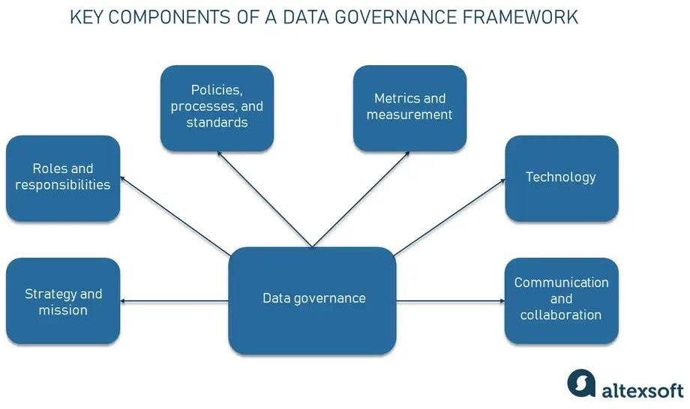

### Ethical Guidelines and AI Governance

In response to the rise of AI and machine learning, governments and industry bodies have created

ethical guidelines for the development and use of AI. These guidelines help address concerns around bias, discrimination, and transparency in automated decision-making processes.

* + **European Union AI Ethics Guidelines**: The EU has been at the forefront of developing ethical guidelines for AI systems. These guidelines emphasize:
    - **Human-centric AI**: AI systems should respect human dignity and autonomy.
    - **Fairness and Non-discrimination**: AI models must be fair and must not reinforce existing biases.
    - **Accountability**: Organizations must take responsibility for the AI systems they deploy and provide transparency on how these systems make decisions.
    - **Robustness and Security**: AI systems should be secure, reliable, and resilient against misuse or manipulation.
  + **OECD AI Principles**: The Organization for Economic Co-operation and Development (OECD) also developed AI principles that emphasize transparency, human rights, and

accountability. These principles aim to guide governments and organizations in the responsible development and deployment of AI systems globally.

### Global Approaches to Data Privacy and AI Regulation

Different regions around the world are adopting varied approaches to data privacy and AI regulation:

* + **United States**: While there is no overarching federal privacy law, states like California have taken the lead with laws like CCPA. There are ongoing discussions about federal data privacy legislation, which would harmonize privacy regulations across the country.
  + **European Union**: In addition to GDPR, the EU is working on regulations for **AI systems** through the proposed **AI Act**, which aims to regulate high-risk AI applications, ensuring they meet stringent requirements related to fairness, safety, and accountability.
  + **China**: China has introduced the **Personal Information Protection Law (PIPL)**, which regulates the collection and processing of personal data and imposes requirements on both domestic and foreign entities. The PIPL emphasizes data security, personal privacy, and the

protection of citizens’ rights, though it differs from GDPR in terms of the scope and nature of state involvement in data oversight.

# Data Privacy:

### Data Privacy in Data Science

Data privacy is one of the most significant ethical considerations in data science. As data science

relies on vast amounts of data, much of it personal or sensitive, ensuring that privacy is preserved is essential. In this context, privacy refers to the protection of individuals' data from unauthorized

access, misuse, or exploitation.

### Personal Data and Data Anonymization

Personal data includes any information that can identify an individual, such as names, email addresses, social security numbers, and even IP addresses. To protect individual privacy, data scientists often rely on **anonymization** and **pseudonymization** techniques.

* + **Anonymization**: This process removes personally identifiable information (PII) from a dataset, making it impossible to trace data back to an individual. However, true

anonymization can be challenging to achieve, as sophisticated techniques may still allow for re-identification of individuals by correlating data points with other datasets.

* + **Pseudonymization**: In this method, identifiable information is replaced with pseudonyms,

allowing for data to be linked to individuals without directly revealing their identities. While pseudonymization offers privacy protection, it is not as strong as anonymization, as it allows for the possibility of re-linking the data to individuals under certain conditions.

### Differential Privacy

**Differential privacy** is an advanced privacy-preserving technique that allows data scientists to

analyze datasets and derive insights without revealing information about individual data points. This technique ensures that the inclusion or exclusion of any single data point does not significantly affect the outcome of an analysis, making it difficult to infer specific information about individuals.

For example, companies like **Apple** and **Google** have implemented differential privacy in their systems to analyze user behavior while safeguarding personal information. Differential privacy is

increasingly being adopted by both private organizations and governmental institutions to balance the need for data analysis with individual privacy.

### Data Minimization and Purpose Limitation

**Data minimization** is a privacy principle that mandates organizations to collect only the data that is necessary for a specific purpose. Collecting excessive or irrelevant data increases the risk of privacy violations and data breaches. **Purpose limitation** goes hand-in-hand with this, ensuring that data is used only for the purpose it was originally collected for, and not for unrelated or unauthorized purposes. Both principles are core components of privacy regulations such as GDPR.

### Informed Consent and User Control

Obtaining **informed consent** is a cornerstone of data privacy. It requires organizations to be transparent about how they collect, use, and share personal data. Individuals must be given clear,

concise information about how their data will be used and should be able to opt-in or opt-out of data collection processes.

Moreover, giving individuals control over their data, such as the ability to access, modify, or delete it, is critical for maintaining trust between organizations and users. This empowerment of users is enshrined in regulations like GDPR, which grants individuals the **right to be forgotten** and the right to access their personal data.

### Privacy by Design and Security Measures

Privacy by design integrates privacy considerations into the core of system design and development. Organizations are encouraged to build privacy features, such as encryption and access controls, into their products and services from the very beginning rather than addressing privacy concerns as an afterthought. Additionally, organizations must implement robust **security measures**, such as

encryption, firewalls, and data access controls, to protect data from breaches or unauthorized access.

# Conclusion:

The present study delved into the intricate domain of ethical considerations in data science, focusing on the delicate equilibrium between privacy and utility. Through a meticulous investigation of

established ethical frameworks, the examination of federated learning's implications, and the proposition of user-centric consent methods, this study sought to contribute to the ongoing discourse on responsible data practices.

In the age of big data, the need for responsible data science is more pressing than ever. Regulatory frameworks like GDPR and CCPA set the foundation for data privacy and ethical data use, but

organizations must go beyond mere compliance to integrate principles of fairness, accountability, and transparency into their data practices.

Regulation and governance are essential for ensuring that data science operates in an ethical and privacy-respecting manner. Frameworks like GDPR and CCPA, combined with governance structures that emphasize transparency, accountability, and fairness, provide a legal and ethical foundation for responsible data science practices. At the same time, advanced privacy-preserving techniques such as differential privacy, data minimization, and informed consent enable organizations to harness the power of data science while protecting individuals

# Reference:

## Braun, A., & Garriga, G. (2018). Consumer journey analytics in the context of data

privacy and ethics. In C. Linnhoff-Popien, R. Schneider & M. Zaddach (Eds.), *Digital marketplaces unleashed*. Berlin: Springer.

## Beagrie and Houghten (2014), The Value of Data Sharing and Curation, Charles Beagrie Ltd, Victoria University, and JISC 2013.

([http://repository.jisc.ac.uk/5568/1/iDF308_-](http://repository.jisc.ac.uk/5568/1/iDF308_-_Digital_Infrastructure_Directions_Report%2C_Jan14_v1-04.pdf)

## [_Digital_Infrastructure_Directions_Report%2C_Jan14_v1-04.pdf](http://repository.jisc.ac.uk/5568/1/iDF308_-_Digital_Infrastructure_Directions_Report%2C_Jan14_v1-04.pdf)).

* Barbosa, M. W., A. D. L. C. Vicente, M. B. Ladeira, and M. P. V. D. Oliveira. 2018. “Managing Supply Chain Resources with Big Data Analytics: A Systematic Review.” *International Journal of Logistics Research and Applications* [21(open in a](https://doi.org/10.1080/13675567.2017.1369501) [new window)](https://doi.org/10.1080/13675567.2017.1369501) ([3(open in a new window)](https://doi.org/10.1080/13675567.2017.1369501)): 177–200.

doi:[https://doi.org/10.1080/13675567.2017.1369501(open in a new window)](https://doi.org/10.1080/13675567.2017.1369501).

* Bumblauskas, D., H. Nold, P. Bumblauskas, and A. Igou. 2017. “Big Data Analytics: transforming Data to Action.” *Business Process Management Journal* [23(open in a](https://doi.org/10.1108/BPMJ-03-2016-0056)

## [new window)](https://doi.org/10.1108/BPMJ-03-2016-0056) ([3(open in a new window)](https://doi.org/10.1108/BPMJ-03-2016-0056)): 703–720.

doi:[https://doi.org/10.1108/BPMJ-03-2016-0056(open in a new window)](https://doi.org/10.1108/BPMJ-03-2016-0056).

* Attewell, P., Monaghan, D. B., & Kwong, D. (2015). *Data mining for the social sciences: An introduction*. University of California

Press. [https://www.jstor.org/stable/10.1525/j.ctt13 × 1gcg](https://www.jstor.org/stable/10.1525/j.ctt13x1gcg)

## Cass, S. (1999). Researcher charged with data theft. *Nature Medicine*, *5*(5), 474–

474. <https://doi.org/10.1038/8350>

## Choudhury, S., J.R. Fishman, M.L. McGowan, and E.T. Juengst. 2014. Big data, open science and the brain: Lessons learned from genomics. *Frontiers in Human*

*Neuroscience* 8: 239. doi:[10.3389/fnhum.2014.00239](https://doi.org/10.3389/fnhum.2014.00239).