# DETECTION OF BOTNET IN IOT USING MACHINE LEARNING

# Vyshnav Unnikrishnan 1 Jobin Mathew Samkutty2 Navin M Mathew3 Muhammad Shareef C S 4 Chandu Asok5

*1,2,3,4 (B.Tech, Computer Science, St.Thomas College of Engineering And Technology, Chengannur, India)*

*5 (Assistant Professor B.Tech, Computer Science, St.Thomas College of Engineering And Technology, Chengannur, India)*

***Abstract***: *The proliferation of Internet of Things (IoT) devices has introduced unprecedented connectivity and convenience but also heightened the vulnerability to botnet attacks. There are an increasing number of Internet of Things (IoT) devices connected to the network these days, and due to the advancement in technology, the security threads and cyberattacks, such as botnets, are emerging and evolving rapidly with high-risk attacks. These attacks disrupt IoT transition by disrupting networks and services for IoT devices. Many recent studies have proposed ML and DL techniques for detecting and classifying botnet attacks in the IoTenvironment. This project presents a straightforward approach to detect botnet activity within IoT networks through the utilization of machine learning techniques. By analyzing network traffic patterns and employing unsupervised learning algorithms, we demonstrate an effective method to identify and mitigate botnet threats in IoT environments. By this project we intend to offer a valuable contribution in enhancing the security of IoT ecosystem.*

***Key Word* :** *Internet of Things(IoT),cybersecurity,botnet attacks,machine learning(ML),UNSW-NB15 dataset,exploratory data analysis,XgBoost.*

1. **Introduction**

The ascent of Web of Things (IoT) gadgets has achieved a flood in IoT-based attacks, with Iot botnet assaults arising as one of the most serious danger. Traditional security measures frequently struggle to keep up with the sophistication of these attacks, necessitating the development of advanced detection techniques, such as machine learning-based approaches that analyze full-time series data to identify malware behavior. These attacks, which are orchestrated by malicious actors, involve infecting internet-connected IoT devices with malware in order to remotely control them. Detecting and mitigating such threats pose significant challenges due to the evolving strategies of attackers and the decentralized nature of botnets.

Botnets,formed through the contamination and change of various gadgets into bots heavily influenced by a botmaster,operate secretive to help out different noxious activities.Orchestrated through order and control infrastructure,botnets can lauch disseminated forswearing of administration (DDoS) attacks,steal delicate data,and spread malware further.Detection endeavors face deterrents because of the polymorphic idea of botnet malware aand the powerful development of their tactics.Effective counteraction and moderation procedures include a diverse approach,including antivirus software,network monitoring,and client education.Moreover, the use of machine learning,particulary directed and solo learning,holds guarantee in enchancing botnet identification capabilities,through challenges continue staying up with the continually developing danger scene.

1. **System Design**

In the case of botnet detection in IoT systems, dataset preparation is a crucial step in the development of any machine learning model. The UNSW-NB15 dataset, which serves as the basis for training and evaluating the botnet detection framework, must be obtained and preprocessed as part of this procedure. The UNSW-NB15 dataset, a notable benchmark dataset in online protection research, contains network traffic information gathered from different sources, including both ordinary and malevolent exercises. Preprocessing this dataset includes different undertakings, for example, information cleaning, standardization, and element designing to guarantee its reasonableness for preparing AI models. Exploratory information examination (EDA) assumes a fundamental part in understanding the qualities of the dataset. Researchers are able to gain insight into the distribution of features, identify potential patterns or anomalies, and identify any imbalances or biases in the data through the use of EDA. This exploratory phase informs feature selection and preprocessing strategies and guides subsequent model development steps. Once the dataset is ready, the system coordinates a multi-facet network classifier intended to recognize ordinary organization traffic and botnet movement. This classifier use progressed AI methods, including Choice Trees, XgBoost, and Calculated Relapse, to successfully order network traffic into double groupings. Relevant data is extracted from raw network traffic data using feature extraction methods. These strategies recognize key qualities or characteristics that are demonstrative of botnet conduct, for example, uncommon correspondence designs, parcel sizes, or organization conventions.

By zeroing in on these highlights, the classifier can figure out how to precisely separate among harmless and pernicious organization movement more. Performance metrics are used to evaluate the classifier's effectiveness in detecting botnet activity after it has been trained. These measurements incorporate exactness, accuracy, review, and F1 score, which give experiences into the model's capacity to accurately characterize network traffic. By dissecting these measurements, specialists can evaluate the general exhibition of the botnet identification system and distinguish regions for development. Certifiable approval is a basic move toward evaluating the flexibility of the system. The trained model is put to the test on real-world network traffic data during this phase to see how well it works in real-world situations. This approval cycle guarantees that the structure can really recognize botnet action in assorted conditions, incorporating those not addressed in the preparation dataset. Constant improvement systems are coordinated into the structure to address advancing dangers and difficulties in IoT security. These instruments include intermittent retraining of the model with refreshed datasets and the fuse of new elements or calculations to upgrade identification abilities. The framework continues to be effective at mitigating emerging botnet threats in IoT systems by continuously iterating on the model and adapting to changing circumstances. All in all, the most common way of planning and carrying out a botnet recognition system includes a few key stages, including dataset securing, preprocessing, highlight extraction, model preparation, execution assessment, certifiable approval, and consistent improvement. By following this extensive methodology, analysts can foster hearty and versatile answers for improve safety efforts in IoT conditions

1. .**Block diagram**

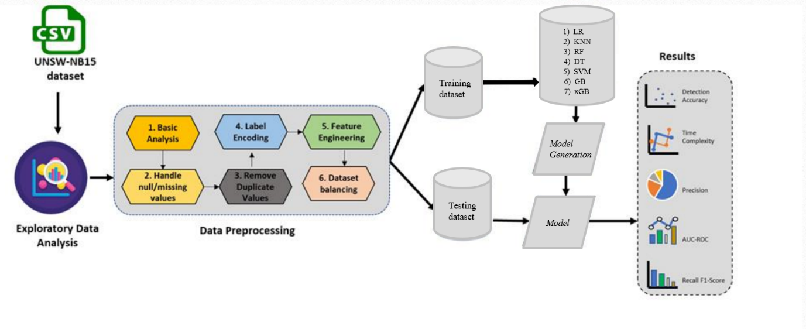

**Figure 1 :** Block diagram of the System

1. **Materials and Methods**

The dataset used for this task, UNSW NB-15, was made by the IXIA PerfectStorm apparatus in UNSW Canberra's Digital Reach Lab to recreate true half breed network exercises and contemporary assault ways of behaving. It includes nine kinds of assaults, like Fuzzers, Observation, DoS, and Worms, among others. Twelve calculations were concocted to create 49 elements in light of class marks, depicted in NB15_features.csv. With over 2 million records, this dataset provides a comprehensive view of network traffic and makes it easier to create effective intrusion detection systems. Part into preparing and testing sets, the dataset supports assessing botnet location execution, significant for upgrading network safety measures. In our proposed structure, different computer based intelligence approaches are utilized to identify botnet assaults. Strategic Relapse is used for characterization undertakings, anticipating the probability of an occasion having a place with a specific class. It dissects the connection between free factors and the reliant paired variable, producing probabilities through a sigmoid capability. On the other hand, Decision Trees depict decisions and their outcomes in a tree-like structure, making them ideal for operations research and decision support. Despite being susceptible to instability and data noise, they are transparent and interpretable. Support Vector Machines (SVMs) are utilized for both grouping and relapse errands, expecting to find the ideal hyperplane that isolates various classes of information. K-Closest Neighbors (KNN) is a memory-based learning calculation that relegates marks in view of the larger part class among the K nearest neighbors. While it's straightforward and successful, its computational expense can be restrictive with enormous datasets. Irregular Backwoods, a gathering learning method, consolidates various choice trees to frame a strong model. It's fit for dealing with high-layered information and non-direct connections yet can turn out to be excessively mind boggling and hard to decipher.

Another ensemble method, Gradient Boosting, trains models iteratively to improve errors, making it good at capturing complex patterns but prone to overfitting and high computational costs. XGBoost, a famous execution of slope helping choice trees, improves AI models with speed, execution, and usability. It offers highlights like regularization for controlling overfitting and dealing with fragmented datasets. These simulated intelligence techniques, each with its assets and limits, add to the adequacy of the botnet identification system. Assessment of the proposed framework includes measures like the disarray grid, surveying characterization results in view of genuine positive (TP), genuine negative (TN), bogus positive (FP), and misleading negative (FN) cases. This assessment structure guarantees the framework's unwavering quality and exactness in distinguishing botnet assaults in IoT conditions. In general, the joining of different computer based intelligence procedures in the proposed structure exhibits a comprehensive way to deal with botnet recognition, utilizing the qualities of every technique to improve online protection in IoT frameworks. The framework aims to remain adaptable and effective in mitigating emerging threats through continuous evaluation and refinement.

1. **Result and Analaysis**

This part presents the reproduction consequences of our proposed answer for identifying botnet attacks on IoT platforms. We used a 115-attribute N BaIot dataset. comprises of 9 IoT gadgets made out of two lac 70,000 records as info. Weutilized a bunch of grouping measurements, including Recognition Exactness, Review, Pre cision, Region Under Bend (AUC), Genuine Positive Rate (TPR), Bogus Positive Rate (FPR), Bogus Exclusion Rate (FOR), Misleading Negative Rate (FNR), Matthews Correla tion Coefficient (MCC), Negative Prescient Worth (NPV), and F1 Score, to assess the presentation of our framework. We used AI and profound learning al gorithms for detecting any anomalies in an IoT-derived network dataset. botnet assaults.To show the adequacy and validity of our proposed technique, we directed investigations to carry out a model equipped for identifying numerous assaults from IoT botnets. In particular, we utilized AI procedures to recognize oddities in network information got from 9 IOT gadgets. The examination was led on three essential classes, including two botnet assaults (Mirai and gafgyt), which comprise of 11 sub-classes, and a harmless class. This approach was taken to assess the model's viability in identifying different sorts of assaults on IoT gadgets Execution Measures To assess the viability of the proposed technique, different AI models were utilized, and the characterization execution was estimated.

1. Precision: Precision measures the proportion of correctly predicted positive instances to the total predicted positives. It's 55.18% for class 0 and 87.49% for class 1.

2. Recall (Sensitivity): Recall measures the proportion of correctly predicted positive instances to all actual positives. It's 78.67% for class 0 and 70.01% for class 1.

3. F1-Score: The F1-score, the harmonic mean of precision and recall, balances both metrics. It's 0.6486 for class 0 and 0.7778 for class 1.

4. Support: Support is the number of actual instances of each class in the dataset. It's 56,000 for class 0 and 119,341 for class 1.

5. Accuracy: Overall accuracy is 72.78%, indicating the proportion of correctly predicted instances to the total.

6. Macro Average: The macro-average computes the average of metrics across all classes. In this case, F1-score, recall, and precision are all 0.7132.

7. Weighted Average: Weighted average calculates metrics for each label and averages them based on the support. Weighted average precision is 0.7717, recall is 0.7278, and F1-score is 0.7365.

8. Confusion Matrix: The confusion matrix provides a detailed breakdown of the model's performance. True negatives (TN), false positives (FP), false negatives (FN), and true positives (TP) are represented in different quadrants. In this case, there are 44,056 TN, 11,944 FP, 35,790 FN, and 83,551 TP.

The venture assessed the presentation of different classifiers utilizing a multi-class disarray framework on the N-BaIoT dataset, which contains nine unique IoT gadgets. A similar test set was utilized across all classifiers to guarantee a fair examination. For instance, the K-nearest neighbor (KNN) algorithm performed well, correctly classifying a large number of instances across all three classes (TP: 17,926 for Class 0, 18,026 for Class 1, and 18,027 for Class 2) with few false positives and false negatives. This performance is shown in Figure 5.2(a). This demonstrates strong execution across the dataset. Essentially, in Figure 5.2(b), the Choice Tree calculation exhibited high precision, accomplishing a significant number of genuine up-sides (TP: 17,931 for Class 0, 18,036 for Class 1, and 18,031 for Class 2) with practically no misleading up-sides and a negligible number of bogus negatives. The Irregular Woodland classifier, portrayed in Figure 5.2(c), conveyed excellent outcomes by precisely grouping occasions (TP: 17,932 for Class 0, 18,032 for Class 1, and 18,031 for Class 2) while keeping a unimportant number of misleading up-sides and a low count of bogus negatives. However, the Support Vector Machine (SVM) algorithm outperformed the KNN algorithm in terms of the rate of false positives and false negatives , indicating slightly less robust performance in this setting. The confusion matrix for Logistic Regression ,Compared to other algorithms, Logistic Regression had a higher rate of false positives and false negatives, indicating that further optimization or consideration of alternative strategies is required. At last, Angle Supporting exhibited great execution with high precision, negligible misleading up-sides, and no bogus negatives, featuring its viability in accurately characterizing cases across all classes. With their high accuracy and low false positive and false negative rates, Random Forest and Gradient Boosting emerged as the best overall performers. KNN likewise exhibited solid execution, but with few misclassifications. In contrast, the higher rates of false positives and false negatives observed in SVM and Logistic Regression point to potential areas for enhancement or alternative model selection. Extra assessment measurements and further examination might be justified to show up at additional decisive decisions in regards to the calculations' general viability in the particular setting of the dataset.

9.AUC-ROC CURVE

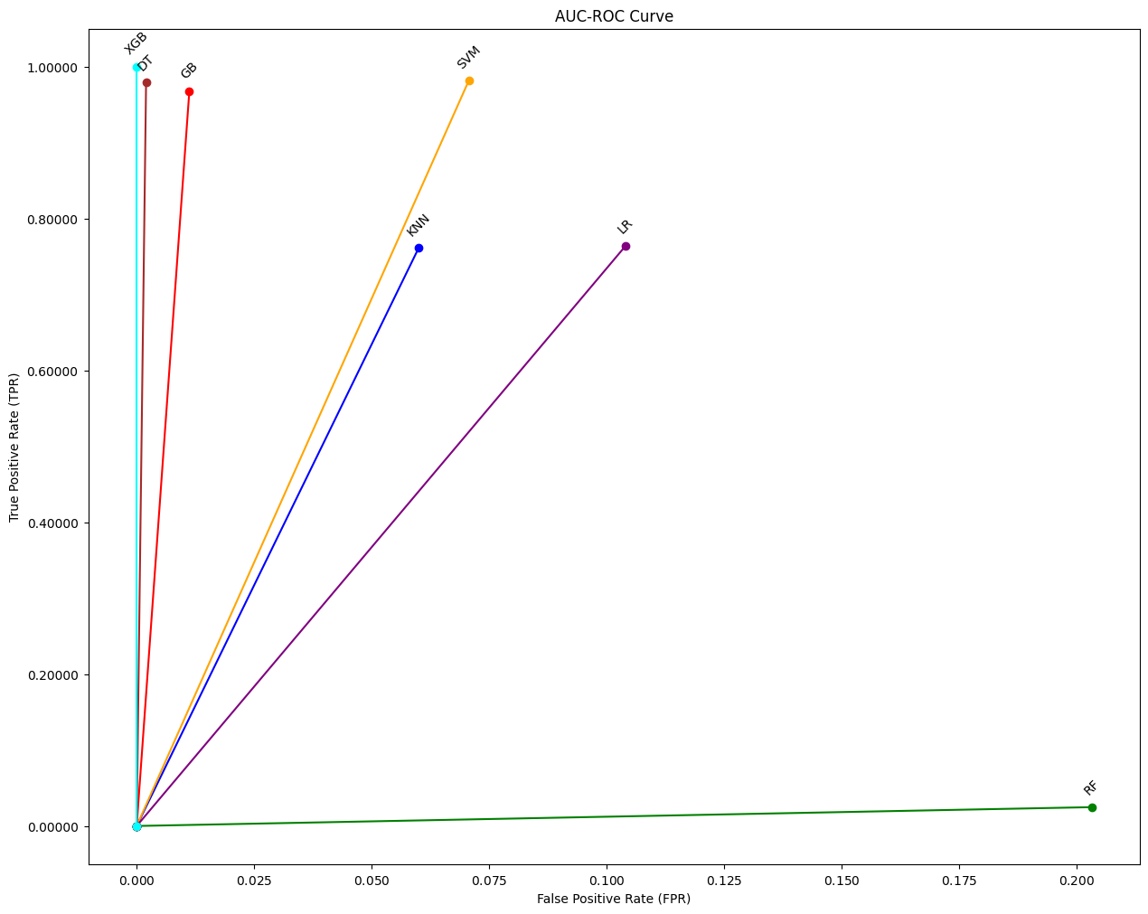

The ROC bend is a graphical portrayal that shows the symptomatic capacity of a parallel classifier framework across various limit settings. At various threshold settings, it plots the True Positive Rate (TPR) against the False Positive Rate (FPR). TPR addresses the extent of positive cases that are accurately recognized as certain (i.e., responsiveness), while FPR addresses the extent of negative examples that are mistakenly distinguished as sure. The AUC-ROC bend is especially helpful for looking at the exhibition of various classifiers. A higher AUC esteem demonstrates better in general execution, as it means a more noteworthy region under the bend and, in this manner, a superior compromise among responsiveness and explicitness. In this specific situation, the slight cross-over of the ROC bends for RF and DT proposes that these calculations perform much the same way as far as accurately grouping examples across the harmless, Mirai, and Gafgyt classes. This perception could show that both RF and DT are successful in recognizing these classes with similar precision and effectiveness. In general, the AUC-ROC curve analysis aids in the selection and optimization of classifiers for particular classification tasks by providing useful insights into the discriminatory power and performance consistency of various machine learning algorithms.

10.ACCURACY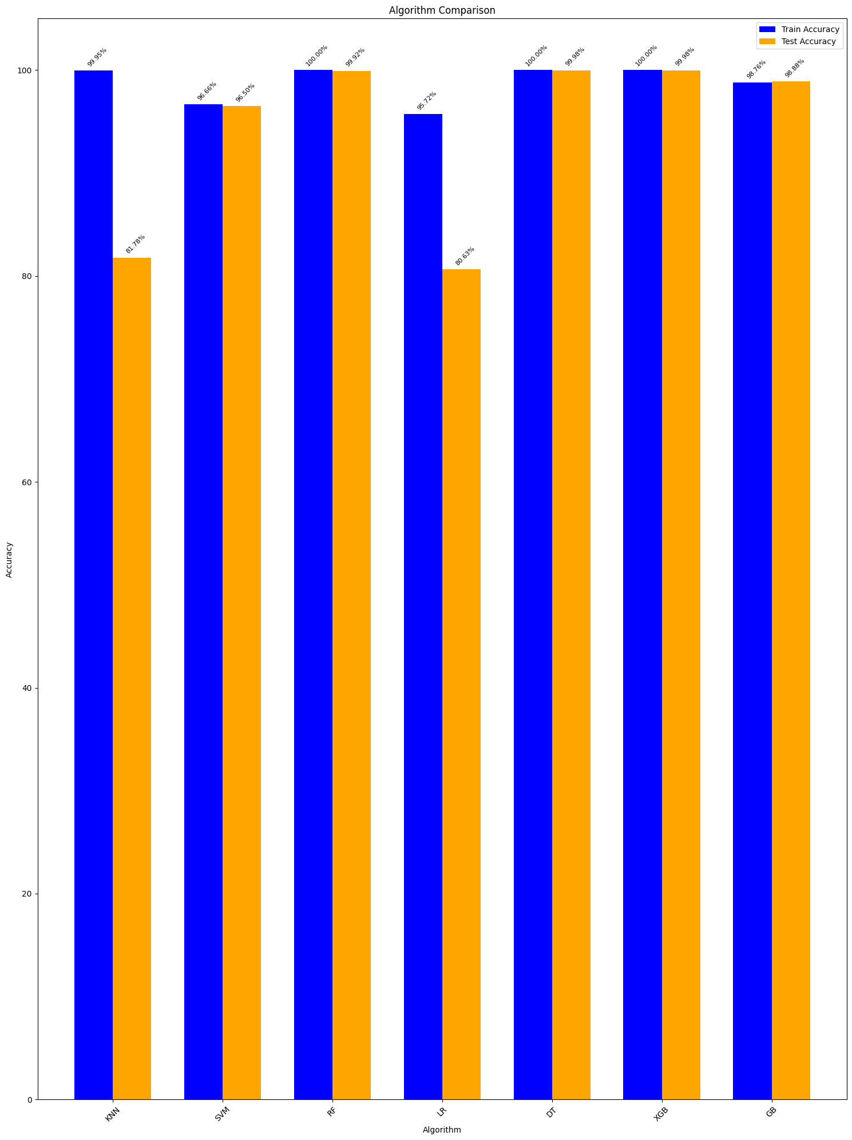

To survey the viability of our trial, we utilized an extensive arrangement of execution measurements, including Review, Accuracy, Precision, Disarray Lattice, and F1-Score. The organized outcomes present the characterization execution of the Irregular Timberland model across 11 particular classes, working with a nuanced assessment of its viability. Surprisingly, the Arbitrary Woods model accomplished extraordinary outcomes, flaunting 99.99% exactness, accuracy, review, and F1-score for IoT gadget order, highlighting its excellent presentation in information classification. Additionally, the alternative models performed admirably, with device category-specific accuracy rates ranging from 99.94% to 99.99%. Table 5.2 gives a thorough examination of the proposed Irregular Woodland model's exhibition, clarifying its vigor and viability in dealing with different order errands.

1. **Future Enchancement**

Later on, we want to proceed with the turn of events and improvement of our a hybrid method for IoT-based intrusion detection was proposed. One of our principal ob jectives is to contrast the exhibition of our calculation and other IoT datasets that contain a bigger number of hubs. By leading this near examination, we can acquire a more profound comprehension of the calculation's viability and distinguish any regions for development. Moreover, we perceive the meaning of decreasing the recognition time expected by our calculation while keeping up with high exactness. In occupied In order to reduce potential dangers, IoT systems need to be able to detect and respond quickly. effectively. To address this test, we mean to carry out new procedures and systems that can upgrade the exhibition of our calculation. These optimiza tions might incorporate refining the component extraction process, improving the preparation strategies, or embracing progressed calculations explicitly intended for productive also, opportune discovery. In the end, the goal of our future work is to improve the adequacy and effectiveness of our proposed half and half calculation. by constantly working on its presentation and guaranteeing its capacity to recognize and answer developing security dangers, we mean to ensure the security and outcome of IoT frameworks. The dynamic nature of IoT conditions requests a proactive and versatile interruption discovery framework, and we are focused on propelling the cutting edge in this f ield to add to the improvement of a safer IoT framework.

1. **Conclusion**

This paper presents a comprehensive approach to detect botnets in IoT environments using machine learning techniques. By analyzing features extracted from IoT network traffic, our model shows promising accuracy in detecting malicious botnet activity, thus reducing potential threats to IoT ecosystems and wider cyberspace. Our research highlights the integration of advanced machine learning techniques into the IoT security framework, which is critical to countering evolving cyber threats. As IoT devices continue to proliferate, securing these interconnected systems will become critical to protecting sensitive data, critical infrastructure, and user privacy. Future research could explore developing more robust, adaptive machine learning models that could detect earlier. invisible botnet behavior in real time. In addition, incorporating anomaly detection techniques and behavioral analytics can improve the resilience of IoT networks to emerging threats. Collaboration between academia, industry, and policymakers is critical to creating comprehensive security standards and protocols that address the unique challenges of IoT ecosystems. Ultimately, by increasing our understanding of botnet detection in IoT environments and driving innovation in machine learning-based security solutions, we can strengthen the foundation of IoT, enabling its transformative potential while protecting against malicious exploitation.

1. **Acknowledgment**

We express our special gratitude to **Dr. SHYJITH M B ,** Head of the Department of Computer Science and Engineering for providing us constant guidance and encouragement throughout the Project preliminary work.We express our sincere gratitude to the Project Supervisor **Mr. JAISON MATHEW JOHN,** Assistant Professor, Department of Computer Science and Engineering for the inspiration and timely suggestions.We also express sincere gratitude to our guide **Mr. CHANDU ASOK** Assistant Professor , Department of Computer Science and Engineering for his guidance and support . We have to appreciate the guidance given by the panel members during the Project Preliminary presentations, thanks to their comments and advice. Last but not the least we place a deep sense of gratitude to our family members and friends who have been constant sources of inspiration during the preparation of the Project Preliminary works

1. **REFERENCES**
2. A. Kumar, A. K. Singh, I. Ahmad et al., “A novel decentralized blockchain architecture for the preservation of privacy and data security against cyberattacks in healthcare,” Sensors, vol. 22, no. 15, pp. 1–14, 2022.
3. T. Alyas, I. Javed, A. Namoun, A. Tufail, S. Alshmrany, and N. Tabassum, “Live migration of virtual machines using a mamdani fuzzy inference system,” Computers, Materials & Continua, vol. 71, no. 2, pp. 3019–3033, 2022.
4. M. S. Mazhar, Y. Saleem, A. Almogren et al., “Forensic analysis on internet of things (IoT) device using machine to machine (M2M) framework,” Electronics, vol. 11, no. 7, p. 1126, 2022.
5. T. Alyas, K. Alissa, M. Alqahtani et al., “Multi-Cloud integration security framework using honeypots,” Mobile Information Systems, vol. 2022, pp. 1–13, Article ID 2600712, 2022.
6. T. Kalsoom, N. Ramzan, S. Ahmed, and M. Ur-Rehman, “Advances in sensor technologies in the era of smart factory and industry 4.0,” Sensors, vol. 20, p. 6783, 2020.
7. M. Ahmad, T. M Ghazal, and N. Aziz, “A survey on animal identification techniques past and present,” International Journal of Computational and Innovative Sciences, vol. 1, no. 2, pp. 1–7, 2022.
8. ] P. Jacob, “UNSW-NB15 dataset feature selection and network intrusion detection using deep learning,” International Journal of Recent Technology and Engineering, vol. 7, no. 5S2, 2019

*.*