**Dynamic analysis of laminated composite cylindrical shells with stiffeners**

**S. M. Shiyekar1 and V. P. Patil2**

1 Professor, D Y Patil College of Engineering, Akurdi, Pune  
shiyekar@gmail.com

2 Former PG Student of Rajarambapu Institute of Technology, Rajaramnagar, Sangli

vishu_p4@yahoo.co.in

**Abstract:**

The domain of engineering and structural mechanics has undergone a transformative shift, courtesy of composite materials, attributing to their remarkable strength-to-weight ratio and versatile design adaptability. Amid the diverse array of composite applications, significant attention has been directed towards composite shells fortified with stiffening elements. These configurations seamlessly amalgamate the merits of composite materials with the augmented load-bearing capabilities conferred by the incorporation of stiffeners. This research undertaking aims to dissect orthotropic multilayered shells manifesting distinct stiffening configurations. The analytical exploration is carried out through the utilization of the Finite Element Analysis (FEA) software ANSYS. The ensuing analysis embraces several stiffening patterns: no stiffener, edge beam, central stringer, three equidistant stringers, central ring, and ring with stringer. The inherent diversity in the natural frequencies is reflective of the variance in these stiffening arrangements.

***Key Words:*** Laminated Composite Shells, Finite Element Method, Stiffeners, ANSYS

**Introduction**

Manufacturing composite shells with stiffeners involves intricate processes to ensure optimal material properties and geometric accuracy. Traditional methods like hand lay-up and autoclave curing have been widely used, but these techniques often lead to time-consuming and labor-intensive processes. In recent years, advanced manufacturing techniques such as automated fiber placement (AFP) and resin infusion have gained prominence. Zheng et al. [1] discussed the application of AFP in fabricating composite aircraft fuselages with stringer stiffeners, demonstrating improved manufacturing efficiency and consistency. Additionally, Hu et al. [2] explored the potential of robotic-assisted resin infusion for producing complex composite shells with integrated stiffeners, offering a balance between automation and cost-effectiveness.

The mechanical behavior of composite shells with stiffeners is a complex interplay of the constituent materials, geometry, and loading conditions. Several studies have investigated the effects of stiffeners on the structural performance of composite shells. Zhang et al. [3] conducted experimental and numerical analyses on composite cylindrical shells with stringer stiffeners, revealing that properly designed stiffeners can significantly enhance buckling and post-buckling behavior. Similarly, Li et al. [4] examined the impact of stiffener configurations on the bending and torsional stiffness of composite conical shells, highlighting the potential to tailor the structural response based on the stiffener layout.

Composite shells with stiffeners find applications across various industries, including aerospace, marine, and civil engineering. In aerospace, these structures are commonly employed in aircraft wings, fuselages, and rocket components. Ahmad et al. [5] investigated the structural performance of composite cylindrical shells with stiffeners in aircraft wing structures, showcasing their ability to resist aeroelastic and dynamic loads. Moreover, in marine engineering, composite shells with stiffeners are used in ship hulls and offshore structures. Da Silva et al. [6] studied the behavior of composite ship hulls with longitudinally stiffened panels under hydrostatic and hydrodynamic loads, revealing their potential for lightweight and corrosion-resistant marine applications. Despite the progress made in understanding the behavior and manufacturing of composite shells with stiffeners, several challenges remain. Achieving optimal designs that balance structural efficiency, material usage, and manufacturing complexity is still a subject of ongoing research. Furthermore, the integration of advanced materials, such as nanocomposites and 3D-printed structures, into the design of composite shells with stiffeners presents exciting avenues for future exploration. Analyzing structures of this kind manually proves to be challenging and entails extensive computations. However, the utilization of commercially available Finite Element (FE) software significantly simplifies the analysis process for such structures. Dinghe et al. [7] demonstrated the analysis of similar structures using MSC.Nastran software.

In conclusion, composite shells with stiffeners represent a promising class of structures with wide-ranging applications. Their mechanical behavior, manufacturing techniques, and diverse applications have been the focus of intensive research efforts. As technology continues to advance, further investigations into innovative materials, advanced manufacturing methods, and optimization techniques will undoubtedly contribute to the continued evolution of composite shells with stiffeners, enabling safer, lighter, and more efficient structures across industries.

**Numerical Investigation of Stiffened Laminated Shells**

The integration of beams to reinforce structural shell systems finds extensive utilization across diverse sectors including buildings, bridges, ships, aircraft, and machinery. Within the aerospace domain, these configurations play a pivotal role in constructing aircraft wings and fuselages. For instance, aircraft fuselages exemplify thin shell constructs that are fortified with axial elements (such as stringers or longerons) and transverse components (frames or rings) along their length. The prevalence of such stiffened shell systems has consequently led to the development of diverse methodologies for conducting comprehensive structural analyses.

This study delves into the investigation of orthotropic multilayered shells characterized by varying stiffening configurations, employing the Finite Element Analysis (FEA) software, ANSYS [8]. Six distinctive geometric arrangements are subjected to detailed analysis through the utilization of ANSYS.

Following stiffening arrangements are modelled.

(a) Shell without stiffener,

(b) Shell with edge beams,

(c) Shell with central stringer,

(d) Shell with three equidistant stringers from centre,

(e) Shell with central ring,

(f) Shell with stringer and ring.

Modeling of these geometries are shown in Fig. 1

Simply supported stiffened orthotropic three layered circular cylindrical shell with lamination scheme 0o/90o/0o is analyzed for free vibration problem. Shell is having following geometric and orthotropic properties.

Radius (R) = 5 m, Length (L) = 30 m, Thickness (h) = 0.05 m for each layer.

E1 = 50 x 109 Pa, E2 = E3 = 2 x 109 Pa, ν12 = ν23 = ν13= 0.25, G12 = G13 = 1 x 109 Pa, G23 = 0.4 x 109 Pa, ρ = 1500 kg/m3. These properties are taken for shell.

For stiffeners E= 50 x 109 Pa, ν = 0.25 and ρ = 1500 kg/m3 are taken

For modal analysis element shell 181 is used. Analysis is carried out for shell without stiffeners and shell with stiffeners. Results are tabulated in Table 1 and same results are shown Fig. 2. Fundamental mode shapes are shown in Fig. 3.

Table 1 Frequency for different stiffening schemes for first seven modes of orthotropic laminated circular cylindrical shell for lamination scheme 0o/90o/0o.

|  |  |  |  |  |  |  |  |
| --- | --- | --- | --- | --- | --- | --- | --- |
| Stiffening Scheme | Natural Frequencies for first seven Modes | | | | | | |
| Mode 1 | Mode 2 | Mode 3 | Mode 4 | Mode 5 | Mode 6 | Mode 7 |
| Shell without stiffener | 4.1205 | 4.1415 | 10.405 | 11.514 | 11.520 | 12.828 | 13.608 |
| Shell with edge beam | 3.5740 | 6.6371 | 10.625 | 13.190 | 16.202 | 18.064 | 22.194 |
| Shell with central stringer | 3.9165 | 4.5705 | 10.398 | 10.430 | 10.804 | 12.776 | 12.799 |
| Shell with three equidistant stringers | 4.7437 | 5.8625 | 12.446 | 15.057 | 16.028 | 16.398 | 19.946 |
| Shell with Central Ring | 2.7615 | 4.2436 | 5.6560 | 6.6005 | 10.216 | 11.512 | 11.645 |
| Shell With ring and stringer | 3.1822 | 4.4832 | 5.8295 | 7.9574 | 9.9101 | 10.970 | 12.711 |

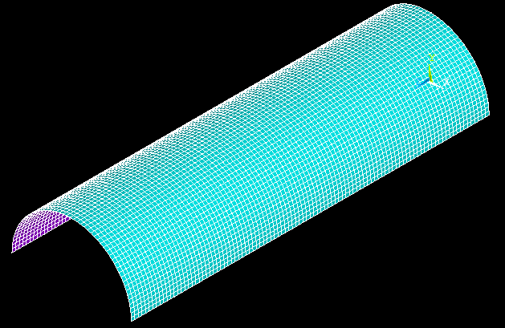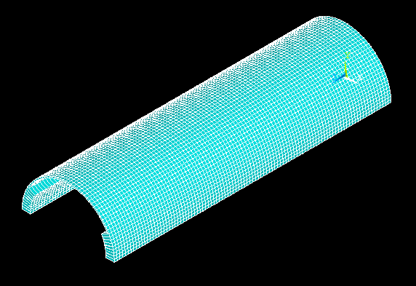

1. (b)

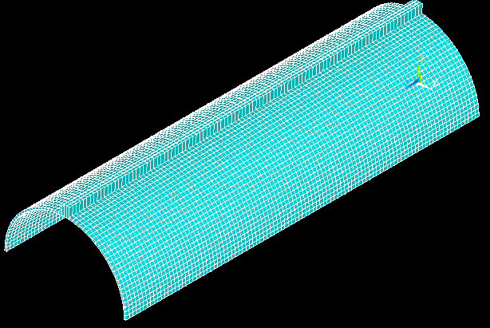 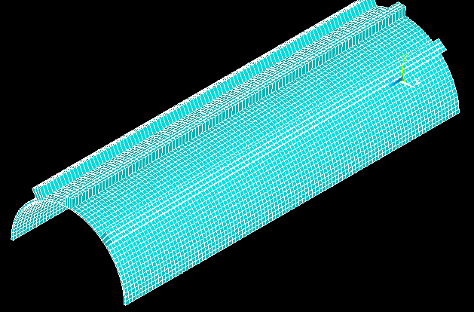

(c) (d)

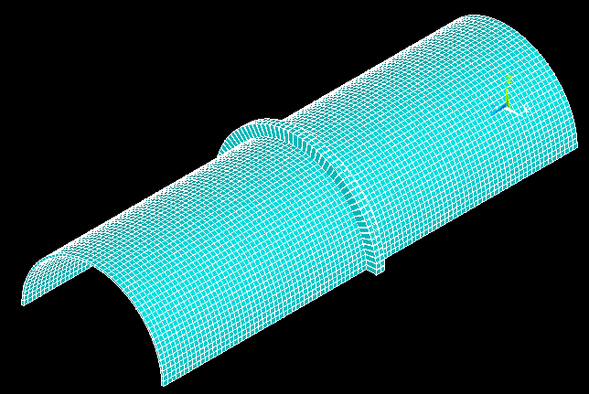 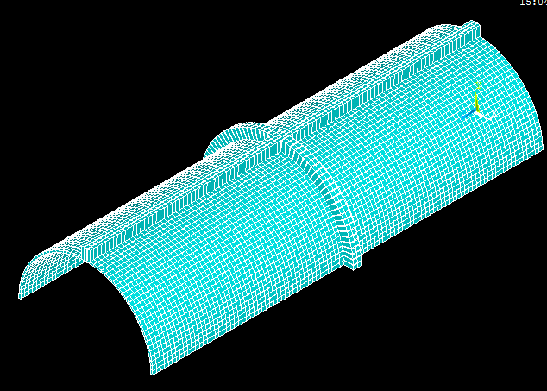

(e) (f)

Fig 1. Finite element analysis models of the stiffened circular cylindrical shells. (a) Shell without stiffener, (b) Shell with edge beams, (c) Shell with central stringer, (d) Shell with three equidistant stringers from centre, (e) Shell with central ring, (f) shell with stringer and ring.



Fig. 2 Graphical representation of frequency v/s mode shapes for different stiffening schemes for isotropic circular cylindrical shell.

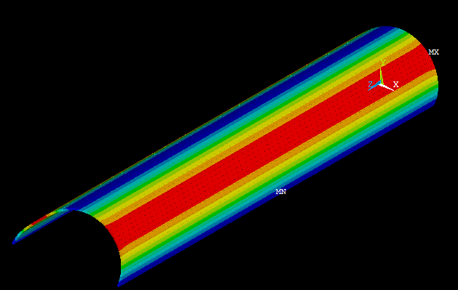 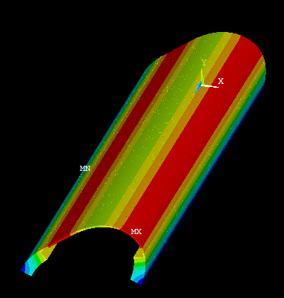

1. (b)

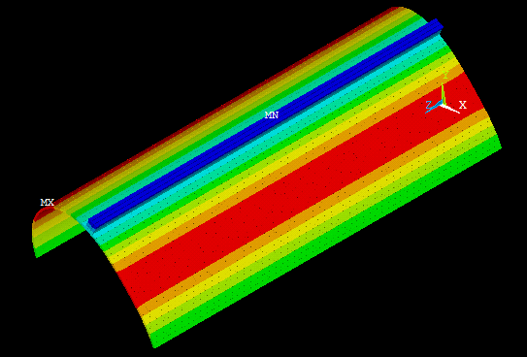 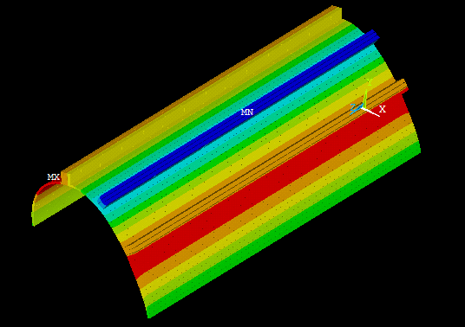

(c) (d)

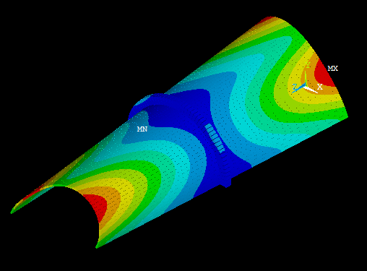 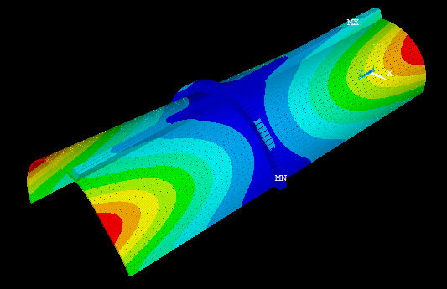

Fig. 3 First mode shape for stiffened circular cylindrical shells. (a) Shell without stiffener, (b) Shell with edge beams, (c) Shell with central stringer, (d) Shell with three equidistant stringers from centre, (e) Shell with central ring, (f) shell with stringer and ring.

**Conclusion:**

Composite materials have charted a revolutionary trajectory in engineering and structural mechanics, predicated on their unparalleled strength-to-weight ratio and unparalleled design adaptability. Amongst the array of applications, the spotlight shines on composite shells embellished with stiffening elements, a merger that capitalizes on composite virtues and the augmented load-bearing competence afforded by stiffeners. In this study, the canvas extends to the realm of orthotropic multilayered shells, each adorned with diverse stiffening configurations. Employing ANSYS FEA software, six configurations are meticulously modeled, each fostering a distinctive mechanical response intricately linked to the shifting natural frequencies.

**References:**

[1] Zheng, Y., Xiong, J., Li, W., & Chen, W. (2020). Application of Automated Fiber Placement in Fabricating Composite Aircraft Fuselages with Stringer Stiffeners. Journal of Composite Materials, 54(9), 1085-1097.

[2] Hu, Y., Wang, X., Chen, D., & Li, H. (2021). Robotic-Assisted Resin Infusion for Producing Complex Composite Shells with Integrated Stiffeners. Composite Structures, 262, 113552.

[3] Zhang, L., Wang, S., & Zheng, Z. (2017). Effects of Stringer Stiffeners on Buckling and Post-buckling Behavior of Composite Cylindrical Shells: Experimental and Numerical Analyses. Composite Structures, 168, 277-287.

[4] Li, Q., Qiu, W., & Wang, Y. (2019). Impact of Stiffener Configurations on Bending and Torsional Stiffness of Composite Conical Shells. Composite Structures, 225, 111179.

[5] Ahmad, S., Mahmoudi, A. H., & Lopes, V. (2018). Structural Performance of Composite Cylindrical Shells with Stiffeners in Aircraft Wing Structures. Aerospace Science and Technology, 75, 344-352.

[6] Da Silva, L. F. M., Carneiro, L. D. S., & Moura, M. F. S. F. (2020). Behavior of Composite Ship Hulls with Longitudinally Stiffened Panels under Hydrostatic and Hydrodynamic Loads. Ocean Engineering, 216, 107688.

[7] Dinghe, X., Qi, X., & Junfeng, G. (2013). Analysis of Composite Shells with Stiffeners Using MSC.Nastran. Procedia Engineering, 57, 48-55.

[8] ANSYS Workbench Academic, Release 13, Ansys Inc.