**ENERGY PRODUCTION OPTIMISATION BY POSITIONING OF SOLAR PANELS AND SURVEILLANCE SYSTEM WITH CLEANING OF PANLES**

**DR JOHN CHEMBUKKAVU 1 ,ASWATHY VIDHYA SAGAR2, ABHINAV V R3, ABHISHEK J4, ALIYA K A5, AMAL NANDHAN C N6**

HoD,Assistant Professor, EEE, IES College of Engineering, Chittilappilly, India1

Student, EEE, IES College of Engineering,

Chittilappilly, India2-6

# ABSTRACT

The pursuit of efficient and sustainable energy generation has led to the widespread adoption of solar panels. However, the optimal performance of these panels can be hindered by factors such as dirt accumulation, suboptimal orientation, and security concerns. To address these challenges, we propose an integrated Solar Panel Tracking, Cleaning, and Surveillance System (SPTCSS).

Our system employs advanced tracking technology to optimize solar panel orientation, ensuring maximum exposure to sunlight throughout the day. Additionally, it incorporates automated cleaning mechanisms, utilizing water and brushes to remove dust, debris, and other contaminants, thereby maintaining peak efficiency.

Furthermore, the surveillance aspect of the system provides real-time monitoring and security features, safeguarding against theft, vandalism, and unauthorized access. Through a network of sensors and cameras, any anomalies or suspicious activities can be promptly detected and addressed.

By integrating tracking, cleaning, and surveillance functionalities into a single system, our solution offers a comprehensive approach to enhancing the performance, longevity, and security of solar panel installations. This not only maximizes energy generation but also minimizes maintenance requirements and mitigates risks, ultimately contributing to a more sustainable and reliable renewable energy infrastructure

.**Index terms-**Adrino nano ,buck sensor, esp 32

# I.INTRODUCTION

In an era where renewable energy sources play an increasingly pivotal role in addressing global energy demands and combating climate change, the optimization of solar energy production stands as a paramount objective. This project delves into the realm of energy production optimization by proposing a multifaceted approach that integrates the strategic positioning of solar panels with the implementation of a surveillance system for effective monitoring and cleaning. The efficiency of solar panels heavily relies on their orientation towards the sun, and by leveraging advanced positioning techniques, such as solar tracking systems, this project seeks to maximize energy generation potential. Furthermore, the integration of a surveillance system adds a layer of intelligence by continuously monitoring the condition of the panels and detecting any accumulation of dirt or debris, which can significantly hamper their performance. Through this innovative amalgamation of technologies, the project aims not only to enhance energy production efficiency but also to minimize maintenance efforts, thereby fostering a sustainable and cost-effective solution for harnessing solar energy.

Clean solar panels are crucial for optimal energy production and environmental sustainability. Regular cleaning not only ensures maximum efficiency but also extends the lifespan of solar panels, thereby reducing maintenance costs and enhancing the return on investment for individuals and communities. By promoting the cleaning of solar panels, we contribute to a cleaner energy future, reduce reliance on fossil fuels, and mitigate climate change effects, thus fostering a healthier and more sustainable society for generations to come.

# II.LITERATURE REVIEW

[1] H. Hottel and B. Woertz,, “Performance of flatplate solar-heat collectors, "Trans. ASME (Am. Soc. Mech. Eng.); (United States), vol. 64, 1942. [1]:First studied the effects of dust on solar panel presentation with the aid of analyzing the dust collecting on such panels. A 3 month test becomes done in a business location close by a four-tune railroad 90m away from Boston, Massachusetts. They located a mean of one% loss of occurrence solar radiation changed into caused by dirt that accumulated on the surface of the sun panel with a slant attitude ofa30°. The very best dilapidation defined for the duration of the check duration becomea4.7%. The researchers found out a correction issue, defined as the ratio of the transference from a polluted or exposed glass plate to clean one, of zero. Ninety nine, with aa45° slant angle; this value changed into general and hooked up in the layout of flat plate collectors till 1970. Kimber et al. tested the consequences of soiling on large grid-linked PV panels in California, USA in 2011. The goal of the have a look at became to deliver a better model to correctly are expecting soiling patients all through the 12 months barely than presumptuous a continual annual fee. After except for websites with nonlinear conduct of soiling and large rainfall of the web sites, the information from 250 sites have been accumulated and later filtered to 46 machine records .[2] Kutaiba-Sabah, Sabah Nimma Faraj (2013) Self Cleaning Solar Panels to Avoid the Effects of Accumulated Dust on Solar Panels Transmittance. International Journal of Science and Research (IJSR), India Online ISSN: 2319-7064In the experiment which is previously done, dust accumulation for the solar panels being investigated for a long period of time that is approximately for one year. The experiments have been done in different countries which have climate conditions of the dusty weather. Those countries are Iraq, Egypt and UAE. The solar panels were never cleaned, initially for one month, and then for two months and so on. The results were there was a decreasing in the transmittance of the solar panels, which is emphasize the effect of accumulated dust, even though the changing in the tilt angel which is in concurrence with the dust deposition on the [3] Shaharin A. Sulaiman ``Effects of Dust on the Performance of PV Panels` International Journal of Mechanical, Aerospace, Industrial, Mechatronics and Manufacturing Engineering Vol:5, 2011

Dust accumulation from the outside environment on the solar photovoltaic (PV) panels system is natural. There were studies which showed that the accumulated dust can minimize the performance of solar panels, but the results were not evidently quantified. The purpose of this research was to study the dust accumulation effects and then analyze the performance of solar PV panels. Experiments were conducted by utilizing dust particles on solar panels with a steady power light source, to conclude the resulting electrical power generated and efficiency. The effect of presence of dust was studied using artificial dust (mud and talcum) under a constant irradiance conducted in an indoor lab. Dust has consequences on the solar PV panel performance. The decline in the peak power generation can be equal to 18%. It was also given away that under larger irradiation; the effect of dust became somewhat minimized but not negligible Recognition Module is used for determining the type of trash disposed. Furthermore, the waste is classified as biodegradables and non-biodegradables[6]. For better indication, a LED light can be used to notify the level of garbage with a buzzer. The LED light indication will be ON unless and until the garbage is not removed from the bin.

# III.BLOCK DIAGRAM

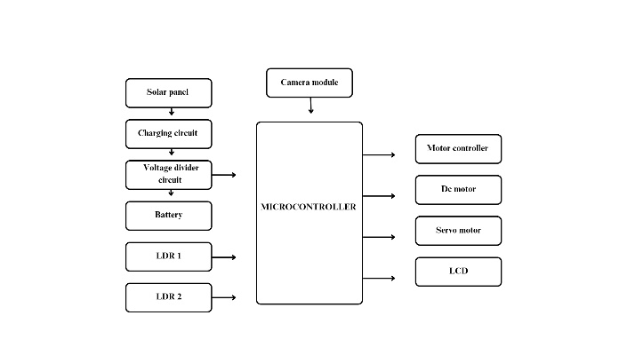

# IV.CIRCUIT DIAGRAM

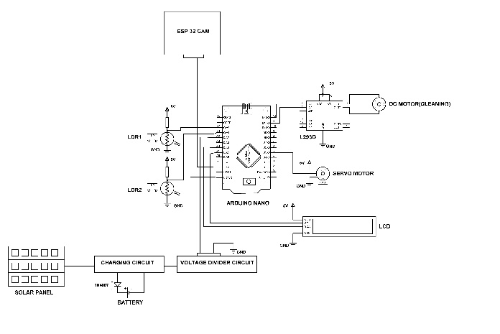

# V.SCOPE

Automatic solar tracking systems offer a promising avenue for optimizing solar energy generation by dynamically adjusting the orientation of solar panels to continuously align with the sun's position. By leveraging sensors and motors, these systems can track the sun's movement throughout the day, maximizing exposure to sunlight and thereby enhancing energy output. This technology holds great potential for improving the efficiency and effectiveness of solar energy installations, particularly in regions with variable sunlight angles and seasonal changes. As renewable energy continues to gain momentum, automatic solar tracking systems are poised to play a vital role in maximizing the utilization of solar resources and advancing the sustainability of energy generation.

Automatic solar cleaning systems present an innovative solution to address the challenge of maintaining optimal performance and efficiency of solar panels. By incorporating mechanisms such as robotic brushes or water sprayers, these systems can effectively remove dust, dirt, and debris buildup from solar panels without requiring manual intervention. This proactive approach not only enhances energy generation by ensuring maximum sunlight absorption but also reduces maintenance costs and extends the lifespan of solar panel installations. As the demand for renewable energy continues to grow, automatic solar cleaning systems offer a compelling solution to optimize the performance and reliability of solar energy systems, especially in environments prone to dust and pollution. Automatic solar surveillance systems provide a cutting-edge solution for enhancing security and monitoring capabilities in solar energy installations.

By integrating surveillance cameras, motion sensors, and remote monitoring capabilities, these systems offer real-time monitoring and detection of unauthorized access, vandalism, or potential faults. With the ability to remotely monitor the solar array, such systems ensure timely intervention in case of security breaches or system malfunctions, thereby safeguarding the integrity and reliability of solar energy installations. As the demand for renewable energy continues to grow, automatic solar surveillance systems are poised to become an essential component in ensuring the security and resilience of solar power infrastructure.

**PROS**

* Increased Efficiency: Solar tracking using LDR allows panels to continuously adjust their position to capture maximum sunlight throughout the day, maximizing energy output..
* .Enhanced Performance: Regular cleaning of solar panels ensures that dirt, dust, and debris are removed, preventing obstruction of sunlight and maintaining optimal performance over time.
* Early Issue Detection: Surveillance enables early detection of potential issues such as equipment malfunctions, damage, or shading, allowing for timely maintenance and minimizing downtime.

# CONS

* Initial Cost: Implementing solar tracking systems and surveillance technology incurs additional upfront costs compared to static solar installations, potentially impacting the initial investment..
* Maintenance Complexity: While surveillance helps detect issues early, it also adds to the complexity of maintenance tasks, requiring regular monitoring and potentially specialized expertise for troubleshooting..
* . Energy Consumption: The operation of surveillance systems may consume additional energy, albeit relatively minor compared to the overall energy production of the solar panels, but still consideration for off-grid or energy-conscious installations..

# VI.CONCLUSION

In conclusion, implementing solar tracking with LDR (Light Dependent Resistor) technology coupled with regular cleaning and surveillance offers significant benefits for solar energy systems. By dynamically adjusting the orientation of solar panels to maximize exposure to sunlight, efficiency is optimized, leading to increased energy output. Additionally, routine cleaning and surveillance ensure the longevity and reliability of the system by preventing degradation and identifying potential issues early on. Together, these integrated strategies enhance the overall performance and effectiveness of solar energy generation, contributing to a sustainable and resilient energy future.

# REFERENCE

1] Shishir Kumar Das, Ankit Srivasan, And Lucky ShrivastavSsipmt, Raipur, Chhattisgarh, India*.* - Hardware Design, Design Concept

2] Mr.Varun Chaudhary, Mr. Rohit Kumar, Mr. Anil Rajput, Mr.Manvendra Singh , E.R. Thakurendra Singh : “ Survey on Smart dustbin ’’

3] Manisha Jayson, Sanket Hiremath Lakshmi H R: “Survey on Smart Bin Automatic waste segregation and collection’’

4] Ajay V P, Bradeep Kumar M, Kishanth A, Vaishnavi Kumar, R. Santhiya Devi, Amirtharajan Rengarajan, K. Thenmozhi, and Padmapriya Praveenkumar: “Survey on Automatic Waste Segregation and Management’’

5] Abhishek Ayush, Abhishek Kumar, Aditi Jha, Nilotpal Sarkar, Suresh Chandra Moharana and Himansu Das: “Survey on Voice Controlled Automatic Dustbin with Garbage Level Sensing”

6] Miko Pamintuan, Shiela Mae Mantiquilla, Hillary Reyes, Mary Jane Samonte: “Survey on I-BIN"

# AUTHORS

1. DR JOHN CHEMBUKKAVU- Head of the Department ,EEE,IES College of Engineering,Chittilapilly,India,eeehod@iesce.info
2. ASWATHY VIDHYA SAGAR- Assistant Professor, EEE, IES College of Engineering, Chittilappilly, India, aswathysagar96@gmail.com
3. ABHINAV V R- Student, EEE, IES College of Engineering, Chittilappilly, India, abhinavvrkannan7@gmail.com
4. ABHISHEK J- Student, EEE, IES College of Engineering, Chittilappilly, India, abhishekj8450@gmail.com
5. ALIYA K A- Student, EEE, IES College of Engineering, Chittilappilly, India, aliyaka2019@gmail.com.
6. AMAL NANDHAN C N- Student, EEE, IES College of Engineering, Chittilappilly, India, cnamalnandhan@gmail.com