**E-Ticketing for Public buses**

Mrs. Sampada Kulkarni

*Assistant Professor, Dept. of I.T., P.E.S Modern College of Engineering, Savitribai Phule Pune University, Maharashtra, India*

Krushna Nagare, Hansika Amrutkar, Usha Sree Alekhya Siddi, Yash Hibare

*Dept. of I.T., P.E.S Modern College of Engineering, Savitribai Phule Pune University, Maharashtra, India*

*Corresponding Author:* [*krushna_nagare@moderncoe.edu.in*](mailto:krushna_nagare@moderncoe.edu.in)

|  |
| --- |
| ***Abstract:***By replacing the antiquated manual, cash-based ticketing procedures with a state-of-the-art digital system, this initiative seeks to modernise public bus transportation in India. Long wait times, operational challenges, and inefficiencies are common outcomes of the current system. The goal of the suggested solution is to completely transform the public transportation experience by putting in place a cutting-edge, digital ticketing system that improves security, convenience, and efficiency for both administrators and users.  This project's main goals are to eliminate manual cash transactions, shorten wait times, and fix operational inefficiencies. With the use of digital technology, the suggested system would expedite the ticketing procedure and provide passengers with an easy-to-use interface for smooth ticket purchases.  This invention increases transaction security while also making the public bus transportation system more efficient overall. Passengers will have a more flexible and easy method to utilise public transport services thanks to the digital ticketing system, which will also significantly reduce wait times and traffic. Real-time data analytics will help administrators by facilitating improved resource allocation and decision-making. The introduction of this digital ticketing solution has the potential to revolutionise India's public transport sector by promoting a more sophisticated and user-friendly framework.  ***Key Word****: Management, Tracking, QR Code, Location, Ticket Confirmation, E-Ticket, Online Payment* |

1. **INTRODUCTION**

The demand for creative solutions to solve the inefficiencies of manual, cash-based ticketing systems has grown in light of the quickly changing public transport market. With the introduction of a state-of-the-art digital ticketing system, this initiative aims to transform public bus transportation in India. This system is an electronic management system. This system ensures that the management process of bus are smoothly done [1]. Acknowledging the difficulties caused by lengthy lines and operational problems, our suggested remedy seeks to improve security, convenience, and effectiveness for users as well as administrators.

Utilising QR code-based ticketing is the foundation of our digital ticketing system, enabling a smooth and frictionless ticketing process. To provide customers with the greatest level of convenience, we have shortened the ticket purchase procedure by creating a specialised mobile application and an intuitive online interface. This digital approach promises a secure and efficient travel experience by prioritising data protection in addition to streamlining the use of tickets.

1. **BENEFITS AND LIMITATIONS OF EXISTING SYSTEM**

**Benefits**: Increased Public Interest and Usage: It indicate a positive impact on public interest and usage of public transportation due to e-ticketing systems. This aligns with existing literature that emphasizes how convenient ticketing systems attract more users, reducing congestion and encouraging eco-friendly travel.

Improved Efficiency and Convenience: It highlights the need for smart systems to reduce waiting times, automate seat allocation, and promote cashless payments. Existing studies often support how such features streamline the ticketing process, enhancing passenger satisfaction and operational efficiency.

Integration and Centralization of Systems: It touches upon the need for integration across various transportation mediums. Literature recognizes the advantages of a centralized system, offering commuters seamless travel experiences without the hassle of managing multiple tickets or apps for different transport modes.

**Limitations**: Limited Scope: It focus on specific cities in Indonesia, while targets the Indian context. This limited geographical scope might restrict the generalizability of findings to broader regions or diverse socio-economic settings.

Methodological Constraints: It rely on qualitative methods and proposed form, respectively. While useful, these methods might not capture the entire spectrum of factors influencing e-ticketing systems' effectiveness, potentially missing nuanced aspects or broader societal implications.

Technology and Accessibility Challenges: It propose technologically advanced systems. However, literature often discusses challenges related to technology adoption, such as infrastructure limitations, digital literacy, or affordability, which could hinder widespread implementation or access.

Environmental Impact Consideration: It highlights the issue of paper wastage due to traditional ticketing systems. However, while emphasizing the environmental benefits of e-tickets, the literature might not extensively address the ecological implications of the required electronic infrastructure or disposal of outdated tech components.

1. **CHALLENGES IN EXISTING SYSTEM**

While they are not universal, transportation issues are present everywhere. In addition, the lack of substitute modes and insufficient transportation services are the primary causes of transportation issues. Although public transport buses have been offering generally good services, there is a perception that these services lack consistency. The most frequent issues commuters have with the current system are listed below. [4] There are at least 1.25 million vehicles in the city and of these about 94% are registered as private vehicles.

1. Excessive wait times at bus stops: Passengers are not informed about how long they must wait for a bus to come. The commuters' unwarranted waiting for buses is a major source of frustration and a waste of time. More waiting time clearly results in overcrowding, too. Commuters must wait an undetermined length of time due to poor time patterns that provide uneven bus intervals.

1. Not enough time to obtain tickets: On occasion, buses might be so packed and the distance to go so short that obtaining a ticket causes havoc. The largest issue during rush hour is finding the conductor and obtaining a ticket in packed buses.

1. Balance not refunded: It occasionally happens that neither the conductor nor the commuter have any change. The conductor might not give the commuter their full refund in these circumstances. Furthermore, the majority of passengers do not assist the conductor by accurately tendering the fare. Giving a fifty Rupee currency note for a ticket worth twelve to thirteen Rupees, for example, could annoy the conductor, particularly if the bus is packed.

1. Failure to provide other passengers a seat: Commuters may have to ride the entire bus standing. There is no set mechanism used for seat allocation, therefore passengers do not always obtain a seat when they need to. Depending on the availability of seats, some passengers choose to sit as soon as they enter the bus, while others stand the entire way.

1. Excessive paper waste: Almost all bus passengers accept tickets, with the exception of those who have passes, therefore the amount of paper needed to create tickets is considerably too large. The production of e-tickets will prevent the significant paper waste that follows from this.

1. Cash usage: Purchasing tickets using cash runs counter to the principles of the cashless economy. Cash is the only method available to purchase tickets directly from the conductor. This runs counter to the Indian government's plan to eliminate currency.

1. **PROPOSED SYSTEM FEATURES**

The system features for the digital ticketing system for Public Buses include:

1. Contactless Payments: Support for various digital payment methods.
2. Ticket Booking: Online booking and reservation of tickets for different routes and schedules.
3. Real-Time Information: Updates on bus routes, schedules, and estimated arrival times.
4. QR Code Tickets: Electronic tickets with QR codes for validation.
5. User Accounts: Personalized accounts for passengers to manage their information and payment details securely.
6. Route Planning: Assistance for passengers in planning routes and finding bus stops.
7. Accessibility Features: Inclusivity through features like voice navigation and screen reader compatibility.
8. Feedback System: A mechanism for passengers to report issues and provide feedback.
9. Admin Dashboard: A dashboard for administrators to monitor and manage the system.
10. Analytics: Data collection and reporting for informed decision-making.
11. Security Measures: Strong security to protect user data and prevent fraud.
12. Offline Ticket Validation: Functionality even in areas with poor or no internet connectivity.
13. Eco-Friendly Initiatives: Encouraging sustainability with electronic receipts and reduced paper usage.
14. Integration with Smart City Initiatives: Collaboration with other smart city services.
15. Customer Support: Assistance through the app and a help center for users.
16. Data Privacy: Compliance with data protection regulations and strong user data privacy.

These features collectively create an efficient, user-friendly, and secure digital ticketing system that enhances the public transportation experience for both passengers and admin, while promoting modernization and sustainability in Pune's transportation infrastructure.

1. **SYSTEM ARCHITECTURE**

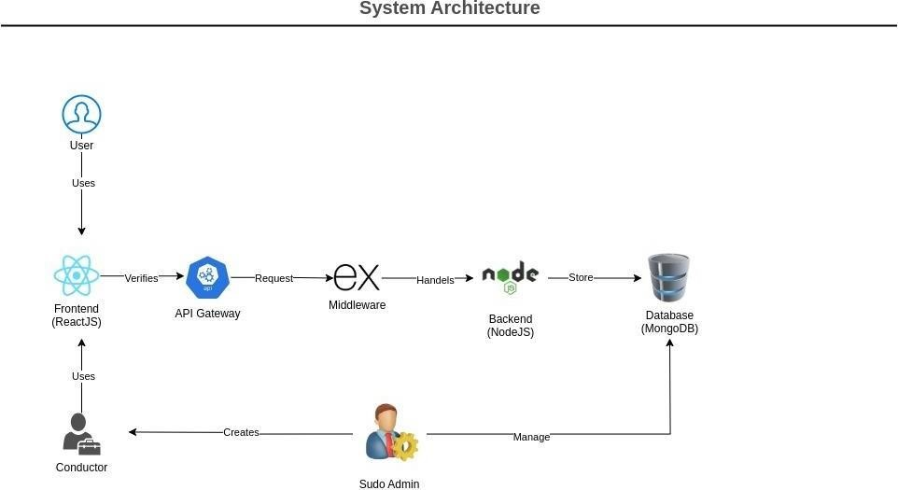

A number of interconnected parts make up the suggested system architecture for India's digital ticketing system for public bus transit, enabling a smooth and effective ticketing procedure. Let's examine each part and how it works:  
  
User: The interface through which travellers utilise the system to buy tickets, check timetables, and obtain further pertinent data. The frontend application is accessible to users on a variety of platforms, including PCs, tablets, and smartphones.  
  
  
Frontend (React.js): Using the React.js framework, this is the application's presentation layer. Passengers may engage with the system using an intuitive interface. Using API calls, the frontend and backend interact to retrieve data and carry out tasks like buying tickets, examining timetables, and verifying availability.

Api Gateway: Serving as a middleman between the frontend and backend services is the API gateway. Requests from the frontend application are received, and they are sent to the relevant backend services. In order to facilitate seamless communication between the frontend and backend components, the API gateway further handles functions like authentication, request validation, and load balancing.

Middleware: This part is positioned in between the backend services and the API gateway. It receives incoming requests, does any necessary validation or preprocessing, and then routes the requests to the relevant backend services. To improve overall system security and speed, the middleware layer may also incorporate extra features like error handling, rate limitation, and logging.

Backend (Node.js): The backend services are in charge of handling database connections, processing user requests, and carrying out business logic. Node.js is utilised in this architecture for developing the backend services because of its scalability and non-blocking I/O paradigm. The frontend application can leverage the APIs exposed by the backend services to carry out a variety of tasks, including user authentication, ticket purchasing, and data retrieval.

Express.js: Express.js, a backend web application framework for Node.js is used for creating servers. It is an open-source software under the MIT license, programmed for creating web applications and APIs.[2]  
  
Database (MongoDB): Passenger, ticket, schedule, and other pertinent data are stored and managed using MongoDB as the database management system. It offers a scalable and adaptable data storage option that can manage substantial data volumes in a dispersed setting. The MongoDB database is accessed by the backend services in order to obtain or store data as needed by the application.

Admin Panel: This part offers scheduling, conductor, user, and other resource management administration functions. The panel allows administrators to check transaction logs, establish and manage conductor accounts, keep an eye on system performance, and carry out other administration duties. To access and modify database-stored data, the admin panel interacts with the backend services.

In general, this system design makes use of cutting-edge technology and industry best practices to produce a reliable, scalable, and effective digital ticketing solution for India's public bus system. Through the integration of many components, including the admin panel, database, frontend, and backend, the system seeks to optimise user experience, expedite the ticketing process, and boost overall operational efficiency within the public transportation industry.

1. **CONCLUSION**

In summary, the study makes a strong argument for the implementation of a digital ticketing system in India in order to modernise public bus transportation. The effort intends to solve the long-standing issues of lengthy wait times, operational inefficiencies, and lack of comfort for both administrators and passengers by substituting modern technology for outdated manual operations. With features like contactless payments, real-time information updates, and QR code tickets, the suggested system presents a viable way to boost sustainability, increase efficiency, and improve user experience in the public transit industry.

Moreover, the suggested system design offers a strong foundation for smooth ticketing operations. It consists of interrelated parts such as the admin panel, database, frontend, and backend. The digital ticketing solution has the power to completely transform India's public transport system and usher in a new age of effectiveness, accessibility, and user pleasure by integrating cutting-edge technology and industry best practices. Overall, the study highlights how digital innovation may significantly alleviate the shortcomings of conventional ticketing systems, opening the door to a more advanced and user-friendly public transport system that can adapt to the changing requirements of India's urban population.

**References**

[1] Bhagyashree R. Mohite, Piyusha A. Kamthe, Prathamesh Y. Gore, Suraj V. Pawar

(2019) - "Electronic Ticketing For PMPML Buses" <https://www.irjet.net/archives/v6/i3/irjet-v6i3480.pdf>

1. Tushar Suvarna, Aditya Mali, Purushotham Panasa, Sanmitra Kamble, Mahalaxmi

Palinje (2022) - "Smart Ticketing System for Public Transport"

<https://www.irjet.net/archives/v9/i4/irjet-v9i4329.pdf>

1. Sanam Kazi, Murtuza Bagasrawala, Farheen Shaikh, Anamta Sayyed (2020) - "Smart E-

Ticketing System for Public Transport Bus" <https://ieeexplore.ieee.org/document/8537302>

1. Eddy Soeryanto Soegoto, Rudy Setiawan, Rizky Jumansyah (2019) - "Impact of E-

Ticketing Application on Bus Transportation in Bandung"

<https://www.atlantis-press.com/article/125931960.pdf>