**Emotion Recognition Using Convolution Neural Networks: Analysis on FER2013 Dataset**

**Gurshish Sarabjit Bedi1, Dr. Jayasree Ravi2**

[1,2]Department of Computer Science, SVKM's Mithibai College of Arts,

Chauhan Institute of Science & Amrutben Jivanlal College of Commerce And Economics (AUTONOMOUS)

**Abstract**

***This research explores emotion recognition using Convolutional Neural Networks (CNNs) with a focus on analyzing the FER2013 dataset. A detailed examination of the model’s architecture, training process, and performance evaluation is presented. The study aims to contribute to the field of emotion recognition and provide insights into the effectiveness of CNNs in this domain. This research delves into the realm of emotion recognition, employing Convolutional Neural Networks (CNNs) with a primary focus on analyzing the FER2013 dataset. Our study introduces a novel CNN architecture designed for accurate classification of seven distinct emotions: Angry, Disgust, Fear, Happy, Sad, Surprise, and Neutral. The research embarks on an in-depth exploration of the model’s intricacies, training methodologies, and performance evaluation metrics.***

**Keywords**: Lung Cancer Classification, Ensemble models, Convolution Neural Network, Classification Models

1. **Introduction**

Emotion recognition is a crucial aspect of human computer interaction, with applications in diverse fields such as affective computing and human behavior analysis. This research addresses the challenge of accurate emotion recognition by leveraging Convolutional Neural Networks (CNNs). The significance of understanding human emotions in technology-driven applications motivates this study. The objectives include developing an effective emotion recognition model and assessing its performance on the FER2013 dataset. The literature review encompasses a scrutiny of at least 15 pertinent papers published after 2017, revealing valuable insights into the current landscape of emotion recognition. However, this comprehensive review brings to light certain limitations within 1 the existing body of work. Notably, there is a discernible lack of specificity in emotion categories and disparities in dataset characteristics, challenging the efficacy and generalizability of established models. This research contributes not only to the advancement of emotion recognition methodologies but also highlights the necessity for more nuanced analyses and standardized benchmarks within the field. Our findings serve as a foundation for future research endeavors, encouraging the development of models that not only excel in accuracy but also prioritize inclusivity and fairness across various demographic and cultural contexts

1. **Related Work**

The study conducted by the authors of [1] explores the use of deep convolutional neural networks (CNNs) for emotion recognition from facial expressions. It addresses the challenge of identifying an individual’s mood based on their unique characteristics. The research discusses various deep learning algorithms that accurately recognize emotions from facial images. This paper [2] introduces a novel approach called FaceNet2ExpNet. It leverages face domain knowledge to regularize the training of an expression recognition network. By combining pre-trained face features with expression features, it achieves better performance in recognizing facial expressions. Deep learning techniques have revolutionized facial expression recognition. This comprehensive survey[3] covers both static images and dynamic image sequences. It categorizes existing methods into conventional approaches and deep learning-based approaches. The review discusses datasets, neural network architectures, evaluation metrics, and challenges in this field. Facial expression recognition is crucial for understanding non-verbal intentions. This survey[4] categorizes methods into conventional and deep learning-based approaches. It provides insights into feature extraction, classification, and evaluation methods. The paper also highlights challenges and opportunities for future research. CNNs have significantly impacted image classification tasks. This review[5] covers their development, from predecessors to state-of-the-art deep learning systems. It discusses early successes, the deep learning renaissance, and improvement attempts. The paper also outlines current trends and challenges in CNN-based image classification. The article [6] investigates emotion recognition from EEG signals and utilizes RNN, LSTM, and GRU architectures. It achieves high accuracy (up to 97%) in emotion detection. The paper [7] focuses on creating a database for emotion recognition. It utilizes EEG signals collected during computer games and aims to enhance emotion recognition systems. The authors of [8] have proposed a model which explores emotion recognition using LSTM RNNs. the model analyzes EEG 3 signals to infer emotional states and concluded that LSTM architecture improves emotion classification. The paper [9] focuses on recognizing emotions from facial images and enables identification of emotions like joy, fear, and sadness. This study is valuable for applications in human computer interaction. The authors of [10] propose an effective approach for automated facial expression recognition (FER). They leverage recent advances in deep Convolutional Neural Networks (CNNs) to accurately interpret semantic information available in faces without hand-designing feature descriptors. Their proposed networks outperform state-of-the-art methods on the well-known FERC-2013 dataset, making them suitable for real-time systems. A study by the authors of [11] explores going deeper in facial expression recognition using deep neural networks. They propose a single-component architecture that classifies facial images into basic expressions (e.g., anger, happiness, fear) using CNNs. Their results are comparable to or better than state-of-the-art methods, with reduced model complexity. [12] focuses on facial expression recognition using CNNs. Their approach leverages fundamental deep learning and computer vision concepts, experimenting with various architectures, hyperparameters, and optimization methods. They achieve a state of-the-art single-network accuracy of 70.10% on the FER2013 dataset without additional training data. The work by the authors of [13] focuses on automating facial emotion recognition. They explore techniques to detect emotions from facial expressions, bridging computer vision, machine learning, and psychology. Understanding and managing emotions play a crucial role in mental well-being and decision-making. Recent advancements in emotion recognition have witnessed the emergence of various approaches. A comprehensive literature review reveals insights from at least 15 papers published after 2017. While these studies contribute significantly, there exist shortcomings such as limited focus on specific emotion categories and variations in dataset characteristics. Addressing these gaps forms the basis for our proposed model. The existing literature on emotion recognition, although substantial, exhibits certain shortcomings that warrant consideration. One prevalent limitation is the inadequate focus on specific emotion categories. Many studies tend to generalize emotion recognition across a broad spectrum, often overlooking nuances inherent in distinct emotions such as contempt or subtle variations within categories like anger. This lack of granularity raises questions about the models’ ability to discern fine-grained emotional states accurately. Furthermore, variations in dataset characteristics across different studies pose a significant challenge. The diversity in data sources, image resolutions, and preprocessing techniques can lead to disparities in model performance and generalization. The absence of standardized benchmarks or a unified dataset for emotion recognition hinders the fair comparison of models, making it challenging to ascertain the true efficacy of each approach. Moreover, the bias present in some datasets may impact the model’s ability to generalize to diverse populations. Emotion recognition models trained on datasets that are skewed towards certain demographics may exhibit suboptimal performance when applied to individuals from different cultural backgrounds or age groups. This bias introduces concerns about the fairness and inclusivity of the models, raising ethical considerations in their real-world applications. Addressing these shortcomings is crucial for advancing the field of emotion recognition. Future research should strive for more comprehensive evaluations, standardized datasets, and increased awareness of potential biases to ensure the development of models that are both accurate and equitable across diverse contexts.

1. **Methodology**

**3.1 Dataset Used**

The FER2013 dataset used in this study comprises facial expression images with corresponding emotion labels. It consists of grayscale images resized to 48x48 pixels. The dataset’s diversity and labelled emotions make it suitable for training and evaluating emotion recognition models. The FER2013 dataset includes over 30,000 images categorized into seven emotions: Angry, Disgust, Fear, Happy, Sad, Surprise, and Neutral. Each image is pre-processed to grayscale and resized to 48x48 pixels, providing a balanced distribution of facial expressions for model training. 3.2 Proposed Methodology Our proposed emotion recognition model employs a CNN architecture. It consists of three convolutional layers with max-pooling, followed by a flatten layer and dense layers. Dropout regularization is applied to mitigate overfitting. The model is trained on the FER2013 dataset to recognize seven different emotions. The diagrammatic representation of the proposed model is shown in Figure 1. Convolutional Neural Networks (CNNs) employ convolution layers which utilize filters to aid in the identification of crucial features within an image. These numerous features play a pivotal role in discerning a specific image. As a CNN is trained on a set of images, it internally learns all of these distinctive features. Furthermore, in the case of employing a deep CNN, the quantity of parameters, also referred to as weights, can reach into the millions, requiring a considerable amount of time for learning. This is where transfer learning becomes advantageous.

Each year, one model tends to outperform the others. After determining the optimal performing model, all of its learned parameters or weights are made publicly accessible. By utilizing Keras applications, you have the capability to directly deploy the superior model along with its pretrained weights, eliminating the need to re-run the training process. This streamlined approach significantly reduces the time investment. All these pre-trained models work on colour images. So, the dataset used in this study is converted from 2- dimensional array to 3-dimensional array - first dimension for number of images, second dimension for pixel resolution in vectorized form and third dimension for rgb layers. Convolution layers are stacked together with no pooling in between. The output that comes from aggregated convolution layers go through max pooling operation.

Figure 1: Proposed Methodology

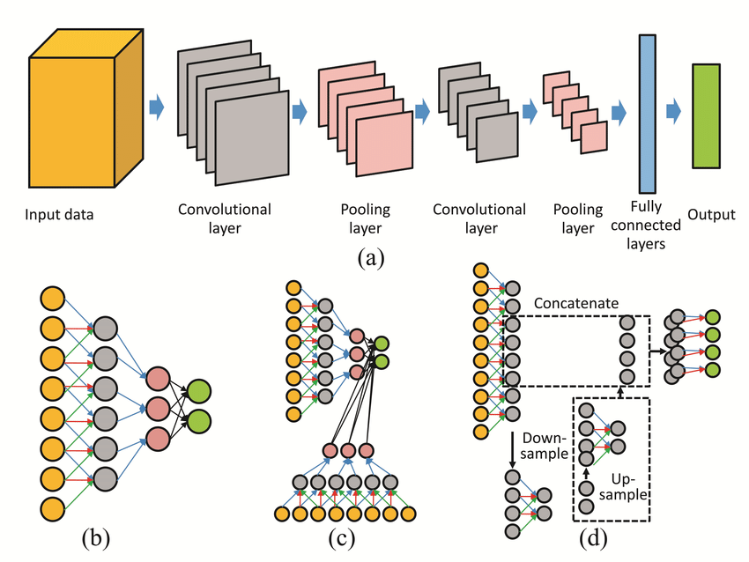

All hidden layers have ReLU activation function as the nonlinearity function. The output layer is has softmax function as these models are trained for multi-class classification problem. The ReLU activation function is represented by the following equation. f(z) = max{0, z} (1) where z is the input and f(z) is the output of the activation function. ReLU is a linear activation which forwards the input if it is positive otherwise makes it 0. The Softmax activation function is a probabilistic version of argmax function. The Softmax activation function is represented by the following equation. σ(x)i = e xi P k j=1 e xj (2) where, σ is the softmax activation function, xi is the input vector, e xi is the standard exponential function of xi , k represents the number of classes present in the input. Adagrad[14] is an adaptive gradient algorithm for stochastic optimization. It dynamically adjusts learning rates for each parameter during training. It’s particularly useful when dealing with sparse data or features with varying importance. Adagrad adapts the learning rate based on the historical gradient information, making it effective for non-convex optimization problems. The proposed CNN architecture is shown in Figure 2.

1. **Performance Evaluation**

To evaluate the model’s performance, it is trained for 20 epochs with a batch size of 64. The Model Checkpoint call-back is employed to save the best model based on validation loss. The model’s accuracy and loss are assessed on the test set. The evaluation results demonstrate the effectiveness of the proposed model in accurately recognizing emotions. Our proposed CNN model addresses the gaps of earlier research in the domain, providing a detailed flowchart and pseudo code to elucidate its architecture. Trained on the FER2013 dataset, our model showcases promising results in accurately identifying diverse emotional states. The evaluation process includes considerations of accuracy, loss, and the implementation of a Model Checkpoint to ensure the retention of the best-performing model.

Figure 2: Proposed CNN Model

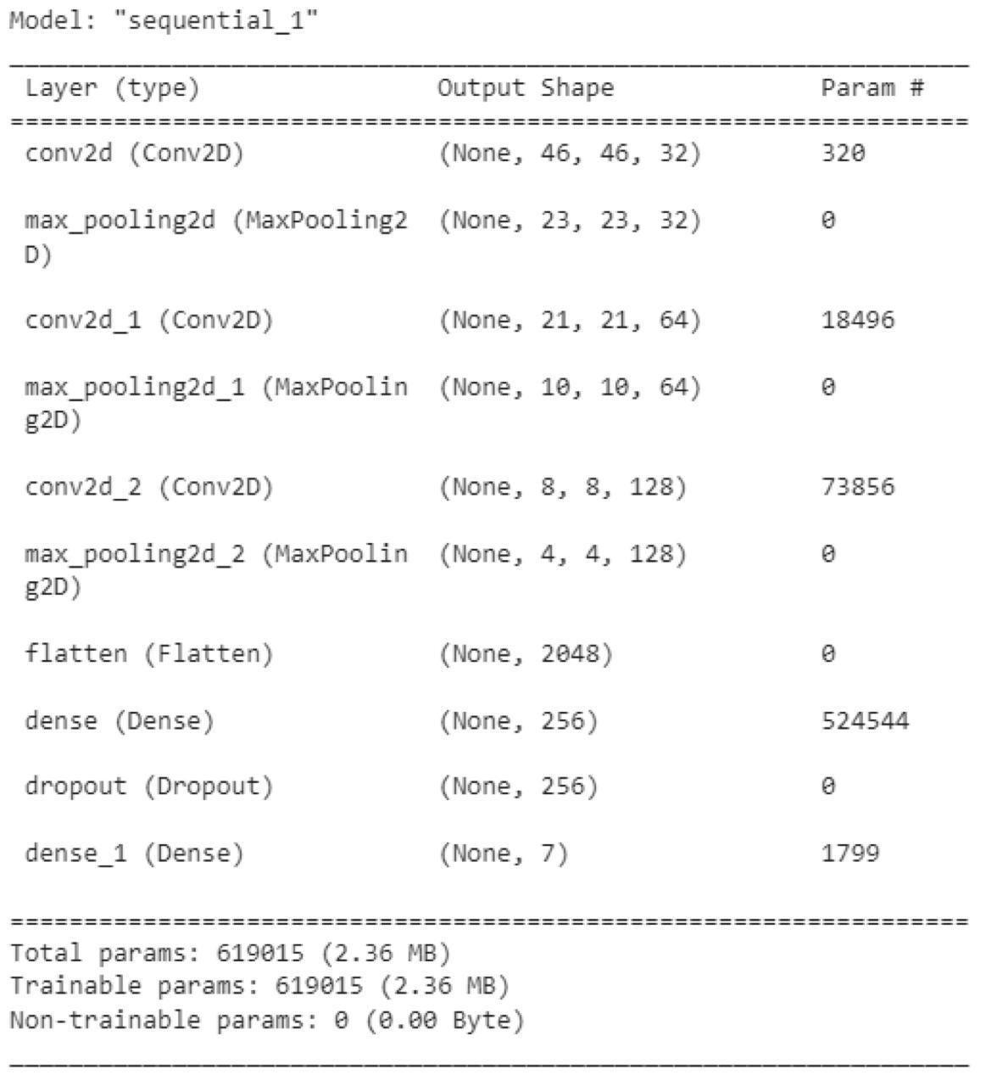

1. **Conclusion and Future Scope**

Our study presents a comprehensive analysis of emotion recognition using CNNs on the FER2013 dataset. The proposed model showcases promising results in accurately classifying emotions. However, certain limitations, such as potential biases and generalization challenges, need consideration. Future research should address these aspects and explore enhancements to further improve emotion recognition systems. The future scope of this research includes investigating advanced techniques to handle biases in emotion recognition models, exploring additional datasets for model generalization, and extending the model to recognize a broader range of facial expressions. Furthermore, the application of emotion recognition in real-world scenarios, such as human computer interaction and mental health assessment, presents exciting avenues for future exploration.

from taking notice of the present issues confronted by the sector as well as the future potential. Because of this, every acre of farmland should be used to its full potential in order to maximize agricultural output. This may be accomplished by using environmentally friendly sensors and communication systems that are powered by artificial intelligence and the internet of things.

**References**

1. Liliana, D.Y.: Emotion recognition from facial expression using deep convolutional neural network. Journal of Physics, Conference Series 1193 (2018)
2. Ding, H., Zhou, S.K., Chellappa, R.: FaceNet2ExpNet: Regularizing a Deep Face Recognition Net for Expression Recognition 7 (2016)
3. Li, S., Deng, W.: Deep facial expression recognition: A survey. IEEE Transactions on Affective Computing 13(3), 1195–1215 (2022). https://doi.org/10.1109/ TAFFC.2020.2981446
4. Kumari, J., Rajesh, R., Pooja, K.M.: Facial expression recognition: A survey. Procedia Computer Science 58, 486–491 (2015). https: //doi.org/10.1016/j.procs.2015.08.011. Second International Symposium on Computer Vision and the Internet (VisionNet’15)
5. Rawat, W., Wang, Z.: Deep convolutional neural networks for image classification: A comprehensive review. Neural Computation 29, 1–98 (2017). https://doi.org/10.1162/ NECO_a_00990
6. Al-Nafjan, A., Hosny, M., Al-Wabil, A., AlOhali, Y.: Classification of human emotions from electroencephalogram (eeg) signal using deep neural network. International Journal of Advanced Computer Science and Applications 8(9) (2017). https://doi.org/10.14569/ IJACSA.2017.080955
7. Alakus, T.B., Gonen, M., Turkoglu, I.: Database for an emotion recognition system based on eeg signals and various computer games – gameemo. Biomedical Signal Processing and Control 60, 101951 (2020). https: //doi.org/10.1016/j.bspc.2020.101951
8. Alhagry, S., Fahmy, A.A., El-Khoribi, R.A.: Emotion recognition based on eeg using lstm recurrent neural network. International Journal of Advanced Computer Science and Applications 8(10) (2017). https://doi.org/ 10.14569/IJACSA.2017.081046
9. Muhamed Ali, A., Ibrahim, A., Zhuang, H.: An approach for facial expression classification. International Journal of Biometrics 9, 96 (2017). [https://doi.org/10.1504/IJBM. 2017.10006477](https://doi.org/10.1504/IJBM.%202017.10006477)
10. Sang, D.V., Van Dat, N., Thuan, D.P.: Facial expression recognition using deep convolutional neural networks. In: 2017 9th International Conference on Knowledge and Systems Engineering (KSE), pp. 130–135 (2017). <https://doi.org/10.1109/KSE.2017.8119447>
11. [Mollahosseini, A., Chan, D., Mahoor, M.H.: Going deeper in facial expression recognition using deep neural networks. In: 2016 IEEE Winter Conference on Applications of Computer Vision (WACV), pp. 1–10 (2016). https: //doi.org/10.1109/WACV.2016.7477450
12. Singh, S., Nasoz, F.: Facial expression recognition with convolutional neural networks. In: 2020 10th Annual Computing and Communication Workshop and Conference (CCWC), pp. 0324–0328 (2020). [https://doi.org/10. 1109/CCWC47524.2020.9031283](https://doi.org/10.%201109/CCWC47524.2020.9031283)
13. Gervasi, O., Franzoni, V., Riganelli, M., Tasso, S.: Automating facial emotion recognition. Web Intell. 17(1), 17–27 (2019)
14. Lydia, A., Francis, S.: Adagrad - an optimizer for stochastic gradient descent Volume 6, 566–568 (2019)