ExpenseXpert: Transforming Financial Management with AI-Driven Predictive Analytics and Efficient Tracking

|  |  |  |  |  |
| --- | --- | --- | --- | --- |
| 1stProf. Shantanu Pawar | 2ndAditya Dhole | 3rdDyneshwar Jaybhaye | 4thTushar Gosawi | 5thShivraj Gaikwad |
| *Assistant Professor, Department of Information technology* | *Student, Department of Information technology* | *Student, Department of Information technology* | *Student, Department of Information Technology* | *Student, Department of Information Technology* |
| *P.E.S. Modern college of Engineering* | *P.E.S. Modern College of Engineering* | *P.E.S. Modern College of Engineering* | *P.E.S. Modern College of Engineering* | *P.E.S. Modern College of Engineering* |
| Pune, India | Pune, India | Pune, India | Pune, India | Pune, India |
| [shantanu.pawar@m](mailto:shantanu.pawar@m)oderncoe.edu.in | [adityadhole2020@gmail.com](mailto:adityadhole2020@gmail.com) | [jaybhaye@gmail.com](mailto:jaybhaye@gmail.com) | [gosawit7@gmail.com](mailto:gosawit7@gmail.com) | [shivrajgaikwad228055@gmail.com](mailto:shivrajgaikwad228055@gmail.com) |

***Abstract*— In today's interconnected and dynamic financial landscape, individuals often face challenges in managing personal finances, exacerbated by a lack of financial literacy. This research introduces an innovative solution, "ExpenseXpert" designed to revolutionize the financial management paradigm. The system leverages artificial intelligence (AI) and machine learning (ML) to streamline expense tracking, budgeting, and financial insights, providing users with unprecedented efficiency and accuracy. The system's proactive approach includes notifications to alert users if they exceed their budget, ensuring financial discipline. It goes beyond traditional expense tracking by generating custom budget plans based on spending patterns, offering a unique feature for users to download summaries of their expenses in PDF or Excel formats.**

***Keywords—Personal finance, Personalized budget planner, PDF/Excel Report Download, expense prediction, GPT 3.5, machine learning, NewsAPI, Yfinance, ARIMA model, LSTM model.***

I. INTRODUCTION

This research paper aims to address the challenges that hinder effective financial management for individuals, such as improper administration of incomes and expenses, lack of conventional budget planning techniques tailored to individual spending habits, unforeseen expenses, and complexities in existing financial-related applications [1]. Financial literacy is a crucial factor in financial management, and the lack of it contributes to the struggles of a majority of people in India, where only 27% of adults are financially literate [2]. The global personal finance software market has seen a rapid increase in demand, but current methodologies and systems are not effective for individuals with low financial literacy. Therefore, it has become increasingly important to develop a smart personal finance management web application that utilizes modern technologies such as machine learning, artificial intelligence, and data visualization methods to increase users' motivations and intentions to use proper personal financial management steps. The research paper introduces a web application that focuses on enhancing user experience and customer satisfaction through five proposed solutions. These solutions include tracking daily expenses and storing it in such a way that user can make a pdf or excel or csv file anytime he wants, visually

representing the expenses so that user can properly understand his/her expenses, generating a custom budget plan based on user spending patterns, and providing user with latest financial news according to the prefered news source, and help user invest properly by providing them the detailed historic data and providing predictions for analysis, and an financial chatbot where user can ask any question related to finance. By reducing errors, the application aims to provide an efficient and time-saving approach to managing finances with a proper budget plan, which can lead to financial success in the users' lives. These solutions aim on introducing new technologies that help providing efficient, time- saving ways to manage finances with a proper budget plan, which will ultimately lead to financial success in their lives.

LITERATURE REVIEW

1. *Personalized Budget Planner*

This Budgeting plays a vital role in the financial planning of every individual, as it serves as a critical step towards achieving their financial objectives. Numerous developers have made attempts to create various applications for managing budgets. In the paper [3], a user-friendly mobile application is proposed for recording and analyzing transactions. Users can input daily income and expenses under default or new categories, with the app maintaining transaction history. The app also utilizes graphical representations to compare budgets against actual income and expenses and generates statistical reports to provide an overview of the user's financial situation. In the paper [4], a computerized daily expense management system that efficiently tracks day-to-day expenses has been proposed. It eliminates the need for hardcopy output by systematically maintaining records of paid and unpaid transactions. This system enables users to easily access stored data, keeping track of their expenses in an organized and effective manner. After conducting an analysis of the existing apps, it was found that none of them provide an automated solution for generating effective budget plans based on users' spending patterns. In response to this gap in the market, our system has been developed to automatically analyze user’s spending behaviors and habits over the previous months using machine learning algorithms. This analysis enables the system to create a personalized budget plan that is both appropriate and effective, allowing users to better manage their finance with confidence.

1. *Financial Chatbot*

This Financial chatbots have emerged as innovative tools for providing personalized financial assistance and support to users in managing their finances effectively. In recent years, there has been a growing interest among researchers and practitioners in exploring the capabilities and applications of financial chatbots across various domains, including banking, investment, personal finance management, and customer service. This literature survey aims to provide an overview of existing research and developments in the field of financial chatbots, highlighting key findings, methodologies, and insights from relevant studies. In the paper [5], outlined a chatbot for digital counselling. They have suggested that utilization of chatbot enables better user interactions and they can talk anytime and anywhere. They have only developed the prototype and haven't started the implementation. Paper [6] designed a therapy chatbot that can furnish the details regarding the health information. The authors highlighted the advantages of having a therapy chatbot which can alleviate the pain of a person remotely. They also give a prototype ofhow the system has to be developed. In the paper [7], they developed a chatbot using Rasa for checking. the finance status. The system can identify the user request and fetch the appropriate response related to finance. The system shows better performance than RNN and it is deployed in wechat. After conducting an analysis of the existing apps, it was found that none of them provide an automated solution for Personalized Financial Assistance, While previous research has explored chatbots in various domains such as digital counseling and therapy, our financial chatbot specifically targets the domain of finance. By focusing on financial management, our chatbot offers personalized assistance to users in managing their finances effectively, which is a distinct need compared to general counseling or therapy chatbots. The paper [7] mentioned the development of a chatbot using Rasa for checking finance status, showing better performance than RNN. Our financial chatbot can differentiate itself by utilizing advanced technologies like the GPT-3.5 API, which offers state-of-the-art natural language processing capabilities. This can lead to more accurate and contextually relevant responses, enhancing the overall user experience. While the paper [7] deployed their chatbot on WeChat, our financial chatbot can explore deployment on various platforms, including but not limited to messaging apps, websites, and mobile applications. This multi-platform approach can further increase accessibility and reach for users, providing a comprehensive solution for financial management.

1. *Capital Currents*

In the contemporary era of digitalization, the management of personal finances has evolved significantly, with the emergence of various expense tracker applications designed to facilitate the monitoring and organization of income and expenditures. This literature survey navigates through a diverse array of expense tracker applications developed by different researchers and developers, each offering unique functionalities and features tailored to address specific user needs. Expense Tracker Application (2021) by Velmurugan and Mrs.P.Usha is an application created by its developers in such a way that allows the user to maintain a computerized record of their expenses. This Expense tracker application gives functionality to its users to track expenses daily. The application is mainly made with the help of Java Apache NetBeans, xml, MySQL is used for database purposes. Application is well built but its users need to remember their username and password on their own for login purposes. It

cannot be done from a social account [8]. Expense Tracker by Atiya Kazi, et al., focuses on a web application named “Expense Tracker”. The “Expense Tracker'' developed by its creators is by using Angular 8 for front end and SQLite for back end. Creators also paid attention to privacy, Therefore, to use the Expense Tracker the user has to login each and every time to access the application. Sign up can be done by username, phone no or email address. Users can use username, password for login purposes. Forgot password and forgot username functionality is also there [14]. Muskaan Sharma, et al., is developed an expense tracker using statistical analysis. The application is efficient in comparison to others. The user interface is attractive. Config module enabled user to store the user’s data. The config file is stored in the local files of the system. Hence the application can view and save data without internet. Format of the files stored is BASON and hence hard to decode. The expense log of the application can be personal only. It is not intended for shared expenses within a group [15]. After studying these papaers we developed features that were not available in the traditional financial management systems. Unlike traditional expense tracker applications, our application stands out by providing users with access to the latest financial information from different news sources. By incorporating real-time updates and insights into market trends, our application empowers users to make informed financial decisions and stay abreast of changing economic landscapes. Another distinctive feature of our application is its flexibility in file format downloads. Users have the convenience of exporting their expense data in multiple formats such as PDF, CSV, or Excel, catering to diverse preferences and compatibility requirements. This capability enhances usability and interoperability, enabling seamless integration with external tools and platforms. Our application distinguishes itself through its visually appealing interface, offering various charts and graphical representations of expense data. By leveraging interactive charts, users can gain deeper insights into their financial habits and trends, facilitating better decision-making and goal tracking. An innovative feature of our application is the proactive budget management system, which alerts users through pop-up notifications when they exceed their predefined budget thresholds. This proactive approach empowers users to maintain financial discipline and avoid overspending, fostering greater financial accountability and control.

1. *Investment Helper*

In recent years, the intersection of machine learning and finance has emerged as a dynamic field of study, offering promising avenues for enhancing predictive modeling, risk assessment, and decision-making processes within financial domains. Researchers have increasingly turned to machine learning techniques to tackle the complex and rapidly evolving challenges inherent in financial markets, driven by the vast amounts of data available and the potential for improved accuracy and efficiency compared to traditional methods. H.B. Hashemi with his colleagues, in their research work stated that MLPs perform superior to LSTMs at prediction stock prices [11]. Their study focused on inter day price predic- tion. We thought of scaling this observation to our problem of short-term price prediction. Pradeep Mahato, in his research work had developed vari- ous ensemble models to predict the movements of the next day's stock price [12]. In [13], the researchers have used historical data to predict the position of stock market. The results of [13] proved that historical data has strong predictive ability. In [14], the researchers have used Artificial Neural Networks (ANN) and statistical technique ARIMA on almost 3 year's data to predict KSE-100 index. After studying the papers mentioned above, our LSTM model leverages historical data similarly to the approach discussed in [13]. However, LSTM models are known for their ability to capture long-term dependencies and patterns in sequential data better than traditional machine learning

techniques. This might lead to more accurate predictions, especially in capturing complex temporal relationships in stock price data.. [11] While H.B. Hashemi et al. found that MLPs outperformed LSTMs for interday price prediction, our focus on long-term price prediction yield different results. By specializing in long-term prediction, our LSTM model capitalize on its ability to capture long-term patterns and fluctuations in stock prices more effectively than MLPs. [12] Pradeep Mahato's ensemble models for predicting next day's stock price movements provide valuable insights into modeling approaches. Our LSTM-based model offer a different perspective by focusing on capturing temporal relationships and patterns directly from historical data, potentially complementing or enhancing the effectiveness of ensemble techniques. The study in [14] utilizes Artificial Neural Networks (ANN) and ARIMA, which are traditional techniques for time series forecasting. Our LSTM-based model outperforms ANN and ARIMA in capturing nonlinear and complex relationships in stock price data, leading to potentially more accurate predictions, especially for long- term forecasting.

METHODOLOGY

1. *Personalized Budget Planner*

This component is used to forecast users' future expensesby analyzing their spending patterns to generate a customized budget that caters to the customer's needs. To achieve this task, time series datasets spanning from 2020- 2023 on daily expenses were used. These daily expense records were categorized into eight different categories, namely education, medical, food, entertainment, transport, personal care, housing/bills, and other. To forecast the amounts for each expense category, a probabilistic model known as Autoregressive Integrated Moving Average (ARIMA) was employed, which effectively captures the time-varying characteristics of the daily expense data. The acquired dataset was non- stationary and since the ARIMA model requires data to be stationary differencing method wasused. To achieve the best possible accuracy in forecasting, values of the hyperparameters were optimized. The dataset was split as 0.8:0.2 for training and test data and used to train the model. For each expense category, separate ARIMA models will be used to do forecasting. Accuracy matrices such as Mean Absolute Percentage Error (MAPE), Mean Error (ME), Mean Absolute Error (MAE), and Min-Max Error (minmax) were used to evaluate the model's forecasting ability. An alternative approach involving the application of the Long Short-Term Memory (LSTM) model was examined for expense forecasting, but the model failed to give acceptable results since LSTM models require more training data to capture complex patterns over an extended period. In this application where daily expenses are utilized to forecast expenses for the next 15 days, the ARIMA modelwas found to be a more suitable choice. This is because the ARIMA model has a proven ability to effectively capture short-term trends and seasonality in the data, making it particularly suited for short-term forecasting tasks.

1. *Financial Chatbot*

The primary objective of this study is to develop a financial chatbot using the GPT-3.5 Turbo API integrated into a Django website. The scope of the chatbot's capabilities includes providing personalized financial assistance, offering investment advice, assisting with budgeting, answering queries about personal finance management, and delivering insights on market trends.

Financial data is collected from trusted sources, including market data, economic indicators, investment strategies, and personal finance management techniques. The data is preprocessed to ensure compatibility with the GPT-3.5 Turbo API for analysis and consumption by the chatbot. The GPT-

3.5 Turbo API is utilized to train the chatbot on financial data. Relevant prompts and examples related to financial queries and responses are provided to the model for training. The trained model is integrated into the Django website to enable real-time interaction with users. Intent recognition and NLU algorithms are implemented to accurately interpret user queries. Named Entity Recognition (NER) techniques are utilized to identify entities such as stock symbols, financial terms, and dates within user queries, enhancing the chatbot's understanding. The GPT-3.5 Turbo API is employed to generate coherent and contextually relevant responses to user queries based on the trained model and input data. Responses are tailored to provide personalized financial advice and assistance to users. Mechanisms for error handling are implemented to address queries that the chatbot cannot understand or respond to adequately. Escalation paths are provided for users to connect with human agents or access additional resources if needed. A user-friendly interface is designed for the Django website to facilitate seamless interactions with the financial chatbot. Emphasis is placed on simplicity, clarity, and ease of use to enhance the overall user experience. Thorough testing is conducted to evaluate the chatbot's performance across various scenarios and user queries. Performance metrics including accuracy, response time, and user satisfaction are assessed to ensure the effectiveness of the chatbot. The financial chatbot is deployed on the Django website once testing is complete and it meets quality standards. Regular maintenance and updates are performed to incorporate new data and capabilities, ensuring the chatbot's effectiveness over time.

1. *Capital Currents*

The primary objective of the Capital Current feature is to provide users with the latest financial information sourced from news articles using the NewsAPI. The scope includes integrating the NewsAPI into the chatbot to fetch real-time financial news and allowing users to customize their news preferences based on their favorite news sources. The NewsAPI is integrated into the chatbot system, allowing access to a wide range of financial news articles from various sources. Configuration settings are adjusted to enable seamless communication between the chatbot and the NewsAPI. Functionality is implemented to enable users to customize their news preferences within the chatbot interface. Users can select their favorite news sources and specify topics of interest to personalize their news feed. The chatbot retrieves the latest financial news articles from the NewsAPI based on user preferences. The retrieved news articles are parsed to extract relevant information such as headlines, article summaries, publication dates, and source details. Users interact with the chatbot to access the latest financial news. The chatbot presents the retrieved news articles to users in a user-friendly format within the chatbot interface. Users can browse through the news articles and select specific articles for further reading. Users have the option to manage their favorite news sources within the chatbot interface. They can add, remove, or update their list of favorite news sources based on their preferences. Thorough testing is conducted to ensure the functionality and reliability of the Capital Current feature. Testing includes verifying the accuracy of news retrieval, assessing the user experience, and evaluating the effectiveness of the different news sources regarding the financial information.

1. *Investment Helper*

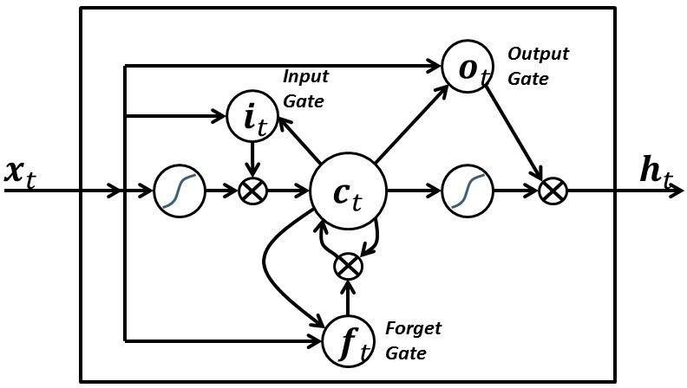

In machine learning, many a times it has been noted that the simplest of algorithms give astounding results than the com- plex algorithms. We have adopted this line of thinking and for the same reason, the paper will be utilizing Feed Forward Mul- tilayer Perceptron and Long Short-Term Memory model. The two models would be trained on the same data and would be made to predict long-term stock prices and their results would be discussed in the following sections. The primary objective of the Investment Helper function is to assist users in making informed investment decisions by predicting stock prices using an LSTM model. LSTMs are a kind of RNNs which effectively capture long term dependencies in time series prediction problems. It is due to these dependencies that the order of input plays a significant role prediction. The steps followed in the overall algorithm of LSTM is the same as MLP except for the processing of input inside every neuron. Unlike normal neurons, the output of every LSTM cell is a result of a multistep process. LSTMs have an additional memory, called cell state, which stores relevant past infor- mation toaid in prediction. The information stored in the cell state is modified by structures, called gates, in the following steps. Initially, the forget gate decides whether to eliminate any available information. The input gate and tanh layer then de- cide which new information is to be stored. Further, the infor- mation gets added and deleted according to the previous gates. Finally, the activation function is applied to the data and the output is produced. Regular maintenance and updates are performed to address any issues, refine the LSTM model, and incorporate feedback from users and market data.

RESULT AND DISCUSSION

To forecast expenses for creating a tailored budget plan, two different models, ARIMA and LSTM, were assessed.

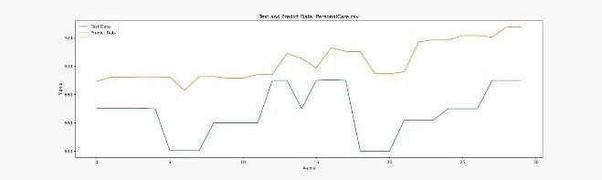

Fig. 1. Test and Predict Data Graph - LSTM Model

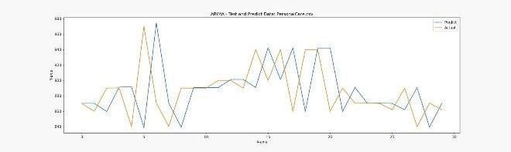

Fig. 2. Test and Predict Data Graph - ARIMA Model

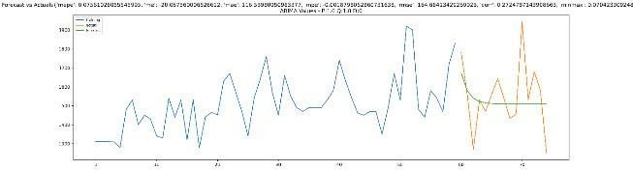

Fig. 3. Forecast vs Actual Value Graph ARIMA Model

After making the datasets stationary, the ARIMA model outperformed the LSTM model in forecasting future values for expense categories. Specifically, the ARIMA model was able to forecast values for the personal care category with a MAPE of 0.0756, which indicates that, on average, the model's predictions have an error rate of approximately 7.56%, an acceptable rate in this context. The reason for ARIMA's superior performance is that it works well with small datasets, whereas LSTM models require large datasetsto learn complex patterns in the data. Since the collected timeseries data for expense categories were limited, the ARIMA model was better at calculating the next predictions. Therefore, the stationary ARIMA model proved to be a more suitable choice for forecasting future expense values for the budget plan.

After conducting a thorough literature review and analyzing existing research on chatbot applications, particularly in the domains of digital counseling, therapy, and finance, we have identified a significant gap in the provision of personalized financial assistance. While previous studies have explored chatbots' potential in various domains, none specifically addressed the need for automated solutions tailored to financial management. In response to this gap, we propose the development of a novel financial chatbot. Leveraging advanced technologies such as the GPT-3.5 API, our chatbot offers state- of-the-art natural language processing capabilities, enabling more accurate and contextually relevant responses. We differentiate our approach by focusing explicitly on financial management, providing personalized assistance to users in managing their finances effectively.

In conclusion, our research presents a novel contribution to the field of chatbot applications, particularly in the domain of financial management. By addressing the gap in existing literature and leveraging advanced technologies, our financial chatbot offers a unique solution for personalized financial assistance.

The performance of the LSTM model in predicting future price trends is illustrated in Figure 2.

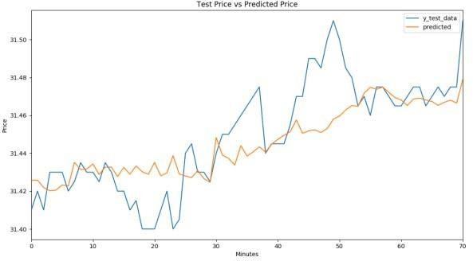

Figure 2: Average case graph of LSTM model's predicted vs actual price

Across the plotted data points, the LSTM model demonstrates notable success in accurately forecasting price movements, whether upward or downward. The model's predictions closely align with the actual price data, indicating its capability to capture underlying trends and patterns effectively.

CONCLUSION

In In-depth analysis by ExpenseXpert financial application research led to the recommendation of an intelligent solution in the form of a web application that automates personal finance management which helps people manage their finances more effectively. This innovative platform serves as a pivotal advancement in the domain of personal finance management, offering a dynamic and automated approach to empower individuals in their financial endeavors. Specifically crafted to enhance financial literacy and streamline expense management, the application is poised to revolutionize how people perceive and handle their finances.At the heart of this groundbreaking application lies a fusion of sophisticated technologies, prominently featuring machine learning and artificial intelligence. These cutting- edge elements not only distinguish ExpenseXpert but also elevate it as a beacon of innovation, guiding users towards a more informed and effective financial management experience. By leveraging the power of machine learning, the application provides personalized budget plans through ARIMA, stock price prediction using LSTM.

In summary, the ExpenseXpert web application stands as a testament to the transformative potential of technology in reshaping personal finance management. By automating tedious tasks, providing real-time financial insights, and offering personalized financial strategies, ExpenseXpert emerges as a comprehensive solution to the complexities associated with managing personal and business finances in our dynamic and interconnected world. This research not only addresses the existing challenges in financial management but also heralds a new era where individuals can navigate their financial journeys with newfound control, efficiency, and insights.

REFERENCES

1. B. K. W. Jian, “PERSONAL FINANCIAL PLANNING AND MANAGEMENT APPS (PFPMA),” p. 29.
2. L. Klapper, A. Lusardi, and P. van Oudheusden, “Financial Literacy Around the World:,” p. 28.
3. K. P. U. Anuruddhi, “Personal Budget Manager Android Application”.
4. U. P. Singh and A. K. Gupta, “Spending Tracker: A Smart Approach to Track Daily Expense,” 2021.
5. Cameron, G., Cameron, D., Megaw, G., Bond, R., Mulvenna, M., O'Neill, S., & McTear, M. (2017, July). Towards a chatbot for digital counselling. In Proceedings of the 31st International BCS Human Computer Interaction Conference (HCI 2017) 31 (pp. 1-7).
6. Sharma, B., Puri, H., & Rawat, D. (2018, April). Digital psychiatry- curbing depression using therapy chatbot and depression analysis. In 2018 Second International Conference on Inventive Communication and Computational Technologies (ICICCT) (pp. 627-631). ΙΕΕΕ.
7. Jiao, A. (2020). An Intelligent Chatbot System Based on Entity Extraction Using RASA NLU and Neural Network. JPhCS, 1487(1),012014.
8. R. Velmurugan and P. U. Mrs, "Expense Tracker Application," International Journal of Research & Technology(IJRT) ISSN: 2349- 6002, vol. 7, no. 10, March 20211.
9. A.Kazi, P. S. Kherade, R. S. Vilankar and P. M. Sawant. "Expense Tracker," Iconic Research And Engineering (IRE) Journals ISSN: 2456-8880, vol. 4, no. 11, May-2021.
10. M. Sharma, A. Bansal, R. R. Dr. and S. Sethi, "A Novel Expense Tracker using Statistical Analysis," International Journal of Innovative Research in Technology (IJIRT) ISSN: 2349-6002, vol. 8, no. 1. 2021.
11. Mahdi Pakdaman Naeini, Hamidreza Taremian, and Homa Baradaran Hashemi, "Stock Market Value Prediction using Neural Networks", 2010 International Conference on Computer Information Systems and Industrial Management Applications(CISIM).
12. Pradeep Mahato, and Vahida Attark, "Prediction of Gold and Silver Stock Price using Ensemble Models", IEEE International Conference on Advances in Engineering & Technology Research (ICAETR 2014), August 01-02, 2014, Dr. Virendra Swarup Group of Institutions, Unnao, India.
13. A. W. Lo, & A. C. MacKinlay, "Stock market prices do not follow random walks: Evidence from a simple specification test," Review of financial studies, vol. 1, no. 1, pp. 41-66, 1988.
14. S. Fatima, & G. Hussain, "Statistical models of KSE100 index using hybrid financial systems," Neurocomputing, vol. 71, no. 13, pp. 2742- 2746, 2008.