**Facial Recognition Attendance System Using Python**

Prabhat Kumar1, Jeevant Srivastava2, Nitin Srivastava3, Harshit Tiwari4, Ms. Varsha Saxena5

*1, 2, 3, 4 Department of Information Technology, Dr. A.P.J. Abdul Kalam Technical University, Uttar Pradesh, India*

*5 Professor of Inderprastha Engineering College, Ghaziabad, Uttar Pradesh, India*1official.prabhat0201@gmail.com, 2jeevasri2002@gmail.com,

3nitinsrivastav580@gmail.com, 4harshitoffical123@gmail.com

***Abstract — Attendance marking in a school room all through a lecture isn't simplest a difficult project but additionally a time eating one at that. because of an surprisingly high variety of college students present all through the lecture there'll always be a probability of proxy attendance(s). Attendance marking with conventional methods has been an area of project. The developing need of efficient and automatic techniques of marking attendance is a growing venture within the place of face recognition. In current years, the hassle of automatic attendance marking has been broadly addressed through the usage of standard biometrics like fingerprint and Radio frequency identity tags and so on., however, these strategies lack the detail of reliability. in this proposed mission an automated attendance marking and management machine is proposed by making use of face detection and popularity algorithms. instead of the use of the conventional methods, this proposed system pursuits to increase an automatic machine that statistics the pupil's attendance by way of the use of facial popularity technology. the principle goal of this paintings is to make the attendance marking and management machine green, time saving, easy and smooth. right here faces might be recognized the usage of face popularity algorithms. The processed photo will then be compared towards the present stored document after which attendance is marked inside the database therefore. compared to present system traditional attendance marking device, this machine reduces the workload of people. This proposed gadget can be applied with 4 levels inclusive of image taking pictures, Segmentation of institution image and Face Detection, Face evaluation and popularity, Updating of Attendance in database.***

***Keywords — Attendance, Facial recognition and detection, Image Processing, Haar cascade, LBPH, OpenCV-Python.***

# **Introduction**

The speedy improvement of pattern recognition and its application in various fields along with signature and face reputation suggests the importance of using this generation in many elements of huge businesses. the primary purpose for that is that these packages assist senior managers make selections that increase performance and effectiveness. then again, so as for the organization to work efficiently, the performance of the people within the company need to be correct and speedy.

Biometrics has the capability to grow to be an indispensable part of various signs utilized in organizations to degree worker overall performance. even though biometric generation is used in many regions, it has not but fulfilled its promise of automating people. Facial reputation is a shape of biometric technology. it's miles considered one of the only methods of analysing photographs and approaches; this is the principle motive why it has acquired so much attention inside the last few years. This evaluation became carried out as a result of numerous studies conferences devoted to the sphere of facial popularity; as an example: international convention on Voice and Video-character-based Authentication (AVBPA) and global convention on computerized Facial and Gesture reputation (AFGR). The facial reputation technique is similar to the general biometric technique in biometric face detection; optimization, extraction and matching are performed.

The facial recognition method may be divided into primary staged: processing before detection wherein face detection and alignment take vicinity (localization and normalization), and afterwards popularity arise through function extraction and matching steps.

*A. Face Detection*

This procedure separated the face regions from the background image. you may use face monitoring to follow the face within the face within the video move.

*B. Facial Alignment*

The purpose of this procedure is to locate the pleasant position and modelling of the face; where the detection step estimates the placement of the face and the step identifies the face consisting of facial contour, eyes, nostril, ears and mouth. Photometric properties together with illumination and grayscale are then normalized, as well as geometric variables together with length and pose.

*C. Feature Extraction*

After the primary steps, function extraction is completed, resulting in desirable facts this is proof against geometric and photometric modifications, which may be used to differentiate faces from exceptional human beings.

*D. Face Matching*

Examine the extracted content material with the capabilities saved within the database and determine the self- belief degree of the healthy.

Face identity applications are getting increasingly more used, and it's far anticipated to preserve developing and become broadly used in both small- and massive-scale programs. This work pursuits to offer an automatic attendance machine that makes use of facial recognition era via photograph/video streaming to discover students, file their attendance within the path manual or section, and examine their performance. The cause in the back of this research is to define pattern popularity, particularly face popularity, which is very essential and used in lots of programs consisting of recognition and detection.

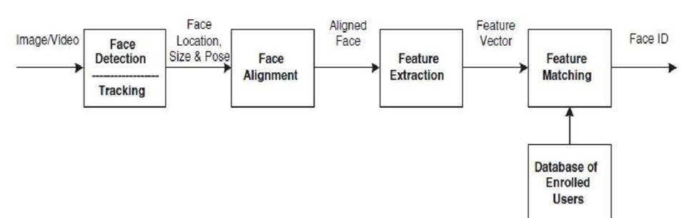

**Figure 1.** Functioning of Facial Recognition

# **Literature Survey**

The are a number of current systems intently associated with the proposed concept of marking attendance in a class by making use of facial reputation strategies and algorithms. To examine these systems a literature survey of the proposed systems become executed. The proposed case take a look at became designed round positive relevant resources related to facial reputation and photograph processing. A descriptive framework changed into designed the usage of the other design processes [1]. This device uses DNN to locate the faces of college students and PCA and LDA algorithm for photograph matching and a SVM classifier and CNN, they performed a accuracy of 86 percent with a database containing eleven pic, the database turned into created via extracting frames from a video recording of a student and those respective frames have been then stored inside the database [1].

The authors developed a device the use of a raspberry pi digital camera module that's hooked up at the door and the database is connected to an internet control server machine. whilst the raspberry pi captures an image, nearby Binary pattern set of rules is applied to it, if it suits the photo stored inside the database, a servo motor opens the door for the student. This applied machine has an accuracy of 95 percent with a dataset of eleven photos [2]. The authors fundamental goal here is to expand a face reputation algorithm with OpenCV 2.4.8 by using using an attendance machine as their case look at, here the authors have com- pared two well-known face popularity algorithms i.e., PCA(Eigenface) LDA (Fisher face) the usage of a ROC curve on their schooling set, the end result became Eigenface out executed Fisher face and got an accuracy of 70 percent to 90 percentage similarity for true faces [3]. The authors here advocate a way of decreasing the candidate gallery set and using facial element type, so as to beautify facial recognition, the authors performed experiments on CMU-PIE image database and PCA (primary component evaluation) set of rules, a success charge of 91.7, the principle aim of this gadget is to try to get down the processing time as a great deal as possible [4]. The authors here have made use of CNN (Convolutional Neural Networks) to detect and extract functions from the captured photos that comprise the faces of the scholars. they've also made use of CNN to train their model and a SVM (assist Vector system) classifier to categorise the trained pictures. They executed an accuracy price of 95 percentage accuracy [5]. The authors right here have developed an utility that makes use of cellular terminals and also the students GPS region to mark attendance and carry out other activities. The app additionally has many functionalities that make interplay easier [6]. The authors here have carried out research on how distance and slope among facial features influences facial recognition, an increase in the facial functions of a face the popularity price will increase, the highest accuracy acquired changed into 94.60 percent with the MLP classifier, thereby showing that the better the number of facial capabilities the better is the recognition charge [7]. The authors here have made use of a NFC (close to area communications) card, the college need to have a cellular device with NFC, to be able to then scan the NFC card of a scholar, the device will even have a digicam so that they can capture the images of the students present. The attendance is then uploaded to the primary server [8]. ﻿

Right here the authors have made use of Eigen face database at the side of foremost factor analysis and integrate them with MATLAB GUI, this machine turned into advanced to conquer the issues of image high-quality, photograph size and varying intensities of light and so on [9]. Here the authors have created a facial picture reputation system using a correlation photo sensor. Differential geometry and vector maps are used to locate the important thing factors of the face a 3-D real time facial imaging system was constructed using the correlation picture sensor [10].

This paper provides an online machine for recording attendance based on facial recognition incorporating facial masks detection. the primary goal of this assignment is to broaden an powerful attendance system based on face reputation and face masks detection, and to offer this service on line thru a browser interface [11]. Recording attendance statistics on line permits information to be without problems recorded in a centralized on-line database. because faces are used as biometric signatures in this assignment, all customers registered inside the device can have their profiles loaded with their face-images samples. initially, before face reputation may be finished, the version training phase based totally on SVM could be performed, mainly to expand a trained version that can carry out face reputation [11].

# **Existing System**

Conventional attendance marking strategies i.e. pen and paper or signing attendance sheets are smooth to pass and trick as giving proxies or false signatures is a common practice among students nowadays, students take an unfair benefit of this at maximum instances. but a facial recognition machine is unassailable and cannot be fooled as everyone has a set of specific and individual functions not unusual to that person and can't be replicated or changed, all of it comes down to one simple reality that is, unless you are physically gift inside the lecture your attendance will no longer get marked.

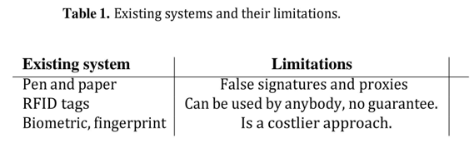

# **Methodology**

This section deals by and large with proposed techniques, methodologies and ideas relevant to facial reputation and image processing that's extra precise and niche to a unmarried process which makes use of facial recognition algorithms picture processing techniques.

The proposed assignment includes 4 sequential phases; namely capture, detection, photo matching and attendance marking.

***5.1 User dashboard***

The user dashboard displays profile statistics, attendance records in a calendar view, and notifications. This format helps customers without problems tune their attendance records and stay knowledgeable about machine updates or reminders. This display features a live digital camera feed with commands for correct face positioning. real-time remarks guarantee customers understand when their face is detected and identified, supplying a affirmation message upon a hit attendance logging.

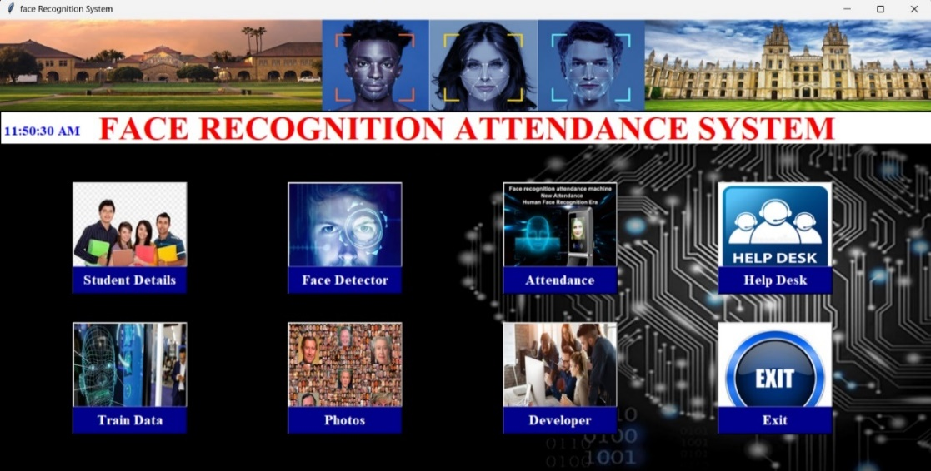

**Figure 2.** User dashboard of Attendance System

***5.2 Primary database creation and Image capturing***

The original database containing the pics of the students is created via taking a live actual time video of the scholars, and splitting the video into thirty frames, con- verting them to grey scale and storing most effective the faces of the students as pictures, then we can be education the respective photographs the use of the LBPH algorithm all the whilst storing their respective histogram price's after which comparing the saved and educated pics in opposition to the captured photographs to mark the attendance. The software program used for splitting the video into frames is Open-CV.

Admins can view and control a list of customers, with seek and clear out alternatives for efficiency. paperwork for adding or modifying consumer details, inclusive of importing profile snap shots and enrolling facial popularity records, also are supplied.

In photo shooting segment the professor will capture a real time video of the elegance room or lecture hall through their personal cell device and making use of the Droid Cam application which links the system this is running to your computer for your cell tool and lets you use your mobile camera to seize the scholars present in the class room, the system may be accessed by the professors by getting access to the laptop where all of the records is stored.

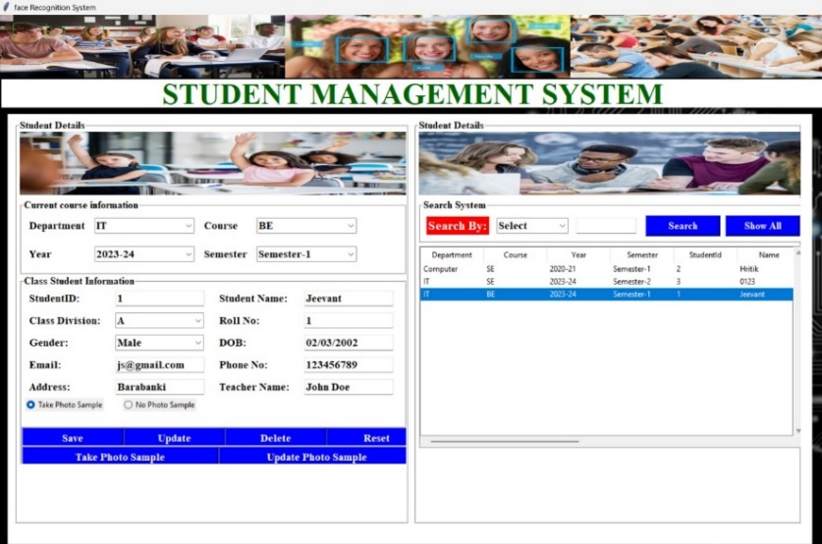

**Figure 3.** Primary database creation and Image capturing

﻿

***5.3 Face Detection Phase***

In this section once the video has begun shooting, concurrently the Haar Cascade algorithm is carried out to the video to get man or woman faces of the students and acquiring the distinct capabilities of their face (eyes, nose, ears and lips) through utilising line features and side capabilities, the Haar cascade algorithm essentially works through giving us the parts of the face which might be wanted maximum for detection i.e, the ROI (region of hobby) and processing and cropping out other regions of the face that do not play a function within the photograph processing and matching element. once the faces are detected they're extracted and saved.

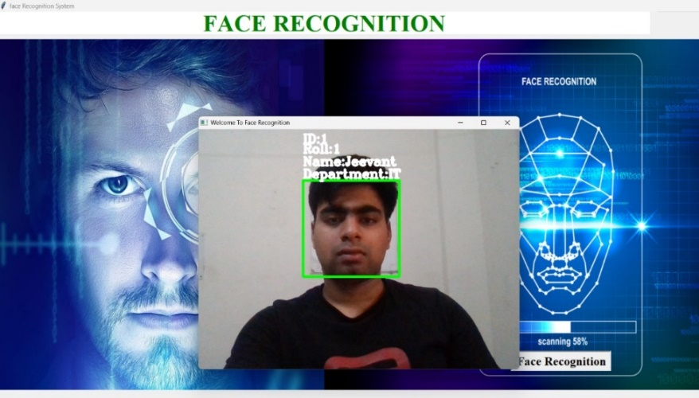

**Figure 4.** Face Detecting using Camera

***5.4 Image Matching and Verification***

In this third and most essential section of recognising the scholar, that is evaluating captured photograph in opposition to the stored pics inside the database, this approach is done through utilising the LBPH set of rules (neighbourhood Binary pattern Histogram), every picture saved in the database has it is histogram value calculated and is cross checked towards the calculated Histogram fee of the pics extracted from the captured video feed.

*Note –* *The name of the scholar seems above and the number shows the self-assurance.*

Checking out and validation are crucial steps in the development of a facial popularity attendance gadget, ensuring that the device meets the requirements and performs correctly in real-international eventualities. conduct massive testing of the deployed machine beneath realistic utilization eventualities to become aware of and deal with any issues or performance bottlenecks. Solicit remarks from end-users (e.g., college students, employees) to assess person pride, usability, and any issues concerning the system's functionality. Validate the system's accuracy and reliability through field trials and contrast with existing attendance tracking strategies.

*Note – machine takes one hundred samples of the single face to boom the accuracy of the system.*

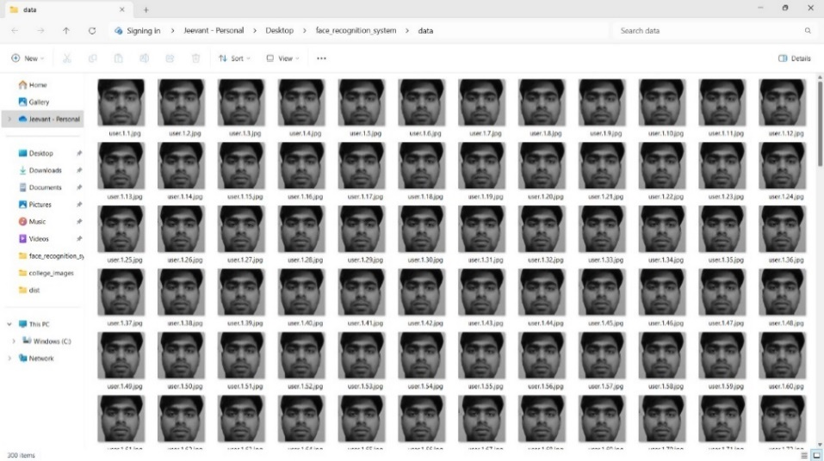

**Figure 5.** Image Matching and verification

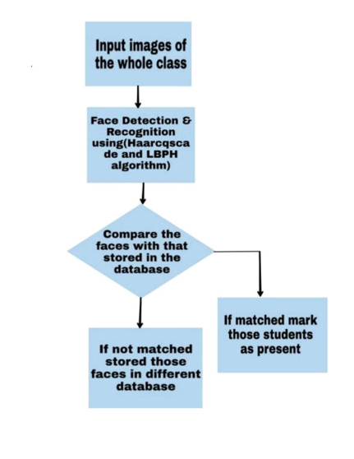

**Figure 6.** Flowchart of the face verification phase

***5.5 Attendance Marking Phase***

In this segment the attendance is marked, if the uploaded image suits the image saved in the database, then the attendance is marked gift for that lecture and stored. The attendance may be exported within the csv file format after the attendance is taken also if any updation is required then the particular csv document may be imported and after doing the requisite corrections it can be saved again as properly. Tere are 4 one-of-a-kind options are supplied i.e. Import, Export, replace and reset.

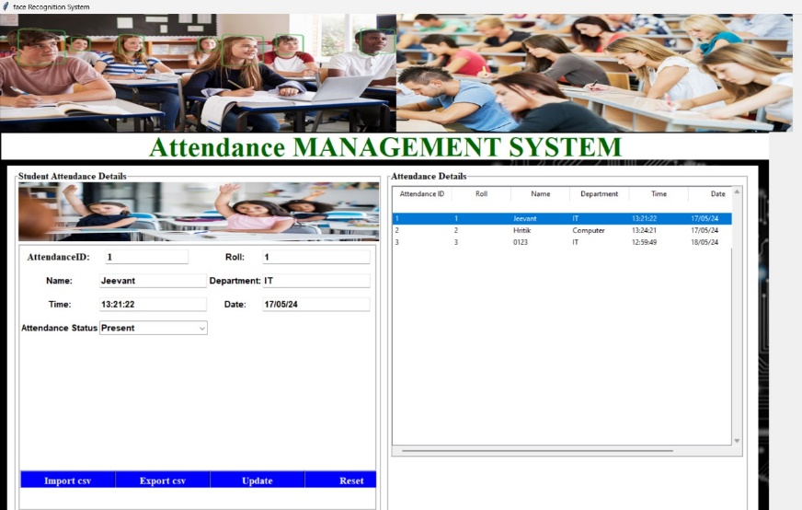

**Figure 7.** Attendance Window of the Attendance system

***5.6 Database for data storage***

SQL database is used for storing the info of the scholars. As, sql databases provide structured records control, ensuring facts integrity and accuracy through constraints like number one and overseas keys. They allow efficient question processing and guide complicated transactions with ACID compliance. Scalability and sturdy security features, which include user authentication and encryption, enhance their reliability. square databases facilitate data recovery with backup mechanisms and provide flexibility through standardized query language. They excel in coping with relational statistics, assist concurrent access, and combine well with diverse programming languages and tools, making them best for diverse programs from easy CRUD operations to complicated statistics analytics and reporting.

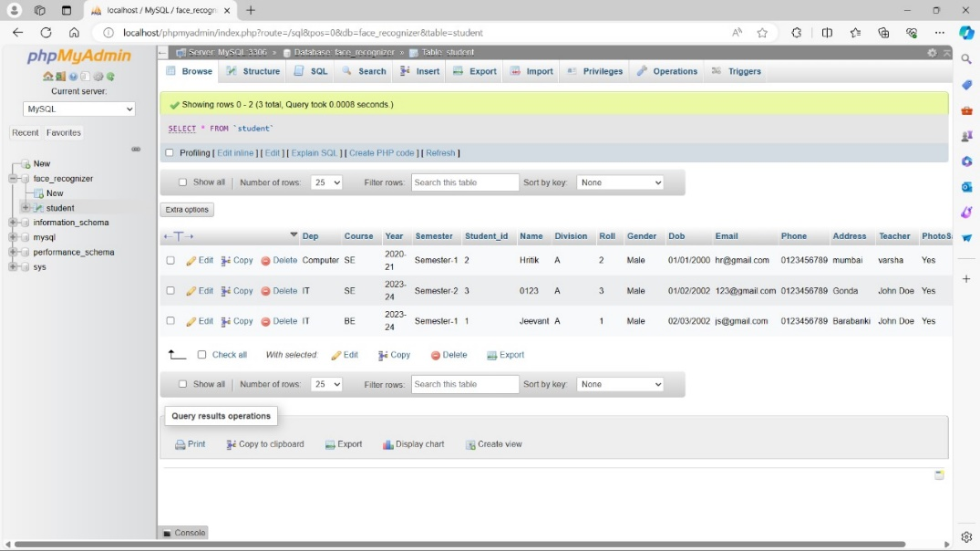

**Figure 8.** SQL Database for storing student details

***5.7 Proposed Architecture***

The architecture for the proposed machine has been designed to hold it quite straightforward and easy to recognize. the steps that ought to be undertaken to reach the final stop step of the device which is making sure the attendance of the student is up to date efficiently and well timed. The device can easily be accessed through anyone, where attendance of the scholars can effortlessly be checked and maintained with the aid of the school as when required. The Droid- Cam ap will allow clean use for taking pictures stay video feeds of the class and concurrently perform reputation for the students. OpenCV-Python can be used to get entry to the Haar Cascade and LBPH algorithms and their libraries which might be required for training, popularity and matching of the captured im- a while in opposition to the saved images available inside the formerly received statistics sets.

***Algorithms Used:***

*5.7.1 Haar Cascade*

The Haar Cascade algorithm is a fixed of classifiers used for object detection. Haar Cascade is a system gaining knowledge of- based method where a lot of superb and negative pix are used to educate the classifier. The pics which we would love to be classified via the classifier are called fantastic pics and the images we might now not want our classifier to categorise are known as terrible snap shots.

*5.7.2 Local Binary Pattern Histogram*

The local Binary pattern is used for face recognition, which means that identifying the captured photograph towards the image already saved in the database. The algorithm makes use of four primary parameters to understand a face. The Local Binary pattern is applied to the picture and in comparison, against the central pixel of the photograph, then we calculate the histogram price for the said lbp photo. The cost of the newly calculated histogram is then as compared in opposition to the already pre-processed histogram fee of the already saved picture inside the database. this is how the local Bi- nary pattern Histogram consists of out facial identity of pics.

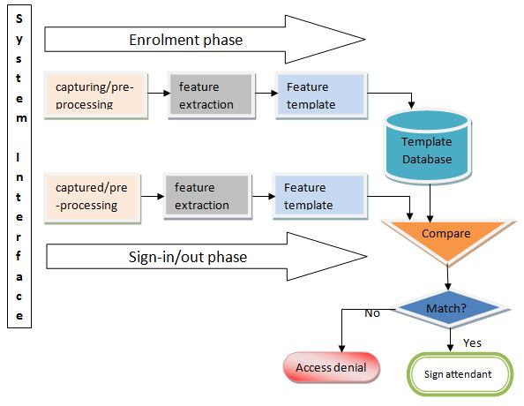

**Figure 9.** Proposed workflow and architecture

***5.8 Benefits of Proposed System***

*5.8.1 Foolproof*

Attendance marking becomes foolproof in nature, college students cannot carry out the previous approach of false proxies for his or her buddies as the system needs faces of the students and nothing else.

*5.8.2 Time saving*

Helps save time that at moments can get lost due to students disrupting the normal attendance marking method.

*5.8.3 Efficient*

Rather than instructors manually updating attendance to the university servers, the machine will itself calculate attendance of students ahead.

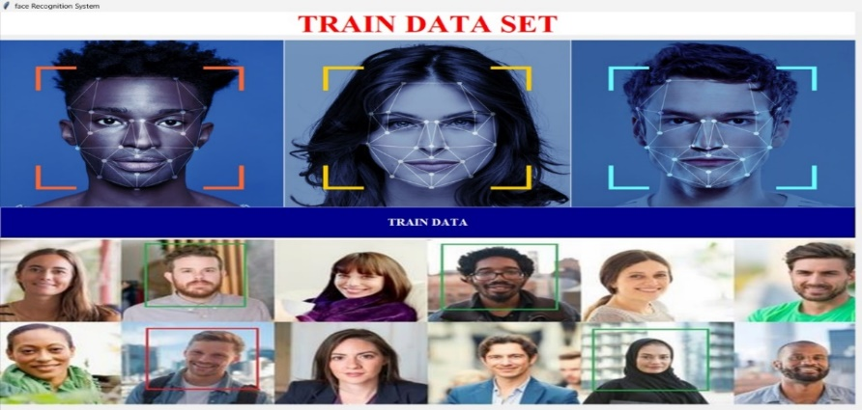

**Figure 10.** Train Data Module of the project

# **Challenges and Problems**

At the beginning of every lecture, phase, or laboratory, the teacher or coaching assistant pauses the lecture to acquire students to participate. this is a protracted system that takes plenty of effort and time, especially when you have many college students. There are also many distractions and distractions all through trying out. in addition, attendance data are broken and lost while transmitted between college students and faculty members.

Whilst there are many college students inside the lecture room, instructors regularly call numerous college students through the wrong names. subsequently, staff use this attendance facts to display student participation. This process may be easy and effective for a small quantity of college students, however on the other hand, processing the records of a massive quantity of students frequently results in human mistakes.

# **Conclusion**

Face reputation structures are a part of facial photo processing packages and their significance as a research place are growing these days. Implementations of machine are crime prevention, video surveillance, man or woman verification, and similar security activities. The face reputation machine implementation may be a part of universities. As facial reputation era continues to adapt, there are opportunities to discover new applications and integrations past attendance tracking. this will contain leveraging facial reputation for get entry to manipulate, traveller control, and personalised person experiences in numerous domains.

This paper offers a simple but efficient approach to calculate the attendance in a class by means of using facial recognition strategies. The output of this gadget may be out- lined as follows:

The machine not handiest detects just one face of a unmarried scholar, however successfully detects more than one college students or faces. The machine takes 100 samples of the unmarried face which facilitates to growth the efficiency of the gadget. The machine additionally efficiently recognises and marks the attendance of the detected students.

We desire to enforce an efficient, time saving and easy to function device on the way to in flip gain both faculty and college students. Through this venture, we have efficaciously demonstrated the feasibility and effectiveness of the usage of facial recognition generation to streamline the attendance control procedure in numerous contexts, from academic institutions to company settings.

# **Acknowledgement**

We would like to express our deepest gratitude to our dedicated development team.

We also extend our thanks to our mentor Mrs. Varsha Saxena for their continuous support and guidance.

We are also thankful to all who contributed to this endeavour.

# **References**

1. *Radhika C. Damale, Prof. Bageshree. V.Pathak. "Face Recognition Based Attendance System Using Machine Learning Algorithms." Proceedings of the Second International Conference on Intelligent Computing and Control Systems (ICICCS 2018) IEEE Xplore Compliant Part Number: CFP18K74-ART; ISBN:978-1-5386- 2842-3. IEEE 2018*
2. *Omar Abdul, Rehman Salim, Rashidah Funke Olanrewaju, Wasiu Adebayo Balogun. "Class Attendance Management System Using Face Recognition." 2018 7th International Conference on Computer and Communication Engineering (ICCCE) IEEE 2018.*
3. *Adrian Rhesa Septian Siswanto, Anto Satriyo Nugroho, Maulahikmah Galinium. "Implementation of Face Recognition Algorithm for Biometrics Based Time Attendance System" Center for Information Communication Technology Agency for the Assessment Appli- cation of Technology (PTIK-BPPT) Teknologi 3 BId., 3F, PUSPIPTEK Serpong, Tangerang, INDONESIA, 15314.*
4. *Jinsu Kim, Usman Cheema, Seungbin Moon. ",Face Recognition Enhancement by Employing Facial Component Classification and Reducing the Candidate Gallery Set. Department of Computer Engineering, Sejong University, Seoul, 143-747, Korea (sb- moon@sejong.ac.kr).*
5. *Nusrat Mubin Ara, Nishikanto Sarkar Simul, Md. Saiful Islam." "Convolutional Neural Network (CNN) Approach for Vision Based Student Recognition System." 2017 20th International Conference of Computer and Information Technology (ICCIT), 22-24 Decem- ber, 2017.*
6. *Xinxiong Liu, Wanru Wang "User Centered Design of Attendance Record System Based on Mobile Terminals" 2017 International Symposium on Computer Science and Intelligent Controls.*
7. *Turgut Özseven, Muharrem Düenci "Face Recognition by Distance and Slope between Facial Landmarks" Gaziosmanpaúa University Turkey, Tokat; Karabuk University, Turkey, Karabük.*
8. *Savitra Paharekari, Chaitali Jadhav, Surabhi Nilangekar, Jitesh Padwal "Automated Attendance System in College Using Face Recognition and NFC" International Journal of Computer Science and Mobile Computing A Monthly Journal of Computer Science and Information Technology ISSN 2320-088X IMPACT FACTOR: 6.017 IJCSMC, Vol. 6, Issue. 6, June 2017, pg.14-21*
9. *Rekha.E, Dr. Ramaprasad.P "An Efficient Auto- mated Attendance Management System based on Eigen Face Recognition "Department of Electrical Engineering, Amity University, Dubai UAE*
10. *Shu Zhan Toru Kuriharak, Shigeru Ando "Facial Authentication System Based on Real-Time 3D Facial Imaging By Using Correlation Image Sensor" School of Computer and Information Department of Information Physics and Computing Hefei University of Technology The University of Tokyo Hefei, Anhui, 230009, China 7-3-1 Bunkyo-Ku, Tokyo 113-8656, Japan shu-han@hfut.edu.cnzhan, bond, ando@alab.t.utokyo.ac.jp*
11. *D. Joshi, P. Patil, V. Singh, A. Vanjari, T. Shinde and H. Giri, "Face Recognition Based Attendance System," 2023 5th Biennial International Conference on Nascent Technologies in Engineering (ICNTE), Navi Mumbai, India, 2023, pp. 1-6, doi: 10.1109/ICNTE56631.2023.10146718.*
12. *Online attendance system based on facial recognition with face mask detection by “Muhammad Haikal Mohd Kamil, Norliza Zaini, Lucyantie Mazalan, Afiq Harith Ahamad”*
13. *R. C. Damale and B. V. Pathak, "Face Recognition Based Attendance System Using Machine Learning Algorithms," 2018 Second International Conference on Intelligent Computing and Control Systems (ICICCS), Madurai, India, 2018, pp. 414-419, doi: 10.1109/ICCONS.2018.8662938.*
14. *A. Arjun Raj, M. Shoheb, K. Arvind and K. S. Chethan, "Face Recognition Based Smart Attendance System," 2020 International Conference on Intelligent Engineering and Management (ICIEM), London, UK, 2020, pp. 354-357, doi: 10.1109/ICIEM48762.2020.9160184.*
15. *S. Dev and T. Patnaik, "Student Attendance System using Face Recognition," 2020 International Conference on Smart Electronics and Communication (ICOSEC), Trichy, India, 2020, pp. 90-96, doi: 10.1109/ICOSEC49089.2020.9215441.*
16. *S. S. Pawaskar and A. M. Chavan, "Face Recognition based Class Management and Attendance System," 2020 IEEE Bombay Section Signature Conference (IBSSC), Mumbai, India, 2020, pp. 180-185, doi: 10.1109/IBSSC51096.2020.9332212.*
17. *R. Hartanto and M. N. Adji, "Face Recognition for Attendance System Detection," 2018 10th International Conference on Information Technology and Electrical Engineering (ICITEE), Bali, Indonesia, 2018, pp. 376-381, doi: 10.1109/ICITEED.2018.8534942.*