**Deep Learning-Based Fruit Quality Classification for Customer Service**

Nguyen Vu Minh Nguyen1, Thao T.P. Nguyen2, Phuong T.K Pham3, and Giao N. Pham4*

1Funix Program, Dept. of Software Engineering, FPT University, Vietnam

2Fucalty. of Computer Science and Engineering, Thuy-Loi University, Hanoi, Vietnam.

3Information Technology Faculty, Hanoi University of Industry, Hanoi, Vietnam.

4Dept. of Computing Fundamentals, FPT University, Hanoi, Vietnam.

E-mail: nguyennvm@funix.edu.vn, thaont@tlu.edu.vn, phamthikimphuong_cntt@haui.edu.vn, giaopn@fe.edu.vn (*corresponding author)

**Abstract**

Consumers always select and buy good quality fruits and vegetable. Selection criteria depend upon the freshness, shape, appearance, color, aroma and sturdiness at the first go. The taste and the shelf life come after that. As fruits play main role in day to day life, the grading of fruits is necessary in evaluating agricultural produce. The present existing technology are also used for fruit quality managing purpose but they are not more effective. There are some disadvantages like less reliability, less efficiency and less accuracy. In this paper, we would like to present a design and integration fruit quality classification solution for customer service. The purpose of this integration is to develop a service to classify the quality of fruits for customer in applications in agriculture, market or logistic.

**Keywords**: Deep Learning; Computer Vision; Image Processing; Fruit disease Detection; Fruit Quality Classification; and Fruit Quality Criteria.

**I. Introduction**

Nowadays, deep learning methods are used in different areas such as industrial image processing, medical imaging, real time imaging, texture classification, object recognition, and so on [1]. Deep learning, image processing and computer vision in agriculture is another fast growing research field [2]. It is an important analysis tool for pre-harvest to post-harvest of crops. It has lots of applications in agriculture. The cultivation of crops can be improved by the technological support. Fruits and vegetables losses are caused by disease. Diseases are seen on the leaves and fruits of plant. So, disease detection plays an important role in cultivation of crops. Moreover, fruit quality classification is a rehashed task in grocery stores and agriculture as shown in Fig. 1 [3], where the clerk needs to characterize everything to decide the cost. A well-known answer for this trouble is to provide codes to every fruit item.

Previously, there many of techniques to classify the quality of fruits both traditional image processing [4, 5] and deep learning [6, 7]. Several methods were employed by the researchers for the classification and detection of fruits quality. Support vector machine(SVM), k-nearest neighbor(KNN), Deep convolution neural network(DCNN), convolution neural network (CNN) are the algorithms examined for fruit classification and detection. But these methods are stopped at demo and prototype. In this paper, we would like to present a system where the fruit classification solution is designed and integrated for customer services. To clarify the proposed solution, our paper is organized as follow: Data is described in Section II; Section III shows the proposed solution; and experimental results are presents in Section IV.

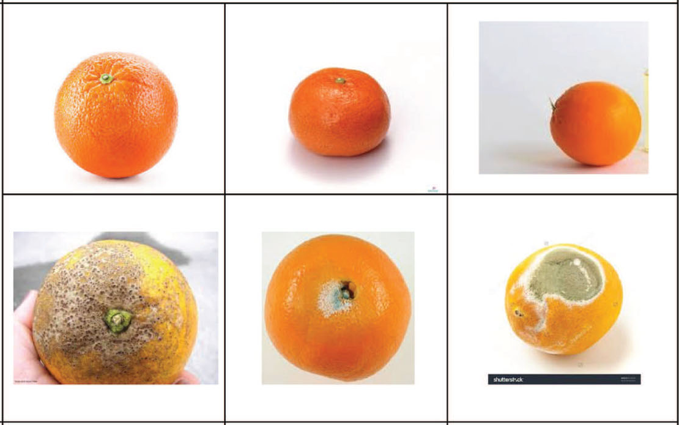

Fig. 1: Fruit quality classification for orange.

**II. Dataset**

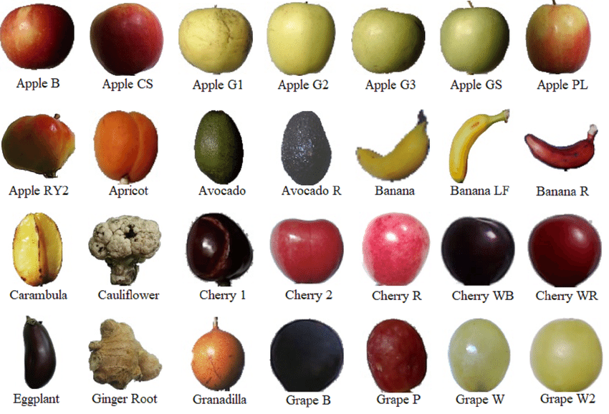

Fig. 2: An example from fruit 360 dataset.

In this article, we have used the Fruits-360 dataset to identity fruits from pictures as described in Fig. 2 [8]. The total number of images: 90483. Training set size: 67692 images (one fruit or vegetable per image). Test set size: 22688 images (one fruit or vegetable per image). The number of classes: 131 (fruits and vegetables). Image size: 100x100 pixels. Filename format: jpg. For this, fruits were planted in the pole of a low-speed engine, and a short film of 20 seconds was recorded. Behind the organic products, we set a white piece of paper as a background. Due to the variations in lighting conditions, the background was not uniform, and we composed a devoted calculation that separated fruits from the background.

**III. The Proposed Solution**

In this project, my target is to classify the quality of fruits. The quality of fruits includes “fresh” or “rotten”; “ripe” or un-ripe; good or broken. In this phase, we only focus on 2 stages “fresh” and “rotten”, and other stages will be experimented next time. Thus, we will only focus popular fruits in Vietnam. We plan that the proposed system will focus on 6 types of fruits as Apple; Orange; Banana; Mango; Pineapple and Tomato. With 6 types of fruits, each type of fruit has two stages such as “fresh” and “rotten”, thus we will have 12 classes. So, this system will use images for 12 classes from fruit 360 dataset.

The system is designed and integrated as shown in Fig. 3. The collected images from fruit 360 dataset are processed and labelled to split into training/validation/testing sets for the training/validation/testing processes. Here, we designed and tried two deep learning methods, Yolo-v4 [9] and Mobinet-SSD [10] to generate the AI model for the fruit quality classification task. The trained AI model is experimented with the testing set to evaluate good or not good before developing to API and web-services. In case, the trained AI model is not good, we will collect more data and perform the re-training and tuning processes.

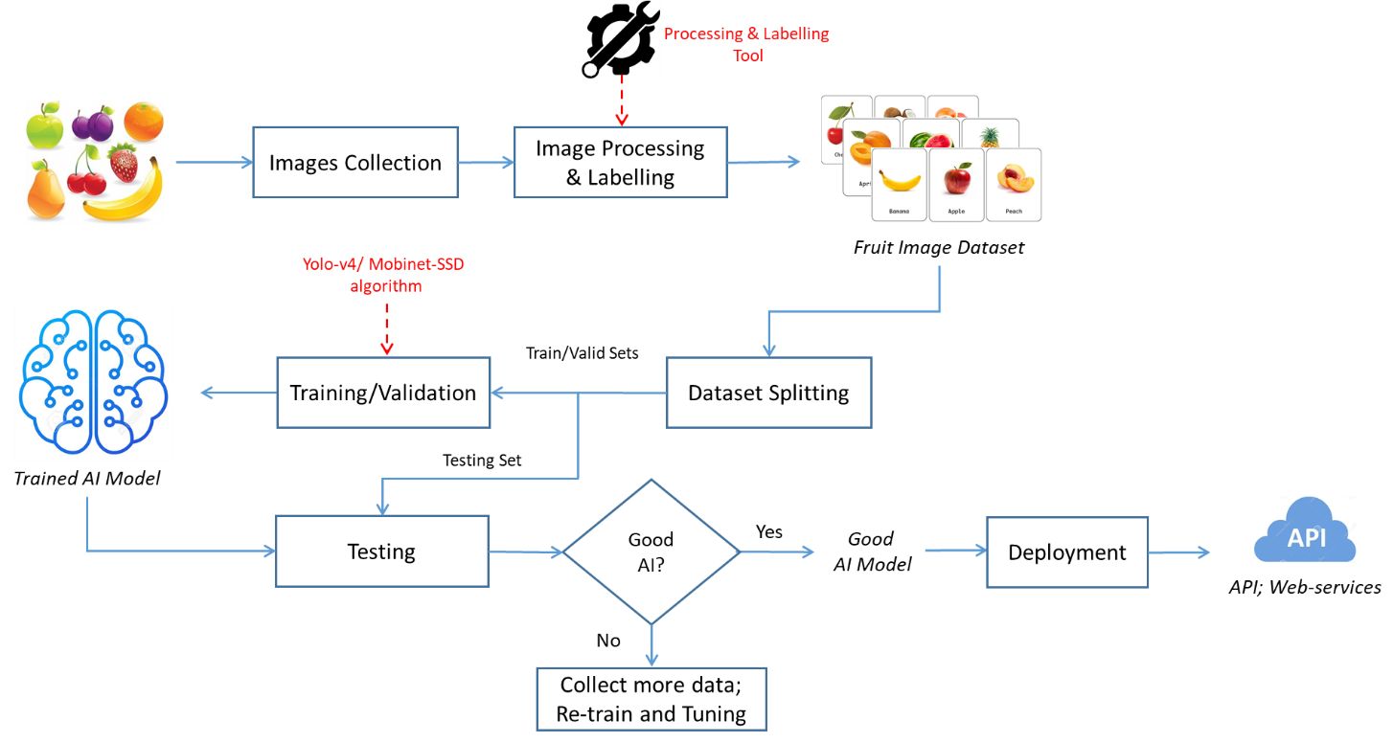

Fig. 5: The proposed solution.

**IV. Experimental Results**

We implemented the proposed solution by the best technologies. For AI model generation, we used two best methods as Yolo-v4 and Mobinet-SSD. The advantage of these methods is able to easily integrated to various environments. The used technologies are Tensor-flow, Flask, Gunicorn, and Boostrap 4. Experimental results show that the proposed solution worked well as shown in Fig. 6. We also developed the proposed solution to web-service to experiment. The proposed solution worked well as shown in Fig. 7.

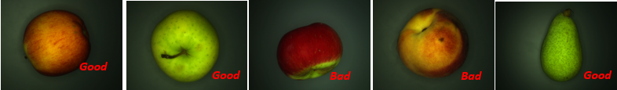

Fig. 6: Experimental results by AI model

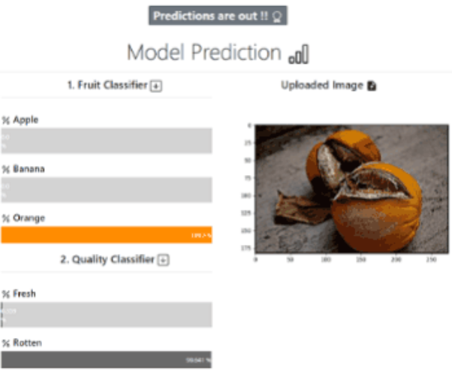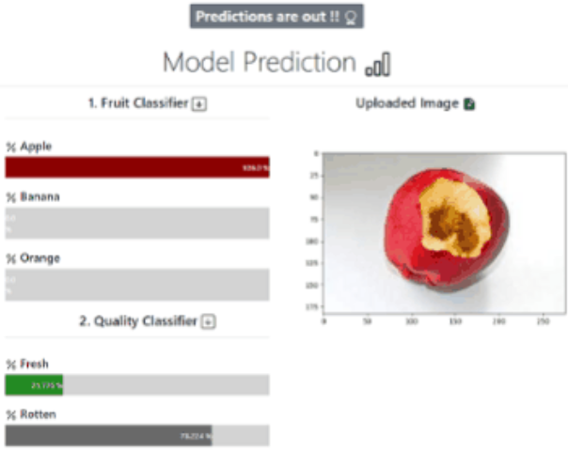

Fig. 7. Experimental results on web-service.

**V. Conclusion**

In this paper, we presented a design and integration of fruit quality classification for customer service for reference to developers. Our purpose in this article is to share the proposed system that is integrated deep learning methods in customer services. We hope that the proposed system will help developers have many ideas or use my proposed system to develop themselves systems.

**Acknowledgments**

This work is supported by FPT University, Hanoi, Vietnam; Hanoi University of Industry, Hanoi, Vietnam; and Thuy-Loi University, Hanoi, Vietnam.

**Disclosure of conflict of interest**

On behalf of all authors, corresponding author declares that there is no conflict of interest to publish this research.

**References**

[1] D. Li, and D. Yu, “Deep Learning: Methods and Applications”, available online: <https://www.microsoft.com/en-us/research/wp-content/uploads/2016/02/DeepLearningBook_RefsByLastFirstNames.pdf> , accessed on 30 Sep. 2021.

[2] K. Andreas, “Deep learning in agriculture: A survey”, *Computers and Electronics in Agriculture,* Vol. 147, pp. 70-90, April 2018.

[3] Y. Fu, “Fruit Freshness Grading Using Deep Learning”, Master Thesis, available online: <https://openrepository.aut.ac.nz/bitstream/handle/10292/13353/Fruit_Fu_24May2020_wyan.pdf?sequence=1&isAllowed=y>, accessed on 04 Oct. 2021.

[4] M. Krishna, G. Jabert G.Pest, “Control in Agriculture Plantation using Image Processing,” Journal of Electronic and Communication Engineering, vol.6(4), pp. 68-74, June 2013.

[5] G. Bhandane, S. Sharma, V.B. Nerkar, “Early Pest Identification in Agriculture Crop using Image Processing,” International Journal of Electrical, Electronics and Computer Engineering, vol.2(2), pp. 77-82,2008.

[6] S. Naik and B. Patel, "Machine Vision based Fruit Clssification and Grading - A Review," International Journal of Computer Applications, vol. 170, No.9, pp. 22- 34, July, 2017.

[7] I. Sa, Z. Ge, F. Dayoub, B. Upcroft, T. Perez, and C. McCool, "DeepFruit: A Fruit Detrection System using Deep Neural Networks," Sensors 2016, 16, 1222.

[8] Fruit 360 dataset, available online: <https://github.com/antonnifo/fruits-360>, accessed on 04 Nov. 2023.

[9] Yolo-v4, available online: <https://github.com/kiyoshiiriemon/yolov4_darknet>, accessed on 04 Nov. 2023.

[10] Mobinet-SSD, available online: <https://github.com/amdegroot/ssd.pytorch>, accessed on 04 Nov. 2023.