**bVote: BLOCKCHAIN BASED VOTING SYSTEM**

Shubham Chutke1, Shreyas Parkar1, Omkar Swargam1, Sumeet Bhimanpally1, Shweta Sharma2

*1Student, Computer Engineering Department, Atharva College of Engineering, Mumbai University, Maharashtra, India*

*2Assistant Professor, Computer Engineering Department, Atharva College of Engineering, Mumbai University, Maharashtra, India*

*Corresponding Author:* [*chutkeshubham2436@gmail.com*](mailto:chutkeshubham2436@gmail.com)*,* [*parkarshreyas77@gmail.com*](mailto:parkarshreyas77@gmail.com)*,* [*omkargvs2001@gmail.com*](mailto:omkargvs2001@gmail.com)*,* [*sumeetb271001@gmail.com*](mailto:sumeetb271001@gmail.com)*,* [*shwetasharma@atharvacoe.ac.in*](mailto:shwetasharma@atharvacoe.ac.in)

|  |
| --- |
| ***Abstract:*** *The current electoral system faces various challenges such as vote rigging, hacking of electronic voting machines, and election manipulation, leading to a lack of faith in the system among citizens. The adoption of an electronic voting system based on blockchain technology could potentially address these issues. This paper proposes a model of e-voting based on popular blockchain frameworks that provide blockchain as a service, which maintains participant confidentiality while still being open to public scrutiny. The paper presents a comprehensive analysis of the theme, demonstrating the usefulness of blockchain technology in the design of a secure and transparent e-voting system. Distributed ledger technology is a powerful tool in the world of information technology, with the potential to revolutionize various applications. Blockchain offers advantages such as cryptological underpinnings and transparency, making it a disruptive technology in modern times. The proposed e-voting system based on blockchain technology offers the potential to improve the resilience of e-voting systems, and ensure the integrity of the election results. Overall, this paper provides insights into the potential of blockchain technology to tackle the challenges facing the current electoral system and improve the transparency and security of e-voting systems.*  ***Key Word****: Iblockchain, confidentiality, Distributed ledger, transparency, security, metamask, solidity, Ethereum, Decentralization, testnet, Hardhat, Dapp, Consensus, immutability, blocks.* |

1. **Introduction**

Voting is a fundamental aspect of democracy, and the accuracy and integrity of the voting process are critical to maintaining public trust. However, current voting methods, such as electronic voting machines (EVMs) or paper-based systems, have significant vulnerabilities. In particular, physical security concerns can compromise EVMs, allowing attackers to manipulate votes. Blockchain is a decentralized and immutable public ledger that can enhance the security and transparency of electronic voting systems. Blockchain technology can prevent tampering, ensure the integrity of the voting process, and provide a resilient system that is not affected by single points of failure. This paper explores the potential of blockchain technology in building a secure and transparent electronic voting system that can restore public trust in the democratic process. The paper discusses the limitations of the current electoral system, the advantages of blockchain technology, and proposes a model of e-voting that leverages blockchain's strengths to ensure the integrity and transparency of the voting process.

1. **Need and Motivation**

The need for a secure and dependable e-voting system is more important than ever in today's digital age. The current EVM system is prone to fraud, manipulation, and other types of interference, leading to a lack of trust in the electoral process. The motivation for this project is to demonstrate that blockchain technology can provide a solution to these issues by creating a tamper-proof, decentralized platform for e-voting. The blockchain-based e-voting system can help eliminate the potential for interference, ensuring fair and accurate results. Overall, the need for a dependable and secure e-voting system is essential for strengthening democracy and enhancing civic participation in the modern age.

1. **Purpose**

The purpose of this paper is to propose a model of e-voting system using blockchain technology to address the limitations of the current electoral system, enhance the security and transparency of electronic voting, and restore public trust in the democratic process.

1. **Basic Concept**

The basic concept of the proposed e-voting system is to use blockchain technology to create a peer-to-peer decentralized platform for tamper-proof voting. The system utilizes ethers for voting purposes, with a small amount of gas fees required to cast a vote. Users must register and login in order to cast their vote securely.

1. **Applications**

The proposed blockchain e-voting system has several applications. The first application is that it can be used by countries to conduct secure and tamper-proof elections. The use of blockchain technology ensures that the voting process is transparent, and every vote is recorded immutably on the blockchain. The system can also eliminate any potential fraudulent activities carried out in the traditional voting system, such as vote rigging, election manipulation, and booth capturing, which can undermine the democratic process. Another application of this system is that it can improve voter participation and turnout This can lead to higher voter participation and turnout, ultimately strengthening the democratic process. Overall, the blockchain e-voting system has various applications that can benefit countries by ensuring secure, transparent, and accessible elections, free from any fraudulent activities.

1. **Review of Literature**

### [1] Literature survey - Online Voting: Voting System Using Blockchain by, Vaibhav Anasune, Pradeep Choudhari, Madhura Kelapure, Pranali Shirke, Prasad Halgaonkar,2019 [7].

The article explores numerous online voting procedures and frameworks. This page provides a brief overview of the various approaches utilised in current online voting. It also discusses several architectural frameworks used in online voting systems, such as centralised architecture, among others.

### [2] An overview of Blockchain technology, Architecture, Consensus and Future Trends, 2017 [3].

### In this paper an overview of how the blockchain technology came into existence, its merits,demerits as well as how this technology can transform the digital storage space is clearly proposed.

The formation of blocks and its components are also explained conceptually with examples such as ripple and many more. It provides a detailed breakdown on what a single block in the entire blockchain comprises of its components, salient features and why it is so difficult to tamper such technology.

### [3] Decentralised Applications using Ethereum Blockchain,2019 [4].

### In this paper various applications using blockchain were explained and how this new technology overpowers the older form of tech otherwise used.

An example of a fair voting system based on the blockchain technology was demonstrated and its use cases were explained in detail, the need of this technology in sensitive areas such as politics, healthcare, public welfare, and data security was clearly highlighted.

The concept of a fork ( A fork in the blockchain is referred to a change that occurs in the blockchain which causes it to split into two paths ) in the blockchain was also touched upon. The widely used Ethereum blockchain was used while developing the voting systems, the merits and demerits of the same were discussed as well as examples of technology based on the Ethereum were explained in detail.

[4] Blockchain-Based Voting System, Friðrik Þ. Hjálmarsson, Gunnlaugur K. Hreiðarsson School of Computer Science Reykjavik University, Iceland,2020 [8].

The paper explains the process of creating and implementing a blockchain-based application that enhances the security and lowers the cost of conducting a nationwide election. When block time arrives, all of the appropriate district nodes verify the vote data, and every vote they agree on is appended to the blockchain. It also illustrates on how a blockchain technology works as different services. It also describes how to write a smart contract, and how a voting system can be carried out making it more secure with the use of blockchain.

[5] Blockchain Based E-Voting System Prof. Mrunal Pathak , Amol Suradkar, Ajinkya Kadam , Akansha Ghodeswar, Prashant Parde Assistant Professor at Information Technology Department, AISSMS Institute of Information technology, Pune, Maharashtra, India ,2021[9].

The conventional voting method is discussed and analysed in this article, as are the advantages of installing a blockchain-based E-voting system that utilises several blockchain-based tools and employs a case study of the manual voting process. Following that, there is a comparison between traditional voting methods with blockchain-based e voting systems. The article also discusses how a country such as Brazil uses blockchain technology to keep election data safe and secure. It also estimates how much a blockchain-based voting system will cost in terms of cash.

[6] Blockchain technology based e-voting system. Prof. Anita A. Lahane1, Junaid Patel1, Talif Pathan1, and Prathmesh Potdar, 1Juhu Versova Link Rd, behind HDFC Bank, Gharkul Society, Bharat Nagar, Versova, Andheri West, Mumbai, Maharashtra 400053, 2020 [2].

The paper describes about the limitations, drawbacks of the existing system, It also makes suggestion about how a cryptographic methods can be used to make it secure with the use of SHA-256 algorithms. It also emphasizes on blockchain technology.

[7] A survey paper on blockchain technology and its real time applications, 2021[ 6].

The paper gives a brief introduction about blockchain technology. It also discusses about different terminologies related to it, different types of blockchains. It also focuses on some real-time blockchain applications as well.

1. **Report on Present Investigation**

**Existing system:**

Current voting systems, such as ballot box voting or electronic voting are vulnerable to a variety of security threats, such as DDoS attacks, polling booth capturing, vote alteration and manipulation, malware attacks, and so on, and require massive amounts of paperwork, human resources, and time. This fosters scepticism towards existing systems.

Electronic voting machines (EVMs) are widely used in democracies around the world. An EVM is a machine that records and count votes. However, there are several issues that must be addressed, and some even claim that these machines, which are designed to ensure fair elections, are being used as tools by corrupt governments and politicians, resulting in lack of voters confidence/trust, and lack of oversight to prevent election fraud.

**General working:**

* EVMs are electronic voting machines that give the voter a button for each candidate choice. A cable connects it to an electronic ballot box.
* It is made up of two parts: a control unit and a balloting unit. They are linked via a 5-meter cable.
* The EVM is powered by a single 6-volt alkaline battery included in the control unit.
* It can also be utilized in places where there is no electricity.
* The control unit is with the polling officer chosen by the Election Commission.
* The Balloting Unit is located in the voting section, where voters enter to secretly vote by pressing the button next to the name and sign of their preferred candidate.

**Limitations:**

* Long Queues during elections.
* Security Breaches like data leaks, vote tampering.
* Lot of paperwork involved, hence less eco-friendly and time-consuming.
* Difficult for differently-abled voters to reach polling booth.
* Cost of expenditure on elections is high.
* Lack of voter’s trust/confidence.
* Lack of oversight to prevent election fraud.

1. **Aim and Objectives**

The aim of the project is to develop a decentralized voting system using blockchain technology to ensure a secure and tamper-proof voting experience. The primary objectives are to create a transparent and verifiable election system, record all votes accurately, restrict voting to eligible voters only, ensure tamper-proof security, and prevent any organization from manipulating the election process for personal gain. The use of blockchain technology will guarantee the immutability of voting records and provide a distributed ledger that cannot be altered by any single entity. The system will also use cryptographic methods to secure user data and prevent any unauthorized access. Through the development of this system, the project hopes to provide a reliable and dependable e-voting method that can be utilized by any individual with a computer or mobile phone, ultimately leading to a more accessible and democratic decision-making process.

1. **Proposed System**

The proposed system is a decentralized voting platform that utilizes blockchain technology for secure and tamper-proof voting. The system requires voters to enroll by registering and logging in to the web portal using a valid Ethereum wallet and metamask account. Upon registration, the voter's details and metamask id are stored on the Ethereum distributed ledger. The system then allows the voter to click on the button against the candidate's name reflected on the ballot and pay a small Ethereum gas fee in ETH to confirm the transaction. The vote is then recorded on the distributed ledger. The system also sets a specific time period in which the entire voting process will be carried out, and once the timeout is called, the results are immediately made available. The objective of the proposed system is to provide a transparent, secure, and tamper-proof voting platform that ensures only eligible voters can cast their votes and no power-hungry organization can manipulate or rig the election process. By leveraging the benefits of blockchain technology, the system seeks to overcome the drawbacks of the present technology developed for voting purposes.

**Fig. 1.** Blockchain E-Voting Block Diagram

1. **Algorithm**
2. Create Struct for Voter And Candidate Each.
3. Initialize counter for Voter and Candidate each to 1.
4. Declare necessary variables with suitable datatype.
5. Create Voter and Candidate Arrays to Store All the Struct Voter and Candidate information.
6. Create mappings for structs created in step 1 with integer variables.
7. Create constructor initializing election commissioner as the deployer account.
8. Create reusable Voter And Candidate ommissioner functions to check if user already present on the block to avoid redundancy.
9. Create functions to displays all the voter and candidate information stored in the respective arrays.
10. Write Voter and Candidate Registration function and storing the passed information in struct blocks and as well in the array.
    1. Perform voterVerification before pushing it onto block.
    2. Check if enrolling user is above 18.
11. Write delete and update functions for Voter and Candidate registered through registration function.
    1. Perform voterVerification before pushing it onto block.
    2. Check if the same candidate or voter is performing the update or delete operations
12. Write a function Vote to perform vote casting to deserving and appropriate selected candidate by the voter.
    1. Allow the voter to vote only if voting has started.
    2. Check if voter is a registered entity.
    3. Check if voter has already voted.

***Admin controls***

1. Create a function to set time(start time, end time) which can only be altered or tailored by the election commissioner.
2. Create a stop voting function in case of emergency.
3. Display results and find maxVoted Candidate.
4. Create a reset function to reset all the stored data on the block and make it available for next election cycle.
5. **Scope**

The scope of this paper is to explore the feasibility of deploying a blockchain-based e-voting system on a global scale. While the application can be deployed on a public blockchain, its immutability limits the possibility of further updates, making it more feasible to implement quality of life changes and improvements through multiple alpha tests before deploying the final product. Economic feasibility of deploying a blockchain-based application is quite low, but the non-existent profit margins pose a challenge. *Technical feasibility* of the system is feasible as scalability problems associated with blockchain mainly arise from the limited transactions per second in cryptocurrency. Operational feasibility requires users to login with their Metamask wallets for casting a vote, allowing users to vote only once and requiring some amount of cryptocurrency in their wallets to pay for the required gas fees. This paper will evaluate the feasibility of the proposed e-voting system in terms of economic, technical, and operational aspects.

1. **Flowchart**

Following flowchart shows the functioning of decentralized application (Dapp) that uses metamask wallet to login to system whose backend is the Ethereum Based Goerli testnet BlockChain and written in solidity language for access control and is deployed on hardhat network. It shows the entire flow of the process how the voting is carried out through the decentralized application created.

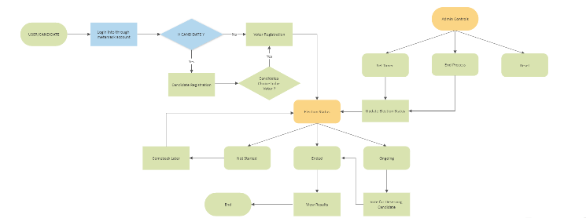

**Fig. 2.** FlowChart

1. **Results and Outcome**

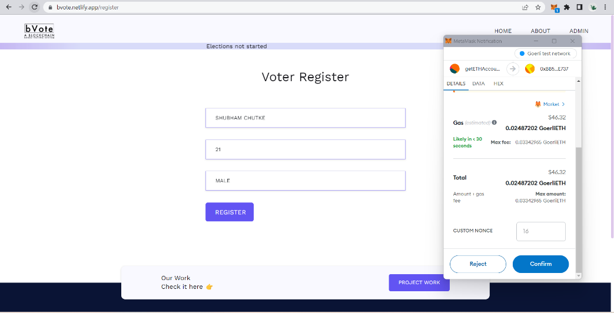

**Fig. 3.** Voter Registration Page

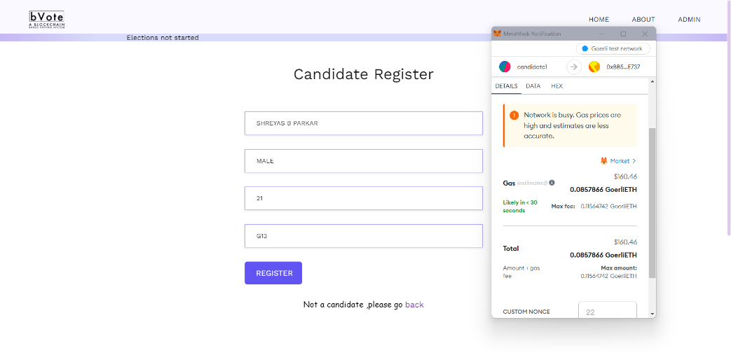

**Fig. 4.** Candidate Registration Page

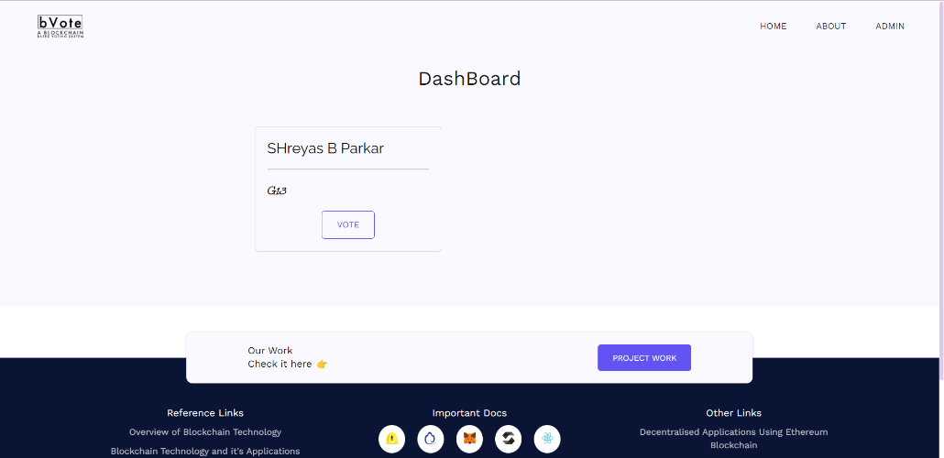

**Fig. 5.** Voting Page

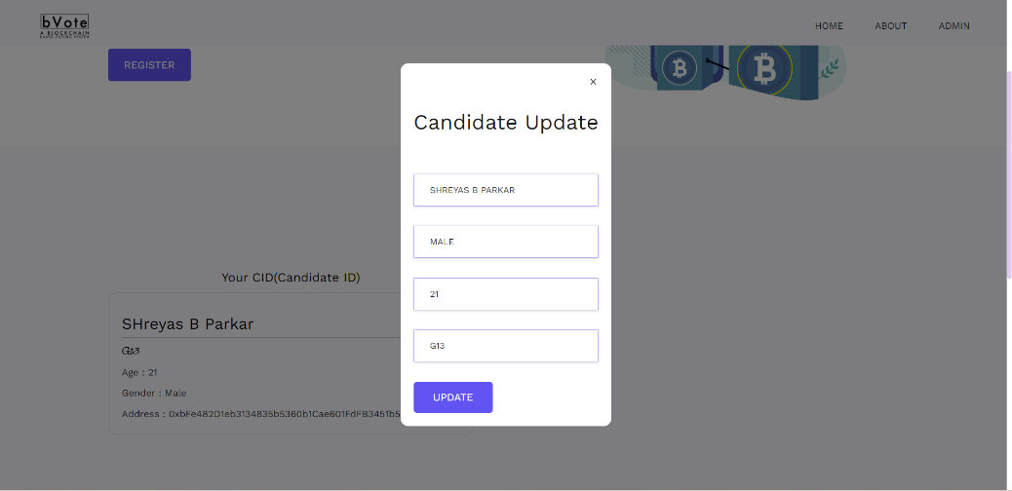

**Fig. 6.** Update Credentials

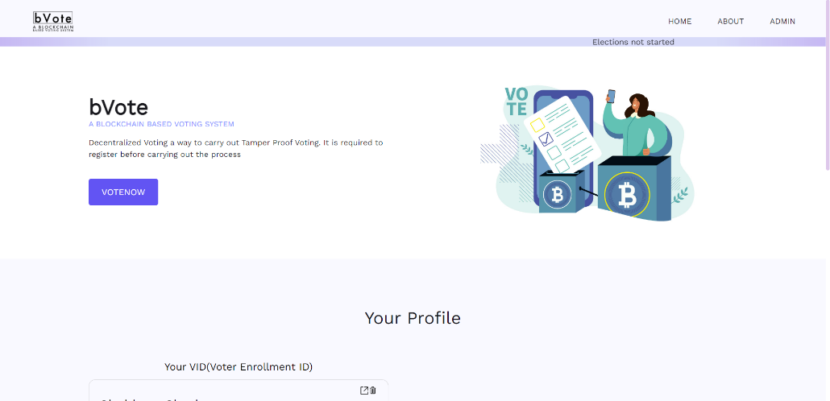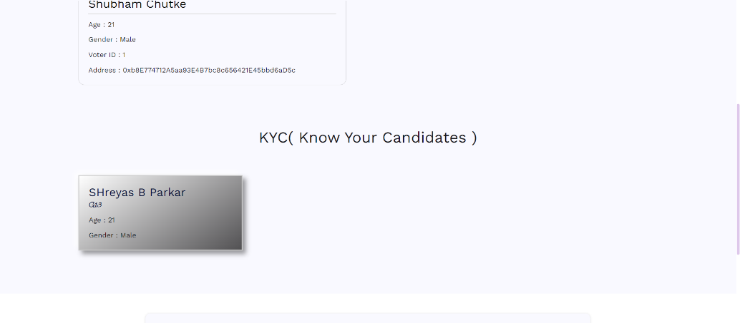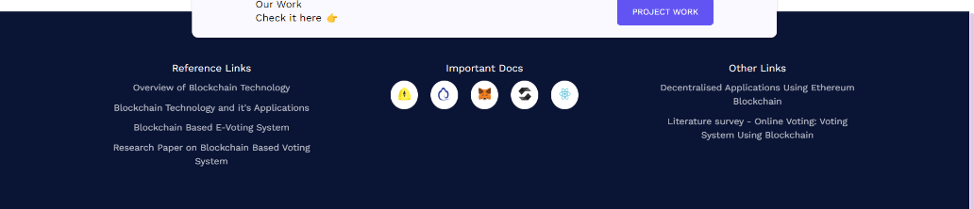

**Fig. 7.** Home Page

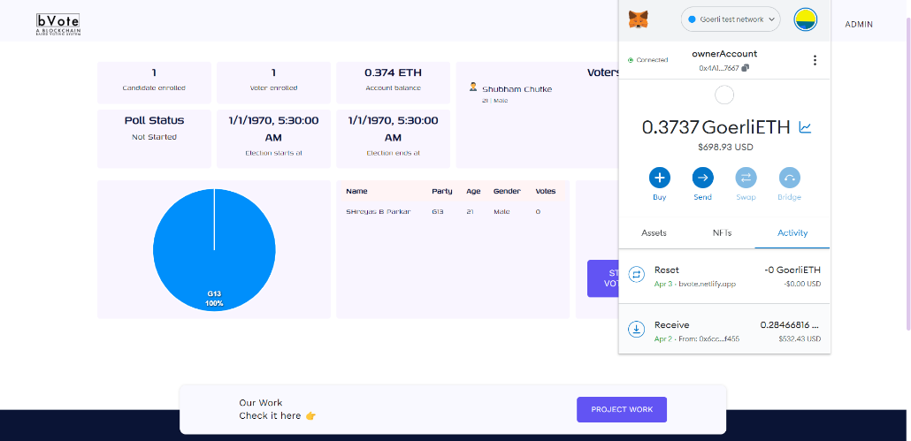

**Fig. 8.** Admin Page - Access Granted to Admin user only

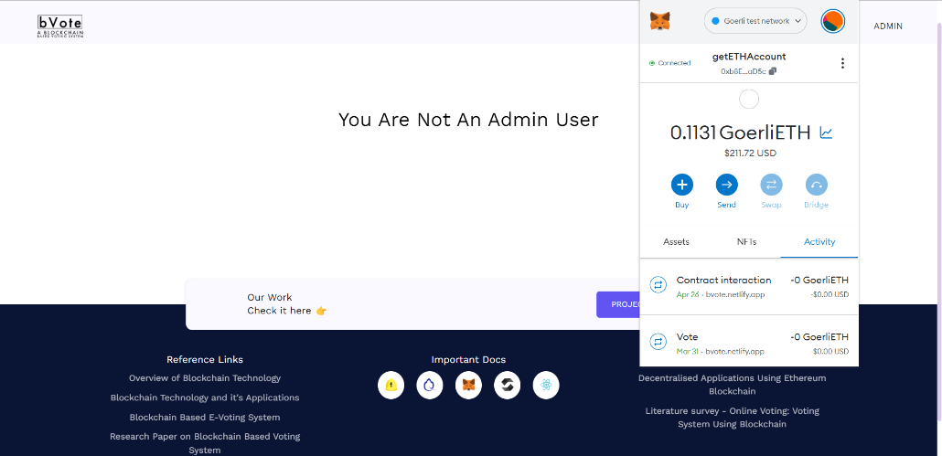

**Fig. 9.** Admin page – Access denied to non-administrator

1. **Future Work**

The proposed blockchain-based voting system has significant potential for future work and improvements. Some of the potential areas for future work are:

* Adding Few More Admin operations: An Admin interface can be added to the system to manage the voting process, verify voters' identities, and monitor the voting process to ensure its integrity.
* Improving the Interface: The user interface can be improved to make it more user-friendly, intuitive, and accessible to a wider range of users.
* Improving the algorithm: The voting algorithm can be improved for better reach and faster processing by optimizing the use of blockchain and cryptographic methods.
* Reducing time consumption: Efforts can be made to reduce the time consumption in creating and verifying blocks in order to make the voting process more efficient.
* Hosting at the production level: The application can be hosted at the production level, which will require the development team to ensure that the system can handle a large number of users and that it is secure and reliable.
* Adding other crypto wallets: Apart from Metamask, other crypto wallets can also be enabled so that more users can access the network and cast their votes.
* Hosting on IPFS: Hosting the application on IPFS can help in improving the system's scalability, reliability, and availability by distributing the data across multiple nodes.
* Moving to private blockchain from public blockchain as it will reduce the gas fee to much less almost negligible also it will provide slight centralized authority to the admin user.

By working on these areas of future work, the proposed blockchain-based voting system can become more robust, efficient, and user-friendly, and can be used on a larger scale to carry out secure and transparent voting processes.

1. **Conclusion**

In conclusion, the implementation of blockchain technology in the electoral voting system has the potential to revolutionize the current system by providing a secure, reliable, and transparent voting process while also enhancing voter participation. Although this system has its flaws and critics have raised concerns regarding the trust of the system, it is still in its early stages and has immense promise. With further developments and improvements, this system can be normalised in society in the future. The future work includes adding admin operations, improving the interface, reducing time consumption in creating and verifying blocks, and enabling other crypto wallets for more user accessibility. Overall, the implementation of blockchain technology in the electoral voting system is an exciting development with the potential to change the way we vote in the future.

**References**

1. [Searching for Trust: Blockchain Technology in an Age of Disinformation](https://blockchain.ubc.ca/searching-trust-blockchain-technology-age-disinformation), 2022 - [Searching for Trust (cambridge.org)](https://www.cambridge.org/core/books/searching-for-trust/B2F64551393899EBC6306EB42FCBE856)
2. Blockchain technology based e-voting system. Prof. Anita A. Lahane1, Junaid Patel1, Talif Pathan1, and Prathmesh Potdar, 1Juhu Versova Link Rd, behind HDFC Bank, Gharkul Society, Bharat Nagar, Versova, Andheri West, Mumbai, Maharashtra 400053, 2020 [(https://doi.org/10.1051/itmconf/20203203001)](https://doi.org/10.1051/itmconf/20203203001)
3. An overview of Blockchain technology, Architecture, Consensus and Future Trends, 2017 - [An Overview of Blockchain Technology: Architecture, Consensus, and Future Trends | IEEE Conference Publication | IEEE Xplore](https://ieeexplore.ieee.org/document/8029379).
4. Decentralised Applications Using Ethereum Blockchain, 2019 - <https://ieeexplore.ieee.org/document/8918887>
5. Understanding Blockchain Technology, Simanta Shekhar Sarmah, 2018 – [(PDF) Understanding Blockchain Technology (researchgate.net)](https://www.researchgate.net/publication/336130918_Understanding_Blockchain_Technology)
6. A survey paper on blockchain technology and its real time applications, 2021 - [A SURVEY PAPER ON BLOCKCHAIN TECHNOLOGY AND IT’S REAL-TIME APPLICATIONS (ijser.org)](https://www.ijser.org/researchpaper/A-SURVEY-PAPER-ON-BLOCKCHAIN-TECHNOLOGY-AND-ITS-REAL-TIME-APPLICATIONS.pdf)
7. Literature survey - Online Voting: Voting System Using Blockchain by, Vaibhav Anasune, Pradeep Choudhari, Madhura Kelapure, Pranali Shirke, Prasad Halgaonkar,2019 - [IRJET-V6I6119.pdf](https://www.irjet.net/archives/V6/i6/IRJET-V6I6119.pdf)
8. Blockchain-Based Voting System, Friðrik Þ. Hjálmarsson, Gunnlaugur K. Hreiðarsson School of Computer Science Reykjavik University, Iceland,2020 - [Research-Paper-BBEVS.pdf (skemman.is)](https://skemman.is/bitstream/1946/31161/1/Research-Paper-BBEVS.pdf)
9. Blockchain Based E-Voting System from Prof. Mrunal Pathak , Amol Suradkar, Ajinkya Kadam , Akansha Ghodeswar, Prashant Parde Assistant Professor at Information Technology Department, AISSMS Institute of Information technology, Pune, Maharashtra, India,2021 - [(PDF) Blockchain Based E-Voting System (researchgate.net)](https://www.researchgate.net/publication/351723225_Blockchain_Based_E-Voting_System)
10. Documentation of solidity, ethersjs - [Solidity — Solidity 0.8.17 documentation (soliditylang.org)](https://docs.soliditylang.org/en/v0.8.17/), [Documentation (ethers.io)](https://docs.ethers.io/v5/)