**Design and Analysis of the Exhaust Muffler for Two-Wheeler Vehicle**

**Trayambak Chandrakar1, Kuldeep Dhruw2,Roshan Kumar Dugga3, Narayan Bhoyar4, Chandra Prakash Dewangan5**

*1,2,3,4,5Department of Mechanical Engineering, Government Engineering College, Raipur, Chhattisgarh 492015, India*

*1muskan02102001@gmail.com, 2*[*kuldeepdhruw81@gmail.com*](mailto:kuldeepdhruw81@gmail.com)*,  3*[*roshandugga0001@gmail.com*](mailto:roshandugga0001@gmail.com)*, 4*[*narayanbhoyar23@gmail.com*](mailto:narayanbhoyar23@gmail.com)*, 5*[*cdewangan147@gmail.com*](mailto:cdewangan147@gmail.com)

*Corresponding Author: cdewangan147@gmail.com*

***Abstract:*** *The muffler is an essential part of every type of car. On two-wheelers, however, it disperses flue gases throughout the atmosphere and reduces engine noise to a bearable level. It is occasionally called an exhaust muffler or a muffler. A silencer's main function is to block off noise produced when flue gas rushes past it quickly. Furthermore, the exhaust gases ought to be released into the atmosphere. The primary focus of this work is on two-wheeled vehicle exhaust mufflers. The current exhaust silencer design is subjected to CFD and fluid structure interaction analysis with engine-specific boundary conditions. The specifications will guide the creation of the muffler's design. ANSYS, a finite element analysis tool is used to measure and verify exhaust gas temperatures, velocities, and back pressure. Furthermore, a modal analysis is conducted to figure out how a geometric adaptation affects the fundamental frequency of the system. The actual testing consists of fabricating a customized exhaust silencer and evaluating it for noise and back pressure on a two-wheeler engine test rig.*

***Key Words:*** *Computational fluid Dynamics, Exhaust Muffler, Temperature, Velocity, ANSYS fluent*

# Introduction

In order to comply with regulations, exhaust systems are designed to reduce harshness, vibration, and noise while also controlling emissions. The exhaust system consists of the underbody, flexible bellow, muffler, resonator, connecting pipes, flanges, tailpipe, and close-coupled catalytic converters. Exhaust gases from engine cylinders are collected by a well-designed exhaust system, which then releases them as soon and softly as is reasonably possible [1-2]. The exhaust system of a car is crucial for limiting emissions and NVH (noise, vibration, and harshness). It is composed of several components, each of which serves a specific function to ensure efficient and environmentally responsible operation. The following are the parts that comprise an exhaust system:

1. Sidewinder: The tailpipe, the final component of the exhaust system, is where the exhaust gasses exit the vehicle. It directs the gasses away from the car and lowers noise levels.
2. Flexible Bellow: By absorbing vibrations and permitting movement, the flexible bellow, which is placed adjacent to the engine

or at exhaust system connections, reduces noise pollution. [3-4]

# Literature Review

Mr. Rajesh G. Hiwarkhede et al [2023]. In this paper researched and studied about the design of exhaust muffler using ANSYS. The purpose of this project is to reduce the silencer noise at maximum velocity. Minimizing exhaust noise is the key objective of this study [1]. Atul A. Patil et al [2014]. The design of the exhaust system, its flow characteristics analysis, and the impact of back pressure on engine performance were all evaluated. In order to maximize brake thermal efficiency while maintaining a minimal back pressure, a balance between two parameters was sought after in the design of the exhaust system covered in this study, which was achieved by CFD analysis [2]. Professor S.B. Bawaskar and Mr. Vishal M. Shrivastav [2018]. In this article, they used finite element analysis (FEA) to research exhaust system design and analysis for two-wheelers. The exhaust muffler for two-wheeled vehicles is the main subject of this work. The study will complete the fluid structure interaction analysis and CFD analysis that will be carried out on the current exhaust muffler design with boundary condition in accordance with engines [3]. Prof. G.S Joshi et al [2015]. The design and development of car silencers for efficient vibration control was the subject of this project's research. This study focuses on reviewing the current design, considering improvements to mitigate the phenomenon's detrimental effects, and assessing the influence of vibration on the silencer's design [4].

# Methodology

● Conducted background research on exhaust systems.

● Exhaust flow-related flow needs and structural loads on the system.

● Acquired the chosen engine exhaust system capacity and measured its dimensions for a computer-aided design model.

● After then, a CAD tool was used to model the exhaust system.

● The exhaust system model was used for the flow analysis. To determine the pressure run a CFD study on the system at a specific velocity.

● Disperse throughout the system.

● carried out a parametric analysis of the CFD simulation in an effort to lower the throughout the system pressure loss.

● Based on the results of the FEA study, the parameter was changed to get the optimal exhaust.

● An experimental investigation of the exhaust system optimization will be conducted.

# Geometries and Properties of Material

Many industries use the well-known engineering simulation program ANSYS for virtual prototyping, performance analysis, and design validation. Two-wheeler exhaust silencer design is done using ANSYS software. For this project, we have decided to focus on a 100 CC vehicle engine, and a two-wheeler exhaust silencer is being built for it. Copper alloys are the material of choice for our inquiry. Regarding the specifics of the design, we are looking at the integration. These notches significantly improve the two-wheeler exhaust muffler and are essential to our design study. [5]

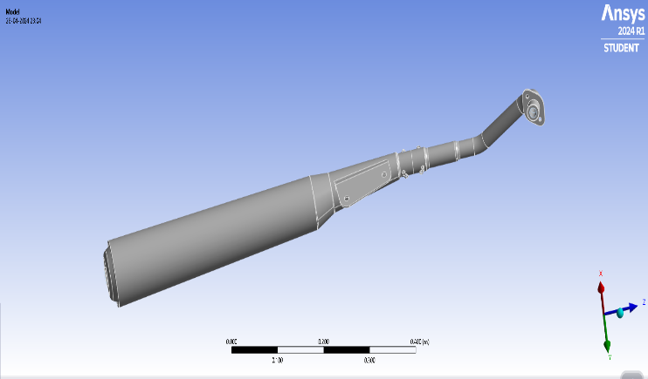 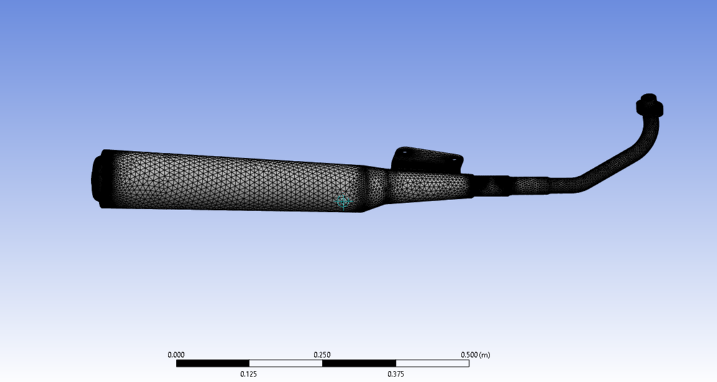

# Fig. 1 Meshed view of exhaust muffler Fig. 2 Meshed view of exhaust muffler

**Composition**

* Aluminium 90% and silicon 10%

**4.1 Properties of aluminized steel – A463**

* Density – 2790 kg/m2
* Specific heat (CP) – 465 J/kg-k
* Thermal conductivity – 52 W/m-k

**4.2 Boundary conditions applied**

It is necessary to use several boundary conditions when conducting CFD analysis. These border parameters will correspond to the actual circumstances. This means that the values of pressure and velocity at the inlet and outlet must be there.

The CFD tool requires the application of both metal and flue gas properties.

**4.3 Flue Gas Properties**

* Velocity of flow {m/s}: - 55, 65, 75
* Convective heat transfer coefficient (h) of outer surface of exhaust system 1000 W/m2-K
* Free stream temperature of the surroundings {T free}: -300 K (approx.)
* Temperature of air at the inlet {T inlet}: - 650 K (approx.)
* Temperature of air at the outlet {T inlet}: -300 K (approx.)
* Free stream temperature {T convective}: - 300 K (approx.)

**Table No. 1:** Nodes and Elements

|  |  |  |
| --- | --- | --- |
| **Domain** | **Nodes** | **Elements** |
| Fluid | 50303 | 246443 |
| Silencer Body | 137085 | 616640 |
| All Domain | 187388 | 863083 |

The temperature contours for a 55 m/s flue gas velocity are displayed in Fig. 3. The initial flue gas temperature was found to be 300 K. The engine cannot create the temperature of 650 K, which has been measured. This rise in temperature is solely due to the engine's continuous generation of heat. The maximum temperature of the inner pipe remains constant along its entire length, and the reduced velocity at the perforated portion results in significant heat transfer. Convection and radiation transfer heat when flue gas enters the big diameter segment. The outer surface of the exhaust system/silencer comes into touch with the ambient air, which is significantly cooler than the flue gas temperature.

Heat transfer is a phenomenon brought on by this temperature discrepancy. Unmistakably, the resultant color pattern indicates a progressively declining temperature. This suggests that both temperature and velocity are declining as they decrease. The silencer and exhaust system's temperature consequently dropped dramatically. It can only be reduced by the convection and radiation processes that take place on the exhaust system's or silencer's surface. [6,7]

Temperature Distribution in Exhaust system/silencer

Results for case 1 Result for case 2

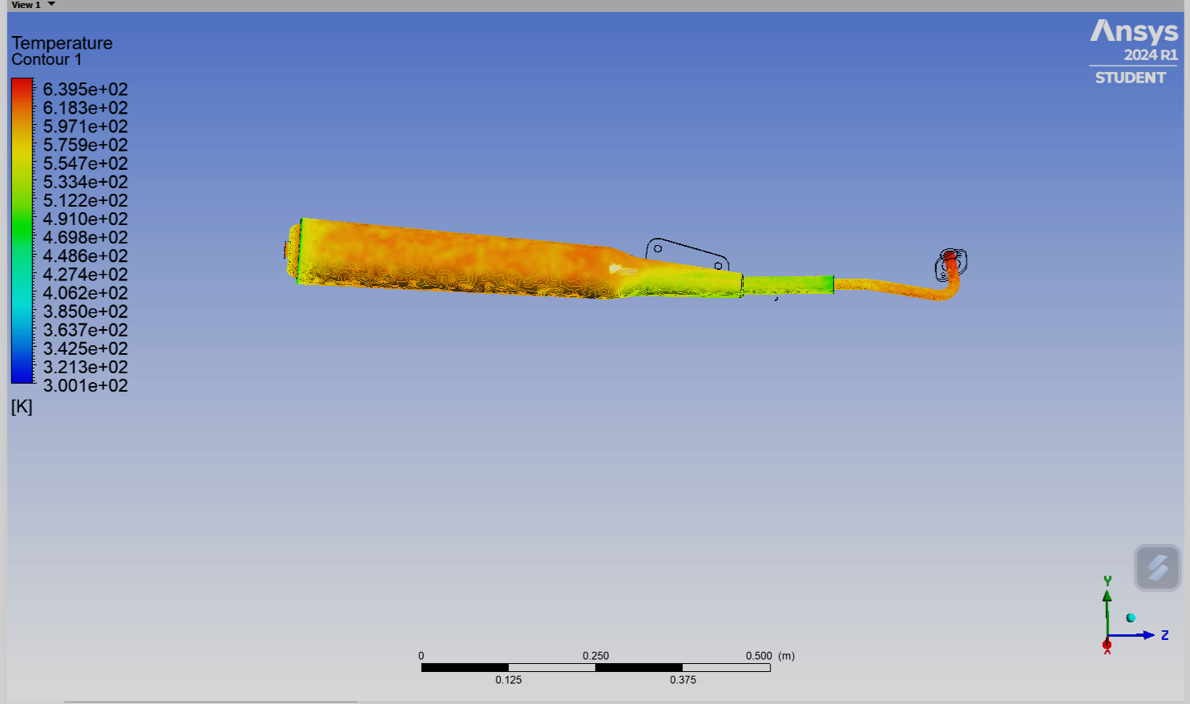 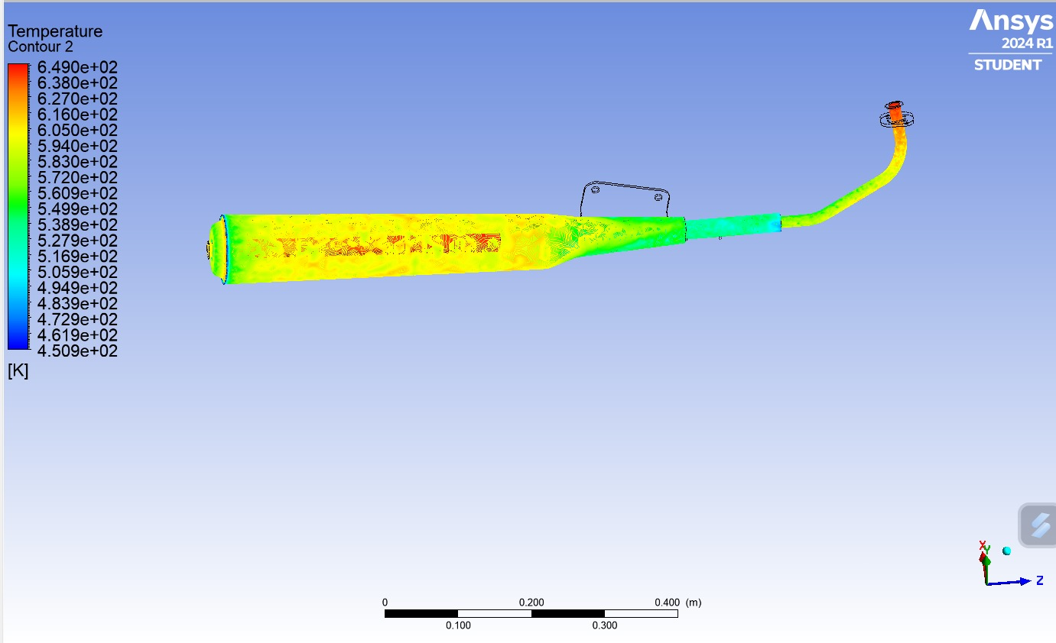

**Fig. 3** Temperature distribution at 55 m/s **Fig. 4** Temperature distribution at 65 m/s

Result for case 3

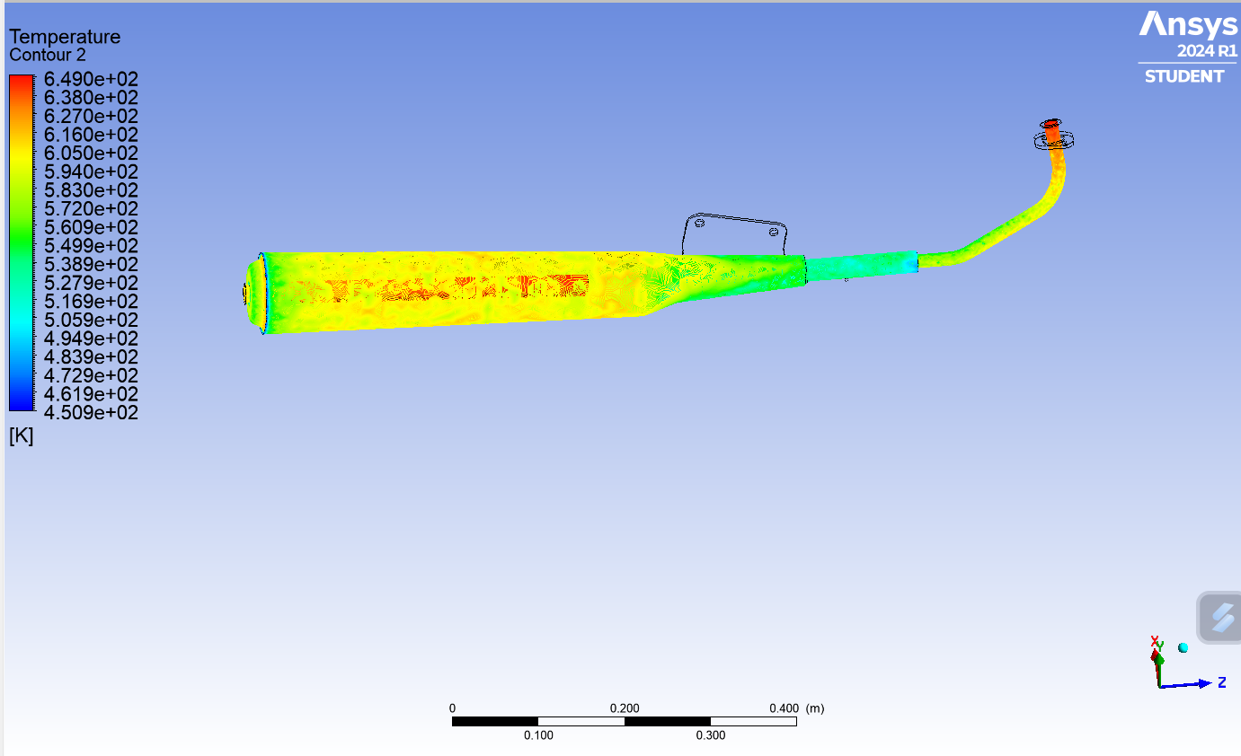

**Fig. 5** Temperature distribution at 75 m/s

The temperature contours at a flue gas velocity of 65 m/s are displayed in Fig. 4. The initial flue gas temperature was found to be 300 K. The engine's maximum temperature that it can produce is 649 K. The highest temperature ever recorded is this one. This rise in temperature is solely due to the engine's continuous generation of heat. Although the inner pipe's maximum temperature is maintained throughout its length, the perforated portion experiences significant heat transfers due to the altered mufflers and speed decrease. Convection and radiation both transfer heat when flue gas enters a large diameter segment.

The outside surface of the silencer or exhaust system is in contact with the ambient air, which is much cooler than the flue gas temperature. The phenomena of heat transfer is brought about by this temperature disparity. It is clear from the color pattern that was produced that the temperature is fast falling. This suggests that both temperature and velocity are decreasing as they decrease. The silencer and exhaust system's temperature consequently dropped dramatically. The exhaust system/silencer's surface processes of convection and radiation are the only ones that may be minimized.[8]

The temperature contours at a flue gas velocity of 75 m/s are displayed in Fig. 5. The initial flue gas temperature was found to be 300 K. This is the highest reported temperature that the engine is capable of producing. The maximum temperature in the inner pipe is maintained throughout its length due to the engine's continuous heat output; however, the perforated component experiences significant heat transfer due to the change in mufflers and the decrease in speed. Convection and radiation transfer heat when flue gas enters a segment with a large diameter. The outside surface of the silencer or exhaust system is in contact with the ambient air, which is much cooler than the flue gas temperature. The phenomena of heat transfer are brought about by this temperature disparity.[9]

It is clear from the color pattern that was produced that the temperature is gradually falling. It suggests that temperature also drops with decreasing velocity. The silencer and exhaust system's temperature consequently dropped dramatically. Only the radiation and convection processes that take place on the exhaust system's surface can lessen it. In all three of the aforementioned cases, the temperature decreases gradually from the exhaust system's or silencer's input to its outlet. Still, the little rise in The temperature is tracked and the highest temperature is recorded when it is supplied. Many conclusions are drawn from the CFD analysis of the exhaust system and silencer. These results are generated according to the selected instance. Three scenarios—50 m/s, 60 m/s, and 70 m/s—were considered for this inquiry.[10]

A summary and explanation of all the results are provided below.

Fig. 6 shows the contours of pressure inside the exhaust system/silencer. This results in a 55 m/s speed attained. Based on the color pattern that was produced, we can see that the pressure is gradually decreasing from the input to the outlet. At the inlet, it reaches its maximum of 1915.75 Pa. The color pattern indicates that after it passes through silencer tunnels, it drops to 295.49 Pa.

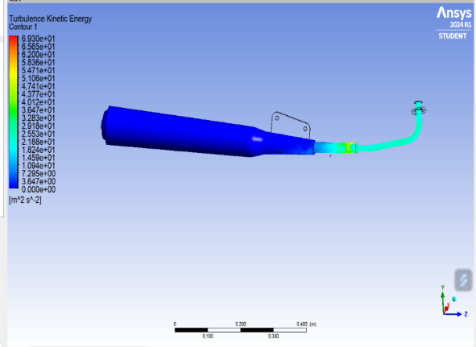Fig. 7 shows the characteristics of turbulent kinetic energy. With a color value ranging from 25 to 172 m2/s2, it shows the colors sky blue and blue. The outflow will generate the greatest kinetic energy, 60.93 m2/s2. The velocity contours in Fig. 8 show that the velocity drop is the major component. It does, however, drop again in the middle section. This drop in velocity illustrates the reduction in noise. Engine noise reduction requires reducing the internal velocity of the silencer or exhaust system. This is explained by the color pattern in the velocity contours. This result is significant because it indicates a reduction in engine noise. [11,12]

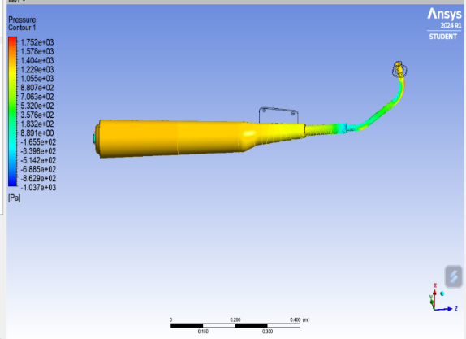

**Fig. 6** Profile of Static Pressure for 55 m/s Velocity **Fig. 7** Profile of Turbulent Kinetic Energy

inside the Exhaust System/Silencer

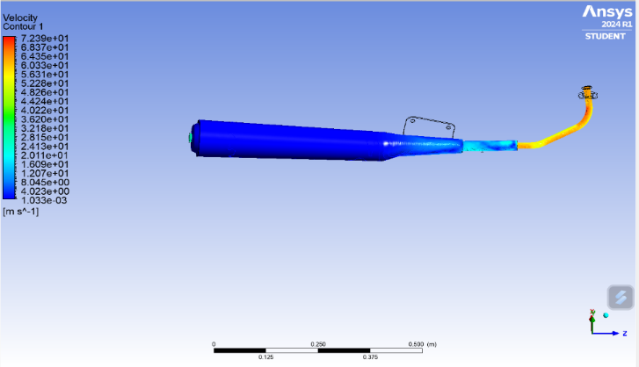

**Fig. 8** Profile of velocity inside the Exhaust System/Silencer

**Table 2:** Results for all three cases

|  |  |  |  |  |  |
| --- | --- | --- | --- | --- | --- |
| **Case** | **Velocity inlet**  **m/s** | **Pressure (Max) Pa** | **Velocity (Max) m/s** | **Turbulence**  **(Max) m2/s2** | **Temperature** |
| 01 | 55 | 1915.75 | 61.3 | 60.96 | 650 K |
| 02 | 65 | 1620.26 | 72.75 | 85.91 | 650 K |
| 03 | 75 | 1839.62 | 83.71 | 109.4 | 650 K |

**Fig. 9** Relation between pressure and turbulence

**Fig. 10** Comparison between inlet velocity and maximum velocity

**Fig. 11** Comparison of all the parameters

1. **Conclusion**

By analyzing all of the CFD data generated for speeds of 55 m/s, 65 m/s, and 75 m/s, it is evident that the exhaust system/silencer reduces as the flue gas velocity inside the outlet increases. We found that 75 m/s is the optimal velocity for the exhaust system/silencer to operate at. Every part of the exhaust system/silencer operates as intended to regulate the flue gas flow. Additionally, noise control is correctly implemented. The exhaust system/silencer design is therefore appropriate for releasing waste gases into the atmosphere without creating an excessive amount of noise. Consequently, neither the silencer design nor the exhaust system needs to be changed.

# References

[1]. Design and Analysis of Two-Wheeler Exhaust System by Using CFD Tool Mr. Rajesh G. Hiwarkhede, Prof. Ajinkya Kuhire 1 Student, 2Professor, Rajashri Shahu College of Engineering, Buldhana, Maharashtra,25-08-2023

[2]. Mr. Vishal M. Shrivastav¹, Prof. S. B. Bawaskar², “Design and Analysis of Exhaust System for the Two-Wheeler using FEA”. 1Design Engineering, S.V.C.E.T, Savitribai Phule Pune University, India, International Research Journal of Engineering and Technology (IRJET) e-ISSN: 2395-0056, Volume: 05 Issue: 06 | June-2018 www.irjet.net p-ISSN: 2395-0072

[3]. Sidharam Ambadas Basargi, “Design and Development of Automobile Exhaust System/Silencer for Effective Vibration Control”. ME Mechanical Engg., pursuing DKTEs Textile and Engineering Institute, Ichalkaranji, Maharashtra, INDIA, International Journal of Latest Trends in Engineering and Technology (IJLTET), Vol. 5 Issue 1 January 2015, page no. 230 ISSN: 2278-621X

[4]. Ravindra S Girge, Nitesh Rane, “Analysis of Two-Wheeler Exhaust System/Silencer with Thermodynamics Principle and Computer Aided Design”. Research Scholar, Asst. Prof. Department of Mechanical Engineering, Dr. APJ Abdul Kalam University, Indore (M.P.), International Journal of Engineering Sciences & Management, [Girge, 9(3) July September. 2019] ISSN: 2277-5528, Impact Factor: 5.085

[5]. Sweta Baruah, Sushowan Chatterjee, “CFD Analysis on an Elliptical Chamber Muffler of a C.I. Engine”. Department of Engineering Design, IIT Madras, India, International Journal of Heat and Technology, Vol. 37, No. 2, June, 2019, pp. 613-619

[6]. Dattatray Dilip Giripunje, 2Prof. Dr. Vilas B. Shinde, 3Swapnil S. Kulkarni, “Thermal Analysis for Motor-Bike Exhaust Exhaust System/Silencer for Ensuring Reduction in Hot Spots Through Design Enhancement”. ME-CAD/CAM & Robotics- Student, 2HOD, Department of Mechanical Engineering, Datta Meghe College of Engineering, Navi Mumbai, International Journal of Advanced Engineering Research and Studies E-ISSN2249–8974

[7]. Kabral, R.; Rämmal, H.; Auriemma, F.; Luppin, J.; Koiv, R.; Tiikoja, H.; Lavrentjev, J., “A Novel Design for Cruiser Type Motorcycle Exhaust System/Silencer Based on Micro-Perforated Elements”. Tallinn University of Technology, Tallinn, Estonia, SAE Technical Paper 2012-32-0109, 2012

[8]. Pradyumna Sarip00alli, K. Sankaranarayana, “CFD Analysis on Flow through a Resistance Muffler of LCV Diesel Engine”. Mechanical Engineering, Gitam Institute of Technology, Gitam University, Visakhapatnam (A.P), India, International Journal of Science, Technology and Society, 2015; 3(4): 132-145, Published online June 2015 (http://www.sciencepublishinggroup.com/j/ij sts), doi: 10.11648/j.ijsts.20150304.16, ISSN: 2330-7412 (Print); ISSN: 2330-7420 (Online)

[9]. Vijay M Mundhe, Eknath R Deore, “Design and analysis of perforated muffler in Automobile Exhaust System”. ME Student (Computer Aided Analysis & Design), Department of Mechanical Engineering, SSVPS BSD COE Dhule, Maharashtra (424001) India, International Journal of Multidisciplinary Research and Development, Volume: 2, Issue: 7, 182-187, July 2015, [www.allsubjectjournal.com,e-ISSN](http://www.allsubjectjournal.com,e-ISSN): 2349-4182, p-ISSN: 2349-5979, Impact Factor: 3.762

[10]. “Review Study of 2-Wheeler Silencer’s Natural Frequency by FFT (Fast Fourier Transform) Analyzer”, by Tushar J. Awari and Dr. S.Y. Gajjal, Indian Research Transactions,97-99, March 2015.

[11]. “Engine exhaust system design based on heat transfer computation” by I. P. Kandylas, and A. M. Stamatelos, Laboratory of Applied Thermodynamics, Mechanical Engineering Department, Aristotle University of Thessaloniki, Greece, 10 December 1998.

[12]. Mohamed Filsuf M. A 1, Dr. S. Sankar 2, Christy Mathew 3, Sreejith K. V 4, “Design and Development for Exhaust Back Pressure Reduction with Noise Control for Motorcycles”. M. Tech. Scholar, Department of Mechanical Engineering, Nehru College of Engineering and Research Centre, Pampady, Kerala, India1, International Journal of Innovative Research in Science, Engineering and Technology (A High Impact Factor, Monthly, Peer Reviewed Journal) Visit: www.ijirset.com, Vol. 7, Issue 5, May 2018.