Comparative Analysis for Prediction of Pneumonia Using Deep Learning Methods

Manan Pruthi1, Ashish Katyal2, Sanyam3, Rishabh Semwal4, Vijay Kumar5

*1(Department of Computer Science and Engineering, Bharati Vidyapeeth’s College of Engineering, New Delhi, India) 2(Department of Computer Science and Engineering, Bharati Vidyapeeth’s College of Engineering, New Delhi, India) 3(Department of Computer Science and Engineering, Bharati Vidyapeeth’s College of Engineering, New Delhi, India) 4(Department of Computer Science and Engineering, Bharati Vidyapeeth’s College of Engineering, New Delhi, India) 5(Department of Computer Science and Engineering, Bharati Vidyapeeth’s College of Engineering, New Delhi, India) Corresponding Author: Manan Pruthi (pruthimanan28@gmail.com)*

***Abstract:*** *Pneumonia is basically an infection which can infect one or both the lungs of a person through their air bladders. The air sacs of such a person might get filled with pus, which in turn cause cough along with problems related to breathing and fever. Pneumonia is usually originated from various organisms such as viruses, fungi and bacteria. Pneumonia may be mild or even life- threatening in some situations. It usually turns out to be very serious for newborns and very young children, also for senior citizens having age more than 65 years, especially people already having some health issues or enfeeble immune systems. This research focuses on comparing the best ways of using Machine Learning and Deep Learning for detecting Pneumonia using its different symptoms as features. For the purpose of this research, the dataset that has been used can be extracted from Kaggle website. It is a comparative study to compare which aspects of the disease should be considered for the best model. We compared various deep learning and machine learning models such as Random Forest and numerous Convolutional Neural Network architectures (VGG-16, Inception V3, 2:1 Architecture without using Batch Normalization and Dropout, 4:2 Architecture using Batch Normalization and Dropout, 5 Convolutional Blocks CNN with Batch Normalization and Max- pooling) for each and every feasible symptom to provide a holisticway of determining whether or not patient suffers from Pneumonia.*

***Key Word****: Pneumonia, Convolutional Neural Network, VGG-16, Inception V3, Random Forest*

# Introduction

Pneumonia basically refers to a disease which interrupts the air sacs of the lungs of a patient. Fungi, bacteria and virus are the major causes of it. Elderly people having low immunity and children below five years of age are at high risk of getting infected by this disease. Pneumonia has killed over a million children worldwide in 2018 and remains a life-threateningdisease nowadays if not detected or diagnosed earlier [1]. Some common methods used to discover pneumonia include CT-scan, MRI or Radiography. The radiograph of the patient‗schest is checked by the Doctor for deciding if he/she is suffering from pneumonia or not. Additionally, the most common routine to detect pneumonia is using the patient‗s medical history and laboratory results.

Radiograph of chest is pierced with the help of X-rays where the soft tissues bring about a dark color and hard tissues like bones are responsible for the bright color [2]. The chest radiographs of patients suffering from Pneumonia looks brighter as compared to the normal ones because of the fluids that fill the air sacs of lungs in case of Pneumonia. Many abnormalities can be seen on the lung cavities since brighter color may speak for blood vessels swelling, cancer cells, or abnormality of heart [2]. For authenticating the spot and range of the area of the lungs which is infected, chest x-ray images turn out to be the supreme method. In this technique, disclosure of the disease may not be very precise and can hence be misunderstood with another ailment. Therefore, the researchers came out with another method in which they trained and evaluated the performance of a CNN model and further categorized the chest x-rays as either being normal or infected with disease using various machine learning classifiers.

1 | Page

These days, Computer Aided Design (CAD) tools have become a very crucial field for research work in machine learning and artificial intelligence. These CAD systems have played a huge role in the medical domain in detecting lung cancers and breast cancers. In order to achieve an accurate diagnosis, the experts amalgamate the CAD to aid its decision-making process. Important features of the images are quite precious for employing machine learning techniques in this system opposed to the regular handcrafted features that have limitations in extracting the significant features [3] [4] [5].

Deep learning has attained the capability to simulate the functions that a human brain performs. It answers real-world problems. Deep learning has the capability to obtain the significant characteristics required for the classification of images through convolutional neural networks [6] and also provide medical favorable results for the analysis of images [7]. CNN [8] is capable in assisting the identification of some features from an image and use this feature to generate probabilities in classifying specific input [9]. In this study, an optimized deep learning model of CNN has been developedfor detecting and classifying pneumonia efficiently [10]. This research work comprises of various CNN models and their experimental analysis as well for the detection of pneumonia. This research paper mainly comprises of seven sections namely Introduction, Objectives, Literature Review, Methodology, Results, Conclusion and References.

# Objectives

The primary objective of the whole research lies in determining whether or not a person is suffering from the disease of pneumonia with the help of chest x-rays, available as a dataset on the Kaggle website. Several models of deep learning as well as transfer learning have been examined to classify the images. Deep Learning assists in extracting features from images that are further used for classifying the x-rays having pneumonia. Different convolutional neural network architectures have been built and trained using the x- ray images of pneumonia patients and those of normal patients. We have also used Random Forest algorithm for further getting better results and comparison of the accuracy of the different models that have been used. The training of the CNN models used has been done on the Chest X-Rays (Pneumonia) dataset taken from Kaggle. This project aims to enhance the therapeutic facilities in places where there are only a limited number of radiotherapists available so that pneumonia can be diagnosed early to prevent further consequences in such remote areas.

# Literature Review

Various methods have been introduced to detect pneumonia with the help of chest X-rays in the past years, particularly various deep learning methods. Deep Learning has been successfully applied to improve the performance of computeraided diagnosis technology (CAD), especially in the field of medical imaging [11], image segmentation [12,13] and image reconstruction [14,15]. In 2017, Rajpurkar et al. [16] proposed a classical deep learning network named DenseNet-121 [17], which was a 121-layer CNN model to accelerate the diagnosis for pneumonia. The framework attained a higher F1 score which was in contrast to what was expected by the expert doctors. Besides, for removing the upshot of the classes that are not balanced, Binary Cross Entropy loss was initiated that was Weighted. On the basis of the number of classes, the difference in weights of non-balanced classes was the difference between Binary Cross Entropy loss.

Nevertheless, the above loss took into consideration the various levels of classes and the difficulties in training. In order to solve the problem of poor generalization ability caused by over-fitting and the problem of spatial sparseness caused by ordinary convolution operation, residual connection network [18] and dilated convolution [19] were used by Liang et al. [20] in the backbone network model. Their recall rate finally got to 96.7%. The F1 score was 92.7%. The CNN model proposed by Jain et al.

[21] combined with transfer learning that effectively used the image features learned in large dataset (taken from Kaggle), sped up the training procedure of the model and made it more difficult to fall into local minimum points. For training, they used two models. They split their large dataset into 3 smaller components: one for training, one for validation, and one for test for the verification of the generalization ability of model.

Verma et. Al [22] adopted several data pre-processing procedures and data augmentation methods, like a random rotation of images and a random translation of the image in horizontal and vertical, which enlarged the dataset and enhanced the representation ability of their CNN model. Finally, their model obtained an extremely outstanding accuracy. Ayan et al. [23] adopted transfer learning and finetuning to train two classical CNN models, Xception-Net and VGG16-Net, to classify images containing pneumonia. The authors [24] proposed four efficient CNN models, which were two pre-trained models ResNet152V2 and MobileNetV2, a CNN architecture, and a Long Short-Term Memory (LSTM) network. They also compared various parameters that have been trained by each model. The four models attained great results as accuracy, F1-score, precision recall and AUC, all came out to be more than 91%.

Li et al. [25] proposed an improved Squeeze-and-Excitation Network (SENet) architecture to locate the pneumonia area in images. Guo et al. [26] developed a model that adaptively assigned one attention score for each dense connected layer and proposed an abnormal-aware attention module to make the network weight the learned low-level features into highlevel features according to the importance of features. Besides, they also initiated a novel angular contrastive loss so that the intra-class loss can be decreased, and the inter-class loss can be increased. The accuracy of their model came out to be 89.41% in WCE images.

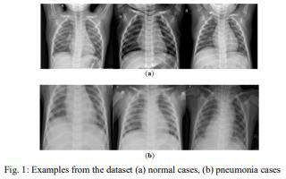

In order to make a summary about the task of pneumonia classification, Baltruschat et al. [27] compared the classification accuracy of currently widespread CNN models in pneumonia X-ray images by using the same hyperparameter settings and same image pre- processing procedures. The method by Nahid et al. [28] proposed a novel CNN architecture which composed of two channels. The first channel was used for image processing. To enhance its contrast, CLAHE method was used. The second channel too processed the images and Canny method was used for the enhancement of its edges. After this, a multichannel CNN model was set up in which the images were made to enter for detecting whether a patient is suffering from pneumonia. Researchers [29] developed a weak supervision approach to release a diagnosis burden of radiologists. They assessed the performance of their model on a dataset having about thirty thousand chest X-ray images. Furthermore, they drew a comparison between the region of interest (ROI) of their own proposed model with that of Radiological Society of North America (RSNA). They even proposed various model architectures, namely Inception, ResNet-50, Xception and Ensemble (weighted mean of the first three models). Inception net turned out to be their best model, with an accuracy of about 78.2% and the F1 score of 64.11% for detecting pneumonia through binary classification.

This paper also includes some more references in CNN processed fields, such as medical image reconstruction, medical image segmentation and so on. The most widely used models in medical image segmentation are U-Net [12] and VNet [13], which propose the idea of a fully connected neural network and stacked down-sampling layers followed by upsampling layers. Additionally, the layers present at front get directly connected to the layers present behind by the network so that the model‗s capability can be improved. The architecture [12], named U-net, consists of some stacked down-sampling convolution layers that adopt 3 3 kernels followed by Rectified Linear unit (ReLU) and 2 2 max pooling operation to obtain hidden feature maps. In order to reconstruct the original images, numerous symmetric convolution layers are used after the down-sampling layers. Similarly, the model architecture [13] named V-net adapts stacked convolution down-sampling and up-sampling layers, whose difference between U-net is the bottom of model, in other words, like their names, U-net and V-net.

# IV. Materials And Methods

## Images of Chest X-Rays, The Dataset

The dataset used for this research is provided by Guangzhou Women and Children‗s Medical Center, Guangzhou and is openly available on Kaggle [30]. All the Xrays having poor quality have been removed before the analysis part itself. The rest has been classified by three experts in the field of radiology [30]. The dataset contains 5,856 images of chest X-rays in JPEG format. It is further composed of three directories - train, val and test, which are used in the form of training, validation and testing data respectively. It originally consists of only 16 images in its val folder. Hence, an 80/10/10 split has been performed so that 80% of the total images can be used for training, 10% for validation and the remaining 10% for testing. Hence, the train directory consists of 4,684 images, val directory contains 586 images and test directory contains 586 images. All these directories contain two sub- directories inside them consisting of images of chest X-rays of patients suffering from pneumonia and those who are not suffering from pneumonia. The names of subfolders directly speak for the data labels. The quality of images was very high and initially they

were of different sizes, but they are resized afterwards for training model. Moreover, data augmentation was used to balance out the X-rays labeled as ―Pneumonia‖ with the X-rays labeled as ―Normal‖ since the former images were greater than the latter initially in the training dataset. Figure 2 shows two images of X-rays with their corresponding labels.

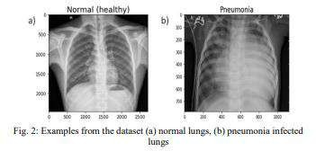

## Preparation of Dataset

Before building a model, it‗s quite important to preprocess the imported data. Firstly, some data augmentation has been performed, followed by feeding some images and test the network and creating labels for them. In the original dataset, there is a dis balance between the pneumonia symptomatic patients comparing with normal ones in the seen examples due to which it became quite necessary to perform data augmentation. This also helps in decreasing the amount of overfitting. In situations when there is no more available data of certain type it can be artificially created by zooming, asymmetrically cropping or rotating input images [31]. All of this can be performed with Keras‗s preprocessing tools [32]. Then two data generators for training and validation data (one for each) have been defined. A data generator loads some part of data we need from the folder and convert this to training required data and targets. The Batch size used for the model is 32.

## Proposed CNN Model

The main tools used in this project are: Numpy, Pandas, Keras, Jupyter notebook, Matplotlib and Seaborn [33]. Google Colaboratory uses them for training and testing as it runs entirely on the cloud. To classify the images, a CNN based algorithm was used. The CNN comes under deep learning. It consists of three basic layers namely, input layer, output layer and hidden layer. Here, the hidden layer plays the role in covering all the calculations. Convolutional layers can be found inside of the hidden layers [32]. Hidden layer is basically a full connected layer. The most important building block of a CNN is the convolutional layer: each neuron in the convolutional layer is only connected to a small number of neurons (receptive field) in the next convolutional layer [32]. Such a design allows the network structure to focus on a small low-level feature in the first hidden layer, and then aggregate them into higher-level features in the next hidden layer, and so on [32]. Designing in its structure is one of the reasons why it is used for image recognizing. Pooling layers work here to reduce sizes of input without a loss of any important details. This is completed to decrease cost and memory use. Figure 3 shows a max pooling layer, which is the most common type of pooling layer [31,32]. We‗ve used max pooling layer too in project, activation function named as ReLU was used. ReLU works accurately in DN network as it‗s fast plus it doesn‗t fluctuate in positive values. There are some variations of the ReLU activation function such as leaky ReLU, parametric leaky ReLU and SELU [32]. To increase efficiency while working in model, dropout process is used. In dropout non used neuron are stopped. The network can get a 1-2% increase in accuracy by introducing dropout.

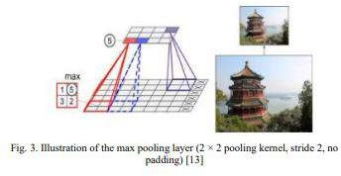

The architecture of the CNN used for this research is shown in Figures 3 and 4. Figure 3 represents the precis of model seen in paper. Features of the CNN model application are seen in Figure 4. Similar approaches were used in [34] and [35]. In [35], the same dataset was used, but the authors used the original split of the data into training, validation and test subsets.

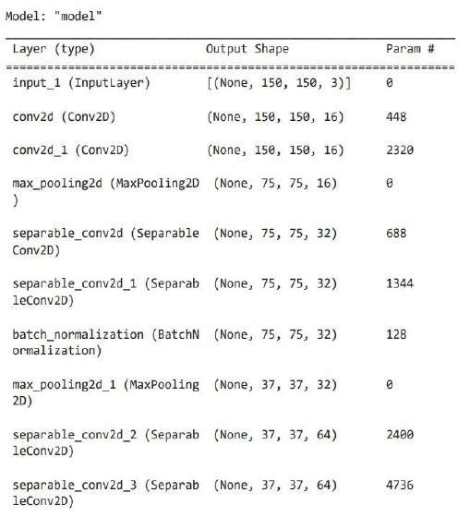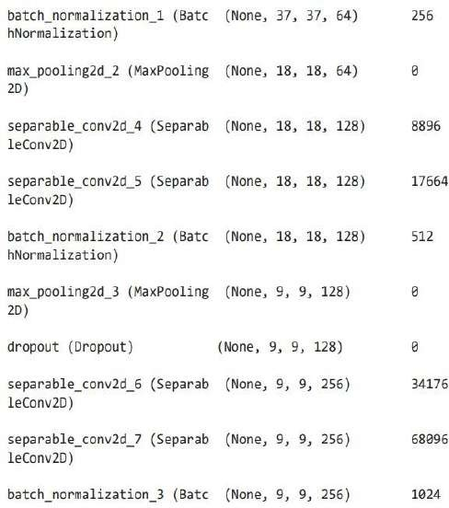

## Fig. 4: The model summary of the CNN model used

### 5 Convolutional blocks CNN using Batch normalization and max-pooling

The model has been built using 5 steps. These steps have been described as - Five convolutional blocks have been used to comprise of convolutional layer, batch-normalization and max-pooling. On top of that, a flatten layer was applied following four layers that are fully connected. To reduce over-fitting, in -between dropouts have also been used. The function of the activation was the ReLu leaving the last layer in which it is twisted because of binary categorizing.

Before model training, it is helpful to define one or more callbacks. Best of all, there are: ModelCheckpoint and EarlyStopping.

**ModelCheckpoint:** Sometimes training takes much time to reach final outcome. That is good, it often requires a lot of iterations as well. In this state, it is better to maintain copy of the most accurate model done when the metrics improving period completes.

**EarlyStopping :** Sometimes, in training, we see that the concept gap (the change between training and validation ) begins to rise , rather than reducing. We see this can be resolved by, lowering model capacity, data augmentation, regularization, expanding training data, etc. When the generalization gap becomes worse, an effective and efficient solution is to stop the training.[37]

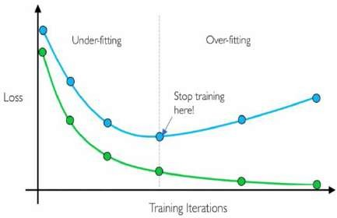

## Fig. 5: EarlyStopping [35]

After that, 10 epochs were used to train the model for a batch-size of 32. However, a greater value batch size tends to give better results but that increases the computational cost. Some research claims that by investing some time on hyperparameter tuning, optimal batch size could be found for good results. Also, the accuracy and loss plots have been visualized.

### 2:1 Architecture without using Batch Normalization and Dropout

In this architecture, two convolutional layers have been used along with one hidden layer of the CNN model without using Batch Normalization and Dropout.

### 4:2 Architecture using Batch Normalization and Dropout

In this architecture, four convolutional layers have been used along with two hidden layers of the CNN model using Batch Normalization and Dropout.

## 4.4. Conventional Models

1. **VGG-16**

VGG16 is an architecture based on convolution neural network (CNN). 16 in the term ‗VGG16‘ refers to the 16 layers of weight that it possesses. This network is the largest network and has around 138 million frameworks. It is said to be one of the best vision model structures in the present world. The best feature of VGG16 is that although it consists of large hyper parameters, it still focuses on conviction layers having a 3x3 filter and a stride of 1. But it usually uses the same padding and a maxpool layer having 2x2 filter with a stride of 2. It maintains the structure of max pool and convolution layers perpetually during the complete architecture. Finally, it consists of two fully connected layers and then a softmax for output.

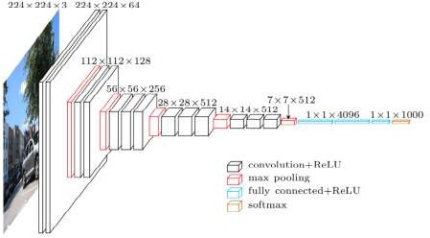

## Fig. 6: Architecture of VGG-16 [36]

Figure 7 shows the model summary of the VGG-16 model used.

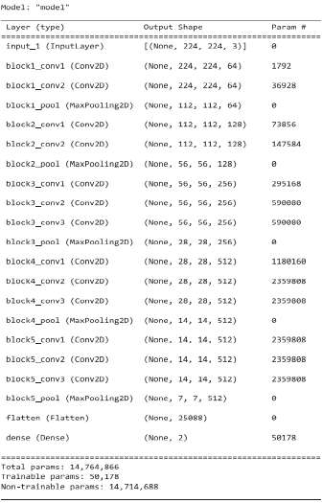

## Fig. 7: The model summary of the VGG-16 used

1. **Inception V3**

Inception v3 is basically a model based on convolutional neural network (CNN) to assist in the process of analysing images and also detecting objects. It is a part of the third version of the Google Inception Convolutional Neural Network. The whole idea behind the design of Inceptionv3 was to permit deeper networks, but at the same time ensuring that the amount of parameters do not grow a bit too much: it comprises of "less than 25 million parameters", which is less, if compared to the 60 million that are there for [AlexNet.](https://en.wikipedia.org/wiki/AlexNet)

Like ImageNet can be considered a separate database for already classified visual objects, Inception V3 facilitates the object separation in the field of computing. The Architecture of Inceptionv3 is also used in various types of programs, commonly used "pre-trained" from ImageNet. One of its such uses is in the area of life sciences, where it assists in the study of the deadly disease

―leukemia‖.

## Random Forest

Random forest is a very popular algorithm of Machine Learning promptly used for solving problems of Classification and Regression, also to build decision-making trees with the help of different samples and use their majority vote in case of problems of classification and average in case of regression.

One of the most crucial features of this algorithm is that it can utilize the data set containing categorical variables just like they are present for classification and continuous variables as in it is in case of regression. It produces the best results of classification problems.

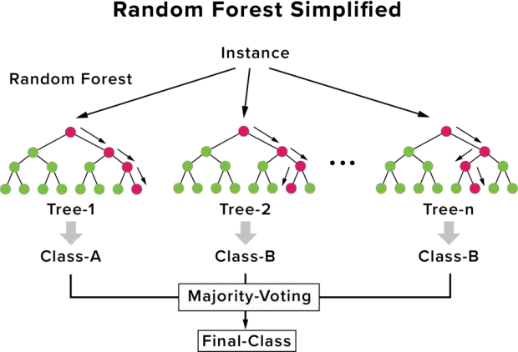

**Fig. 8: Random Forest [37]**

# V. Result

The validation accuracy has been assessed as a measure for studying and analyzing each classifier. The accuracy and loss graphs were also plotted for better understanding.

## Comparison of Performance of Models

We have assessed the accuracies of the Random Forest algorithm along with 5 CNN models, namely VGG-16, Inception V3, 2:1 Architecture without using Batch Normalization and Dropout, 4:2 Architecture using Batch Normalization and Dropout, 5 Convolutional Blocks CNN with Batch Normalization and Max-Pooling. Figures 9, 10, 11, 12, 13 show the accuracy and loss plotted in graphs for all CNN based classifier models. Table 1 shows that the Random Forest algorithm significantly underperformed compared to CNN models. Accuracy is very low for it (75.00%). In the CNN models, the 2:1 Architecture without using Batch Normalization and Dropout has performed the best with an accuracy of 94.65%, followed by VGG-16 having an accuracy of 91.99%. The 4:2 Architecture using Batch Normalization and Dropout and our own 5 convolutional block CNN model

with Batch Normalization and Max-Pooling have got very near accuracies of 91.88% and 90.70% respectively. Inception V3 has also performed decently with an accuracy of 88.39%. The results are as follows:

TABLE I

Comparison of various Machine and Deep Learning models

|  |  |
| --- | --- |
| **Method Used** | **Accuracy (%)** |
| Random Forest | 75.00 |
| Convolutional Neural Networks | |
| VGG-16 | 91.99 |
| Inception V3 | 88.39 |
| 2:1Architecture without using Batch Normalization and Dropout | 94.65 |
| 4:2 Architecture using Batch Normalization and Dropout | 91.88 |
| 5 Convolutional Blocks CNN with Batch Normalization and Max-pooling | 90.70 |

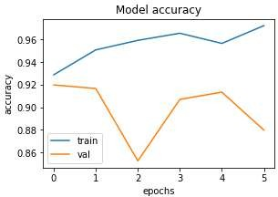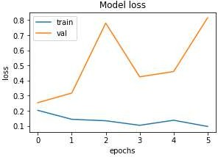

## Fig. 9: Loss and Accuracy plots for VGG-16

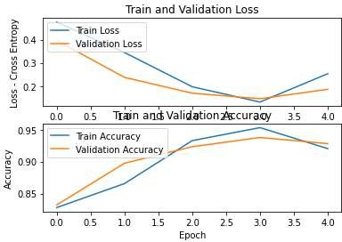

**Fig. 10: Loss and accuracy plots for Inception V3**

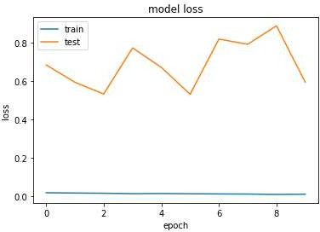

## Fig. 11: Loss plot for 4:2 Architecture using Batch Normalization and Dropout

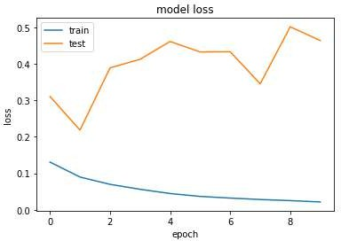 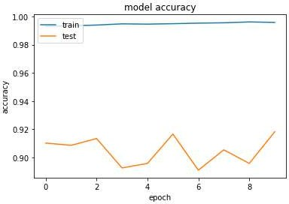

## Fig. 12: Loss and accuracy plots for 2:1 Architecture without using Batch Normalization and Dropout

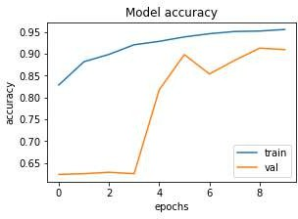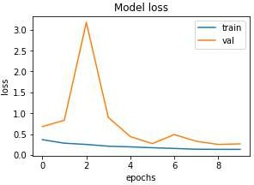

**Fig. 13: Accuracy and loss plots for 5 Convolutional blocks CNN with Batch Normalization and Max-pooling**

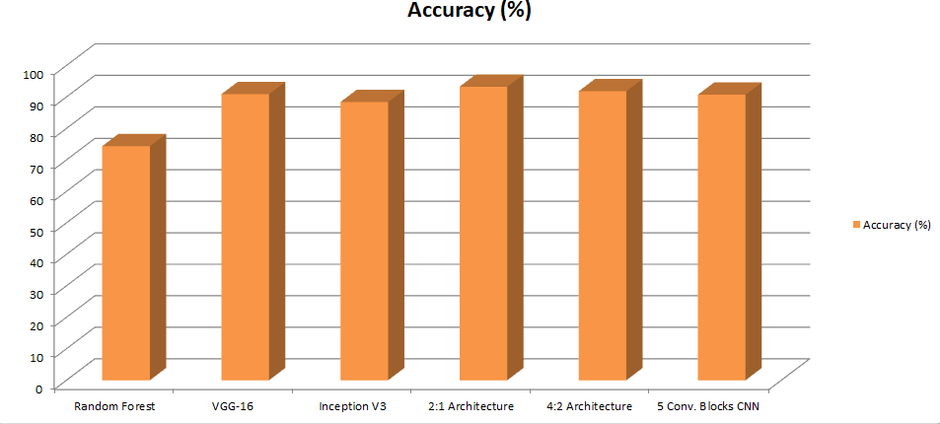

**Fig. 14: Comparison of various models applied**

# VI. Conclusion

This study explores the work of in-depth learning in diagnosing pneumonia from a computer vision using the Random Forest algorithm and convolutional neural network architectures. All CNN models used are tested for fine tuning and feature extraction. The images of the chest x-rays of patients who are infected by pneumonia and those who are normal are extracted as a dataset from Kaggle website. VGG16, 2:1 Architecture without using Batch Normalization and Dropout, 4:2 Architecture using Batch Normalization and Dropout and 5 Convolutional Blocks CNN with Batch Normalization and Max-pooling come out to be the most efficient models with an accuracy of 90% to 95%. Random Forest has got the accuracy level of 75.00%, which is lowest among all the models. Overall, all models produced good results for both pneumonia as well as routine chest x-ray. This research work provides a different approach to determine pneumonia, thereby helping to provide medical facilities. In future, refinements to other convolutional neural network structures such as ResNet, GoogleNet, shuffleNet, and MobileNet architectures to detect pneumonia should also be used to optimize hyper-parameters and can be taken into consideration to further make the model more accurate. This research will assist medical staff while taking decisions in real time on the implementation of an accurate model in finding a pneumonia case and gaining the ability to diagnose pneumonia through in-depth study.

# VII. Future Scope

The primary objective of the whole research lies in determining whether or not a person is suffering from the disease of pneumonia with the help of chest x-rays, available as a dataset on the Kaggle website. Several models of deep learning as well as transfer learning have been examined to classify the images. Deep Learning assists in extracting features from images that are further used for classifying the x-rays having pneumonia. Different convolutional neural network architectures have been built and trained using the xray images of pneumonia patients and those of normal patients. We have also used Random Forest algorithm for further getting better results and comparison of the accuracy of the different models that have been used. The training of the CNN models used has been done on the Chest X-Rays (Pneumonia) dataset taken from Kaggle. This project aims to enhance the therapeutic facilities in places where there are only a limited number of radiotherapists available so that pneumonia can be diagnosed early to prevent further consequences in such remote areas. In future, refinements to 13 other convolutional neural network structures such as ResNet, GoogleNet, shuffleNet, and MobileNet architectures to detect pneumonia should also be used to optimize hyper- parameters and can be taken into consideration to further make the model more accurate. Also, the research can be further extended to classifying a patient as either having bacterial pneumonia, viral pneumonia or no pneumonia. Classification can further be made between the pneumonia that is caused due to COVID-19 and the normal pneumonia. The project can also be deployed as a desktop/web application so that people across the globe can make use of it at the comfort of their homes. Also, a larger dataset can

be used in the future for detection to give higher accuracy and produce better results. This research will assist medical staff while taking decisions in real time on the implementation of an accurate model in finding a pneumonia case and gaining the ability to diagnose pneumonia through in-depth study.

# VIII. References

1. P. Rui, K. Kang, National Ambulatory Medical Care Survey: 2018 Emergency Department Summary Tables.
2. E. Sayed, et. al, Computer-aided Diagnosis of Human Brain Tumor though MRI: A Survey and a new algorithm, Expert System with Applications (41): 2014.
3. D.K. Das, M. Ghosh, M. Pal, A.K. Maiti, and C. Chakraborty, Machine learning approach for automated screening of malaria parasite using light microscopic images, Micron 45, 97106, 2013.
4. M. Poostchi, K. Silamut, R. Maude, S. Jaeger, and G. Thoma, Image analysis and machine learning for detecting malaria, Translational Research, 2018.
5. N.E. Ross, C.J. Pritchard, D.M. Rubin, and A.G. Duse, Automated image processing method for the diagnosis and classification of malaria on thin blood smears, Medical and Biological Engineering and Computing 44, 5, 427436, 2006.
6. A.S. Razavian, H. Azizpour, J. Sullivan, and S. Carlsson, CNN features off-the-shelf: an astounding baseline for recognition, In Proceedings of the IEEE conference on computer vision and pattern
7. Fafi, Kusworo and Catur, Breast Tumor Detection using Haar-Like Feature Method on Ultrasonography (USG) Imaging, International Journal of Innovative Research in Advanced Engineering, Volume V, 154-157. doi://10.26562/IJIRAE.2018.MYAE10082.
8. Abiyev R. H., Ma‗aitah M. K. S., Deep Convolutional Neural Networks for Chest Diseases Detection, Journal of Healthcare Engineering, 2018.
9. A. Krizhevsky, I. Sutskever, & G.E. Hinton, ImageNet Classification with Deep Convolutional Neural Networks, Neural Information Processing Systems, 25. 10.1145/3065386, 2012.
10. M. Cicero, A. Bilbily, E. Colak, T. Dowdell, B. Gra, K. Perapaladas, and J. Barfett, Training and Validating a Deep Convolutional Neutral Network for Computer-Aided Detection and Classification of Abnormalitites on Frontal Chest Radiographs, Investigative Radiology 52(5) 281- 287, 2017.
11. Le, W.T.; Maleki, F.; Romero, F.P.; Forghani, R.; Kadoury, S. Overview of machine learning: Part 2. Neuroimaging Clin. N. Am. 2020, 30, 417– 431. [CrossRef] [PubMed]
12. Ronneberger, O.; Fischer, P.; Brox, T. U-net: Convolutional networks for biomedical image segmentation. In Medical Image Computing and Computer-Assisted Intervention—MICCAI 2015; Springer International Publishing: Cham, Switzerland, 2015; pp. 234–241.
13. Milletari, F.; Navab, N.; Ahmadi, S.A. V-Net: Fully Convolutional Neural Networks for Volumetric Medical Image Segmentation. In Proceedings of the 2016 Fourth International Conference on 3D Vision (3DV), Stanford, CA, USA, 25–28 October 2016; pp. 565–571.
14. Jeelani, H.; Martin, J.; Vasquez, F.; Salerno, M.; Weller, D. Image quality affects deep learning reconstruction of MRI. In Proceedings of the 2018 IEEE 15th International Symposium on Biomedical Imaging (ISBI 2018), Washington, DC, USA, 4 –7 April 2018; pp. 357–360.
15. Chlemper, J.S.; Caballero, J.; Hajnal, J.; Price, A.N.; Rueckert, D. A deep cascade of convolutional neural networks for dynamic MR image reconstruction. IEEE Trans. Med. Imaging 2017, 37, 491–503. [CrossRef] [PubMed]
16. Rajpurkar, P.; Irvin, J.; Zhu, K.; Yang, B.; Mehta, H.; Duan, T.; Ding, D.; Bagul, A.; Langlotz, C.; Shpanskaya, K.; et al. Chexnet: Radiologistlevel pneumonia detection on chest x-rays with deep learning. arXiv 2017, arXiv:1711.05225.
17. Huang, G.; Liu, Z.; Van Der Maaten, L.; Weinberger, K.Q. Densely Connected Convolutional Networks. In Proceedings of the 2017 IEEE Conference on Computer Vision and Pattern Recognition (CVPR), Honolulu, HI, USA, 21–26 July 2017; pp. 2261– 2269.
18. He, K.; Zhang, X.; Ren, S.; Sun, J. Deep residual learning for image recognition. In Proceedings of the IEEE Conference on Computer Vision and Pattern Recognition, Las Vegas, NV, USA, 27–30 June 2016; pp. 770–778.
19. Yu, F.; Koltun, V.; Funkhouser, T. Dilated Residual Networks. In Proceedings of the 2017 IEEE Conference on Computer Vision and Pattern Recognition (CVPR), Honolulu, HI, USA, 25–30 June 2017; pp. 636–644.
20. Liang, G.; Zheng, L. A transfer learning method with deep residual network for pediatric pneumonia diagnosis. Comput. Methods Programs Biomed. 2020, 187, 104964. [CrossRef] [PubMed] [21] Jain, R.; Nagrath, P.; Kataria, G.; Kaushik, V.S.; Hemanth, D.J. Pneumonia detection in chest X-ray images using convolutional neural networks and transfer learning. Measurment 2020, 165. [CrossRef]
21. Verma, D.; Bose, C.; Tufchi, N.; Pant, K.; Tripathi, V.; Thapliyal, A. An efficient framework for identification of Tuberculosis and Pneumonia in chest X-ray images using Neural Network. Procedia Comput. Sci. 2020, 171, 217–224. [CrossRef]
22. Ayan, E.; Unver, H.M. Diagnosis of Pneumonia from Chest X-Ray Images Using Deep Learning. In Proceedings of the 2019 Scientific Meeting on Electrical-Electronics & Biomedical Engineering and Computer Science (EBBT), Istanbul, Turkey, 24–26 April 2019; pp. 1– 5.
23. Elshennawy, N.M.; Ibrahim, D.M. Deep-pneumonia framework using deep learning models based on chest X-ray images. Diagnostics 2020, 10, 649. [CrossRef] [PubMed].
24. Li, B.; Kang, G.; Cheng, K.; Zhang, N. Attention-Guided Convolutional Neural Network for Detecting Pneumonia on Chest X-Rays. In Proceedings of the 2019 41st Annual International Conference of the IEEE Engineering in Medicine and Biology Society (EMBC), Berlin, Germany, 23–27 July 2019; pp. 4851–4854.
25. Guo, X.; Yuan, Y. Triple ANet: Adaptive Abnormal-aware Attention Network for WCE Image Classification. In Proceedings of the 19th International Conference on Application of Concurrency to System Design (ACSD 2019), Aachen, Germany, 23–28 June 2019; pp. 293– 301.
26. Baltruschat, I.M.; Nickisch, H.; Grass, M.; Knopp, T.; Saalbach, A. Comparison of Deep Learning Approaches for Multi- Label Chest X-Ray Classification. Sci. Rep. 2019, 9, 1–10. [CrossRef] [PubMed] [28] Nahid, A.-A.; Sikder, N.; Bairagi, A.K.; Razzaque, A.; Masud, M.; Kouzani, A.Z.; Mahmud, M.A.P. A Novel Method to Identify Pneumonia through Analyzing Chest Radiographs Employing a Multichannel Convolutional Neural Network. Sensors 2020, 20, 3482. [CrossRef] [PubMed]
27. Odaibo, D.; Zhang, Z.; Skidmore, F.; Tanik, M. Detection of visual signals for pneumonia in chest radiographs using weak supervision. 2019 SoutheastCon 2019, 1–5. [CrossRef].
28. D. Kermany, K. Zhang, M. Goldbaum, ―Labeled Optical Coherence Tomography (OCT) and Chest X-Ray Images for

Classification‖, Mendeley Data, v2, 2018. Accessed July 2020. [Online]. Available: <http://dx.doi.org/10.17632/rscbjbr9sj.2>

1. R.C. González, R.E. Woods. ―Digital Image Processing‖, Prentice Hall, 2007, pp 85. [32]. A. Geron, ―Hands-On Machine Learning with ScikitLearn, Keras, and TensorFlow‖, O‗Reilly Media, Inc., Canada, 2019.
2. Jupyter Notebook: Project Jupyter. Accessed July 2020. [Online]. Available: [http://jupyter.org](http://jupyter.org/) [33] D. Varshni, K. Thakral, L. Agarwal, R. Nijhawan, A. Mittal, "Pneumonia Detection Using CNN based Feature Extraction," 2019 IEEE International Conf. on Electrical, Computer and Communication 14 Technologies (ICECCT), Coimbatore, India, 2019, pp 1 -7. [35]. V. Sirish Kaushik et al., ―Pneumonia Detection Using Convolutional Neural Networks (CNNs)‖, In: Singh P., Pawłowski W., Tanwar S., Kumar N., Rodrigues J., Obaidat M. (eds) Proceedings of First International Conference on Computing, Communications, and CyberSecurity (IC4S 2019). Lecture Notes in Networks and Systems, vol 121. Springer, Singapore.
3. Dataset -Link: https://[www.kaggle.com/datasets/paultimothymooney/chest](http://www.kaggle.com/datasets/paultimothymooney/chest) -xray - pneumonia
4. https://towardsdatascience.com/deep -learning -for -detecting -pneumonia - from - x -ray -images -fc9a3d9fdba8
5. https://towardsdatascience.com/step -by -step -vgg16 -implementation -in - keras -for -beginners -a833c686ae6c [37]https://upload.wikimedia.org/wikipedia/commons/7/76/Random_forest_ diagram_complete.png