**Empowering Nonverbal Communication: A Comprehensive Examination of Sign Language Recognition Systems and Implementation of Interpretation**

Krishna1, Navya2, Magan Lodhi3, Khushi Jain4  
*1, 2, 3, 4 Department of Information Technology, Dr. A.P.J. Abdul Kalam Technical University, Uttar Pradesh, India  
1krishna.kug070@gmail.com, 2[navyamalik292@gmail.com,](mailto:2003013054@ipec.org.in,)  
3maganlodhi31@gmail.com, 4[k](mailto:2003013054@ipec.org.in,)hushiijain0910@gmail.com*

***Abstract —* This paper provides a analysis of previous research on sign language recognition systems and their impact on Providing meaningful interaction among non-verbal individuals. It introduces a real-time sign language interpreter that translates text into gestures and vice-versa, accommodating regional sign languages and promoting personal expression. In a manner distinct from previous systems, it emphasizes individualization and includes text chat features for seamless communication. By enabling users to create and share their own gestures, it Promotes cultural diversity and authentic self-expression, promoting inclusivity and empowerment within the non-verbal community. This innovative solution also alleviates the pressure on non-verbal communication users to perform gestures in front of a camera for accurate recognition, addressing issues with outdated sign languages and the lack of personal sign gestures.**

***Keywords —* Sign Language Recognition, Text-to-sign Translation, Sign Language Interpreter, Sign Language Evolution, Recognition Models, Recognition Techniques.**

# **Introduction**

In a world where communication is paramount in various aspects of life, non-verbal individuals face considerable obstacles due to the inherent speed and reliability of verbal communication. This discrepancy often leads to social exclusion and pressure to conform to verbal communication norms, which are perceived as faster and more comprehensible. However, non-verbal individuals struggle to communicate as effectively as their verbal counterparts. Existing studies reveal a poignant reality: non-verbal individuals struggle with substantial challenges when navigating social environments primarily dominated by verbal communication, frequently resulting in feelings of isolation and marginalization. Conventional sign language recognition systems often struggle to meet the personalized needs of non-verbal communicators, lacking emotion and expression in their text outputs. Many existing systems are cost-prohibitive for commercialization and limited to static gestures or the sign language alphabet. In response, our study introduces a real-time sign language interpreter translating text into dynamic gestures, accommodating various regional sign languages and promoting diversity. Unlike previous systems, ours emphasizes personalization and individual expression, allowing users to create and share their own gestures while integrating text chat features for smoother communication. Through empowerment and innovation, our research aims to alleviate social and psychological pressures faced by non-verbal individuals, fostering inclusivity and belonging within the community. The World Health Organization (WHO) reports that over 70 million people worldwide are deaf, with 360 million experiencing varying degrees of hearing impairment, including 32 million children [1]. There are more than 300 sign languages globally, serving a population exceeding 72 million individuals who are deaf or hard of hearing [2]. Currently, only 41 countries recognize sign language as an official language out of 195 countries [3]. Sign language's grammar differs significantly from spoken language, utilizing hand shapes, signals, facial expressions, and body language for communication [20]. Despite advancements in artificial intelligence (AI), sign language recognition (SLR) remains challenging. SLR systems are vital for aiding communication for the hearing impaired and fostering inclusive technologies, yet many challenges persist. Lighting conditions, background disturbance, and variations in hand movements complicate SLR development [4]. In situations where individuals cannot hear or speak, sign language serves as a crucial means of communication. However, the diversity of gestures and expressions in sign language across regions poses challenges for accurate recognition systems [2].

1. *Sign Language Recognition Systems Studies*

*A.1. Sign Language Recognition Systems Taxonomy*

The taxonomy mainly divides research into three levels: Elementary (sign characters), Advanced (sign words), and Professional (sentence interpretation) [5]. The taxonomy sign language recognition systems categorizes approaches based on input modalities, feature extraction, and recognition techniques. These include video, glove-based, and sensor-based systems, analyzing hand shape, motion, and trajectory.

Classification involves vision-based, glove-based, and wearable sensor systems, with data represented through image-based or skeleton-based techniques. Feature extraction focuses on hand shape, motion, and facial expression recognition. Recognition techniques encompass template matching, machine learning, and deep learning methods. Gesture segmentation involves temporal segmentation and syntax parsing. Output modalities include text, avatar animation, and audio output. Integration efforts target mobile applications, web platforms, and collaboration with assistive technologies.

|  |  |  |
| --- | --- | --- |
| **Method** | **Vision-based Method** | **Sensor-based or Gloves-based Method** |
| ***Capturing Device*** | Video Camera | Sensors and gloves |
| ***Obstacle*** | Environment, disturbance, and noise | Environment, disturbance, and noise |
| ***Efficiency*** | Low (depends on resolution) | Better than vision-based method (depends on sensor performance) |
| ***Cost*** | Low | High |
| ***Limitation*** | Challenging concerns for time, speed, and overlapping; requires more feature extraction techniques. | Not suitable for real-time application; requires minimal feature extraction. |
| ***Advantage*** | Fast speed. | Better performance. |

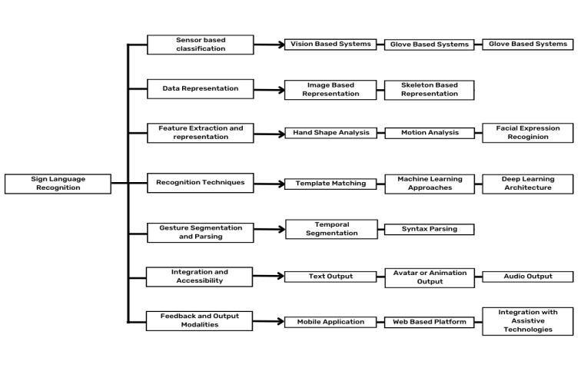

|  |  |  |
| --- | --- | --- |
| Table I: Comparison of Vision-based and Sensor-based/Gloves-based Methods for Sign Language Recognition: A Primary Taxonomy Overview. |  | Fig. 1. Taxonomy of Sign Language Recognition Systems. It covers data representation, feature extraction, recognition techniques, segmentation, output formats, and platform integration to improve accessibility. |

*A.2. Needs of Sign Language Recognition Systems*

Sign language recognition systems are crucial for breaking communication barriers and fostering inclusivity for individuals reliant on sign language [6]. With limited sign language interpreters and accessibility challenges, these systems offer essential solutions, enhancing accessibility in various contexts [7]. Unlike traditional methods like lip-reading, they ensure effective communication, particularly in education, healthcare, and social settings [6]. By accurately translating sign language, these systems promote equality and empower non-verbal individuals, enabling their full participation in society [7]. As technology advances, these systems contribute to creating a more inclusive and accessible world [6].

*A.3. Challenges of Sign Language Recognition Systems*

Sign language recognition (SLR) systems encounter challenges such as hand-shape and movement variability, facial expressions, and grammar complexity. Limited datasets impede training, particularly for underrepresented sign languages, leading to subpar performance. Distinguishing similar signs is hindered by ambiguity and homo-phony, while real-time processing requires efficient algorithms to reduce latency. Developing personalization algorithms for user preferences remains a research obstacle.

|  |  |  |  |
| --- | --- | --- | --- |
| **Reference** | **Cite** | **Authors** | **Challenges** |
| [14] | "Real Time Indian Sign Language Detection System." International Journal of Advanced Research in Science, Communication and Technology, (2023). doi: 10.48175/ijarsct-9540 | Nikhil Salvi, Qureshi Zaid, Nikhil Bhodke | Variability in hand shape, motion profile, position of hand, face, and body parts contributing to each sign. |
| [15] | S., A., Shahul, Hameed, T, A., Sheeba, O. "Design Challenges in Effective Algorithm Development of Sign Language Recognition System." International journal of engineering and advanced technology, undefined (2023). doi: 10.35940/ijeat.c4030.0212323 | Sajeena A, T A Shahul Hameed, Sheeba O | Image acquisition, segmentation, feature extraction, classification, and detection. |
| [16] | "Cross Transferring Activity Recognition to Word Level Sign Language Detection" (2022). doi: 10.1109/cvprw56347.2022.00273 | Srijith Radhakrishnan et al. | Lack of large-scale labeled datasets, variability in signers, background, lighting, and intersigner variation. |
| [17] | "Sign Language Digit Detection with MediaPipe and Machine Learning Algorithm." undefined (2022). doi: 10.1109/iccsce54767.2022.9935659 | Safyzan Salim et al. | Efficiently translating gestures from sensor data, increasing programming complexity. |

Table II: Challenges in Previous Work: Summary of Research Papers Challenges in Sign Language Detection and Recognition Systems.

1. *Sign language Interpreter*

*B.1. Understanding the Role of a Sign Language Interpreter*

Sign language recognition systems hold significant promise but face many challenges, placing non-verbal communicators in a constant struggle to convey their messages through gestures captured by cameras, often inducing feelings of discomfort and tension [8]. They have to make fast and precise sign gestures to keep up with the people who use verbal communication, which places immense pressure on non-verbal individuals, exacerbating their unease and stress levels as they seek efficient interaction [9]. Consequently, many have turned to texting as a more accessible and less demanding means of communication. The necessity for accurate interpretation of sign language further underscores the importance of proficiency in both signing and adapting to technological advancements [8, 10-11]. To overcome these challenges, sign language interpreters stand out as remarkable advancements, fundamentally transforming communication for the non-verbal communication community. These sign language interpreters work differently from traditional recognition systems. They harness pattern recognition algorithms and computer vision to interpret sign language in real-time, leveraging depth-sensing cameras and motion sensors for precision [12-13]. By providing independence and autonomy, they dismantle barriers and promote inclusivity between non-verbal and verbal communities [9], offering unparalleled precision and reliability in communication across various situations [9].

# **Literature Survey**

Previous Research shows in sign language recognition systems primarily relies on computer vision and sensorbased recognition mechanisms, employing image processing techniques with cameras to capture images or videos for data analysis [18]. The choice of camera affects performance, with higher resolution cameras requiring more processing power and memory [18-19]. Other research explores hand gloves equipped with flex sensors and motion trackers, leveraging neural networks for real-time applications, albeit at a higher cost due to expensive hardware. Another approach involves portable accelerometer and surface electromyogram sensors to detect hand gestures, providing speech and text output. However, none of these methods offer two-way communication or graphical representations of signs. Our proposed system aims to fill this gap by enabling two-way conversation with graphical representations in a user-friendly mobile app interface, potentially benefiting both non-verbal an verbal individuals. While various techniques have been attempted, including image processing and neural networks, none have adequately addressed user training, self updation and feedback. This research proposes a method for training users in sign language, followed by testing to assess proficiency. By focusing on mainstream and local sign language, the system offers a structured approach to learning and practicing, addressing a significant gap in existing solutions.

Eiichi Asakawa et al. [21] This experiment analyzes a deep learning-based gesture generation model using a Convolutional neural network (CNN) from spoken text. Datasets preparation involves adding text information to an existing datasets, and models are trained using specific speaker data. The quality of generated gestures is compared with an existing speech-to-gesture generation model through user perceptual studies, showing comparable or superior performance. Investigations explore data cleansing, loss function selection, and model transferability between speakers. The text-to-gesture generation model utilizes a transformer architecture, demonstrating good quality gesture generation. Research questions aim to compare text-togesture with speech-to-gesture generation models, analyze model components' effects, and assess model transferability. Contributions include demonstrating comparable quality gestures, revealing the importance of data cleansing and loss function selection, and illustrating model transferability between speakers. The detailed analysis provided about the experiments and results on text-to-gesture (T2G) and speech-to-gesture (S2G) generation models is comprehensive, highlighting the effectiveness of the developed T2G generation model compared to S2G models. Key factors affecting gesture quality include data cleansing and loss function choice, with motion loss proving more effective. Experiments with transformer architectures confirm the potential of T2G models. Future research avenues include exploring loss functions reflecting human perception of gestures and constructing gesture generation models for languages other than English. The text-to-gesture generation model takes spoken words as input and outputs gesture motion coordinates using a CNN. A user perceptual study compares generated gestures from the text-to-gesture model with an existing speech-to-gesture model. Evaluation protocols involve quantitative measures like MAE, APE, PCK, and STD, along with qualitative user study evaluations. The study concludes that the text-to-gesture model demonstrates comparable or superior performance, emphasizing the importance of data cleansing, loss function selection, and model transferability.

K.Shenoy et al. [22] introduces a real-time system for recognizing hand poses and gestures in the Indian Sign Language (ISL) using grid-based features, aiming to facilitate communication between the hearing and speech impaired and society. It achieves high accuracy through techniques such as face detection, object stabilization, and skin color segmentation, with hand poses identified using grid-based feature extraction and classified via the k-Nearest Neighbors algorithm, and gestures recognized through Hidden Markov Models. The system demonstrates 99.7% accuracy for static hand poses and 97.23% accuracy for gesture recognition. Hand extraction involves obtaining a black and white image to isolate the hand region, while motion tracking calculates the hand's centroid in each frame. Classification utilizes k-Nearest Neighbors for hand poses and Hidden Markov Models for gesture recognition, with high accuracy and fast processing times. Implemented as an Android application, it captures ISL gestures using the smartphone's camera, sending frames to a remote server for processing and displaying classified results. Although currently limited to single-handed gestures, future work aims to expand recognition to two-handed gestures and sentences using Natural Language Processing algorithms. Despite challenges like lighting conditions and clothing requirements, the system achieves precise and real-time recognition, outperforming other approaches, and can be extended to other sign languages with appropriate datasets.

Podder KK et al.[23] real-time Bangla Sign Language interpreter has been developed to integrate over 200,000 hearing and speech-impaired individuals into Bangladesh's workforce, utilizing deep machine learning models trained on robust datasets to address challenges in Bangla Sign Language (BdSL) recognition and detection, including variations in skin tone, hand orientation, and background. The study emphasizes the importance of background images for training CNN models, particularly focusing on accurate BdSL Alphabet and Numerals recognition, with the ResNet18 model achieving exceptional performance at 99.99% accuracy. A specific datasets, BdSLHD-2300, was created for hand detection, aiding in training hand segmentation models. Transfer learning and data augmentation techniques were employed for training pre-trained CNN models, with semantic segmentation models utilized for background removal. Evaluation metrics included accuracy, IoU, Dice Similarity Coefficient, precision, sensitivity, F1 score, specificity, and AUC, with ResNet18 consistently outperforming other models. Real-time Bangla Sign Alphabets and Numerals interpretation was facilitated by a rolling prediction average algorithm. Recommendations for future research include incorporating sign words and sentences, exploring Vision Transformers, and implementing domain adaptation for real-time applications, along with smartphone implementation for user-friendly access. Supplementary materials provide additional insights into the experimental setup and results, with all authors contributing to the study's design and execution.

Almasre MA et al. [24] The research focused on recognizing Arabic Sign Language (ArSL) gestures via depth sensors, analyzing 143 signs from 10 users for 5 ArSL words, extracting 235 angles per joint and bone pair, and splitting the datasets into training and testing sets. Support Vector Machine (SVM) classifiers with linear and radial kernels achieved high accuracies,

|  |  |  |  |  |  |  |
| --- | --- | --- | --- | --- | --- | --- |
| **Reference** | **Paper** | **Authors** | **Insights** | **Method Used** | **Results** | **Limitations** |
| [25] | Sign Language Detection | - | In this paper , feature extraction and classification using ORB and SVM and the second is using CNN architecture were used to convert it to the tflite format for Android Development. | ORB feature extraction and classification using SVM CNN architecture for image classification and tflite conversion | Proposed models: ORB and SVM, CNN architecture for classification. Trained CNN model converted to tflite format for Android Development. | ORB is limited by the accuracy of the decision tree classifier. No mention of limitations specific to CNN architecture. |
| [26] | [Sign language detection and conversion to text using CNN and OpenCV](https://typeset.io/papers/sign-language-detection-and-conversion-to-text-using-cnn-and-2kseerev" \o "https://typeset.io/papers/sign-language-detection-and-conversion-to-text-using-cnn-and-2kseerev) | H.R., Akhilesh, Kumar. et al. | In this paper , a model was proposed to convert sign language to the text by which everyone can understand the sign language of the peoples who are unable to speak, and the model can be trained using KNN, SVM, Logistic regression and CNN. | Trained model using CNN algorithm for accurate image recognition. Created own datasets for training model to improve accuracy. | Model trained on CNN for sign language recognition. Integration with OpenCV for improved hand gesture recognition accuracy. | Model fails with OpenCV for hand gesture recognition. Improved accuracy by creating own datasets and integrating inputs. |
| [27] | [The Importance and Challenges of Sign Language Translator- A Review](https://typeset.io/papers/the-importance-and-challenges-of-sign-language-translator-a-1yzkyn6u" \o "https://typeset.io/papers/the-importance-and-challenges-of-sign-language-translator-a-1yzkyn6u) | Basanta Mahato | In this paper , the authors investigated how this research might be used in education and developed a tutorial system for deaf or hard-of-hearing youngsters that analyses their English writing and provides specialized lessons and recommendations using intelligent computer-aided instruction. Robotic finger-spelling hands and virtual reality sensors Sign recognition software and Hidden Markov Modelling Significant strides in understanding and representing sign language Development of sign recognition software and translation technologies Challenges in sign language translation technologies Limitations in synthesized signs for instructional materials | Robotic finger-spelling hands and virtual reality sensors Sign recognition software and Hidden Markov Modelling | Significant strides in understanding and representing sign language Development of sign recognition software and translation technologies | Challenges in sign language translation technologies Limitations in synthesized signs for instructional materials |
| [28] | Hand-Gesture Detection Using Principal Component Analysis (PCA) and Adaptive Neuro-Fuzzy Inference System (ANFIS) | Anif, Hanifa, Setianingrum., Arifa, Fauzia., Dzul, Fadli, Rahman | Differences in the use of image sizes have an influence on the accuracy of hand signal prediction, indicated by the decreasing accuracy value when given a smaller size in the four scenarios that have been studied. | Principal Component Analysis (PCA) Adaptive Neuro-Fuzzy Inference System (ANFIS) | The largest accuracy obtained in hand-gesture detection is 76.20%. The smallest accuracy obtained in hand-gesture detection is 52.38%. | Inaccuracies due to language development, outdated sign language dictionary, unclear movements. Smaller image sizes result in decreased accuracy of hand signal prediction. |
| [29] | [Real Time Indian Sign Language Detection System](https://typeset.io/papers/real-time-indian-sign-language-detection-system-2ckeh9s2" \o "https://typeset.io/papers/real-time-indian-sign-language-detection-system-2ckeh9s2) | - | In this article , the authors presented the development and application of a model for recognizing sign language based on a Convolutional neural network (CNN) and utilized a pre-trained SSD mobile net V2 architecture trained on their own datasets. | Camera-based approach for recording sign language in real-time Processing of video frames to determine boundaries and analyze body components | The SGD model had a training accuracy of 100 and a validation accuracy of roughly 81. The project has the ability to transform phrases with a 5 millisecond time delay between each word. | No emphasis on ISL in deaf schools' teaching strategies. Lack of sign language curriculum and teacher training programs. |

|  |  |  |  |  |  |  |
| --- | --- | --- | --- | --- | --- | --- |
| **Reference** | **Paper** | **Authors** | **Insights** | **Method Used** | **Results** | **Limitations** |
| [30] | Video Conferencing with Sign language Detection | Vaidik, Gupta., Rohan, Punjani., Mayur, Vaswani., Jyoti, Kundale | This project intends to solve the problem of deaf and hard of hearing people unable to interact via spoken language and find typical video conferencing solutions difficult to use by creating a user-friendly Video Conferencing App that can identify sign language in real time and provide correct subtitles. | Real-time sign language detection Providing correct subtitles for sign language interpretation | User-friendly Video Conferencing App with real-time sign language detection. Provides correct subtitles for deaf and hard of hearing individuals. | Deaf and hard of hearing face communication obstacles daily. Traditional communication methods challenging for deaf individuals during Covid epidemic. |
| [31] | Automatic Recognition of Mexican Sign Language Using a Depth Camera and Recurrent Neural Networks. | Kenneth et al. | This work introduces an automatic sign language recognition system based on multiple gestures, including hands, body, and face, and compares multiple model architectures based on recurrent networks such as Long Short-Term Memories (LSTM) and Gated Recurrent Units (GRU) and develops a noise-robust approach. | Wearable embedded computer with a camera and gloves Artificial Neural Network as a classifier | Average precision of 88% Average recall of 90% | RGB cameras have limitations in image processing techniques. Factors like light, focus, and direction can affect results. |
| [32] | Global-Local Enhancement Network for NMF-Aware Sign Language Recognition | Hezhen, Hu., Wengang, Zhou., Junfu, Pu., Houqiang, Li | Wang et al. as mentioned in this paper proposed a Global-Local Enhancement Network (GLE-Net) with two mutually promoted streams toward different crucial aspects of sign language recognition, one capturing the global contextual relationship, while the other stream captures the discriminative fine-grained cues. | Global-Local Enhancement Network (GLE-Net) with two mutually promoted streams. Introduced first non-manual-feature-aware isolated Chinese sign language datasets (NMFs-CSL). | GLE-Net proposed for SLR with two crucial streams. Introduced NMFs-CSL datasets with 1,067 sign words. | Ambiguity in sign words due to non-manual features. Lack of datasets focusing on non-manual features. |
| [33] | American Sign Language Identification Using Hand Trackpoint Analysis. | Yugam, Bajaj., Puru, Malhotra | This paper proposes a novel machine learning based pipeline for American Sign Language identification using hand track points that converts a hand gesture into a series of hand track point coordinates that serve as an input to the system. | Hand trackpoint analysis Machine learning algorithms: k-NN, Random Forest, Neural Network | Achieved 95.66% accuracy in identifying American sign language gestures. | - |
| [34] | ASL Words Recognition of Skeletal Videos Using Processed Video Driven Multi-Stacked Deep LSTM. | S., B., Abdullahi., Kosin, Chamnongtha | This paper proposes to augment the feature vector of dynamic sign words with knowledge of hand dynamics as a proxy and classifyynamic sign words using motion patterns based on the extracted feature vector using a probability density function over a time frame. | Feature augmentation with hand dynamics knowledge Enhanced features using maximal information correlation | Achieved 97.98% accuracy in sign word classification experiment. Outperformed conventional methods on ASL, SHREC, and LMDHG datasets. | Ambiguous features in double-hand dynamic sign words lead to errors. Similar hand motion trajectories determined by probability density function approximation. |
| [35] | Jointly Harnessing Prior Structures and Temporal Consistency for Sign Language Video Generation | - | Wang et al. as discussed by the authors proposed Structure-aware Temporal Consistency Network (STCNet) to jointly optimize the prior structure of human with the temporal consistency for sign language video generation. | Structure-aware Temporal Consistency Network (STCNet) Cycle-consistency losses: short-term and long-term cycle losses. | Proposed STCNet optimizes body structure and temporal consistency for sign language. Introduced cycle-consistency losses to ensure continuity in generated videos. | Ignoring prior geometrical knowledge of human bodies Lack of video continuity, especially in long durations |

|  |  |  |  |  |  |  |
| --- | --- | --- | --- | --- | --- | --- |
| **Reference** | **Paper** | **Authors** | **Insights** | **Method Used** | **Results** | **Limitations** |
| [36] | Sign language recognition from digital videos using feature pyramid network with detection transformer. Multimedia Tools and Applications | Yu, Liu., Parma, Nand., Md, Akbar, Hossain., Minh, Nguyen., Wei-Mon, Yan | In this article , the authors proposed a new deep learning model ResNet152 + FPN (i.e., Feature Pyramid Network), which is based on Detection Transformer, aiming to improve the current state-of-the-art sign language recognition accuracy. | The paper proposes a Vision Transformer-based sign language recognition method called DETR (Detection Transformer). The method uses a new deep learning model ResNet152 + FPN (Feature Pyramid Network) based on Detection Transformer. | The proposed method achieved a detection accuracy improvement of 1.70% compared to standard models. The overall accuracy of the proposed method was 96.45%. | - |
| [37] | Recursive Feature Elimination for Improving Learning Points on Hand-Sign Recognition | Rung Ching, Chen., William, Eric, Manongga., Christine, Dewi | In this article , the Recursive Feature Elimination (RFE) method was proposed for feature selection to improve the accuracy of digit hand-sign detection, which reduced the interference from the image background and used fewer parameters compared to traditional hand sign classification using pixel-based features and CNN. | Mediapipe for hand feature extraction Recursive Feature Elimination (RFE) for feature selection | Removing non essential hand landmarks improves digit hand-sign detection accuracy. Models trained with fewer features show higher accuracy in detection. | RFE implementation limitation in the Python library addressed using a novel distance. Not all hand landmarks equally important in digit hand-sign detection. |
| [38] | ChaLearn LAP Large Scale Signer Independent Isolated Sign Language Recognition Challenge: Design, Results and Future Research | Ozge, Mercanoglu, Sincan., Julio, C., S., Jacques, Junior., Sergio, Escalera., Hacer, Yalim, Kele | The ChaLearn LAP Large Scale Signer Independent Isolated SLR Challenge as mentioned in this paper was organized at CVPR 2021 with the goal of overcoming some of the aforementioned challenges, such as robustness of the models to a large diversity of signs and signers, and fairness of models to performers from different demographics. | Pose/hand/face estimation, transfer learning, external data, fusion/ensemble of modalities Different strategies to model spatio-temporal information | Winning teams achieved more than 96% recognition rate. Methods still fail to distinguish among very similar signs. | Models fail to distinguish very similar signs with similar hand trajectories. Challenges include robustness to diverse signs and signers, fairness to demographics. |
| [39] | Text2Sign: Towards Sign Language Production Using Neural Machine Translation and Generative Adversarial Networks | Stoll, S., Camgoz, N.C., Hadfield, S.et al. | The paper introduces a novel deep learning approach for translating spoken language into sign language videos. By combining neural machine translation with motion graphs and sign generation networks, the system accurately converts spoken sentences into sign language videos, addressing challenges of signer and sign language variability. Experimental results demonstrate its effectiveness, with potential for improving accessibility, and future work aims to enhance its capabilities. | Neural Machine Translation (NMT): Utilized an encoder-decoder architecture with attention mechanism for translating spoken language sentences into sign gloss representations. Motion Graphs (MG): Constructed a graph-based representation of sign language poses by aligning and averaging example sequences for each gloss, facilitating the generation of human pose sequences from spoken language sentences. | Translation Performance: Attained similar results to current methods in converting spoken language sentences to sign gloss representations, proven by BLEU, ROUGE scores, and Word Error Rate.  Sign Video Generation: Produced authentic synthetic sign language videos employing multi-signer and high-definition generation networks, showcasing substantial realism and diversity in motion and appearance for numerous signers. | Limited datasets availability posed challenges for text-to-sign translations, requiring the use of multiple datasets from various domains and languages. The averaging approach utilized mean sequences as nodes in the Motion Graph (MG), potentially limiting the capture of variability in sign language motion and expression. |

Table III: Sign Language Recognition Literature Work. Related work with sign language recognition systems that are build using different approaches, and how they cover diverse aspects of sign language recognition.

without cumbersome equipment. Supervised machine learning, particularly SVMs, is crucial, with various classifier algorithms utilized, showcasing high accuracies in ArSL sign recognition. The gesture recognition pipeline involves inputting data into devices like Kinect and Leap Motion Controller sensors, extracting features such as angles and bone directions, and classifying data using SVMs with different kernels. Feature representation as histograms aids in visualizing complex data distributions. The prototype tested with ten proficient ArSL participants demonstrated practical implementation. The dataset's structure comprises 235 features organized into observations and features, with pre-processing steps removing null values and zero variance features. The datasets was split into training and testing sets, with the SVM classifier implemented using linear and radial kernel functions. The linear kernel outperformed the radial kernel in testing, with default parameters proving suitable. Using a linear kernel with fewer parameters proved efficient for ArSL gesture recognition, suggesting potential for improved interaction among the hearing impaired. Future work may focus on recognizing ArSL phrases and enhancing sensor speed for real-time recognition.

# **Methodology**

The integrated methodology for developing a comprehensive sign language recognition and text-to-gesture generation system encompasses several key steps. Initially, diverse datasets comprising text descriptions paired with corresponding gesture sequences, as well as sign language video data, are collected. These datasets undergo pre-processing to tokenize text, encode gestures, align pairs, and enhance video quality through noise reduction, background subtraction, and hand segmentation. Relevant features are then extracted from both textual descriptions and gesture sequences, including word embedding for text and hand shape, movement trajectory, and facial expressions for gestures. Model architectures, potentially incorporating Convolutional Neural Networks (CNNs), Recurrent Neural Networks (RNNs), or a combination of both, are chosen for text-to-gesture generation and sign language recognition tasks, featuring layers for text embedding, convolutional layers for feature extraction, and recurrent layers for sequence modeling. Models are trained using the pre-processed datasets, with parameters fine-tuned to improve generalization and prevent over-fitting. Performance is evaluated on separate validation and test datasets using metrics like accuracy, precision, recall, and F1-score, with optimization techniques applied to enhance model performance. Finally, the optimized models are tested on unseen data and deployed in real-world applications or environments, such as virtual assistants or human-computer interaction systems, to facilitate enhanced accessibility and communication for individuals with nonverbal communication needs.

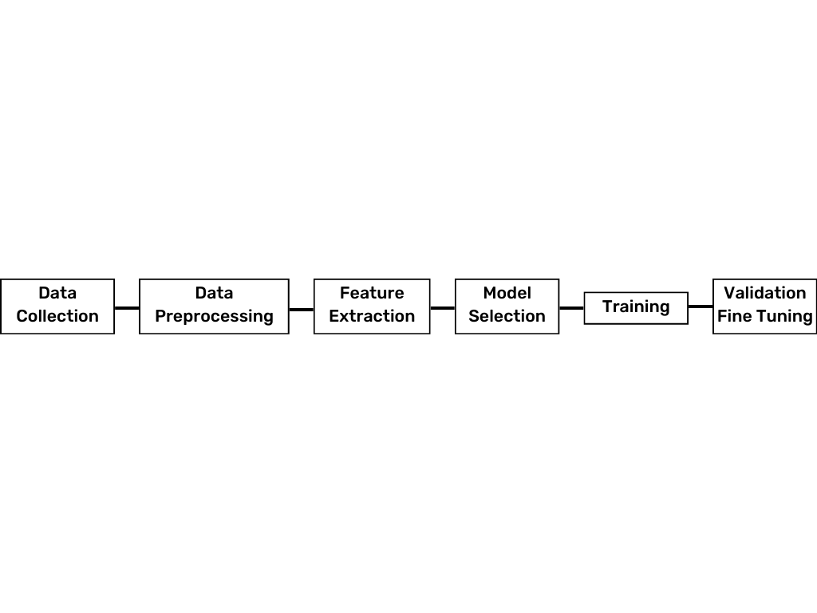

Fig. 2. General procedure flow of Sign language recognition.

Developing a sign language recognition system involves several key steps. Initially, diverse data is collected through methods like video recording or existing databases to ensure comprehensive coverage of signs and gestures. This data then undergoes pre-processing, including noise reduction, background subtraction, and hand segmentation, to enhance its quality. Feature extraction follows, where relevant information such as hand shape, movement trajectory, and facial expressions is extracted using techniques like HOG and deep learning representations. Next, a suitable recognition model is selected and trained, which could be rule-based systems, HMMs, SVMs, or deep learning architectures like CNNs and RNNs. The trained model is evaluated using separate test data, with metrics like accuracy and F1-score used to gauge its performance and generalization ability. Finally, once the model achieves satisfactory results, it's deployed and integrated into applications and systems to aid individuals with nonverbal communication needs.

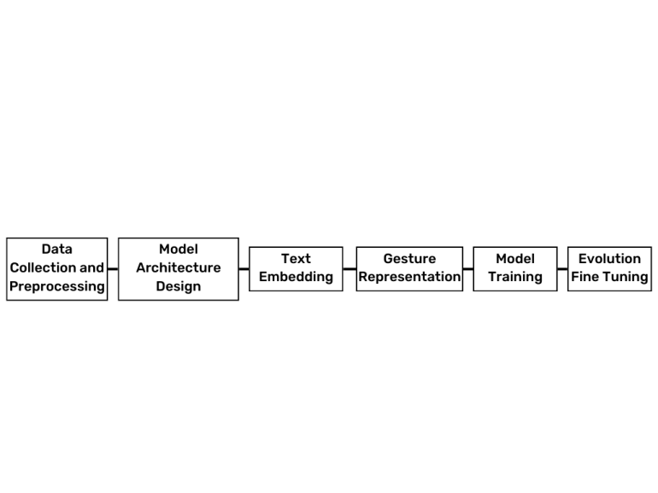

Fig. 3. General procedure flow of Text-to-Sign language gesture generation.

To develop a text-to-gesture generation system, the following steps are crucial: Begin by gathering a datasets comprising textual descriptions paired with corresponding gesture sequences, serving as the foundation for training and evaluation. Next, clean and pre-process the datasets to ensure consistency and quality, including tokenization, normalization, alignment, and handling of missing or noisy data. Then, extract relevant features from both text descriptions and gesture sequences, incorporating textual features such as word embedding and gesture features like joint positions or motion trajectories. Choose an appropriate model architecture for the task, which could involve rule-based systems, machine learning models like neural networks, or a combination of both. Proceed to train the selected model using the pre-processed datasets, optimizing parameters to minimize a chosen objective function measuring the disparity between predicted and ground truth gesture sequences. Validate the trained model on a separate datasets to assess performance and identify potential issues like over fitting. Evaluate model performance using metrics such as accuracy, precision, recall, or F1-score to gauge its effectiveness in generating accurate gesture sequences from text inputs. Fine-tune the model architecture, hyper-parameters, and feature representations based on validation and evaluation results, employing optimization techniques such as adjusting learning rates or regularization methods. Finally, test the optimized model on unseen data to ensure robustness before deploying the text-to-gesture generation system in real-world applications or environments.

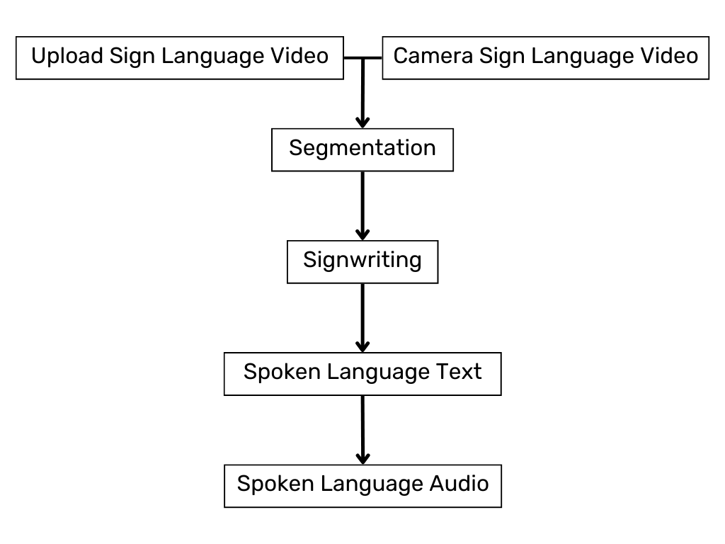

Fig. 4. Proposed application procedure for Sign language recognition.

This procedure for sign language recognition systems involves uploading or capturing sign language video, segmenting it into individual signs, converting them into SignWriting or other standardized forms, translating signs into written text, optionally generating spoken language audio, and ultimately providing access to interpreted content. This facilitates communication accessibility for the deaf or hard of hearing by converting sign language into understandable written or spoken language.

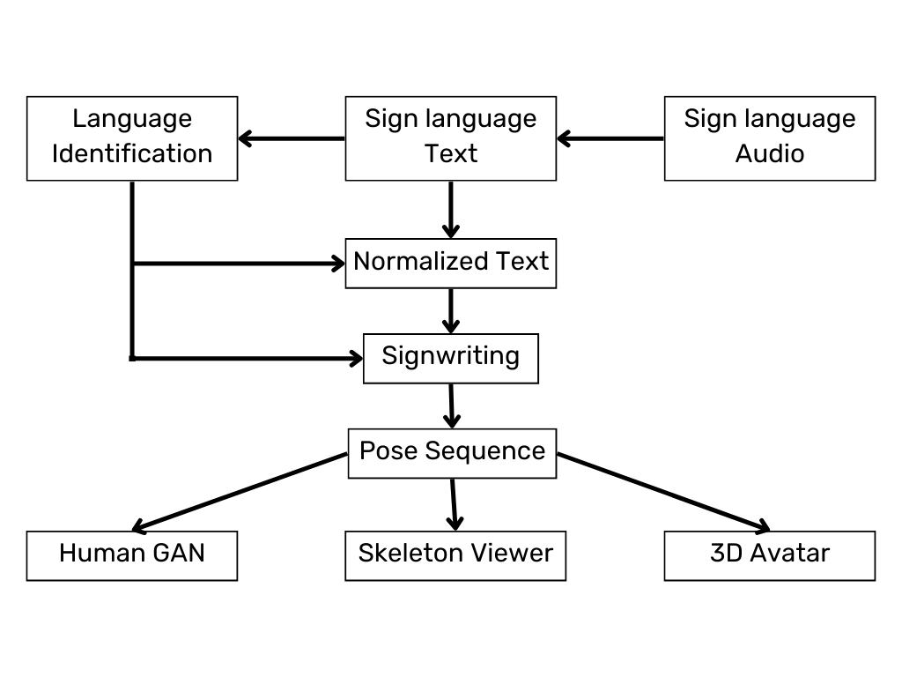

Fig. 5. Proposed application procedure for Text to Sign language generation.

This procedure for sign language recognition involves collecting audio input of spoken languages, converting it into text, identifying the language, normalizing the text, representing it visually with SignWriting, translating it into pose sequences, extracting relevant features, visualizing with a skeleton viewer or generating gestures with a Human GAN, and rendering a 3D avatar performing the sign language gestures. These steps collectively contribute to accurately recognizing and interpreting sign language gestures from spoken language input.

# **Results**

These results highlight the system's effectiveness in enhancing accessibility for individuals with nonverbal communication needs.

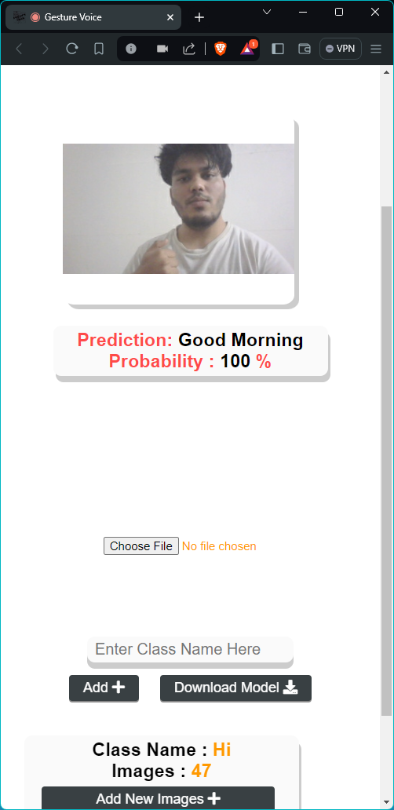

Fig. 6. Sign language recognition - prediction output with Camera preview window, prediction, and prediction probability.

**Note: The displayed probability indicates the limitations of insufficient datasets for achieving accurate recognition add 30 or more images.**

**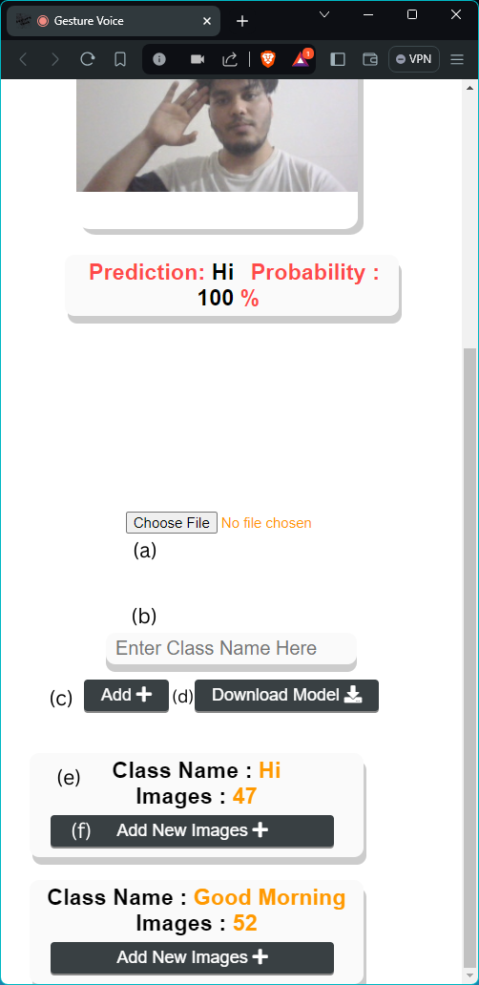**

Fig. 7. Self Updation - Sign language recognition. (a) Pre-trained Model upload option, (b) Sign Gesture name, (c) Add sign gesture for training, (d) download trained model, (e) Class details card, (f) add images (data) for training.

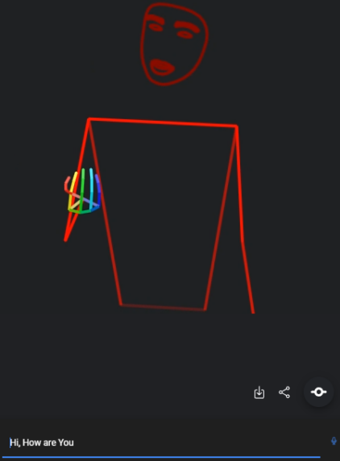

Fig 8. Text-to-sign language production interface featuring download and share options.

The "Gesture Voice" app offers three key functionalities.

* It enables users to produce sign language by selecting their preferred text input language and sign language locality, allowing for automatic generation of sign language based on input text.
* Users can update the app's sign language capabilities by granting camera permissions, adding new gesture names, and uploading images for training. For optimal accuracy, a minimum of 30 images per gesture is recommended, and users can add multiple gesture classes. Additionally, users have the option to utilize pre-trained model files in JSON format or download trained models. The app recognizes sign gestures in real-time as users update, enhancing its usability and effectiveness.
* The app includes a convenient chat feature, eliminating the need for users to switch to another app for sharing or continuing conversations, thereby providing a seamless user experience.

# **Discussion**

The importance of advancing sign language recognition systems to bridge communication gaps for non-verbal individuals. It emphasizes the need for personalized, culturally inclusive systems that accommodate diverse user needs and promote individual expression. The research introduces a real-time sign language interpreter that supports regional sign languages and user-generated gestures, aiming to enhance inclusivity and empowerment. It also addresses social and psychological pressures faced by non-verbal individuals by providing a user-friendly mobile app interface and leveraging technological advancements in deep learning and sensor technology. The proposed system not only improves communication efficiency but also fosters understanding and empathy between non-verbal and verbal individuals. Overall, the research represents a significant advancement in sign language recognition technology, offering a solution that prioritizes personalization, inclusivity, and real-time interaction, potentially revolutionizing communication accessibility for non-verbal individuals.

# **Conclusion**

This paper presents a comprehensive analysis of sign language recognition systems and their impact on empowering non-verbal communication. It underscores the challenges faced by non-verbal individuals in navigating verbal-dominated social environments and highlights the importance of personalized, culturally inclusive solutions. The introduction of a real-time sign language interpreter that supports regional sign languages and user-generated gestures marks a significant advancement in promoting inclusivity and empowerment within the non-verbal community. By emphasizing individual expression and leveraging technological innovations, such as pattern interpretation and present technology, the proposed system addresses social and psychological pressures faced by non-verbal individuals. Additionally, the research fosters understanding and empathy between non-verbal and verbal communities, ultimately contributing to enhanced communication accessibility.

In summary, this study represents a crucial step forward in sign language recognition technology, offering a solution that prioritizes inclusivity, personalization, and real-time interaction, thereby revolutionizing communication possibilities for non-verbal individuals.

# **Acknowledgement**

We would like to express our deepest gratitude to the our dedicated development team.

We also extend our thanks to our Rudraksh and Md. Ashif for their continuous support and guidance.

We are also thankful to all who contributed to this endeavor.

# **References**

[1] World Health Organization. WHO: 1 in 4 people projected to have hearing problems by 2050; 1-Dec-2021. [https://www.who.int/news/item/02-03-2021-who-1-in-4-people-projected-to-have-hearing-problems-by-2050](https://www.who.int/news/item/02-03-2021-who-1-in-4-people-projected-to-have-hearing-problems-by-2050" \t "https://keep.google.com/u/1/" \l "NOTE/_blank)  
[2] Sign Language. [https://education.nationalgeographic.org/resource/sign-language/](https://education.nationalgeographic.org/resource/sign-language/" \t "https://keep.google.com/u/1/" \l "NOTE/_blank)  
[3] Which Countries Recognize Sign Language As An Official Language? [https://www.worldatlas.com/articles/which-countries-recognize-sign-language-as-an-official-language.html#:~:text=In%20addition%2C%20International%20Sign%20Language,language%20as%20an%20official%20language](https://www.worldatlas.com/articles/which-countries-recognize-sign-language-as-an-official-language.html" \l ":~:text=In addition, International Sign Language,language as an official language" \t "https://keep.google.com/u/1/" \l "NOTE/_blank)  
[4] Speech disorder. [https://en.m.wikipedia.org/wiki/Speech\_disorder#:~:text=Developmental%20verbal%20dyspraxia%20also%20known,surgical%20accident%2C%20or%20cerebral%20palsy](https://en.m.wikipedia.org/wiki/Speech_disorder" \l ":~:text=Developmental verbal dyspraxia also known,surgical accident, or cerebral palsy" \t "https://keep.google.com/u/1/" \l "NOTE/_blank)  
[5] Nimratveer Kaur Bahia and Rajneesh Rani. 2023. Multi-level Taxonomy Review for Sign Language Recognition: Emphasis on Indian Sign Language. ACM Trans. Asian Low-Resour. Lang. Inf. Process. 22, 1, Article 23 (January 2023), 39 pages. [https://doi.org/10.1145/3530259](https://doi.org/10.1145/3530259" \t "https://keep.google.com/u/1/" \l "NOTE/_blank)  
[6] Sign Language in the Interface: Access for Deaf Signers [https://www.google.com/url?sa=t&source=web&rct=j&opi=89978449&url=https://huenerfauth.ist.rit.edu/pubs/huenerfauth-hanson-chapter38.pdf&ved=2ahUKEwjc5LrWqaOFAxXlyzgGHUjGDYUQFnoECA8QBg&usg=AOvVaw237PGPR6RDGsfjFJYJWgiL](https://www.google.com/url?sa=t&source=web&rct=j&opi=89978449&url=https://huenerfauth.ist.rit.edu/pubs/huenerfauth-hanson-chapter38.pdf&ved=2ahUKEwjc5LrWqaOFAxXlyzgGHUjGDYUQFnoECA8QBg&usg=AOvVaw237PGPR6RDGsfjFJYJWgiL&authuser=1" \t "https://keep.google.com/u/1/" \l "NOTE/_blank)  
[7] Razieh Rastgoo, Kourosh Kiani, Sergio Escalera, Sign Language Recognition: A Deep Survey, Expert Systems with Applications, Volume 164, 2021, 113794, ISSN 0957-4174, [https://doi.org/10.1016/j.eswa.2020.113794](https://doi.org/10.1016/j.eswa.2020.113794" \t "https://keep.google.com/u/1/" \l "NOTE/_blank).  
[8] Advances, Challenges, and Opportunities in Continuous Sign Language Recognition. [https://fci.stafpu.bu.edu.eg/Computer%20Science/1273/publications/nada%20bahaa%20ibrahim%20ahmed\_1205-1227.pdf](https://fci.stafpu.bu.edu.eg/Computer Science/1273/publications/nada bahaa ibrahim ahmed_1205-1227.pdf" \t "https://keep.google.com/u/1/" \l "NOTE/_blank)  
[9] Non-verbal Communication in Depression, By Heiner Ellgring. page No. - 65-66, 126, 131, 140, 165. [https://books.google.co.in/books?hl=en&lr=&id=1ktcau92m8QC&oi=fnd&pg=PR15&dq=Psychological+Effects+of+Sign+Language+Recognition+Systems+on+Non-Verbal+Communicators&ots=UF6YhX8Sc\_&sig=vlNCFeGSBv0IznvclWNUSVewK\_s&redir\_esc=y#v=onepage&q&f=false](https://books.google.co.in/books?hl=en&lr&id=1ktcau92m8QC&oi=fnd&pg=PR15&dq=Psychological Effects of Sign Language Recognition Systems on Non-Verbal Communicators&ots=UF6YhX8Sc_&sig=vlNCFeGSBv0IznvclWNUSVewK_s&redir_esc=y&authuser=1" \l "v=onepage&q&f=false" \t "https://keep.google.com/u/1/" \l "NOTE/_blank)  
[10] Farooq, U., Rahim, M.S.M., Sabir, N. et al. Advances in machine translation for sign language: approaches, limitations, and challenges. Neural Comput & Applic 33, 14357–14399 (2021). [https://doi.org/10.1007/s00521-021-06079-3](https://doi.org/10.1007/s00521-021-06079-3" \t "https://keep.google.com/u/1/" \l "NOTE/_blank)  
[11] B. Joksimoski et al., "Technological Solutions for Sign Language Recognition: A Scoping Review of Research Trends, Challenges, and Opportunities," in IEEE Access, vol. 10, pp. 40979-40998, 2022, doi: 10.1109/ACCESS.2022.3161440.  
[12] G. G. Nath and C. S. Arun, "Real time sign language interpreter," 2017 IEEE International Conference on Electrical, Instrumentation and Communication Engineering (ICEICE), Karur, India, 2017, pp. 1-5, doi: 10.1109/ICEICE.2017.8191869.  
[13] S. S Kumar, T. Wangyal, V. Saboo and R. Srinath, "Time Series Neural Networks for Real Time Sign Language Translation," 2018 17th IEEE International Conference on Machine Learning and Applications (ICMLA), Orlando, FL, USA, 2018, pp. 243-248, doi: 10.1109/ICMLA.2018.00043.  
[14] "Real Time Indian Sign Language Detection System." International Journal of Advanced Research in Science, Communication and Technology, null (2023).:46-52. doi: 10.48175/ijarsct-9540  
[15] Design Challenges in Effective Algorithm Development of Sign Language Recognition System. [https://www.ijeat.org/portfolio-item/c40300212323/](https://www.ijeat.org/portfolio-item/c40300212323/" \t "https://keep.google.com/u/1/" \l "NOTE/_blank)  
[16] S. Radhakrishnan, N. C. Mohan, M. Varma, J. Varma and S. N. Pai, "Cross Transferring Activity Recognition to Word Level Sign Language Detection," 2022 IEEE/CVF Conference on Computer Vision and Pattern Recognition Workshops (CVPRW), New Orleans, LA, USA, 2022, pp. 2445-2452, doi: 10.1109/CVPRW56347.2022.00273.  
[17] S. Salim, M. M. A. Jamil, R. Ambar, R. Roslan and M. G. Kamardan, "Sign Language Digit Detection with MediaPipe and Machine Learning Algorithm," 2022 IEEE 12th International Conference on Control System, Computing and Engineering (ICCSCE), Penang, Malaysia, 2022, pp. 180-184, doi: 10.1109/ICCSCE54767.2022.9935659.  
[18] A Review on Image and Video processing, Byeong-Ho KANG. [https://citeseerx.ist.psu.edu/document?repid=rep1&type=pdf&doi=ac026b7297ab9409e037bd790fcf6e0318547388](https://citeseerx.ist.psu.edu/document?repid=rep1&type=pdf&doi=ac026b7297ab9409e037bd790fcf6e0318547388" \t "https://keep.google.com/u/1/" \l "NOTE/_blank)  
[19] Morikawa C, Kobayashi M, Satoh M, Kuroda Y, Inomata T, Matsuo H, Miura T, Hilaga M. Image and video processing on mobile devices: a survey. Vis Comput. 2021;37(12):2931-2949. doi: 10.1007/s00371-021-02200-8.  
[20] Gesture Voice. [https://drive.google.com/file/d/1vbEGzKPnbeCmpsjvq233KtgOxwEPdyrg/view?usp=sharing](https://drive.google.com/file/d/1vbEGzKPnbeCmpsjvq233KtgOxwEPdyrg/view?usp=sharing&authuser=1" \t "https://keep.google.com/u/1/" \l "NOTE/_blank)  
[21] Eiichi Asakawa, Naoshi Kaneko, Dai Hasegawa, Shinichi Shirakawa, Evaluation of text-to-gesture generation model using convolutional neural network, Neural Networks, Volume 151, 2022, Pages 365-375, ISSN 0893-6080, [https://doi.org/10.1016/j.neunet.2022.03.041](https://doi.org/10.1016/j.neunet.2022.03.041" \t "https://keep.google.com/u/1/" \l "NOTE/_blank).  
[22] K. Shenoy, T. Dastane, V. Rao and D. Vyavaharkar, "Real-time Indian Sign Language (ISL) Recognition," 2018 9th International Conference on Computing, Communication and Networking Technologies (ICCCNT), Bengaluru, India, 2018, pp. 1-9, doi: 10.1109/ICCCNT.2018.8493808.  
[23] Podder KK, Chowdhury MEH, Tahir AM, Mahbub ZB, Khandakar A, Hossain MS, Kadir MA. Bangla Sign Language (BdSL) Alphabets and Numerals Classification Using a Deep Learning Model. Sensors. 2022; 22(2):574. [https://doi.org/10.3390/s22020574](https://doi.org/10.3390/s22020574" \t "https://keep.google.com/u/1/" \l "NOTE/_blank)  
[24] Almasre MA, Al-Nuaim H. Comparison of Four SVM Classifiers Used with Depth Sensors to Recognize Arabic Sign Language Words. Computers. 2017; 6(2):20. [https://doi.org/10.3390/computers6020020](https://doi.org/10.3390/computers6020020" \t "https://keep.google.com/u/1/" \l "NOTE/_blank)  
[25] "Sign Language Detection." undefined (2022). doi: 10.48550/arxiv.2209.03578  
[26] H.R., Akhilesh, Kumar., Mohit, Kumar, Sharma., Rohit., Kunal, Singh, Bisht., Ashish, Kumar., Rachna, Jain., Preeti, Nagrath., Pritpal, Singh. "Sign language detection and conversion to text using CNN and OpenCV." Nucleation and Atmospheric Aerosols, undefined (2022). doi: 10.1063/5.0108711  
[27] Basanta, Mahato. "The Importance and Challenges of Sign Language Translator- A Review." Spectrum of Emerging Sciences, undefined (2023). doi: 10.55878/ses2023-3-1-8  
[28] Anif, Hanifa, Setianingrum., Arifa, Fauzia., Dzul, Fadli, Rahman. "Hand-Gesture Detection Using Principal Component Analysis (PCA) and Adaptive Neuro-Fuzzy Inference System (ANFIS)." Jurnal Teknik Informatika, undefined (2022). doi: 10.15408/jti.v15i1.24869  
[29] "Real Time Indian Sign Language Detection System." International Journal of Advanced Research in Science, Communication and Technology, undefined (2023). doi: 10.48175/ijarsct-9540  
[30] Vaidik, Gupta., Rohan, Punjani., Mayur, Vaswani., Jyoti, Kundale. "Video Conferencing with Sign language Detection." undefined (2022). doi: 10.1109/ASIANCON55314.2022.9908973  
[31] Kenneth, Mejía-Peréz., Diana-Margarita, Córdova-Esparza., Juan, R., Terven., Ana, M., Herrera-Navarro., Teresa, García, Ramírez., Alfonso, Ramírez-Pedraza. "Automatic Recognition of Mexican Sign Language Using a Depth Camera and Recurrent Neural Networks." Applied Sciences, undefined (2022). doi: 10.3390/app12115523  
[32] Hezhen, Hu., Wengang, Zhou., Junfu, Pu., Houqiang, Li. "Global-Local Enhancement Network for NMF-Aware Sign Language Recognition." undefined (2021). doi: 10.1145/3436754  
[33] Yugam, Bajaj., Puru, Malhotra. "American Sign Language Identification Using Hand Trackpoint Analysis." arXiv: Computer Vision and Pattern Recognition, undefined (2022). doi: 10.1007/978-981-16-2594-7\_13  
[34] S., B., Abdullahi., Kosin, Chamnongthai. "American Sign Language Words Recognition of Skeletal Videos Using Processed Video Driven Multi-Stacked Deep LSTM." Sensors, undefined (2022). doi: 10.3390/s22041406  
[35] "Jointly Harnessing Prior Structures and Temporal Consistency for Sign Language Video Generation." undefined (2022). doi: 10.48550/arxiv.2207.03714  
[36] Yu, Liu., Parma, Nand., Md, Akbar, Hossain., Minh, Nguyen., Wei-Mon, Yan. "Sign language recognition from digital videos using feature pyramid network with detection transformer." Multimedia Tools and Applications, undefined (2023). doi: 10.1007/s11042-023-14646-0  
[37] Rung-Ching, Chen., William, Eric, Manongga., Christine, Dewi. "Recursive Feature Elimination for Improving Learning Points on Hand-Sign Recognition." Future Internet, undefined (2022). doi: 10.3390/fi14120352  
[38] Ozge, Mercanoglu, Sincan., Julio, C., S., Jacques., Sergio, Escalera., Hacer, Yalim, Keles. "ChaLearn LAP Large Scale Signer Independent Isolated Sign Language Recognition Challenge: Design, Results and Future Research." undefined (2021). doi: 10.1109/CVPRW53098.2021.00386  
[39] Stoll, S., Camgoz, N.C., Hadfield, S. et al. Text2Sign: Towards Sign Language Production Using Neural Machine Translation and Generative Adversarial Networks. Int J Comput Vis 128, 891–908 (2020). [https://doi.org/10.1007/s11263-019-01281-2](https://doi.org/10.1007/s11263-019-01281-2" \t "https://keep.google.com/u/1/" \l "NOTE/_blank)