**GLOBAL POSITIONING SYSTEM AND ASSOCIATED TECHNOLOGIES IN BIODIVERSITY CONSERVATION**

**Chanchal Shrivastav*1 Jyoti1, Manoj Joshi2 and Gaurav Bhadauriya2**

PG Department of Zoology1, Department of Botany2

***Khandelwal College****of Management Science and Technology - [KCMT],****Bareilly***

*(Affiliated to the M.J.P.R. University Bareilly, Uttar Pradesh-India 243122)*

*Email: chanchalbest123@gmail.com*

|  |
| --- |
| ***Abstract:***  The Global Positioning System (GPS) functions as a satellite-based radio navigation system, delivering dependable positioning, navigation, and timing services across the globe continuously. GPS satellites orbit the Earth with remarkable precision, transmitting signal data to ground receivers. It stands as the sole system capable of indicating one's precise location on Earth at any time and under any weather conditions. Differential GPS, utilized to enhance measurement accuracy, finds applications in diverse fields such as species monitoring and tracking, habitat mapping, combating illegal wildlife trade, climate change research, conservation planning, community engagement, and education, as well as understanding connectivity patterns. Conservation organizations and local authorities utilize GPS technology to manage land effectively by capturing positional data in point form. The integration of GPS with the latest 5G technology heralds a new era in life conservation and biodiversity preservation, aiming to thwart wildlife trafficking. India emerges as a progressive force in various domains, including the Western Ghats, Himalayan regions, deserts, and bolstering border security. Indian wildlife system can be preserved as heritage and given as a gift to the coming new generations.  ***Key Word****:* **Radio navigation system, Satellite, Accuracy, Conservation organization**. |

1. **Introduction**

Geospatial technology has long aimed to map wildlife and monitor their habitats. Traditional inventory methods have been inadequate, leaving gaps in databases. However, the introduction of remote sensing satellites has revolutionized this process. By leveraging satellite data collected remotely through sensors and cameras with varying spatial, spectral, and temporal resolutions, this technology offers a swift and efficient means of wildlife inventorying and habitat observation.

Remotely sensed data offers several advantages, including synoptic, regular, near real-time, and highly accurate information. Wildlife managers can utilize this data to assess species-habitat relationships and environmental impacts effectively (Keller et al., 2014). Moreover, recent advancements in satellite imaging have yielded higher resolutions, and such data are now accessible for free through platforms like USGS, NOAA, and Copernicus. Additionally, the availability of big data in the cloud has facilitated easier computations. For instance, the Global Forest Watch, based on the Google Earth Engine platform and utilizing Landsat data spanning four decades, aids analyses through indirect methods such as forest fragmentation indicators (Riiters et al., 2014).

The past few decades have seen a lot of interest in global positioning systems because of their widespread appeal in both industry and academics. It is a positioning system run by the US Department of Defense that is dependent on satellites. Using a network of satellites, GPS enables the gathering of data regarding the geographic position of any site. It offers enormous promise for biodiversity management and conservation, as well as for many other biological research fields that depend on the precise positions of items. It functions as a potent tool for describing the geographical features of ecological systems when integrated with GIS. Locating the sample plots was a useful application of GPS, and the data collected was utilized for mapping and spatial-statistical analysis. (Behera et al. 2000).

Significant changes have been brought about by increased human interference and overuse of resources, which also provide worrying indications of an accelerated loss of biodiversity. There are significant drawbacks to the traditional species-level approach to biodiversity management, as well as a significant shift in the emphasis on biological conservation and management. As a result, the focus of policy has shifted from single-species conservation to habitat conservation. The spatial separation of biodiversity-rich and poor places has resulted in a noticeable shift in the understanding of the priorities for biodiversity conservation and management in recent times. The preservation of biodiversity is intimately linked to other global environmental shifts and challenges associated with globalization, including changes in land use and cover, climate change, and sustainable development (Gude et al. 2007; Liu et al. 2011). Because of the unprecedented rate at which people have altered ecosystems during the past century, biodiversity—the diversity of genes, animals, and ecosystems—has sharply decreased (Balmford et al. 2003). The loss of knowledge of biodiversity, particularly among those who have a strong interaction with the natural world, exacerbates this loss. India is renowned for having a high species and genetic diversity over a broad range of ecological zones.

Additionally, many other developments in technologies such as bioacoustics and tags, camera traps, sound recorders, fire alarms, etc. are enabling these C2 sensors to be used as non-destructive and partially automated ground and survey options (Lausch et al., 2016; Hansen et al., 2013). By integrating animal location data with remote sensing data and conducting analysis within Geographic Information System (GIS) frameworks, researchers gain insights into wildlife habitats, ranges, and their interactions with the environment. Consequently, conservation policies can leverage these technological solutions for more effective implementation.

1. **Material And Methods**

According to this 5G speed of development, we have a mobile android app, a server and broadband, many special and their data-analysis for their study and in the presence of parameters, the location of the person present there (person, animal, plants, fire-truck, land map) can be tracked. For this purpose, we are using a GPS tracker and Google search engine or Google GPS map, which can study many types of animals, biodiversity, animal resources, and their population.

How can we promote its use for discovering new sources with the help of mobile data networks? We can use all the tools included with the help of software and mobile Google GPS map, such as promoting travel surveys, providing food tracking to households, typing of animals, preventing smuggling of unnecessary animals or important substances, informing/dealing with the help of alarms installed in the forest. With the help of this mobile network data, we can effectively provide accurate information in the form of signals to the number of GPS or sensing towers and publish this data through a recorder or the tower frequency through the sensor. We all know that Call Detail Records (CDR) is today's video live conferencing through which we can send messages or do live recording from within the country and abroad. With GPS, we can collect accurate information about the location of a resource like a phone up to about 50 to 500 meters. Sometime in 2015 (Central Communication Commissioner 2015), other words were given based on these words. It can be recorded on cell phones. Similarly, we can collect tools and many software used in biodiversity conservation in the form of latitude and longitude with the help of the internet through time steps. We can also calculate the correct information by sharing it.

Mobile network data is a relatively new source of data. Previous efforts to enhance travel surveys have included the use of mobile network data, most often through Call Detail Records (CDR). The mobile network consists of a series of towers, and the spacing, number of towers, and signal strength directly impact data accuracy. These data are recorded when a cellphone transmits radiofrequency waves with cellular towers, typically when the phone is active, such as during calls or messages. Similar to GPS, the location of the cellphone is determined based on its distance from nearby towers, allowing for location accuracy within 50–300 meters (Federal Communication Commission, 2015). In other words, this data is recorded from cell phones regardless of the service provider. Data is generated whenever a cellular device connects to the network, which can occur in several ways, including making or receiving calls, sending or receiving messages, and connecting to the internet. This data source generally collects the device’s estimated location (latitude and longitude) and a timestamp for the connection.

**III Result**

**Learning outcomes from GPS data measuring**

**➢** Wildlife, Habitat formation, Natural suitability analysis using GIS/ GPS and remote sensing

➢ GPS as a mobile app/ tracking app, and some online interactive web applications like Map of Life, Forecast, Global Forest Watch, and Half-Life.

➢ Before going further, I would like to inform you what is the medium through which we humans can track other animals using satellite remote sensing and GIS.

**GPS sensing satellites**

Remote sensing satellites equipped with remote sensing equipment are designed to observe and collect data about many features of the Earth. These satellites are known as terrain observation satellites. These satellites vary in altitude, orbit characteristics, and the types of sensors they carry. The data they collect comes in various resolutions: spectral, radiometric, spatial, and temporal.

* **Spectral resolution** refers to the ability of the sensor to distinguish between different wavelengths of electromagnetic radiation (e.g., visible light, infrared) within the electromagnetic spectrum.
* **Radiometric resolution** relates to the sensitivity of the sensor in detecting and measuring variations in electromagnetic radiation intensity. This measurement proves that there can be that many gray levels between pure white and pure black. The mapping data can be measured in bytes and also inward no. of 7-bit, 8-bit, 9-bit, and 10-bit, etc. For example, IRS-1A (1988) / 1B (1991) measure 7-bit resolutions, Cartosat-2 (2007) has 10-bit radio biometry resolutions, and 16-bit resolutions are obtained from IRS P-3 (1996) MOS-AMO, MOS-B MOS-C which is useful for a mapping data.
* **Spatial resolution instantaneous** field of view (IFOV) defines the level of detail or clarity in the images captured by the satellite, determined by the size of the smallest feature that can be detected.
* **Temporal resolution** indicates how frequently the satellite revisits and captures data for the same area over time. **Example s:** The temporal resolution of Landsat 4/5 is sixteen days. GPS sensing science and application can be summarized in the terrain biodiversity, and ecosystem sections:

1. **Source of Electromagnetic Energy:** This can be the sun (natural source) or a transmitter carried by the sensor (artificial source), emitting electromagnetic radiation towards the Earth's surface.
2. **Transmission and Interaction with the Atmosphere:** The energy emitted reaches the Earth's surface, but it interacts with the atmosphere along the way. This interaction can include scattering and absorption, affecting the quality and quantity of energy that reaches the surface.
3. **Interaction with the Earth's Surface:** The energy interacts with objects and materials on the Earth's surface. Different surfaces reflect, absorb, or emit varying amounts and wavelengths of electromagnetic radiation depending on their properties.
4. **Transmission to the Sensor**: Reflected or emitted energy from the Earth's surface travels back through the atmosphere to the remote sensor, which is typically placed on a satellite or aircraft.
5. **Detection by the Sensor:** The sensor detects the incoming energy and converts it into electrical signals. These signals can then be processed to create photographic images or other types of data outputs.
6. **Transmission/Recording of Sensor Output:** The sensor output (electrical signals or images) is transmitted back to Earth or recorded on board the platform (satellite or aircraft).
7. **Preprocessing of Data:** Raw sensor data undergoes preprocessing steps to correct for atmospheric effects, sensor calibration, geometric corrections, and other enhancements to generate usable data products.
8. **Collection of Ground Truth and Collateral Information:** Ground truth data, such as field measurements or samples, are collected to validate and calibrate remote sensing data. Collateral information, such as maps or existing databases, may also be integrated.
9. **Data Processing and Interpretation:** Remote sensing data are processed further to extract meaningful information. This includes image analysis, classification, and interpretation to identify features, monitor changes, or derive specific information about the Earth's surface or atmosphere

**Geographic Information System**

Many systems of computer software and hardware have shown many points of geographical features and their GIS package dynamically. As we all must have seen, in this age of technology, the main factor is to collect location data and work as their management, evaluation and along with this, many landlines software connected by them can be shown in the form of a map by connecting them through some medium. Through many types of Google engines, we can easily find many answers and their solutions, which can be done from any mobile. Along with this, we can prove the utility of many such platforms which identify the GPS facility given through satellite in the form of a database.

People have adopted 5G technology as a means of tracking through Google Maps which is helpful for many animals in the future, for example, we can use it for domestic animals and for farmers to do farming as well as to keep an eye on their general life and resources, which will be beneficial for biodiversity and animals.

**Google Earth Engine**

The problems of big data management can be solved by Google Earth Engine which provides many resources like the distance of a long path can be measured easily in a short time and we can use the capabilities of storing and modifying the large database in a short time. There are many applications in computer systems which are Application Programming Interface (API) and Interactive Development Environment (IDE) (Tamimi Nia, 2020). The time series analysis (Time-lapse of GEE) and Climate Engine App helps in monitoring temporal changes. Many software like the new 2020 help in monitoring the quality and changes of time series and GPS time lapse.

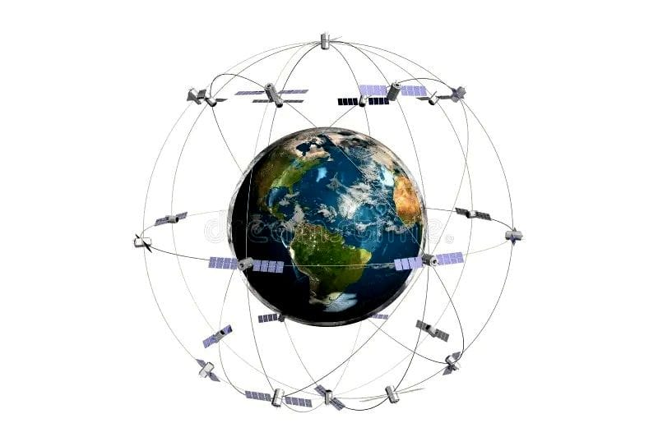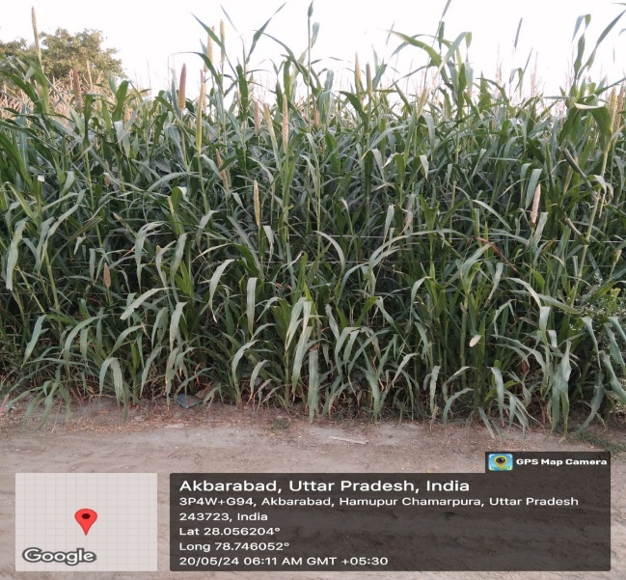

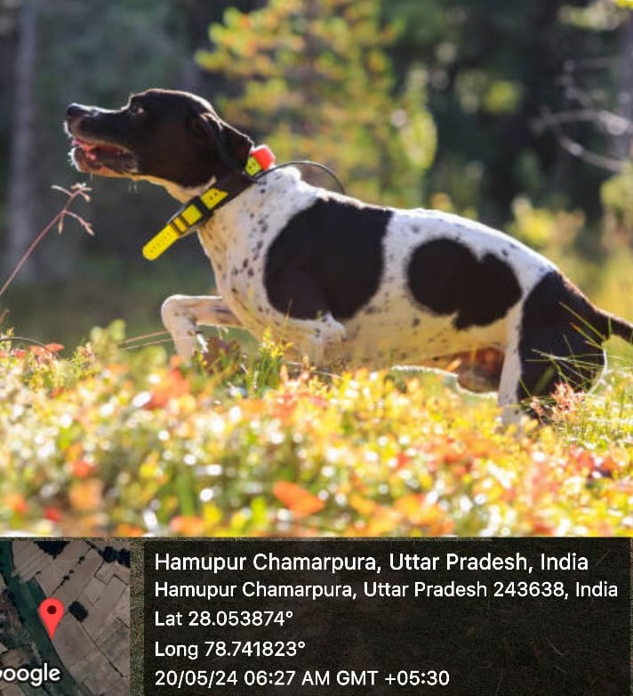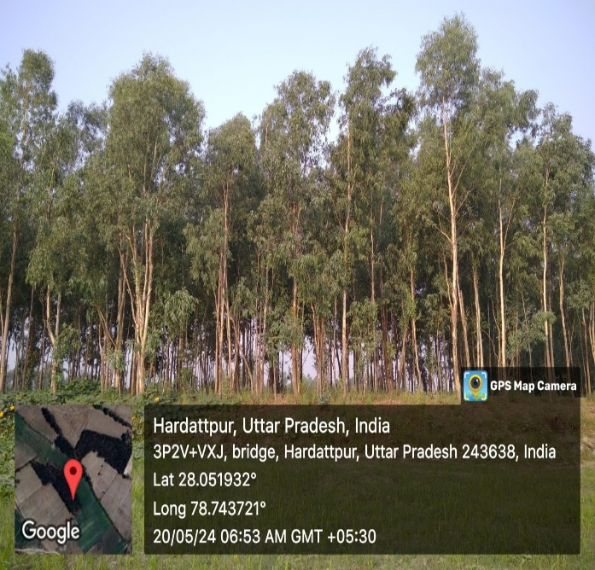

**Fig: 1 GPS Biodiversity Wildlife Habitat Suitability**

GPS has different types of trackers, one of which helps in knowing the exact location and even the distance covered. If by any chance a person is not able to know where he is standing or no one is present there to help him. In such cases, GPS surely helps them. As shown in the presentation of distance location tracked from 10 different locations by mobile GPS, KCMT College, Bareilly and Keshlata Hospital, Budaun to Kachari Road, Sahaswan to Jhagirabad Chauraha, Akbarabad to Hamupur Chamarpura etc. Bareilly location has been included.

|  |  |  |  |  |
| --- | --- | --- | --- | --- |
| **S. No.** | **Location** | **From** | **To** | **Distance** |
| 01 | Bareilly | KCMT College | Keshlata Hospital | 10 km |
| 02 | Bareilly | Akbari Bhawan | Old Age Home | 4.6 km |
| 03 | Ujhani | Rathore Dharmkanta | Indian Oil Petrol pump | 3 km |
| 04 | Ujhani | Ujhani | Kachhla Ghat | 15 km |
| 05 | Sahaswan | Gopal Mandir | Narora | 50 km |
| 06 | Budaun | Kachari Road | Sarasota Dham, Sahaswan | 49 km |
| 07 | Sahaswan | Nayaganj Chauraha | Post Office, Bilsi | 23 km |
| 08 | Sahaswan | Jhagirabad Chauraha | Sukrra Ghat | 10 km |
| 09 | Sahaswan | Akbarabad | Hamupur Chamarpura | 30 km |
| 10 | Sahaswan | Hamupur Chamarpura | Hardattpur | 5 km |

**Table:1 Tracked Locations**

**Wildlife Habitat Suitability:**

Traditional methods and Earth are used for land-based studies Modern technology has historically been used to study wildlife habitat and corridor uses (Bhat and Rawat, 1995; John Singh and Joshua, 1994; Mishra and John Singh, 1996). However, these approaches are often time-consuming and inefficient, especially in rugged and inaccessible terrain. Over the past few decades, the application of geospatial technology in wildlife studies has gained prominence in India. Researchers have underscored its role in evaluating habitats, identifying wildlife corridors, and enhancing their management (Khanna et al., 2001; Kushwaha and Hazarika, 2004; Nandy et al., 2007). From a conservation perspective, understanding wildlife habitats enables proactive protection and conservation efforts to prevent degradation and destruction. Geographic Information System (GIS) platforms play a crucial role in habitat modelling by integrating various parameters such as water bodies, land use/ earth cover, forests (biodiversity), transportation networks (Air tacks roads and railways), streams, drainage patterns, slopes and conservation of rarer species. Researchers and analysts define criteria based on literature and field knowledge, and these thematic layers are combined using advanced techniques like weighted overlay in GIS to generate suitability maps. Species distribution models are constructed using diverse datasets, incorporating raster-based layers such as land use/land cover and other environmental variables. These models predict potential habitat suitability for specific species, integrating ground-based information and statistical computations (Goparaju et al., 2017; Ahmad et al., 2018). This holistic approach combines spatial analysis with ecological insights to inform conservation strategies effectively.

**Map of Life:**

The life of any animal is divided based on their map species which can be collected for their description and globally. We all know some international conservation organizations which are useful for protecting nature like IUCN, Worldwide Found Nature (WWF), and Global World Biodiversity and Information Facility (GBEF). In addition to these data, some special species are provided by the organizations, by which colored mapping or species occurrences and their points, protected areas in the eco-region are also added.

All these are hosted on a platform with cloud along with storage management backup and reconstruction. A primary objective of this Map of Life is to provide useful and useful information in any geographical area around the world by providing information about the presence and species of their exact range location. With time, location weather, and time, their mobility and their comprehensive knowledge and intelligence can also be collected by GPS location of mobile data. It is being used in world and biodiversity education research as well as many monitoring. In the coming time, it will also be helpful for policy and maker's determination to keep the borders of many countries safe. Apart from the web browser-based platform, Map of Life can also be used as a mobile app to search and identify biodiversity and record its GPS location. Data can be collected on organisms and biological resources around the world and many efforts can be facilitated by exploring species habitat and biodiversity trends.

The Map of Life integrates various global sources of data describing species distribution, provided by organizations such as the International Union for Conservation of Nature (IUCN), the World-Wide Fund for Nature (WWF), and the Global Biodiversity Information Facility (GBIF). These data include expert species range maps, species occurrence points, ecoregions, and protected areas, all hosted on a cloud platform for storage, management, backup, and access. A primary objective of the Map of Life is to compile the most accurate species range information and species lists available for any geographic area worldwide. By accumulating comprehensive knowledge on species distributions and their dynamics over time, it supports global biodiversity education, research, and monitoring, and aids decision-making processes for policymakers. In addition to its web-based platform, the Map of Life offers a mobile app for discovering, identifying, and recording biodiversity. GBIF complements these efforts by providing free and open access to data on all forms of life across the globe, facilitating exploration of species habitats and biodiversity trends.

**Forest health assessment is made easier by web-based systems such as GPS-based advanced information of Bioresources and Management System (FIRECAST) and (FIRMS).** These platforms can provide accurate information on many active events such as locating FIREs, assessing the loss of a wide range of biodiversity, as well as tracking encroachments on forest areas to preserve their biological elements, monitoring bio-trafficking, and using data from several satellites to monitor and assess forest conditions. They can be leveraged by technology such as web-based maps, email, or FIRE Alert alarms or software and provide timely information via downloadable data formats such as (TXT, KML & SHP) apps. This system can be used through many mediums which will work as a constructive and effective way to monitor and protect the health of the buildings. There are many effective management tools available like web-based platforms, satellites, overpasses, etc. This software can be used to transmit real-time and active current events within 2 to 3 hours of the satellite or overpass through web web-based platform.

**GLOBAL FOREST WATCH:**

Through Global Forest Watch (G.F.W), we have ensured that several such satellites will be launched from 2017 to 2023 to make comprehensive forest conservation and wildlife data freely available. The objective of this is to promote transparency, to make scientific information easily available while increasing the usefulness of deforestation and smuggling of animal parts, diseases caused by them, resource utilization, etc. In this, the facility of alert alarm to the consumer through email or to hold the government and companies accountable for illegal activities and to keep the efforts taken in their community and their activities safe, many mapping or custom maps can be made by which by studying the analysis of the change in the location of the vehicle and forest work, the data can be used for many research and their favorable facilities through GPS, apart from this, we can use it like a tool kit through many apps and website web browser in specific areas.

The Half-Earth Project, a collaboration between E.O. Wilson's Biodiversity Foundation and ERI, aims to conserve half of Earth's lands and seas to protect over 85% of the planet's biodiversity. This initiative addresses the current species extinction crisis, emphasizing that of the estimated 10 million species on Earth, only 2 million are documented. The project introduces National Report Cards to assess countries' conservation efforts, aiming to restore global green cover and safeguard numerous species.

Animal trafficking is a pervasive global issue that affects a wide range of species. Among the commonly trafficked animals are:

**Mammals**: Big Cats: Many big species of Big Cats are found in India, including tigers, leopards, lions, Domesticated Cats, etc. Mammals like penguins can be smuggled for their organs and meat as well as other vital organs.

**Reptiles:** These include three groups, lizard, snake, and tortoise. Smuggling of these animals is proving to be a big business in many countries like China, and Korea as food. To stop this, we can use GPS technology.

**Fishes:** We all know that about 35 to 40% of India's freshwater fish species are found as food, which is in great demand in foreign countries outside India. Along with this, to promote some ornamental and aquarium businesses, smuggling of these animals and fishes can be ensured by tracking alarms.

**Aves:** Birds are being smuggled in large quantities as exotic birds and as common birds, predatory birds, and pet birds' feathers and parts. For example, the feathers of the peacock found in India are used in religious fields as part of Sanskrit festivals. There are many such smuggling cases.

**Insects and Invertebrates:** We all know about insect smuggling. Recently, many international systems have permitted about 16 insect species to be consumed as food. Many such rare insects like butterflies, ephedra, butterflies, and other insects prove useful in medicine, and small-scale industries.

Similarly, to deal with animal smuggling and to deal with and prevent them by keeping in view their multi-dimensional aspects, can prove to be very beneficial.

**Efforts to Combat Animal Trafficking:** Combating animal trafficking requires a multi-faceted approach:

1. **International Cooperation**: Cross-border collaboration among countries to enforce wildlife protection laws and treaties like CITES (Convention on International Trade in Endangered Species of Wild Fauna and Flora).
2. **Law Enforcement Actions**: Strengthening law enforcement capabilities to detect, intercept, and prosecute wildlife traffickers.
3. **Conservation Initiatives**: Protecting habitats and implementing breeding programs to support at-risk species populations.
4. **Public Awareness Campaigns**: Under this, both the public and education affected by animal trafficking can be brought to a common platform and the demand for its products can be kept to a minimum and limited to as many species as possible.
5. **Technology Utilization: Technology Utilization can be as simple as leveraging GPS tracking data analytics in the field of 5G technology to monitor wildlife movements and uncover multiple patterns that can be useful in tracking and capturing wildlife trafficking and smuggling activities.**

Despite many such efforts, we are unable to stop the trade and their smuggling, hence we can use such GPS technology by accessing any data of life and software and use its information in educational, scientific, and technological form. The entire demand for this smuggling can be stopped which is beneficial for future life and biodiversity.

**IV Discussion**

We all know that modern technology, including the 5G generation and AI-based era, provides an opportunity to protect diversity and its conservation as well as the benefits of its activities and life. Many factors can be used to affect the increasing population of organisms and the transmission of data and this can be done only in the form of management, in which the GPS tracker of mobile devices, Google Maps, and many other up-tracking technologies can be made simple and safe, many of these include us:-

* **Habitat Loss: Through GPS tracker technical resources, remote sensing, and AI-based mobile, information about the movement of biodiversity organisms and changes in their habitat, information about their expansion in forests, and timely intervention and land use projects can be obtained.**
* **diseases and their outbreaks: If we want to get information about medical and animal diseases in the field of GPS data collection and communication, then it is not possible now that we have started living in this era because many such technical resources are not possible to track through GPS, so we can promote this method through GPS sensing.**
* **Bio trafficking by humans: Biodiversity tracking technologies can help monitor and combat illegal wildlife trade by providing accurate location, data, and movement patterns of trafficked species, thereby assisting enforcement agencies in preventing the activities.**

By integrating these technologies, we can create a comprehensive approach to biodiversity conservation, effectively managing and conserving biological resources and cultural heritage. This paves the way for a new dimension in conservation efforts, enhancing our ability to protect the natural world in the face of increasing environmental challenges.

**V Conclusion**

Global Positioning System (GPS) In this method, we have concluded by using tracking related apps through Google Maps of mobiles. By using the diagram of the Bareilly area, we have concluded that it can be used in many broad forms to keep an individual or any organism safe. In which accurate information on management and security can be available. Along with this, by providing reliable equipment, we can bring revolution in biodiversity conservation. Along with this, by adding and keeping in mind its research and scientific activities, by keeping the data of mapping of wildlife and assessment of their habitat, their changing location and maintenance of population safe, we can think about new things for the coming generation and multi-dimensional use. GPS North is an accurate information pattern based on many satellites which can be based on the technology of auto alarm system along with information through this app and other apps. In fact, at this time, resources for surveillance and border security will also have to be included. In the system of geographical inventory, we will also have to collect remote sensing, Geographic Information Systems (GIS), and GPS. Conservationist place is the day-to-day maintenance of biological and geographical conditions. Can also keep details which has proved useful in many areas. I would like to inform you that from 2022 to June 2024, due to many disasters in the biological resource areas in the mountainous regions like Haldwani, Pithoragarh, and Nainital hills, due to the increase in temperature, about 3500 species of biodiversity can be destroyed due to forest fires, their correct information could be updated through location update by mobile apps through GPS or fire alarm system.

Top of Form

**References**

1. Ahmad, F., Goparaju, L., and Qayum, A., (2018) Wildlife habitat suitability and conservation hotspot mapping: Remote sensing and GIS-based decision support system. AIMS Geosciences. 4(1), pp 66 -87.
2. Bhat S.D., Rawat G.S. (1995) Habitat use by Chetal (Axis axis) in Dharadunuttrakhand, Rajaji National Park, India. Tropical Ecology, 36(2), pp177-189.
3. C shrivastav, S.cshrivastav*.* "Different Aphids species on various growth stages of wheat crop and their losses": Feb 2020 volume -7 ISSN: 2348-4039, at www.ijermt.org
4. Chanchal Shrivastav *et al; “*Diversity study of Aphids fauna occurred in major kharif and rabi crop ecosystem in Bareilly Region”: Volume-6, Issue-5 May- 2019. jars.
5. Goparaju, L., Ahmad, F. & Sinha, D. (2017) Wildlife Habitat Suitability Analysis Around Madihan Forest, Mirzapur District, Uttar Pradesh, India: A Geospatial Approach. Eurasian Journal of Forest Science. 5(1), pp13-28
6. Hansen, M. C., P. V. Potapov, R. Moore, M. Hancher, S. A. Turubanova, A. Tyukavina, D. Thau, S. V. Stehman, S. J. Goetz, T. R. Loveland, A. Kommareddy, A. Egorov, L. Chini, C. O. Justice, and Townshend,
7. J. R. G.. (2013) “High-Resolution Global Maps of 21st-Century Forest Cover Change.” cience 342 (15 November): 850–53. Data are available on-line from: <http://earthenginepartners.appspot.com/science-2013-global-forest>.
8. Jetz, W., McPherson, J. M., and Guralnick, R. P. (2012) Integrating biodiversity distribution knowledge: toward a global map of life. Trends in Ecology and Evolution 27:151-159. DOI:10.1016/j.tree.2011.09.007.
9. Johnsingh, A.J.T., Joshua, J. (1994) Conserving Rajaji and Corbett National Parks: the Elephant as a flagship species. Orya 28, pp135-140.
10. *Joshi M, Bhadauriya G and Shrivastav.C “Importance of Adhotodavasicanees in traditional system of medicine” a review.int j Pharma science & Res 2024; 15(8): 1000-07.doi:10.13040/IJPSR. 0975-8232.15(8).1000-07.*
11. Keller, Jeffrey K., Smith, Charles R (eds). (2014) Improving GIS-based wildlife-habitat analysis. New York, Springer.
12. Khanna, V., Ravichandran, M.S., Kushwaha, S.P.S. (2001) Corridor analysis in Rajaji – Corbett Elephant reserve.A remote sensing and GIS approach. Journal of the Indian Society of Remote Sensing 29, pp 41-46. Kushwaha, S.P.S., Hazarika, R. (2004) Assessment of habitat loss in Kameng and Sonitpur elephant reserves. Current Science 87, pp1447-1453.
13. Lausch, A.; Bannehr, L.; Beckmann, M.; Boehm, C.; Feilhauer, H.; Hacker, J.M.; Heurich, M.; Jung, A.; Klenke, R.; Neumann, C.; et al. Linking earth observation and taxonomic, structural and functional biodiversity: Local to ecosystem perspectives. Ecol. Indic. (2016) 70, pp 317–339.
14. Mishra, C., Johnsingh, A.J.T. (1996) On habitat selection by the Goral (Naemorhaedus goral) bedfordi (BovidaeArtiodactyla). Journal of Zoology 240, pp 573-80.
15. Riitters, K.; Wickham, J.; Costanza, J.K.; Vogt, P. A global evaluation of forest interior area dynamics using tree cover data from 2000 to 2012. (2016) Landsc. Ecol., 31, pp 137–148.
16. Riitters,K.; Wickham, J.; O’Neill, R.; Jones, .B.; mith, E. (2000) Global-scale patterns of forest fragmentation. Conserv. Ecol., 4, 3.
17. Tamiminia,H., Salehi,B., Mahdianpari,M., Quackenbush,L., Adeli,S., and Brisco,B., (2020) Google Earth Engine for geo-big data applications: A meta-analysis and systematic review,” I PR J. Photogrammetry Remote ens., vol. 164, pp. 152–170