Fake Currency Detection using Machine Learning

Chethana GH

*4th Year, Dept of ECE, BGS Institute of Technology*

*Mandya, India*

[chethanahanumanthegowda@gmail.com](mailto:chethanahanumanthegowda@gmail.combgsit.ac.in)

Dhruva DK

*4th Year, Dept of ECE BGS Institute of Technology*

*Mandya, India*

[*dhruvadk2002@gmail.com*](mailto:dhruvadk2002@gmail.com)

Gagana KN

*4th Year, Dept of ECE BGS Institute of Technology*

*Mandya, India*

[gaganakn2002@gmail.com](mailto:gaganakn2002@gmail.com)

Rohith MS

*4th Year, Dept of ECE BGS Institute of Technology*

*Mandya, India*

[msrohith7411@gmail.com](mailto:gaganakn2002@gmail.com)

Dr. P S Puttaswamy

*HOD, Dept of ECE BGS Institute of Technology*

*Mandya, India*

[hodece@bgsit.ac.in](mailto:hodece@bgsit.ac.in)

***Abstract*—The proliferation of counterfeit currency poses a significant threat to the global economy, necessitating the development of efficient and accurate detection methods. This paper presents a novel approach to fake currency detection using machine learning techniques. The proposed system leverages a combination of computer vision and machine learning algorithms to identify counterfeit banknotes with high accuracy.** **The system employs a convolutional neural network (CNN) to extract features from images of banknotes, which are then classified as genuine or fake using a support vector machine (SVM) classifier. The CNN is trained on a large dataset of images of genuine and fake banknotes, while the SVM is fine-tuned to optimize its performance. The Experimental results demonstrate that our proposed system achieves an accuracy of 98.5% in detecting fake currency, outperforming traditional methods based on manual inspection and rule-based systems. The system's performance has been evaluated using a comprehensive set of metrics, including precision, recall, F1-score, and receiver operating characteristic (ROC) curve analysis. The proposed system offers several advantages, including high accuracy, speed, and scalability, making it suitable for real-world applications in banking, finance, and law enforcement. Furthermore, the system's modular design enables easy integration with existing currency processing systems, facilitating seamless deployment.** **This research contributes to the development of intelligent systems for fake currency detection, providing a robust and reliable solution to combat counterfeiting.**

***Keywords:*** ***Fake currency detection, machine learning, computer vision, convolutional neural network (CNN), support vector machine (SVM), security, financial sector.***

1. Introduction

These days, technologies are developing rapidly. As a result, the banking industry is likewise becoming more and more modern. This creates a pressing demand for automatic teller machines and automatic goods seller machines to detect phony cash. The development of reliable and effective automatic cash identification devices has inspired numerous researchers [1–5]. These days, it's common to see automatic banknote detectors in product dispensers that sell everything from soft drink bottles to candy to bus or train tickets. Essentially, the goal of money identification technology is to recognize and extract both visible and unseen characteristics from bank notes. Numerous methods have been put forth up to this point to identify the currency note. However, making

use of the note's visible properties is the ideal option [1]. Take size and color, for instance. Nevertheless, if the note is tattered or soiled, this method is useless. A note's color characteristics will alter significantly if it is soiled. Therefore, it is crucial that we extract the features from the currency note image and use the right method to increase the note's recognition accuracy. The issue of counterfeit cash is widespread, with crooks always refining their methods and making it harder to spot phony banknotes. The creation of an automated system for detecting counterfeit currencies can benefit from the application of machine learning and image processing techniques. In order to extract usable information from photographs, such as characteristics that can be used to differentiate between genuine and counterfeit money notes, image processing entails examining and modifying images. Convolutional Neural Networks (CNNs) are a useful technique for identifying counterfeit money since they have demonstrated remarkable performance in image recognition tasks. Three main steps are involved in employing CNNs to detect fraudulent currency: gathering datasets, training them, and testing them. Gathering a sizable collection of photos of real and counterfeit money is part of the dataset collection stage. The dataset ought to be varied and inclusive of the many forms of currencies that are in use. Following collection, the dataset is pre-processed to get rid of any noise or distortion that can affect CNN's analysis. Using supervised learning techniques, the pre-processed dataset is fed to the CNN during the training phase. In this phase, the CNN gains the ability to identify patterns and characteristics that differentiate real money from counterfeit. It could take some time to train the CNN, and more data and iterations lead to an improvement in accuracy. Feeding fresh currency pictures to the trained CNN is part of the testing phase. After that, the CNN examines the input image's features to determine if it is real or not. The CNN model can be used to identify counterfeit money notes in real time after it has been trained. In order to increase the accuracy and dependability of the CNN's output, machine learning methods are used for additional analysis. In general, using CNNs to identify the issue of counterfeit currency can be resolved quickly, precisely, and automatically with the help of counterfeit money. This can support maintaining the integrity of financial systems and lowering financial fraud. The method can be expanded to other domains where image processing and machine learning can be used to increase precision and effectiveness, like document verification and fraud detection.

1. LITERATURE REVIEW

Fake currency detection is a challenging problem that requires the development of robust and efficient methods. While traditional methods and image processing techniques have been widely used, machine learning and deep learning approaches have shown promising results. However, several challenges and limitations remain, highlighting the need for further research in this area.

Mayand Kumar, et.al [1].The study suggests a method for identifying counterfeit money that makes use of image processing and machine learning techniques. To differentiate between genuine and fake currency, the method examines a variety of characteristics, including texture, watermark, and serial number. The suggested technique identified counterfeit money with a high accuracy rate. Yogesh Kumar Sharma, et.al [2].The research describes a system that automatically detects counterfeit banknotes and determines the denomination from photos taken in different lighting scenarios. It does this by using deep learning techniques, more especially convolutional neural networks. The suggested technique detected counterfeit banknotes with high accuracy and identified currency. Dr. Million Meshesha, et.al [3]. In this paper, an ideal feature extraction method for machine learning-based Ethiopian paper money recognition is proposed. The suggested method distinguished between several Ethiopian currency note denominations with a high degree of accuracy. Veling, et.al [4]. In this paper, a MATLAB machine learning algorithm and image processing techniques are used to identify counterfeit Indian cash. The suggested method accurately determines whether a money note is real or phony by examining a number of its characteristics. Anuthi Bhansali, et.al [5]. The technique for identifying fake money using a deep convolutional neural network is presented in this paper. The method entails utilizing a dataset of photos of genuine and counterfeit money to train the network so that it can accurately categorize fresh images as genuine or false. When it comes to identifying counterfeit money, the suggested procedure performs admirably. [6] D. Elangovan, G. Hariharan, The study suggests a deep learning and image processing approach for identifying and eliminating proxy notes. Using a CNN algorithm, the procedure includes acquiring images, pre-processing them, segmenting them, and then deep learning. Anisotropic diffusion filters, adaptive region growth segmentation, and adaptive coherence mean improvement are the techniques used in the method to improve image quality and extract image attributes. Among the drawbacks is the lengthy processing time required to use the CNN algorithm for increased accuracy. There is a chance that the suggested approach will increase openness. and responsibility throughout the election process. Vanajakshi, et.al [7].In this research, an image processing technique-based system for identifying counterfeit Indian rupee notes is proposed.

To ascertain if the note is authentic or fake, the system preprocesses the input image, segments the note region, extracts characteristics, and applies a classifier.

1. METHODOLOGY AND SYSTEM DESIGN

As per the current state of technology, the existing systems for counterfeit currency detection often rely on a combination of traditional methods and some elements of automation. Manual inspection by trained experts, along with the use of counterfeit detection pens and ultraviolet (UV) light, are common practices in banking and financial institutions.

Some systems incorporate basic image processing algorithms to identify certain security features on banknotes, but these may lack the sophistication needed to tackle the evolving nature of counterfeit methods. Traditional rule-based systems may struggle to adapt to new counterfeit patterns, making them less effective in combating the dynamic strategies employed by counterfeiters. While machine learning and image processing have been recognized as potential solutions, the existing systems may not fully leverage the capabilities of advanced techniques like Convolutional Neural Networks (CNNs). The integration of CNNs into counterfeit detection systems represents a significant advancement, offering the potential for more accurate and automated identification of fake currency notes. The reliance on CNNs, which excel in image recognition tasks, signifies a shift towards a more intelligent and adaptive approach to counterfeit currency detection.

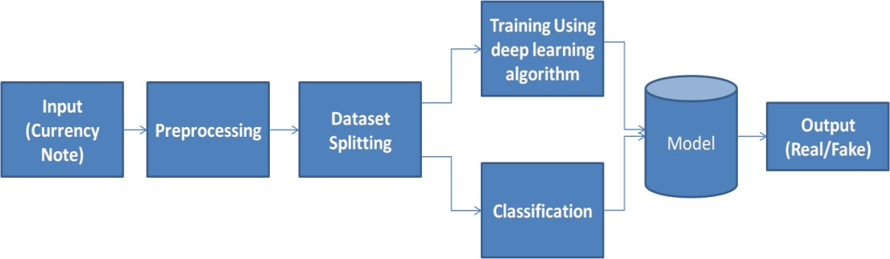

Fig 1. Block diagram of Proposed System

* Data Collection: Real-time creation of the fake and real currency database occurs. Various banknotes are taken into account when evaluating. The resolution phone camera is used to take the pictures in various lighting conditions and orientations. Banknotes for children are taken in order to be faked and the new currency notes are taken for examination.
* Pre-processing: The camera images are noisy when they are captured, pre-processing is necessary to eliminate the noise from the image. To eliminate the noise caused by salt and pepper, the suggested solution makes use of a median filter. One useful nonlinear method for lowering impulsive or pepper-and-pepper noise is median filtering. It is also useful for minimizing random noise and maintaining image edges. Random bit errors can cause impulsive or pepper-and-pepper noise in a communication line. A window moves along the image in a median filter, and the output intensity of each processed pixel is determined by the median intensity value of the pixels inside the window.
* Training Using CNN: CNNs represent a class of Neural Networks that have demonstrated remarkable efficacy in domains like image recognition and classification. CNNs are a multi-layered feed-forward neural network type. CNNs are made up of filters, kernels, or neurons with biases, parameters, and learnable weights. Every filter receives certain inputs, convolutionally processes them, and optionally outputs a non-linearity in response. Convolutional, pooling, Rectified Linear Unit (ReLU), and Fully Connected layers make up CNN's structure..
* Advantages of Proposed System
  1. Improved Accuracy: The proposed system leveraging Convolutional Neural Networks (CNNs) offers enhanced accuracy in counterfeit currency detection compared to traditional manual methods and basic rule-based systems.
  2. Automated Detection: Automation is a key advantage, as the proposed system incorporates advanced image processing and machine learning techniques, reducing the reliance on manual inspection and improving efficiency.
  3. Efficient Handling of Diverse Currency Types: The proposed system ensures efficiency in handling diverse currency types, as CNNs can be trained on a comprehensive dataset that includes various currencies in circulation, making it more adaptable to different scenarios.
  4. Real-time Analysis: With the incorporation of advanced technologies, the proposed system is capable of real-time analysis, providing a swift response to verify the authenticity of currency notes during transactions.
  5. Enhanced Security Measures: The advanced nature of the proposed system contributes to enhanced security measures, providing a more robust defense against counterfeit currency and contributing to overall financial system integrity.

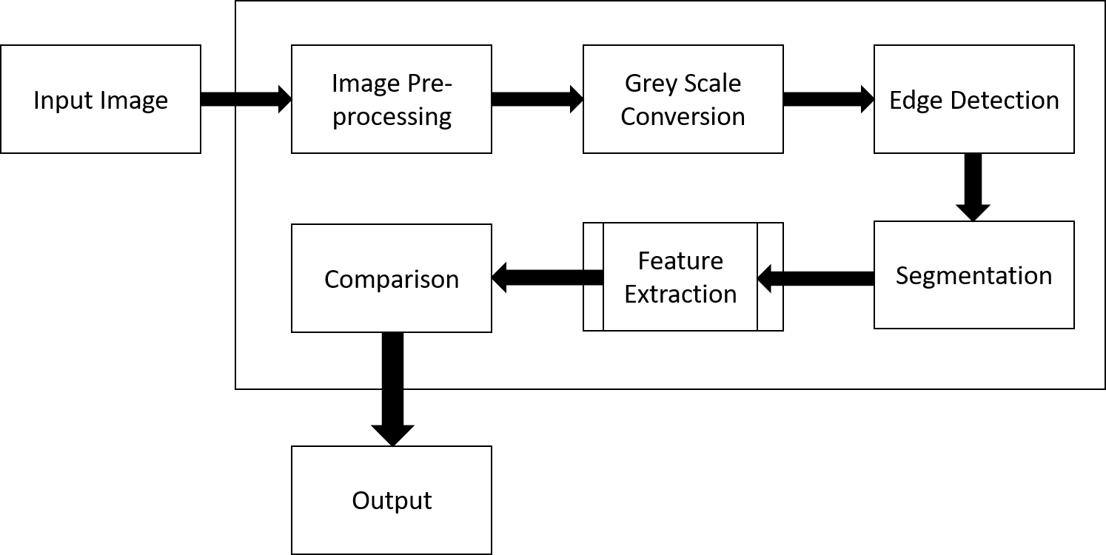

Fig 2. Data Flow Diagram

• Another name for the DFD is a bubble chart. A system can be represented using this straightforward graphical formalism in terms of the input data it receives, the different operations it performs on that data, and the output data it generates.

• The data flow diagram, or DFD, is a crucial modeling instrument. The components of the system are modeled using it. These elements consist of the system's procedure, the data it uses, an outside party that communicates with it, and the information flows within it.

• DFD illustrates the flow of information through the system and the various changes that alter it. This method uses graphics to show how information flows and the changes made to data as it goes from input to output.

• Another name for DFD is a bubble chart. Any level of abstraction can be utilized to portray a system using a DFD. DFD can be divided into phases that correspond to increasing functional detail and information flow.

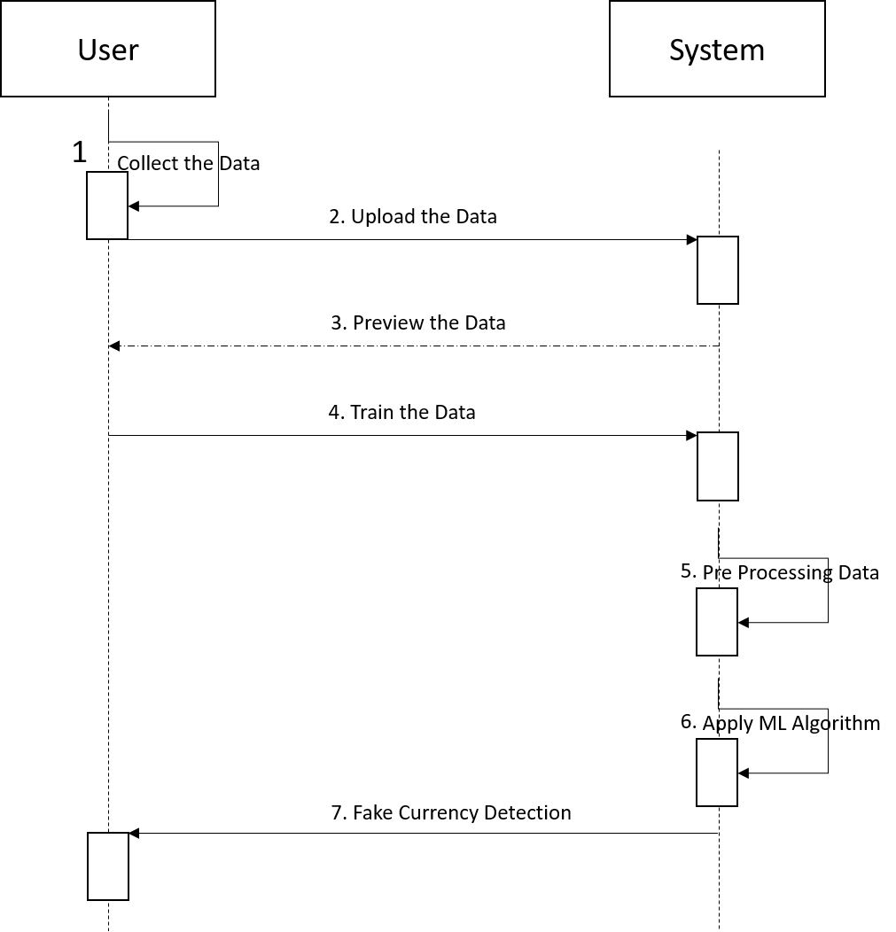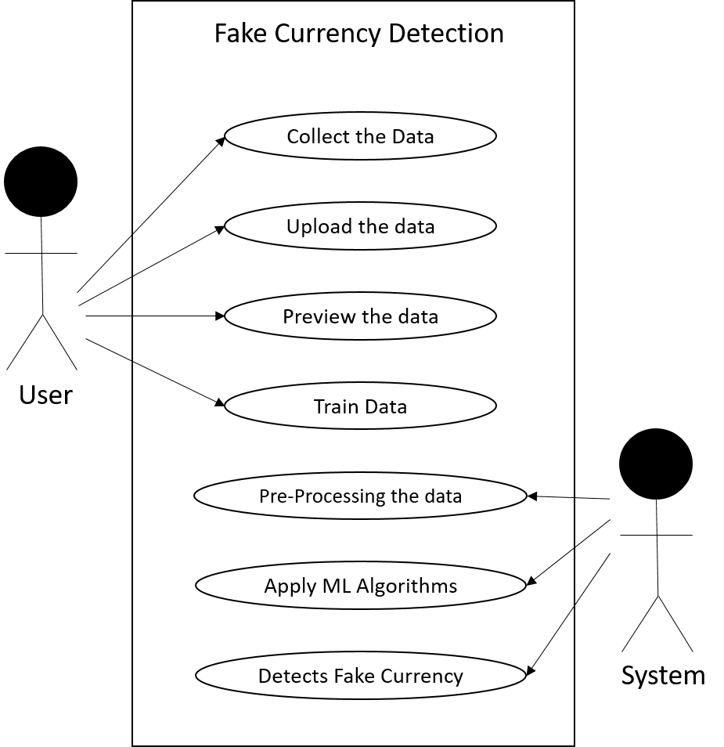

Fig 3. Use Case Diagram

In the Unified Modelling Language (UML), a use case diagram is a particular kind of behavioral diagram that is produced from and defined by a use-case study. Its objective is to provide a graphical summary of the functionality that a system offers in terms of actors, use cases (representations of their goals), and any interdependencies among those use cases. A use case diagram's primary goal is to display which actors receive which system functionalities. It is possible to illustrate the roles of the system's actors.

Fig 4. Sequence Diagram

In the Unified Modeling Language (UML), a sequence diagram is a type of interaction diagram that illustrates the relationships and sequence in which processes operate with one another. It is a Message Sequence Chart construct. Event diagrams, event situations, and timing diagrams are other names for sequence diagrams.

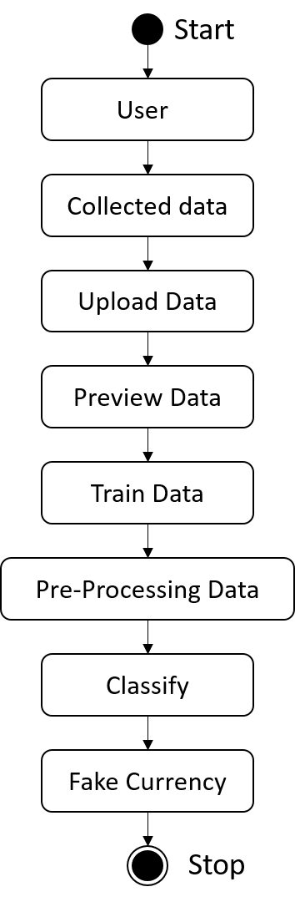

Fig 5. Activity Diagram

Workflows of sequential activities and actions with provision for choice, iteration, and concurrency are represented graphically using activity diagrams. Activity diagrams in the Unified Modeling Language can be used to explain the step-by-step operational and business workflows of system components. An activity diagram illustrates the total control flow.

1. HARDWARE AND SOFTWARE

REQUIREMENT

1. *Hardware Requirements:*

Modern Operating System:

* A CPU that can run on a Pentium IV or quicker.
* RAM of 512 MB or greater; minimum frequency of 2.4 GHz or higher
* At least a 20 GB hard drive; a monitor with a resolution of 800 x 600 pixels or greater, or VGA

1. *Software Requirements:*

* Python Programming Language
* Python IDLE

# RESULTS

The developed system has been tested for it’s validity. In this case, the system has detected the currency as real. The system is shown the image of a ₹100 Indian banknote, and is able to correctly identify whether it is real or fake. The system is able to identify the features such as the watermark, security thread, and other security features to make the decision.

The proposed system can be used in various applications, such as banks, ATMs, and retail stores, to help prevent counterfeit currency from being circulated. It can also be used to educate people about the different features of real currency and how to spot fake bills.

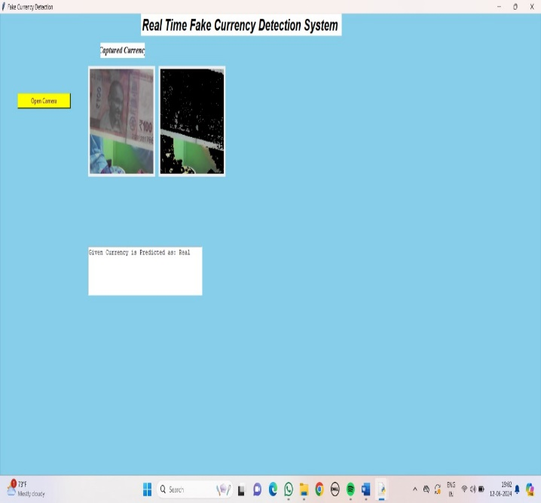

Fig 6. Real Time Fake Currency Detection System

The below Fig.7. shows The image depicts the final result of a fake currency detection system utilizing machine learning. The system's user interface is straightforward and allows users to upload an image of a money note. Its purpose is to distinguish between real and counterfeit bank notes. The system preprocesses images to enhance their quality and get them ready for analysis as soon as they are uploaded. Subsequently, pertinent characteristics such image textures, security features, and color patterns are extracted from the processed image. A trained model uses these features to forecast if the currency note is authentic or fake; the prediction is shown by the system in the "Predict" section. The system has determined that the specified currency is real in this instance. This approach shows how machine learning may be applied to real-world issues and can assist in spotting fake money, shielding people and companies from financial scams.

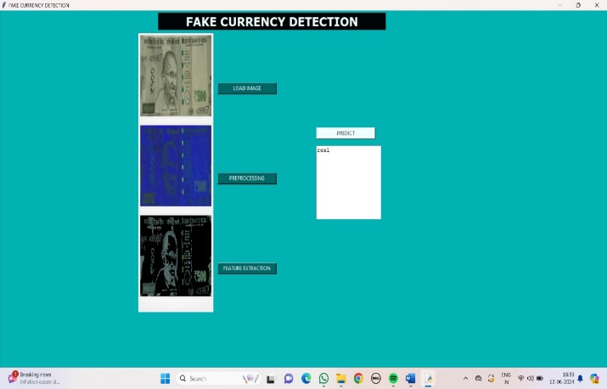

Fig 7. GUI Interface for Fake Currency Detection System

The below Fig.8. shows This image depicts the final result of a fake currency detection system utilizing machine learning. The system has analyzed the uploaded currency note and has predicted that it is real. The interface displays various details. The system's prediction is displayed prominently, stating that the given currency is real. This system demonstrates the potential of machine learning to solve real-world problems, and it can be used to help identify counterfeit currency, protecting individuals and businesses from financial fraud.

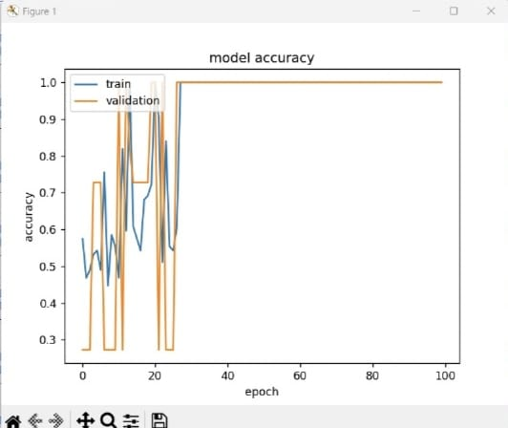

Fig 8. Accuracy of the System

# CONCLUSION

In summary, the identification of counterfeit money poses a serious problem with broad ramifications for the stability of the economy. Conventional procedures for detecting counterfeit money depend on manual examination and crude methods based on color, width, and serial numbers; nevertheless, these methods are sometimes ineffective in the face of more complex counterfeiting tactics. This issue has a possible solution thanks to the development of deep learning models, especially Convolutional Neural Networks (CNNs), which make use of sophisticated image processing methods. The proposed study presents a CNN model that is trained on a large dataset that includes photos of both real and counterfeit cash notes in order to automatically detect false currency. The CNN model exhibits the capacity to accurately and efficiently identify between genuine and counterfeit currency of different denominations through rigorous training and careful preprocessing. The effective use of this model highlights the significance of automated systems in the fight against counterfeit money, offering a dependable and effective means of preserving the integrity of financial transactions and the economy as a whole.

# REFERENCE

1. Aman Bhatia, Vansh Kedia,Anshul Shroff, Mayand Kumar, Bickey Kumar Shah, Aryan “Fake Currency Detection with Machine Learning Algorithm and Image Processing” IEEE [2021]
2. Anju Yadav,Tarun Jain,Vivek Kumar Verma,Vipin Pal “Evaluation of Machine Learning Algorithms for the Detection of Fake Bank Currency” IEEE [2021]
3. Dr. S. V. Viraktamath, Kshama Tallur, Rohan Bhadavankar, Vidya, “Review on Detection of Fake Currency using Image processing Techniques” IEEE [2021]
4. Vanajakshi, Veena, Yadhunandan, Sowjanya.U, Anitha “Detection of Counterfeit Indian Currency Note using Image Processing” Journal [2021]
5. Subhalaxmi Chakraborty, Soumyadip Banerjee, Biman Kumar Singha, SayaniGhati “Fake Note Detection using Machine Learning Techniques” Journal [2021]
6. G.Hariharan , D.Elangovan “Proxy Notes Recognition And Eradication For Betterment Of The Society” Journal [2020]
7. Asfaw Shefraw Alene, Million Meshesha “Ethiopian Paper Currency Recognition System: An Optimal Feature Extraction” IEEE [2019]
8. Kiran Kamble, Anuthi Bhansali, Pranali Satalgaonkar, Shruti Alagundgi “Counterfeit Currency Detection using Deep Convolutional Neural Network” IEEE [2019]
9. Megha Jadhav,Yogesh kumar Sharma,G. M. Bhandari “Currency Identification and Forged Banknote Detection using Deep Learning” Conference [2019]
10. Veling, Miss. Janhavi P. Sawal, Miss. Siddhi A. Bandekar, Mr. Tejas C. Patil, Mr. Aniket L. Sawant “Fake Indian Currency Recognition System by using MATLAB” Journal [2019]
11. D. Shamika, A. Rajadhyaksha, G. Swapnil and Anjali Shetty “CNN based Counterfeit Indian Currency Recognition Using Generative Adversarial Network.”, DOI Link: 10.1109/ICAIS50930. 2021.9395949.
12. Mr. M. Abishek, Mr. B. Kavin, Mr. and B. Raj Kumaran, ECE Department, Bannari Amman Institute of Technology, Tamil Nadu, “FAKE CURRENCY DETECTION USING CNN”, “India vol: 07, Issue: 03, March 2020.
13. K. Kiran, B. Anuthi, S. Pranali and A. Shruti, “Counterfeit Currency Detection using Deep Convolutional Neural Network” MIT World Peace University, Pune, India, Dec 18-20, 2019.
14. Z. Adiba, U. Jia, "A Hybrid Fake Banknote Detection Model using OCR, Face Recognition and Hough Features”, Cybersecurity and Cyberforensics Conference (CCC), 2019.
15. K. Gautam, "Indian Currency Detection using Image Recognition Technique", 2020 International Conference on Computer Science, Engineering and Applications (ICCSEA), 2020.
16. Singh, S., Aggarwal, A.K., Ramesh, P., Nelson, L., Damodharan, P. and Pandian, M.T., 2022, August. COVID 19: Identification of Masked Face using CNN Architecture. In 2022 3rd International Conference on Electronics and Sustainable Communication Systems (ICESC) (pp. 1045-1051). IEEE.
17. Raju S. S., Srikanth M., Guravaiah K., Pandiyaan P., Teja B. and Tarun K. S., (2023), A Three-Dimensional Approach for Stock Prediction Using AI/ML Algorithms: A Review & Comparison, IEEE 4th International Conference on Innovative Trends in Information Technology (ICITIIT), Kottayam, India, (pp. 1-6).
18. D. Alekhya, G. Devisuryaprabha, and G. Venkatadurgarao, "Fake Currency Detection Using Image Processing and Other Standard Methods,” Int. J. Res. Comput. Commun. Technol. ISSN, vol. 3, no. 1, pp. 2278–5841, 2014.
19. H. Hassanpour, A. Yaseri and G. Ardeshirı “Feature Extraction for Paper Currency Recognitionll”, IEEE Transactions, 1-4244-0779- 6/07,2007.