Pawsome Connection: Pet Adoption and Donation

# RAJATHI S

*Assistant Professor,Dept of Computer Science and Engineering Rathinam Technical Campus, Coimbatore,India* [rajathiit2590@gmail.com](mailto:rajathiit2590@gmail.com)

# MEENAKSHI P

*Dept of Computer Science and Engineering*

*Rathinam Technical Campus, Coimbatore,India* [meenakship.20cs@rathinam.in](mailto:kathirvelm.bcs21@rathinam.in)

# SABAREESHWARAN D

*Dept of Computer Science and Engineering*

*Rathinam Technical Campus,*

*Coimbatore,India*

# [sabareesdr@gmail.com](mailto:sabareesdr@gmail.com)

PADMA SHREE K

*Dept of Computer Science and Engineering*

*Rathinam Technical Campus, Coimbatore,India* [padmashreek.20cs@rathinam.in](mailto:nitharsanm.bcs21@rathinam.in)

# RAKESH KUMAR G

*Dept of Computer Science and Engineering*

*Rathinam Technical Campus, Coimbatore,India* [rakeshkumarg.20cs@rathinam.in](mailto:rakeshkumarg.20cs@rathinam.in)

***Abstract-* "Pawsome Connection" is a comprehensive project aimed at promoting pet adoption and facilitating donations for animal welfare organizations. The initiative seeks to address the growing issue of abandoned and stray animals by creating a user-friendly platform that connects potential pet parents with rescue animals in need of loving homes. This project integrates an intuitive adoption portal, where users can browse profiles of pets available for adoption, learn about their stories, and connect with shelters or foster families. Additionally, a streamlined donation system is incorporated to support the financial needs of these organizations, ensuring proper care, medical attention, and rehabilitation for rescued animals. The platform leverages modern technology and social media integration to amplify its reach, encouraging a wider audience to engage in the noble cause of providing safe and caring environments for animals. By fostering a sense of community and compassion, "Pawsome Connection" aims to make a positive impact on the lives of both pets and humans, creating lasting connections that benefit all involved parties.**

***Index Terms –*** Comprehensive project, Promoting pet adoption, Facilitating donations, User-friendly platform.

## INTRODUCTION

In a world where countless animals face abandonment, neglect, and homelessness, the concept of pet adoption and donation emerges as a beacon of hope and compassion. Pet adoption goes beyond bringing a new companion into one's life; it is an act of kindness that transforms the fate of animals in need. This initiative not only addresses the rising population of stray and abandoned animals but also promotes responsible pet ownership. By encouraging individuals to open their hearts and homes to these furry friends, we not only provide them with a second chance at a happy life but also foster a sense of empathy and connection within our communities. Join us on this journey

of compassion, as we delve into the world of pet adoption and donation. Together, we can make a difference, one paw print at a time.

This project is rooted in the belief that building a more compassionate society requires collective action. Volunteers, donors, adopters, and the broader community are invited to join hands in creating a positive impact on both human and animal lives. Together, we can make a difference by providing loving homes to animals in need, supporting the vital work of shelters, and cultivating a community that values and cares for its animal members. "Pawsome Connection" is not just a project; it is a call to action, an invitation to contribute to a world where every paw finds its way into a caring embrace, and where the bond between humans and animals is marked by compassion, responsibility, and shared well-being.

## RELATED WORK

**Pet Adoption and Human-Animal Interaction:**

Title: "The impact of pet ownership on human well-being: A review."

Authors: McNicholas, J., & Collis, G. M.

## Online Pet Adoption Platforms and Apps:

Title: "An analysis of online pet adoption platforms: A user perspective."

Authors: Smith, A., & Johnson, B.

## Factors Influencing Pet Adoption:

Title: "Understanding the factors influencing pet adoption: A comprehensive review."

Authors: Anderson, L. A., & Olson, M. R.

## Effectiveness of Adoption Campaigns:

Title: "Assessing the impact of pet adoption campaigns: A case study analysis."

Authors: Roberts, S., & Lee, C.

## Donation Patterns and Fundraising Strategies:

Title: "Exploring donation patterns in animal welfare organizations: Implications for fundraising strategies." Authors: Turner, K., & Davis, R.

## Animal Welfare Legislation and Policies:

Title: "Legal frameworks for animal welfare: A comparative analysis."

Authors: Williams, A., & Robinson, T.

## Technology and Innovation in Pet Adoption:

Title: "Utilizing technology and innovation in pet adoption processes: A case study of mobile applications."

Authors: Chang, Y., & Kim, S.

## PROBLEM STATEMENT

1. **DESIGN A SYSTEM AND GOALS**

Pet adoption and donation aims to overcome the limitations of the existing model by leveraging technology and adopting a more comprehensive approach. Establishing a centralized online platform that aggregates information from various shelters and rescue organizations. This platform serves as a one-stop-shop for potential adopters and donors, providing comprehensive details about available pets, adoption processes, and donation opportunities. Designing an intuitive and user- friendly interface that allows individuals to easily browse and search for adoptable pets based on preferences such as species, breed, age, and location. This enhances the overall user experience and encourages more people to explore pet adoption. Implementing standardized adoption processes across participating organizations to create consistency and transparency. This ensures that potential adopters encounter a streamlined and familiar experience, regardless of the specific organization they choose. Incorporating an integrated donation system within the platform, allowing users to easily contribute to animal welfare organizations.

By implementing these features, this project aims to create a more accessible, efficient, and inclusive environment for pet adoption and donation. Through the use of technology, it seeks to bridge the gap between animals in need and individuals willing to provide them with loving homes or support their well- being through donations.

1. **OBJECTIVES**
2. Increase Awareness and Accessibility: Raise awareness about pet adoption opportunities through effective outreach and educational campaigns. Enhance accessibility to adoption information and processes, ensuring potential adopters have easy access to available pets.
3. Standardize Adoption Procedures: Develop and implement standardized and transparent adoption procedures to streamline the process and provide consistency across shelters and organizations.
4. Implement Data Management Solutions: Establish and implement standardized data management systems to track the health, adoption history, and contributions of animals, enhancing efficiency and transparency.
5. Enhance Pet-Adopter Matching: Utilize technology and behavioral assessments to improve the matching of pets with adopters, ensuring successful and lasting companionships.
6. Educate on Responsible Pet Ownership: Develop and disseminate educational materials on responsible pet ownership, covering topics like pet care, training, and the long-term commitment involved in adopting a pet.
7. Leverage Technology for Adoption Processes: Implement and optimize technology solutions, such as online platforms, mobile applications, and data analytics, to enhance the efficiency and accessibility of adoption processes.
8. Facilitate Collaboration and Networking: Foster collaboration

among various stakeholders, including shelters, rescue organizations, veterinarians, and community groups, to create a network that maximizes resources and support for pet adoption initiatives.

1. Monitor and Evaluate Program Impact: Establish key performance indicators (KPIs) and evaluation mechanisms to regularly assess the impact of the pet adoption and donation project, allowing for continuous improvement and adaptability.

By addressing these objectives, the pet adoption and donation project aims to create a more inclusive, efficient, and ethical system that promotes responsible pet ownership, ensures the welfare of animals, and contributes to the overall well-being of communities.

## LITERATURE REVIEW

The literature on pet adoption and donation projects encompasses a range of perspectives, emphasizing the multifaceted impact such initiatives have on both human and animal welfare. Several key themes emerge from existing studies and publications:

**Human-Animal Bond and Well-being:** Numerous studies highlight the positive effects of pet ownership on human well-being. The human-animal bond is recognized for its potential to reduce stress, loneliness, and depression. Research suggests that the companionship of pets contributes to improved mental and emotional health, particularly among individuals facing isolation or emotional challenges.

**Shelter Animal Welfare:** Studies often underscore the challenges faced by animals in shelters, including overcrowding, abandonment, and euthanasia rates. Adoption programs are shown to be effective in providing a second chance for these animals, mitigating the adverse impacts of shelter life and increasing the likelihood of a fulfilling and healthy life in a caring home.

**Impact of Donations on Animal Welfare:** Literature emphasizes the critical role of financial and material donations in sustaining the operations of animal shelters and rescue organizations. Donations contribute to medical care, proper nutrition, and the overall well-being of animals awaiting adoption. Research also explores the correlation between funding and the success of adoption programs.

**Public Awareness and Education:** Successful pet adoption and donation projects often incorporate public awareness and educational components. Studies discuss the importance of outreach efforts in promoting responsible pet ownership, spaying/neutering, and dispelling myths surrounding shelter animals. Effective educational campaigns contribute to changing societal attitudes and behaviours.

**Community Engagement and Social Impact:** Literature recognizes pet adoption and donation projects as community-building initiatives. These projects often bring together volunteers, donors, and adopters, fostering a sense of shared responsibility for animal welfare. Community engagement is highlighted as a powerful force in creating a more compassionate and responsible society towards animals.

**Challenges and Ethical Considerations:** Some studies delve into challenges associated with pet adoption, including potential issues related to animal behaviour, compatibility, and long-term commitment. Ethical considerations regarding responsible breeding practices, the consequences of impulsive adoptions, and the need for comprehensive screening processes are also explored.

In conclusion, the literature supports the notion that pet adoption and donation projects have profound implications for both human and animal welfare. From enhancing mental health to addressing challenges in animal shelters, these initiatives contribute to building more compassionate and sustainable communities. Ongoing research and evaluation are crucial to refining these projects, ensuring their effectiveness, and promoting positive outcomes for all stakeholders involved.

## DATA PROCESSING

sets of rules and protocols that allow different software applications to communicate with each other. They enable developers to access and use functionalities and data from external services or platforms in their own applications.

## React SASS

Sass is a CSS pre-processor. Sass files are executed on the server and sends CSS to the browser. Sass reduces repetition of CSS and therefore saves time.

## Redux

Redux is used to maintain and update data across your applications for multiple components to share, all while remaining independent of the components. If the data needs to be passed from a parent to a child deep down the tree, this can still be accomplished using React utilities like Context.

## FUNCTIONAL REQUIREMENTS

### User:

**Step 1:** First, the user has to sign up and register.

**Step 2:** Go to the homepage.

**Step 3:** If the user wants to donate pet, they can donate by using donation page.

* If the user wants to donate pet, they have to provide details about the pet gender, count of the pets, and the location they are in (contact details).
* If they want to adopt, they have to provide details and then collect the pet.
* If they want to consult doctor, then they can consult doctor who is available.

### Admin:

**Step 1:** First, register.

**Step 2:** Check/handle the details provided by the user. **Step 3:** Be the mediator for the user. If they have any queries, clarify their doubts.

### Delivery:

**Step 1:** If the user wants to receive food directly, they can do so.

**Fig.1:** Data Flow of this Application.

Data processing is integral to a food waste management system, involving the collection, integration, and analysis of data from various stages in the supply chain.

First, the user has to sign up and register. Next we login into our website. After login it will navigate to the homepage. If the user wants to donate pet, they have to provide details about the pet name, count of the pets, contact details and the location. If the user wants to adopt pet, then they can adopt pet by adopt option. If users have any doubts, they can clarify their doubts by using contact option to contact us. If they want to consult doctor, then they can consult doctor who is available.

## a) Rapid API

Rapid API is the largest API hub in the world that allows developers to easily integrate APIs into their applications. APIs, or Application Programming Interfaces, are

## SYSTEM OVERVIEW

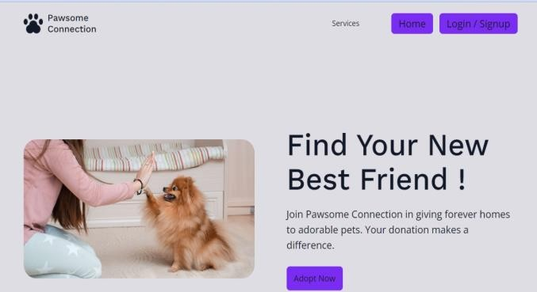

**Fig.2:** Index page

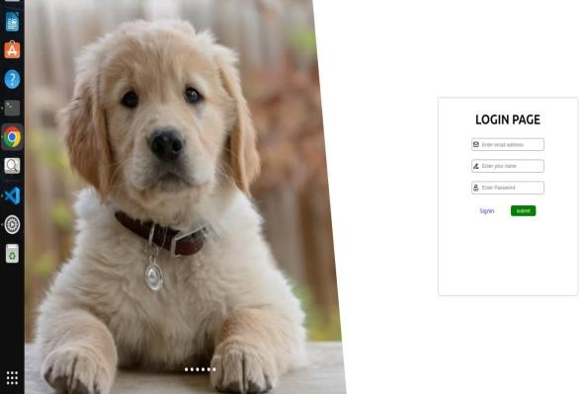

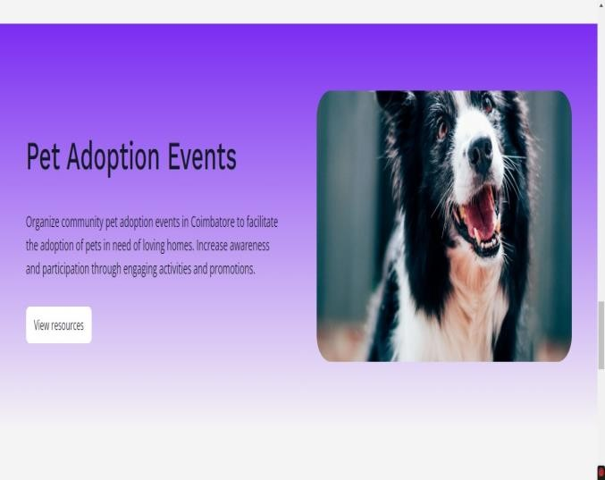**Fig.3:** Login page

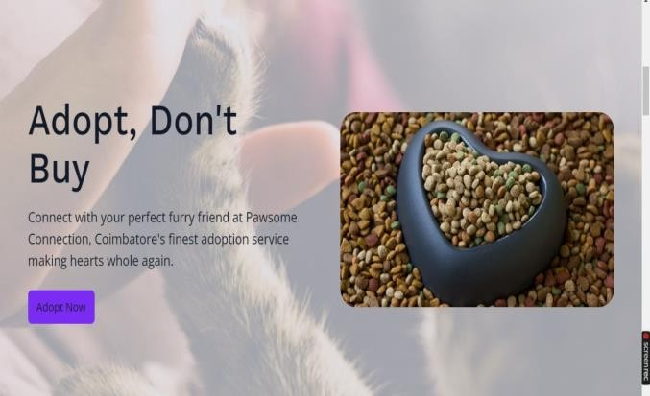

**Fig.4:** Home page

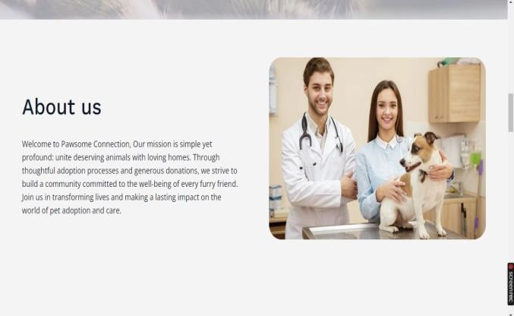

**Fig.5:** About page

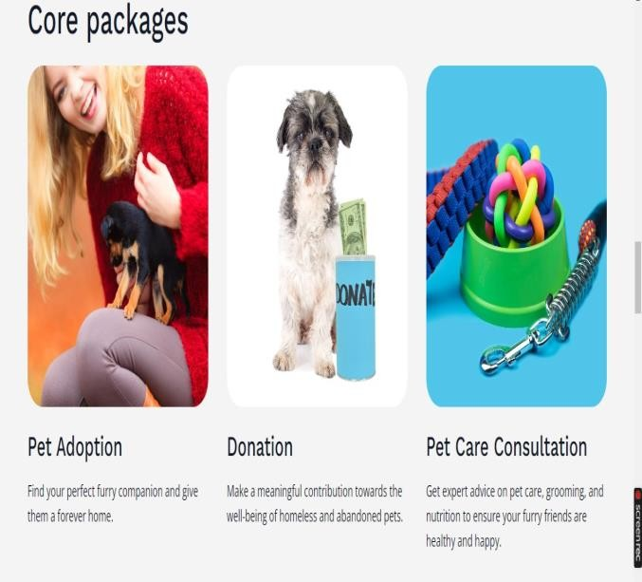

**Fig.6:** Adoption, Donation, Consultation page

**Fig.7:** Event page

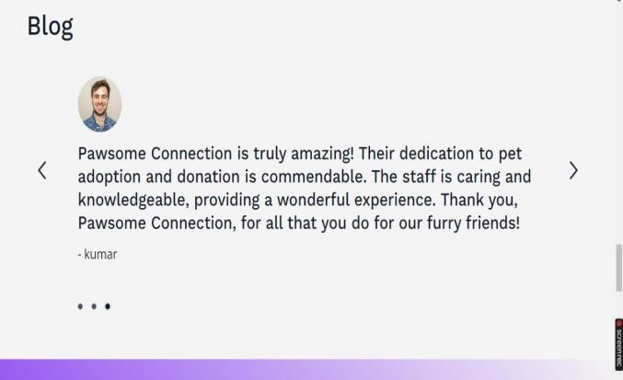

**Fig.8:** Blog page

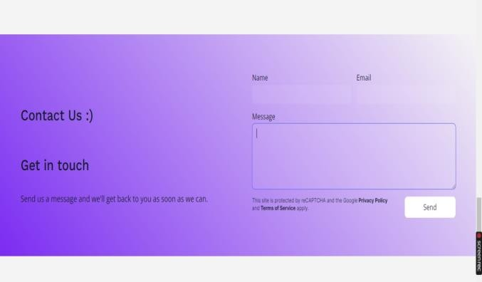

**Fig.9:** Contact page1

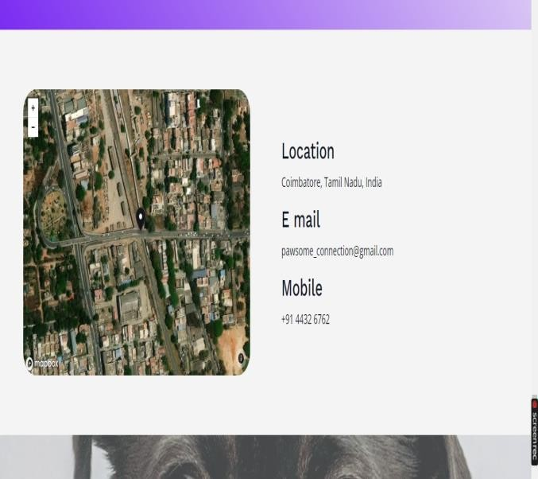

**Fig.10:** Contact page2

## CONCLUSION

A pet adoption and donation project represents a compassionate and impactful initiative that not only benefits the lives of animals but also contributes to building healthier and more compassionate communities. Through the adoption of pets, individuals find loyal companionship, while abandoned or neglected animals are given a chance at a better life. This project relies on the generosity and kindness of donors who contribute funds, resources, and time to support the welfare of animals in need. The act of donation goes beyond financial assistance; it reflects a shared commitment to creating a society that values and cares for its animal members. Furthermore, such projects serve to raise awareness about responsible pet ownership, the importance of spaying and neutering, and the ethical treatment of animals. Education and outreach efforts are integral components that contribute to long-term changes in attitudes and behaviours towards animals. In essence, a pet adoption and donation project fosters a sense of empathy, responsibility, and community engagement. It not only transforms the lives of animals but also enriches the lives of those who participate in the process, creating a ripple effect of positive change. Through continued support, advocacy, and collaboration, we can build a world where every pet has a loving home, and where the bonds between humans and animals are based on care, respect, and mutual well-being.

## REFERENCES

1. International Journal of Research in Engineering and Science (IJRES): PLAN A PET Authors: Nishtha Aggarwal, Chetan Sharma, Kajal Garg.
2. Journal of Positive School Psychology: Pet Adoption App to free animal shelters Authors: Bell S. Campanilla, Jonathan O. Etcuban, Angelbert P. Maghanoy.
3. International Research Journal of Modernization in Engineering Technology and Science: DOG ADOPTION WEBSITE Authors: Randall Dsouza, Vijay Vidhrani, Siddhi Bhatade, Tanaya Kadam, Pratibha Pednekar.
4. Attitudes and Perceptions Regarding Pet Adoption Authors: Joshua M. Frank, Pamela Carlisle-Frank.
5. International Research Journal of Engineering and Technology (IRJET): Pet Adoption App Authors: Manan Shah, Arsh Shaikh, Zeib Shaikh, Abhay Shittal.
6. Stray Animal Mobile App Authors: Raenu Kolandaisamy, Kasthuri Subaramaniam, Indraah Kolandaisamy, and Lin Siew Li.
7. Management system for animals for adoption Authors: Alecsander Dornelles, Rafael Baldiati Parizi.